# The Memory Capacity of Neural Networks

### **Course:** Seminar/Project Machine Learning & Neuroinformatics/Brain-Computer Interfacing (708.415)

### **Author:** Christoph Rieger

### **Student number:** 01530103

### **Date:** 08.02.2023

# Introduction

This project aims to investigate the memory capacity of neural networks depending on their size and architecture. Randomly generated input and output patterns are handed to the network to be memorized. Two different network architectures, as well as two different definitions of when a pattern is learned correctly, are analyzed.

# Methods

### Data

The input vectors x and target vectors y are binary vectors of size N. The number of these vectors is defined by the dataset size DS. Different values for DS were tried for each network, until the maximum number of memorizable patterns was determined. All input and target vectors for each DS together yield the matrices X and Y.   
The vectors x and y have a sparsity s which was chosen as 0.1. This means that 10% of the bits of x and y were active with values of one and the rest of the bits were inactive with values of zero. Both vectors were generated randomly, but no duplicate vectors with the same bits were allowed within the input and output matrix respectively.

### Network

The first network used was a 1-Layer fully connected network and will be called simple network from now on. It has N input neurons and N output neurons. The input and output layer are fully connected. The activation function used was the sigmoid function, which scales the outputs between zero and one. This behavior is desired because the target vector’s values lie between those values. For an arbitrary value a it is defined as

(1)

After the application of the activation function the network’s prediction/output z is obtained. The prediction and the target vector are then handed over to the loss function. In this experiment the network is performing a binary classification task between y and z for each single bit. Thus, Binary cross-entropy (BCE) was chosen because it is designed for such classification tasks. For a batch size of one it is given by

(2)

As optimizer stochastic gradient descent and ADAM were tested. After evaluation ADAM was chosen as optimizer for this experiment because it was converging faster than stochastic gradient descent with no apparent drawback.

The described “simple“ network was later expanded by a recurrence between the output neurons. The training process now consisted of two steps through time, while using the same input vector. The first step was identical to the first network, the input goes to the N input neurons and is passed via the fully connected layer to the N output neurons.   
After that, in the second step, the input was again given to the input neurons of the network. Additionally, the output neurons of step 1 were connected to the output neurons of step 2, creating a recurrent layer with trainable weights. These recurring connections were initialized fully connected between the two output layers, but all weights of connections between the same output neurons (e.g.: output neuron 1 of step 1 to output neuron 1 of step 2) were always kept at zero. By that N2 – N trainable connections were added to the network.

At last, the recurrent network was expanded once more by adding a third step, which functioned in the same way as step 2, taking the original input vector as input and connecting the output neurons of step two to the output neurons of step 3. This resulted in three total steps with the same input vector.

The learning rate used for training was 0.01 for all networks except the recurrent network with 3 steps. For the recurrent network with 3 steps the learning rate had to be reduced to 0.001 because the loss was not converging.

### Loss and classification

In the evaluation phase each bit of the network’s prediction z had to be cast to either one or zero. This was done by setting all outputs greater or equal than 0.5 to 1 and all smaller than 0.5 to 0.

Two different definitions of when a pattern counts as correctly memorized by the network were analyzed. The first one only counted a pattern as memorized if the output vector is equal to the target vector.

To create a more lenient definition a second definition was introduced. It calculated the number of bits to ignore #bti as

. (3)

During each training step output neurons with the worst loss were disabled. This was done #bti times for the group of output neurons that had a target of 1 and another #bti times for the group that had a target of 0. The neurons were “disabled” by setting their loss to 0. The idea behind this procedure was that stochastically the input and output patterns could overlap many of their active bits, making it more difficult for the network to 100% correctly classify those overlapping patterns. The bits to ignore are supposed to counteract this stochastic increased difficulty of memorization.  
Due to this disabling of output neurons, and thus preventing them from learning, the validation paradigm also had to be adjusted. Instead of requiring all the bits of the output and target vector to be equal, #bti of the active group and #bti of the inactive group were allowed to be unequal.

### Analyzed networks

To summarize, four different networks were trained and analyzed.

1. simple network
2. simple network with the custom loss function
3. recurrent network that took two steps with the same input data and with custom loss function
4. recurrent network that took three steps with the same input data and with custom loss function

### Determination of the maximum memorizable patterns

To determine the maximum number of memorizable patterns the appropriate DS for the network had to be searched. It was not possible to simply take a DS much bigger than the maximum of memorizable patterns, because for those the network was not trainable properly and it performed poorly.  
Instead the biggest dataset a network can still memorize perfectly was searched. After finding it the DS was increased by 100 until the biggest DS was found where the network could still memorize more than 90% of the dataset.

### Calculation of mean and standard deviation of the memorized patterns

The simple network without a recurrent layer was trained five times with each set of parameters and the mean and standard deviation of the memorized patterns was calculated over those five training runs. For the more complex recurrent network only three runs were performed, to speed up the training process. The maximum amount of memorized patterns used as result was taken from the best performing run.

# Results

The results of the experiment for all four networks are given in Table 1 and 2. The accuracy was calculated as maximum number of memorized patterns divided by the dataset size.

|  |  |  |  |  |  |  |
| --- | --- | --- | --- | --- | --- | --- |
|  | | N | | | | |
| 100 | 200 | 300 | 400 | 500 |
| Simple network | Maximum number of memorized patterns | 283 | 580 | 897 | 1194 | 1494 |
| Accuracy  [%] | 94.33 | 96.67 | 99.67 | 99.5 | 99.6 |
| Mean of memorized patterns | 243 | 550 | 883.8 | 1165.6 | 1486.8 |
| Standard deviation of memorized patterns | 23.95 | 32 | 11.95 | 23.56 | 7.93 |
| Simple network with custom loss function | Maximum number of memorized patterns | 337 | 694 | 1077 | 1580 | 2008 |
| Accuracy  [%] | 96.29 | 99.14 | 97.91 | 98.75 | 95.62 |
| Mean of memorized patterns | 305 | 674.8 | 1046 | 1395.2 | 1904 |
| Standard deviation of memorized patterns | 24 | 20.7 | 26.56 | 169 | 141.7 |

Table 1: Results for the simple network, once with basic loss and once with custom loss

|  |  |  |  |  |  |
| --- | --- | --- | --- | --- | --- |
|  | | N | | | |
| 50 | 100 | 150 | 200 |
| Recurrent network  (2 steps) | Maximum number of memorized patterns | 534 | 920 | 1241 | 1549 |
| Accuracy  [%] | 97.09 | 92 | 95.46 | 96.81 |
| Mean of memorized patterns | 524.8 | 902.2 | 1228 | 1539.33 |
| Standard deviation of memorized patterns | 6.18 | 12.5 | 9.27 | 7.13 |
| Recurrent network  (3 steps) | Maximum number of memorized patterns | 589 | 1219 | 1528 | 1950 |
| Accuracy  [%] | 98.17 | 93.77 | 95.5 | 92.86 |
| Mean of memorized patterns | 577.66 | 1199 | 1503 | 1929.33 |
| Standard deviation of memorized patterns | 13.3 | 14.51 | 17.72 | 14.7 |

Table 2: Results for the recurrent network, once with 2 steps and once with 3 steps

In Figure 1 the number of memorized patterns depending on N of each network can be seen.

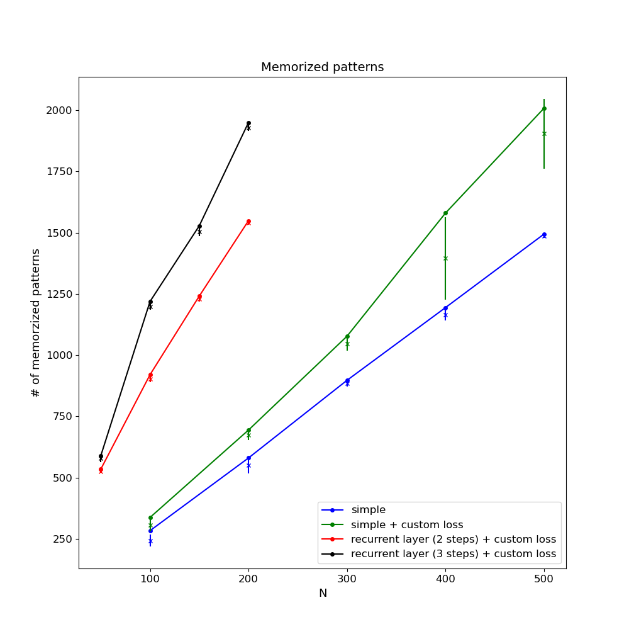

Figure 1: Number of patterns memorized of the 3 different networks. The datapoints of the graphs are the maximum number of memorized patterns of all training runs. Marked with “x” is the mean of the runs with the standard deviation as a vertical line.

The number of memorized patterns per N, depending on N, for each network can be seen in Figure 2.

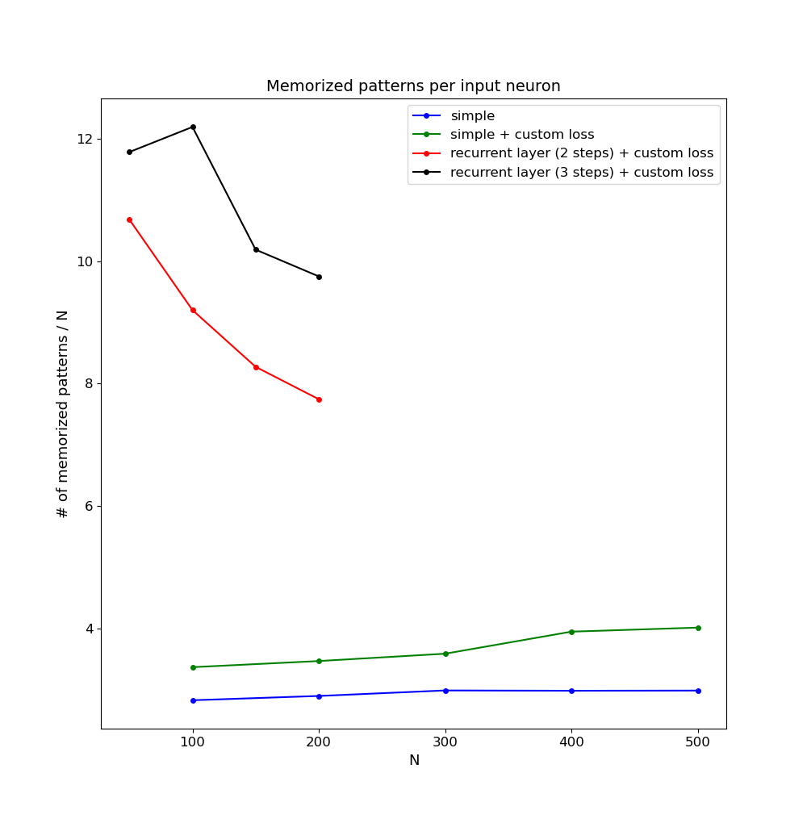

Figure 2: Number of memorized patterns per N.

The number of memorized patterns per N squared, depending on N, for each network can be seen in Figure 3.

## 

Figure 3: Number of memorized patterns per N squared.

# 

# Discussion

In Figure 1 the simple network was memorizing the least patterns of all networks. In Figure 2 its slope was constant, for each added neuron about three more patterns could be memorized.  
By expanding the simple network with the custom loss function it was able to memorize more patterns, the bits to ignore acting like a positive offset. Furthermore, in Figure 2 for N of 400 and 500 the number of patterns per N started to rise, indicating that the network’s memory capacity started to rise faster than the complexity of the data. However, when looking at the standard deviation of this network and the mentioned N in Figure 1 and in Table 1 it was extraordinarily high compared to all other standard deviations. It is unknown why it deviated, as the standard deviation was calculated over 5 training runs as for the simple network. But it could stochastically explain why the number of patterns per N was higher for N of 400 and 500, as the maximum values are further from the mean values, compared to the other N. This would mean that that the network’s memory capacity did not start to outpace the complexity of the data, but rather that it was a statistical outlier. A reason for training runs with the same parameters to yield vastly different numbers of memorized patterns could be the dataset, which is generated randomly at the beginning of each run. Depending on chance bits of data vectors are overlapping, making them more difficult for the network to memorize. One interesting metric to record would have been the percentage of overlapping bits in the input and target vectors and then calculate the correlation between that and the final accuracy of a training run. Another reason for the runs to differ in accuracy is the random initialization of the weights, to determine this impact multiple training runs would have needed to be performed with the same dataset.

When looking at Figure 1 and Table2 again the recurrent network with 2 steps and custom loss performed better than the simple networks. This was expected, as the additional recurrent layer introduced another N2 – N connections to the network, making it more complex. When looking at Figure 2 its number of patterns per N is higher than for the simple networks, however the value is sinking with rising N. This behavior most likely occurred because the training was more difficult. The loss of the simple networks strictly decreased with each training epoch, making the training process straight forward. In contrast the loss of the recurrent network increased and decreased many times during the training process. Because of that the recurrent network was much harder to train and that could explain the decreasing memorized patterns per N of it. Its performance could be improved even further by adding additional hidden layers.

When performing 3 instead of 2 steps through time with the recurrent network the memory capacity increased even further, as seen in Figure 1 and Table 2. This was also expected, as the complexity of what the network can learn increased by adding an additional step through time. However the training of the network became more difficult once again, and the learning rate had to be reduced from 0.01 to 0.001 for the loss function to converge. The performance of this network can be seen in Figure 1 and Table 2. The network performed similarly to the recurrent network with 2 steps, just with a positive offset. In Figure 2 there was one outlier at N of 50 where the number of patterns per N was lower than for N of 100. This was not expected, as for both recurrent networks all other numbers of patterns per N strictly decreased with rising N. To reduce the chance of it being a statistical outlier the training process for this N was repeated an additional time with even more epochs, yielding a similar result. This network needed to converge to a very low loss to achieve a high accuracy and even though it saw the data set 3500 times and the loss function seemed to have converged even more epochs might be necessary to fully utilize the capacity of this network. The necessity of a high number of training epochs was only apparent for N of 50, as for bigger N the data set also increased in size, letting the network learn more times each epoch.

The observed behavior of the memorized patterns regarding N2 can be seen in Figure 3. If the network were able to memorize N2 patterns for every N, as was initially theorized, the graphs would have a constant slope of zero at a value of one. This is not the case however as all graphs have a negative slope at every N. Furthermore, the number of patterns per N2 also is never at one, but below it.   
The negative slope in Figure 3 is explained with the rising complexity of the input and target vectors with rising N. As the networks get more capable with rising N, the data also becomes more complex, because they hold more active bits. As can be seen in Figure 2 the simple networks slowly increase the number of memorized patterns per N with rising N, but not in a quadratic dependency, which supports the argument of the rising complexity of the data. The falling graphs of the recurrent networks in this Figure are supposed to be due to the imperfect training of these networks. As mentioned before their higher complexity made it difficult to train them and each training process took about two days. Thus, it is very likely, that the number of memorized patterns of the recurrent networks could be increased by improving the training process and training them for longer. It was expected that, the slope of the recurrent networks in Figure 2 should be bigger than the slope of the simple networks. This assumption is made, because with rising N their number of connections, and thus their memory capacity, rise faster than for the simple networks.  
Furthermore the initial expectation, that the value of the graphs in Figure 3 of the simple networks should be at one, seems faulty, as this would occur only when each data vector only had one active bit. Under that condition the simple networks would be able to memorize N2 for each N. In this experiment however the number of active bits rises with N, thus increasing the complexity of the data. Because of that realization the value smaller than one seems to be correct.