Report on Efficient Data Management in R

Denis Cohen, Cosima Meyer, Marcel Neunhoeffer & Oliver Rittmann

17 February 2020

## R Markdown

This is an R Markdown document. Markdown is a simple formatting syntax for authoring HTML, PDF, and MS Word documents. For more details on using R Markdown see <http://rmarkdown.rstudio.com>.

When you click the **Knit** button a document will be generated that includes both content as well as the output of any embedded R code chunks within the document. You can embed an R code chunk like this:

load(file = "../gen-data/ess-proc.RData")  
  
  
##### Working with the data  
  
## ----inference----------------------------------------------  
ess_est <- ess %>%  
 mutate(v_center_left = (v_center_left == "Yes")) %>%  
 group_split(cntry) %>%  
 lapply(function(dat) {  
 mod <- glm(v_center_left ~ uemp5yr,  
 data = dat,  
 weights = dweight)  
 pred <- predict(mod,  
 newdata = data.frame(uemp5yr = "Yes"),  
 se.fit = TRUE)  
 pos_welfare <- unique(dat$welfare)  
 output <- data.frame(  
 est = pred$fit,   
 lower95 = pred$fit + qnorm(.025) * pred$se,  
 upper95 = pred$fit + qnorm(.975) * pred$se,  
 welfare = unique(dat$welfare)  
 )  
 return(output)  
 }) %>%  
 bind_rows()

In this code chunk we load our data set and do inference.

## Including Plots

Finally, we also want to produce and include a plot to our manuscript. We will also save the plot to the figures folder. So we could reuse the plot e.g. in a presentation.

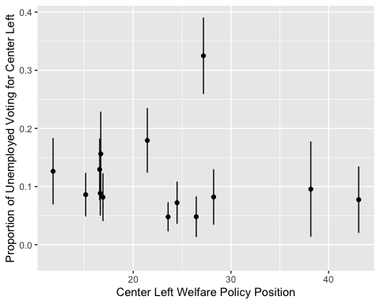

Note that the echo = FALSE parameter was added to the code chunk to prevent printing of the R code that generated the plot.