RN2903A UART BOOT LOADER

The RN2903A   receives ASCII UART commands.

The “LoRaDevUtility” PC software allows importing of the AU915 bootloader hex file and programming the RN2903 connected via UART.

DFU = Device Firmware Update

Typical connection of the RN2903 for UART bootloader

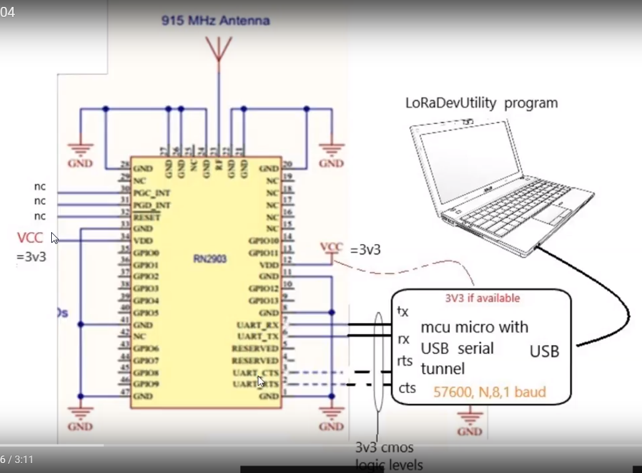

LoRaDevUtility

See info here

<https://youtu.be/s3507ZLmZvE>

<https://youtu.be/T2c_iLpkXCI>

LoRaDevUtility Operation

Once connected to the RN2903

1. Select the DFU TAB
2. Select the AU915 hex file
3. 4. 5. 6. Select the default UART connections

7. Go… select device firmware update

Close  LoRaDevUtiltiy  and  remove and then connect the RN2903

Restart the LoRaDevUtility and select the RN2903 UART comport

Next page is a screen shot of the LoRaDevUtility

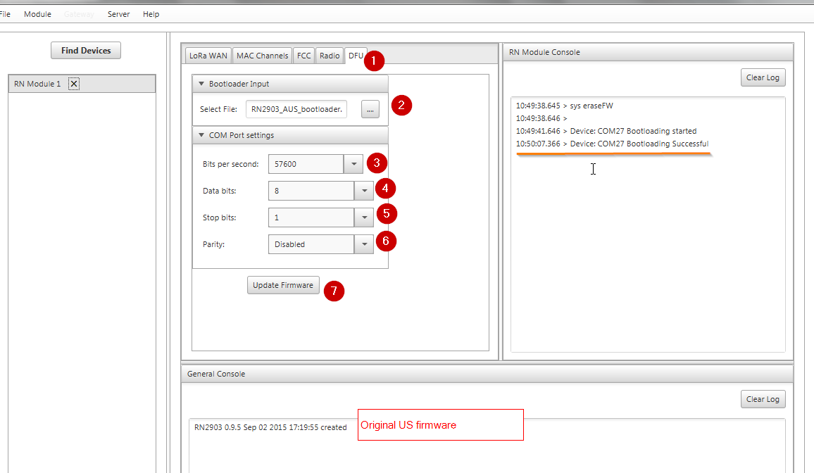

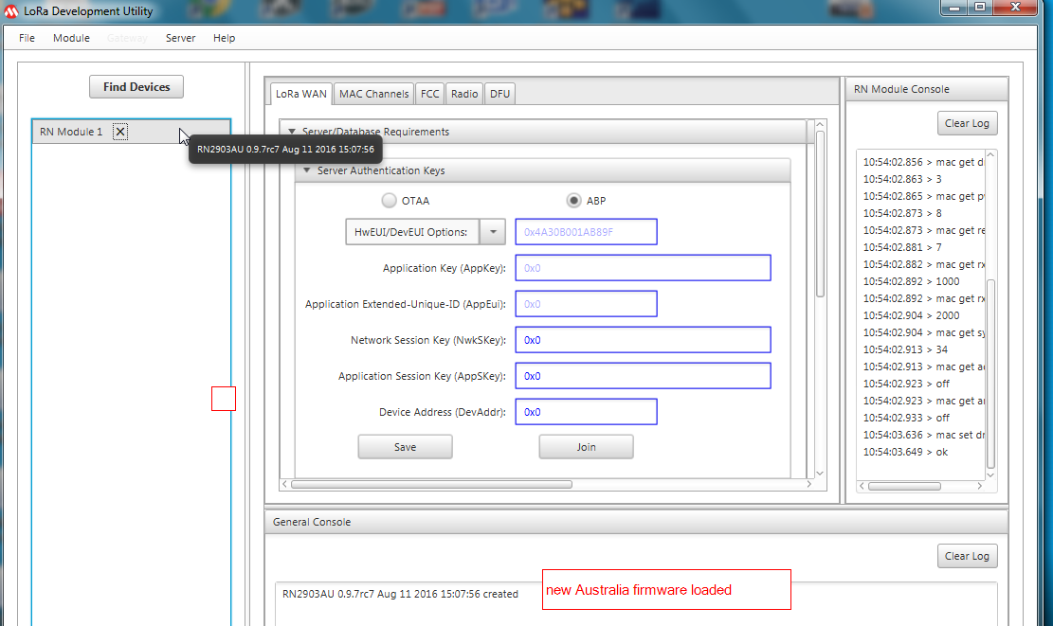

Download the loRaDevUtility from the link in the video

 Also here <http://ww1.microchip.com/downloads/en/DeviceDoc/LoRaSuite-windows-1.0.exe>

 See how I used the LoRaDevUntility to  look at the settings and tinker with the setting

<https://youtu.be/1JZg6rVEw2A>

 Using LoRaDevutility to program an RN2903

Additonal Information

============

LoRa® Technology Evaluation

Suite User’s Guide

<http://ww1.microchip.com/downloads/en/DeviceDoc/40001847A.pdf>

Section 5.2 should be useful