Git Version Control

- fast and modern implementation of version control
- provides a history of content changes
- facilitates collaborative changes to files
- any type of knowledge worker

What is Git
- Local Git
  - Distributed so that connectivity does´t block work
  - easy to learn and use
- Distributed Git
  - Team-centric so that collobration happens naturally
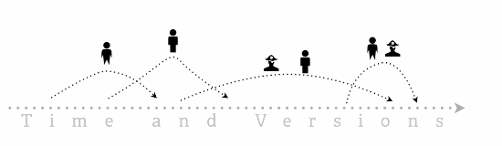

  - each taking a personal copy of the files, changing,.. taking them back overlaping in time
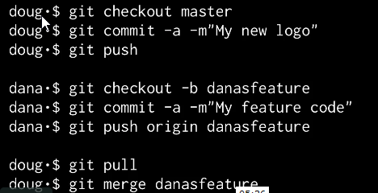

- Advanced Git
  - customizable, flexible
  - suitable for advanced users
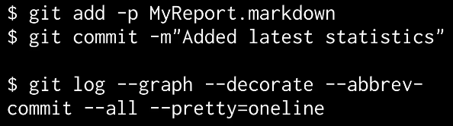

Get going with Git
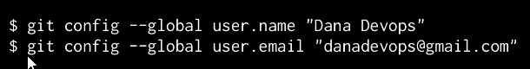

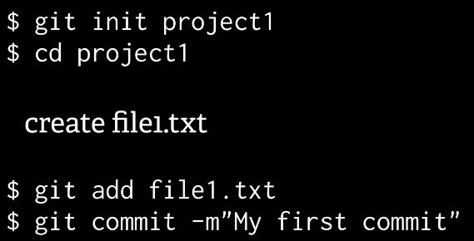

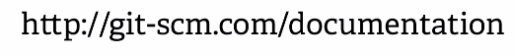

Quick Wins
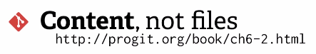

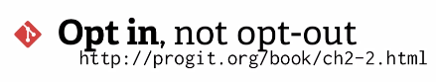
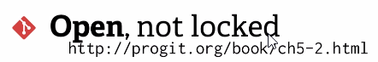



minimal interaction for version control
journal not backup
Anywhere, not just Online

