OlaFresco Deborah Raf Christof Giuseppe Dirk
https://www.hellofresh.com/?redirectedFromAccountArea=true as an example
https://contattafiles.s3.us-west-1.amazonaws.com/tnt14094/S3YvQYDIBbNCF95/Project2.pdf example in mindmapping
https://www.figma.com/file/TfuASWoDguQtPz0bHJRtvf7Y/Untitled?node-id=0%3A1 figma example

>The landing page explains the service

1page >If you open de website you find the landing page ..
with navbar on top and 8 buttons.. 6left 2right

right home 1page >If you click on the Hellofresh button you go to the lading page
1 page >If you click on the Our Plans button you go to the Our Meal Plans
-Delicious recipes and pre-measured ingredients delivered straight to your door.
-ratings
-FAQs
-Stay updated
right 3pages>If you click on the How it Works you can choose out of 3pages
> How it works
- step1 pick a plan, step 2 get your delivery, step 3 cook eat enjoy!
- Benefits
-Frequently Asked Questions
>Our suppliers
-banner Fresh from the source + watch the video
-our promise
-logos and companies
-get cooking
>Recycling
-banner How to recycle
-3 blocks with animations how to use hellofresh Box, Insulating Liners , Kit boxes and separator, …

right 2pages>if you click our menus you can choose out of 2pages
>our menus
– menus for feb 23 – Mar01
classic plan veggie plan family plan
photo’s with name dish, ingredients, time to make
– get cooking
>Recipe Archive
-Search all recipes beam
-Delicious and Quick Recipes
Quick meals Hall of fame Family friendly world cuisines most popular recipes
most recent recipes easy to cook

right 1page> if you click wine you can choose 1page
– banner GET COZY START SIPPIN’
6 bottles delivered monthly
Entertain, gift, or enjoy on its own
button join wine club >> you go on page to enter club and choose wine

– how it works
3 blocks Tell us what you feel like drinking
Enjoy 6 bottles, delivered to your doorstep
Feeling fancy? Learn about your wines
1 button see february wines when click you can go to join wine club en see wines

– Choose Your Preference
3 blocks Mixed Wine Plan select button
………..
Red wine plan select button all buttons go to inlog page or select
………..
white wine plan select button
………..

– banner Easily Pair Your Pour

– 3blocks Cook with your wine
save for later
Discover more flavor
– FAQ’S

right 1page>gifts

– banner Give the gift of HelloFresh
Share the fun by giving the most delicious gift of all.
– Delight them with deliciousness
– 3 blocks Classic
veggie
family
left 1 page > button GET STARTED

– nav bar vb
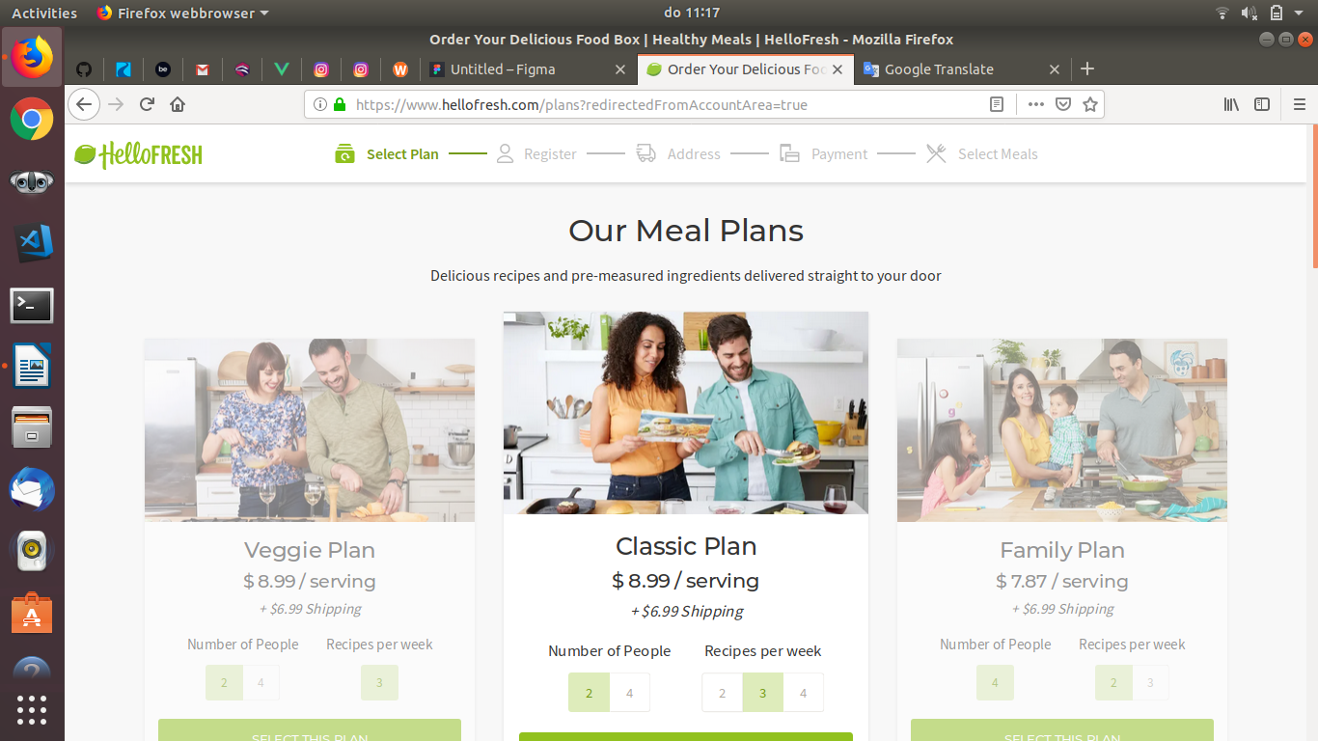
– our meal plans
– 3 blocks
– 3 blocks
left 1page>button log in
footer
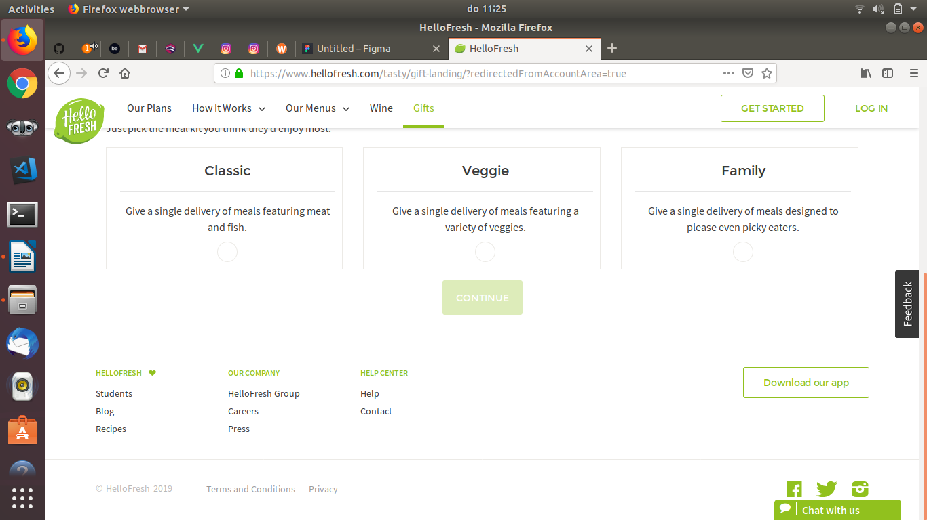
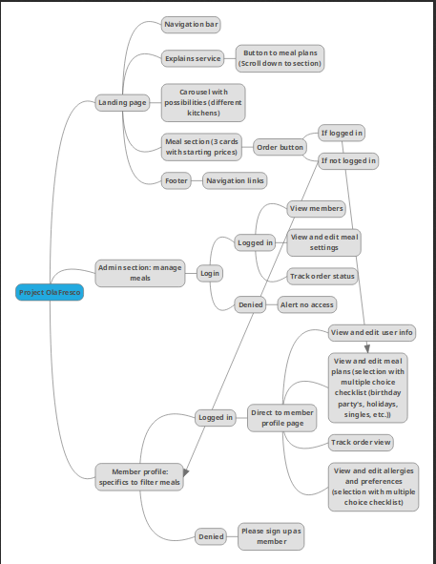
mindmapping

manuren:

