Bekabeling elektronica

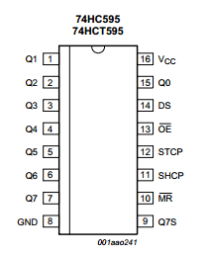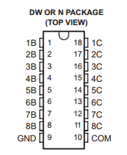

Blauw = ground  
Oranje = +5V  
Wit/Oranje = Serial out -> Serial data input  
Wit/Groen = shift register -> base transistor  
Wit/Blauw = OE  
Zwart/Wit = Clock (SHCP)  
Groen = Latch (STCP)  
Zwart = DATA (DS)