Datacenter REIT Stability and Growth
A trailing twelve-month comparison of Equinix, Digital Realty, and Iron Mountain

Prepared by: Christopher Davenport, Equity Research and Portfolio Analytics
Prepared for: Sarah Chen and the Investment Committee, Meridian Capital Advisors
Data window: Trailing twelve months (June 2025 through June 2026)
A note on scope and validity
It is worth stating at the outset that the metrics used in this report are not the measures one would rely on to determine which company to invest in. Stability is approximated through the coefficient of variation of the daily price range, and growth is approximated through a simple regression of price on time, whereas a genuine equity assessment would draw on measures such as beta, the Sharpe ratio, drawdown, and benchmark comparison. For this reason, the interpretation that follows lacks construct and predictive validity and should not be read as investment advice.
Rather, this project was undertaken to develop a specific set of data skills: ingesting live data through an API, reshaping a multi-index table, designing a relational MySQL database, transforming the data with SQL, conducting the analysis in Python, and surfacing the results through Power BI and Excel. Accordingly, the report is written under the guise that these are valid metrics for evaluating a company, so that the full analytical workflow could be exercised from end to end.

1. Introduction
Meridian Capital Advisors currently holds positions in datacenter real estate investment trusts (REITs) across several client portfolios. Given that demand for artificial intelligence infrastructure has drawn considerable market attention to this sector, the purpose of this analysis is to assess whether the firm’s existing exposure sits in the most stable names, or whether rebalancing toward a more consistent performer warrants consideration. It should be emphasized that this is not a recommendation to buy or sell. Rather, the intent is to surface the data clearly enough that the investment committee can draw its own conclusions.
The analysis addresses two questions. The first concerns growth, namely which company grew the most and how consistently it did so, which is operationalized through a per company linear regression of adjusted close price on time, reporting both the slope and the R squared value. The second concerns stability, namely which company’s price fluctuated least from month to month, which is operationalized through the coefficient of variation (CV) of the daily price range, aggregated to the monthly level. Daily return is examined as a supporting view of day-to-day behavior.
Taken together, the findings indicate that Equinix demonstrated the strongest and most consistent growth over the trailing twelve months while also carrying the lowest volatility for the majority of the period, which makes it the standout of the three on these metrics. Iron Mountain emerges as a reasonable second on growth consistency despite being the most volatile of the group, and Digital Realty places third, having shown the weakest growth but otherwise steady and contained behavior for most of the year. The remainder of this report proceeds from company selection, through each metric in turn, to the limitations that qualify these conclusions.

2. Analysis

2.1 Company selection
The analysis began with the intention of tracking companies investing in AI datacenter infrastructure, initially Amazon Web Services (AWS), Google Cloud, and Oracle. This set was ultimately rejected on grounds of construct validity. Because AWS and Google Cloud are divisions of substantially larger parent companies, their stock prices reflect the performance of the entire parent and a range of unrelated factors rather than datacenter operations specifically. In other words, measuring these companies would not actually measure the construct of interest.
Accordingly, the analysis pivoted to three pure play datacenter REITs: Equinix (EQIX), Digital Realty (DLR), and Iron Mountain (IRM). These three share enough structural congruence to render the comparison meaningful, given that they operate within the same sector, hold the same asset class, receive comparable regulatory treatment, compete for similar customers, and are exposed to the same external forces such as energy costs, interest rates, and land pricing. Iron Mountain is a partial exception worth noting, as it began as a physical document storage company and has been transitioning into datacenters. However, because its core business remains storage in a broadly comparable form, it offers an interesting point of contrast to the two pure play peers rather than disqualifying itself from the comparison.

2.2 Growth
Growth was estimated by separately fitting a linear regression of adjusted closing price on sequential trading day for each company. The slope describes the average change in share price as trading days increased across the period, whereas R² describes the proportion of variance in price explained by trading day. A high R² therefore suggests that the price followed a steady, directional linear pattern across the period, while a low R² suggests that the relationship between price and trading day was less linear.
Company | Regression equation | Slope | R²
Equinix (EQIX) | y = 1.45x + 862.86 | 1.45 | 0.70
Iron Mountain (IRM) | y = 0.12x + 100.19 | 0.12 | 0.42
Digital Realty (DLR) | y = 0.10x + 170.95 | 0.10 | 0.35
Equinix is the clear leader on this measure. It carries both the highest average price and, by a considerable margin, the steepest slope, indicating that its price increased by more per trading day than that of either peer. Its R² of 0.70 is likewise the highest of the three, suggesting that trading day explained a substantial proportion of the variance in its price and that its growth followed a relatively consistent linear pattern across the period.
Iron Mountain posted the second-steepest slope, marginally above Digital Realty, though its R² of 0.42 indicates that trading day explained only a moderate proportion of the variance in its price. Its price therefore increased across the period, but followed a less consistent linear pattern than Equinix. This may reflect the influence of company-specific or broader market factors, including those associated with its ongoing business transition, though the regression alone cannot determine their effects. Digital Realty had both the lowest slope and the lowest R² , at 0.35, indicating the smallest average increase in price per trading day and the weakest linear relationship between price and trading day of the three companies.

Quarterly Closing Price by Company, Q2 2025–Q2 2026
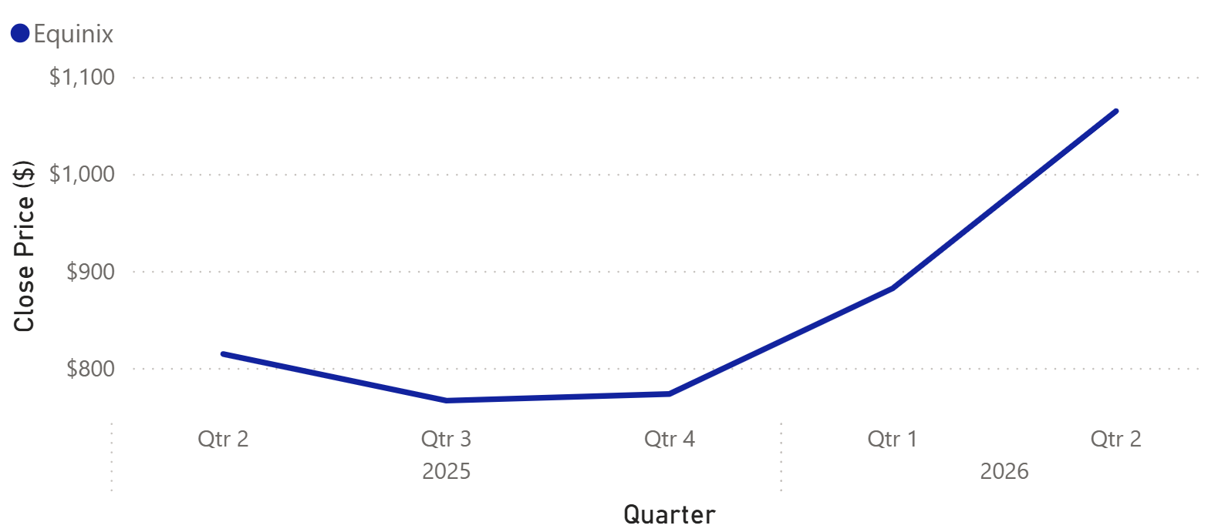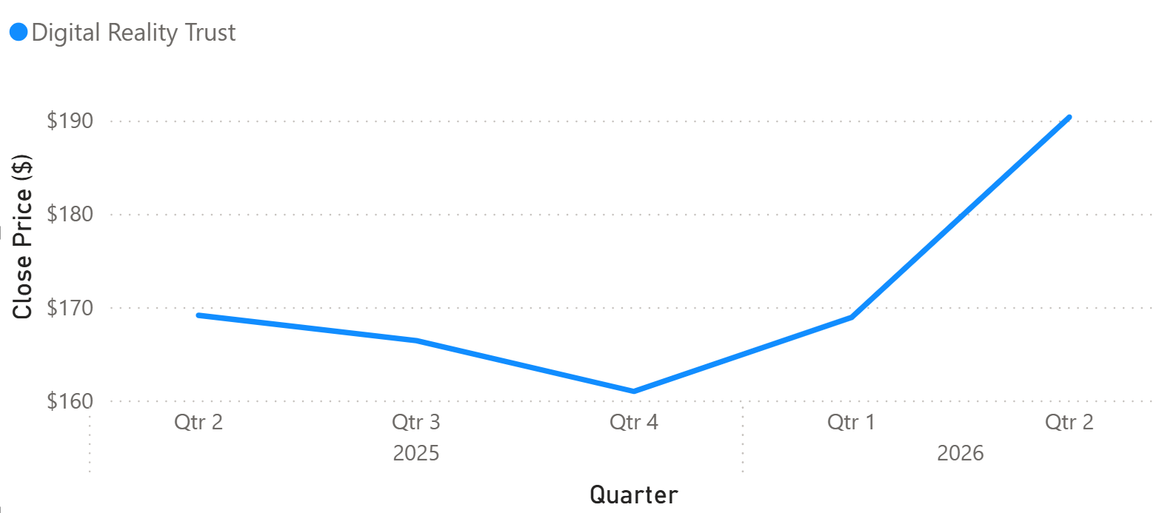
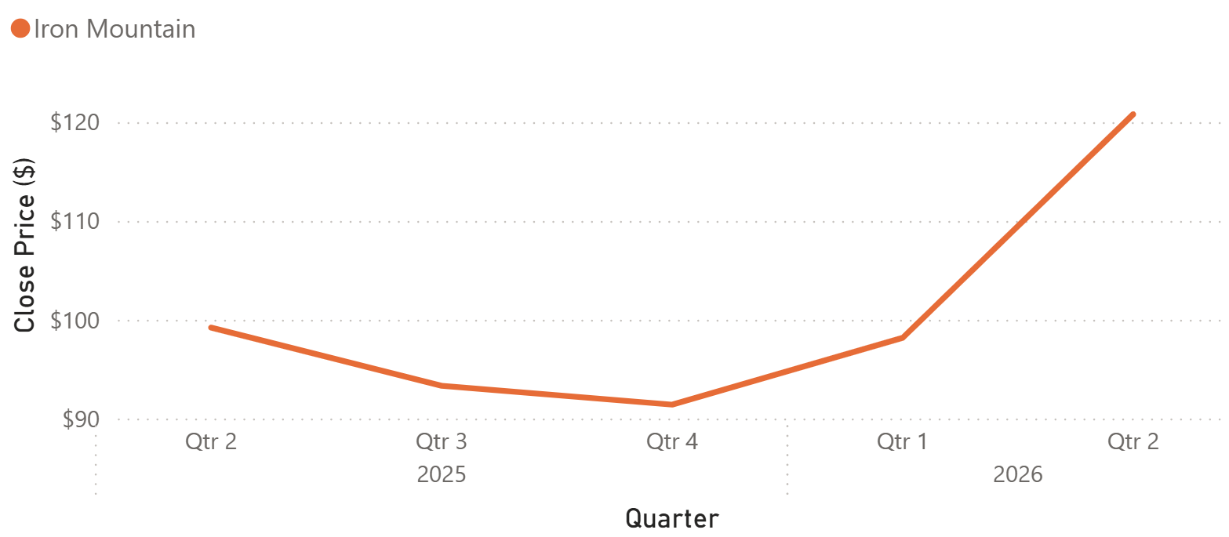

2.3 Stability
Stability was measured through the coefficient of variation of the daily price range. For each trading day, the range was calculated as the daily high minus the daily low. These ranges were then aggregated by month, and the CV was computed as the standard deviation of the daily range divided by its mean. The coefficient of variation was chosen over the raw standard deviation because the three companies trade at markedly different price levels. By measuring variation relative to each company’s own average daily range, the CV permits a fair comparison of how stable each stock’s intraday price movement was relative to its typical level.
Company | CV range (monthly) | Mean CV | Pattern
Equinix (EQIX) | 23.78% – 80.88% | 38.93% | High at start, then lowest
Digital Realty (DLR) | 29.72% – 57.99% | 38.41% | Low except a December spike
Iron Mountain (IRM) | 23.11% – 77.91% | 45.35% | Highest for most of the period
The central finding is that, after a turbulent first month, Equinix settled into the lowest relative volatility of the three for the remainder of the period. Its highest CV, 80.88%, occurred in June 2025, the first month of data collection. From that point forward, however, Equinix consistently recorded the lowest CV of the three.
Iron Mountain, by contrast, exhibited the highest relative volatility throughout most of the period and recorded the highest mean CV, at 45.35%. Digital Realty represented an interesting middle case. Its mean CV of 38.41% was nearly identical to that of Equinix, and its CV values spanned the narrowest range of the three. However, it experienced several short-lived volatility spikes, most notably in December, that were sharper than those observed for Equinix but less sustained than Iron Mountain’s elevated volatility.

Monthly Relative Volatility by Company
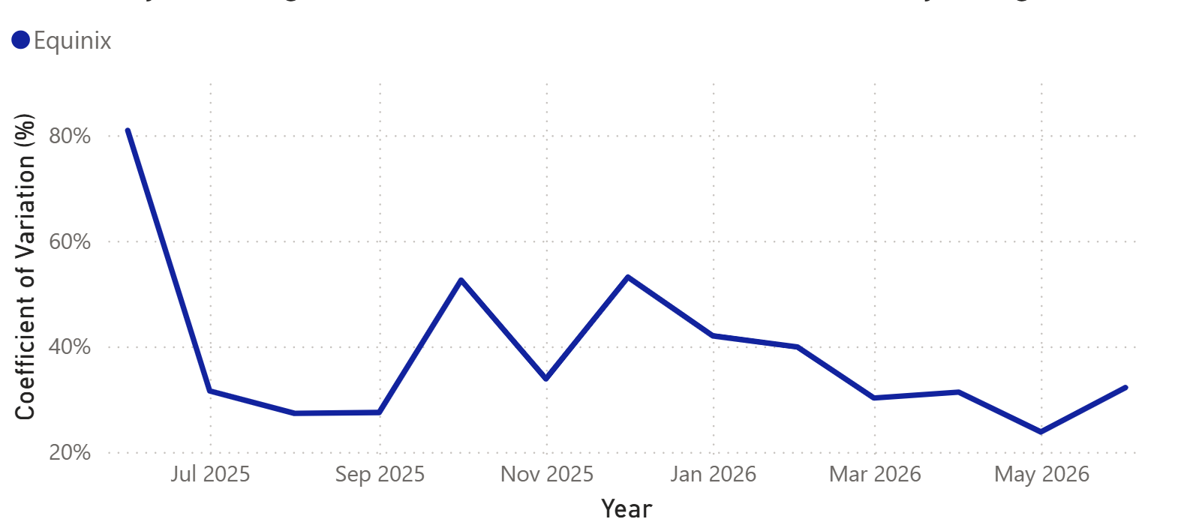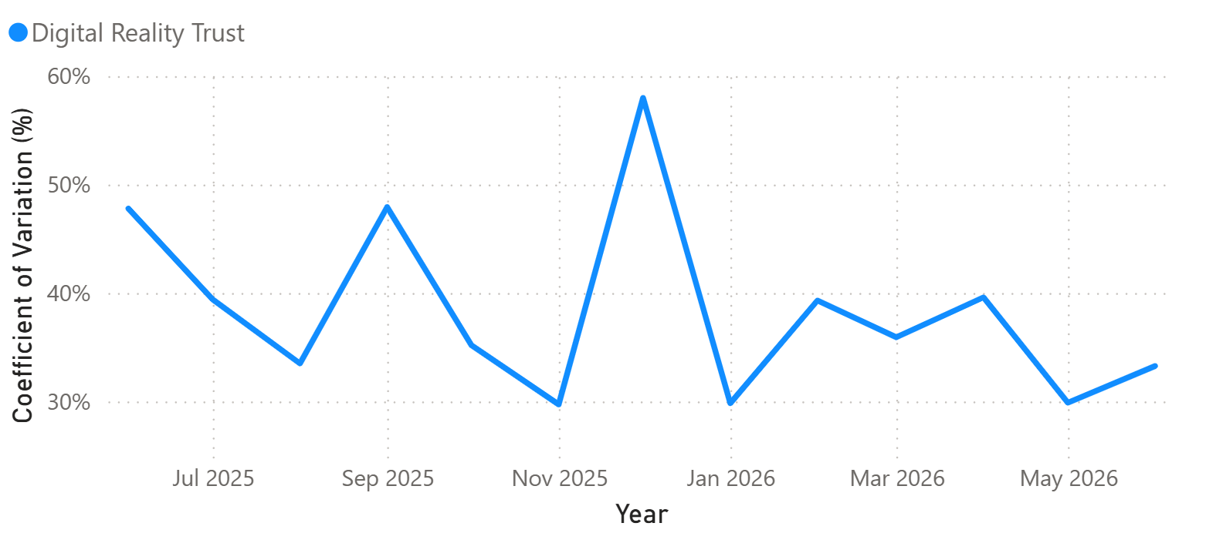
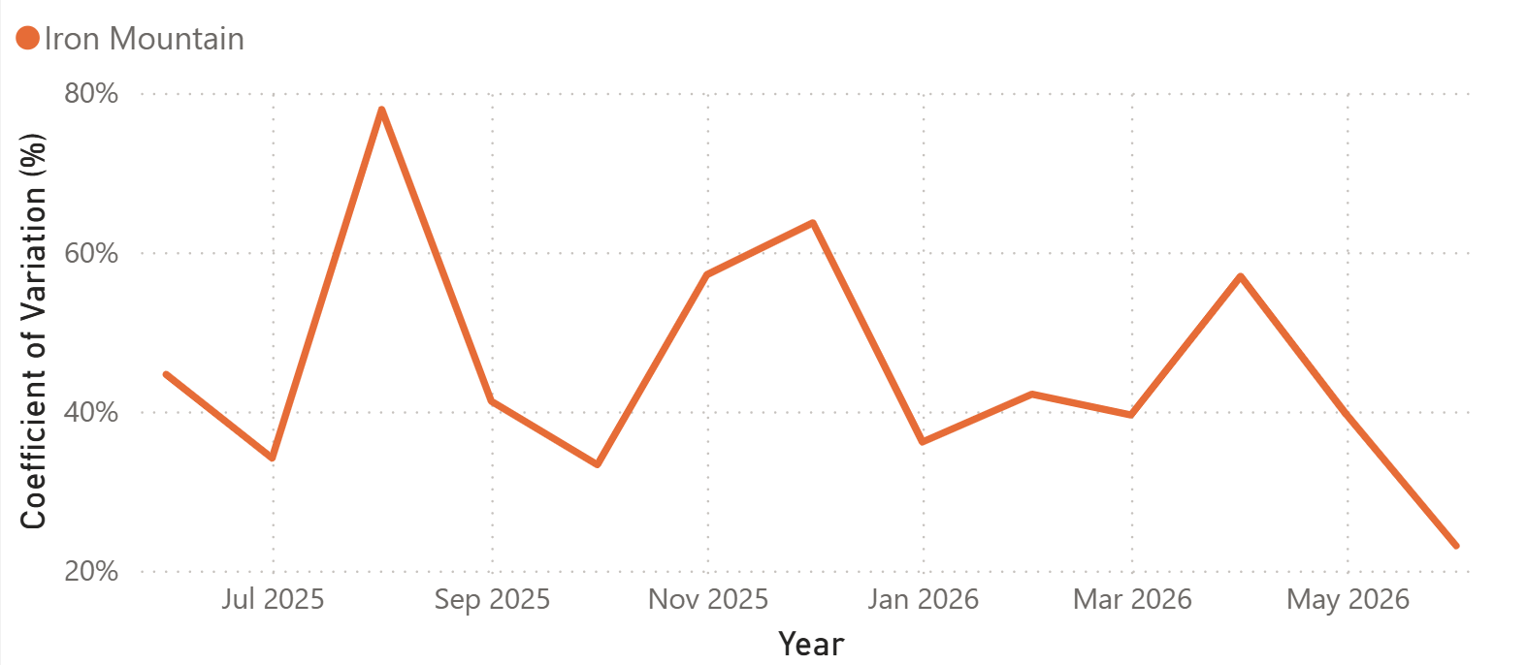

2.4 Daily return
Daily return was examined as a supporting view of day-to-day price behavior. Across all three companies, daily returns remained closely centered around zero, as is typical over short time horizons. The more informative comparison therefore lies in the spread of returns rather than in any directional pattern.
Company | Daily return range | Character
Equinix (EQIX) | -9.90% – 20.88% | Wide swings; weakest at the very start
Iron Mountain (IRM) | -16.70% – 24.81% | Largest extremes in both directions
Digital Realty (DLR) | -6.89% – 11.36% | Tightest band; lowest peak and lowest loss
Equinix recorded the lowest quarterly average daily return early in the period, with its weakest reading occurring in the first measured quarter. This aligns with the elevated volatility observed during the same window. From the third quarter of 2025 onward, however, its average daily return remained near zero before turning positive in both measured quarters of 2026. Iron Mountain’s returns likewise remained close to zero, though they reached the widest positive and negative extremes of the three. Digital Realty, for its part, recorded the lowest positive peak but also the smallest losses, giving it the narrowest range of returns overall.

Quarterly Average Daily Return by Company
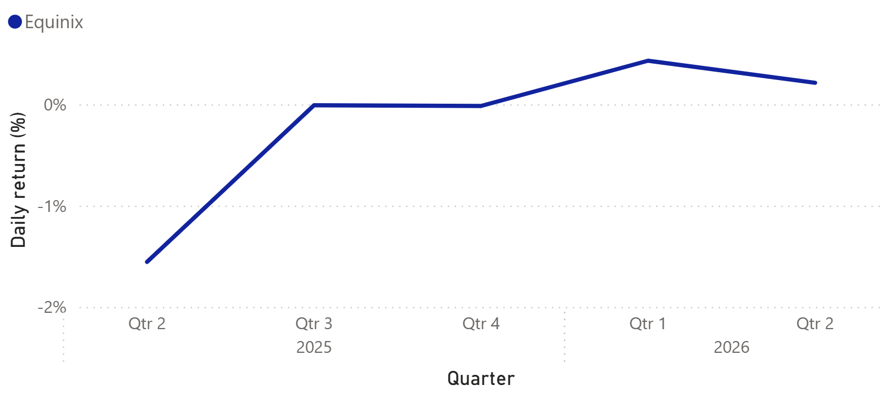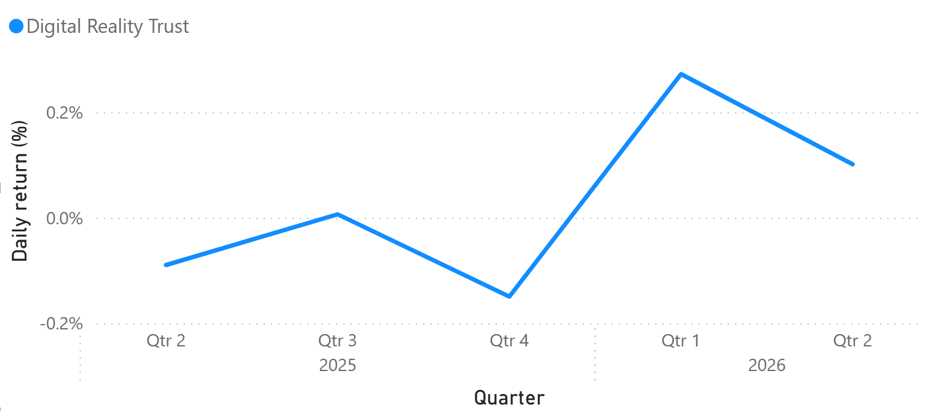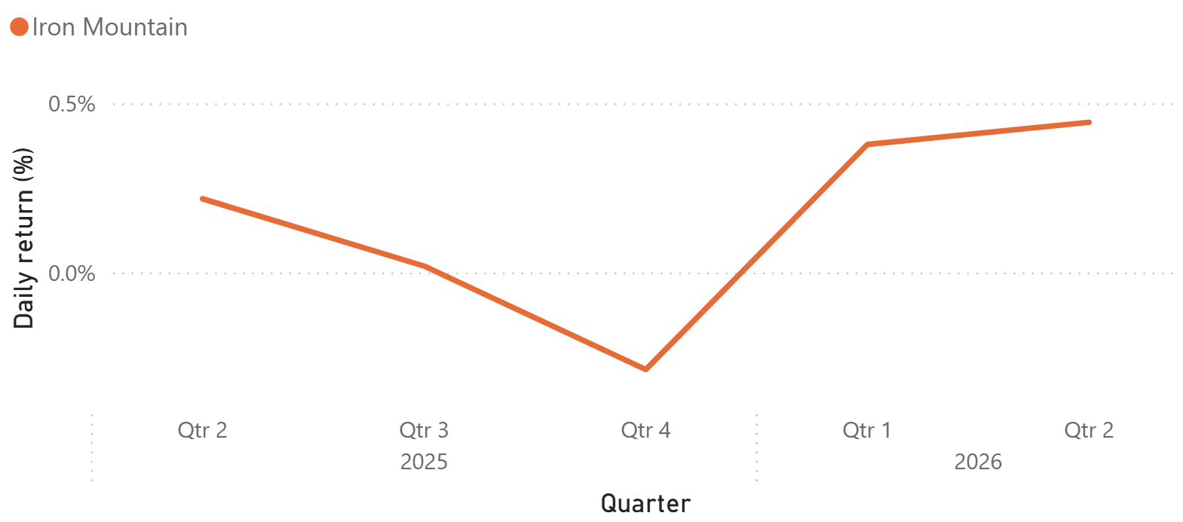

2.5 A shared pattern across all three companies
One cross-company observation merits particular attention. All three companies followed a strikingly similar price curve over the period, with the same mid-period decline and subsequent recovery occurring at roughly the same time. This synchrony suggests that a shared market or sector-level influence may have affected all three companies, rather than the pattern being driven entirely by company-specific events. Possible explanations include shifts in the broader real estate environment, changes in the data center market or sentiment surrounding AI infrastructure. Identifying the underlying driver lies beyond the scope of the present analysis, but it represents a productive direction for further research because it may affect all three holdings simultaneously.

3. Conclusion and recommendation
Taken together, and strictly within the limits of these metrics, Equinix appears to be the strongest of the three for a long-term position. It combined the steepest and most consistent price growth with the lowest relative volatility for most of the period. Its most obvious practical drawback is its high share price, which may make it less accessible to investors purchasing whole shares, though share price alone does not indicate whether the company is overvalued.

Iron Mountain emerges as a reasonable second. It had the lowest average share price, its growth slope edged out that of Digital Realty and trading day explained a greater proportion of the variance in its price. Its principal caveat is stability, as it recorded the highest relative volatility of the three and the widest range of returns. This pattern may be related to its ongoing business transition, though the present analysis cannot determine the source of that volatility.

Digital Realty places third. Although its price followed the broader pattern observed across the three companies, it recorded the weakest slope and the lowest (R^2). It also experienced several sharp but short-lived volatility spikes against an otherwise relatively contained profile. Overall, it performed acceptably but did not lead on any of the measures examined.

Finally, the similar price curves observed across all three companies should be flagged to the committee. Their shared mid-period decline and subsequent recovery suggest that common market or sector-level influences may have affected all three holdings. Further research into those shared influences would likely add more value than extending the present descriptive comparisons alone.

Appendix

A. Methodology and key decisions

Stability metric
The coefficient of variation of the daily range was selected over the raw standard deviation so that volatility could be compared fairly across companies trading at very different price levels. A standard deviation of a few dollars carries a very different meaning for a $1,000 stock than for a $100 stock, whereas the CV expresses variability as a proportion of the mean and thereby removes that distortion.
Growth metric and centering.

The regression used adjusted close rather than raw close so that stock splits and dividends would not introduce artificial discontinuities into the price series. The time variable was centered prior to fitting, which renders the intercept interpretable as the mean adjusted close over the period rather than as an extrapolation to a day zero preceding the data. This was verified empirically, as the centered intercept equals the mean adjusted close for each company.

B. On inferential statistics and autocorrelation
Inferential tests were considered and then deliberately excluded. Kruskal-Wallis and Dunn’s post hoc comparisons were initially run to test whether the differences between companies were statistically significant, but they were subsequently removed from the final analysis. Daily stock prices are autocorrelated, meaning that today’s price is strongly influenced by yesterday’s price. This violates the independence-of-observations assumption underlying both the Kruskal-Wallis test and the standard errors and p-values of the regression. Because that assumption is violated, the p-values cannot be trusted. Consequently, no claim of statistical significance is made anywhere in this report.

The slope and R² are therefore reported as descriptive summaries rather than inferential estimates. Modeling the autocorrelation directly, for instance through ARIMA-based methods, would be the appropriate next step and is noted here as future work.

C. Regression outputs
Company | Slope | Intercept | R²
Equinix (EQIX) | 1.4483 | 862.86 | 0.7046
Iron Mountain (IRM) | 0.1211 | 100.19 | 0.4176
Digital Realty (DLR) | 0.1047 | 170.95 | 0.3488
Intercepts reflect the centered time variable and therefore equal each company’s mean adjusted close over the period.

D. Data source and pipeline
All price data were sourced from the yfinance API over a trailing 12-month window and loaded into a MySQL star schema comprising the companies, daily_prices, monthly_summary and regression_results tables. The monthly CV and return figures were computed in SQL using window functions and chained common table expressions, while the regressions were run in Python with statsmodels. Because the data window rolls forward over time, the history begins in mid-June 2025, and consequently the earliest month contains fewer trading days than a full month. The full methodology and project change log are maintained alongside the project repository.

