Datacenter REIT Stability and Growth
A trailing twelve-month comparison of Equinix, Digital Realty, and Iron Mountain

Prepared by: Christopher Davenport, Equity Research and Portfolio Analytics
Prepared for: Sarah Chen and the Investment Committee, Meridian Capital Advisors
Data window: Trailing twelve months (June 2025 through June 2026)
A note on scope and validity
It is worth stating at the outset that the metrics used in this report are not the measures one would rely on to determine which company to invest in. Stability is approximated through the coefficient of variation of the daily price range, and growth is approximated through a simple regression of price on time, whereas a genuine equity assessment would draw on measures such as beta, the Sharpe ratio, drawdown, and benchmark comparison. For this reason, the interpretation that follows lacks construct and predictive validity and should not be read as investment advice.
Rather, this project was undertaken to develop a specific set of data skills: ingesting live data through an API, reshaping a multi-index table, designing a relational MySQL database, transforming the data with SQL, conducting the analysis in Python, and surfacing the results through Power BI and Excel. Accordingly, the report is written under the guise that these are valid metrics for evaluating a company, so that the full analytical workflow could be exercised from end to end.

1. Introduction
Meridian Capital Advisors currently holds positions in datacenter real estate investment trusts (REITs) across several client portfolios. Given that demand for artificial intelligence infrastructure has drawn considerable market attention to this sector, the purpose of this analysis is to assess whether the firm’s existing exposure sits in the most stable names, or whether rebalancing toward a more consistent performer warrants consideration. It should be emphasized that this is not a recommendation to buy or sell. Rather, the intent is to surface the data clearly enough that the investment committee can draw its own conclusions.
The analysis addresses two questions. The first concerns growth, namely which company grew the most and how consistently it did so, which is operationalized through a per company linear regression of adjusted close price on time, reporting both the slope and the R squared value. The second concerns stability, namely which company’s price fluctuated least from month to month, which is operationalized through the coefficient of variation (CV) of the daily price range, aggregated to the monthly level. Daily return is examined as a supporting view of day to day behavior.
Taken together, the findings indicate that Equinix demonstrated the strongest and most consistent growth over the trailing twelve months while also carrying the lowest volatility for the majority of the period, which makes it the standout of the three on these metrics. Iron Mountain emerges as a reasonable second on growth consistency despite being the most volatile of the group, and Digital Realty places third, having shown the weakest growth but otherwise steady and contained behavior for most of the year. The remainder of this report proceeds from company selection, through each metric in turn, to the limitations that qualify these conclusions.

2. Analysis

2.1 Company selection
The analysis began with the intention of tracking companies investing in AI datacenter infrastructure, initially Amazon Web Services, Google Cloud, and Oracle. This set was ultimately rejected on grounds of construct validity. Because AWS and Google Cloud are divisions of substantially larger parent companies, their stock prices reflect the performance of the entire parent and a range of unrelated factors rather than datacenter operations specifically. In other words, measuring these companies would not actually measure the construct of interest.
Accordingly, the analysis pivoted to three pure play datacenter REITs: Equinix (EQIX), Digital Realty (DLR), and Iron Mountain (IRM). These three share enough structural congruence to render the comparison meaningful, given that they operate within the same sector, hold the same asset class, receive comparable regulatory treatment, compete for similar customers, and are exposed to the same external forces such as energy costs, interest rates, and land pricing. Iron Mountain is a partial exception worth noting, as it began as a physical document storage company and has been transitioning into datacenters. However, because its core business remains storage in a broadly comparable form, it offers an interesting point of contrast to the two pure play peers rather than disqualifying itself from the comparison.

2.2 Growth
Growth was estimated by fitting a separate linear regression of adjusted close price on a sequential trading day variable for each company. The slope describes the average rate of price growth across the period, whereas R squared describes the proportion of price movement that is explained by the passage of time. A high R squared therefore suggests a steady, directional climb, while a low R squared suggests that whatever growth occurred was comparatively erratic and likely driven by factors other than time alone.
Company | Regression equation | Slope | R²
Equinix (EQIX) | y = 1.45x + 862.86 | 1.45 | 0.70
Iron Mountain (IRM) | y = 0.12x + 100.19 | 0.12 | 0.42
Digital Realty (DLR) | y = 0.10x + 170.95 | 0.10 | 0.35
Equinix is the clear leader on this measure. It carries both the highest average price and, by a considerable margin, the steepest slope, which indicates that its price rose more over the period than that of either peer. Its R squared of 0.70 is likewise the highest of the three, suggesting that time explained a substantial share of its price movement and that the growth it exhibited was relatively stable rather than erratic.
Iron Mountain posted the second steepest slope, marginally above Digital Realty, though its R squared of 0.42 indicates that time was only a moderate predictor of its price. This pattern suggests that extraneous factors, plausibly related to its ongoing business transition, played a meaningful role in shaping its trajectory. Digital Realty, for its part, had both the lowest slope and the lowest R squared at 0.35, which indicates the weakest growth and the least time explained movement of the three.
[ Insert here: regression / price trend chart from the Power BI retrospective dashboard ]
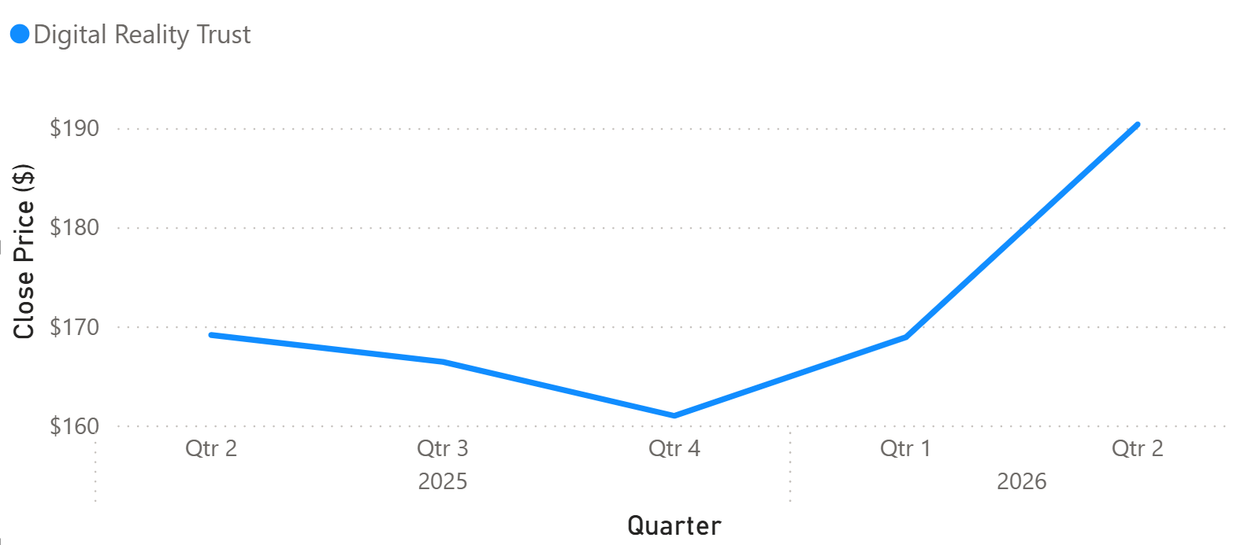
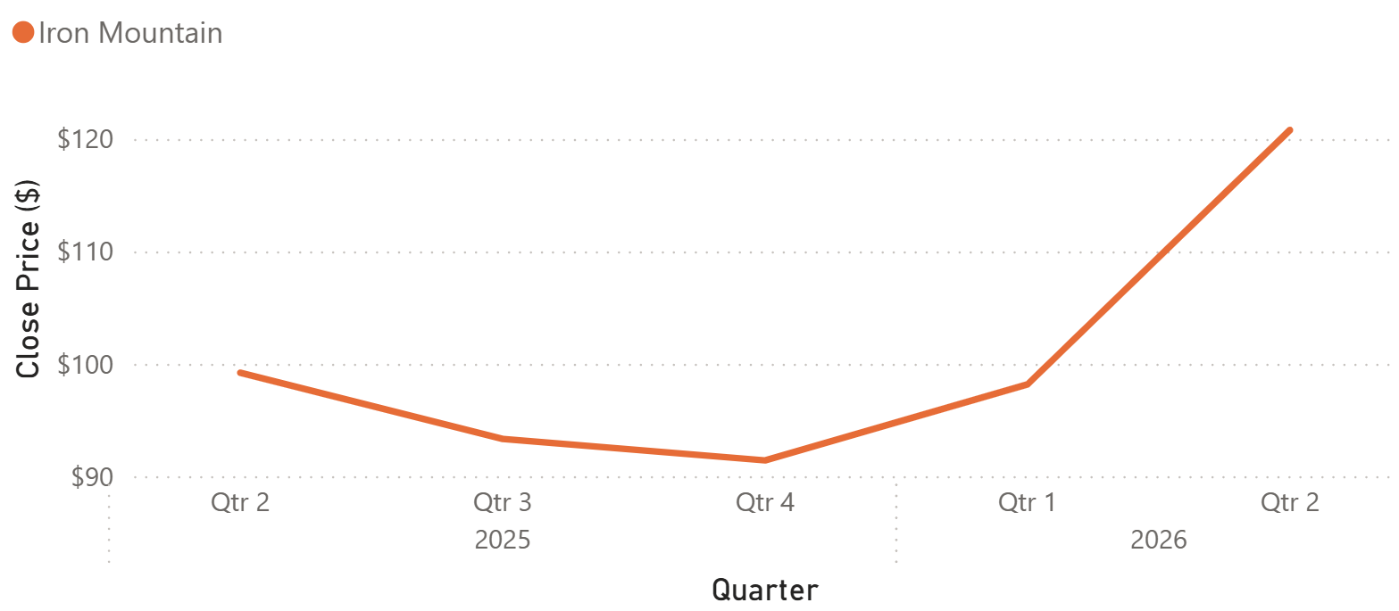
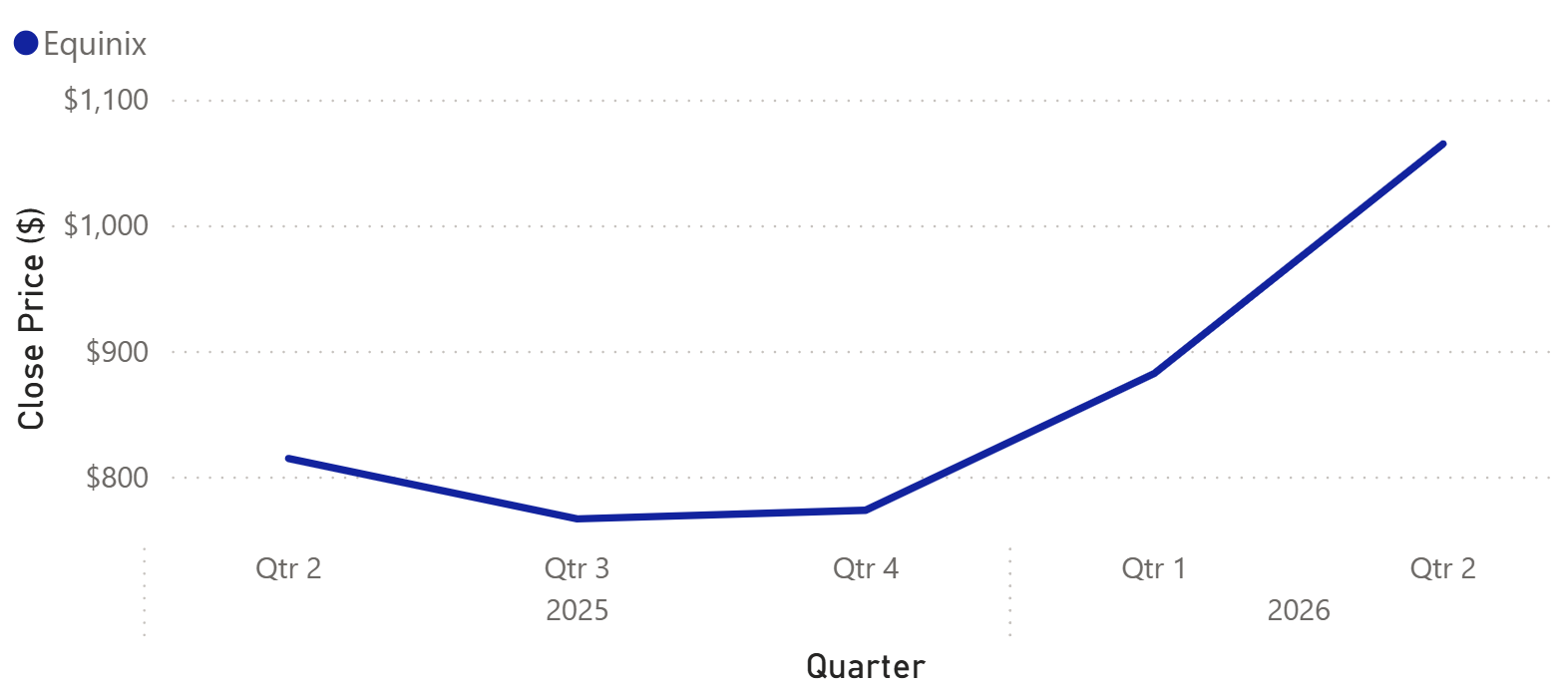

2.3 Stability
Stability was measured through the coefficient of variation of the daily price range. For each trading day, the range was taken as the daily high minus the daily low; these ranges were then aggregated by month, and the CV was computed as the standard deviation of the range divided by its mean. The coefficient of variation was chosen over the raw standard deviation because the three companies trade at markedly different price levels (Equinix near $1,000, Digital Realty near $180, and Iron Mountain near $100), and CV normalizes for that difference, thereby permitting a fair comparison of relative volatility.
Company | CV range (monthly) | Mean CV | Pattern
Equinix (EQIX) | 23.78% – 80.88% | 38.93% | High at start, then lowest
Digital Realty (DLR) | 29.72% – 57.99% | 38.41% | Low except a December spike
Iron Mountain (IRM) | 23.11% – 77.91% | 45.35% | Highest for most of the period
The central finding here is that Equinix, following a turbulent first month, settled into the lowest volatility of the three for the remainder of the period. Its single highest CV reading of 80.88% occurred in the first month of data collection (June 2025), yet from that point forward it was consistently the calmest of the three names.
Iron Mountain, by contrast, carried the highest volatility throughout most of the recorded period and the highest mean CV at 45.35%. Digital Realty represents an interesting middle case, in that its mean CV of 38.41% is effectively tied with Equinix and its overall range is the tightest of the three, yet it experienced short lived volatility spikes, most notably in December, that were sharper than those of Equinix though briefer than Iron Mountain’s sustained elevation.
[ Insert here: volatility (CV) chart from the Power BI retrospective dashboard ]
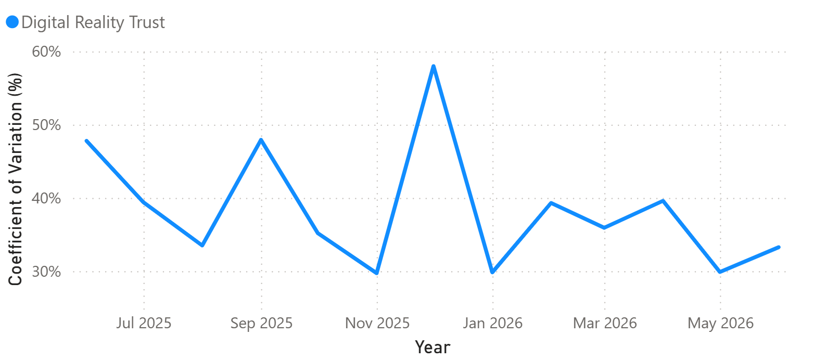
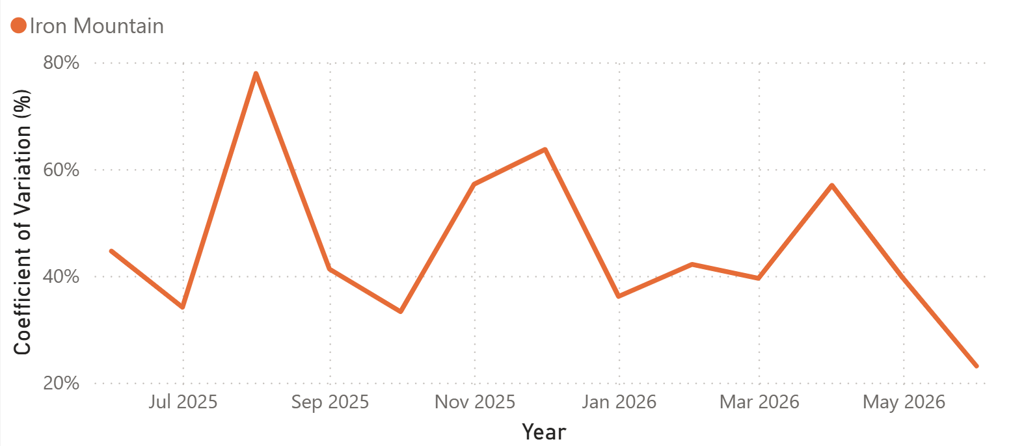
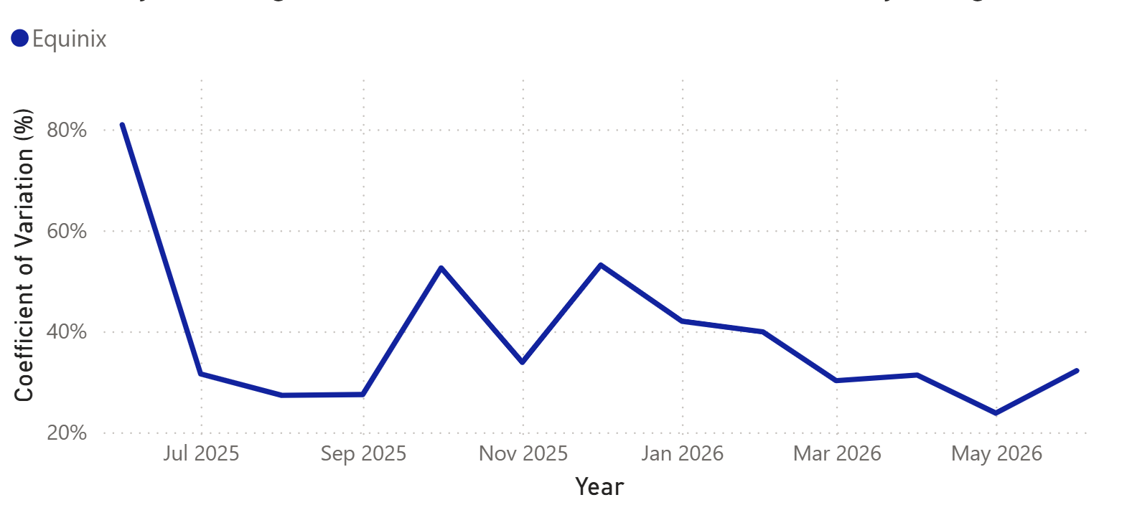

2.4 Daily return
Daily return was examined as a supporting view of day to day behavior. Across all three companies, daily returns hovered closely around zero, which is to be expected for established stocks, so the more informative comparison lies in the spread of returns rather than in any directional trend.
Company | Daily return range | Character
Equinix (EQIX) | -9.90% – 20.88% | Wide swings; weakest at the very start
Iron Mountain (IRM) | -16.70% – 24.81% | Largest extremes in both directions
Digital Realty (DLR) | -6.89% – 11.36% | Tightest band; lowest peak and lowest loss
Equinix had the lowest return early in the period, with its weakest reading falling in the first measured quarter, which aligns with the high volatility it exhibited during that same window. From the third quarter of 2025 onward, however, its daily return wavered around zero before turning positive across both 2026 periods. Iron Mountain’s returns likewise bounced closely around zero, though with the widest extremes of the three. Digital Realty, for its part, had the lowest return peak but also the smallest losses, which gave it the most contained daily behavior overall.
[ Insert here: daily return chart from the Power BI retrospective dashboard ]
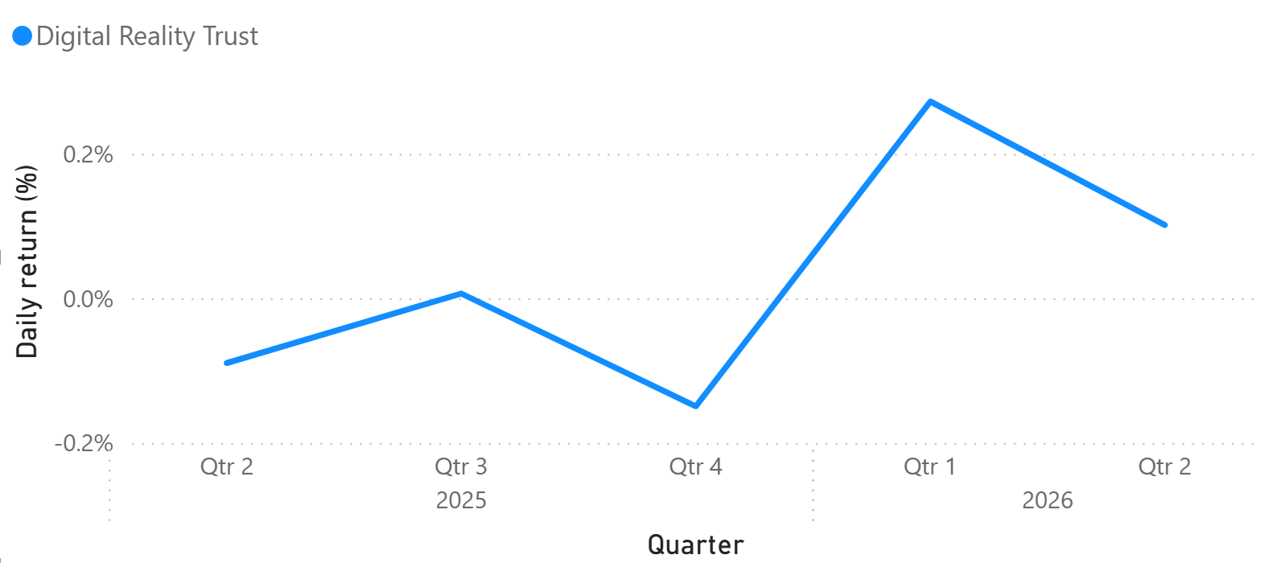
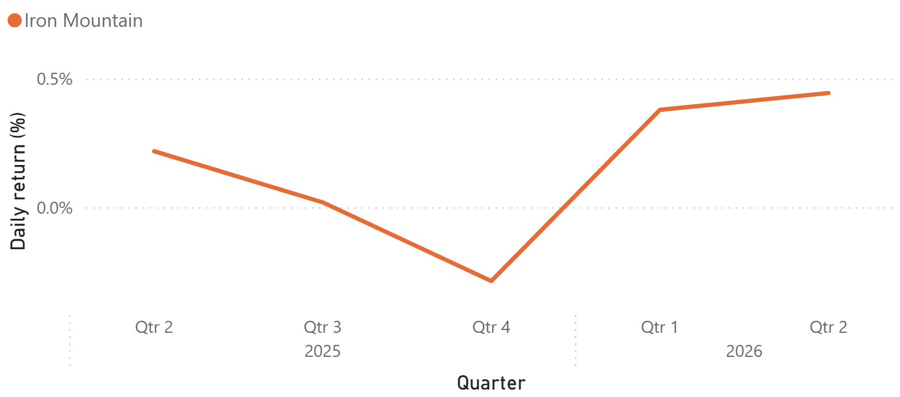
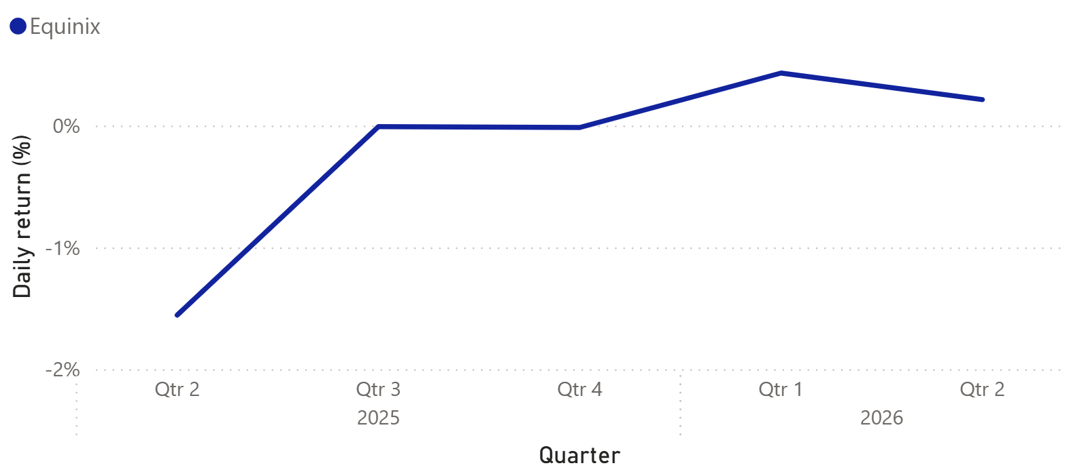

2.5 A shared pattern across all three companies
One cross company observation merits particular attention. All three companies traced a strikingly similar price curve over the period, in that the same mid period dip and the same subsequent recovery appeared in each, occurring at roughly the same time. This synchrony suggests a common driver acting on the sector as a whole rather than a set of company specific events, plausibly shifts in the real estate environment, the datacenter market, or broad sentiment surrounding AI infrastructure. While identifying that driver lies beyond the scope of the present analysis, doing so would be a productive direction for further research, particularly because it bears on all three holdings simultaneously.

3. Conclusion and recommendation
Taken together, and strictly within the limits of these metrics, Equinix appears to be the strongest of the three for a long term position, as it combined the highest and most consistent growth with the lowest volatility for the majority of the period. Its one notable drawback is price, given that it is by a wide margin the most expensive of the three to invest in.
Iron Mountain emerges as a reasonable second. Its average price is the lowest of the three, its growth slope edged out that of Digital Realty, and time explained more of its price movement than it did for Digital Realty. Furthermore, its daily return behavior, while volatile, followed more directional trends. The principal caveat is that it was the most volatile name overall, which is consistent with a company still working through a transition in its business model.
Digital Realty places third. Although its growth tracked the broader sector pattern, it did so with the weakest slope and the least time explained movement, and it exhibited sharp but short volatility spikes against an otherwise low and contained profile. In short, it performed acceptably without leading on any single measure.
Finally, the shared price curve observed across all three names is worth flagging to the committee directly. Because the three moved together to such a degree, sector level developments may matter more to these holdings than the differences between the individual companies, and it is there that additional research would likely add the most value.

Appendix

A. Methodology and key decisions
Stability metric. The coefficient of variation of the daily range was selected over the raw standard deviation so that volatility could be compared fairly across companies trading at very different price levels. A standard deviation of a few dollars carries a very different meaning for a $1,000 stock than for a $100 stock, whereas CV expresses variability as a proportion of the mean and thereby removes that distortion.
Growth metric and centering. The regression used adjusted close rather than raw close so that stock splits and dividends would not introduce artificial discontinuities into the price series. The time variable was centered prior to fitting, which renders the intercept interpretable as the mean adjusted close over the period rather than an extrapolation to a day zero preceding the data. This was verified empirically, in that the centered intercept equals the mean adjusted close for each company.

B. On inferential statistics and autocorrelation
Inferential tests were considered and then deliberately excluded. Kruskal-Wallis and Dunn’s post hoc comparisons were initially run to test whether the differences between companies were statistically significant, but they were subsequently removed from the final analysis. The reason is that daily stock prices are autocorrelated, in that today’s price is strongly influenced by yesterday’s, which violates the independence of observations assumption underlying both the Kruskal-Wallis test and the standard errors and p-values of the regression. Because that assumption is violated, the p-values cannot be trusted, and consequently no claim of statistical significance is made anywhere in this report. The slope and R squared are therefore reported as descriptive summaries rather than inferential estimates. Modeling the autocorrelation directly, for instance through ARIMA based methods, would be the appropriate next step and is noted here as future work.

C. Regression outputs
Company | Slope | Intercept | R²
Equinix (EQIX) | 1.4483 | 862.86 | 0.7046
Iron Mountain (IRM) | 0.1211 | 100.19 | 0.4176
Digital Realty (DLR) | 0.1047 | 170.95 | 0.3488
Intercepts reflect the centered time variable and therefore equal each company’s mean adjusted close over the period.

D. Data source and pipeline
All price data was sourced from the yfinance API over a trailing twelve month window and loaded into a MySQL star schema comprising the companies, daily_prices, monthly_summary, and regression_results tables. The monthly CV and return figures were computed in SQL using window functions and chained common table expressions, while the regressions were run in Python with statsmodels. Because the data window rolls forward over time, the history begins in mid June 2025, and consequently the earliest month contains fewer trading days than a full month. Full methodology and the project changes log are maintained alongside the project repository.

