11/9/2026
Christopher Doyle – ST10445478, Daniel Wilson - ST10446445, AND Paballo Nthutang - ST10446382
EMERIS UNIVERSITY
INSY7314 – FINAL POE
HUSTLEHUB+
Contents
Group Members & Responsibility 2
SUBMISSION AND EVIDENCE LINKS 2
1. INTRODUCTION AND PROJECT OVERVIEW 3
1.1 Application architecture 3
1.2 Parts 1, 2 and 3 3
1.3 Evidence approach 3
2. FRONTEND DESIGN AND USER FLOW 4
2.1 Homepage and navigation 4
2.2 Income dashboard and chart 5
2.3 Client booking confirmation 7
3.FRONTEND TESTING AND RESPONSIVENESS 9
3.1 Testing contribution 9
3.2 Responsive screen evidence 9
4. CI/CD AND AUTOMATED TEST EVIDENCE 13
4.1 Integration test pipeline 13
5. STATIC CODE ANALYSIS AND THREAT REVIEW 15
5.1 Security controls and risk categories 15
6. DOCKER CONTAINERS AND END-TO-END VERIFICATION 16
7. CLOUD LOGGING AND SECURITY EVIDENCE 18
7.1 Logging architecture 18
7.2 Booking and simulated transaction events 18
7.3 Validation and application errors 19
7.4 Account lockout 20
7.5 Authentication outcomes 21
7.6 Persistent token revocation 22
8. TAX ESTIMATION AND FINANCIAL DATA SECURITY 24
9. REFERENCE LIST 25
APPENDIX A — LIST OF FIGURES 26

Group Members & Responsibility
Name | Student Number | Responsibility
Christopher Doyle | ST10445478 | Project integration, backend/authentication, security, income/tax functionality, documentation and final handover.
Daniel Wilson | ST10446445 | Independent review, README/security documentation, CI/CD, Docker, static analysis, logging and security evidence.
Paballo Nthutang | ST10446382 | UI/UX improvements, frontend verification, Playwright automation, responsiveness and screenshot collection.

SUBMISSION AND EVIDENCE LINKS
Repository: https://github.com/Christopher-Doyle/HustleHub-INSY7314
Detailed application README: https://github.com/Christopher-Doyle/HustleHub-INSY7314/blob/main/HustleHub/README.md
Historical passing CI run (8 November 2026): https://github.com/Christopher-Doyle/HustleHub-INSY7314/actions/runs/42374523350
Playwright evidence artefact: https://github.com/Christopher-Doyle/HustleHub-INSY7314/actions/runs/42374523350/artifacts/13575705430
Semgrep artefact: https://github.com/Christopher-Doyle/HustleHub-INSY7314/actions/runs/42374523350/artifacts/13574743148
Container runtime logs: https://github.com/Christopher-Doyle/HustleHub-INSY7314/actions/runs/42374523350/artifacts/13575566168
Final main CI run (verified passing 9 November 2026): https://github.com/Christopher-Doyle/HustleHub-INSY7314/actions/runs/42617237979
Final main commit: bb399797959950b29bc829f39b7c651e0d7db10c
YouTube demonstration video: https://youtu.be/8nqANjeblu8
Official Classroom50 submission location: https://github.com/EMWCCN/insy7314-2026-g3-insy7314-2026-hustlehub-plus-part1-christopher-doyle.git

1. INTRODUCTION AND PROJECT OVERVIEW
HustleHub+ is a MERN-based freelance marketplace where freelancers publish Gigs and clients can browse and book services. Each completed simulated booking creates a transaction record used to update the freelancer's income, transaction history and estimated tax dashboard. No actual payment is processed (HustleHub+ project team, 2026).

1.1 Application architecture
The frontend is built with React and Vite, the secure API uses Node.js and Express, and MongoDB stores users, Gigs, bookings and financial records. JWT authentication and database-backed role checks govern protected functionality. Docker Compose starts the MongoDB, Express and Nginx services as one HTTPS-enabled stack (HustleHub+ project team, 2026).

1.2 Parts 1, 2 and 3
Part 1 established the secure foundation: registration, bcrypt password hashing, JWT authentication, database persistence, HTTPS, validation and security controls. Part 2 introduced the Gig marketplace, freelancer management, bookings, transactions and administration. Part 3 completed the financial dashboard and introduced automated CI/CD, static analysis, containers, structured/cloud logging and additional tested security features.

1.3 Evidence approach
All 33 images in this revised report are copied from the group's original evidence tab. Figures 1–9 relate to Pabi's frontend work; Figures 10–19 document CI and container evidence; and Figures 20–33 show Better Stack logging and security records. The captions follow the figure-numbering guidance in the IIE Harvard–Anglia style guide (The Independent Institute of Education, 2026).
The dashboard images in Figures 3–4 use mocked API responses for browser presentation tests. They prove responsive rendering but must not be treated as proof of live database transactions. The Docker smoke and real browser tests separately check the integrated application flow.

2. FRONTEND DESIGN AND USER FLOW

2.1 Homepage and navigation
The landing page gives clients access to Gig browsing and freelancers access to registration and their management features. Desktop and mobile layouts use consistent navigation and readable calls to action. The original screenshots appear as Figures 1 and 2.
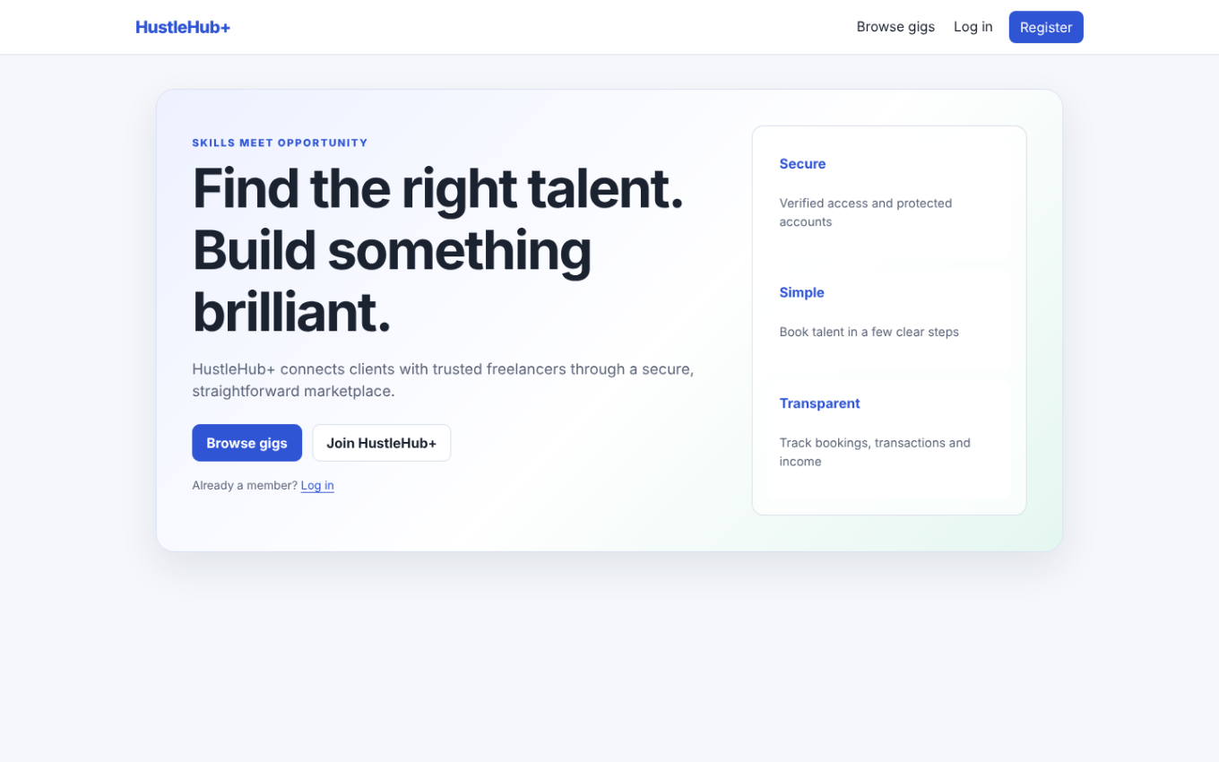
Figure 1: Desktop homepage and main navigation. [Screenshot]. Source: HustleHub+ project team (2026, unpublished).
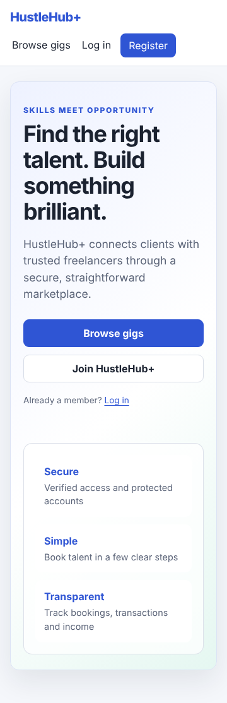
Figure 2: Mobile homepage and navigation layout. [Screenshot]. Source: HustleHub+ project team (2026, unpublished).

2.2 Income dashboard and chart
The freelancer dashboard shows lifetime platform earnings, income within the applicable tax year, tax estimates, an after-tax estimate and a monthly income visualisation. Figures 3 and 4 illustrate desktop and mobile rendering using mock responses. The underlying tax methods are drawn from the published SARS individual income tax brackets and rebate (South African Revenue Service, 2026).
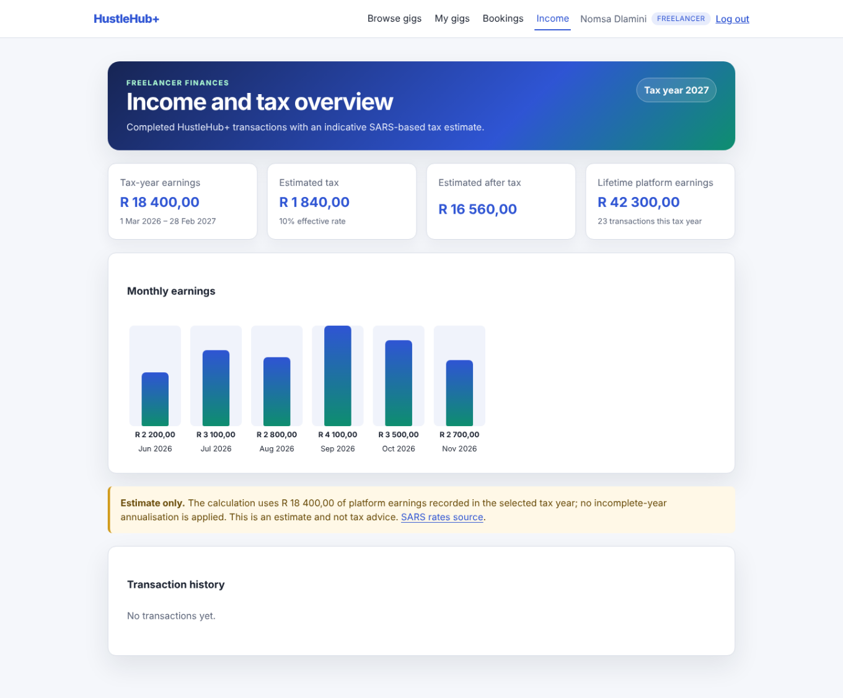
Figure 3: Freelancer income and tax dashboard at desktop width (mocked test data). [Screenshot]. Source: HustleHub+ project team (2026, unpublished).
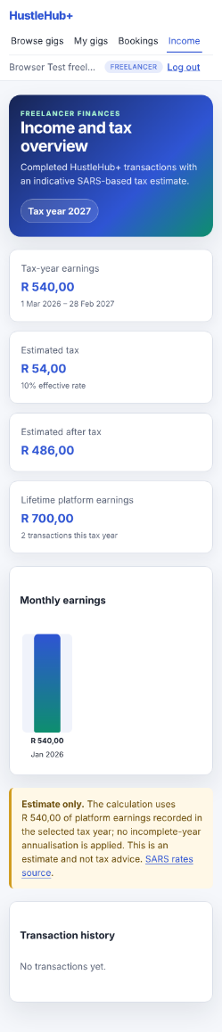
Figure 4: Freelancer income and tax dashboard at mobile width (mocked test data). [Screenshot]. Source: HustleHub+ project team (2026, unpublished).

2.3 Client booking confirmation
After a successful booking, the UI shows the Gig, transaction-related value, confirmation status and a booking identifier. Figure 5 records the confirmation page. The current Playwright suite should verify the actual heading and Booking ID rather than an outdated heading string.
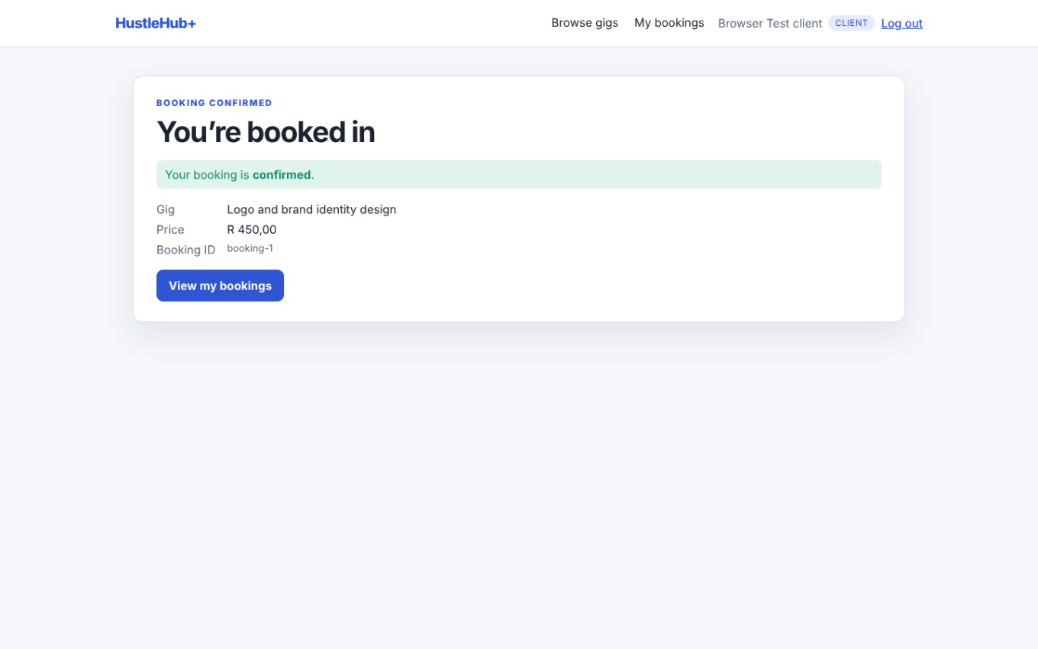
Figure 5: Client booking confirmation screen. [Screenshot]. Source: HustleHub+ project team (2026, unpublished).

3.FRONTEND TESTING AND RESPONSIVENESS

3.1 Testing contribution
The original group evidence reports 15 passing additional Playwright checks and 88 passing frontend unit tests following Pabi's changes. The recorded coverage includes role restrictions, session persistence, logout and screen-width overflow. These are the figures reported by the team; final submission must use the latest successful CI outcome (Microsoft, 2026).
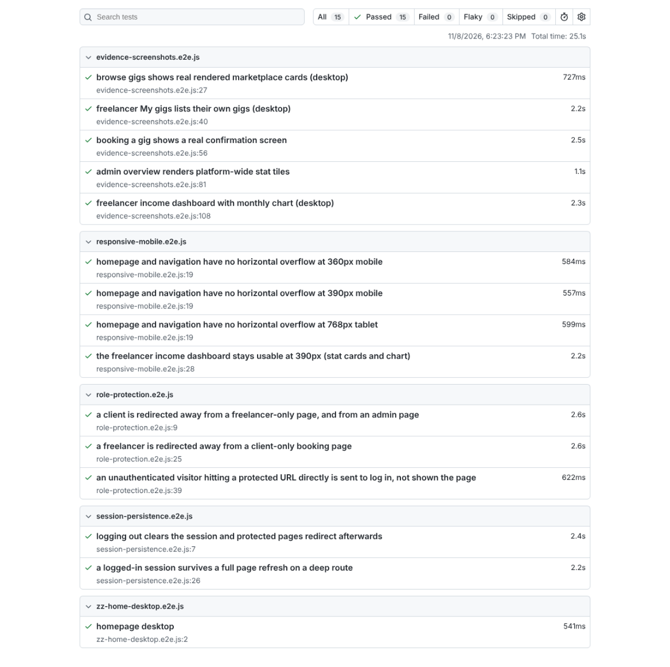
Figure 6: Playwright browser-test report for the expanded frontend checks. [Screenshot]. Source: HustleHub+ project team (2026, unpublished).

3.2 Responsive screen evidence
Figures 7–9 show the homepage at different viewport widths. The screenshots support the intended responsive layout, with no horizontal overflow and clear primary navigation. Their presentation should be supplemented by keyboard and accessibility testing in the final demo.
Figure 7: Responsive homepage in a narrow mobile viewport. [Screenshot]. Source: HustleHub+ project team (2026, unpublished).
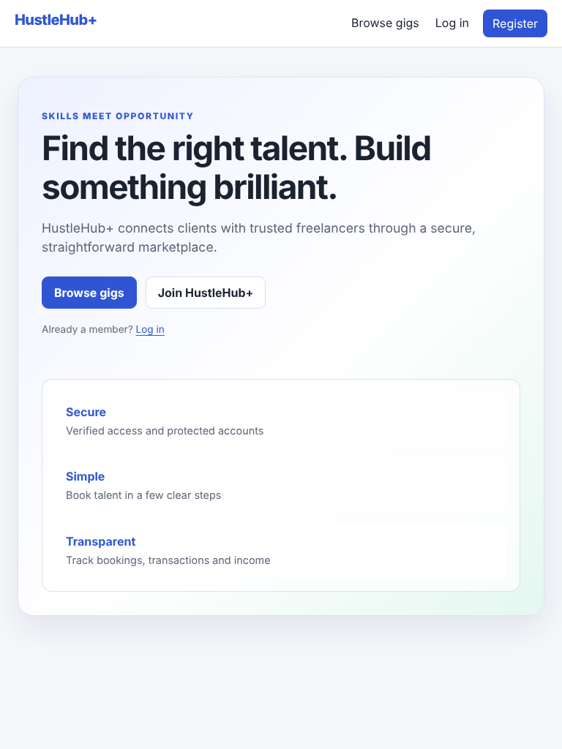
Figure 8: Responsive homepage at an intermediate viewport. [Screenshot]. Source: HustleHub+ project team (2026, unpublished).
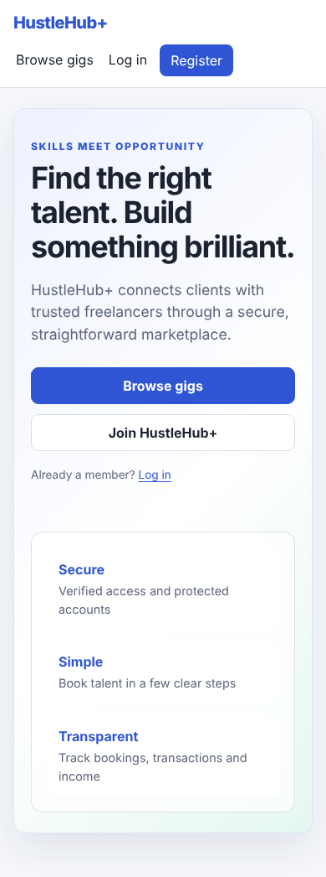
Figure 9: Additional mobile layout showing navigation and content. [Screenshot]. Source: HustleHub+ project team (2026, unpublished).

4. CI/CD AND AUTOMATED TEST EVIDENCE

4.1 Integration test pipeline
The Part 3 GitHub Actions workflow runs backend unit/API tests, OpenAPI validation, Newman, frontend unit tests, the production build, dependency checks, Docker image builds, service health checks, an HTTPS smoke test, Playwright browser tests and static analysis. Required checks should make the run fail when any test or security gate fails.
The older passing run referenced in this report recorded 61 backend tests, 77 frontend tests and 239 Newman assertions without failures. Pabi's later frontend contributions increased the separate test coverage, so the exact final figures must come from a new passing main-branch run.
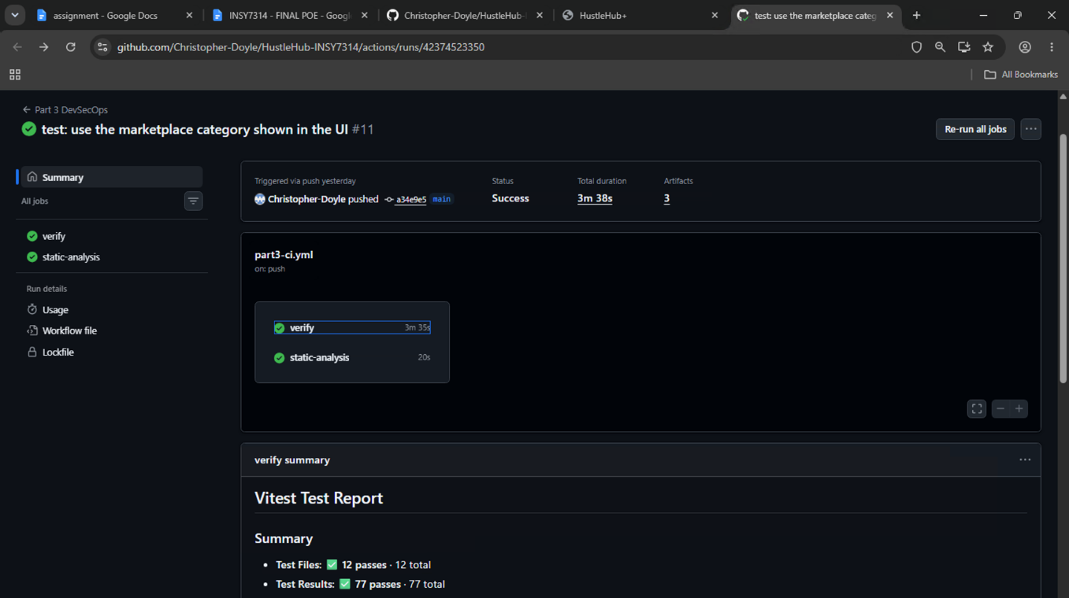
Figure 10: Frontend test-result summary. [Screenshot]. Source: HustleHub+ project team (2026, unpublished).
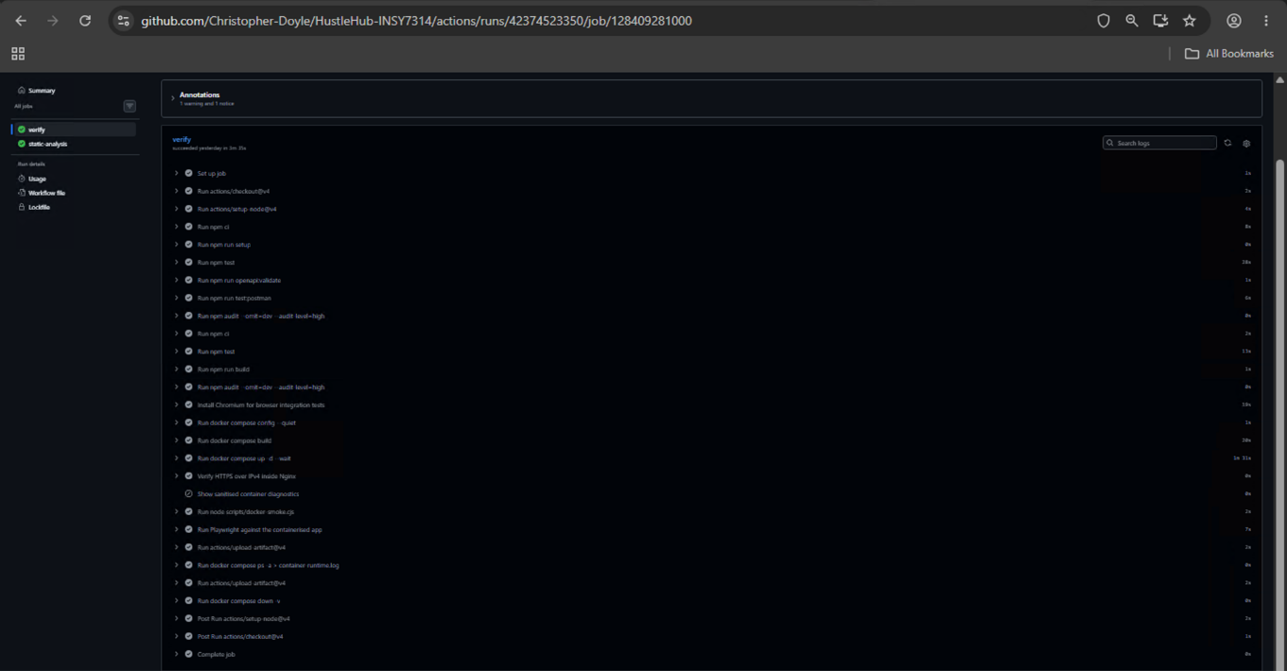
Figure 11: GitHub repository and CI evidence view. [Screenshot]. Source: HustleHub+ project team (2026, unpublished).
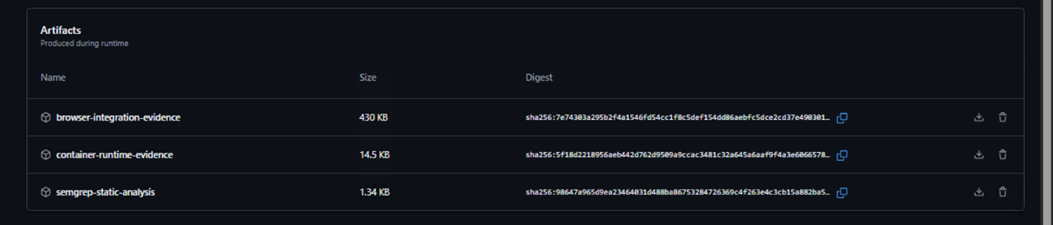
Figure 12: GitHub Actions downloadable artefacts. [Screenshot]. Source: HustleHub+ project team (2026, unpublished).
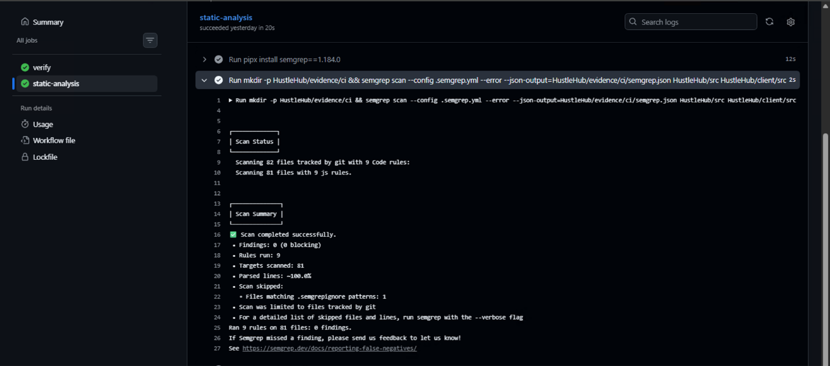
Figure 13: CI job log showing automated verification. [Screenshot]. Source: HustleHub+ project team (2026, unpublished).

5. STATIC CODE ANALYSIS AND THREAT REVIEW
The project integrates Semgrep into GitHub Actions and saves a machine-readable JSON report. Its configured rules detect selected dangerous patterns and block the workflow on findings. A report of zero findings must be interpreted within the limited scope of those rules rather than as proof that all vulnerabilities have been eliminated (Semgrep, Inc., 2026).
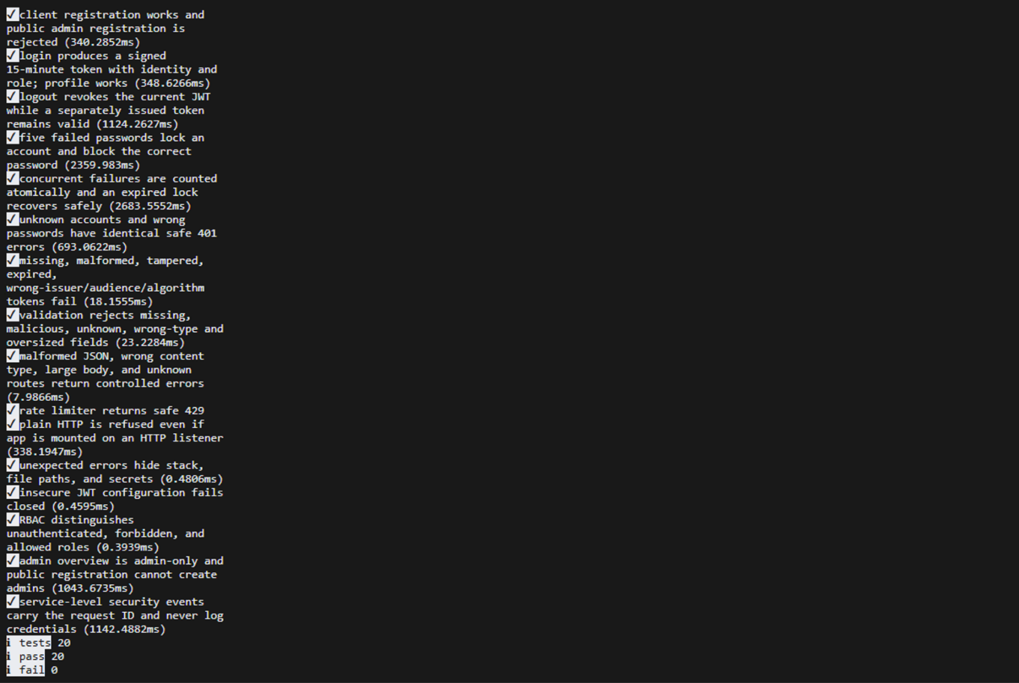
Figure 14: Terminal output from automated build and verification. [Screenshot]. Source: HustleHub+ project team (2026, unpublished).

5.1 Security controls and risk categories
The security review maps likely marketplace risks to protections: validation and safe error handling for injection concerns; authentication for account misuse; RBAC and ownership checks for broken access control; HTTPS, CORS and headers for web deployment; and logging for investigation. The risk categories follow OWASP's guidance (OWASP Foundation, 2021).
The project's two additional Part 3 controls are an atomic repeated-login lockout and persistent JWT token revocation. Their effectiveness depends on correctly implemented backend checks and regression tests, not only on the presence of log records.

6. DOCKER CONTAINERS AND END-TO-END VERIFICATION
Separate Dockerfiles build the API and React frontend. Nginx serves the frontend over HTTPS and proxies API calls to Express; MongoDB runs as a dependency in Docker Compose. The supplied screenshots document image/container startup, an API response, the running React site and service checks. Figures 15–19 are reproduced below.
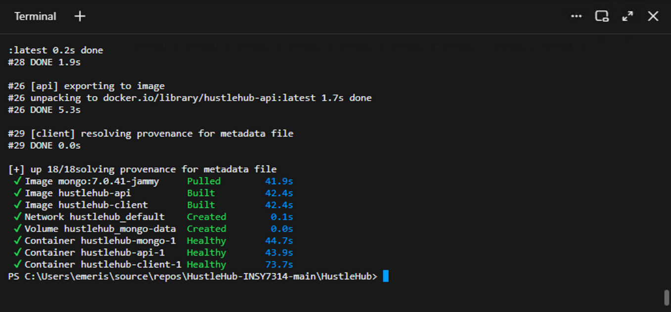
Figure 15: Docker Compose image and container startup output. [Screenshot]. Source: HustleHub+ project team (2026, unpublished).
Figure 16: Additional Docker Compose terminal verification. [Screenshot]. Source: HustleHub+ project team (2026, unpublished).
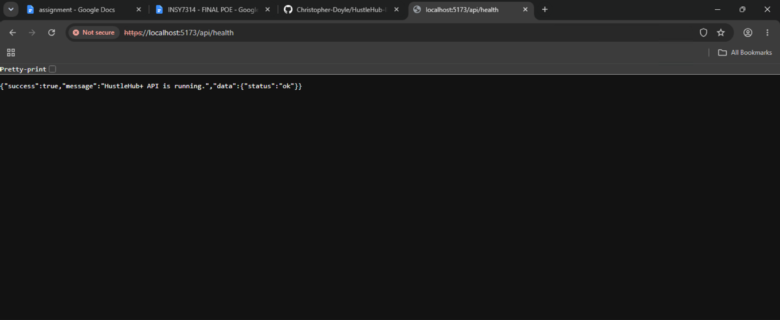
Figure 17: HTTPS API response in the running containerised system. [Screenshot]. Source: HustleHub+ project team (2026, unpublished).
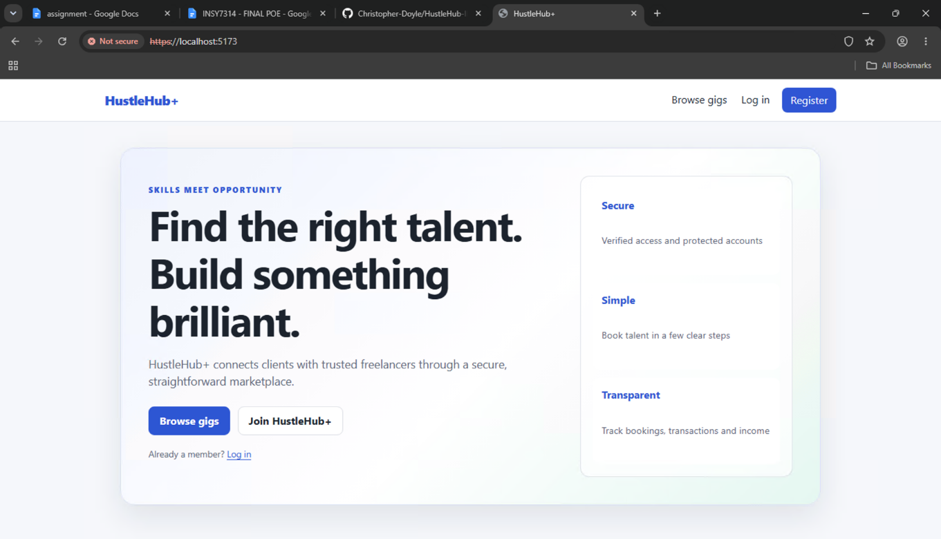
Figure 18: Containerised React application shown in a browser. [Screenshot]. Source: HustleHub+ project team (2026, unpublished).
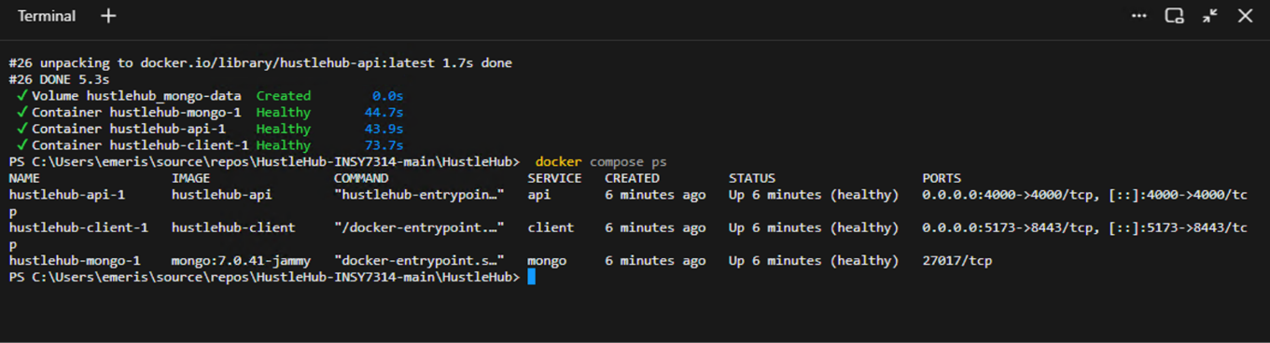
Figure 19: Docker Compose service-status output. [Screenshot]. Source: HustleHub+ project team (2026, unpublished).

7. CLOUD LOGGING AND SECURITY EVIDENCE

7.1 Logging architecture
Application events are structured in JSON with timestamps, event names, severities and request correlation IDs. The implementation exports selected sanitised records through HTTPS to Better Stack, compatible with its documented ingestion format (Better Stack, 2026). The original evidence states that records arrived in the hustlehub-demo Live tail on 8 November 2026.

7.2 Booking and simulated transaction events
Figure 20 shows correlated activity in Live tail. Figures 21 and 22 show booking_created and transaction_created JSON records. These demonstrate the relationship between a successful booking and a recorded simulated transaction.
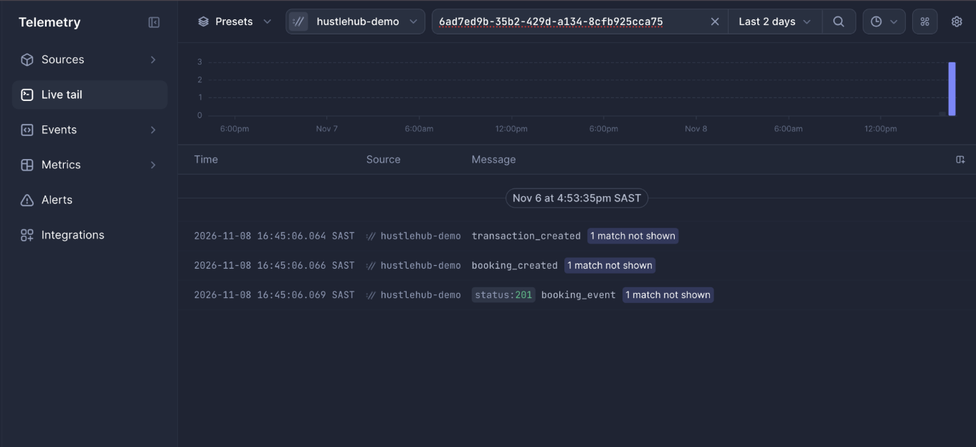
Figure 20: Better Stack Live tail with correlated booking and transaction events. [Screenshot]. Source: HustleHub+ project team (2026, unpublished).
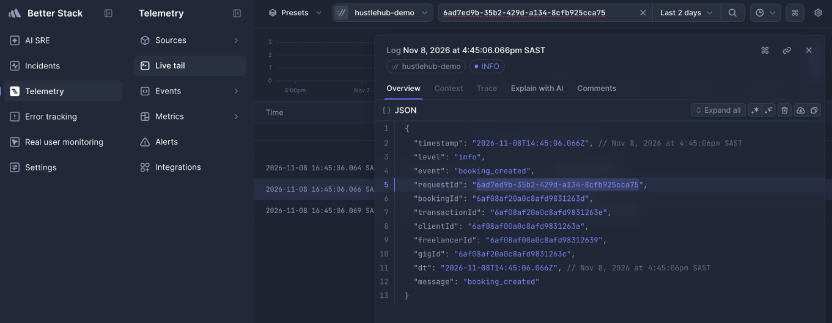
Figure 21: Better Stack booking_created event with request correlation. [Screenshot]. Source: HustleHub+ project team (2026, unpublished).
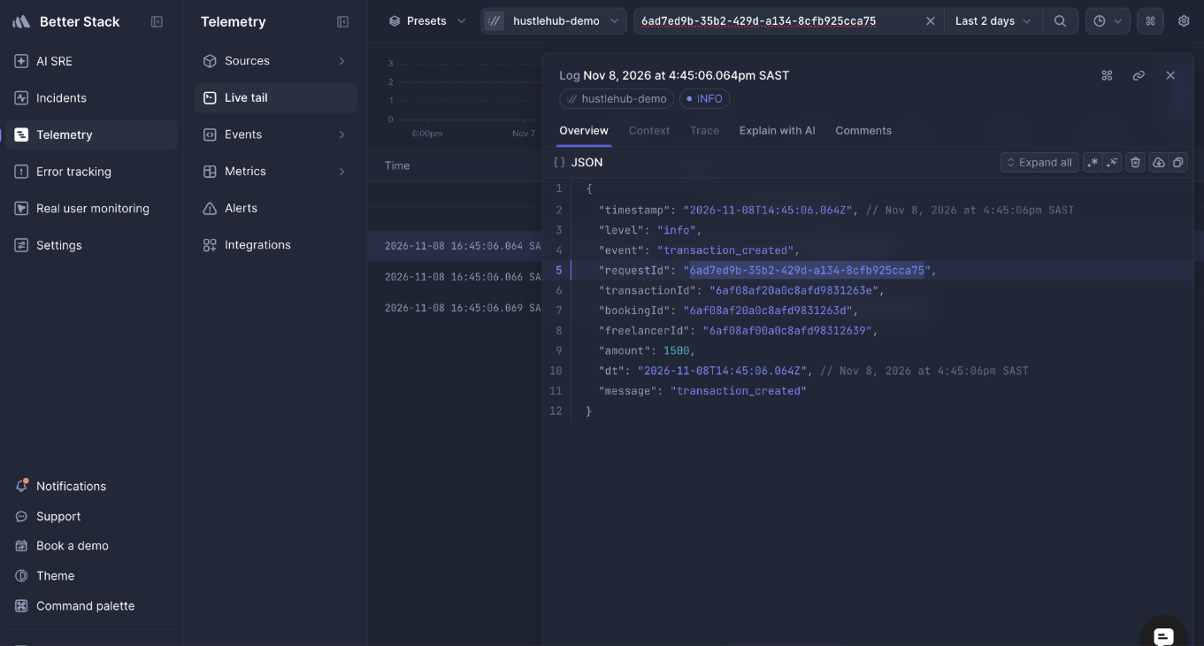
Figure 22: Better Stack transaction_created event and simulated amount. [Screenshot]. Source: HustleHub+ project team (2026, unpublished).

7.3 Validation and application errors
Figures 23 and 24 show validation-related request_error logging and associated HTTP response events, supporting evidence that failed requests are monitored as well as successful transactions.
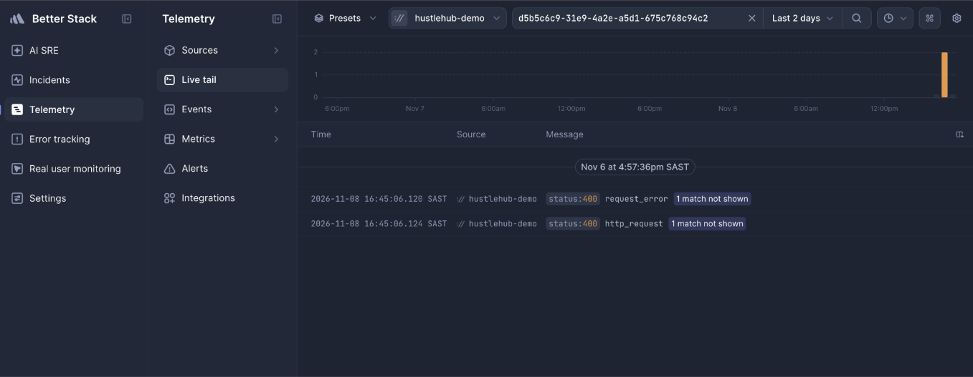
Figure 23: Better Stack validation-error and request-error event search. [Screenshot]. Source: HustleHub+ project team (2026, unpublished).
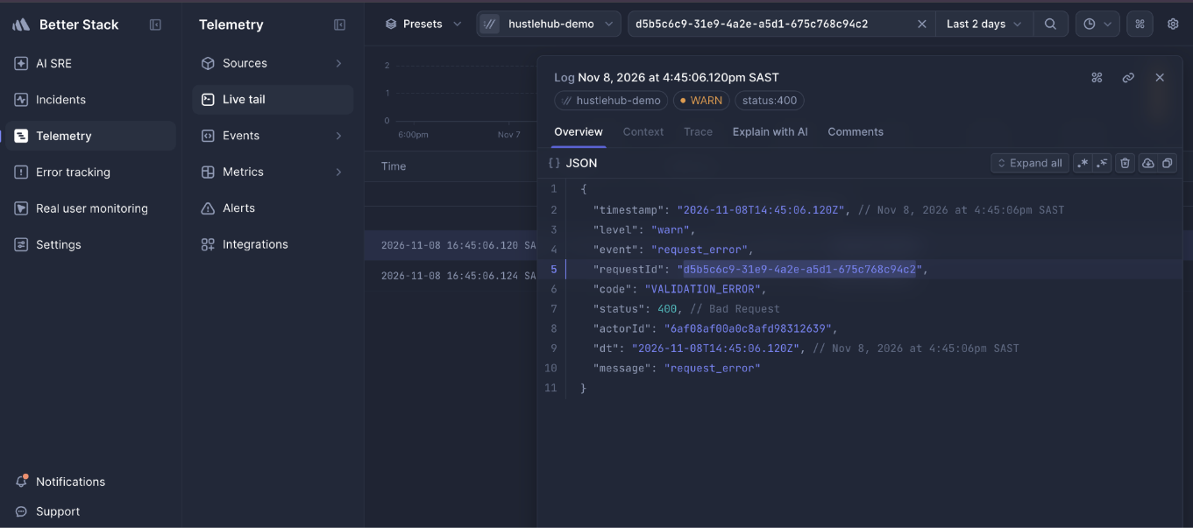
Figure 24: Better Stack request_error JSON entry for validation failure. [Screenshot]. Source: HustleHub+ project team (2026, unpublished).

7.4 Account lockout
Figures 25 and 26 show account_locked events after repeated failed authentication and the associated HTTP 401 responses. This is observable evidence of the additional account-lockout feature.
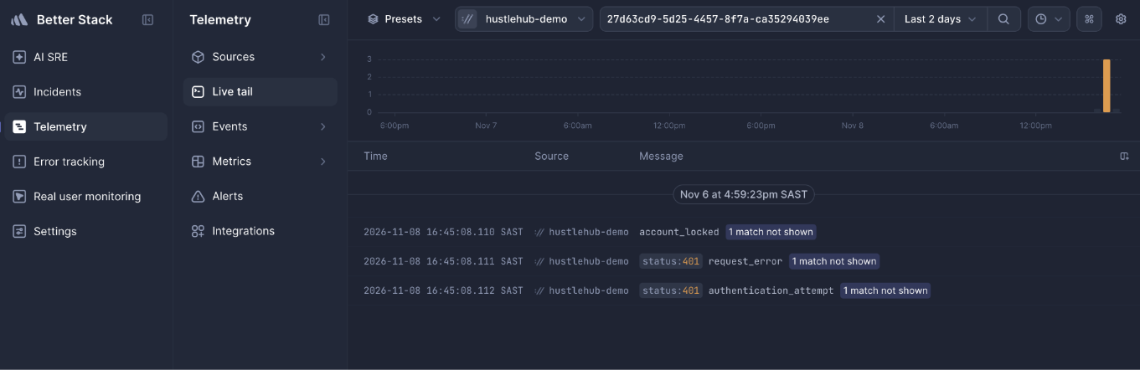
Figure 25: Better Stack account-lockout event and matching HTTP 401 responses. [Screenshot]. Source: HustleHub+ project team (2026, unpublished).
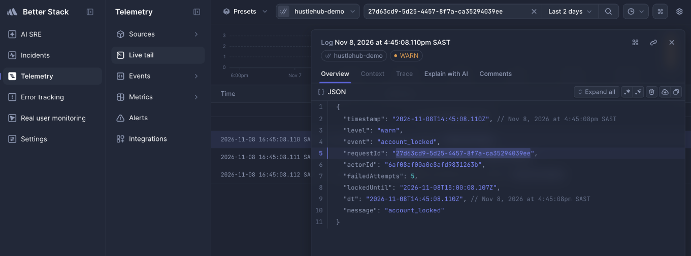
Figure 26: Better Stack account_locked JSON entry. [Screenshot]. Source: HustleHub+ project team (2026, unpublished).

7.5 Authentication outcomes
Figures 27 and 28 document successful authentication, and Figures 29 and 30 document a failed attempt. All records shown were generated in the team's demonstration environment.
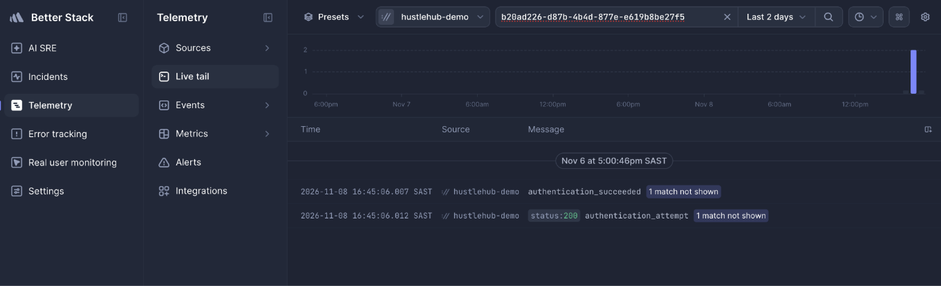
Figure 27: Better Stack successful authentication and HTTP response. [Screenshot]. Source: HustleHub+ project team (2026, unpublished).
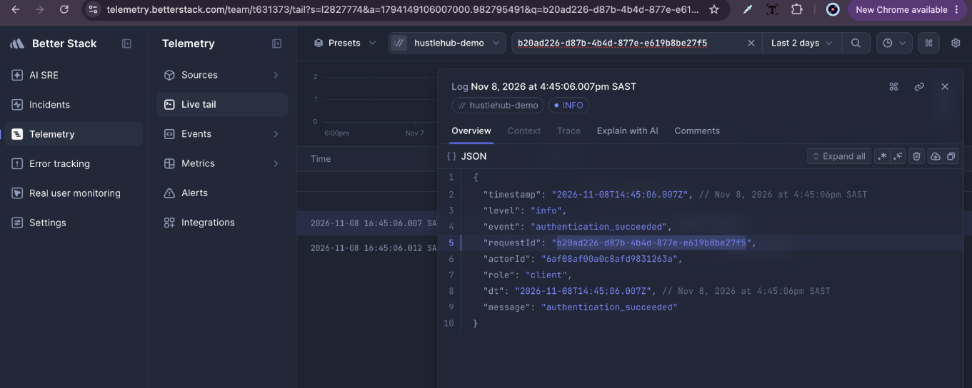
Figure 28: Better Stack authentication_succeeded JSON record. [Screenshot]. Source: HustleHub+ project team (2026, unpublished).
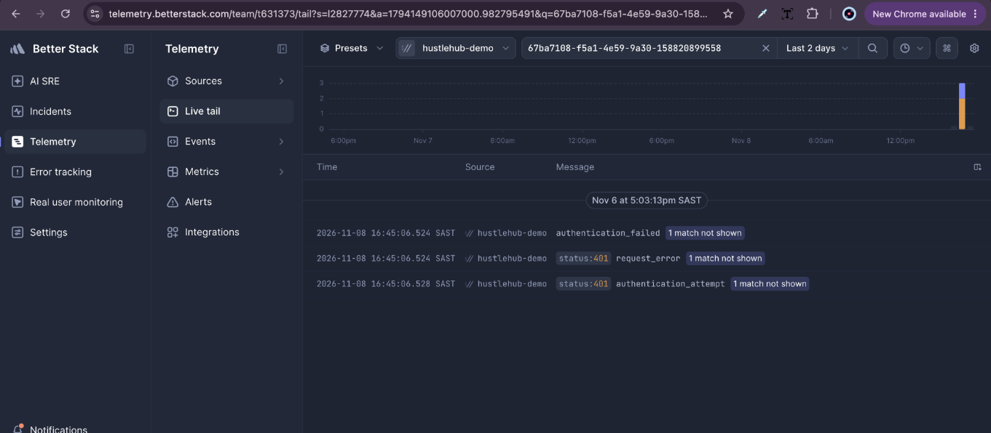
Figure 29: Better Stack failed authentication and HTTP 401 response. [Screenshot]. Source: HustleHub+ project team (2026, unpublished).
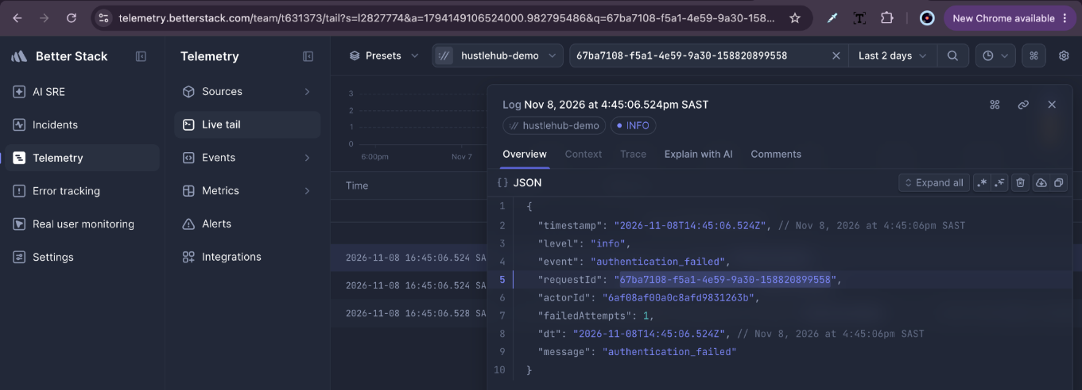
Figure 30: Better Stack authentication_failed JSON record. [Screenshot]. Source: HustleHub+ project team (2026, unpublished).

7.6 Persistent token revocation
Figures 31–33 show token_revoked events and the logout request. The final demonstration must also prove that the API rejects a revoked JWT, since a log entry alone does not establish that authentication is blocked.
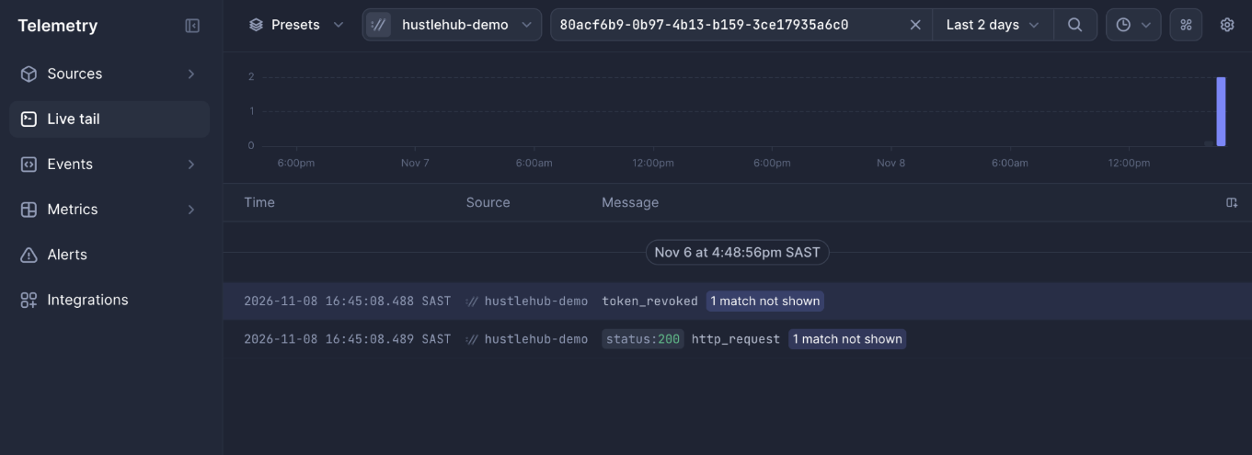
Figure 31: Better Stack token_revoked event and corresponding logout request. [Screenshot]. Source: HustleHub+ project team (2026, unpublished).
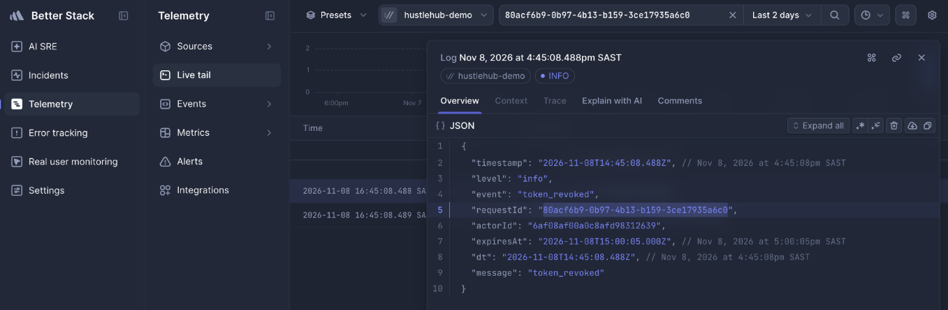
Figure 32: Better Stack token_revoked JSON record. [Screenshot]. Source: HustleHub+ project team (2026, unpublished).
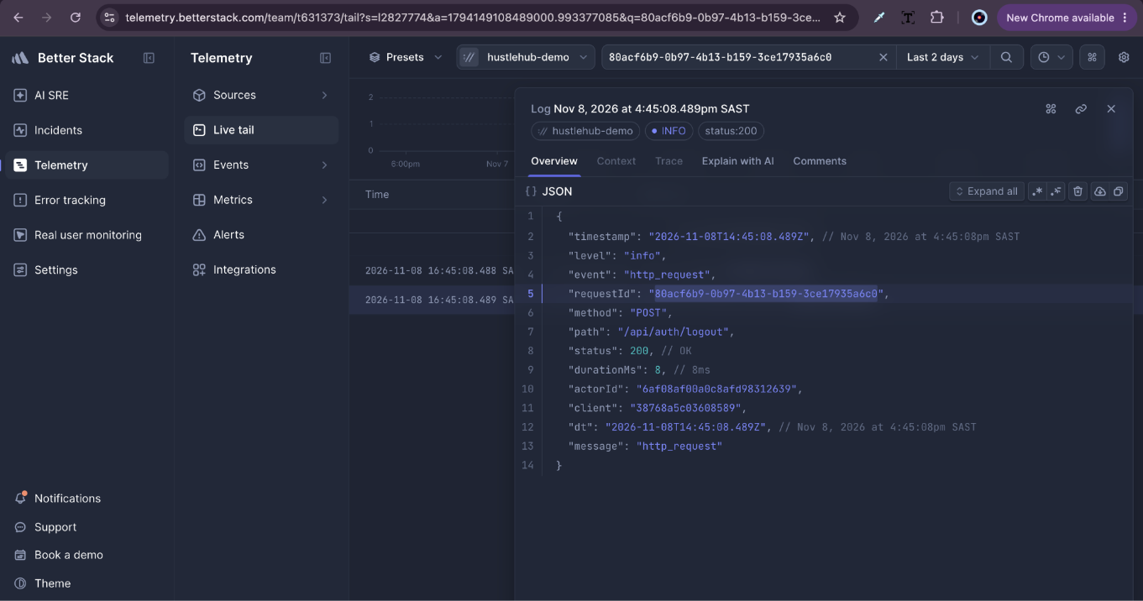
Figure 33: Better Stack successful logout HTTP event. [Screenshot]. Source: HustleHub+ project team (2026, unpublished).

8. TAX ESTIMATION AND FINANCIAL DATA SECURITY
The financial feature distinguishes total lifetime simulated income from earnings within the 2027 South African tax year, running from 1 March 2026 to 28 February 2027. The estimate applies the published progressive income-tax brackets and the primary rebate to platform earnings, and it is described as an estimate rather than an official personal tax assessment (South African Revenue Service, 2026).
Income routes should derive ownership from the authenticated freelancer account and prevent clients or unrelated freelancers from accessing private financial records. The group video should show an actual completed simulated transaction updating the live dashboard, not only the mocked UI captures.

9. REFERENCE LIST
Alphabetical IIE Harvard–Anglia references. The website access dates below are those recorded in the team's source documentation.
Better Stack, 2026. Ingesting logs. [online] Available at: https://betterstack.com/docs/logs/ingesting-data/http/logs/ [Accessed 8 November 2026].
HustleHub+ project team, 2026. HustleHub+ Final POE: application, automated test, Docker and cloud logging evidence. [Unpublished project screenshots].
Microsoft, 2026. Playwright: continuous integration. [online] Available at: https://playwright.dev/docs/ci [Accessed 8 November 2026].
OWASP Foundation, 2021. OWASP Top 10:2021. [online] Available at: https://top10.owasp.org/2021/ [Accessed 8 November 2026].
Semgrep, Inc., 2026. Sample CI configurations. [online] Available at: https://semgrep.dev/docs/semgrep-ci/sample-ci-configs [Accessed 8 November 2026].
South African Revenue Service, 2026. Rates of tax for individuals. [online] Available at: https://www.sars.gov.za/tax-rates/income-tax/rates-of-tax-for-individuals/ [Accessed 8 November 2026].
The Independent Institute of Education, 2026. Harvard–Anglia style reference guide: adapted for The IIE. [pdf] Referencing guide provided for this assessment.

APPENDIX A — LIST OF FIGURES
Figure 1. Desktop homepage and main navigation.
Figure 2. Mobile homepage and navigation layout.
Figure 3. Freelancer income and tax dashboard at desktop width (mocked test data).
Figure 4. Freelancer income and tax dashboard at mobile width (mocked test data).
Figure 5. Client booking confirmation screen.
Figure 6. Playwright browser-test report for the expanded frontend checks.
Figure 7. Responsive homepage in a narrow mobile viewport.
Figure 8. Responsive homepage at an intermediate viewport.
Figure 9. Additional mobile layout showing navigation and content.
Figure 10. Frontend test-result summary.
Figure 11. GitHub repository and CI evidence view.
Figure 12. GitHub Actions downloadable artefacts.
Figure 13. CI job log showing automated verification.
Figure 14. Terminal output from automated build and verification.
Figure 15. Docker Compose image and container startup output.
Figure 16. Additional Docker Compose terminal verification.
Figure 17. HTTPS API response in the running containerised system.
Figure 18. Containerised React application shown in a browser.
Figure 19. Docker Compose service-status output.
Figure 20. Better Stack Live tail with correlated booking and transaction events.
Figure 21. Better Stack booking_created event with request correlation.
Figure 22. Better Stack transaction_created event and simulated amount.
Figure 23. Better Stack validation-error and request-error event search.
Figure 24. Better Stack request_error JSON entry for validation failure.
Figure 25. Better Stack account-lockout event and matching HTTP 401 responses.
Figure 26. Better Stack account_locked JSON entry.
Figure 27. Better Stack successful authentication and HTTP response.
Figure 28. Better Stack authentication_succeeded JSON record.
Figure 29. Better Stack failed authentication and HTTP 401 response.
Figure 30. Better Stack authentication_failed JSON record.
Figure 31. Better Stack token_revoked event and corresponding logout request.
Figure 32. Better Stack token_revoked JSON record.
Figure 33. Better Stack successful logout HTTP event.

