State-Space Estimation Using a Linear-Gaussian SSM For IMU Data
EuRoC MAV (V1_01_easy) – 6D State-Space Filtering with FilterPy

Dataset
The dataset was sourced from ETH Zurich’s Autonomous Systems Lab. It provides visual-inertial datasets that are collected from a micro aerial vehicle (MAV). The dataset contains stereo images, synchronized IMU measurements, and accurate motion and structure ground-truth. We limit the scope of this project to a Linear-Gaussian State-Space model, using only the Inertial Measurement Unit data (angular rate and acceleration, 200 Hz) and excluding sensors that would cause non-linear interactions (Camera sensors, Vicon tracking and LiDAR )

Application
This project applies a 6-dimensional linear Kalman Filter to smooth noisy IMU gyroscope and accelerometer measurements from the EuRoC MAV dataset. The goal is state-space smoothing and estimation to extract latent signal from noisy sensor readings. This type of smoothing Is used in drone sensor preprocessing, anomaly detection, and preparing signals for downstream forecasting or control algorithms.

EDA
To start off our analysis we rename the ambiguous variable names into their respective type of sensor (Accelerometer or Gyroscope) with their respective axis (x, y, z). The dataset timestamp originally comes in nanoseconds, but for ease of use we transform it into second units in relative time since start.
The next step was looking at the raw sensor measurements; we plotted each axis of the raw signals over their own type of sensor to show variability differences between them. We should note that the plots are a bit deceiving due to differing scales of the Y-axes but as we will see a bit later in this report the raw accelerometer measurements have higher variance than the gyroscope (Angular Velocity).
The variance among the gyroscopes seems to be similar, with gyro_x appearing to have the most variance out of the 3 sensors. The raw accelerometer observations differ more compared to the gyroscopes – due to the difference of their measurements (meters per second squared vs radians per second). Accelerometer X seems to be the most variable followed by accel_z then accel_y.
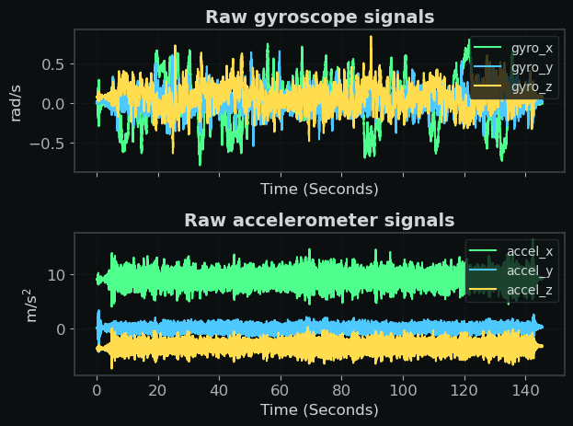
The variances for the raw measurements are as follows:
Sample Variance Differenced Sample Variance
gyro_x 0.071238 gyro_x 0.000526
gyro_y 0.012861 gyro_y 0.006056
gyro_z 0.022779 gyro_z 0.001567
accel_x 1.296645 accel_x 3.903093
accel_y 0.270197 accel_y 0.645817
accel_z 0.722386 accel_z 2.509868
By comparing the variance and differenced variance we can distinguish between axes (sensor_x,y,z) dominated by noise and axes where the latent state evolves over time, letting us separate sensor jitters from actual motion in the system. We use these numbers to guide our selection of Q (Process Noise Covariance) and R (Measurement Noise Covariance) for our state-space model.

Modeling
We define Xt – The state equation as a 6-D state corresponding to the IMU channels at timestep t, containing the latent state.
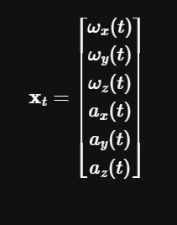
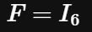
We set set F (Transition Matrix) as a random walk (I : Identity matrix)to help model each IMU state as a slowly evolving latent signal surrounded by measurement noise, capturing the true latent state over a constant time interval. Wt here is defined as process noise, and Q represents the process noise covariance - which decides how much the latent state is allowed to change between timesteps.

We define Zt – the Measurement Equation as another 6-D vector which contains the raw sensor readings from the data corresponding at timestep t.
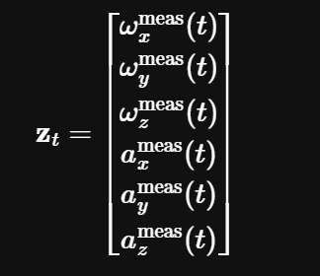
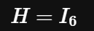
We set the H (Measurement Matrix) as (I: Identity Matrix) since the IMU channels directly measure the state directly, but with added noise from the sensors. Since we are only modeling the linear effects, we disregard adjusting H since adjusting it would mean scaling, rotating, mixing, or inferring data – leading to nonlinear modeling and out of the scope of this project. Vt here is defined as the measurement noise, R represents the measurement noise covariance - which decides how much the Kalman filter should trust the raw measurements based on how noisy the readings are at each timestep.
We chose a q scaler of 0.01 to keep the model stable, as we are modeling IMU sensor readings with a random walk we want to let the state move but only a slight bit to balance the sensitivity of real motion and noise suppression.

Kalman Filter
The Kalman filter algorithm runs in two phases at each time step:
Predict
- Using the state model to predict the next state before seeing the measurement
- Produces the prior state estimate (xhat(t|t-1)) and its covariance
Update
- Compares predicted measurement (Hxhat(t|t-1)) to observed measurement zt
- The difference between the predicted measurement and observed measurement is the innovation or measurement residual.
We use innovation to calculate kalman gain - which balances the trust between model and measurement.
- Updates the state estimate to xhat(t|t)
In this project we adjust the Kalman Filter (Q, R, F, H) manually and based on calculated variance to experiment and see how the model reacts to different specified levels, although it is noted that we can estimate Q and R using MLE or other Bayesian approaches. We use the FilterPy library to implement this state-space model with the Kalman Filter Algorithm which is used to estimate the latent state.
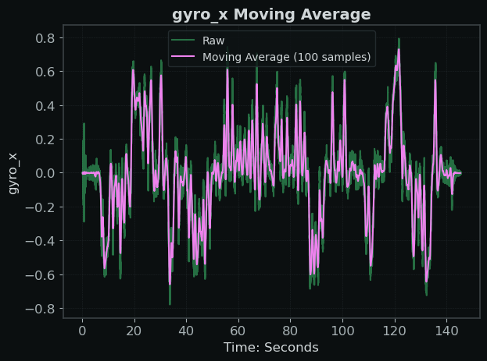
Here we show the Moving Average just to compare a regular smoothing technique to demonstrate how a state space model operates in comparison. These are 2 very different types of smoothing.

We can see that the moving average smoothed the data but that’s about it, it lowers the variance but kills the signal which is the opposite of what a state -space model does.
Now let’s compare it to the filter results using the SSM and Kalman Filter:
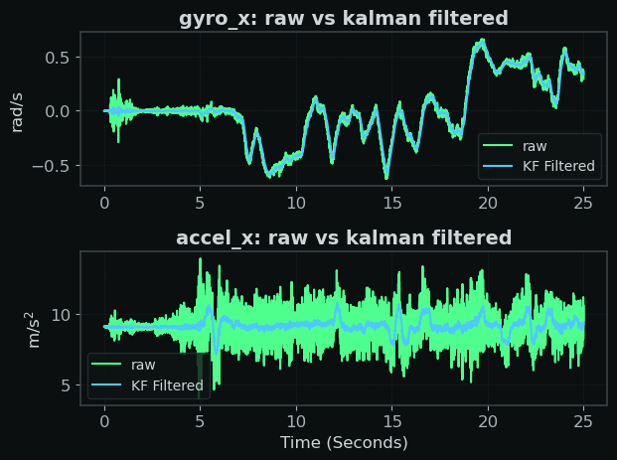

We see here unlike the moving average the Kalman Filtered data mostly smooths the noise without killing the latent signal. The hidden state here is the blue lines which you can see separates the actual movements of the MAV drone from measurement noise.
Here we show the variance reduction for each of the IMU sensor channels to inspect how the Kalman Filter handled each one.
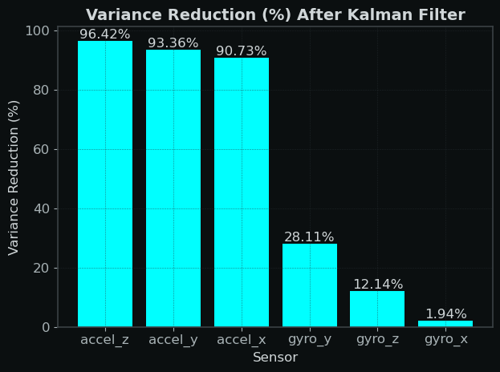
As expected, the highest variance got smoothed the most (Accelerometers), however we noted that although gyro_x had the most variance among the gyroscope sensors it was reduced the least, indicating that gyro_x holds a lot of signal compared to the other sensors. This also shows our Filter is working as it removed based on noise-signal not on just variance, which would have given an oversmoothed result.

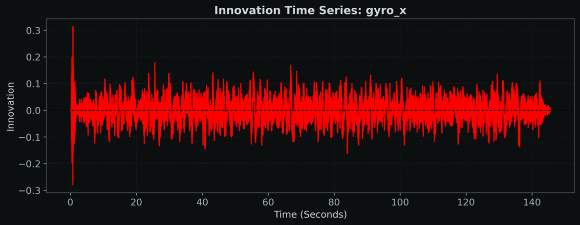
Diagnostics: Innovations
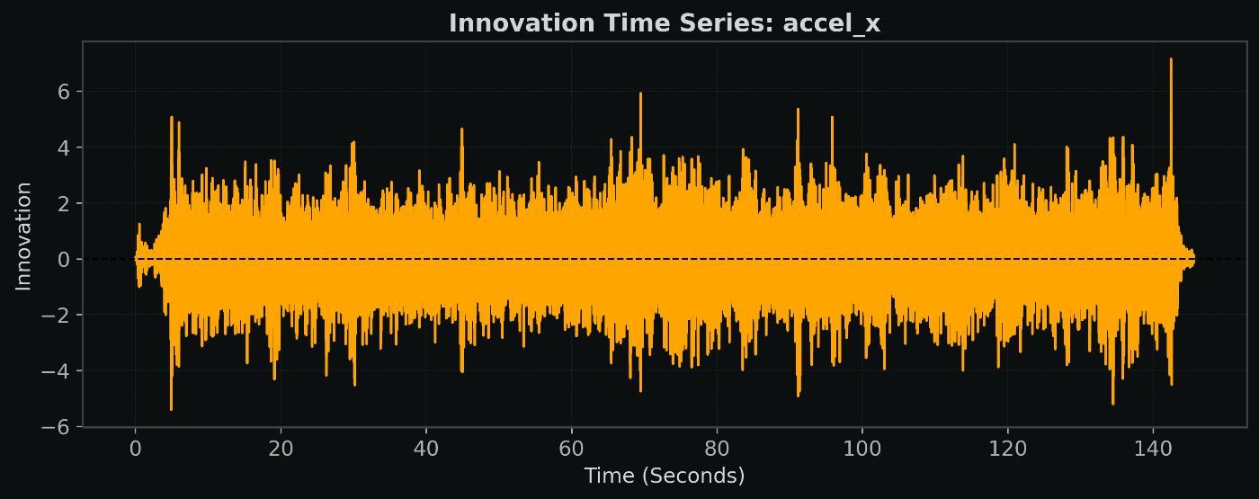
Innovation residuals are the difference between the Kalman filters one-step ahead forecast and the actual measurement at time t. We use these for residual diagnostics to see if the model (F, H, Q, R) is well specified:

Both Innovation plots for gyro_x and accel_x show a similar structure, they both have means around 0, show no trend, and have constant variance for the most part. We can say that they meet white noise/gaussian assumptions.

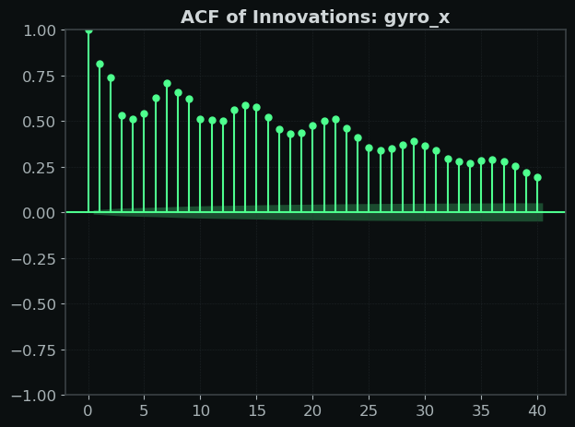
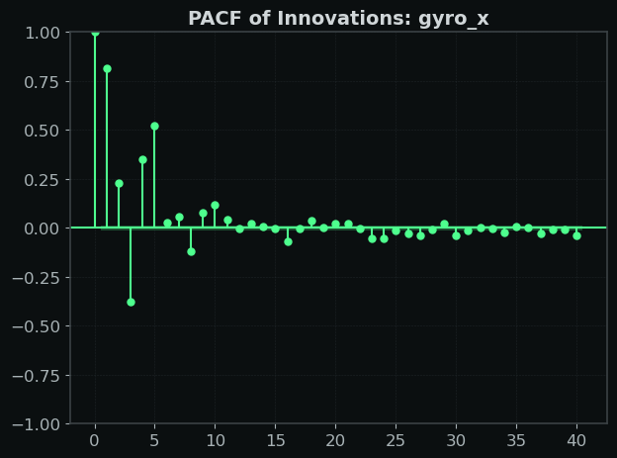
Diagnostics: ACF and PACF
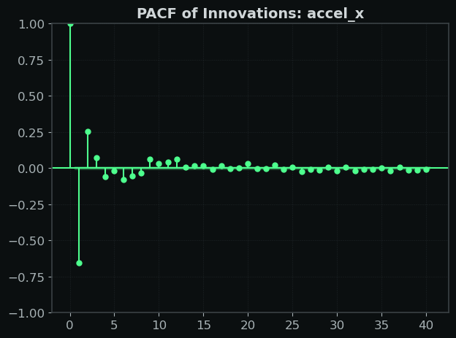
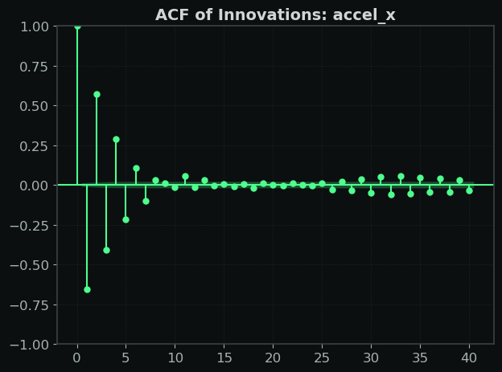
For gyro_x sensors the ACF and PACF show a structure/decay pattern that a low order AR(p) may be able to handle – as we can see from the slow decaying ACF and PACF cutting off around lag 5. These plots show us that the state equation or measurement equation was mis specified and indicates the random walk model we set with F was too simple for the gyroscopes.

These accel_x ACF/PACF plots show us a different story - There is no significant structure/decay past a few lags in the ACF plot. As for PACF it seems the lags die out after lag 1. The accelerometer innovations behave like white noise, indicating that our specified model properly captures accelerometer noise.

Conclusion and Further Steps
This project showed how a simple linear state-space model with a Kalman Filter can effectively extract a latent state from noisy measurements. Using innovation analysis, ACF/PACF, and variance reduction we confirmed the model was well-specified and stable for some sensors – Accelerometers but mis specified for Gyroscope measurements.
Future steps involve changing the state vector to account for some type of gyroscope autocorrelation that is shown by diagnostics. We can fine tune F (Transition Matrix), as well as Q to better capture the true structure of the gyro_x channel by adding a gyro bias term modeled as a random walk in the state equation which I hypothesize will reduce autocorrelation and capture the drift.
In practice, this type of smoothing is used in applications such as drone sensor preprocessing, anomaly detection, and preparing signals for downstream forecasting or control algorithms.

