Intermediate Microeconomics
Fall 2005

Midterm Exam

Direction: This is a close book, close notes exam; there is 100 points possible, please pay attention to the weights as you allocate your time; the exam starts at 3:30 and ends at 5:00 sharp. Good luck!
- (25 points) Consider the utility function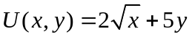.
- Is the assumption that ‘more is better’ satisfied for both goods?
- What is 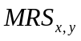 for this utility function?
- Is the diminishing, constant, or increasing as the consumer substitutes for along an indifference curve?
- (25 points) A consumer purchases two goods, food 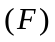 and clothing 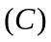. Her utility function is given by 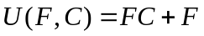. The price of food is 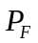 , the price of clothing is 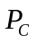, and the consumer’s income is .
- What is the demand function for clothing?

- Is clothing a normal good in this case?
3. (25 points) Suppose that Natasha’s utility function is given by u(I) = I^{0.5}, where I represents annual income in thousands of dollars.
1) Is Natasha risk loving, risk neutral, or risk averse? Explain.
2) Suppose that Natasha is currently earning an income of $10,000 (I = 10) and can earn that income next year with certainty. She is offered a chance to take a new job that offers a .5 probability of earning $16,000, and a .5 probability of earning $5,000. Should she take the new job?
3) In (2), would Natasha be willing to buy insurance to protect against the variable income associated with the new job? If so, how much would she be willing to pay for that insurance?

4. (25 points) Suppose a consumer has the two period utility function:
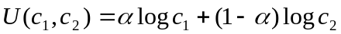
where 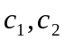represent the amount of consumption in period 1 and 2 respectively. The consumer’s income consists just of inherited assets A in period 1, and there is no income in second period. If the remaining income is invested in an asset, it can earn a rate of interest r.
- Interpret the economic meaning of the parameter in the utility function.
- Obtain the optimal allocation of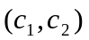, and illustrate it with the graph.
- Explain how the optimal consumptions in periods 1 and 2 vary with A, r, and.

