Christopher Wilson
IT-230
February 22, 2026

Course.cs
using System;

namespace WPFRegisterStudent
{
public class Course
{
// Stores the course name
private string name;

// Tracks whether the student has already registered for this course
private bool isRegisteredAlready = false;

// Constructor initializes the course with a name
public Course(string name)
{
this.name = name;
}

// Sets the course name (not used often, but included for completeness)
public void SetName(string name)
{
this.name = name;
}

// Returns the course name
public string GetName()
{
return name;
}

// Returns true if the course has already been registered
public bool IsRegisteredAlready()
{
return isRegisteredAlready;
}

// Marks the course as registered
public void SetToRegistered()
{
isRegisteredAlready = true;
}

// Ensures the ComboBox and ListBox display the course name
public override string ToString()
{
return name;
}
}
}
Main Window:
using System;
using System.Collections.Generic;
using System.Windows;
using System.Windows.Controls;

namespace WPFRegisterStudent
{
public partial class MainWindow : Window
{
Course choice;
private int totalCredits = 0;
private List<Course> registeredCourses = new List<Course>();

public MainWindow()
{
InitializeComponent();
}

private void Window_Loaded(object sender, RoutedEventArgs e)
{
Course course1 = new Course("IT 145");
Course course2 = new Course("IT 200");
Course course3 = new Course("IT 201");
Course course4 = new Course("IT 270");
Course course5 = new Course("IT 315");
Course course6 = new Course("IT 328");
Course course7 = new Course("IT 330");

this.comboBox.Items.Add(course1);
this.comboBox.Items.Add(course2);
this.comboBox.Items.Add(course3);
this.comboBox.Items.Add(course4);
this.comboBox.Items.Add(course5);
this.comboBox.Items.Add(course6);
this.comboBox.Items.Add(course7);

this.textBox.Text = "0";
}

private void button_Click(object sender, RoutedEventArgs e)
{
// Validate selection
if (comboBox.SelectedItem == null)
{
MessageBox.Show("Please select a course before registering.");
return;
}

choice = (Course)comboBox.SelectedItem;

// Rule 1: No duplicate registration
if (choice.IsRegisteredAlready())
{
MessageBox.Show("Error: You have already registered for this course.");
return;
}

// Rule 2: No more than 9 credit hours
if (totalCredits >= 9)
{
MessageBox.Show("Error: You cannot register for more than 9 credit hours.");
return;
}

// Register the course
choice.SetToRegistered();
registeredCourses.Add(choice);

// Update credits
totalCredits += 3;
textBox.Text = totalCredits.ToString();

// Confirmation
MessageBox.Show("Registration confirmed for: " + choice.GetName());

// Update ListBox
listBox.Items.Clear();
foreach (Course c in registeredCourses)
{
listBox.Items.Add(c);
}
}
}
}

Screenshots
Start
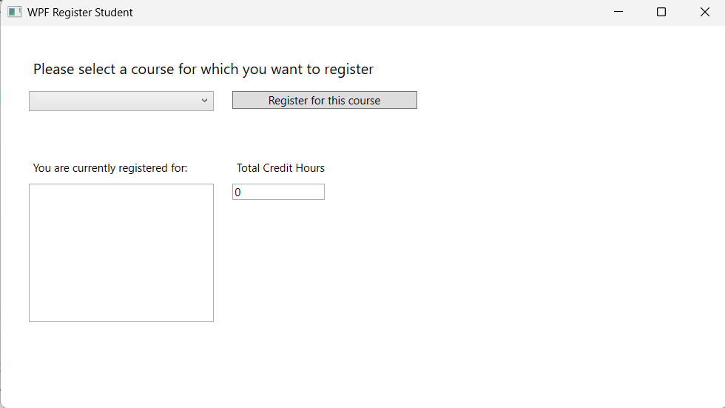
Registering a new course
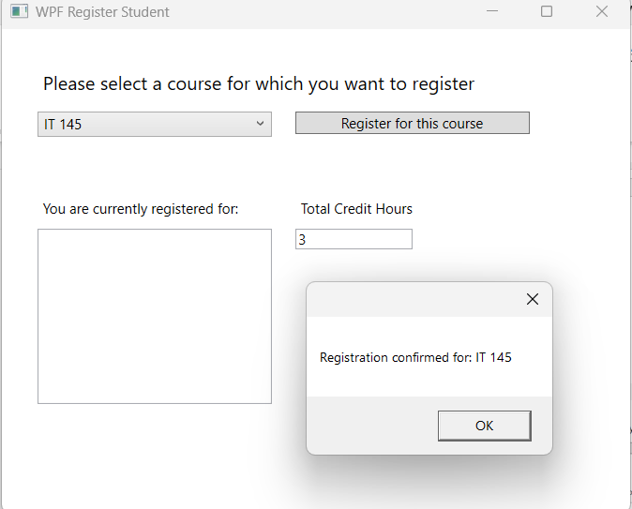
Error for selecting more than nine credits
