

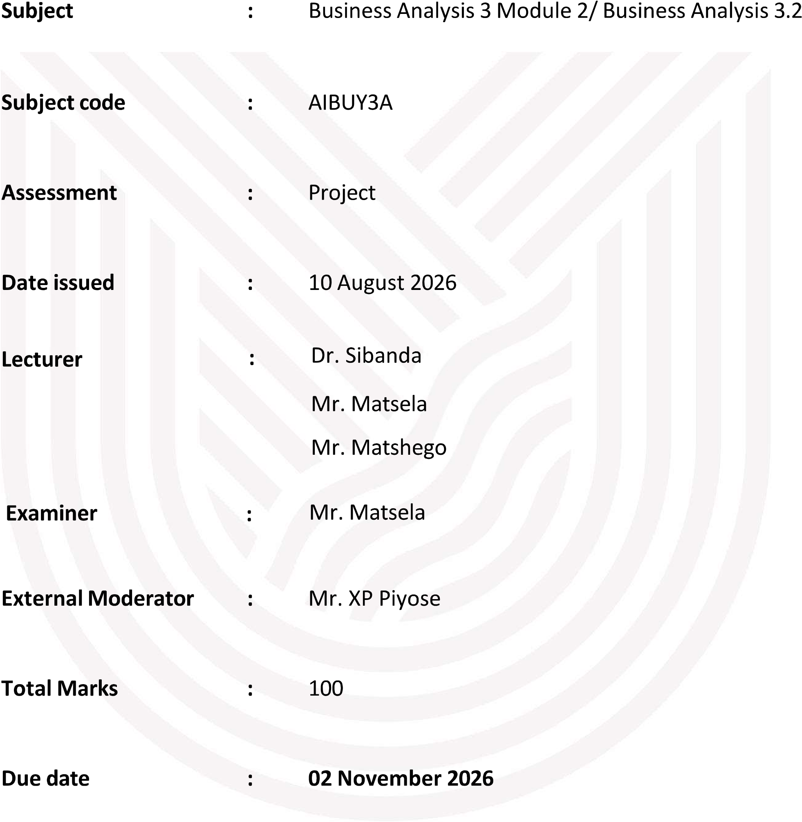
DECLARATION
We , Mabunda Christopher , Treasure Mabasa , Siyahluma Madlavana and Sarah

declare that the contents of this project represent our own unaided work, and that the project has not previously been submitted for academic examination towards any qualification. Furthermore, it represents our own opinions and not necessarily those of the Vaal University of Technology.

TABLE OF CONTENTS
EduPrediction: AI-Based Early Warning System for Student Academic Performance and Risk Prediction
No. | Contents
1. | Business Background
2. | Problem Definition
3. | AI Solution
3.1 | Dataset Description
3.2 | Student Academic Risk Categories
3.3 | System Components
4. | Business Objectives
5. | Requirements
5.1 | Dataset Features
5.2 | Technologies Used
5.3 | Machine Learning Models
6. | Constraints
7. | Risks
8. | Conclusion

EduPrediction: AI-Based Early Warning System for Student Academic Performance and Risk Prediction
EDUPREDICTION: AI-BASED EARLY WARNING SYSTEM FOR STUDENT ACADEMIC PERFORMANCE AND RISK PREDICTION
1. BUSINESS BACKGROUND
EduPrediction is an AI-powered system designed to help educational institutions identify students who may be at risk of poor academic performance. The system uses student information such as study time, absences, previous failures, family support, school support, internet access, parental education and academic marks. Using machine learning, the system classifies students into High Risk, Medium Risk and Low Risk categories so that support can be provided early.
2. PROBLEM DEFINITION
Many institutions struggle to identify struggling students before their academic performance declines. Student data is often available but is not analysed effectively. This can lead to poor results and late interventions. By analysing student information and previous academic performance, EduPrediction can identify students who may need additional support.
3. AI SOLUTION
The solution uses the student-por dataset. Important variables include age, gender, studytime, failures, absences, family support, school support, internet access, parental education, G1, G2 and G3. The machine learning model uses these features to predict academic risk levels. G3 (final grade) is used as the target variable.
Risk Categories:
High Risk: G3 less than 10
Medium Risk: G3 between 10 and 13
Low Risk: G3 greater than or equal to 14
The system consists of a machine learning model, a Streamlit dashboard and a simple recommendation chatbot.
4. BUSINESS OBJECTIVES
- Predict student academic risk levels.
- Identify students requiring intervention.
- Provide a dashboard for lecturers and administrators.
- Improve academic performance.
- Support data-driven decision making.
- Reduce manual monitoring.

5. REQUIREMENTS
Dataset features:
Age, Gender, Study Time, Absences, Previous Failures, Mother's Education (Medu), Father's Education (Fedu), Family Support, School Support, Internet Access, G1, G2 and G3.
Technologies:
Python, Pandas, NumPy, Scikit-learn, Matplotlib, Seaborn and Streamlit.
Machine Learning Models:
Decision Tree and Random Forest.
6. CONSTRAINTS
- Dataset may contain missing values.
- Limited project time.
- Accuracy depends on data quality.
- Users may require training.
7. RISKS
- Overfitting of the model.
- Poor data quality.
- Incorrect predictions.
- User adoption challenges.
CONCLUSION
EduPrediction focuses on academic performance prediction rather than dropout prediction because the selected dataset contains academic indicators and final grades. The proposed solution fully aligns with the available dataset and can be implemented in Python using machine learning, Streamlit and a recommendation chatbot.

