Asteroid Dodge Game with Multi-User ROM-based Authentication, RAM-based Score Tracking, Difficulty Levels, and Adjustable Timer

Team Q4

User Manual

Nhat Nguyen PSID: ***4700

Christopher Andrew PSID: 1885918

Gantabya Kadel PSID: ***8522

Matthew Andersen PSID: 1812071

*ECE 5440 – Advanced Digital Design*

*Spring 2022*

# Introduction

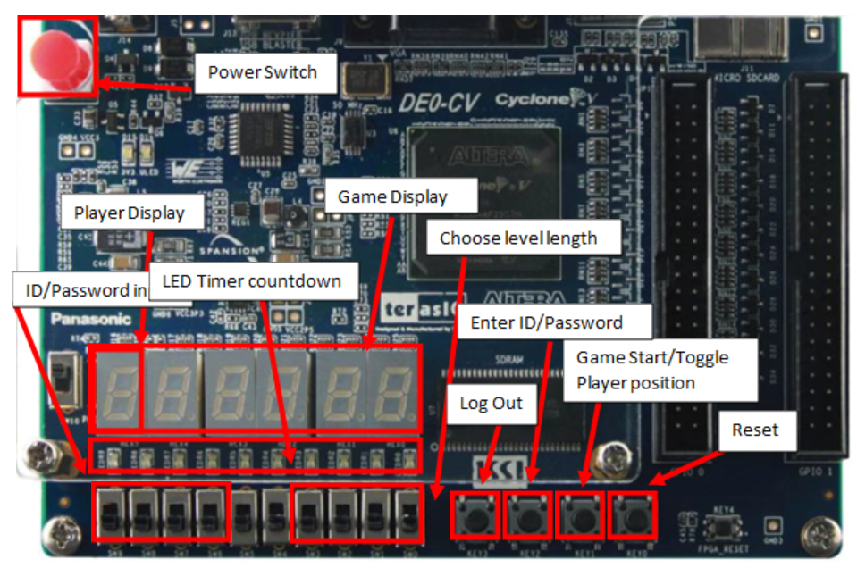

*Fig. 1. Diagram of User Interface for Asteroid Dodge Game.*

## About

This project details a side-scrolling, asteroid-dodging space game, where the goal is to continually travel right and avoid the debris flying at you for as long as possible. Score is tracked across multiple users, and the global best score is also tracked and displayed. Additional features include difficulty increment, a user-adjustable game timer, and LED display animations.

# Gameplay

### Game Setup Instructions

1. Ensure the programming switch located on the left side of the board is switched to the run position
2. Ensure that the DC power Jack is plugged into the board and plugged into a powered American standard 120 [V] wall outlet
   1. Alternatively the device can be powered by the USB blaster port
3. If there are no LED’s lit, press the red power switch on the upper right side of the board
4. If nothing happens, check that the power cable is plugged in at both ends.
5. If there is a single blue LED lit and the 7 segment displays show the word “ID” the game is loaded correctly
6. Press the right most push button switch, KEY0, to restart the game and allow a player to log into the game

### Game Login Instructions

1. To log into the game we must first enter our desired username, a 4 digit number.
2. Each digit is submitted by selecting the username digit in binary using the leftmost 4 slide switches.
3. The username is then submitted to the game using the password/enter ID button KEY2
4. Valid usernames are
   1. 8522
   2. 4700
   3. 5928
   4. 2071
   5. FFFF
5. Once you have entered a valid ID you are then taken to the passcode screen and the 7 segment displays will display the word “PSCO”
6. Next you must enter the 6 digit passcode associated with the previously entered username
7. Password digits are selected using the leftmost 4 slide switches
8. Password digits are submitted using the password/enter ID button KEY2
9. Valid passwords, password are associated with the ID that shares the same position in the list
   1. A54E32
   2. EEE420
   3. F24630
   4. AAB431
   5. FFFFFF
10. If you successfully log into the game you will be greeted with the global score display then the player score display a few seconds latter
11. You will then be able to play the game

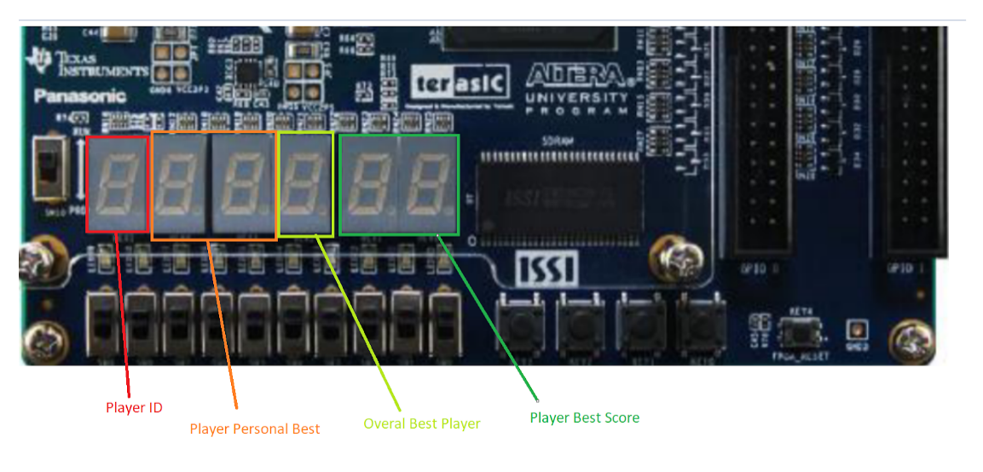

### Playing the game

1. First you must select the size of your fuel gage using the rightmost set of 4 slide switches in binary
   1. Each point of fuel represents 5 seconds of level time. Default is 10 lights.
   2. Longer levels are more difficult
2. In order to play a game after logging in the game start/toggle player position button KEY1 must be pressed
3. In order to score a point the player must dodge oncoming objects on the 7 segment displays until the fuel gage runs out
4. If the player succeeds in dodging all asteroids, they are awarded 1 point and their score will be displayed
   1. The LED’s in the countdown timer will blink if the player beats their personal best
   2. The LED’s in the countdown timer will fill up if the player beats the global best
5. If they player fails at completing a level they will see the global score screen for a few seconds before returning to the personal score screen
6. The player can log out of the game at any time game play is not happening.