AI Philosophy Salon
Student : Jinwei Zhang scyjz19@nottingham.ac.uk
Supervisor : Paul Tennent paul.tennent@nottingham.ac.uk

1. Background and Motivation
The AI Philosophy Salon is designed as a small performative talk show between four famous philosophers — Aristotle, Sartre, Wittgenstein, and Russell. But this theme is mostly a framework. Our real aim is to build a reusable multi-agent dialogue system using several LLM models that can talk to each other. Each agent will take turns, listen, and keep a coherent discussion, making the dialogue feel alive and human-like. The project treats dialogue as performance — the agents are not only giving answers but performing a conversation. In the future, the same framework can replace the philosophers with other characters, and be used for creative or educational purposes.

2. Aim and Objectives
Aim:
To design and build an AI salon system that can let philosophers have a discussion, with voice and animation in Unity.
In a broader sense, the aim is to develop a simple but reusable multi-agent framework so different characters can talk in a structured, performative way.
Objectives:
1. Build backend that manages turn-taking, message flow, timing, and basic memory between agents.
2. Create light prompt settings that each agent has a stable speaking style
3. Use LLM Studio to test the agents early, then move to a local runtime setup for running models.
4. Make a Unity front-end to show text, play voice (TTS), and make simple gestures/lip sync.
5. Link everything end-to-end and test the overall system performance.
6. Make the system modular and extensible to support different character personas beyond philosophers.
7. Include a human host character to lead or moderate the philosophers’ discussion and interact with the agents when necessary.

3. Methodology
This project is more like an engineering work. I will build some small parts first, test them one by one, and then try to connect them together.
In the beginning, I will focus on the dialogue logic and the agent prompts.
LLM Studio will be used as a small sandbox to check how many agents talk and take turns.
After that, I will run the models in my local computer, maybe by using Python or some other framework that can work.
Unity will be used for the visual part. The lip sync and animation will be simple, not real like a movie.
I will test the timing and stability many times, and make it better when the flow not smooth.
Tools: LLM Studio (for early testing), local model runtime (Python with PyTorch), RESTful APIs for backend communication, Unity (frontend), Whisper (STT), and ElevenLabs (TTS).
Data: only AI generated dialogue will be used, no real person data in this project.

4. Work Packages
Work Package | Description | Milestone / Output
WP1: Background Research | Review multi-agent LLM systems and performative dialogue ideas. Decide tools and simple standards for prompts and messages. | Short research note + initial architecture sketch.
WP2: Backend Dialogue Manager | Implement turn-taking, context window, message passing, and logging. Provide a simple interface for Unity to connect. | Text-only multi-agent demo (two agents first).
WP3: LLM Integration | Test four agent personas in LLM Studio, then connect to local runtime. Do timing tests and robustness checks. | Four-agent text dialogue working with measured latency.
WP4: Frontend & Unity | Create minimal scene, subtitles, TTS playback, and simple gestures/lip movement for visual feedback. | Visible demo with voice and animation.
WP5: System Integration & Evaluation | Connect backend and Unity. Tune delays, fix issues, capture demo video, and prepare dissertation and report sections. | End-to-end demo + report + video.

5. Work Plan (Backend → Frontend → Backend from 10.29--4.15 about 24 weeks)
Weeks 1–6: Backend Round 1 – Build basic dialogue logic, message flow, and turn-taking; test with two agents in LLM Studio.
Weeks 7–10: Frontend Round 1 – Create basic Unity scene with subtitles, simple TTS, and animation; connect mock data for visualisation.
Weeks 11–16: Backend Round 2 – Optimise timing, improve stability, move to local runtime; refine agent responses and control flow.
Weeks 17–20: Integration – Connect backend and frontend; run end-to-end tests; tune delays and improve user experience.
Weeks 21–24: Final Stage – Write report, polish visuals, capture demo video, and final submission
.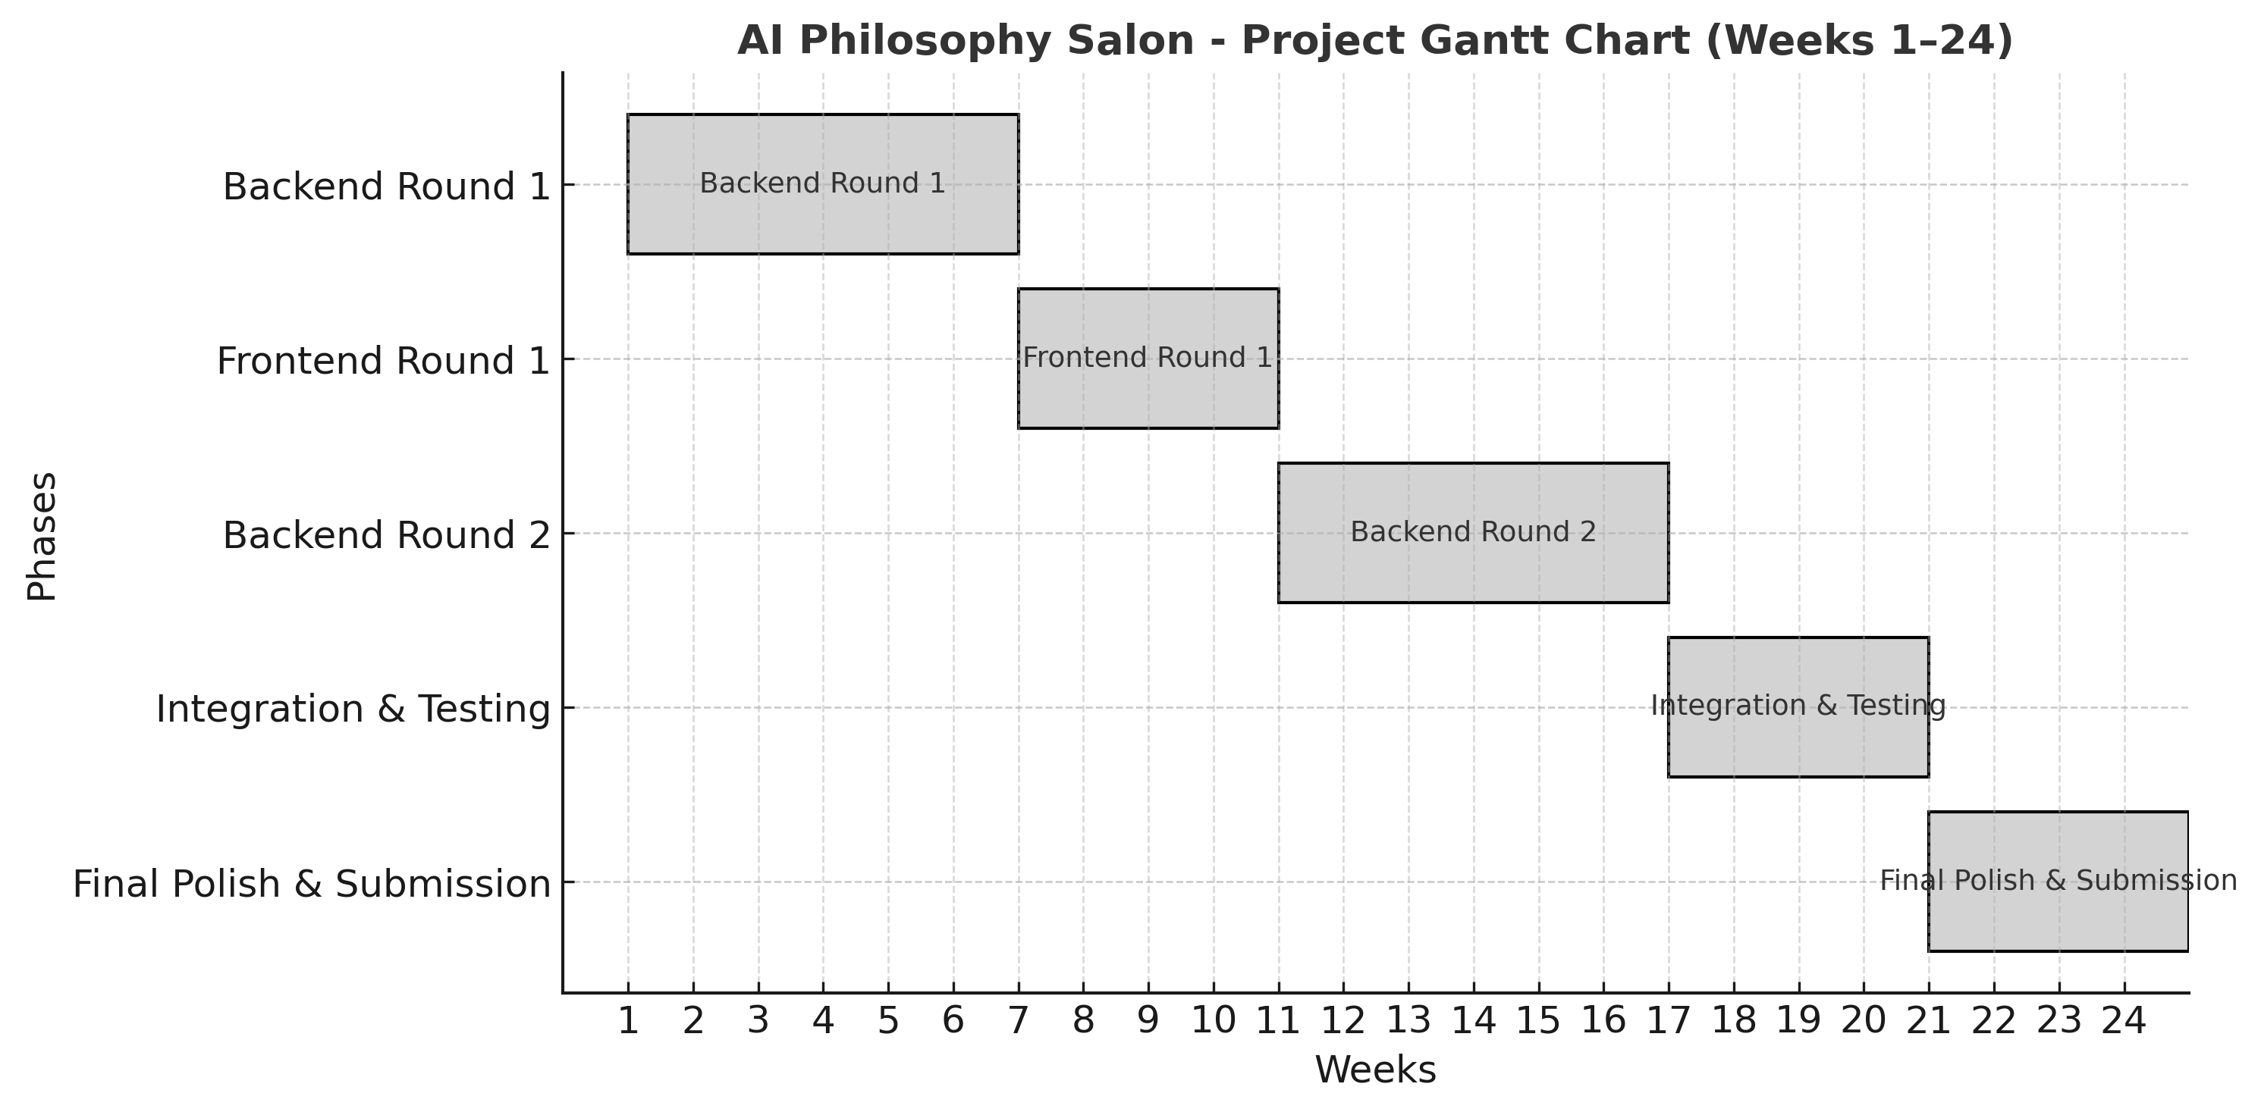

6. Deliverables
1. A working AI Philosophy Salon prototype (four agents, turn-based dialogue, Unity front-end with audio).
2. Source code and simple run guide (backend + Unity).
3. Short demonstration video showing the performative dialogue system.
4. Technical report (method, system design, integration, and evaluation).
5. Final dissertation documenting the full research process, system development, and evaluation results.

