**Cu Sample (Oct 8)**

Original results as found by Old Program without any modification. Note that these numbers were produced by adjusting the distances for shrinkage as shown on the poster in the wall of the crystallography room:

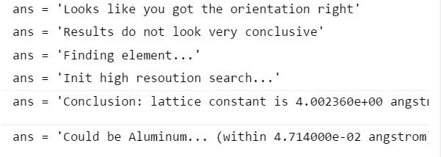

Original Graph Calculated on New Program before residual modifications, and with the strange hole distance being used:

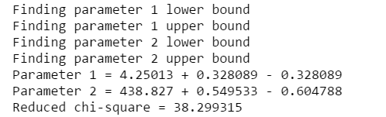

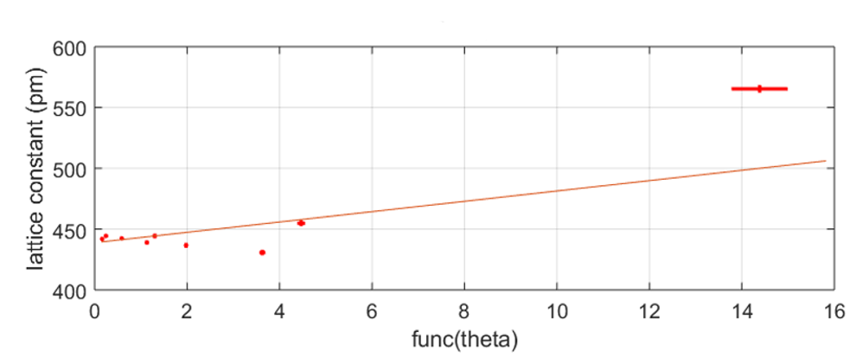

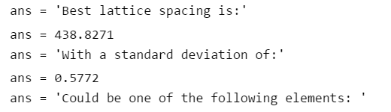

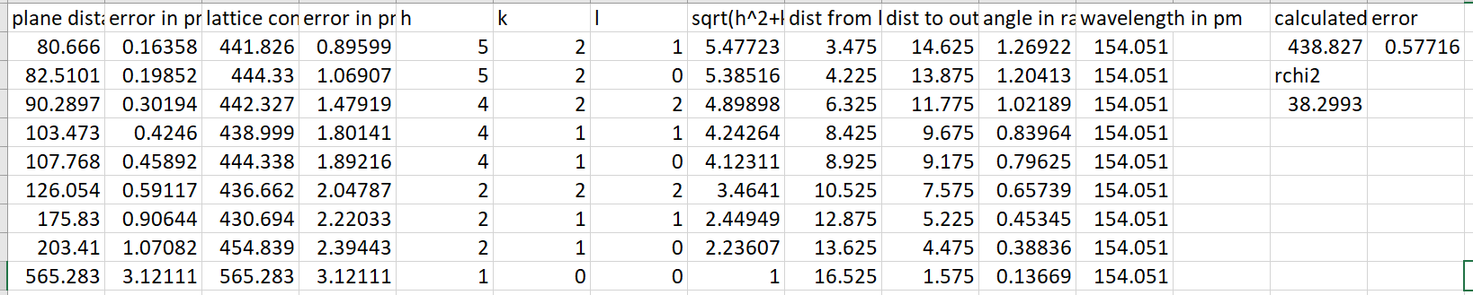

Analysis after splitting each spectral line into low and high wavelength distances, as well as calculating the input hole position differently (averaging the second and third rings instead of using the first since the first one is really off):

Low Wavelength:

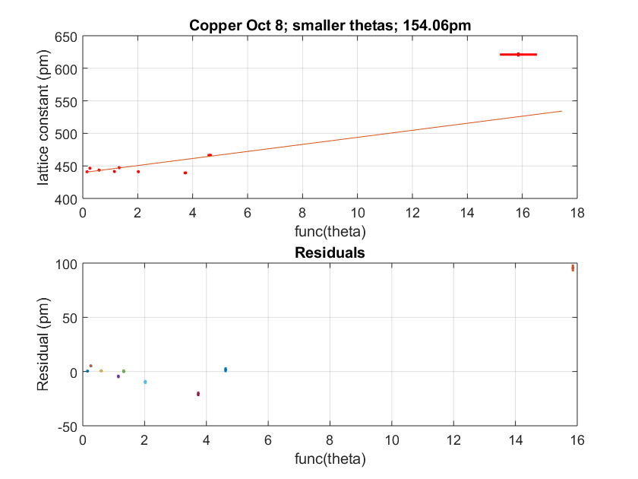

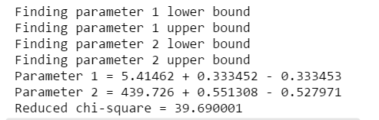

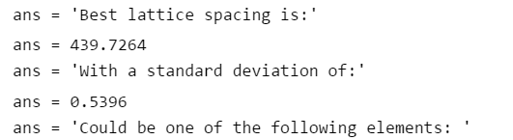



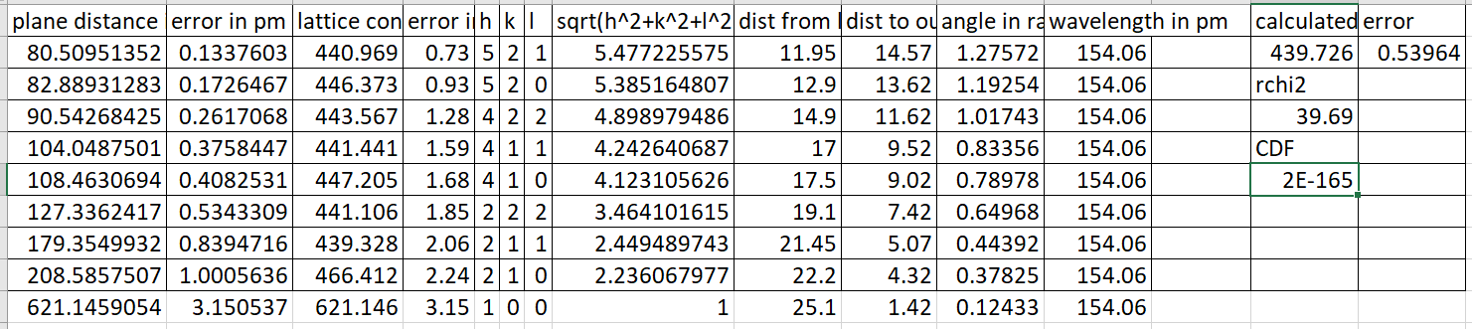

High Wavelength:

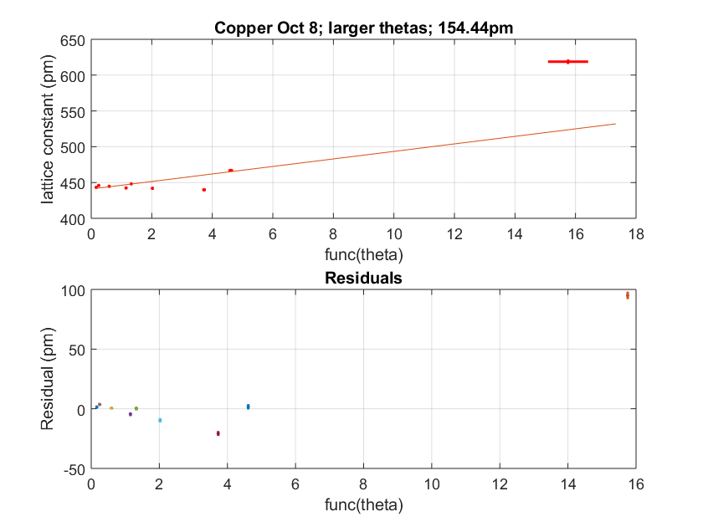

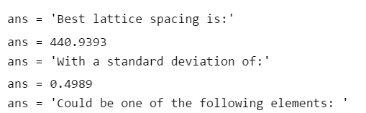



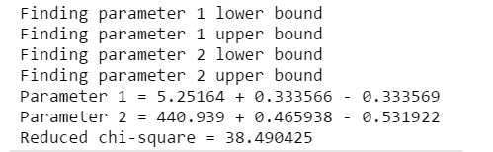

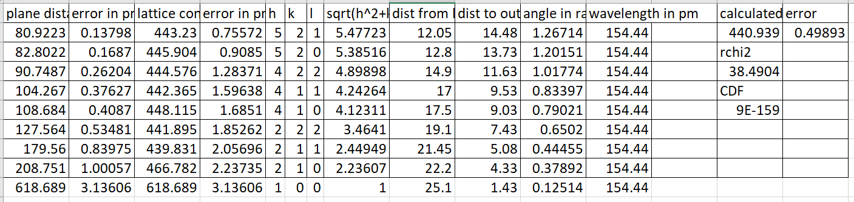

Removing the strange datapoint:

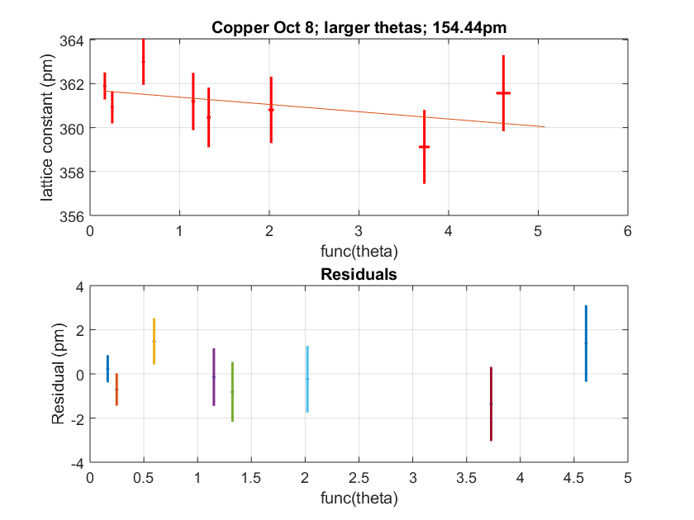

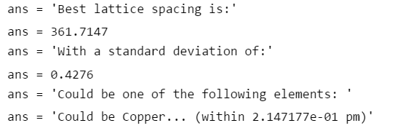

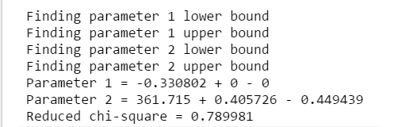

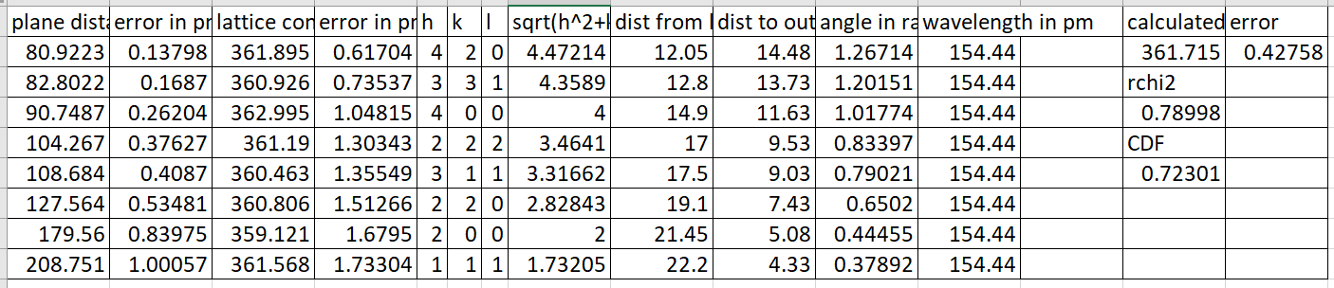

**W Sample (Oct 11)**

Note: for both W samples the hole distances used where the average of the first two rings of large separation

Tungsten low wavelength with residuals:

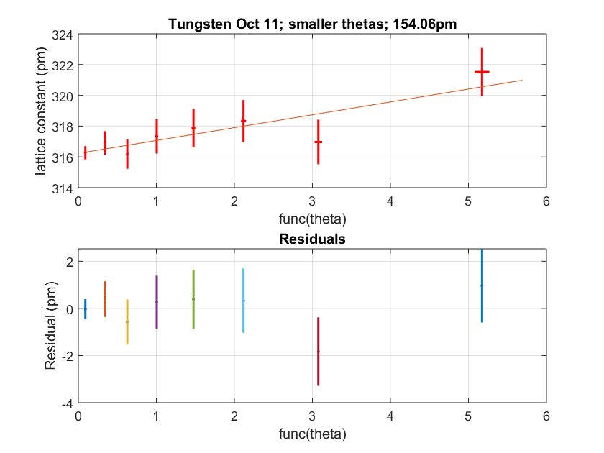

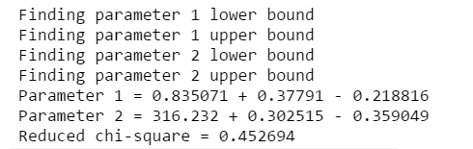

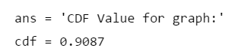

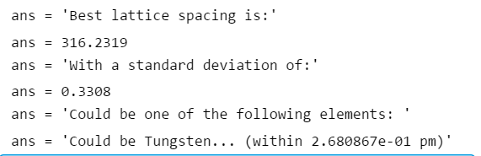

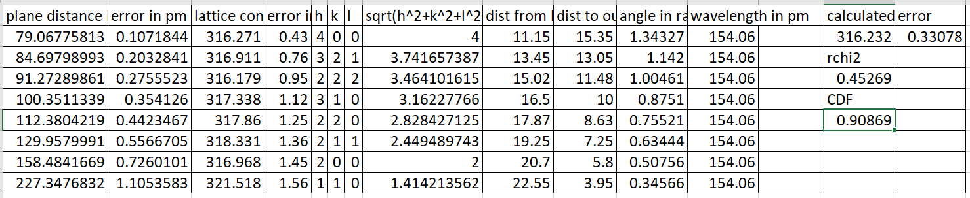

Tungsten High wavelength with residuals:

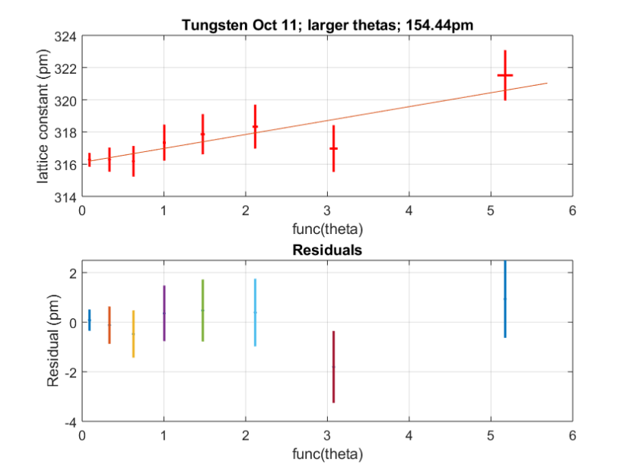

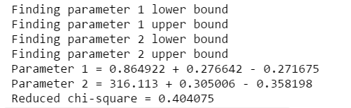



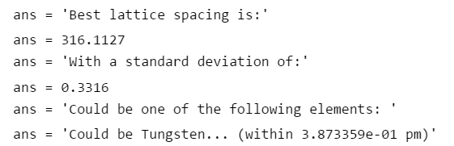

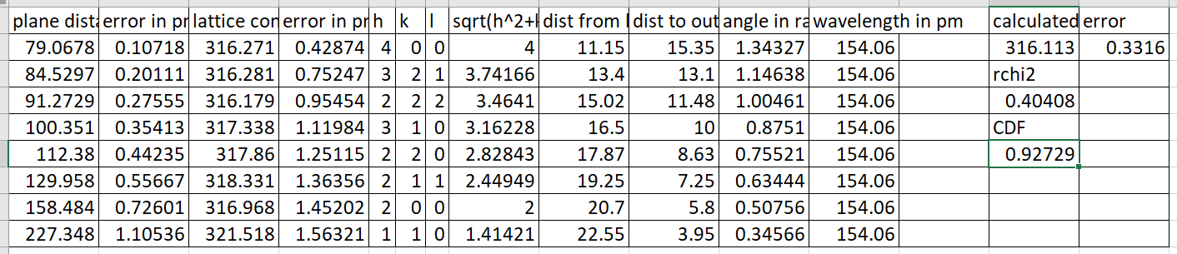

**Ag Sample (Oct 11)**

Note: for Ag, the input hole distance was an average of three rings, the first two finely separated ones and then the next large ring; for the output hole it was 2 rings averaged

Lower wavelengths:

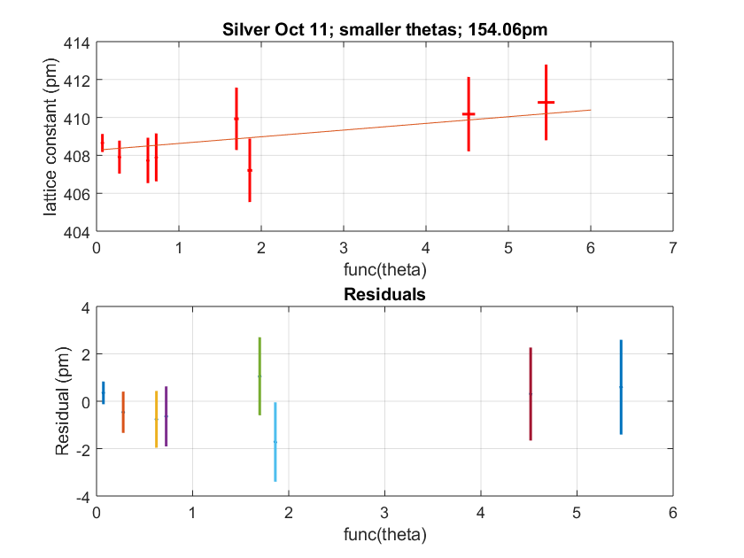

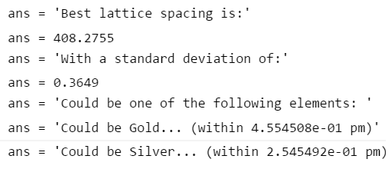

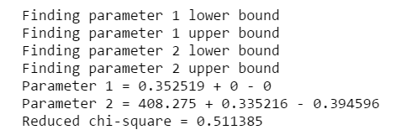



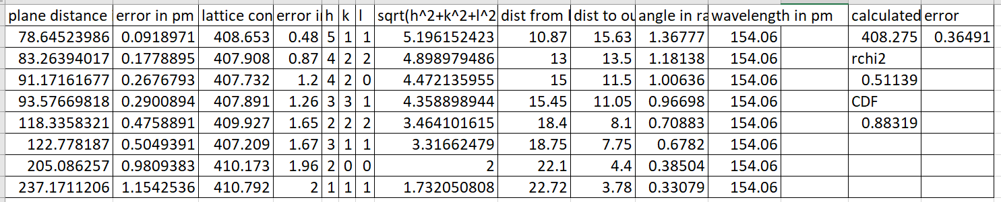

Higher wavelengths:

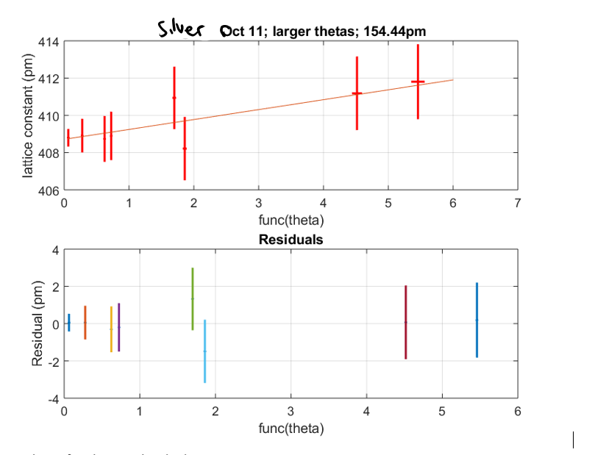

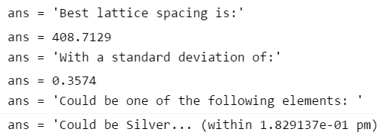

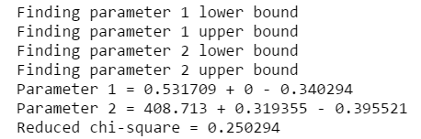



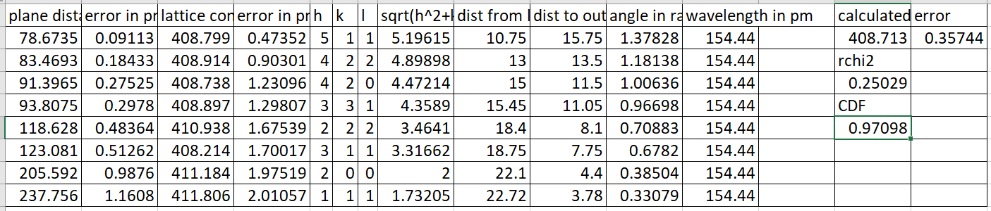

**Unknown Sample (Oct 22)**

High Wavelength:

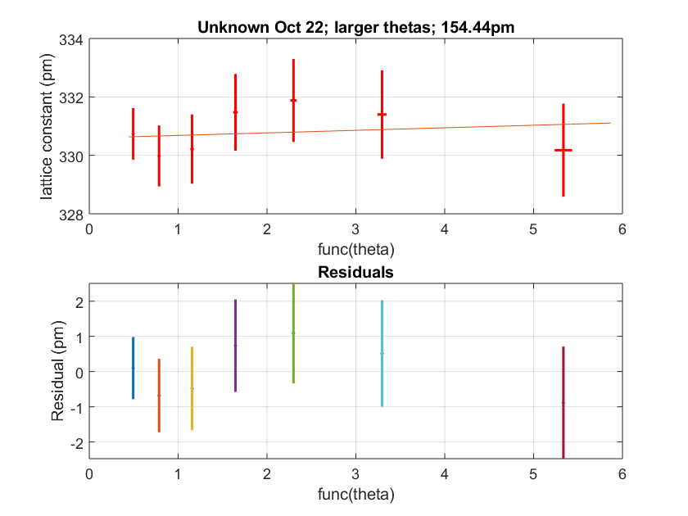

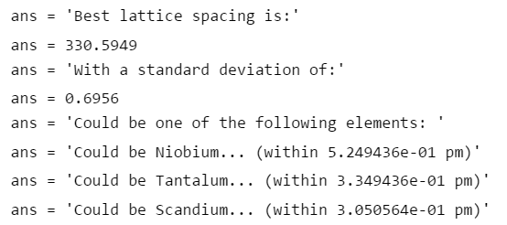

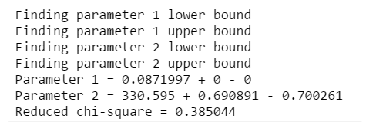



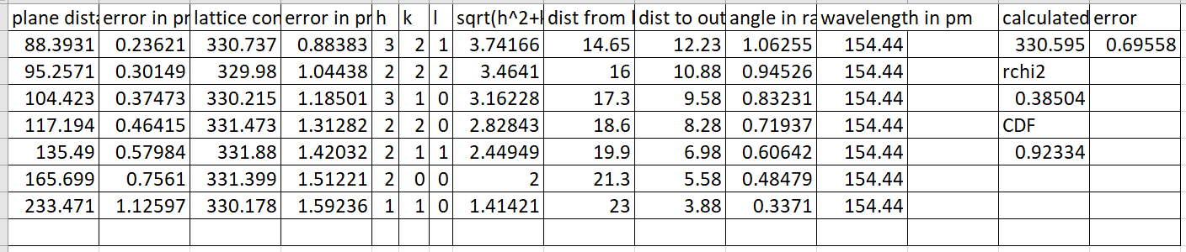

Low wavelength:

