**NOV 19 Ge N DOPED**

|  |  |  |  |  |  |  |  |  |  |
| --- | --- | --- | --- | --- | --- | --- | --- | --- | --- |
| T (K) | | ns (cm-2) | | 1/R (1/ohm) | | R (ohm) | | Mu (cm2V-1s-1) | |
| 298.1 | 0.1 | 3.71E+15 | 1E+15 | 0.0928 | 0.0006 | 10.78 | 0.07 | 156 | 47 |
| 318.1 | 0.1 | 8E+15 | 1E+15 | 0.1213 | 0.0009 | 8.24 | 0.06 | 93 | 17 |
| 338.1 | 0.1 | 2.1E+16 | 1E+15 | 0.239 | 0.003 | 4.19 | 0.05 | 72 | 5 |
| 358.1 | 0.1 | 5.0E+16 | 4E+15 | 0.496 | 0.008 | 2.02 | 0.03 | 62 | 5 |
| 378.1 | 0.1 | 1.3E+17 | 2E+16 | 0.50 | 0.01 | 2.02 | 0.06 | 24 | 4 |

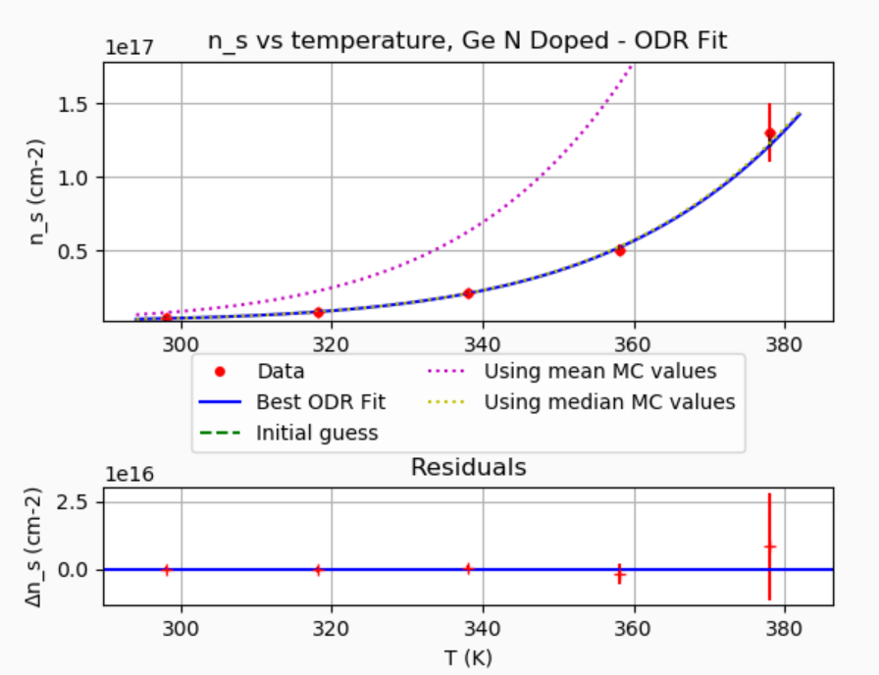

***********************************************************

ORTHOGONAL DISTANCE REGRESSION

***********************************************************

Fitting 5 Data points from file n_data.txt this Model function

def Eq4(x,*p):

delta_E = p[0]

m = p[1]

n_ex = p[2]

k_B = 1.38*(10**-23)

h_bar = 1.05457*(10**-34)

return ((k_B*x/(2*numpy.pi*h_bar*h_bar))**(3/2)*m**(3/2)*numpy.exp(-1*delta_E/(2*k_B*x)) +n_ex)

Systematics

correlated_offset = False

correlated_scale = True

x_true = 0+/-0 + (1+/-0)*x_measured

y_true = 0+/-0 + (1+/-0)*y_measured

**** ODR has finished with: Sum of squares convergence

Estimated parameters, uncertainties, and starting guesses

p[0] = 1.5281e-19 +/- 1.5218e-20 Guessed: 1e-19

p[1] = 3.673e-24 +/- 5.7054e-24 Guessed: 1e-23

p[2] = 1.8123e+15 +/- 1.3069e+15 Guessed: 1e+14

ODR Correlation Matrix

[[1. 0.99928304 0.77942476]

[0.99928304 1. 0.76190132]

[0.77942476 0.76190132 1. ]]

Quasi Chi-Squared/dof = 0.24929, Quasi CDF = 77.93555%

**** Running Monte Carlo CDF Estimator ****

1001 successful MC simulations in 4.47464 seconds.

Fraction of Monte Carlo quasi-chi-squared values larger than value for ODR fit:

Monte Carlo CDF = 79.7%

MC Fit parameters Average + Standard Deviation; Median and 68.3% interval

p[0] = 1.5273e-19 +/- 1.5742e-20 ; 1.5331e-19 + 1.4459e-20 - 1.5928e-20

p[1] = 1.1744e-23 +/- 2.8164e-23 ; 3.8538e-24 + 1.2728e-23 - 3.0983e-24

p[2] = 1.6803e+15 +/- 1.3965e+15 ; 1.7545e+15 + 1.2704e+15 - 1.3999e+15

Monte Carlo Correlation Matrix

[[1. 0.58748729 0.79952129]

[0.58748729 1. 0.4381413 ]

[0.79952129 0.4381413 1. ]]

Check For Bias in MC Fit parameters

(Monte Carlo median)/(fit value) - 1

p[0] Bias : +0.002753 +/- 0.004015 ( 0.69 SD)

p[1] Bias : +0.05574 +/- 0.3257 ( 0.17 SD)

p[2] Bias : -0.03124 +/- 0.02919 ( -1.07 SD)

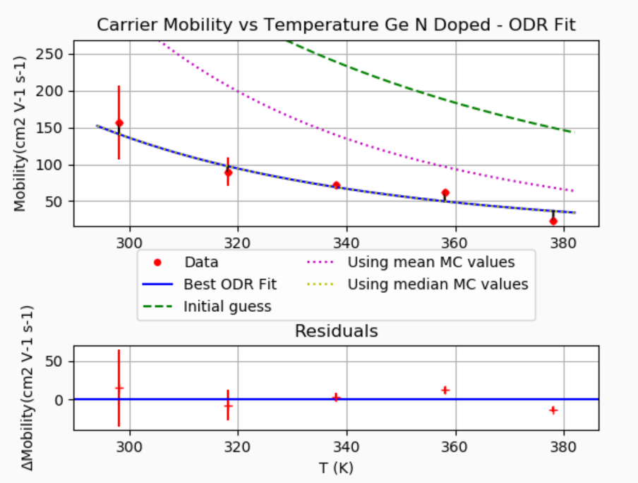

***********************************************************

ORTHOGONAL DISTANCE REGRESSION

***********************************************************

Fitting 5 Data points from file MobilityData.txt this Model function

def mobilityFormula(x, *p):

C = p[0]

B = p[1]

return C*x**B

Systematics

correlated_offset = False

correlated_scale = True

x_true = 0+/-0 + (1+/-0)*x_measured

y_true = 0+/-0 + (1+/-0)*y_measured

**** ODR has finished with: Iteration limit reached

Estimated parameters, uncertainties, and starting guesses

p[0] = 1.5334e+16 +/- 1.9458e+17 Guessed: 1e+13

p[1] = -5.6729 +/- 2.1674 Guessed: -4.2

ODR Correlation Matrix

[[ 1. -0.99995693]

[-0.99995693 1. ]]

Quasi Chi-Squared/dof = 5.60850, Quasi CDF = 0.07676%

**** Running Monte Carlo CDF Estimator ****

1001 successful MC simulations in 4.97321 seconds.

Fraction of Monte Carlo quasi-chi-squared values larger than value for ODR fit:

Monte Carlo CDF is less than 0.1%

and is consistent with 0.0%

For a better limit run with more iterations!

MC Fit parameters Average + Standard Deviation; Median and 68.3% interval

p[0] = 2.335e+18 +/- 2.1529e+18 ; 1.7665e+18 + 2.5123e+18 - 1.342e+18

p[1] = -6.4147 +/- 0.28964 ; -6.4822 + 0.23971 - 0.14943

Monte Carlo Correlation Matrix

[[ 1. -0.67952162]

[-0.67952162 1. ]]

Check For Bias in MC Fit parameters

(Monte Carlo median)/(fit value) - 1

p[0] Bias : +0.1738 +/- 2.021 ( 0.09 SD)

p[1] Bias : +0.004909 +/- 0.004555 ( 1.08 SD)

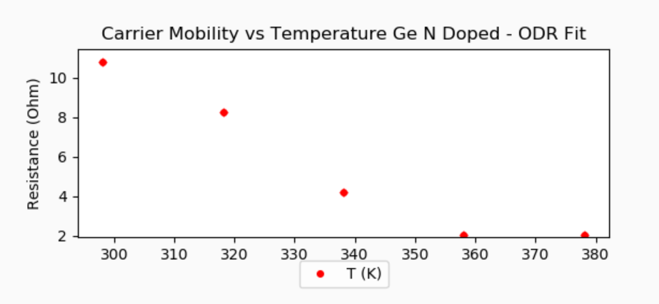

**NOV 19 Si N DOPED**

|  |  |  |  |  |  |  |  |  |  |
| --- | --- | --- | --- | --- | --- | --- | --- | --- | --- |
| T (K) | | ns (cm-2) | | 1/R (1/ohm) | | R (ohm) | | Mu (cm2V-1s-1) | |
| 298.1 | 0.1 | 3.6E+15 | 3E+14 | 0.083 | 0.001 | 12.1 | 0.1 | 140 | 10 |
| 318.1 | 0.1 | 3.4E+15 | 2E+14 | 0.074 | 0.003 | 13.5 | 0.5 | 134 | 8 |
| 338.1 | 0.1 | 2.8E+15 | 2E+14 | 0.070 | 0.002 | 14.3 | 0.4 | 160 | 10 |
| 358.1 | 0.1 | 3.1E+15 | 8E+14 | 0.057 | 0.002 | 17.5 | 0.7 | 120 | 30 |
| 373.1 | 0.1 | 2E+15 | 1E+15 | 0.053 | 0.002 | 19.0 | 0.6 | 140 | 60 |

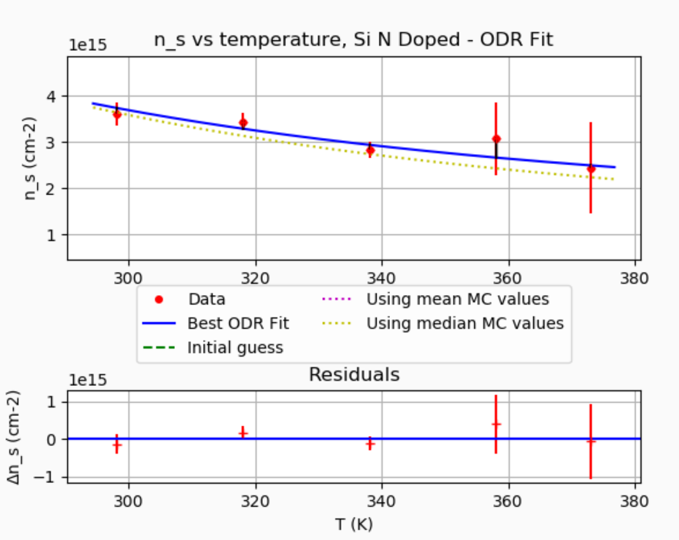

***********************************************************

ORTHOGONAL DISTANCE REGRESSION

***********************************************************

Fitting 5 Data points from file n_data.txt this Model function

def Eq4(x,*p):

delta_E = p[0]

m = p[1]

n_ex = p[2]

k_B = 1.38*(10**-23)

h_bar = 1.05457*(10**-34)

return ((k_B*x/(2*numpy.pi*h_bar*h_bar))**(3/2)*m**(3/2)*numpy.exp(-1*delta_E/(2*k_B*x)) +n_ex)

Systematics

correlated_offset = False

correlated_scale = True

x_true = 0+/-0 + (1+/-0)*x_measured

y_true = 0+/-0 + (1+/-0)*y_measured

**** ODR has finished with: Iteration limit reached

Estimated parameters, uncertainties, and starting guesses

p[0] = -1.7321e-20 +/- 5.4489e-19 Guessed: 1e-20

p[1] = 1.424e-32 +/- 1.7965e-30 Guessed: 1e-33

p[2] = -3.1475e+15 +/- 4.1237e+17 Guessed: 1e+10

ODR Correlation Matrix

[[ 1. 0.99999589 -0.99998444]

[ 0.99999589 1. -0.9999963 ]

[-0.99998444 -0.9999963 1. ]]

Quasi Chi-Squared/dof = 0.85878, Quasi CDF = 42.36787%

**** Running Monte Carlo CDF Estimator ****

1001 successful MC simulations in 10.0286 seconds.

Fraction of Monte Carlo quasi-chi-squared values larger than value for ODR fit:

Monte Carlo CDF = 60.7%

MC Fit parameters Average + Standard Deviation; Median and 68.3% interval

p[0] = -1.6641e-20 +/- 4.279e-21 ; -1.7468e-20 + 4.8947e-21 - 5.6453e-22

p[1] = 3.0622e-32 +/- 4.8691e-32 ; 1.5555e-32 + 3.6014e-32 - 7.2177e-33

p[2] = -6.0567e+15 +/- 8.5484e+15 ; -3.8962e+15 + 3.0231e+15 - 6.4319e+15

Monte Carlo Correlation Matrix

[[ 1. 0.50847282 -0.51405302]

[ 0.50847282 1. -0.98549494]

[-0.51405302 -0.98549494 1. ]]

Check For Bias in MC Fit parameters

(Monte Carlo median)/(fit value) - 1

p[0] Bias : +0.02368 +/- 0.01664 ( 1.42 SD)

p[1] Bias : +0.02531 +/- 0.2615 ( 0.10 SD)

p[2] Bias : +0.2012 +/- 0.2047 ( 0.98 SD)

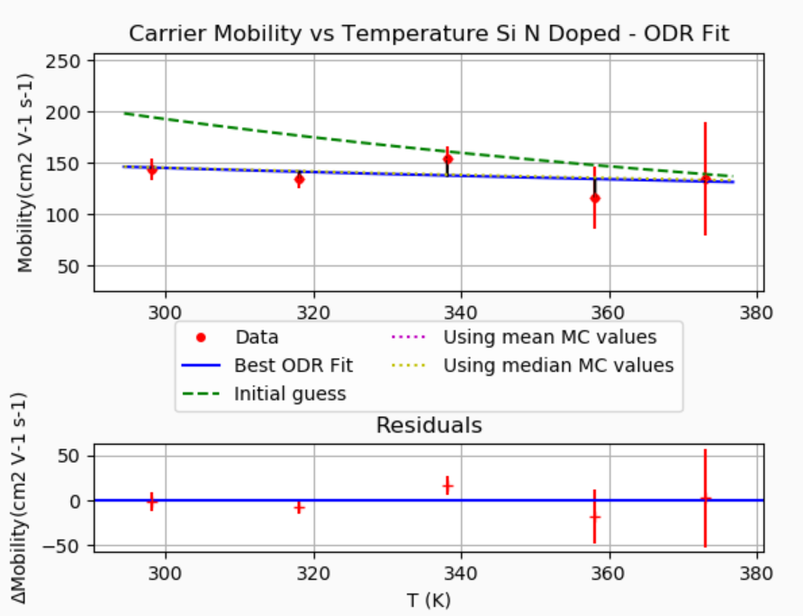

***********************************************************

ORTHOGONAL DISTANCE REGRESSION

***********************************************************

Fitting 5 Data points from file MobilityData.txt this Model function

def mobilityFormula(x, *p):

C = p[0]

B = p[1]

return C*x**B

Systematics

correlated_offset = False

correlated_scale = True

x_true = 0+/-0 + (1+/-0)*x_measured

y_true = 0+/-0 + (1+/-0)*y_measured

**** ODR has finished with: Iteration limit reached

Estimated parameters, uncertainties, and starting guesses

p[0] = 1720 +/- 8077.2 Guessed: 1e+06

p[1] = -0.43388 +/- 0.81477 Guessed: -1.5

ODR Correlation Matrix

[[ 1. -0.99995817]

[-0.99995817 1. ]]

Quasi Chi-Squared/dof = 1.23512, Quasi CDF = 29.50881%

**** Running Monte Carlo CDF Estimator ****

1001 successful MC simulations in 4.65742 seconds.

Fraction of Monte Carlo quasi-chi-squared values larger than value for ODR fit:

Monte Carlo CDF = 28.6%

MC Fit parameters Average + Standard Deviation; Median and 68.3% interval

p[0] = 5519.7 +/- 20125 ; 42.332 + 2879.3 - 37.619

p[1] = 0.063363 +/- 0.52148 ; 0.21042 + 0.37961 - 0.73011

Monte Carlo Correlation Matrix

[[ 1. -0.56888842]

[-0.56888842 1. ]]

Check For Bias in MC Fit parameters

(Monte Carlo median)/(fit value) - 1

p[0] Bias : -0.214 +/- 1.231 ( -0.17 SD)

p[1] Bias : -0.09802 +/- 0.05213 ( -1.88 SD)

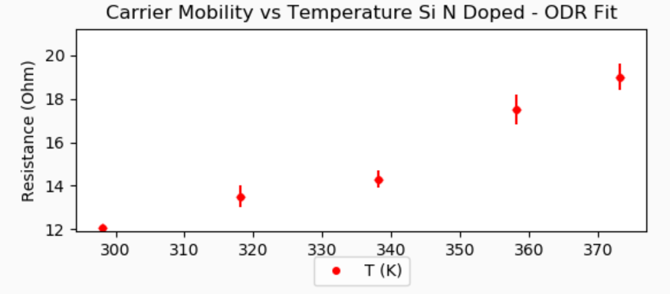

**NOV 18 Si UNDOPED**

|  |  |  |  |  |  |  |  |  |  |
| --- | --- | --- | --- | --- | --- | --- | --- | --- | --- |
| T (K) | | ns (cm-2) | | 1/R (1/ohm) | | R (ohm) | | Mu (cm2V-1s-1) | |
| 298.1 | 0.1 | 3.0E+14 | 2E+13 | 0.0206 | 0.0002 | 48.5 | 0.4 | 430 | 30 |
| 318.1 | 0.1 | 2.9E+14 | 2E+13 | 0.00657 | 5E-05 | 152 | 1 | 141 | 8 |
| 338.1 | 0.1 | 2.9E+14 | 2E+13 | 0.00583 | 4E-05 | 171 | 1 | 125 | 7 |
| 358.1 | 0.1 | 3.1E+14 | 2E+13 | 0.00517 | 4E-05 | 193 | 1 | 106 | 6 |
| 378.1 | 0.1 | 2.7E+14 | 2E+13 | 0.00465 | 4E-05 | 215 | 2 | 108 | 7 |

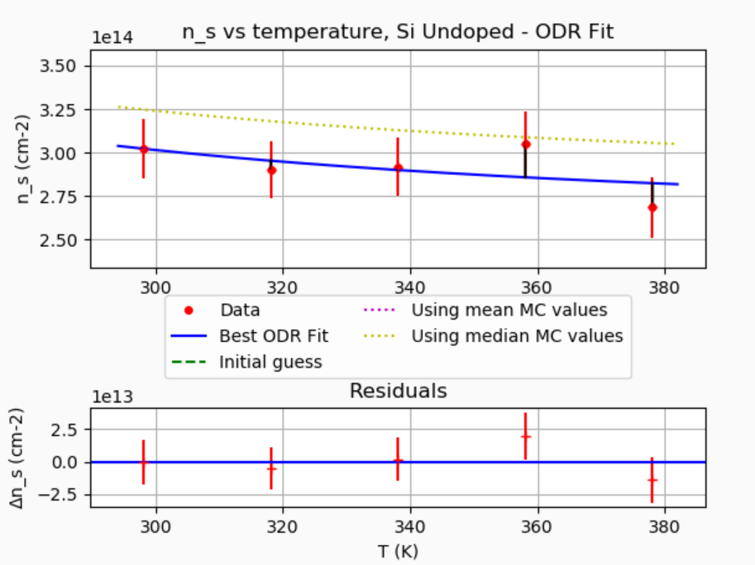

***********************************************************

ORTHOGONAL DISTANCE REGRESSION

***********************************************************

Fitting 5 Data points from file n_data.txt this Model function

def Eq4(x,*p):

delta_E = p[0]

m = p[1]

n_ex = p[2]

k_B = 1.38*(10**-23)

h_bar = 1.05457*(10**-34)

return ((k_B*x/(2*numpy.pi*h_bar*h_bar))**(3/2)*m**(3/2)*numpy.exp(-1*delta_E/(2*k_B*x)) +n_ex)

Systematics

correlated_offset = False

correlated_scale = True

x_true = 0+/-0 + (1+/-0)*x_measured

y_true = 0+/-0 + (1+/-0)*y_measured

**** ODR has finished with: Sum of squares convergence

Estimated parameters, uncertainties, and starting guesses

p[0] = -1.9295e-20 +/- 1.6549e-18 Guessed: 1e-20

p[1] = 1.4173e-34 +/- 4.8938e-32 Guessed: 1e-33

p[2] = 2.1508e+14 +/- 1.256e+16 Guessed: 1e+10

ODR Correlation Matrix

[[ 1. 0.99999485 -0.99997721]

[ 0.99999485 1. -0.99999363]

[-0.99997721 -0.99999363 1. ]]

Quasi Chi-Squared/dof = 0.92918, Quasi CDF = 39.48768%

**** Running Monte Carlo CDF Estimator ****

c:\Users\chris\Programming Stuffs\GitHub Saved\phy327Labs\Lab3_HallEffect\Lab3Codes\Eq4_N_vs_T.py:74: RuntimeWarning: overflow encountered in multiply

return ((k_B*x/(2*numpy.pi*h_bar*h_bar))**(3/2)*m**(3/2)*numpy.exp(-1*delta_E/(2*k_B*x)) +n_ex)

1001 successful MC simulations in 9.86712 seconds.

Fraction of Monte Carlo quasi-chi-squared values larger than value for ODR fit:

Monte Carlo CDF = 55.1%

MC Fit parameters Average + Standard Deviation; Median and 68.3% interval

p[0] = -2.6771e-20 +/- 2.5728e-20 ; -1.891e-20 + 9.6798e-21 - 3.6764e-20

p[1] = -1.7822e-32 +/- 5.7639e-31 ; 1.2454e-34 + 3.2967e-34 - 1.2413e-34

p[2] = 2.4705e+14 +/- 8.0308e+14 ; 2.4001e+14 + 3.7692e+13 - 1.1047e+14

Monte Carlo Correlation Matrix

[[ 1. -0.18589009 0.00150019]

[-0.18589009 1. -0.01022241]

[ 0.00150019 -0.01022241 1. ]]

Check For Bias in MC Fit parameters

(Monte Carlo median)/(fit value) - 1

p[0] Bias : -0.04017 +/- 0.06503 ( -0.62 SD)

p[1] Bias : +0.1411 +/- 398.4 ( 0.00 SD)

p[2] Bias : +0.08915 +/- 0.1611 ( 0.55 SD)

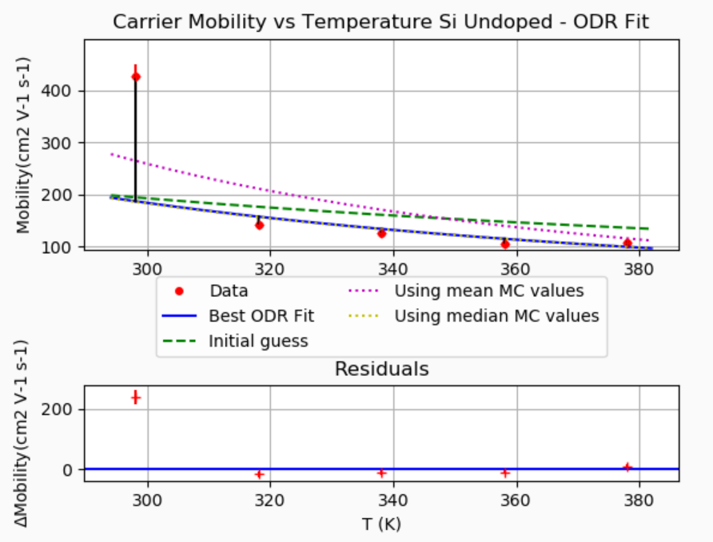

***********************************************************

ORTHOGONAL DISTANCE REGRESSION

***********************************************************

Fitting 5 Data points from file MobilityData.txt this Model function

def mobilityFormula(x, *p):

C = p[0]

B = p[1]

return C*x**B

Systematics

correlated_offset = False

correlated_scale = True

x_true = 0+/-0 + (1+/-0)*x_measured

y_true = 0+/-0 + (1+/-0)*y_measured

**** ODR has finished with: Iteration limit reached

Estimated parameters, uncertainties, and starting guesses

p[0] = 6.9481e+08 +/- 9.9421e+09 Guessed: 1e+06

p[1] = -2.6554 +/- 2.4537 Guessed: -1.5

ODR Correlation Matrix

[[ 1. -0.99993486]

[-0.99993486 1. ]]

Quasi Chi-Squared/dof = 34.34523, Quasi CDF = 0.00000%

**** Running Monte Carlo CDF Estimator ****

1001 successful MC simulations in 4.64992 seconds.

Fraction of Monte Carlo quasi-chi-squared values larger than value for ODR fit:

Monte Carlo CDF is less than 0.1%

and is consistent with 0.0%

For a better limit run with more iterations!

MC Fit parameters Average + Standard Deviation; Median and 68.3% interval

p[0] = 1.1038e+11 +/- 6.6567e+10 ; 9.8461e+10 + 8.439e+10 - 5.2731e+10

p[1] = -3.484 +/- 0.14147 ; -3.5044 + 0.13366 - 0.10615

Monte Carlo Correlation Matrix

[[ 1. -0.85122841]

[-0.85122841 1. ]]

Check For Bias in MC Fit parameters

(Monte Carlo median)/(fit value) - 1

p[0] Bias : -0.149 +/- 0.5977 ( -0.25 SD)

p[1] Bias : -0.01024 +/- 0.005742 ( -1.78 SD)

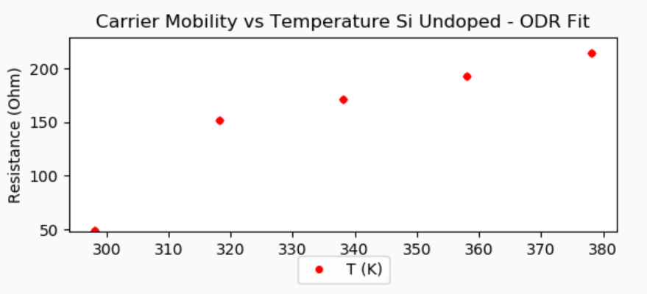

**NOV 18 Ge P DOPED**

|  |  |  |  |  |  |  |  |  |  |
| --- | --- | --- | --- | --- | --- | --- | --- | --- | --- |
| T (K) | | ns (cm-2) | | 1/R (1/ohm) | | R (ohm) | | Mu (cm2V-1s-1) | |
| 298.1 | 0.1 | 4.3E+14 | 2E+13 | 0.0206 | 0.0002 | 48.4 | 0.4 | 299 | 16 |
| 318.1 | 0.1 | 3.9E+14 | 2E+13 | 0.0175 | 0.0006 | 57 | 2 | 277 | 19 |
| 338.1 | 0.1 | 4.5E+14 | 2E+13 | 0.0159 | 0.0002 | 62.9 | 0.6 | 222 | 12 |
| 358.1 | 0.1 | 6.2E+14 | 3E+13 | 0.0165 | 0.0002 | 60.7 | 0.6 | 165 | 9 |
| 378.1 | 0.1 | 2.3E+15 | 1E+14 | 0.0226 | 0.0003 | 44.2 | 0.6 | 61 | 4 |

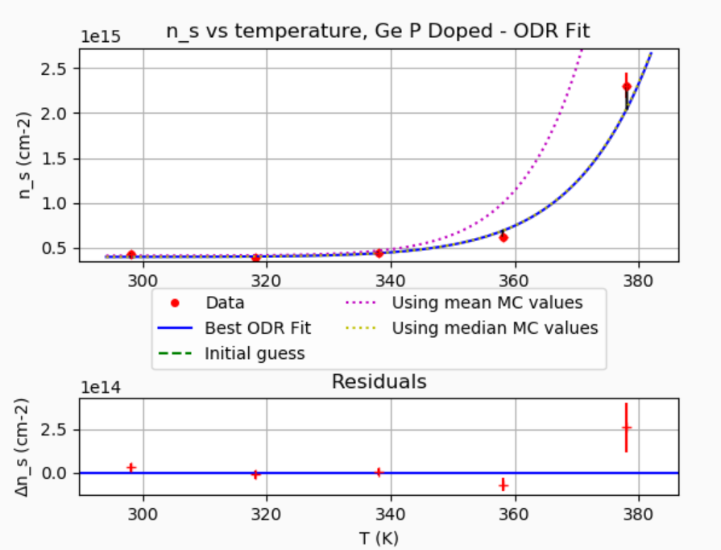

***********************************************************

ORTHOGONAL DISTANCE REGRESSION

***********************************************************

Fitting 5 Data points from file n_data.txt this Model function

def Eq4(x,*p):

delta_E = p[0]

m = p[1]

n_ex = p[2]

k_B = 1.38*(10**-23)

h_bar = 1.05457*(10**-34)

return ((k_B*x/(2*numpy.pi*h_bar*h_bar))**(3/2)*m**(3/2)*numpy.exp(-1*delta_E/(2*k_B*x)) +n_ex)

Systematics

correlated_offset = False

correlated_scale = True

x_true = 0+/-0 + (1+/-0)*x_measured

y_true = 0+/-0 + (1+/-0)*y_measured

**** ODR has finished with: Iteration limit reached

Estimated parameters, uncertainties, and starting guesses

p[0] = 3.1353e-19 +/- 6.1816e-20 Guessed: 1e-19

p[1] = 2.4589e-19 +/- 1.4796e-18 Guessed: 1e-23

p[2] = 3.9941e+14 +/- 3.2892e+13 Guessed: 1e+14

ODR Correlation Matrix

[[1. 0.99964576 0.50235764]

[0.99964576 1. 0.49405048]

[0.50235764 0.49405048 1. ]]

Quasi Chi-Squared/dof = 4.51534, Quasi CDF = 1.09399%

**** Running Monte Carlo CDF Estimator ****

1001 successful MC simulations in 9.60335 seconds.

Fraction of Monte Carlo quasi-chi-squared values larger than value for ODR fit:

Monte Carlo CDF = 1.0%

MC Fit parameters Average + Standard Deviation; Median and 68.3% interval

p[0] = 3.8238e-19 +/- 1.889e-20 ; 3.8664e-19 + 1.2028e-20 - 2.2162e-20

p[1] = 5.2472e-16 +/- 6.5284e-16 ; 3.0482e-16 + 6.662e-16 - 2.6944e-16

p[2] = 4.1324e+14 +/- 1.3425e+13 ; 4.1276e+14 + 1.4315e+13 - 1.244e+13

Monte Carlo Correlation Matrix

[[1. 0.68664624 0.26333995]

[0.68664624 1. 0.19106267]

[0.26333995 0.19106267 1. ]]

Check For Bias in MC Fit parameters

(Monte Carlo median)/(fit value) - 1

p[0] Bias : +0.0005346 +/- 0.003856 ( 0.14 SD)

p[1] Bias : +0.0229 +/- 9.123 ( 0.00 SD)

p[2] Bias : -0.001724 +/- 0.001531 ( -1.13 SD)

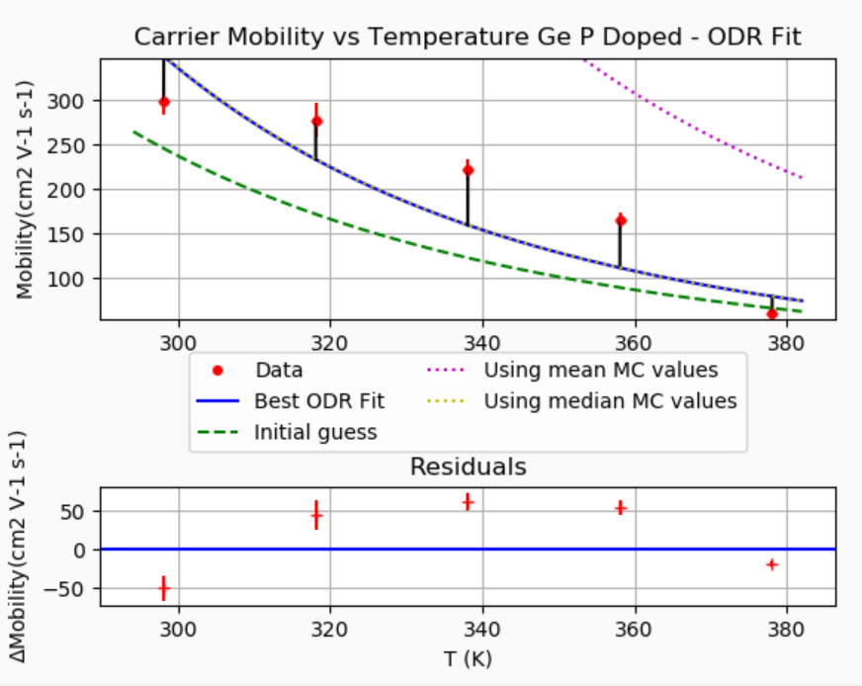

***********************************************************

ORTHOGONAL DISTANCE REGRESSION

***********************************************************

Fitting 5 Data points from file MobilityData.txt this Model function

def mobilityFormula(x, *p):

C = p[0]

B = p[1]

return C*x**B

Systematics

correlated_offset = False

correlated_scale = True

x_true = 0+/-0 + (1+/-0)*x_measured

y_true = 0+/-0 + (1+/-0)*y_measured

**** ODR has finished with: Sum of squares convergence

Estimated parameters, uncertainties, and starting guesses

p[0] = 8.2098e+17 +/- 7.3465e+18 Guessed: 1e+16

p[1] = -6.212 +/- 1.5392 Guessed: -5.5

ODR Correlation Matrix

[[ 1. -0.99985209]

[-0.99985209 1. ]]

Quasi Chi-Squared/dof = 32.15296, Quasi CDF = 0.00000%

**** Running Monte Carlo CDF Estimator ****

1001 successful MC simulations in 2.58553 seconds.

Fraction of Monte Carlo quasi-chi-squared values larger than value for ODR fit:

Monte Carlo CDF is less than 0.1%

and is consistent with 0.0%

For a better limit run with more iterations!

MC Fit parameters Average + Standard Deviation; Median and 68.3% interval

p[0] = 2.3347e+18 +/- 4.7916e+18 ; 7.8171e+17 + 3.0157e+18 - 5.9652e+17

p[1] = -6.2119 +/- 0.25256 ; -6.2041 + 0.25088 - 0.26954

Monte Carlo Correlation Matrix

[[ 1. -0.66897884]

[-0.66897884 1. ]]

Check For Bias in MC Fit parameters

(Monte Carlo median)/(fit value) - 1

p[0] Bias : +0.03155 +/- 0.3009 ( 0.10 SD)

p[1] Bias : +0.000811 +/- 0.001742 ( 0.47 SD)

