C
Computer
Science

by
Christopher Andrew Topalian

Copyright 2000-2025
All Rights Reserved

Dedicated
to
God the Father

Download Visual Studio - Search Google
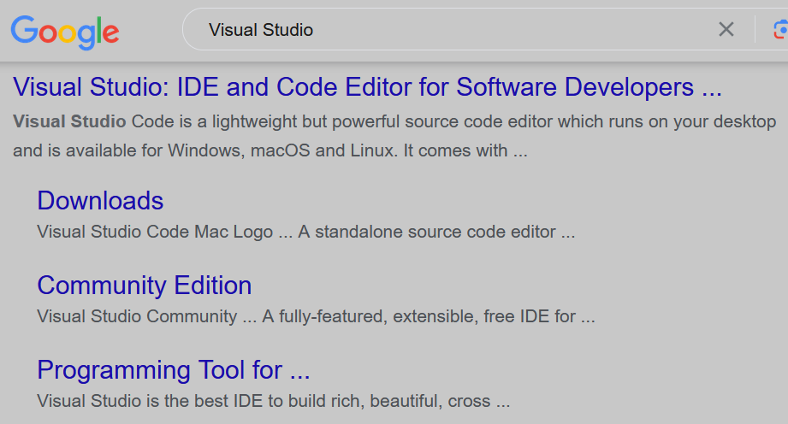

We Go To: google.com

We Search for: Visual Studio

We Left Click on: Downloads

Or, we can go directly
to the Visual Studio website
as shown on the next page.

Download Visual Studio - Directly from Website
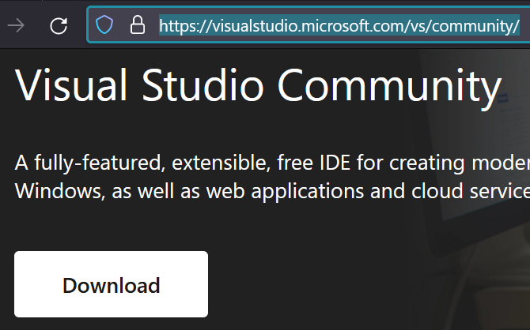
https://visualstudio.microsoft.com/vs/community/

We Go To: https://visualstudio.microsoft.com/vs/community

We Download: Visual Studio Installer

We Go To our Downloads Folder and:
Double Left Click the Install file to Install it.

After it is installed, we can open VS Studio.
Once open, we can then install the C++ package, which has in it, the ability to create C apps too.

We Download and Install:
Desktop development with C++
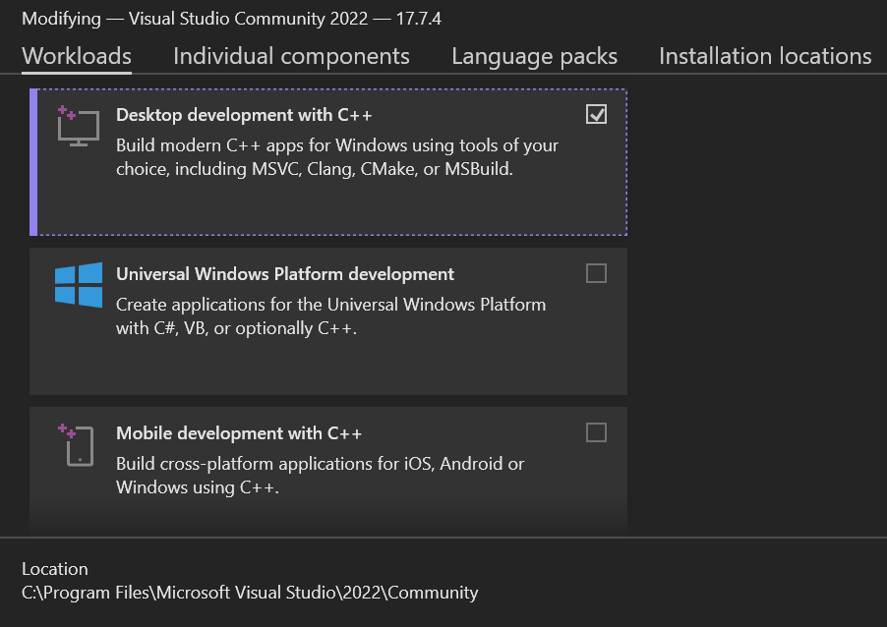
Desktop development with C++
Build modern C++ apps for Windows using tools of your choice, including MSVC, Clang, CMake, or MSBuild.


We Put a Checkmark in the box
and then Left Click the
Install while downloading button

This will download and install the ability to use Visual Studio to create C++ Desktop Applications, but also, C applications too.

Create a New Project
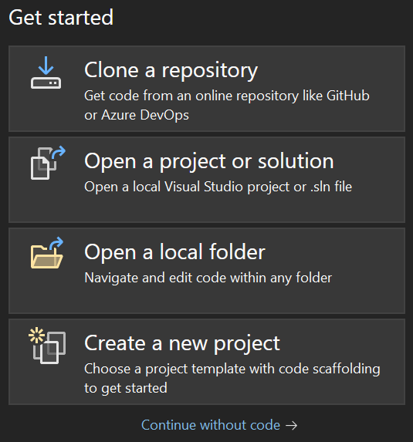

We Choose: Create a new project

Choices for a New Project
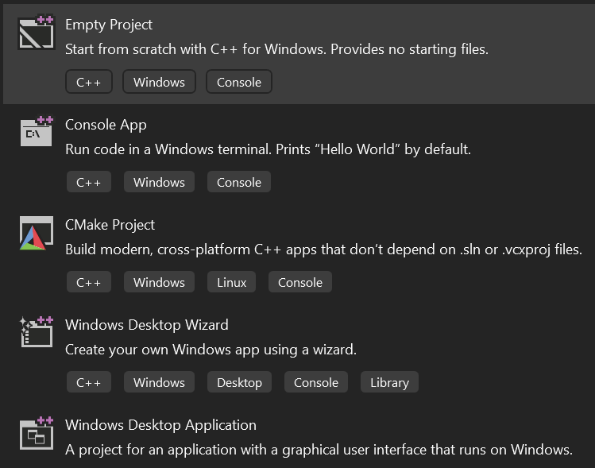

We Left Click: Empty Project
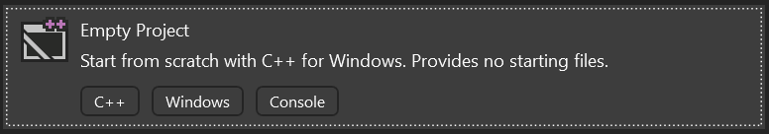


We Left Click: Next Button
Back
Next

Project Name - 001
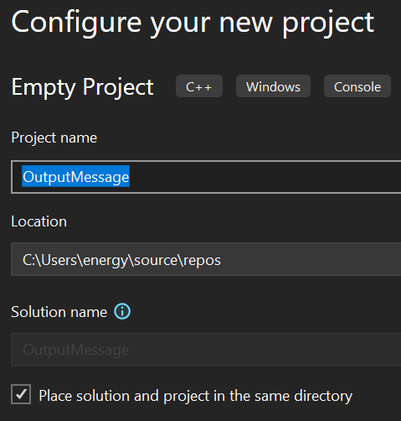

001

D:\_1Code\C\001



We name our first project as: 001

We put a Checkmark in: Place solution and project in the same directory

We Left Click: Create Button

Creating our main.c file in Source Files Folder

We Right click on: Source Files Folder

We Choose: Add
Solution '001' (1 of 1 project)
001
References
External Dependencies
Header Files
Resource Files
Source Files
main.cpp
Search Solutions Explorer (Ctrl+;)

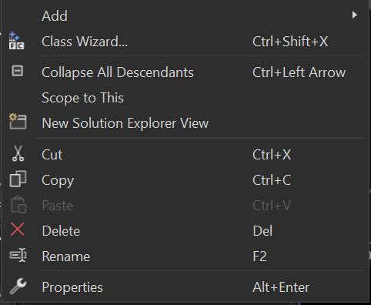
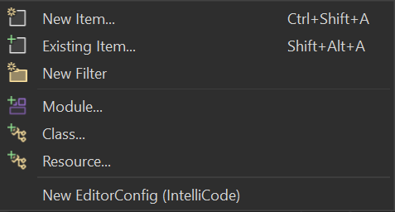
We Choose: New Item...
Add
Class Wizard… Ctrl + Shift + X
Collapse All Descendants
Scope to This
New Solution Explorer View
Cut Ctrl + X
Copy
Paste Ctrl + V
Copy Ctrl + C
Delete Del
Rename F2
Properties Alt + Enter
New Item… Ctrl+Shift+A
Existing Item… Ctrl+Alt+A
New Filter
Module...
Class...
Resource...
New EditorConfig (IntelliCode)
We Choose: C++ File (.cpp)

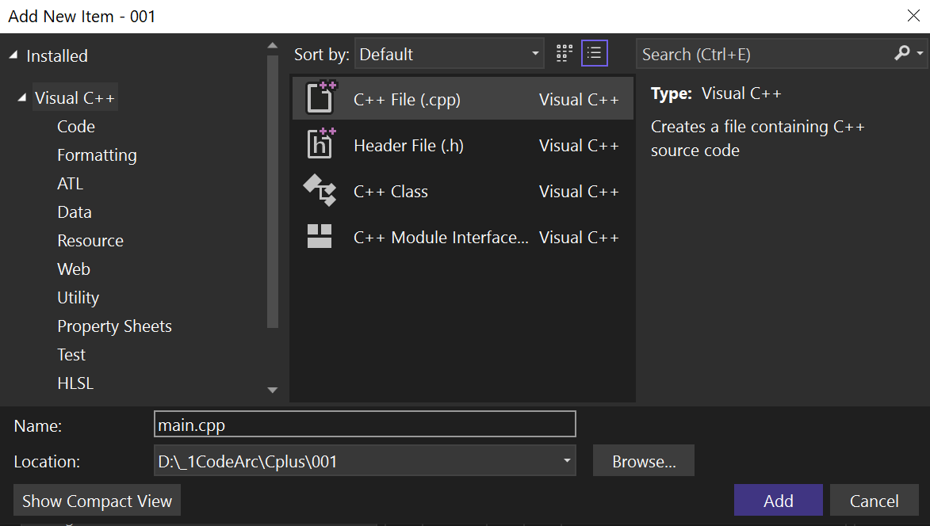
D:\_1Code\C\001
main.c

We Name our File: main.c

We Left Click: Add button

We see our created file: main.c

main.c is now open
Solution '001' (1 of 1 project)
001
References
External Dependencies
Header Files
Resource Files
Source Files
main.c
Search Solutions Explorer (Ctrl+;)
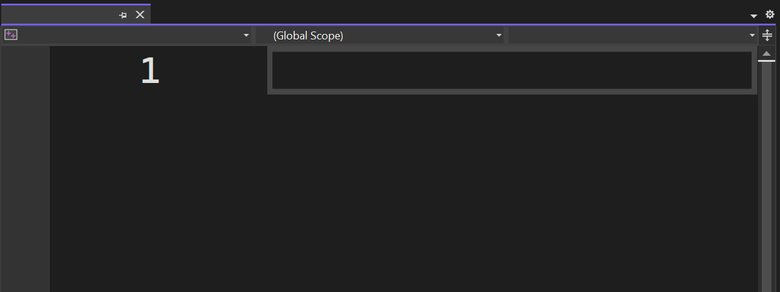
001
main.c

We can now: Type our Code :-)

We make Bigger Font by:

Control + Scroll Wheel Forward

We make Smaller Font by:

Control + Scroll Wheel Backward

main.c Code - Screenshot

Here is a screenshot of: Our C Code
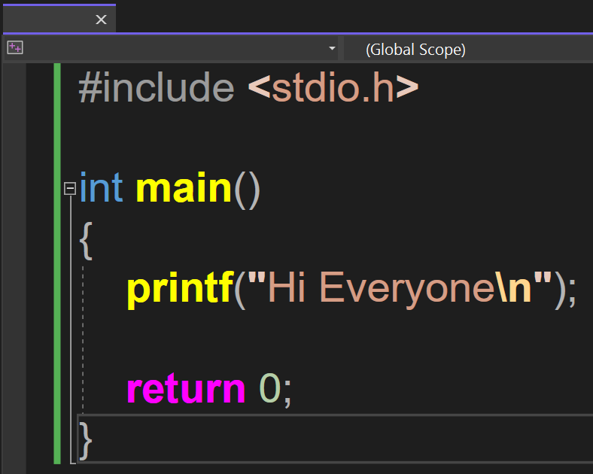
main.c
001

On the next page
we show the same code,
but with better font.

// Outputting Text

// main.c

#include <stdio.h>

int main()
{
printf("Hi Everyone\n");

return 0;
}

// Building and Running our App

We Left Click on: Local Windows Debugger

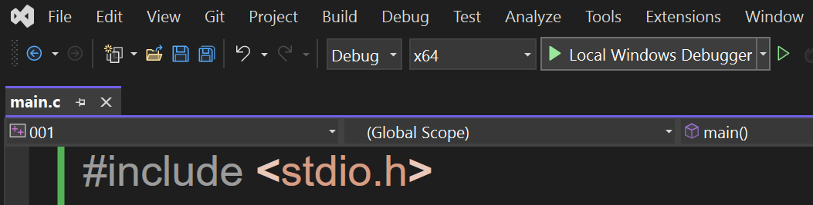
Our app opens in the Debug Console Window, with the message of: Hi Everyone

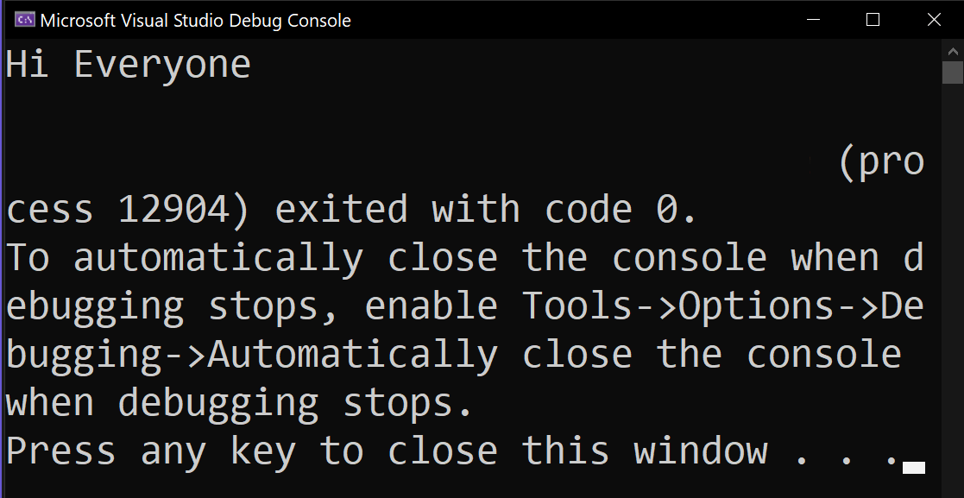

D:\_1Code\C\001\x64\Debug\001.exe

We make Bigger Console Font by:

Control + Scroll Wheel Forward

We make Smaller Console Font by:

Control + Scroll Wheel Backward

// Outputting Text, Exit by Pressing Enter
// main.c

#include <stdio.h>

int main()
{
printf("Hi Everyone\n");

printf("Press Enter to Exit\n");

// wait for user to press Enter
getchar();

return 0;
}

// Input from user
// main.c

#include <stdio.h>

int main()
{
// max name is 100 chars + null terminator
char name[101];

printf("Enter First Name: ");

// read input from user and prevent buffer overflow
scanf_s("%s", name, (unsigned int)sizeof(name));

printf("Hi %s\n", name);

printf("\nPress Enter to Exit\n");

// remove newline char left in input buffer
getchar();

// wait for user to press Enter
getchar();

return 0;
}

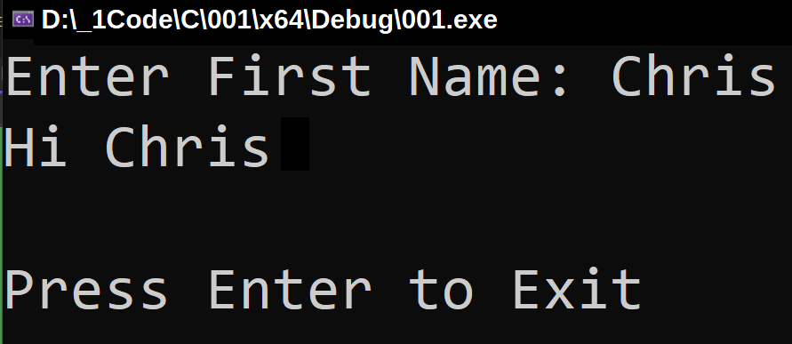

// Custom Function - askName
// main.c

#include <stdio.h>

void askName(char* name)
{
printf("Enter First Name: ");

// read input from user and prevent buffer overflow
scanf_s("%s", name, (unsigned int)sizeof(name));
}

int main()
{
// max name is 100 chars + null terminator
char userName[101];

askName(userName);
printf("Hi %s\n", userName);

printf("\nPress Enter to Exit\n");
// remove newline char left in input buffer by scanf_s
getchar();

// wait for user to press Enter
getchar();

return 0;
}

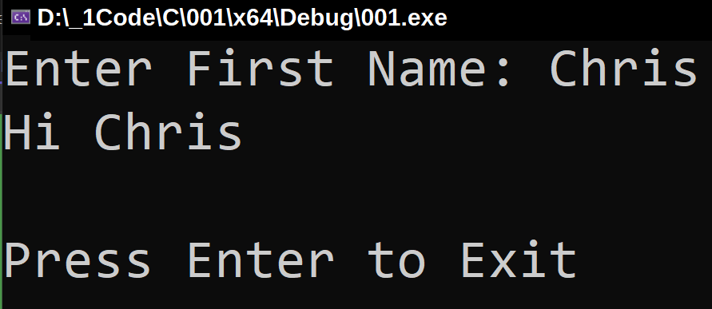

// Custom Function - consoleLog
// main.c

#include <stdio.h>

void consoleLog(const char *message)
{
printf("%s\n", message);
}

int main()
{
consoleLog("Hi Everyone");

printf("Press Enter to Exit\n");

// wait for user to press Enter
getchar();

return 0;
}

Header File - We define our function in a header file for easy use

Instead of pasting this useful function in every script in our application, we will instead type it once in a header file and put it in the Header Files Folder.

Using a header file is easier, because we place the header files in the Header Files folder and then include that header file with a reference in our main.c and other files.

In our header file, we type the terms
#ifndef
and
#define
to designate that it will be used in other files.

Header File - Add - New Item

We right click on: Header Files folder

Solution '001' (1 of 1 project)
001
References
External Dependencies
Header Files
Resource Files
Source Files
main.c
Search Solutions Explorer (Ctrl+;)
Add
Class Wizard… Ctrl + Shift + X
Collapse All Descendants
Scope to This
New Solution Explorer View
Cut Ctrl + X
Copy
Paste Ctrl + V
Copy Ctrl + C
Delete Del
Rename F2
Properties Alt + Enter
New Item… Ctrl+Shift+A
Existing Item… Ctrl+Alt+A
New Filter
Module...
Class...
Resource...
New EditorConfig (IntelliCode)

We choose: Add

We choose: New Item

We choose: Header File .h

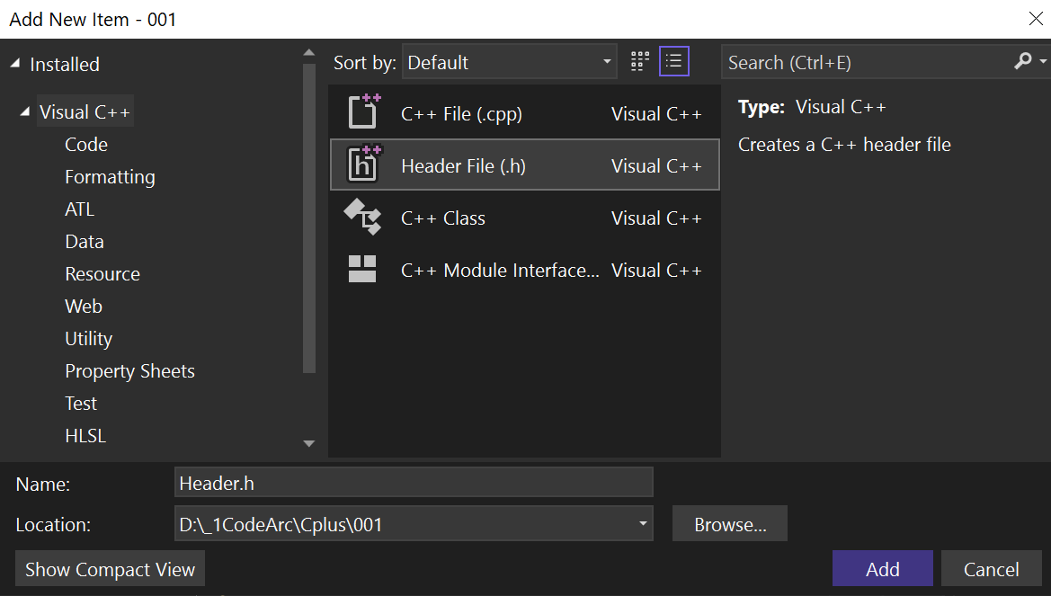
D:\_1Code\C\001
CONSOLELOG.h
We name it: CONSOLELOG.h

We Left Click: Add button

// CONSOLELOG.h header file
// CONSOLELOG.h

#ifndef CONSOLELOG
#define CONSOLELOG
#include <stdio.h> // printf

void consoleLog(const char *message)
{
printf("%s\n", message);
}

#endif

// Our main.c uses CONSOLELOG.h header file
// main.c

#include "CONSOLELOG.h"

#include <stdio.h> // printf

int main()
{
consoleLog("Hi Everyone");

printf("Press Enter to Exit\n");

// wait for user to press Enter
getchar();

return 0;
}

// PROMPT.h header file
// PROMPT.h

#ifndef PROMPT
#define PROMPT
#include <stdio.h> // scanf_s
#include <string.h> // strlen

void prompt(char* userInput)
{
// read input from user and prevent buffer overflow
scanf_s("%s", userInput, 101);

// wait for user to press Enter
getchar();
}

#endif

// main.c uses CONSOLELOG.h and PROMPT.h
// main.c

#include "PROMPT.h"
#include "CONSOLELOG.h"
#include <stdio.h> // printf, scanf

int main()
{
// max input is 100 chars + null terminator
char input[101];

consoleLog("Enter First Name");
prompt(input);

printf("Hi %s\n", input);

consoleLog("Press Enter to Exit\n");

// wait for user to press Enter
getchar();

return 0;
}

File Structure of the previous Examples
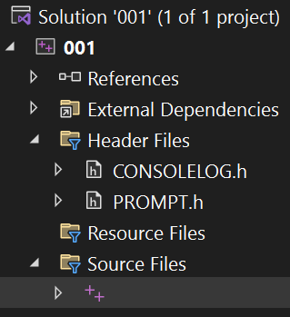

main.c

We have 2 Header Files:

CONSOLELOG.h

and

PROMPT.h

We have 1 main.c file:

main.c uses CONSOLELOG.h and PROMPT.h header files

// Array of Objects
// main.c

#include <stdio.h> // printf

// define a structure to represent a person
struct Person
{
char name[50];
int age;
};

int main()
{
// create an array of Person structs
struct Person people[] =
{
{ "John", 25 },
{ "Jane", 30 },
{ "Fiona", 28 }
};

// calculate number of elements in array
int numPeople = sizeof(people) / sizeof(people[0]);

// iterate over each person in the array
for (int i = 0; i < numPeople; i++)
{
printf("Name: %s, Age: %d\n", people[i].name, people[i].age);
}

printf("\nPress Enter to Exit");

// wait for user to press Enter
getchar();

return 0;
}
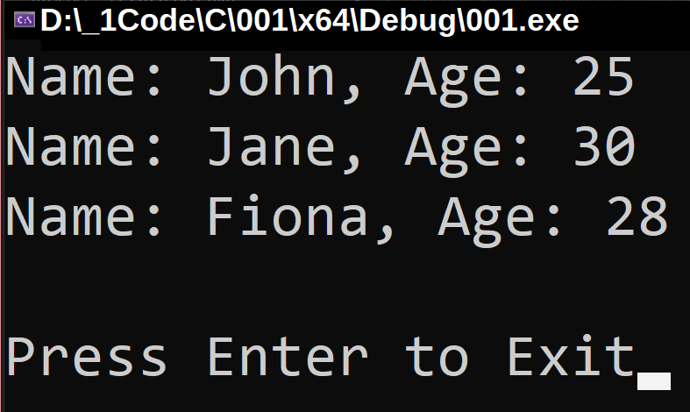

// for loop diagram
TRUE
FALSE
Start number
Exit
body
increment++
test

// for loop
// main.c

#include <stdio.h> // printf

int main()
{
for (int i = 1; i <= 100; i++)
{
printf("%d ", i);
printf("\n");
}

printf("\nPress Enter to Exit");

// wait for user to press Enter
getchar();

return 0;
}

// while loop diagram

FALSE
start
Exit
body
test

TRUE

// whileLoop
// main.c

#include <stdio.h> // printf

int main()
{
int i = 0; // initialize the counter

while (i < 100)
{
printf("%d ", i);
i++; // increment counter
}

printf("\n"); // print new line after loop

printf("\nPress Enter to exit");

getchar(); // wait for user input

return 0;
}

// Using pointers to modify variables in functions - (pass by reference)

#include <stdio.h>

void increment(int* num)
{
// *num is a pointer to i
(*num)++; // this changes the variable i
}

int main()
{
int i = 0;

increment(&i); // passing the address of i

printf("%d\n", i); // prints 1 because i was modified through the pointer

printf("\nPress Enter to Exit");
getchar();
return 0;
}

// result: 1
// if else - strcmp, without null terminating the string
// main.c

#include <stdio.h> // printf, scanf_s
#include <string.h> // strcmp

int main()
{
char name[101]; // buffer to store the name

printf("Enter your name: ");

// read input from user and prevent buffer overflow
scanf_s("%s", name, (unsigned int)sizeof(name));

// remove newline char left in input buffer
getchar();

if (strcmp(name, "Chris") == 0)
{
printf("Hi Chris.\nIt is good that you are visiting Earth.\n");
}
else
{
printf("Howdy %s. Tell Chris to Sign in later.\n", name);
}

printf("\nPress Enter to Exit");

// wait for user to press Enter
getchar();

return 0;
}
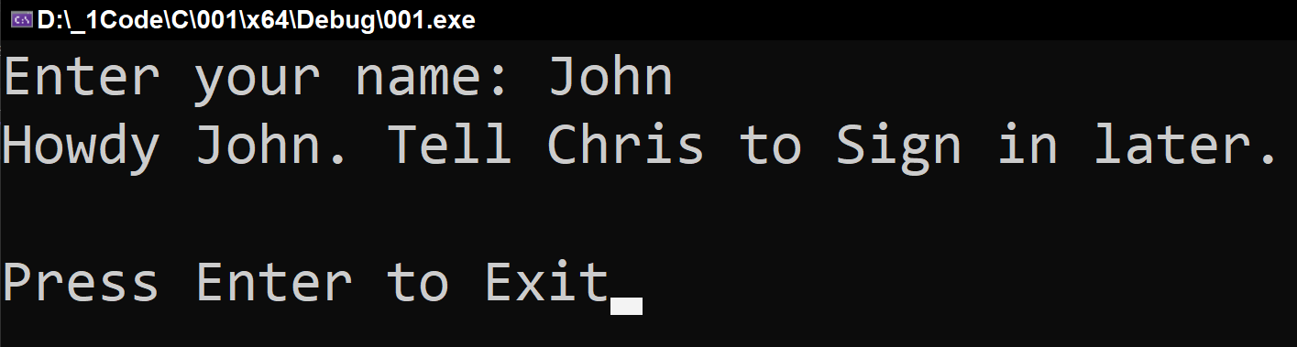

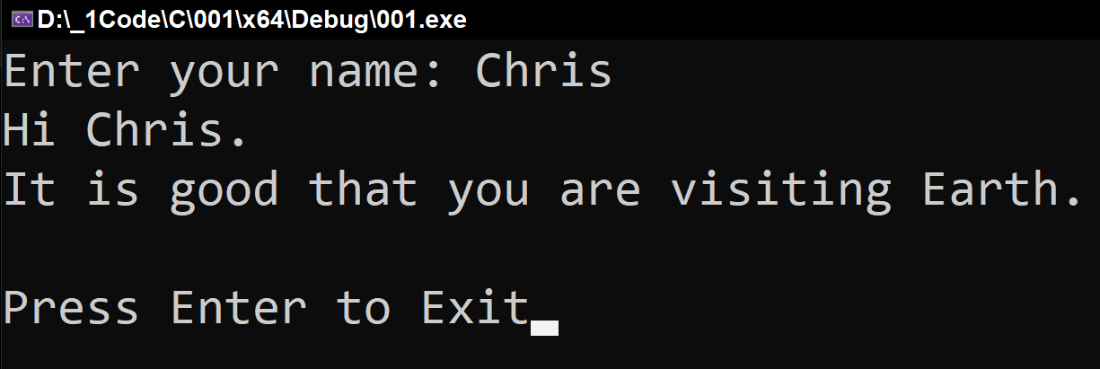

// if else - strcmp, null terminating the string
// main.c

#include <stdio.h>
#include <string.h>

int main()
{
char name[101]; // buffer to store the name

printf("Enter your name: ");

// read input from user and prevent buffer overflow
scanf_s("%100s", name, (unsigned int)sizeof(name) - 1);

// explicitly null terminate the string
name[sizeof(name) - 1] = '\0';

// remove newline char left in input buffer
getchar();

if (strcmp(name, "Chris") == 0)
{
printf("Hi Chris.\nIt is good that you are visiting Earth.\n");
}
else
{
printf("Howdy %s. Tell Chris to Sign in later.\n", name);
}

printf("\nPress Enter to Exit");

// wait for user to press Enter
getchar();

return 0;
}

// This version makes sure that we first null terminate the string before comparison.

// Open Browser to a URL
// main.c

#include <windows.h>

int main()
{
ShellExecuteA(NULL, "open", "https://www.google.com", NULL, NULL, SW_SHOWNORMAL);

return 0;
}

// Open Browser to a URL using char url
// main.c

#include <windows.h>

int main()
{
// URL to open
const char* url = "https://www.google.com";

// open web browser to specified URL
ShellExecuteA(NULL, "open", url, NULL, NULL, SW_SHOWNORMAL);

return 0;
}

// Custom Function - Open Browser to a URL
// main.c

#include <windows.h>

void openURL(const char *url)
{
ShellExecuteA(NULL, "open", url, NULL, NULL, SW_SHOWNORMAL);
}

int main()
{
const char *url = "https://www.google.com";

openURL(url);

return 0;
}

// Create Text File with Data
// main.c

#include <stdio.h>

int main()
{
// declare FILE pointer
FILE* outputFile;

// open file for writing
if (fopen_s(&outputFile, "ourTextFile.txt", "w") == 0)
{
// write data to file using fprintf_s
if (fprintf_s(outputFile, "Hi Everyone\n") > 0)
{
// close file
fclose(outputFile);

printf("Data written successfully.\n");
}
else
{
printf("Error writing data to file.\n");
// close file if an error occurs
fclose(outputFile);
}
}
else
{
printf("Failed to open file.\n");
}

return 0;
}

// Custom Function - Create Text File with Data
// main.c

#include <stdio.h>

void writeToFile(const char* fileName, const char* content)
{
// declare FILE pointer
FILE* outputFile;

// open file for writing
if (fopen_s(&outputFile, fileName, "w") == 0)
{
// check if file opened successfully
if (outputFile != NULL)
{
// write data to file
fprintf(outputFile, "%s\n", content);

// close file
fclose(outputFile);

printf("Data written to %s successfully.\n", fileName);
}
else
{
printf("Failed to open file %s.\n", fileName);
}
}
else
{
printf("Failed to open file %s.\n", fileName);
}
}

int main()
{
const char* fileName = "ourTextFile.txt";
const char* content = "Hi Everyone";

writeToFile(fileName, content);

return 0;
}

// Read a Text File
// main.c

#include <stdio.h>

void displayFileContents(const char* fileName) {
// declare FILE pointer
FILE* inputFile;

// open file for reading
if (fopen_s(&inputFile, fileName, "r") == 0)
{
// check if file opened successfully
if (inputFile != NULL)
{
// max line length is 255 chars + 1 null terminator
char line[256];

printf("Contents of %s:\n", fileName);

// read, display file contents line by line
while (fgets(line, sizeof(line), inputFile) != NULL)
{
printf("%s", line);
}

// close the file
fclose(inputFile);
}
else
{
printf("Error opening file: %s\n", fileName);
}
}
else
{
printf("Error opening file: %s\n", fileName);
}
}

int main()
{
const char* fileName = "ourTextFile.txt";

displayFileContents(fileName);

printf("\nPress Enter to Exit");

// wait for user to press Enter
getchar();

return 0;
}

// Count Number of Lines in a Text File
// main.c

#include <stdio.h>

int main()
{
// declare FILE pointer
FILE* inputFile;

// open text file for reading
if (fopen_s(&inputFile, "ourTextFile.txt", "r") == 0)
{
// check if the file opened successfully
if (inputFile == NULL)
{
fprintf(stderr, "File won't open.\n");
return 1; // return an error code
}

// variable to store the count of lines
int lineCount = 0;

// temp buffer stores each line read from file
// max line length is 255 chars + 1 null terminator
char line[256];

// read file line by line and count lines
while (fgets(line, sizeof(line), inputFile) != NULL)
{
lineCount++;
}

// close the file
fclose(inputFile);

// display the total number of lines
printf("Number of lines in the file: %d\n", lineCount);
}
else
{
fprintf(stderr, "File won't open.\n");
return 1; // return an error code
}

return 0;
}

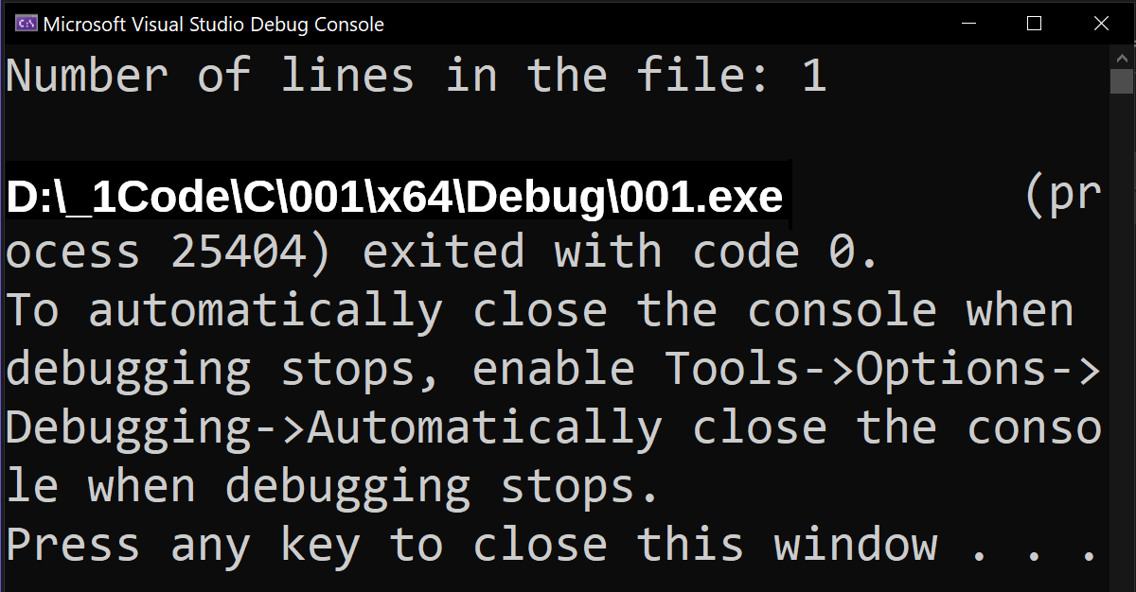

// Calculate Hard Drive Memory Statistics

#include <stdio.h>
#include <windows.h>

int main()
{
ULARGE_INTEGER freeBytesAvailable;
ULARGE_INTEGER totalBytes;
ULARGE_INTEGER totalFreeBytes;

if (GetDiskFreeSpaceEx(NULL, &freeBytesAvailable, &totalBytes, &totalFreeBytes))
{
printf("Total space: %llu bytes\n", totalBytes.QuadPart);

printf("Free space: %llu bytes\n", totalFreeBytes.QuadPart);

printf("Available space: %llu bytes\n", freeBytesAvailable.QuadPart);
}
else
{
perror("Error getting disk space information");
return 1; // return an error code
}

printf("\nPress Enter to Exit");

// wait for user to press Enter
getchar();

return 0;
}

// How to Find Our Application .exe File
Solution '001' (1 of 1 project)
001
References
External Dependencies
Header Files
Resource Files
Source Files
main.c
Search Solutions Explorer (Ctrl+;)

We put mouse arrow on:
Solution '001' (1 of 1 project)
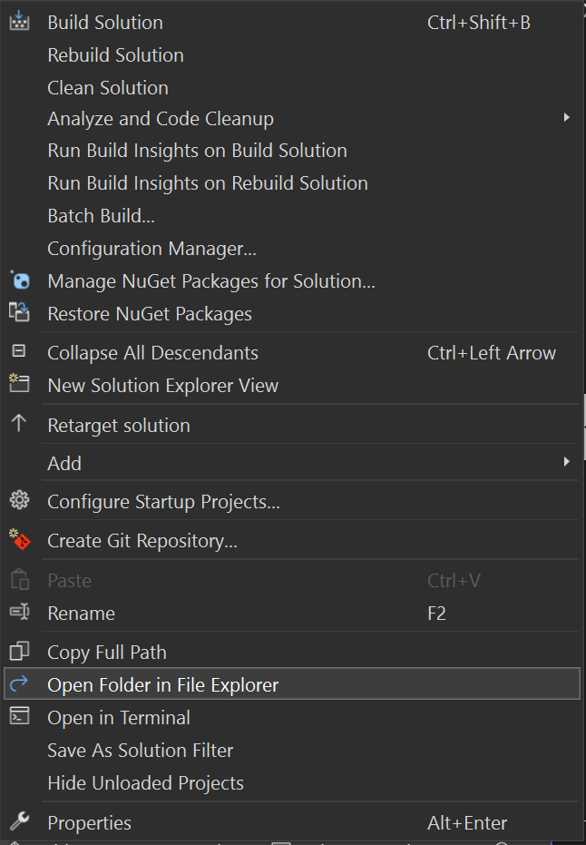

Open Folder in File Explorer

We Choose: Open Folder in File Explorer

We see that our Project Folder has opened:
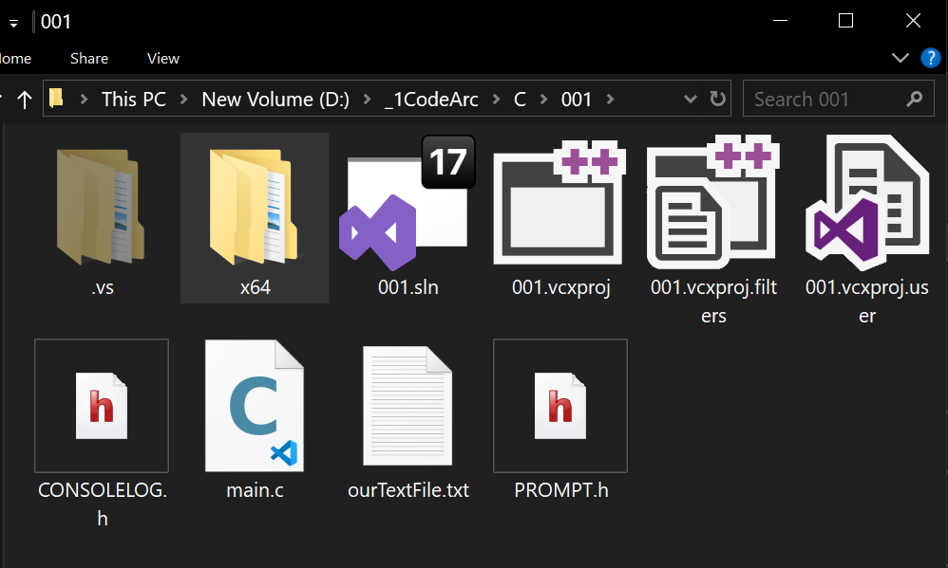
This PC > New Volume (D:) > _1Code > C > 001

We Open: x64 Folder to find the Debug Folder
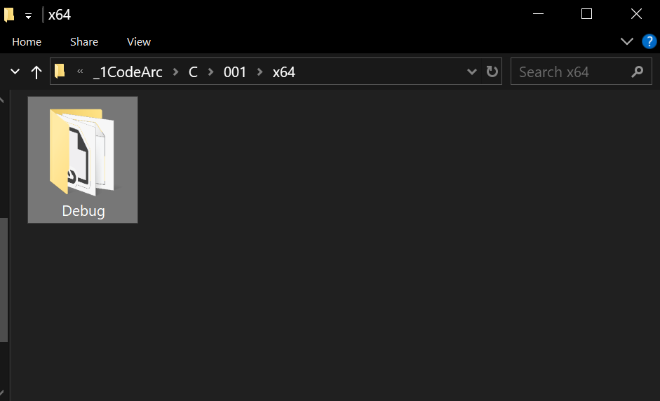
_1Code > C > 001 > x64

We Open: Debug Folder to find 001.exe

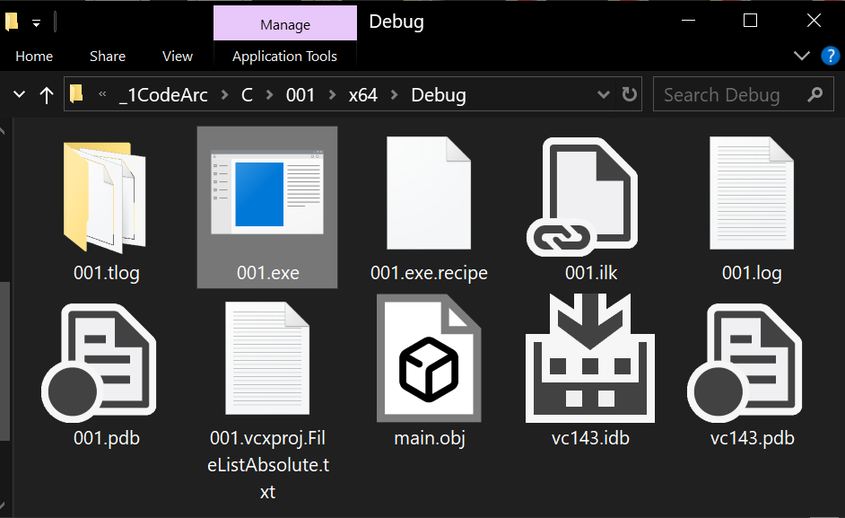
_1Code > C > 001 > x64 > Debug

We Double Left Click: 001.exe

Our application should activate.

Happy Programming :-)

// get current working directory

#include <stdio.h>
#include <stdlib.h>
#include <windows.h> // GetCurrentDirectory

int main()
{
char buffer[MAX_PATH];

// get the current working directory
if (!GetCurrentDirectory(MAX_PATH, buffer))
{
perror("Error getting current working directory");
return EXIT_FAILURE;
}

printf("Current working directory: %s\n", buffer);

return EXIT_SUCCESS;
}

// random0to1

#include <stdio.h>
#include <stdlib.h>
#include <time.h>

int main()
{
// seed the random number generator with the current time
srand((unsigned int)time(NULL));

// generate a random float between 0.0 and 1.0
float randomFloat = (float)rand() / (float)RAND_MAX;

// print the random float
printf("Random float: %f\n", randomFloat);

// prompt user to press Enter to exit
printf("Press Enter to Exit\n");
getchar();

return 0;
}

//----//

/*
Random float: 0.767113
Press Enter to Exit
*/

// random_integer_0_to_10.c

#include <stdio.h>
#include <stdlib.h>
#include <time.h>

int main()
{
// seed the random number generator with the current time
srand((unsigned int)time(NULL));

// generate a random integer between 1 and 10
int randomInteger = (rand() % 10) + 1;

// print the random integer
printf("Random integer: %d\n", randomInteger);

// prompt user to press Enter to exit
printf("Press Enter to Exit\n");
getchar();

return 0;
}

//----//

/*
Random integer: 7
Press Enter to Exit
*/

// getCurrentDate.c

#include <stdio.h>
#include <time.h>

void getCurrentDate(char* buffer, size_t bufferSize)
{
// get current time
time_t now = time(NULL);

// declare a tm structure to hold local time
struct tm localTime;

// use localtime_s for safe local time conversion
localtime_s(&localTime, &now);

// format the date as "YYYY-MM-DD" and store it in buffer
strftime(buffer, bufferSize, "%Y-%m-%d", &localTime);
}

int main()
{
char date[11]; // buffer to store date string

// get current date
getCurrentDate(date, sizeof(date));

// print current date
printf("Current date: %s\n", date);

return 0;
}

//----//

/*
Current date: 2024-10-31
*/

// getCurrentDate_if_date.c

#include <stdio.h>
#include <time.h>
#include <string.h>

void getCurrentDate(char* buffer, size_t bufferSize)
{
// get current time
time_t now = time(NULL);

// declare a tm structure to hold local time
struct tm localTime;

// use localtime_s for safe local time conversion
localtime_s(&localTime, &now);

// format the date as "YYYY-MM-DD" and store it in buffer
strftime(buffer, bufferSize, "%Y-%m-%d", &localTime);
}

int main()
{
char date[11]; // buffer to store current date string
const char* specifiedDate = "2024-10-31"; // specify date to compare

// get current date
getCurrentDate(date, sizeof(date));

// print current date
printf("Current date: %s\n", date);

// check if the current date matches the specified date
if (strcmp(date, specifiedDate) == 0)
{
printf("Today is the specified date: %s\n", specifiedDate);
}
else
{
printf("Today is not the specified date.\n");
}

return 0;
}

//----//

/*
Current date: 2024-10-31
Today is the specified date: 2024-10-31
*/

// getDayOfMonth.c

#include <stdio.h>
#include <time.h>

int getDayOfMonth()
{
// get current time
time_t now = time(NULL);

// declare a tm structure to hold local time
struct tm localTime;

// use localtime_s for safe local time conversion
localtime_s(&localTime, &now);

// return the day of the month
return localTime.tm_mday;
}

int main()
{
// get and print the current day of the month
printf("Current day of the month: %d\n", getDayOfMonth());

return 0;
}

//----//

/*
Current day of the month: 31
*/

// getYear.c

#include <stdio.h>
#include <time.h>

int getYear()
{
// get current time
time_t now = time(NULL);

// declare a tm structure to hold local time
struct tm localTime;

// use localtime_s for safe local time conversion
localtime_s(&localTime, &now);

// return the year
return localTime.tm_year + 1900; // tm_year is years since 1900
}

int main()
{
// get and print the current year
printf("Current year: %d\n", getYear());

return 0;
}

//----//

/*
Current year: 2024
*/

// sleep_print.c

#include <stdio.h>
#include <stdlib.h>
#include <time.h>

int main()
{
printf("Count to 4\n");

// sleep for 4 seconds
#ifdef _WIN32
Sleep(4000); // Sleep function in milliseconds on Windows
#else
sleep(4); // sleep function in seconds on other systems
#endif

printf("4 seconds passed\n");

// prompt user to press Enter to exit
printf("Press Enter to Exit");
getchar(); // waits for Enter

return 0;
}

//----//

/*
Count to 4
4 seconds passed
Press Enter to Exit
*/

// reverse_string.c

#include <stdio.h>
#include <string.h>

void reverseString(char* str)
{
int length = strlen(str);
char temp;

// reverse the string in place
for (int i = 0; i < length / 2; i++)
{
temp = str[i];
str[i] = str[length - i - 1];
str[length - i - 1] = temp;
}
}

int main()
{
char word[] = "kingdom";

// reverse the word
reverseString(word);

// print the reversed word
printf("Reversed word: %s\n", word);

// prompt user to press Enter to exit
printf("Press Enter to Exit");
getchar(); // waits for Enter

return 0;
}

//----//

/*
Reversed word: modgnik
Press Enter to Exit
*/

// split_words.c

#include <stdio.h>
#include <string.h>

#define MAX_WORDS 10
#define MAX_WORD_LENGTH 50

int main()
{
char words[] = "Tabitha Lee";

char splitWords[MAX_WORDS][MAX_WORD_LENGTH]; // array to hold split words

int count = 0;

// use strtok_s to split the string
char* context; // for strtok_s

char* token = strtok_s(words, " ", &context); // split by space

while (token != NULL && count < MAX_WORDS)
{
// copy the token to the array safely
strncpy_s(splitWords[count], MAX_WORD_LENGTH, token, MAX_WORD_LENGTH - 1);

splitWords[count][MAX_WORD_LENGTH - 1] = '\0'; // ensure null-termination

count++;

// get the next token
token = strtok_s(NULL, " ", &context);
}

// print the split words
for (int i = 0; i < count; i++)
{
printf("%s\n", splitWords[i]);
}

// prompt user to press Enter to exit
printf("Press Enter to Exit");
getchar(); // waits for Enter

return 0;
}

//----//

/*
Tabitha
Lee
Press Enter to Exit
*/

// get_os_name.c

#include <stdio.h>

int main()
{
// determine the operating system
#ifdef _WIN32
printf("Operating System: Windows\n");
#elif __linux__
printf("Operating System: Linux\n");
#elif __APPLE__ || __MACH__
printf("Operating System: macOS\n");
#else
printf("Operating System: Unknown\n");
#endif

// prompt user to press Enter to exit
printf("Press Enter to Exit");
getchar(); // waits for Enter

return 0;
}

//----//

/*
Operating System: Windows
Press Enter to Exit
*/

// mph_to_kph.c

#include <stdio.h>

int main()
{
double mph, kph;

// prompt user for input
printf("Enter speed in miles per hour (mph): ");
if (scanf_s("%lf", &mph) != 1)
{
printf("Invalid input.\n");
return 1; // exit if input is invalid
}

// convert mph to kph
kph = mph * 1.60934;

// display result
printf("Speed in kph: %.2f\n", kph);

return 0;
}

//----//

/*
Enter speed in miles per hour (mph): 40
Speed in kilometers per hour (kph): 64.37
*/

// pointersTutorial

#include <stdio.h>

int main()
{
int num = 10; // declare an integer variable
int* pointerToNum = &num; // declare a pointer variable and assign it the address of 'num'

printf("Value of num: %d\n", num); // prints the value of num (10)

printf("Address of num: %p\n", &num); // prints the memory address of num

printf("Pointer pointerToNum points to address: %p\n", pointerToNum); // prints the address stored in pointerToNum (address of num)

printf("Value stored at the address pointerToNum is pointing to: %d\n", *pointerToNum); // dereferencing pointerToNum, prints the value of num (10)

printf("\nPress Enter to Exit");
getchar();

return 0;
}

/*
Value of num: 10
Address of num: 0000009DB02FF764
Pointer pointerToNum points to address: 0000009DB02FF764
Value stored at the address pointerToNum is pointing to: 10

Press Enter to Exit
*/

// arrayOfObjects

#include <stdio.h>
#include <string.h>

// define the Person class (struct)
struct Person {
char name[50];
char dob[20];
int score;
};

int main()
{
// create an array of 3 Person objects
struct Person people[3] = {
{"John Doe", "1995-03-25", 85},
{"Jane Smith", "1993-07-19", 92},
{"Alice Brown", "1996-12-12", 78}
};

// use a for loop to display the information of each person
for (int i = 0; i < 3; i++) {
printf("Name: %s\n", people[i].name);
printf("Date of Birth: %s\n", people[i].dob);
printf("Score: %d\n", people[i].score);
printf("\n");
}

printf("\nPress Enter to Exit");
getchar();

return 0;
}

/*
Name: John Doe
Date of Birth: 1995-03-25
Score: 85

Name: Jane Smith
Date of Birth: 1993-07-19
Score: 92

Name: Alice Brown
Date of Birth: 1996-12-12
Score: 78

Press Enter to Exit
*/

// arrayOfObjectsFilterByScore

#include <stdio.h>
#include <string.h>

// define the Person class (struct)
struct Person {
char name[50];
char dob[20];
int score;
};

int main()
{
// create an array of 3 Person objects
struct Person people[3] = {
{"John Doe", "1995-03-25", 85},
{"Jane Smith", "1993-07-19", 92},
{"Alice Brown", "1996-12-12", 78}
};

// define the threshold score for filtering
int scoreThreshold = 80;

// use a for loop to display the information of people who meet the score condition
for (int i = 0; i < 3; i++) {
if (people[i].score > scoreThreshold)
{
printf("Name: %s\n", people[i].name);
printf("Date of Birth: %s\n", people[i].dob);
printf("Score: %d\n", people[i].score);
printf("\n");
}
}

printf("\nPress Enter to Exit");
getchar();

return 0;
}

/*
Name: John Doe
Date of Birth: 1995-03-25
Score: 85

Name: Jane Smith
Date of Birth: 1993-07-19
Score: 92

Press Enter to Exit
*/

True Artificial Intelligence System

Tautology
1111
Contra-
-diction
0000
XOR
0110
XNOR
1001
AND
0001
NAND
1110
OR
0111
NOR
1000
MI
1101
MNI
0010
LP
0011
LC
1100
RP
0101
RC
1010
CI
1011
CNI
0100
16-Gon
For More Tutorials:

GitHub.com/ChristopherTopalian

GitHub.com/ChristopherAndrewTopalian

Youtube.com/ScriptingCollege

Youtube.com/@CollegOfScripting

X.com/CollegeOfScript

Rumble.com/user/CollegeofScripting

Sites.google.com/view/CollegeOfScripting

CollegeOfScripting.weebly.com

CollegeOfScripting.wordpress.com

Dedicated to God the Father

This book is created by the
College of Scripting Music & Science.

Always remember, that each time you write a script with a pencil and paper, it becomes imprinted so deeply in memory that the material and methods are learned extremely well. When you Type the scripts, the same is true.

The more you type and write out the scripts by keyboard or pencil and paper, the more you will learn programming!

Write & Type EVERY example that you find.
Keep all of your scripts organized.
Every script that you create increases your programming abilities.

SEEING CODE, is one thing,
but WRITING CODE is another.
Write it, Type it, Speak it, See it, Dream it.

www.CollegeOfScripting.weebly.com

