**同济大学计算机系**

**计算机组成原理实验报告**



**学 号 1750844**

**姓 名 周展田**

**专 业 计算机科学与技术**

**授课老师 张冬冬**

1. 实验内容

在本次实验中，将使用Verilog HDL实现31条MIPS指令的CPU的设计、前仿真、后仿真和下板调试运行。

1. 数据通路

（一）单独数据通路：

1 ADD

格式：ADD rd, rs, rt

操作：取指令，rd←rs+rt, PC←NPC(PC+4)

所需部件：PC, NPC, IMEM, Regfile, ALU

输入输出关系：

|  |  |  |  |  |  |  |  |
| --- | --- | --- | --- | --- | --- | --- | --- |
|  | PC | NPC | IMEM | Rgefile | | ALU | |
|  |  |  |  | Rd | Rdc | A | B |
| ADD | NPC | PC | PC | ALU | 15-11 | Rs | Rt |

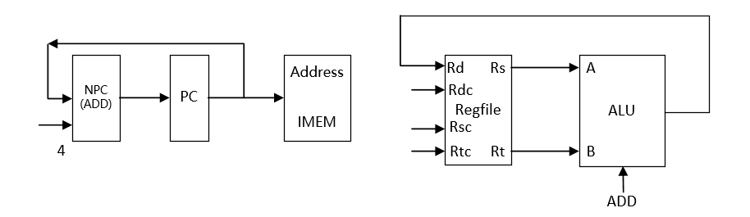

2 ADDU

格式：ADDU rd, rs, rt

操作：取指令，rd←rs+rt, PC←NPC(PC+4)

所需部件：PC, NPC, IMEM, Regfile, ALU

输入输出关系：

|  |  |  |  |  |  |  |  |
| --- | --- | --- | --- | --- | --- | --- | --- |
|  | PC | NPC | IMEM | Rgefile | | ALU | |
|  |  |  |  | Rd | Rdc | A | B |
| ADDU | NPC | PC | PC | ALU | 15-11 | Rs | Rt |

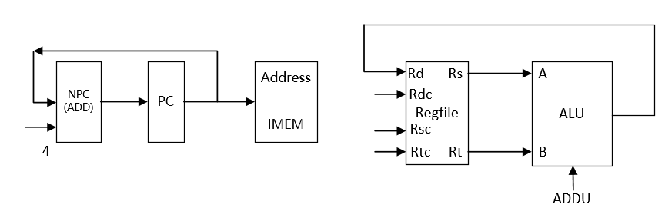

3 SUB

格式：SUB rd, rs, rt

操作：取指令，rd←rs-rt, PC←NPC(PC+4)

所需部件：PC, NPC, IMEM, Regfile, ALU

输入输出关系：

|  |  |  |  |  |  |  |  |
| --- | --- | --- | --- | --- | --- | --- | --- |
|  | PC | NPC | IMEM | Rgefile | | ALU | |
|  |  |  |  | Rd | Rdc | A | B |
| SUB | NPC | PC | PC | ALU | 15-11 | Rs | Rt |

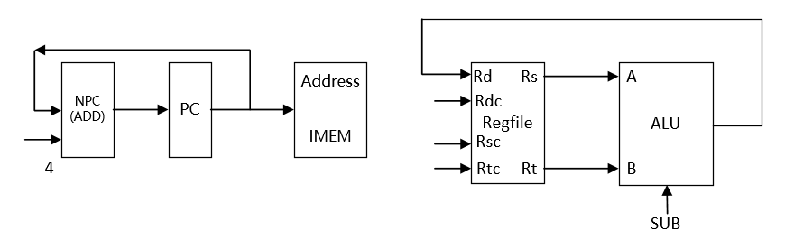

4 SUBU

格式：SUBU rd, rs, rt

操作：取指令，rd←rs-rt, PC←NPC(PC+4)

所需部件：PC, NPC, IMEM, Regfile, ALU

输入输出关系：

|  |  |  |  |  |  |  |  |
| --- | --- | --- | --- | --- | --- | --- | --- |
|  | PC | NPC | IMEM | Rgefile | | ALU | |
|  |  |  |  | Rd | Rdc | A | B |
| SUBU | NPC | PC | PC | ALU | 15-11 | Rs | Rt |

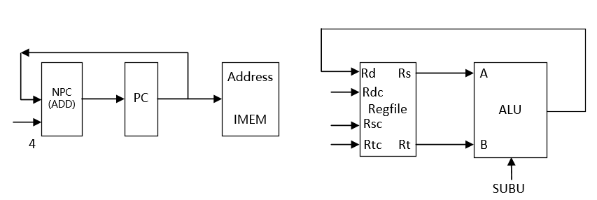

5 AND

格式：AND rd, rs, rt

操作：取指令，rd←rs & rt, PC←NPC(PC+4)

所需部件：PC, NPC, IMEM, Regfile, ALU

输入输出关系：

|  |  |  |  |  |  |  |  |
| --- | --- | --- | --- | --- | --- | --- | --- |
|  | PC | NPC | IMEM | Rgefile | | ALU | |
|  |  |  |  | Rd | Rdc | A | B |
| AND | NPC | PC | PC | ALU | 15-11 | Rs | Rt |

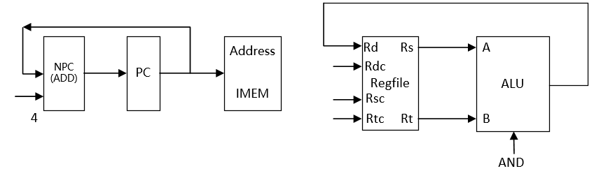

6 OR

格式：OR rd, rs, rt

操作：取指令，rd←rs | rt, PC←NPC(PC+4)

所需部件：PC, NPC, IMEM, Regfile, ALU

输入输出关系：

|  |  |  |  |  |  |  |  |
| --- | --- | --- | --- | --- | --- | --- | --- |
|  | PC | NPC | IMEM | Rgefile | | ALU | |
|  |  |  |  | Rd | Rdc | A | B |
| OR | NPC | PC | PC | ALU | 15-11 | Rs | Rt |

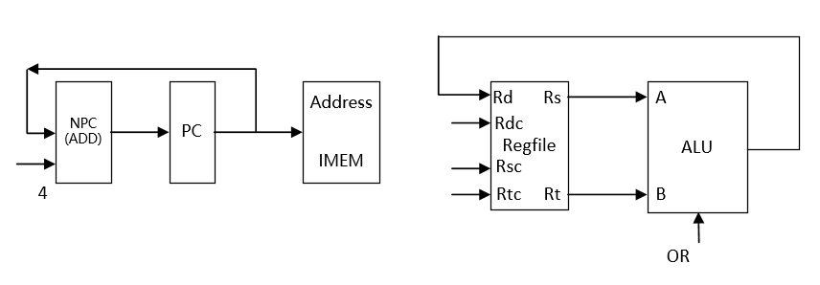

7 XOR

格式：XOR rd, rs, rt

操作：取指令，rd←rs ^ rt, PC←NPC(PC+4)

所需部件：PC, NPC, IMEM, Regfile, ALU

输入输出关系：

|  |  |  |  |  |  |  |  |
| --- | --- | --- | --- | --- | --- | --- | --- |
|  | PC | NPC | IMEM | Rgefile | | ALU | |
|  |  |  |  | Rd | Rdc | A | B |
| XOR | NPC | PC | PC | ALU | 15-11 | Rs | Rt |

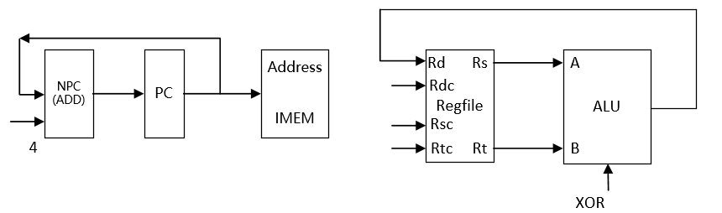

8 NOR

格式：NOR rd, rs, rt

操作：取指令，rd←~(rs | rt), PC←NPC(PC+4)

所需部件：PC, NPC, IMEM, Regfile, ALU

输入输出关系：

|  |  |  |  |  |  |  |  |
| --- | --- | --- | --- | --- | --- | --- | --- |
|  | PC | NPC | IMEM | Rgefile | | ALU | |
|  |  |  |  | Rd | Rdc | A | B |
| NOR | NPC | PC | PC | ALU | 15-11 | Rs | Rt |

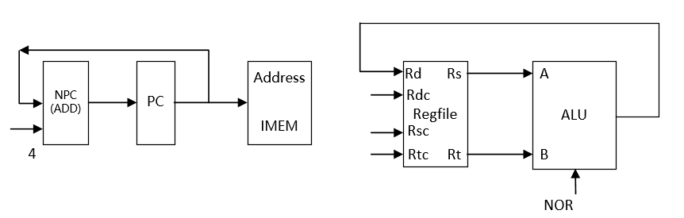

9 SLT

格式：SLT rd, rs, rt

操作：取指令，rd← rs < rt , PC←NPC(PC+4)

所需部件：PC, NPC, IMEM, Regfile, ALU

输入输出关系：

|  |  |  |  |  |  |  |  |
| --- | --- | --- | --- | --- | --- | --- | --- |
|  | PC | NPC | IMEM | Rgefile | | ALU | |
|  |  |  |  | Rd | Rdc | A | B |
| SLT | NPC | PC | PC | ALU | 15-11 | Rs | Rt |

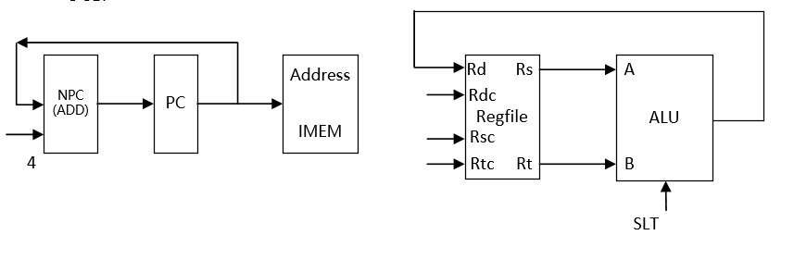

10 SLTU

格式：SLTU rd, rs, rt

操作：取指令，rd← rs < rt , PC←NPC(PC+4)

所需部件：PC, NPC, IMEM, Regfile, ALU

输入输出关系：

|  |  |  |  |  |  |  |  |
| --- | --- | --- | --- | --- | --- | --- | --- |
|  | PC | NPC | IMEM | Rgefile | | ALU | |
|  |  |  |  | Rd | Rdc | A | B |
| SLTU | NPC | PC | PC | ALU | 15-11 | Rs | Rt |

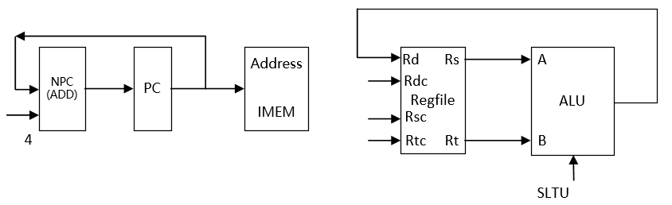

11 SLL

格式：SLL rd, rt, sa

操作：取指令, rd←rt << sa , PC←NPC(PC+4)

所需部件：PC, NPC, IMEM, Regfile, ALU, Ext5

输入输出关系：

|  |  |  |  |  |  |  |  |  |
| --- | --- | --- | --- | --- | --- | --- | --- | --- |
|  | PC | NPC | IMEM | Rgefile | | ALU | | Ext5 |
|  |  |  |  | Rd | Rdc | A | B |  |
| SLL | NPC | PC | PC | ALU | 15-11 | Ext5 | Rt | Sa |

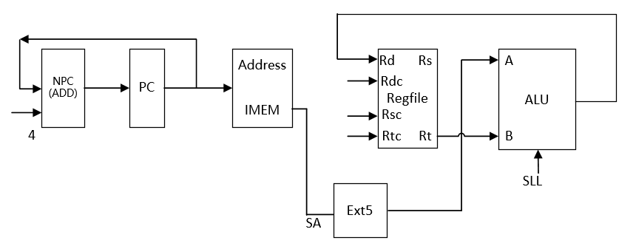

12 SRL

格式：SRL rd, rt, sa

操作：取指令, rd←rt >> sa (logical) , PC←NPC(PC+4)

所需部件：PC, NPC, IMEM, Regfile, ALU, Ext5

输入输出关系：

|  |  |  |  |  |  |  |  |  |
| --- | --- | --- | --- | --- | --- | --- | --- | --- |
|  | PC | NPC | IMEM | Rgefile | | ALU | | Ext5 |
|  |  |  |  | Rd | Rdc | A | B |  |
| SRL | NPC | PC | PC | ALU | 15-11 | Ext5 | Rt | Sa |

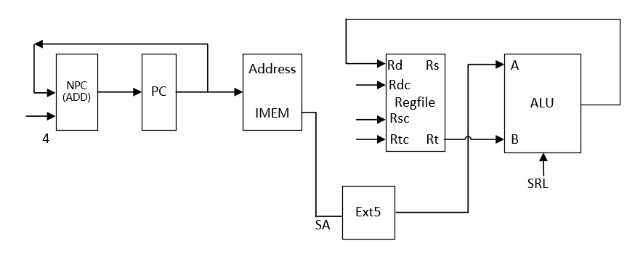

13 SRA

格式：SRA rd, rt, sa

操作：取指令, rd←rt >> sa (arithmetic) , PC←NPC(PC+4)

所需部件：PC, NPC, IMEM, Regfile, ALU, Ext5

输入输出关系：

|  |  |  |  |  |  |  |  |  |
| --- | --- | --- | --- | --- | --- | --- | --- | --- |
|  | PC | NPC | IMEM | Rgefile | | ALU | | Ext5 |
|  |  |  |  | Rd | Rdc | A | B |  |
| SRA | NPC | PC | PC | ALU | 15-11 | Ext5 | Rt | Sa |

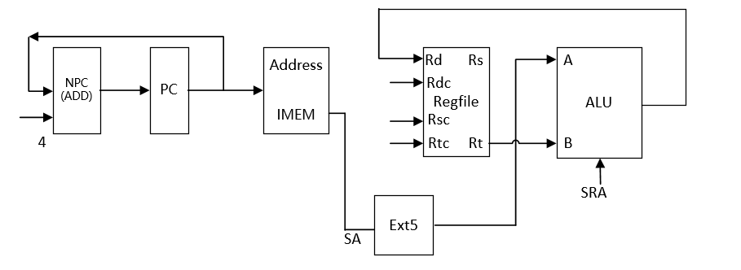

14 SLLV

格式：SLLV rd, rt, rs,

操作：取指令, rd←rt << rs , PC←NPC(PC+4)

所需部件：PC, NPC, IMEM, Regfile, ALU

输入输出关系：

|  |  |  |  |  |  |  |  |
| --- | --- | --- | --- | --- | --- | --- | --- |
|  | PC | NPC | IMEM | Rgefile | | ALU | |
|  |  |  |  | Rd | Rdc | A | B |
| SLLV | NPC | PC | PC | ALU | 15-11 | Rs | Rt |

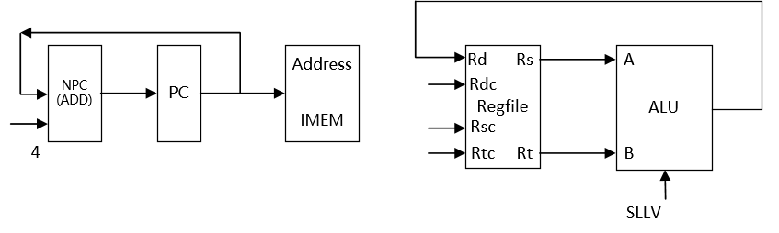

15 SRLV

格式：SRLV rd, rt,rs

操作：取指令, rd←rt >> rs (logical) , PC←NPC(PC+4)

所需部件：PC, NPC, IMEM, Regfile, ALU

输入输出关系：

|  |  |  |  |  |  |  |  |
| --- | --- | --- | --- | --- | --- | --- | --- |
|  | PC | NPC | IMEM | Rgefile | | ALU | |
|  |  |  |  | Rd | Rdc | A | B |
| SRLV | NPC | PC | PC | ALU | 15-11 | Rs | Rt |

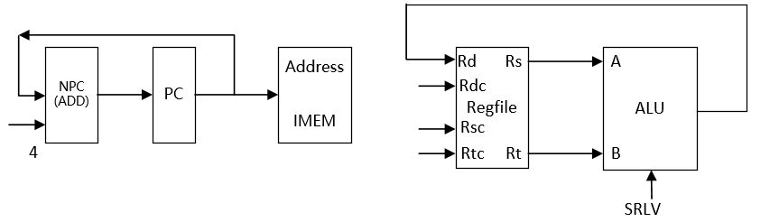

16 SRAV

格式：SRAV rd, rt,rs

操作：取指令, rd←rt >> rs (arithmetic) , PC←NPC(PC+4)

所需部件：PC, NPC, IMEM, Regfile, ALU

输入输出关系：

|  |  |  |  |  |  |  |  |
| --- | --- | --- | --- | --- | --- | --- | --- |
|  | PC | NPC | IMEM | Rgefile | | ALU | |
|  |  |  |  | Rd | Rdc | A | B |
| SRAV | NPC | PC | PC | ALU | 15-11 | Rs | Rt |

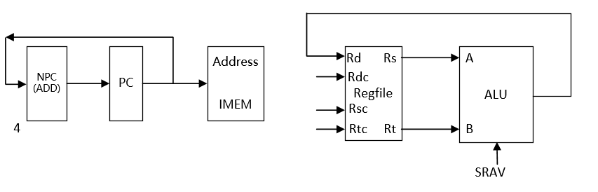

17 JR

格式：JR rs

操作：取指令, PC←rs, PC←NPC(PC+4)

所需部件：PC, NPC, IMEM, Regfile

输入输出关系：

|  |  |  |  |  |  |  |  |
| --- | --- | --- | --- | --- | --- | --- | --- |
|  | PC | NPC | IMEM | Rgefile | | ALU | |
|  |  |  |  | Rd | Rdc | A | B |
| JR | Rs | PC | PC |  |  |  |  |

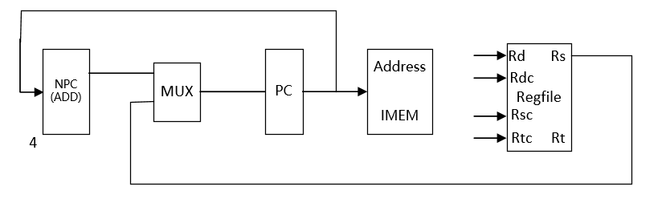

18 ADDI

格式：ADDI rt, rs, imm16

操作：取指令、rt←rs+imm16(sign_extend) 、PC←NPC(PC+4)

所需部件：：PC、NPC、IMEM、Rregfile、ALU、Ext16

输入输出关系：

|  |  |  |  |  |  |  |  |  |
| --- | --- | --- | --- | --- | --- | --- | --- | --- |
|  | PC | NPC | IMEM | Rgefile | | ALU | | Ext16 |
|  |  |  |  | Rd | Rdc | A | B |  |
| ADDI | NPC | PC | PC | ALU | 20-16 | Rs | Ext16 | Imm16 |

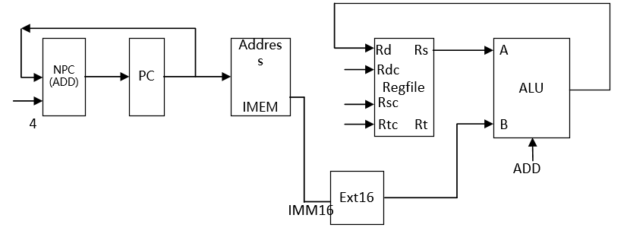

19 ADDIU

格式：ADDIU rt, rs, imm16

操作：取指令、rt←rs+imm16(sign_extend) 、PC←NPC(PC+4)

所需部件：PC、NPC、IMEM、Rregfile、ALU、Ext16

输入输出关系：

|  |  |  |  |  |  |  |  |  |
| --- | --- | --- | --- | --- | --- | --- | --- | --- |
|  | PC | NPC | IMEM | Rgefile | | ALU | | Ext16 |
|  |  |  |  | Rd | Rdc | A | B |  |
| ADDIU | NPC | PC | PC | ALU | 20-16 | Rs | Ext16 | Imm16 |

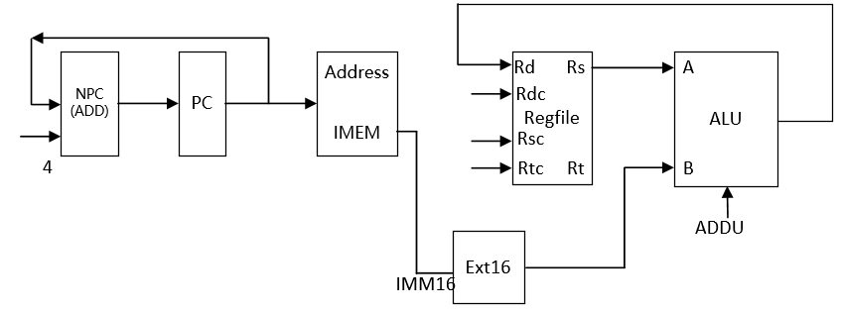

20 ANDI

格式：ANDI rt, rs, imm16

操作：取指令、rt←rs&imm16(zero_extend) 、PC←NPC(PC+4)

所需部件：PC、NPC、IMEM、Rregfile、ALU、Ext16

输入输出关系：

|  |  |  |  |  |  |  |  |  |
| --- | --- | --- | --- | --- | --- | --- | --- | --- |
|  | PC | NPC | IMEM | Rgefile | | ALU | | Ext16 |
|  |  |  |  | Rd | Rdc | A | B |  |
| ANDI | NPC | PC | PC | ALU | 20-16 | Rs | Ext16 | Imm16 |

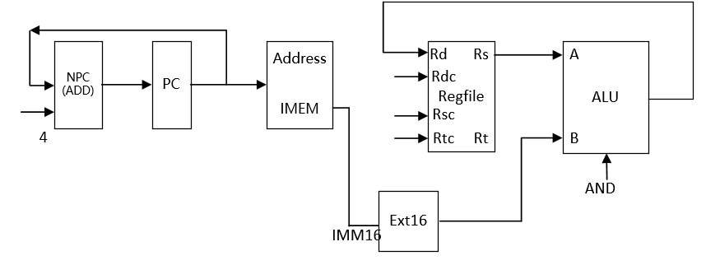

21 ORI

格式：ORI rt, rs, imm16

操作：取指令、rt←rs|imm16(zero_extend) 、PC←NPC(PC+4)

所需部件：PC、NPC、IMEM、Rregfile、ALU、Ext16

输入输出关系：

|  |  |  |  |  |  |  |  |  |
| --- | --- | --- | --- | --- | --- | --- | --- | --- |
|  | PC | NPC | IMEM | Rgefile | | ALU | | Ext16 |
|  |  |  |  | Rd | Rdc | A | B |  |
| ORI | NPC | PC | PC | ALU | 20-16 | Rs | Ext16 | Imm16 |

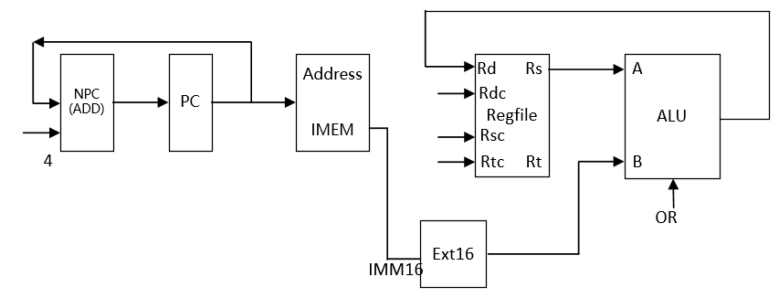

22 XORI

格式：XORI rt, rs, imm16

操作：取指令、rt←rs^imm16(zero_extend) 、PC←NPC(PC+4)

所需部件：PC、NPC、IMEM、Rregfile、ALU、Ext16

输入输出关系：

|  |  |  |  |  |  |  |  |  |
| --- | --- | --- | --- | --- | --- | --- | --- | --- |
|  | PC | NPC | IMEM | Rgefile | | ALU | | Ext16 |
|  |  |  |  | Rd | Rdc | A | B |  |
| XORI | NPC | PC | PC | ALU | 20-16 | Rs | Ext16 | Imm16 |

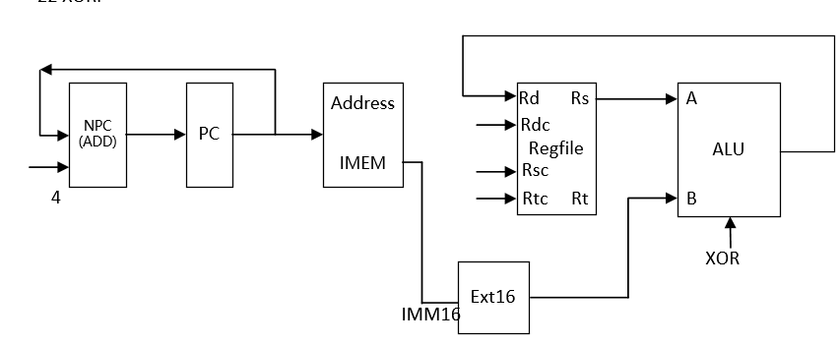

23 LW

格式：LW rt, offset(base)

操作：取指令、rt←memory[rs + offset]、PC←NPC(PC+4)

所需部件：PC、NPC、IMEM、ALU、Ext16、DMEM

输入输出关系：

|  |  |  |  |  |  |  |  |  |  |  |
| --- | --- | --- | --- | --- | --- | --- | --- | --- | --- | --- |
|  | PC | NPC | IMEM | Rgefile | | ALU | | Ext16 | DMEM | |
|  |  |  |  | Rd | Rdc | A | B |  | Addr | Data |
| LW | NPC | PC | PC | DMEM  (data) | 20-16 | Rs  (base) | Ext16 | Offset | ALU |  |

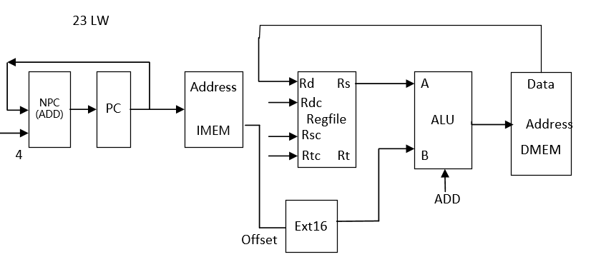

24 SW

格式：SW rt, offset(base)

操作：取指令、memory[base + offset]←rt、PC←NPC(PC+4)

所需部件：PC、NPC、IMEM、ALU、Ext16、DMEM

输入输出关系：

|  |  |  |  |  |  |  |  |  |  |  |
| --- | --- | --- | --- | --- | --- | --- | --- | --- | --- | --- |
|  | PC | NPC | IMEM | Rgefile | | ALU | | Ext16 | DMEM | |
|  |  |  |  | Rd | Rdc | A | B |  | Addr | Data |
| SW | NPC | PC | PC | DMEM  (data) |  | Rs  (base) | Ext16 | Offset | ALU | Rt |

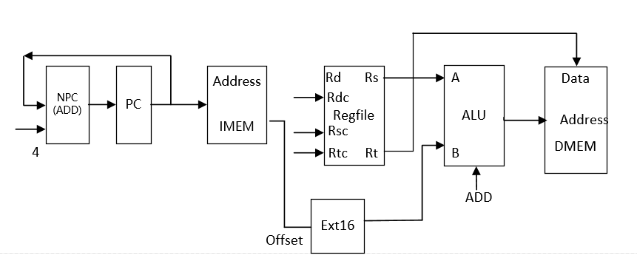

25 BEQ

格式：BEQ rs, rt, offset

操作: if (rs=rt)PC←NPC + Sign_ext(offset||02)

else PC← NPC(PC+4)

所需部件：PC、NPC、IMEM、Regfile、ALU、Ext18、ADD

输入输出关系：

|  |  |  |  |  |  |  |  |  |  |  |
| --- | --- | --- | --- | --- | --- | --- | --- | --- | --- | --- |
|  | PC | NPC | IMEM | Rgefile | | ALU | | Ext18 | ADD | |
|  |  |  |  | Rd | Rdc | A | B |  | A | B |
| BEQ | ADD | PC | PC |  |  | Rs | Rt | Offset | Ext18 | NPC |

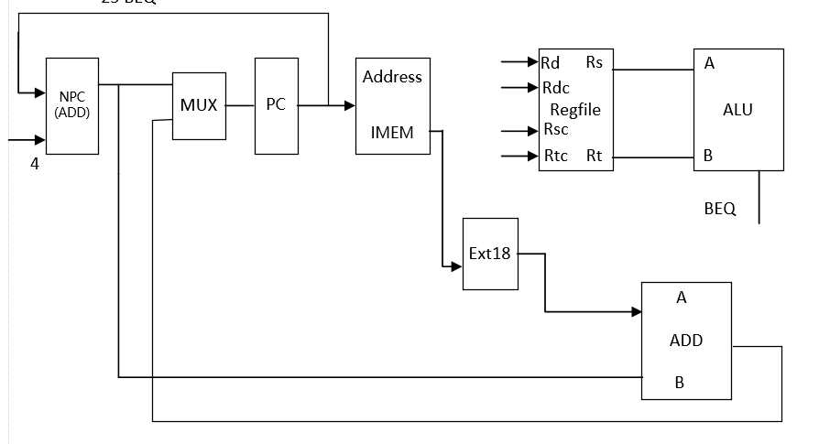

26 BNE

格式：BNE rs, rt, offset

操作：if (rs≠rt)PC←NPC + Sign_ext(offset||02)

else PC← NPC(PC+4)

所需部件：PC、NPC、IMEM、Regfile、ALU、Ext18、ADD

输入输出关系：

|  |  |  |  |  |  |  |  |  |  |  |
| --- | --- | --- | --- | --- | --- | --- | --- | --- | --- | --- |
|  | PC | NPC | IMEM | Rgefile | | ALU | | Ext18 | ADD | |
|  |  |  |  | Rd | Rdc | A | B |  | A | B |
| BNE | ADD | PC | PC |  |  | Rs | Rt | Offset | Ext18 | NPC |

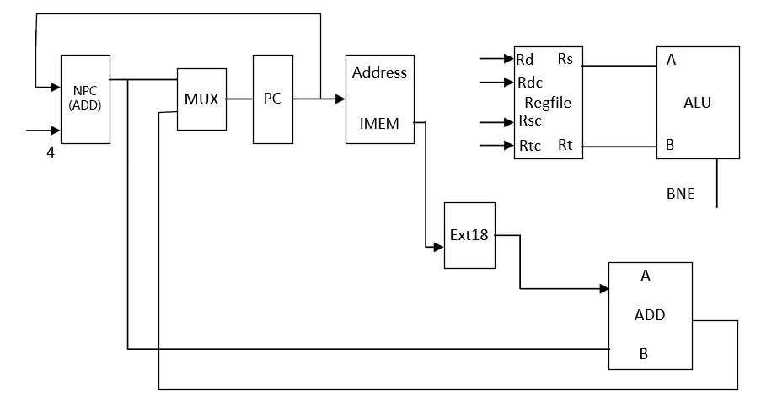

27 SLTI

格式：SLTI rt, rs, imm16

操作：取指令、rt←rs < ext.imm16(sign_extend) 、PC←NPC(PC+4)

所需部件：PC、NPC、IMEM、Rregfile、ALU、Ext16

输入输出关系：

|  |  |  |  |  |  |  |  |  |
| --- | --- | --- | --- | --- | --- | --- | --- | --- |
|  | PC | NPC | IMEM | Rgefile | | ALU | | Ext16 |
|  |  |  |  | Rd | Rdc | A | B |  |
| SLTI | NPC | PC | PC | ALU | 20-16 | Rs | Ext16 | Imm16 |

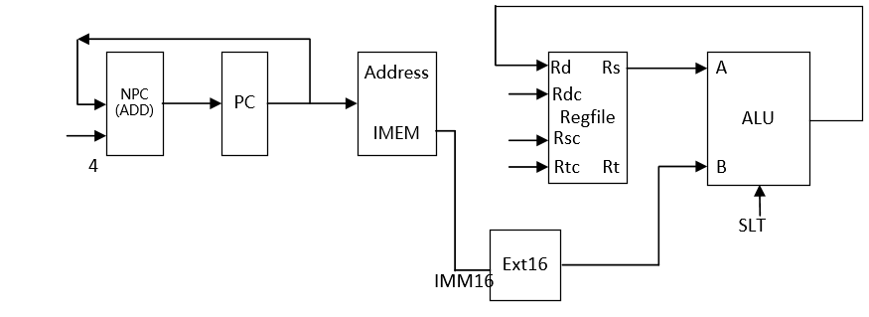

28 SLTIU

格式：SLTIU rt, rs, imm16

操作：取指令、rt←rs < ext.imm16(sign_extend) 、PC←NPC(PC+4)

所需部件：PC、NPC、IMEM、Rregfile、ALU、Ext16

输入输出关系：

|  |  |  |  |  |  |  |  |  |
| --- | --- | --- | --- | --- | --- | --- | --- | --- |
|  | PC | NPC | IMEM | Rgefile | | ALU | | Ext16 |
|  |  |  |  | Rd | Rdc | A | B |  |
| SLTIU | NPC | PC | PC | ALU | 20-16 | Rs | Ext16 | Imm16 |

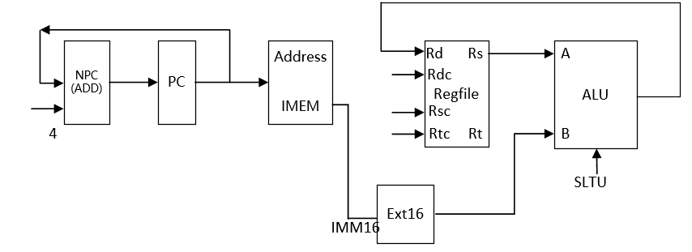

29 LUI

格式：LUI rt, imm16

操作：取指令、rt←imm16||016 、PC←NPC(PC+4)

所需部件：PC、NPC、IMEM、Rregfile、ALU、Ext16

输入输出关系：

|  |  |  |  |  |  |  |  |  |
| --- | --- | --- | --- | --- | --- | --- | --- | --- |
|  | PC | NPC | IMEM | Rgefile | | ALU | | Ext16 |
|  |  |  |  | Rd | Rdc | A | B |  |
| LUI | NPC | PC | PC | ALU | 20-16 |  | Ext16 | Imm16 |

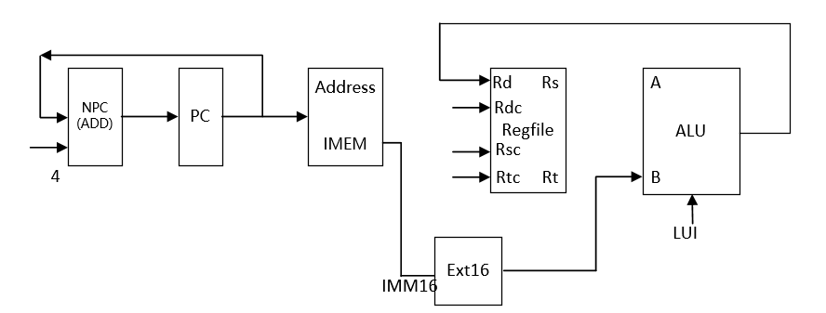

30 J

格式：J target

操作：取指令、PC ← PC31-28||instr_index||02 , PC←NPC(PC+4)

所需部件：PC、NPC、IMEM

输入输出关系：

|  |  |  |  |  |  |  |  |  |
| --- | --- | --- | --- | --- | --- | --- | --- | --- |
|  | PC | NPC | IMEM | Rgefile | | ALU | |  |
|  |  |  |  | Rd | Rdc | A | B |  |
| J | || | PC | PC |  |  |  |  |  |

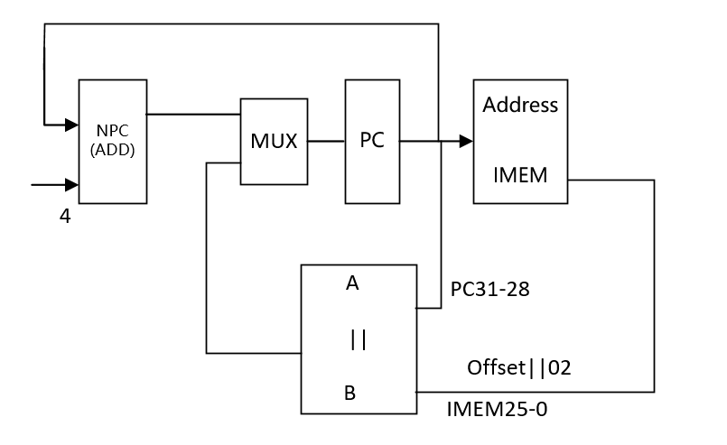

31 JAL

格式：JAL target

操作：取指令、 R[31] ← PC + 8,PC ← PC31-28||instr_index||02 , PC←PC+4

所需部件：：PC、NPC、IMEM

输入输出关系：

|  |  |  |  |  |  |  |  |  |
| --- | --- | --- | --- | --- | --- | --- | --- | --- |
|  | PC | NPC | IMEM | Rgefile | | ALU | |  |
|  |  |  |  | Rd | Rdc | A | B |  |
| JAL | || | PC | PC | ALU |  | PC | 8 |  |

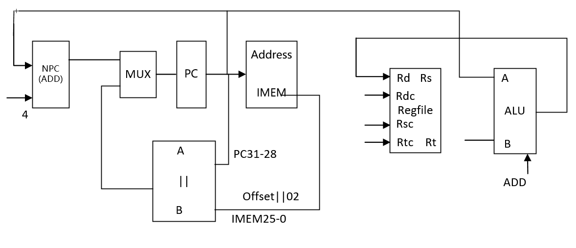

（二）整个数据通路

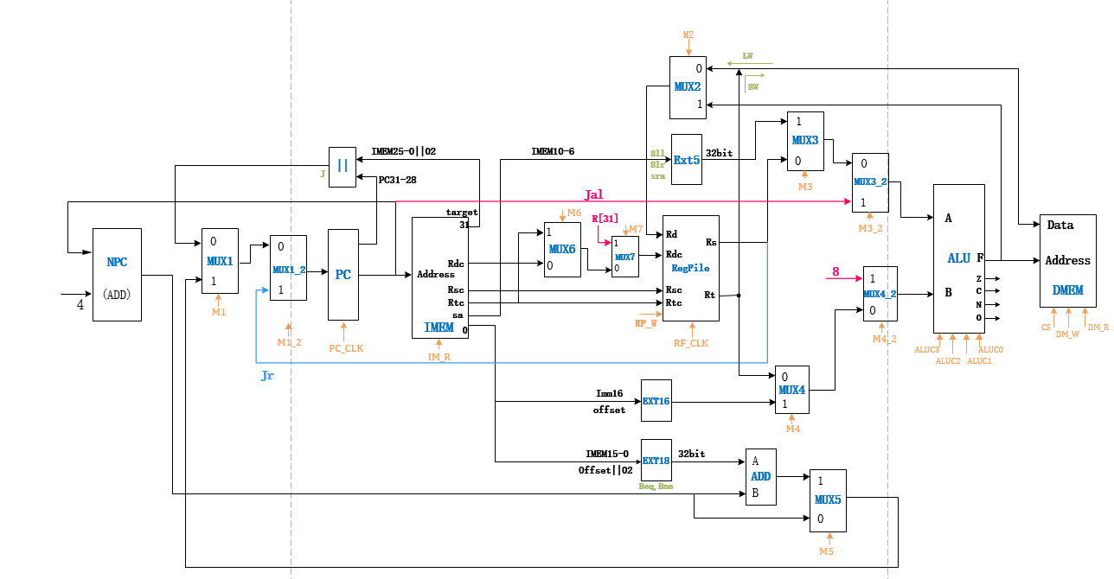

（三）部件表：

**31条指令CPU所需部件及数据通路图**

|  |  |  |  |  |  |  |  |  |  |  |  |  |  |
| --- | --- | --- | --- | --- | --- | --- | --- | --- | --- | --- | --- | --- | --- |
|  |  | PC | NPC | IMEM | RegFile | | ALU | | Ext16 | Ext5 | Ext18 | DMEM | |
|  |  |  |  |  | Rd | Rdc | A | B |  |  |  | Addr | Data |
| 1 | Add | NPC | PC | PC | ALU | 15-11 | Rs | Rt |  |  |  |  |  |
| 2 | Addu | NPC | PC | PC | ALU | 15-11 | Rs | Rt |  |  |  |  |  |
| 3 | Sub | NPC | PC | PC | ALU | 15-11 | Rs | Rt |  |  |  |  |  |
| 4 | Subu | NPC | PC | PC | ALU | 15-11 | Rs | Rt |  |  |  |  |  |
| 5 | and | NPC | PC | PC | ALU | 15-11 | Rs | Rt |  |  |  |  |  |
| 6 | or | NPC | PC | PC | ALU | 15-11 | Rs | Rt |  |  |  |  |  |
| 7 | xor | NPC | PC | PC | ALU | 15-11 | Rs | Rt |  |  |  |  |  |
| 8 | nor | NPC | PC | PC | ALU | 15-11 | Rs | Rt |  |  |  |  |  |
| 9 | slt | NPC | PC | PC | ALU | 15-11 | Rs | Rt |  |  |  |  |  |
| 10 | sltu | NPC | PC | PC | ALU | 15-11 | Rs | Rt |  |  |  |  |  |
| 11 | sllv | NPC | PC | PC | ALU | 15-11 | Rs | Rt |  |  |  |  |  |
| 12 | srlv | NPC | PC | PC | ALU | 15-11 | Rs | Rt |  |  |  |  |  |
| 13 | srav | NPC | PC | PC | ALU | 15-11 | Rs | Rt |  |  |  |  |  |
| 14 | sll | NPC | PC | PC | ALU | 15-11 | Ext5 | Rt |  | sa |  |  |  |
| 15 | srl | NPC | PC | PC | ALU | 15-11 | Ext5 | Rt |  | sa |  |  |  |
| 16 | sra | NPC | PC | PC | ALU | 15-11 | Ext5 | Rt |  | sa |  |  |  |
| 17 | Addi | NPC | PC | PC | ALU | 20-16 | Rs | Ext16 | Imm16 |  |  |  |  |
| 18 | Addiu | NPC | PC | PC | ALU | 20-16 | Rs | Ext16 | Imm16 |  |  |  |  |
| 19 | Andi | NPC | PC | PC | ALU | 20-16 | Rs | Ext16 | Imm16 |  |  |  |  |
| 20 | Ori | NPC | PC | PC | ALU | 20-16 | Rs | Ext16 | Imm16 |  |  |  |  |
| 21 | Xori | NPC | PC | PC | ALU | 20-16 | Rs | Ext16 | Imm16 |  |  |  |  |
| 22 | Slti | NPC | PC | PC | ALU | 20-16 | Rs | Ext16 | Imm16 |  |  |  |  |
| 23 | Sltiu | NPC | PC | PC | ALU | 20-16 | Rs | Ext16 | Imm16 |  |  |  |  |
| 24 | Lui | NPC | PC | PC | ALU | 20-16 |  | Ext16 | Imm16 |  |  |  |  |
| 25 | Lw | NPC | PC | PC | DMEM (data) | 20-16 | Rs (base) | Ext16 | offset |  |  | ALU |  |
| 26 | Sw | NPC | PC | PC | DMEM (data) |  | Rs (base) | Ext16 | offset |  |  | ALU | Rt |

|  |  |  |  |  |  |  |  |  |  |  |  |  |  |
| --- | --- | --- | --- | --- | --- | --- | --- | --- | --- | --- | --- | --- | --- |
|  |  | PC | NPC | IMEM | RegFile | | ALU | | Ext18 | ADD | | || | |
|  |  |  |  |  | Rd | Rdc | A | B |  | A | B | A | B |
| 27 | Beq | ADD | PC | PC |  |  | Rs | Rt | Offset | NPC | Ext18 |  |  |
| 28 | Bne | ADD | PC | PC |  |  | Rs | Rt | Offset | NPC | Ext18 |  |  |
| 29 | J | || | PC | PC |  |  |  |  |  |  |  | PC  31-28 | IMEM 25-0 |
| 30 | Jal | || | PC | PC | ALU |  | PC | 8 |  |  |  | PC  31-28 | IMEM 25-0 |
| 31 | jr | rs | PC | PC |  |  |  |  |  |  |  |  |  |

1. 模块建模

1 顶层模块sccomp_dataflow，调用cpu,imem和dram

module sccomp_dataflow(

input clk_in,

input reset,

output [31:0] inst,

output [31:0] pc

);

wire [31:0] imm;

wire [31:0] Rt;

wire [31:0] alu_r;

wire cs;

wire dm_w;

wire dm_r;

wire [31:0] ram_out;

assign inst=imm;

imem imem(((pc- 32'h00400000)/4),imm);

//imem im(pc,inst)

//IMEM imem(1,((pc- 32'h00400000)/4),imm);

cpu sccpu(clk_in,reset,imm,ram_out, //input

Rt,alu_r,pc,cs,dm_w,dm_r); //output

DMEM dram(

.clk(clk_in),

.CS(cs), //enable control signal

.DM_W(dm_w), //write

.DM_R(dm_r), //read

.Addr((alu_r[9:0]-32'h10010000)/4),

.Data_in(Rt),

.Data_out(ram_out)

);

endmodule

2 cpu模块 发送控制信号

module cpu(

input clk_in,

input reset,

input [31:0]imem,//

input [31:0] ram_out,

output [31:0] Rt,

output [31:0] alu_r,

output [31:0] pc,

output cs, //dmem control signal

output dm_w, //dmem write

output dm_r//dmem read

);

wire [31:0]npc;

wire M3,M3_2,M4,M4_2, M2,M5,M1,M1_2,M6,M7; //mux2

wire ALUC3,ALUC2,ALUC1,ALUC0;

wire RF_W; //regfiles write

wire RL_CLK; //regfiles clk

wire [3:0]ALUC;//alu control

wire [31:0] PC;

wire [31:0] mux_out_1;

wire [31:0] mux_out_1_2;

wire [31:0] mux_out_2;

wire [31:0] mux_out_3;

wire [31:0] mux_out_3_2;

wire [31:0] mux_in_4;

wire [31:0] mux_out_4;

wire [31:0] mux_out_4_2;

wire [31:0] mux_out_5;

wire [31:0] Rs; //Rs

wire [31:0] ext18_sign;

wire [4:0] rdc;

wire [4:0] rsc;

wire [4:0] rtc;

wire [31:0] ext16;

wire [31:0] ext16_sign;

wire ext16_sin_judge;

wire zero;

wire carry;

wire negative;

wire overflow;

assign pc = PC;

//assign RDC_T = rdc;

assign mux_out_2_T=mux_out_2;

wire _add, _addu, _sub, _subu, _and, _or, _xor, _nor;

wire _slt, _sltu, _sll, _srl, _sra, _sllv, _srlv, _srav, _jr;

wire _addi, _addiu, _andi, _ori, _xori, _lw, _sw;

wire _beq, _bne, _slti, _sltiu, _lui, _j, _jal;

//1~17

assign _add = (imem[31:26]==6'b000000&&imem[5:0]==6'b100000)?1'b1:1'b0;

assign _addu = (imem[31:26]==6'b000000&&imem[5:0]==6'b100001)?1'b1:1'b0;

assign _sub = (imem[31:26]==6'b000000&&imem[5:0]==6'b100010)?1'b1:1'b0;

assign _subu = (imem[31:26]==6'b000000&&imem[5:0]==6'b100011)?1'b1:1'b0;

assign _and = (imem[31:26]==6'b000000&&imem[5:0]==6'b100100)?1'b1:1'b0;

assign _or = (imem[31:26]==6'b000000&&imem[5:0]==6'b100101)?1'b1:1'b0;

assign _xor = (imem[31:26]==6'b000000&&imem[5:0]==6'b100110)?1'b1:1'b0;

assign _nor = (imem[31:26]==6'b000000&&imem[5:0]==6'b100111)?1'b1:1'b0;

assign _slt = (imem[31:26]==6'b000000&&imem[5:0]==6'b101010)?1'b1:1'b0;

assign _sltu = (imem[31:26]==6'b000000&&imem[5:0]==6'b101011)?1'b1:1'b0;

assign _sll = (imem[31:26]==6'b000000&&imem[5:0]==6'b000000)?1'b1:1'b0;

assign _srl = (imem[31:26]==6'b000000&&imem[5:0]==6'b000010)?1'b1:1'b0;

assign _sra = (imem[31:26]==6'b000000&&imem[5:0]==6'b000011)?1'b1:1'b0;

assign _sllv = (imem[31:26]==6'b000000&&imem[5:0]==6'b000100)?1'b1:1'b0;

assign _srlv = (imem[31:26]==6'b000000&&imem[5:0]==6'b000110)?1'b1:1'b0;

assign _srav = (imem[31:26]==6'b000000&&imem[5:0]==6'b000111)?1'b1:1'b0;

assign _jr = (imem[31:26]==6'b000000&&imem[5:0]==6'b001000)?1'b1:1'b0;

//18~29

assign _addi = (imem[31:26]==6'b001000)?1'b1:1'b0;

assign _addiu = (imem[31:26]==6'b001001)?1'b1:1'b0;

assign _andi = (imem[31:26]==6'b001100)?1'b1:1'b0;

assign _ori = (imem[31:26]==6'b001101)?1'b1:1'b0;

assign _xori = (imem[31:26]==6'b001110)?1'b1:1'b0;

assign _lw = (imem[31:26]==6'b100011)?1'b1:1'b0;

assign _sw = (imem[31:26]==6'b101011)?1'b1:1'b0;

assign _beq = (imem[31:26]==6'b000100)?1'b1:1'b0;

assign _bne = (imem[31:26]==6'b000101)?1'b1:1'b0;

assign _slti = (imem[31:26]==6'b001010)?1'b1:1'b0;

assign _sltiu = (imem[31:26]==6'b001011)?1'b1:1'b0;

assign _lui = (imem[31:26]==6'b001111)?1'b1:1'b0;

//30 31

assign _j = (imem[31:26]==6'b000010)?1'b1:1'b0;

assign _jal = (imem[31:26]==6'b000011)?1'b1:1'b0;

wire exception;

wire [4:0] cause;

wire wdata;

assign wdata = Rt;

wire [31:0] rdata;

wire [31:0] status;

wire [31:0] exc_addr; //un

//Control signal expression

assign M3 = _sll || _srl || _sra ;

assign M3_2 = _jal ;

assign M4 = _addi || _addiu || _andi || _ori || _xori || _slti || _sltiu || _lui || _lw || _sw ;

assign M4_2 = _jal ;

assign M6 =_addi||_addiu||_andi||_ori||_xori|||_slti||_sltiu||_lui||_lw;//||_mfc0;

assign M7 =_jal;

assign ALUC[3] = _slt || _sltu ||_sllv || _srlv || _srav || _sll || _srl || _sra || _slti || _sltiu || _lui ;

assign ALUC[2] = _and || _or ||_xor || _nor || _sllv || _srlv || _srav || _sll || _srl || _sra || _andi || _ori || _xori ;

assign ALUC[1] = _add || _sub ||_xor || _nor || _slt || _sltu || _sllv || _sll || _addi || _xori || _slti || _sltiu ;

assign ALUC[0] = _sub || _subu ||_or || _nor || _slt || _srlv || _srl || _ori || _slti || _beq || _bne ;//||_teq;//cp0 teq

assign M2 = !_lw;

assign rdc = M6?imem[20:16]:(M7?5'd31:imem[15:11]);

assign RF_W= (!_sw)&&(!_beq)&&(!_bne)&&(!_j)&&(!_jr);

assign RL_CLK= ((!_sw)&&(!_beq)&&(!_bne)&&(!_j)&&(!_jal)&&(!_jr))&&clk_in;

assign M5 = (_beq&&zero) || (_bne&&(!zero)) ;

assign M1 = (!_j)&&(!_jal) ;

assign M1_2 = _jr ;

assign cs = _lw || _sw;

assign dm_r = _lw;

assign dm_w = _sw;

assign ext16_sin_judge = _addi || _addiu || _slti||_sltiu || _lw; //sign_ext

assign ext18_sign = {{14{imem[15]}},{imem[15:0],2'h0}};

assign npc = PC + 4;

assign ext16_sign = {{16{imem[15]}},imem[15:0]};//

assign ext16 = {16'h0,imem[15:0]};

assign mux_in_4 = ext16_sin_judge?ext16_sign:ext16;

assign rsc = imem[25:21];

assign rtc = imem[20:16];

assign mux_out_1=M1?mux_out_5:{PC[31:28],imem[25:0],2'b00}; //mux1

assign mux_out_1_2=M1_2?Rs:mux_out_1; //mux1_2

assign mux_out_2=M2?alu_r:ram_out; //mux2

assign mux_out_3=M3?{27'b0,imem[10:6]}:Rs;

assign mux_out_3_2=M3_2?PC:mux_out_3;

assign mux_out_4=M4?mux_in_4:Rt;

assign mux_out_4_2=M4_2?32'd4:mux_out_4;

assign mux_out_5=M5?ext18_sign+npc:npc;

pcreg PCreg(

.clk(clk_in),

.rst(reset),

.ena(1),

//.wena(1),

.data_in(mux_out_1_2),

.data_out(PC)

);

regfile cpu_ref(

.clk(clk_in),

.rst(reset),

.ena(1),

.we(RF_W),

.raddr1(rsc), //rsc

.raddr2(rtc),//rtc

.waddr(rdc), //rdc 5bits

.wdata(mux_out_2), //rd

.rdata1(Rs), //rs

.rdata2(Rt) //rt

);

ALU alu(

.a(mux_out_3_2),

.b(mux_out_4_2),

.aluc(ALUC),

.r(alu_r),

.zero(zero),

.carry(carry),

.negative(negative),

.overflow(overflow)

);

endmodule

3 dmem模块

module DMEM(

input clk,

input CS, //enable control signal

input DM_W, //write

input DM_R, //read

input [9:0] Addr,

input [31:0] Data_in,

output [31:0] Data_out

);

reg [31:0] num [0:31];

assign Data_out=CS? (DM_R? num[Addr]: 32'h00000000):32'bzzzz_zzzz_zzzz_zzzz_zzzz_zzzz_zzzz_zzzz;

always@(negedge clk or negedge CS)

begin

if(CS&&DM_W)num[Addr]<=Data_in;

end

endmodule

4 ALU负责完成各类计算

module ALU(

input [31:0] a, //OP1

input [31:0] b, //OP2

input [3:0] aluc, //controller

output [31:0] r, //result

output zero,

output carry,

output negative,

output overflow);

parameter Addu = 4'b0000; //r=a+b unsigned

parameter Add = 4'b0010; //r=a+b signed

parameter Subu = 4'b0001; //r=a-b unsigned

parameter Sub = 4'b0011; //r=a-b signed

parameter And = 4'b0100; //r=a&b

parameter Or = 4'b0101; //r=a|b

parameter Xor = 4'b0110; //r=a^b

parameter Nor = 4'b0111; //r=~(a|b)

parameter Lui1 = 4'b1000; //r={b[15:0],16'b0}

parameter Lui2 = 4'b1001; //r={b[15:0],16'b0}

parameter Slt = 4'b1011; //r=(a-b<0)?1:0 signed

parameter Sltu = 4'b1010; //r=(a-b<0)?1:0 unsigned

parameter Sra = 4'b1100; //r=b>>>a

parameter Sll = 4'b1110; //r=b<<a

parameter Srl = 4'b1101; //r=b>>a

parameter bits=31;

parameter ENABLE=1,DISABLE=0;

reg [32:0] result;

wire signed [31:0] sa=a,sb=b;

always@(*)begin

case(aluc)

Addu: begin

result=a+b;

end

Subu: begin

result=a-b;

end

Add: begin

result=sa+sb;

end

Sub: begin

result=sa-sb;

end

Sra: begin

if(a==0) {result[31:0],result[32]}={b,1'b0};

else {result[31:0],result[32]}=sb>>>(a-1);

end

Srl: begin

if(a==0) {result[31:0],result[32]}={b,1'b0};

else {result[31:0],result[32]}=b>>(a-1);

end

Sll: begin

result=b<<a;

end

And: begin

result=a&b;

end

Or: begin

result=a|b;

end

Xor: begin

result=a^b;

end

Nor: begin

result=~(a|b);

end

Sltu: begin

result=a<b?1:0;

end

Slt: begin

result=sa<sb?1:0;

end

Lui1,Lui2: result = {b[15:0], 16'b0};

default:

result=a+b;

endcase

end

assign r=result[31:0];

assign carry = result[32];

assign zero=(r==32'b0)?1:0;

assign negative=result[31];

assign overflow=result[32];

endmodule

5 regfiles模块

module regfile(

input clk,

input rst,

input ena,

input we,

input [4:0] raddr1,

input [4:0] raddr2,

input [4:0] waddr,

input [31:0] wdata,

output wire [31:0] rdata1,

output wire [31:0] rdata2

);

reg [31:0]array_reg[31:0];

assign rdata1 = ena?array_reg[raddr1]:32'bz;

assign rdata2 = ena?array_reg[raddr2]:32'bz;

always @(negedge clk or posedge rst)

//always @(posedge clk or posedge rst)

begin

if (rst) begin

array_reg[0] <= 32'h0;

array_reg[1] <= 32'h0;

array_reg[2] <= 32'h0;

array_reg[3] <= 32'h0;

array_reg[4] <= 32'h0;

array_reg[5] <= 32'h0;

array_reg[6] <= 32'h0;

array_reg[7] <= 32'h0;

array_reg[8] <= 32'h0;

array_reg[9] <= 32'h0;

array_reg[10] <= 32'h0;

array_reg[11] <= 32'h0;

array_reg[12] <= 32'h0;

array_reg[13] <= 32'h0;

array_reg[14] <= 32'h0;

array_reg[15] <= 32'h0;

array_reg[16] <= 32'h0;

array_reg[17] <= 32'h0;

array_reg[18] <= 32'h0;

array_reg[19] <= 32'h0;

array_reg[20] <= 32'h0;

array_reg[21] <= 32'h0;

array_reg[22] <= 32'h0;

array_reg[23] <= 32'h0;

array_reg[24] <= 32'h0;

array_reg[25] <= 32'h0;

array_reg[26] <= 32'h0;

array_reg[27] <= 32'h0;

array_reg[28] <= 32'h0;

array_reg[29] <= 32'h0;

array_reg[30] <= 32'h0;

array_reg[31] <= 32'h0;

end

else if ((ena&we)&& (waddr != 0))

array_reg[waddr] <= wdata;

end

endmodule

6 pc寄存器

module pcreg(clk,rst,ena,data_in,data_out);

input clk;

input rst;

input ena;

input [31:0]data_in;

output reg[31:0]data_out;

wire [31:0]data;

always@(*)

begin

if(ena==1)

data_out=data;

else

data_out=data_out;

end

Asynchronous_D_FF DFF0(.CLK(clk),.D(data_in[0]),.RST_n(rst),.Q1(data[0]));

Asynchronous_D_FF DFF1(.CLK(clk),.D(data_in[1]),.RST_n(rst),.Q1(data[1]));

Asynchronous_D_FF DFF2(.CLK(clk),.D(data_in[2]),.RST_n(rst),.Q1(data[2]));

Asynchronous_D_FF DFF3(.CLK(clk),.D(data_in[3]),.RST_n(rst),.Q1(data[3]));

Asynchronous_D_FF DFF4(.CLK(clk),.D(data_in[4]),.RST_n(rst),.Q1(data[4]));

Asynchronous_D_FF DFF5(.CLK(clk),.D(data_in[5]),.RST_n(rst),.Q1(data[5]));

Asynchronous_D_FF DFF6(.CLK(clk),.D(data_in[6]),.RST_n(rst),.Q1(data[6]));

Asynchronous_D_FF DFF7(.CLK(clk),.D(data_in[7]),.RST_n(rst),.Q1(data[7]));

Asynchronous_D_FF DFF8(.CLK(clk),.D(data_in[8]),.RST_n(rst),.Q1(data[8]));

Asynchronous_D_FF DFF9(.CLK(clk),.D(data_in[9]),.RST_n(rst),.Q1(data[9]));

Asynchronous_D_FF DFF10(.CLK(clk),.D(data_in[10]),.RST_n(rst),.Q1(data[10]));

Asynchronous_D_FF DFF11(.CLK(clk),.D(data_in[11]),.RST_n(rst),.Q1(data[11]));

Asynchronous_D_FF DFF12(.CLK(clk),.D(data_in[12]),.RST_n(rst),.Q1(data[12]));

Asynchronous_D_FF DFF13(.CLK(clk),.D(data_in[13]),.RST_n(rst),.Q1(data[13]));

Asynchronous_D_FF DFF14(.CLK(clk),.D(data_in[14]),.RST_n(rst),.Q1(data[14]));

Asynchronous_D_FF DFF15(.CLK(clk),.D(data_in[15]),.RST_n(rst),.Q1(data[15]));

Asynchronous_D_FF DFF16(.CLK(clk),.D(data_in[16]),.RST_n(rst),.Q1(data[16]));

Asynchronous_D_FF DFF17(.CLK(clk),.D(data_in[17]),.RST_n(rst),.Q1(data[17]));

Asynchronous_D_FF DFF18(.CLK(clk),.D(data_in[18]),.RST_n(rst),.Q1(data[18]));

Asynchronous_D_FF DFF19(.CLK(clk),.D(data_in[19]),.RST_n(rst),.Q1(data[19]));

Asynchronous_D_FF DFF20(.CLK(clk),.D(data_in[20]),.RST_n(rst),.Q1(data[20]));

Asynchronous_D_FF DFF21(.CLK(clk),.D(data_in[21]),.RST_n(rst),.Q1(data[21]));

Asynchronous_D_FF1 DFF22(.CLK(clk),.D(data_in[22]),.RST_n(rst),.Q1(data[22]));//reset==1

Asynchronous_D_FF DFF23(.CLK(clk),.D(data_in[23]),.RST_n(rst),.Q1(data[23]));

Asynchronous_D_FF DFF24(.CLK(clk),.D(data_in[24]),.RST_n(rst),.Q1(data[24]));

Asynchronous_D_FF DFF25(.CLK(clk),.D(data_in[25]),.RST_n(rst),.Q1(data[25]));

Asynchronous_D_FF DFF26(.CLK(clk),.D(data_in[26]),.RST_n(rst),.Q1(data[26]));

Asynchronous_D_FF DFF27(.CLK(clk),.D(data_in[27]),.RST_n(rst),.Q1(data[27]));

Asynchronous_D_FF DFF28(.CLK(clk),.D(data_in[28]),.RST_n(rst),.Q1(data[28]));

Asynchronous_D_FF DFF29(.CLK(clk),.D(data_in[29]),.RST_n(rst),.Q1(data[29]));

Asynchronous_D_FF DFF30(.CLK(clk),.D(data_in[30]),.RST_n(rst),.Q1(data[30]));

Asynchronous_D_FF DFF31(.CLK(clk),.D(data_in[31]),.RST_n(rst),.Q1(data[31]));

Endmodule

1. 测试模块建模

1 cpu_tb

module CPU_tb();

reg clk;

reg rst;

wire [31:0] inst;

wire [31:0] pc;

//integer file_output;

//integer counter = 0;

sccomp_dataflow uut(.clk_in(clk),.reset(rst),.inst(inst),.pc(pc)//,.addr(addr)

);

initial

begin

// file_output = $fopen("E:/result.txt");

clk = 0;

rst = 1;

#5;

rst = 0;

end

always

begin

#10;

clk = ~clk;

//if (clk == 1'b0)

//begin

//if (counter == 1500)

//begin

//$fclose(file_output);

//end

//#4

// counter = counter + 1;

// if (counter > 600)

// begin

//$fdisplay(file_output,"pc:%h",pc-32'h00400000);

// $fdisplay(file_output,"pc:%h",pc);

// $fdisplay(file_output,"instr:%h",uut.inst);

//$fdisplay(file_output,"regfile0: %h",uut.sccpu.cpu_ref.array_reg[0]);

//$fdisplay(file_output,"regfile1: %h",uut.sccpu.cpu_ref.array_reg[1]);

//$fdisplay(file_output,"regfile2: %h",uut.sccpu.cpu_ref.array_reg[2]);

//$fdisplay(file_output,"regfile3: %h",uut.sccpu.cpu_ref.array_reg[3]);

//$fdisplay(file_output,"regfile4: %h",uut.sccpu.cpu_ref.array_reg[4]);

//$fdisplay(file_output,"regfile5: %h",uut.sccpu.cpu_ref.array_reg[5]);

//$fdisplay(file_output,"regfile6: %h",uut.sccpu.cpu_ref.array_reg[6]);

//$fdisplay(file_output,"regfile7: %h",uut.sccpu.cpu_ref.array_reg[7]);

//$fdisplay(file_output,"regfile8: %h",uut.sccpu.cpu_ref.array_reg[8]);

//$fdisplay(file_output,"regfile9: %h",uut.sccpu.cpu_ref.array_reg[9]);

//$fdisplay(file_output,"regfile10: %h",uut.sccpu.cpu_ref.array_reg[10]);

//$fdisplay(file_output,"regfile11: %h",uut.sccpu.cpu_ref.array_reg[11]);

//$fdisplay(file_output,"regfile12: %h",uut.sccpu.cpu_ref.array_reg[12]);

//$fdisplay(file_output,"regfile13: %h",uut.sccpu.cpu_ref.array_reg[13]);

//$fdisplay(file_output,"regfile14: %h",uut.sccpu.cpu_ref.array_reg[14]);

//$fdisplay(file_output,"regfile15: %h",uut.sccpu.cpu_ref.array_reg[15]);

//$fdisplay(file_output,"regfile16: %h",uut.sccpu.cpu_ref.array_reg[16]);

//$fdisplay(file_output,"regfile17: %h",uut.sccpu.cpu_ref.array_reg[17]);

//$fdisplay(file_output,"regfile18: %h",uut.sccpu.cpu_ref.array_reg[18]);

//$fdisplay(file_output,"regfile19: %h",uut.sccpu.cpu_ref.array_reg[19]);

//$fdisplay(file_output,"regfile20: %h",uut.sccpu.cpu_ref.array_reg[20]);

//$fdisplay(file_output,"regfile21: %h",uut.sccpu.cpu_ref.array_reg[21]);

//$fdisplay(file_output,"regfile22: %h",uut.sccpu.cpu_ref.array_reg[22]);

//$fdisplay(file_output,"regfile23: %h",uut.sccpu.cpu_ref.array_reg[23]);

//$fdisplay(file_output,"regfile24: %h",uut.sccpu.cpu_ref.array_reg[24]);

//$fdisplay(file_output,"regfile25: %h",uut.sccpu.cpu_ref.array_reg[25]);

//$fdisplay(file_output,"regfile26: %h",uut.sccpu.cpu_ref.array_reg[26]);

//$fdisplay(file_output,"regfile27: %h",uut.sccpu.cpu_ref.array_reg[27]);

//$fdisplay(file_output,"regfile28: %h",uut.sccpu.cpu_ref.array_reg[28]);

//$fdisplay(file_output,"regfile29: %h",uut.sccpu.cpu_ref.array_reg[29]);

//$fdisplay(file_output,"regfile30: %h",uut.sccpu.cpu_ref.array_reg[30]);

//$fdisplay(file_output,"regfile31: %h",uut.sccpu.cpu_ref.array_reg[31]);

// end

//end

end

endmodule

在测试时，只需要修改cpu_tb以及IMEM的相应文件路径即可

module IMEM(

input IM_R, //read

input [9:0] Addr,

output reg [31:0] data_out

);

reg [31:0] mem[1023:0];

initial begin

$readmemh("E:/31test/intrs/_4_jr.txt",mem);

end

always @ (*)

begin

if(!IM_R)

begin

data_out <= 32'hzzzz_zzzz;

end

else // read data

data_out <= mem[Addr];

end

endmodule

使用$readmemh初始化IMEM，读取相应的指令，进行测试

1. 实验结果
2. 前仿真测试

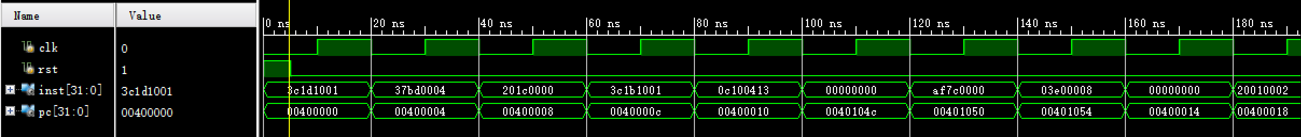

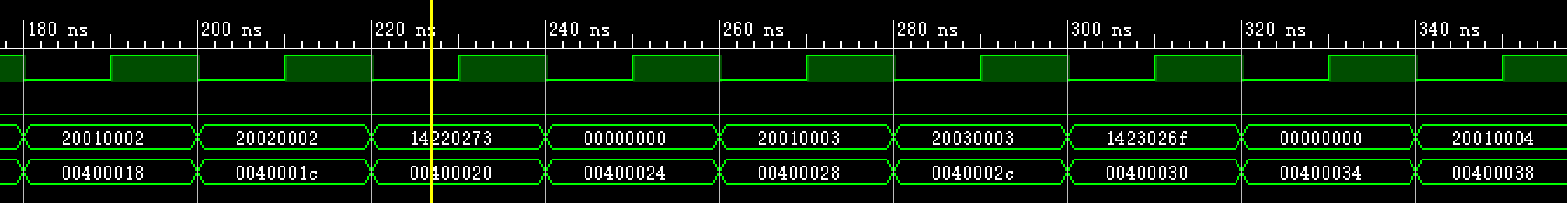

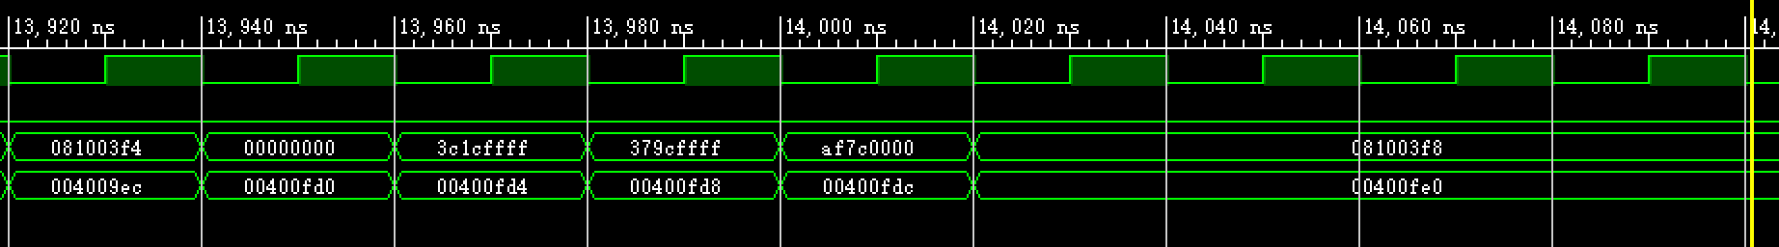

1. 后仿真测试

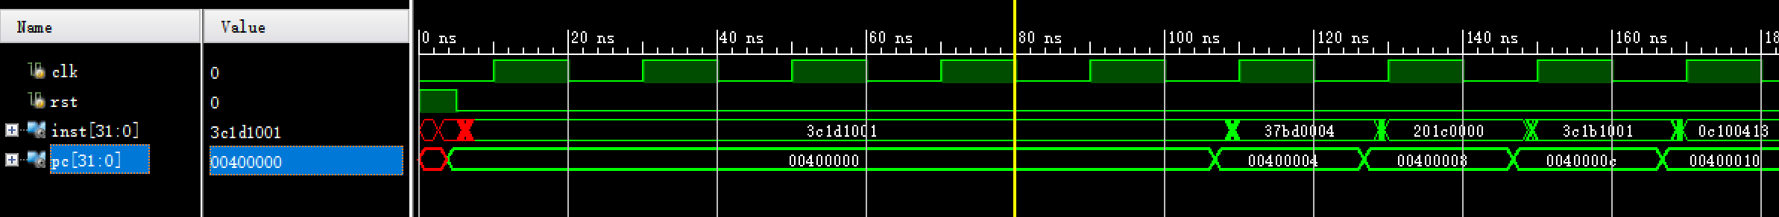

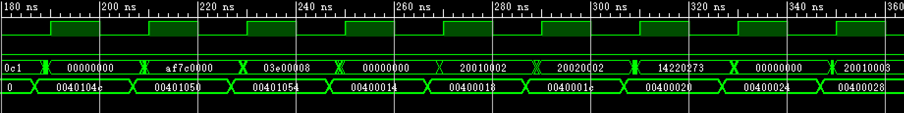

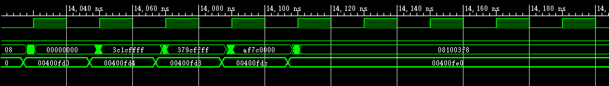

1. 下板测试

Inst:

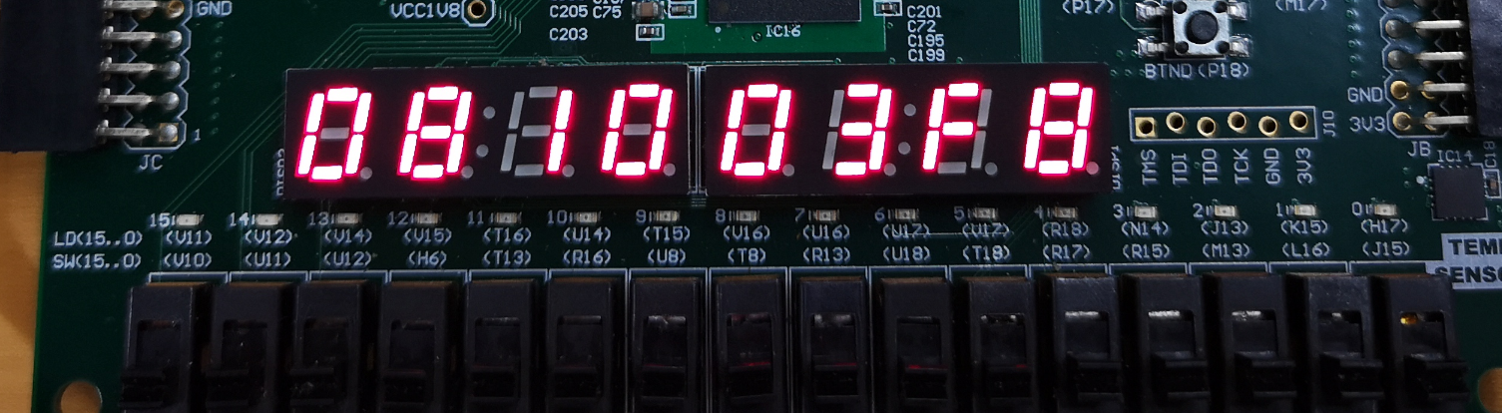

PC:

