数据通路;

1 ADD

格式：ADD rd, rs, rt

操作：取指令，rd←rs+rt, PC←NPC(PC+4)

所需部件：PC, NPC, IMEM, Regfile, ALU

输入输出关系：

|  |  |  |  |  |  |  |  |
| --- | --- | --- | --- | --- | --- | --- | --- |
|  | PC | NPC | IMEM | Rgefile | | ALU | |
|  |  |  |  | Rd | Rdc | A | B |
| ADD | NPC | PC | PC | ALU | 15-11 | Rs | Rt |

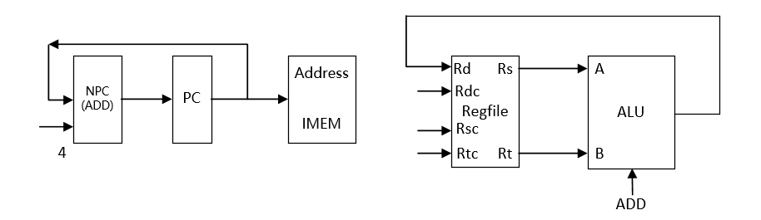

2 ADDU

格式：ADDU rd, rs, rt

操作：取指令，rd←rs+rt, PC←NPC(PC+4)

所需部件：PC, NPC, IMEM, Regfile, ALU

输入输出关系：

|  |  |  |  |  |  |  |  |
| --- | --- | --- | --- | --- | --- | --- | --- |
|  | PC | NPC | IMEM | Rgefile | | ALU | |
|  |  |  |  | Rd | Rdc | A | B |
| ADDU | NPC | PC | PC | ALU | 15-11 | Rs | Rt |

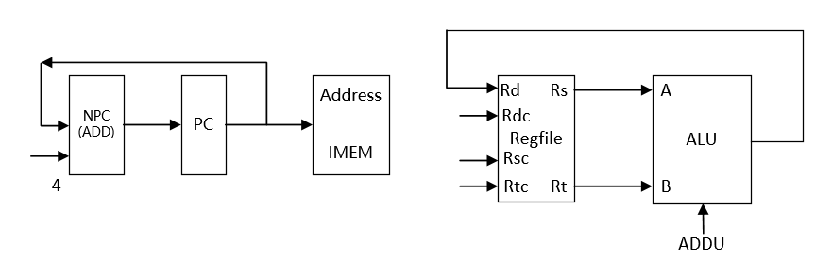

3 SUB

格式：SUB rd, rs, rt

操作：取指令，rd←rs-rt, PC←NPC(PC+4)

所需部件：PC, NPC, IMEM, Regfile, ALU

输入输出关系：

|  |  |  |  |  |  |  |  |
| --- | --- | --- | --- | --- | --- | --- | --- |
|  | PC | NPC | IMEM | Rgefile | | ALU | |
|  |  |  |  | Rd | Rdc | A | B |
| SUB | NPC | PC | PC | ALU | 15-11 | Rs | Rt |

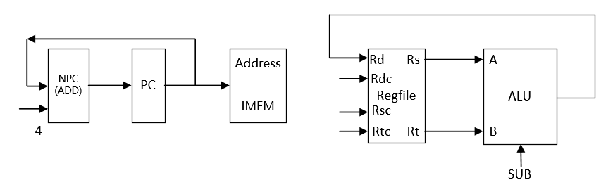

4 SUBU

格式：SUBU rd, rs, rt

操作：取指令，rd←rs-rt, PC←NPC(PC+4)

所需部件：PC, NPC, IMEM, Regfile, ALU

输入输出关系：

|  |  |  |  |  |  |  |  |
| --- | --- | --- | --- | --- | --- | --- | --- |
|  | PC | NPC | IMEM | Rgefile | | ALU | |
|  |  |  |  | Rd | Rdc | A | B |
| SUBU | NPC | PC | PC | ALU | 15-11 | Rs | Rt |

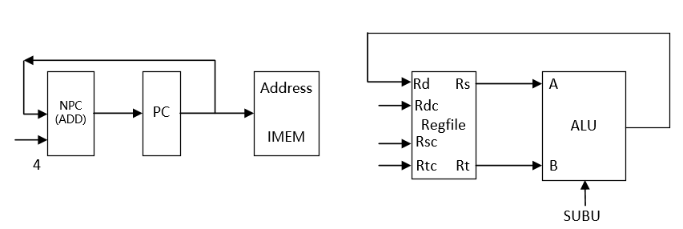

5 AND

格式：AND rd, rs, rt

操作：取指令，rd←rs & rt, PC←NPC(PC+4)

所需部件：PC, NPC, IMEM, Regfile, ALU

输入输出关系：

|  |  |  |  |  |  |  |  |
| --- | --- | --- | --- | --- | --- | --- | --- |
|  | PC | NPC | IMEM | Rgefile | | ALU | |
|  |  |  |  | Rd | Rdc | A | B |
| AND | NPC | PC | PC | ALU | 15-11 | Rs | Rt |

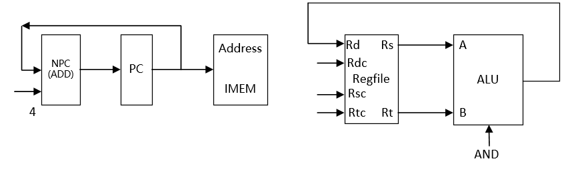

6 OR

格式：OR rd, rs, rt

操作：取指令，rd←rs | rt, PC←NPC(PC+4)

所需部件：PC, NPC, IMEM, Regfile, ALU

输入输出关系：

|  |  |  |  |  |  |  |  |
| --- | --- | --- | --- | --- | --- | --- | --- |
|  | PC | NPC | IMEM | Rgefile | | ALU | |
|  |  |  |  | Rd | Rdc | A | B |
| OR | NPC | PC | PC | ALU | 15-11 | Rs | Rt |

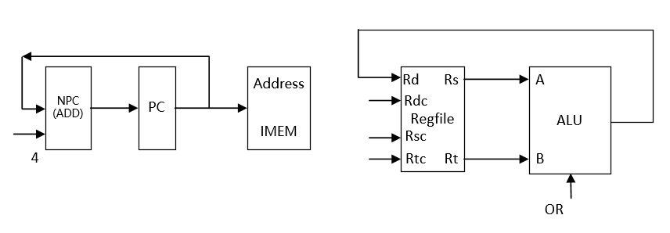

7 XOR

格式：XOR rd, rs, rt

操作：取指令，rd←rs ^ rt, PC←NPC(PC+4)

所需部件：PC, NPC, IMEM, Regfile, ALU

输入输出关系：

|  |  |  |  |  |  |  |  |
| --- | --- | --- | --- | --- | --- | --- | --- |
|  | PC | NPC | IMEM | Rgefile | | ALU | |
|  |  |  |  | Rd | Rdc | A | B |
| XOR | NPC | PC | PC | ALU | 15-11 | Rs | Rt |

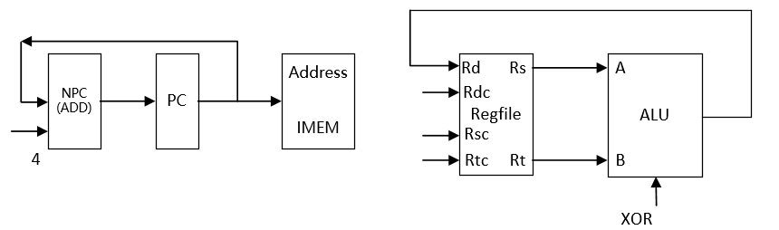

8 NOR

格式：NOR rd, rs, rt

操作：取指令，rd←~(rs | rt), PC←NPC(PC+4)

所需部件：PC, NPC, IMEM, Regfile, ALU

输入输出关系：

|  |  |  |  |  |  |  |  |
| --- | --- | --- | --- | --- | --- | --- | --- |
|  | PC | NPC | IMEM | Rgefile | | ALU | |
|  |  |  |  | Rd | Rdc | A | B |
| NOR | NPC | PC | PC | ALU | 15-11 | Rs | Rt |

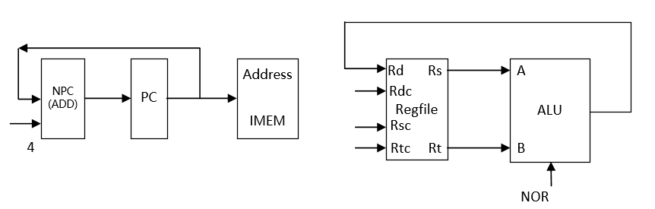

9 SLT

格式：SLT rd, rs, rt

操作：取指令，rd← rs < rt , PC←NPC(PC+4)

所需部件：PC, NPC, IMEM, Regfile, ALU

输入输出关系：

|  |  |  |  |  |  |  |  |
| --- | --- | --- | --- | --- | --- | --- | --- |
|  | PC | NPC | IMEM | Rgefile | | ALU | |
|  |  |  |  | Rd | Rdc | A | B |
| SLT | NPC | PC | PC | ALU | 15-11 | Rs | Rt |

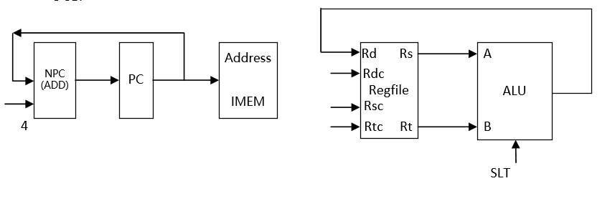

10 SLTU

格式：SLTU rd, rs, rt

操作：取指令，rd← rs < rt , PC←NPC(PC+4)

所需部件：PC, NPC, IMEM, Regfile, ALU

输入输出关系：

|  |  |  |  |  |  |  |  |
| --- | --- | --- | --- | --- | --- | --- | --- |
|  | PC | NPC | IMEM | Rgefile | | ALU | |
|  |  |  |  | Rd | Rdc | A | B |
| SLTU | NPC | PC | PC | ALU | 15-11 | Rs | Rt |

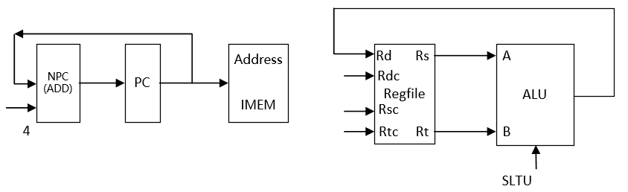

11 SLL

格式：SLL rd, rt, sa

操作：取指令, rd←rt << sa , PC←NPC(PC+4)

所需部件：PC, NPC, IMEM, Regfile, ALU, Ext5

输入输出关系：

|  |  |  |  |  |  |  |  |  |
| --- | --- | --- | --- | --- | --- | --- | --- | --- |
|  | PC | NPC | IMEM | Rgefile | | ALU | | Ext5 |
|  |  |  |  | Rd | Rdc | A | B |  |
| SLL | NPC | PC | PC | ALU | 15-11 | Ext5 | Rt | Sa |

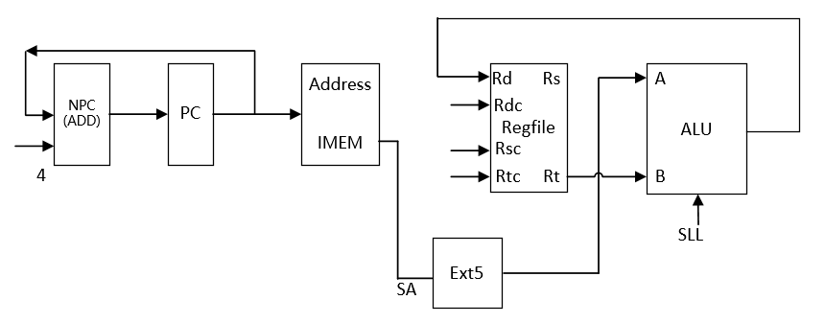

12 SRL

格式：SRL rd, rt, sa

操作：取指令, rd←rt >> sa (logical) , PC←NPC(PC+4)

所需部件：PC, NPC, IMEM, Regfile, ALU, Ext5

输入输出关系：

|  |  |  |  |  |  |  |  |  |
| --- | --- | --- | --- | --- | --- | --- | --- | --- |
|  | PC | NPC | IMEM | Rgefile | | ALU | | Ext5 |
|  |  |  |  | Rd | Rdc | A | B |  |
| SRL | NPC | PC | PC | ALU | 15-11 | Ext5 | Rt | Sa |

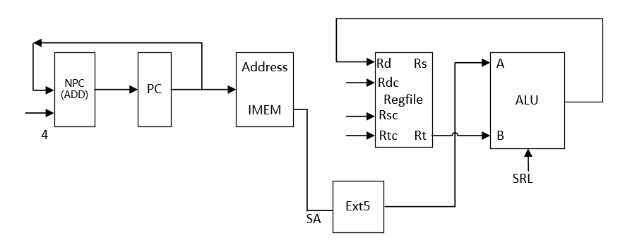

13 SRA

格式：SRA rd, rt, sa

操作：取指令, rd←rt >> sa (arithmetic) , PC←NPC(PC+4)

所需部件：PC, NPC, IMEM, Regfile, ALU, Ext5

输入输出关系：

|  |  |  |  |  |  |  |  |  |
| --- | --- | --- | --- | --- | --- | --- | --- | --- |
|  | PC | NPC | IMEM | Rgefile | | ALU | | Ext5 |
|  |  |  |  | Rd | Rdc | A | B |  |
| SRA | NPC | PC | PC | ALU | 15-11 | Ext5 | Rt | Sa |

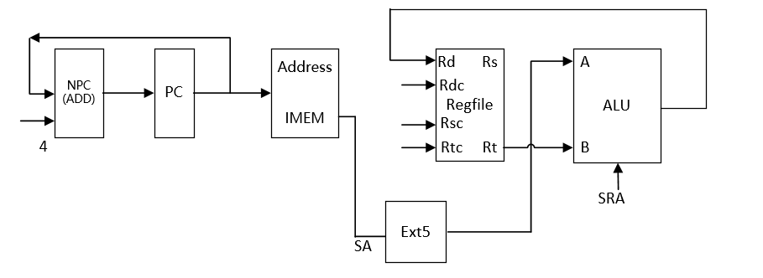

14 SLLV

格式：SLLV rd, rt, rs,

操作：取指令, rd←rt << rs , PC←NPC(PC+4)

所需部件：PC, NPC, IMEM, Regfile, ALU

输入输出关系：

|  |  |  |  |  |  |  |  |
| --- | --- | --- | --- | --- | --- | --- | --- |
|  | PC | NPC | IMEM | Rgefile | | ALU | |
|  |  |  |  | Rd | Rdc | A | B |
| SLLV | NPC | PC | PC | ALU | 15-11 | Rs | Rt |

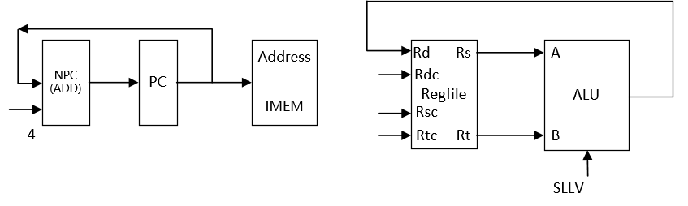

15 SRLV

格式：SRLV rd, rt,rs

操作：取指令, rd←rt >> rs (logical) , PC←NPC(PC+4)

所需部件：PC, NPC, IMEM, Regfile, ALU

输入输出关系：

|  |  |  |  |  |  |  |  |
| --- | --- | --- | --- | --- | --- | --- | --- |
|  | PC | NPC | IMEM | Rgefile | | ALU | |
|  |  |  |  | Rd | Rdc | A | B |
| SRLV | NPC | PC | PC | ALU | 15-11 | Rs | Rt |

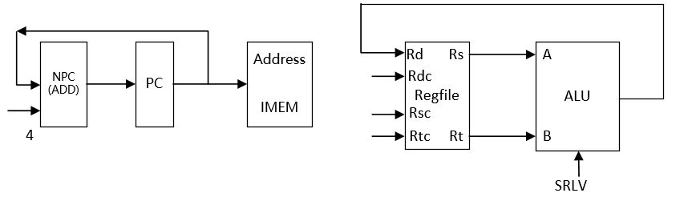

16 SRAV

格式：SRAV rd, rt,rs

操作：取指令, rd←rt >> rs (arithmetic) , PC←NPC(PC+4)

所需部件：PC, NPC, IMEM, Regfile, ALU

输入输出关系：

|  |  |  |  |  |  |  |  |
| --- | --- | --- | --- | --- | --- | --- | --- |
|  | PC | NPC | IMEM | Rgefile | | ALU | |
|  |  |  |  | Rd | Rdc | A | B |
| SRAV | NPC | PC | PC | ALU | 15-11 | Rs | Rt |

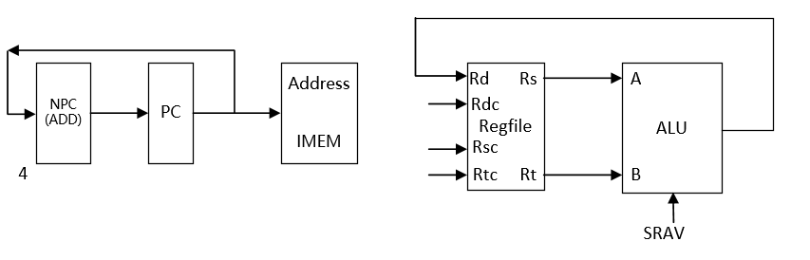

17 JR

格式：JR rs

操作：取指令, PC←rs, PC←NPC(PC+4)

所需部件：PC, NPC, IMEM, Regfile

输入输出关系：

|  |  |  |  |  |  |  |  |
| --- | --- | --- | --- | --- | --- | --- | --- |
|  | PC | NPC | IMEM | Rgefile | | ALU | |
|  |  |  |  | Rd | Rdc | A | B |
| JR | Rs | PC | PC |  |  |  |  |

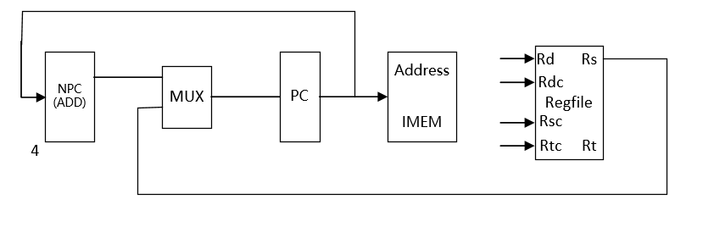

18 ADDI

格式：ADDI rt, rs, imm16

操作：取指令、rt←rs+imm16(sign_extend) 、PC←NPC(PC+4)

所需部件：：PC、NPC、IMEM、Rregfile、ALU、Ext16

输入输出关系：

|  |  |  |  |  |  |  |  |  |
| --- | --- | --- | --- | --- | --- | --- | --- | --- |
|  | PC | NPC | IMEM | Rgefile | | ALU | | Ext16 |
|  |  |  |  | Rd | Rdc | A | B |  |
| ADDI | NPC | PC | PC | ALU | 20-16 | Rs | Ext16 | Imm16 |

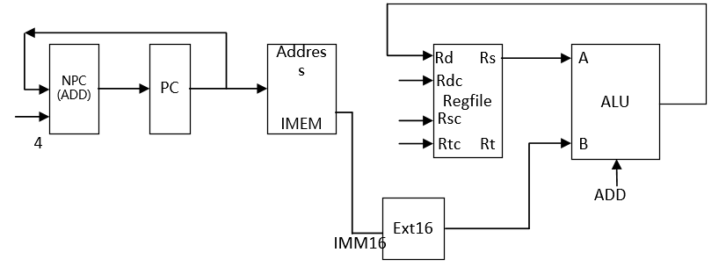

19 ADDIU

格式：ADDIU rt, rs, imm16

操作：取指令、rt←rs+imm16(sign_extend) 、PC←NPC(PC+4)

所需部件：PC、NPC、IMEM、Rregfile、ALU、Ext16

输入输出关系：

|  |  |  |  |  |  |  |  |  |
| --- | --- | --- | --- | --- | --- | --- | --- | --- |
|  | PC | NPC | IMEM | Rgefile | | ALU | | Ext16 |
|  |  |  |  | Rd | Rdc | A | B |  |
| ADDIU | NPC | PC | PC | ALU | 20-16 | Rs | Ext16 | Imm16 |

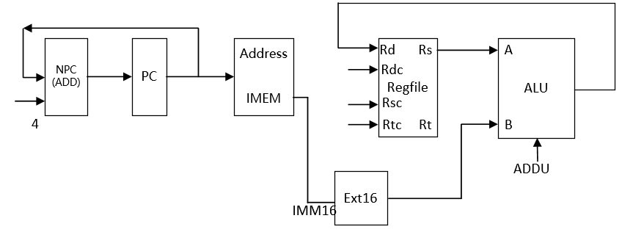

20 ANDI

格式：ANDI rt, rs, imm16

操作：取指令、rt←rs&imm16(zero_extend) 、PC←NPC(PC+4)

所需部件：PC、NPC、IMEM、Rregfile、ALU、Ext16

输入输出关系：

|  |  |  |  |  |  |  |  |  |
| --- | --- | --- | --- | --- | --- | --- | --- | --- |
|  | PC | NPC | IMEM | Rgefile | | ALU | | Ext16 |
|  |  |  |  | Rd | Rdc | A | B |  |
| ANDI | NPC | PC | PC | ALU | 20-16 | Rs | Ext16 | Imm16 |

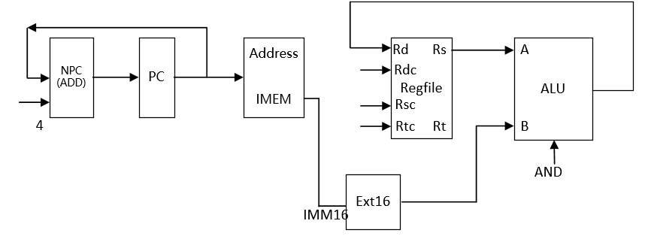

21 ORI

格式：ORI rt, rs, imm16

操作：取指令、rt←rs|imm16(zero_extend) 、PC←NPC(PC+4)

所需部件：PC、NPC、IMEM、Rregfile、ALU、Ext16

输入输出关系：

|  |  |  |  |  |  |  |  |  |
| --- | --- | --- | --- | --- | --- | --- | --- | --- |
|  | PC | NPC | IMEM | Rgefile | | ALU | | Ext16 |
|  |  |  |  | Rd | Rdc | A | B |  |
| ORI | NPC | PC | PC | ALU | 20-16 | Rs | Ext16 | Imm16 |

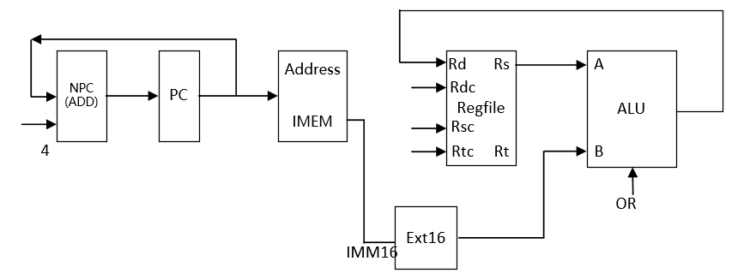

22 XORI

格式：XORI rt, rs, imm16

操作：取指令、rt←rs^imm16(zero_extend) 、PC←NPC(PC+4)

所需部件：PC、NPC、IMEM、Rregfile、ALU、Ext16

输入输出关系：

|  |  |  |  |  |  |  |  |  |
| --- | --- | --- | --- | --- | --- | --- | --- | --- |
|  | PC | NPC | IMEM | Rgefile | | ALU | | Ext16 |
|  |  |  |  | Rd | Rdc | A | B |  |
| XORI | NPC | PC | PC | ALU | 20-16 | Rs | Ext16 | Imm16 |

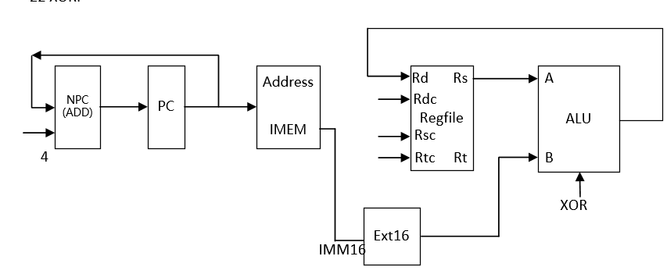

23 LW

格式：LW rt, offset(base)

操作：取指令、rt←memory[rs + offset]、PC←NPC(PC+4)

所需部件：PC、NPC、IMEM、ALU、Ext16、DMEM

输入输出关系：

|  |  |  |  |  |  |  |  |  |  |  |
| --- | --- | --- | --- | --- | --- | --- | --- | --- | --- | --- |
|  | PC | NPC | IMEM | Rgefile | | ALU | | Ext16 | DMEM | |
|  |  |  |  | Rd | Rdc | A | B |  | Addr | Data |
| LW | NPC | PC | PC | DMEM  (data) | 20-16 | Rs  (base) | Ext16 | Offset | ALU |  |

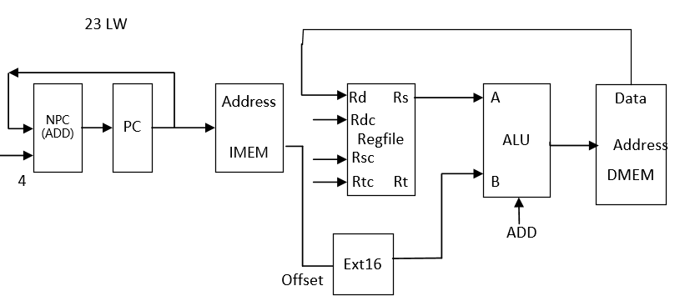

24 SW

格式：SW rt, offset(base)

操作：取指令、memory[base + offset]←rt、PC←NPC(PC+4)

所需部件：PC、NPC、IMEM、ALU、Ext16、DMEM

输入输出关系：

|  |  |  |  |  |  |  |  |  |  |  |
| --- | --- | --- | --- | --- | --- | --- | --- | --- | --- | --- |
|  | PC | NPC | IMEM | Rgefile | | ALU | | Ext16 | DMEM | |
|  |  |  |  | Rd | Rdc | A | B |  | Addr | Data |
| SW | NPC | PC | PC | DMEM  (data) |  | Rs  (base) | Ext16 | Offset | ALU | Rt |

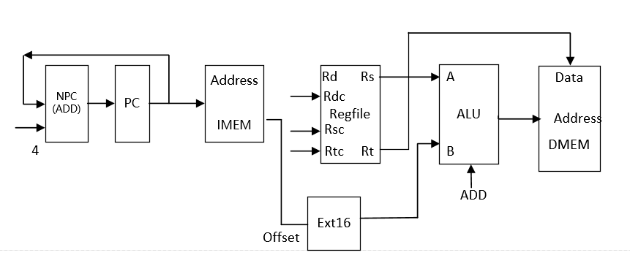

25 BEQ

格式：BEQ rs, rt, offset

操作: if (rs=rt)PC←NPC + Sign_ext(offset||02)

else PC← NPC(PC+4)

所需部件：PC、NPC、IMEM、Regfile、ALU、Ext18、ADD

输入输出关系：

|  |  |  |  |  |  |  |  |  |  |  |
| --- | --- | --- | --- | --- | --- | --- | --- | --- | --- | --- |
|  | PC | NPC | IMEM | Rgefile | | ALU | | Ext18 | ADD | |
|  |  |  |  | Rd | Rdc | A | B |  | A | B |
| BEQ | ADD | PC | PC |  |  | Rs | Rt | Offset | Ext18 | NPC |

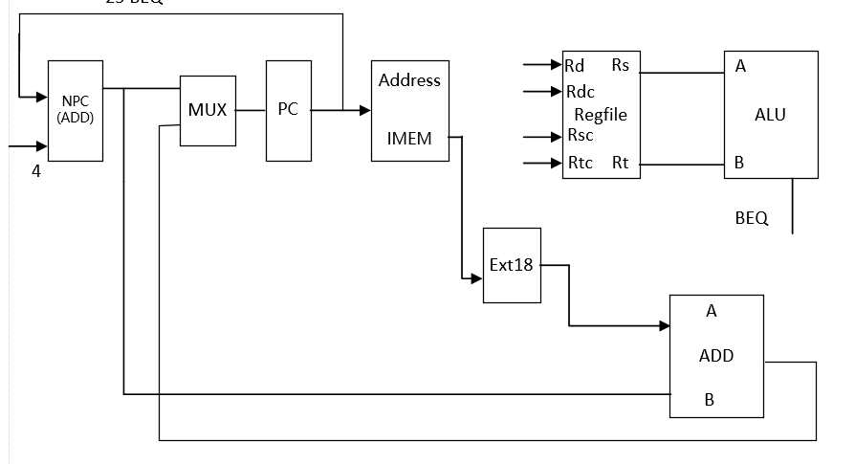

26 BNE

格式：BNE rs, rt, offset

操作：if (rs≠rt)PC←NPC + Sign_ext(offset||02)

else PC← NPC(PC+4)

所需部件：PC、NPC、IMEM、Regfile、ALU、Ext18、ADD

输入输出关系：

|  |  |  |  |  |  |  |  |  |  |  |
| --- | --- | --- | --- | --- | --- | --- | --- | --- | --- | --- |
|  | PC | NPC | IMEM | Rgefile | | ALU | | Ext18 | ADD | |
|  |  |  |  | Rd | Rdc | A | B |  | A | B |
| BNE | ADD | PC | PC |  |  | Rs | Rt | Offset | Ext18 | NPC |

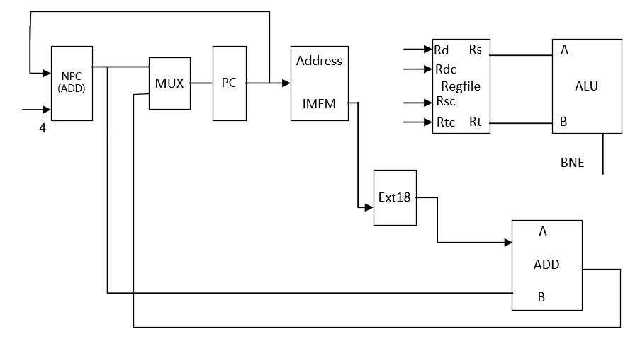

27 SLTI

格式：SLTI rt, rs, imm16

操作：取指令、rt←rs < ext.imm16(sign_extend) 、PC←NPC(PC+4)

所需部件：PC、NPC、IMEM、Rregfile、ALU、Ext16

输入输出关系：

|  |  |  |  |  |  |  |  |  |
| --- | --- | --- | --- | --- | --- | --- | --- | --- |
|  | PC | NPC | IMEM | Rgefile | | ALU | | Ext16 |
|  |  |  |  | Rd | Rdc | A | B |  |
| SLTI | NPC | PC | PC | ALU | 20-16 | Rs | Ext16 | Imm16 |

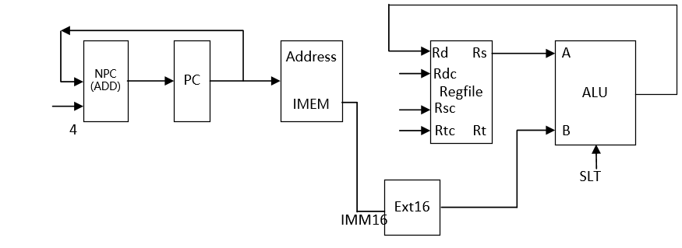

28 SLTIU

格式：SLTIU rt, rs, imm16

操作：取指令、rt←rs < ext.imm16(sign_extend) 、PC←NPC(PC+4)

所需部件：PC、NPC、IMEM、Rregfile、ALU、Ext16

输入输出关系：

|  |  |  |  |  |  |  |  |  |
| --- | --- | --- | --- | --- | --- | --- | --- | --- |
|  | PC | NPC | IMEM | Rgefile | | ALU | | Ext16 |
|  |  |  |  | Rd | Rdc | A | B |  |
| SLTIU | NPC | PC | PC | ALU | 20-16 | Rs | Ext16 | Imm16 |

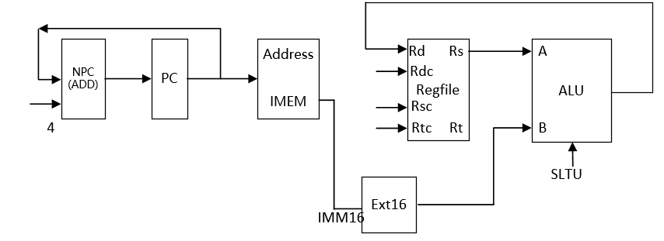

29 LUI

格式：LUI rt, imm16

操作：取指令、rt←imm16||016 、PC←NPC(PC+4)

所需部件：PC、NPC、IMEM、Rregfile、ALU、Ext16

输入输出关系：

|  |  |  |  |  |  |  |  |  |
| --- | --- | --- | --- | --- | --- | --- | --- | --- |
|  | PC | NPC | IMEM | Rgefile | | ALU | | Ext16 |
|  |  |  |  | Rd | Rdc | A | B |  |
| LUI | NPC | PC | PC | ALU | 20-16 |  | Ext16 | Imm16 |

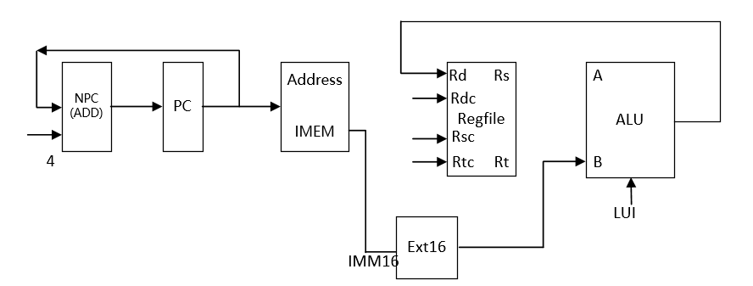

30 J

格式：J target

操作：取指令、PC ← PC31-28||instr_index||02 , PC←NPC(PC+4)

所需部件：PC、NPC、IMEM

输入输出关系：

|  |  |  |  |  |  |  |  |  |
| --- | --- | --- | --- | --- | --- | --- | --- | --- |
|  | PC | NPC | IMEM | Rgefile | | ALU | |  |
|  |  |  |  | Rd | Rdc | A | B |  |
| J | || | PC | PC |  |  |  |  |  |

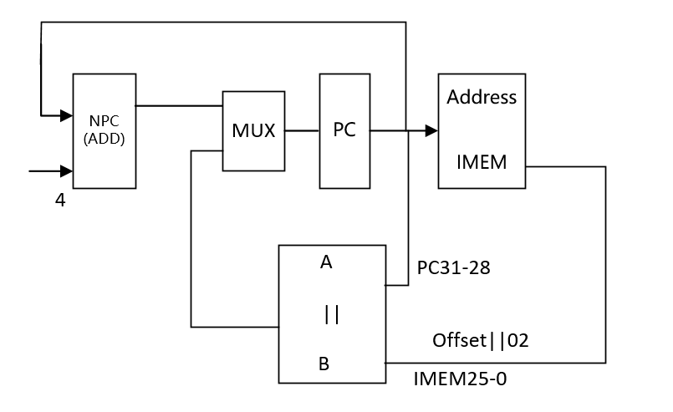

31 JAL

格式：JAL target

操作：取指令、 R[31] ← PC + 8,PC ← PC31-28||instr_index||02 , PC←PC+4

所需部件：PC、NPC、IMEM

输入输出关系：

|  |  |  |  |  |  |  |  |  |
| --- | --- | --- | --- | --- | --- | --- | --- | --- |
|  | PC | NPC | IMEM | Rgefile | | ALU | |  |
|  |  |  |  | Rd | Rdc | A | B |  |
| JAL | || | PC | PC | ALU |  | PC | 8 |  |

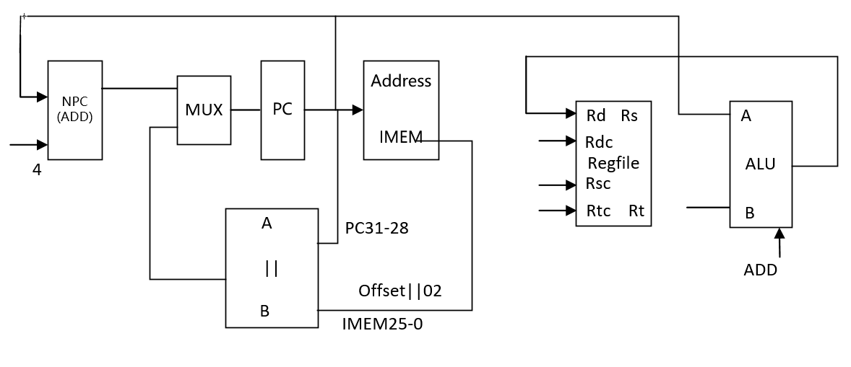

32 BREAK

格式：BREAK MIPS32

操作：取指令、 EPC ← PC, cause ← 01001, status<<5, PC←PC+4

所需部件：PC、NPC、CP0

输入输出关系：

|  |  |  |  |  |  |  |  |
| --- | --- | --- | --- | --- | --- | --- | --- |
|  | PC | NPC | IMEM |  | EPC | cause | exception |
| BREAK | NPC | PC | PC |  | PC | 01001 | 1 |

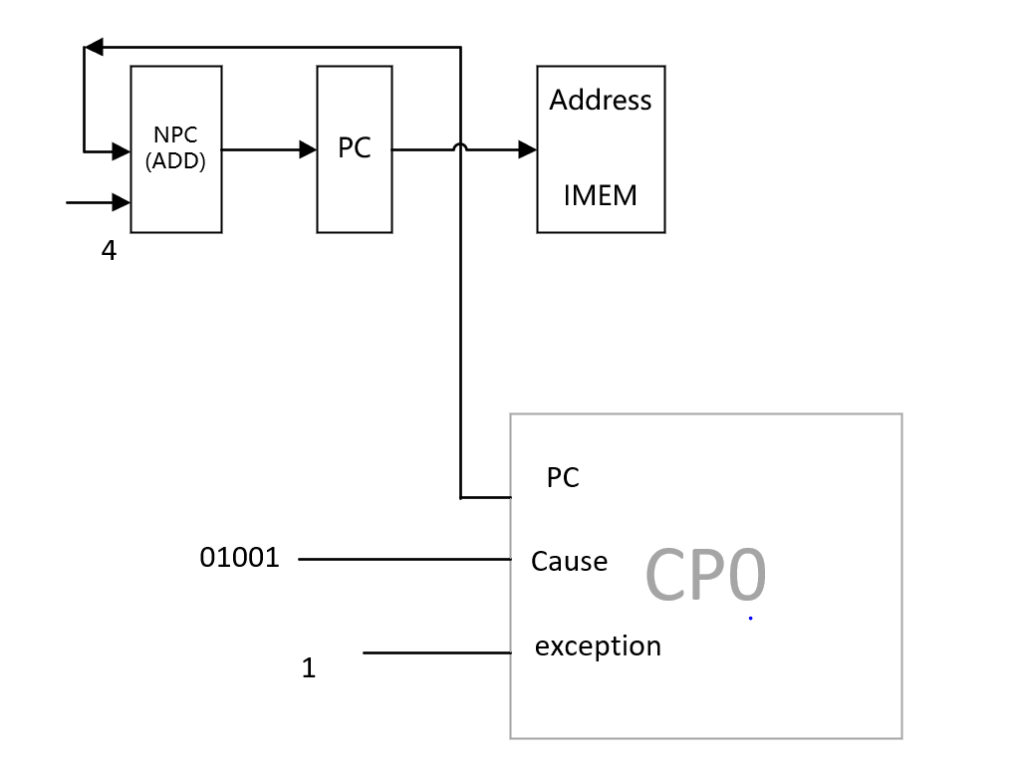

33 SYSCALL

格式：SYSCALL

操作：取指令、 EPC ← PC, cause ← 01000, status<<5, PC←PC+4

所需部件：PC、NPC、CP0

输入输出关系：

|  |  |  |  |  |  |  |
| --- | --- | --- | --- | --- | --- | --- |
|  | PC | NPC | IMEM | EPC | cause | exception |
| break | NPC | PC | PC | PC | 01000 | 1 |

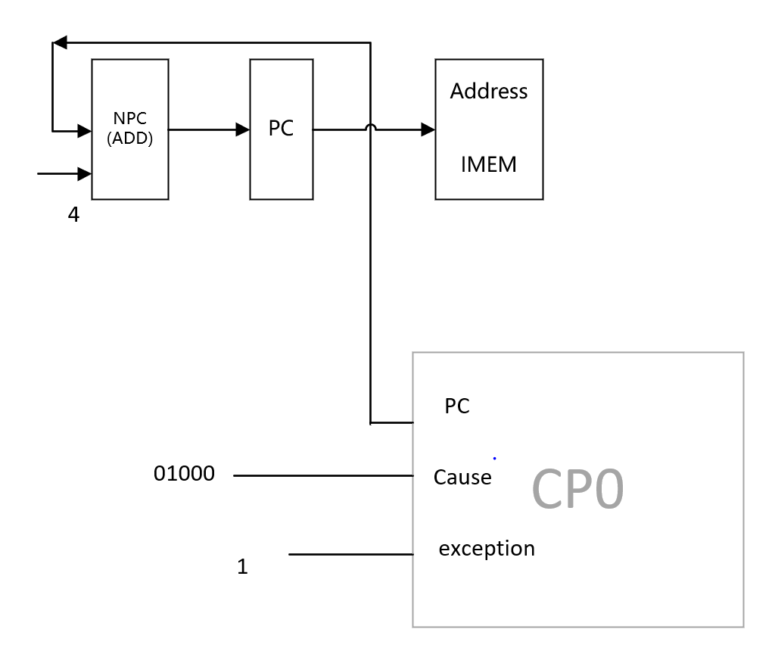

34 TEQ

格式：TEQ rs,rt

操作取指令、 R[rs]-R[rt]、EPC ← PC、cause ← 01000, status<<5, PC←PC+4

所需部件：PC、NPC、CP0、IMEM、Regfiles、ALU

输入输出关系：

|  |  |  |  |  |  |  |  |  |
| --- | --- | --- | --- | --- | --- | --- | --- | --- |
|  | PC | NPC | IMEM | EPC | cause | exception | ALU | |
|  |  |  |  |  |  |  | A | B |
| teq | NPC | PC | PC | PC | 01101 | 1 | Rs | Rt |

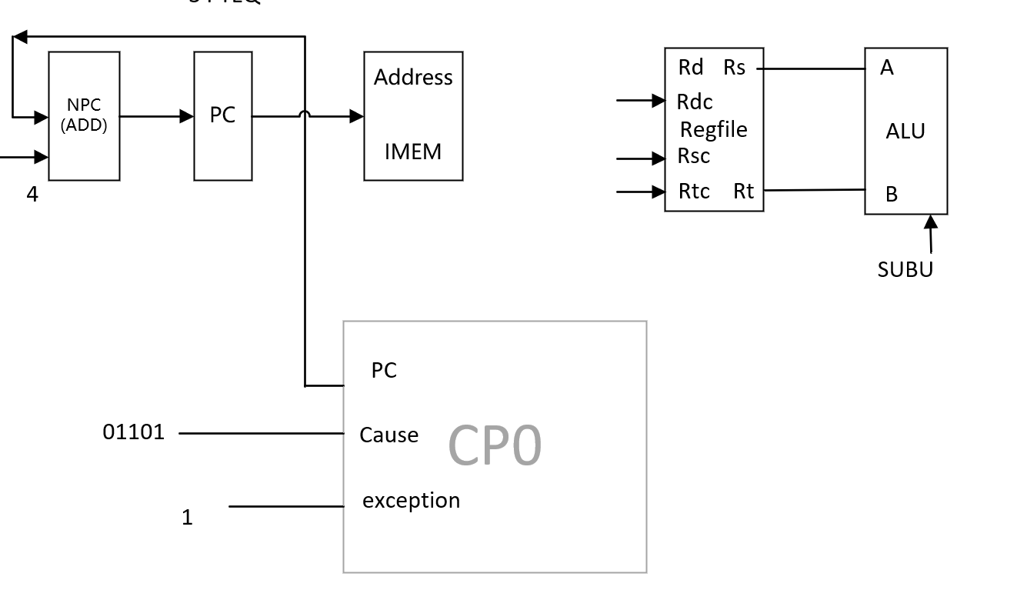

35 ERET

格式：ERET

操作：取指令、 PC ← EPC, PC←PC+4

所需部件: PC、NPC、CP0

输入输出关系：

|  |  |  |  |  |
| --- | --- | --- | --- | --- |
|  | PC | NPC | IMEM |  |
| eret | EPC | PC | PC |  |

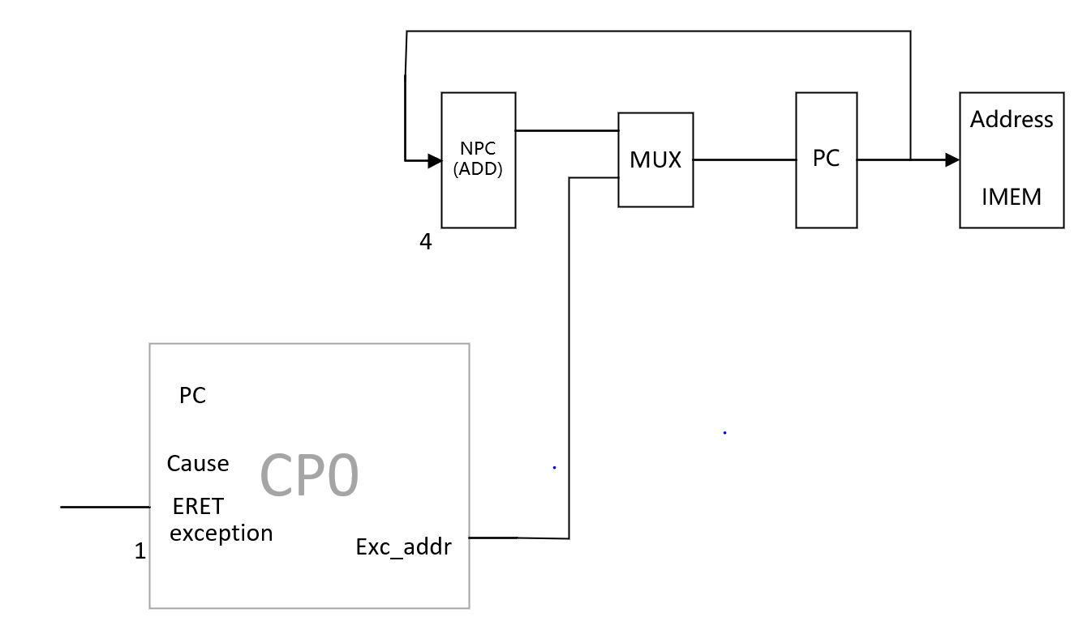

36 MFC0

格式：MFC0 rt,rd

MFC0 rt,rd,sel

操作：取指令、 R[rt] ← CP0 R[rd], PC←PC+4

所需部件：PC、NPC、CP0、Rregfile

输入输出关系：

|  |  |  |  |  |  |
| --- | --- | --- | --- | --- | --- |
|  | PC | NPC | IMEM | RegFile |  |
|  |  |  |  | Rd |  |
| MFC0 | NPC | PC | PC | Rdata |  |

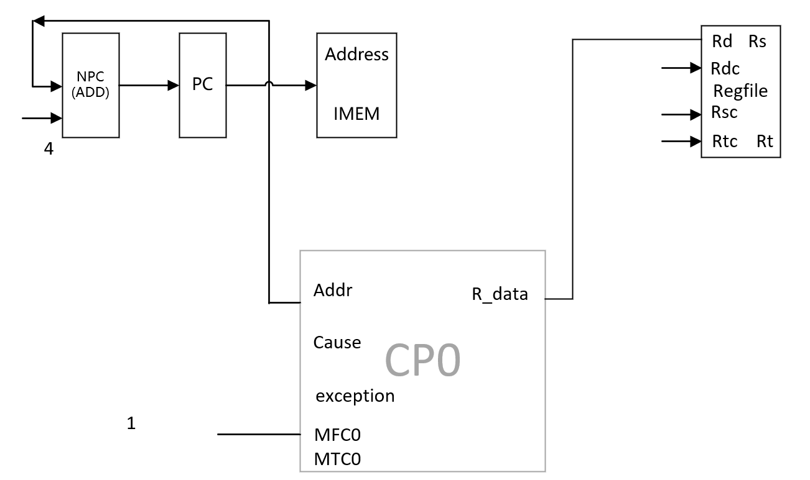

37 MTC0

格式：MTC0 rt,rd

MTC0 rt,rd,sel

操作：取指令、 CP0 R[rd] ←R[rt], PC←PC+4

所需部件：PC、NPC、CP0、Rregfile

输入输出关系：

|  |  |  |  |  |  |
| --- | --- | --- | --- | --- | --- |
|  | PC | NPC | IMEM |  |  |
| MTC0 | NPC | PC | PC |  |  |

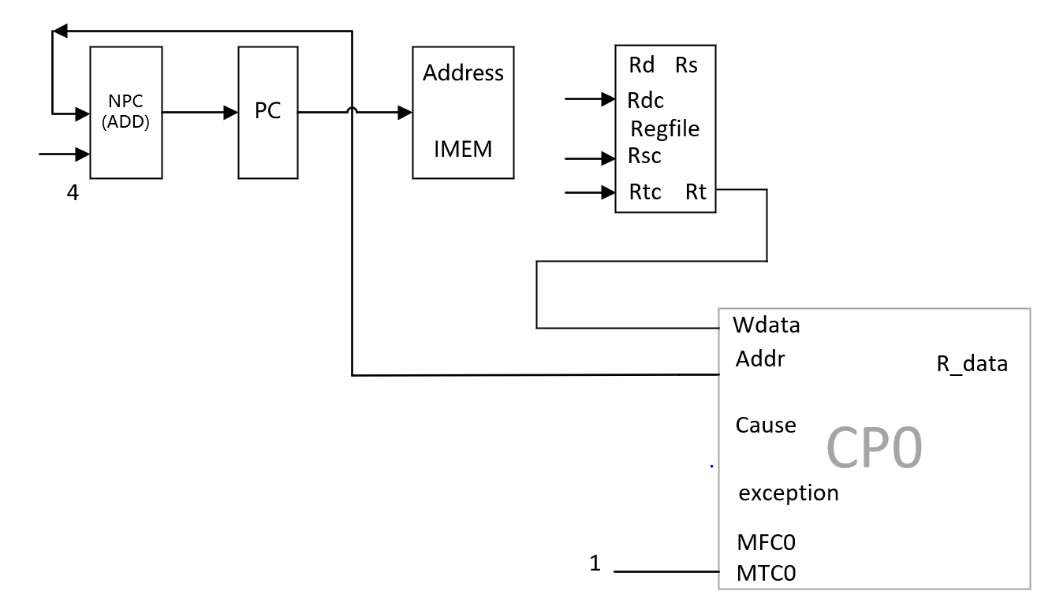

38、Clz rd rs

所需的操作: 取指令、R[rd] ←count_leading_zeros R[rs], PC←PC+4

所需器件：PC、NPC、Rregfile



|  |  |  |  |  |
| --- | --- | --- | --- | --- |
|  | PC | NPC | IMEM | RegFile |
|  |  |  |  | Rd |
| clz | NPC | PC | PC | TEMP |

39、DIVU rd rs

所需的操作: 取指令、(HI,LO)←R[rd]/R[rt], PC←PC+4

所需器件：PC、NPC、Rregfile、DIVU、LO、HI



|  |  |  |  |  |  |  |  |
| --- | --- | --- | --- | --- | --- | --- | --- |
|  | PC | NPC | IMEM | DIVU | | LO | HI |
|  |  |  |  | dividend | divisor |  |  |
| divu | npc | pc | pc | rs | rt | q | r |

40、DIV rd rs

所需的操作: 取指令、(HI,LO)←R[rd]/R[rt], PC←PC+4

所需器件：PC、NPC、Rregfile、DIV、LO、HI



|  |  |  |  |  |  |  |  |
| --- | --- | --- | --- | --- | --- | --- | --- |
|  | PC | NPC | IMEM | DIV | | LO | HI |
|  |  |  |  | dividend | divisor |  |  |
| divu | npc | pc | pc | rs | rt | q | r |

41、Lb rt,offset(base);

所需的操作: 取指令、R[rt]←memory[R[base] + offset]、PC←PC+4

所需器件：PC、NPC、IMEM、ALU、Ext16、DMEM



|  |  |  |  |  |  |  |  |  |  |  |
| --- | --- | --- | --- | --- | --- | --- | --- | --- | --- | --- |
|  | PC | NPC | IMEM | RegFile | ALU | | Ext16 | Ext5 | DMEM | |
|  |  |  |  | Rd | A | B |  |  | Addr | Data |
| Lb | NPC | PC | PC | DMEM  (data) | Rs  (base) | Ext16 | offset |  | ALU |  |

42、Lbu rt,offset(base);

所需的操作: 取指令、R[rt]←memory[R[base] + offset]、PC←PC+4

所需器件：PC、NPC、IMEM、ALU、Ext16、DMEM



|  |  |  |  |  |  |  |  |  |  |  |
| --- | --- | --- | --- | --- | --- | --- | --- | --- | --- | --- |
|  | PC | NPC | IMEM | RegFile | ALU | | Ext16 | Ext5 | DMEM | |
|  |  |  |  | Rd | A | B |  |  | Addr | Data |
| Lbu | NPC | PC | PC | DMEM  (data) | Rs  (base) | Ext16 | offset |  | ALU |  |

43、Lhu rt,offset(base);

所需的操作: 取指令、R[rt]←memory[R[base] + offset]、PC←PC+4

所需器件：PC、NPC、IMEM、ALU、Ext16、DMEM



|  |  |  |  |  |  |  |  |  |  |  |
| --- | --- | --- | --- | --- | --- | --- | --- | --- | --- | --- |
|  | PC | NPC | IMEM | RegFile | ALU | | Ext16 | Ext5 | DMEM | |
|  |  |  |  | Rd | A | B |  |  | Addr | Data |
| Lhu | NPC | PC | PC | DMEM  (data) | Rs  (base) | Ext16 | offset |  | ALU |  |

44、Lh rt,offset(base);

所需的操作: 取指令、R[rt]←memory[R[base] + offset]、PC←PC+4

所需器件：PC、NPC、IMEM、ALU、Ext16、DMEM



|  |  |  |  |  |  |  |  |  |  |  |
| --- | --- | --- | --- | --- | --- | --- | --- | --- | --- | --- |
|  | PC | NPC | IMEM | RegFile | ALU | | Ext16 | Ext5 | DMEM | |
|  |  |  |  | Rd | A | B |  |  | Addr | Data |
| Lh | NPC | PC | PC | DMEM  (data) | Rs  (base) | Ext16 | offset |  | ALU |  |

45、Sb rt,offset(base);

所需的操作: 取指令、memory[R[base] + offset] ← R[rt]、PC←PC+4

所需器件：PC、NPC、IMEM、ALU、Ext16、DMEM



|  |  |  |  |  |  |  |  |  |  |  |
| --- | --- | --- | --- | --- | --- | --- | --- | --- | --- | --- |
|  | PC | NPC | IMEM | RegFile | ALU | | Ext16 | Ext5 | DMEM | |
|  |  |  |  | Rd | A | B |  |  | Addr | Data |
| Sb | NPC | PC | PC | DMEM  (data) | Rs  (base) | Ext16 | offset |  | ALU | Rt |

46、Sh rt,offset(base);

所需的操作: 取指令、memory[R[base] + offset] ← R[rt]、PC←PC+4

所需器件：PC、NPC、IMEM、ALU、Ext16、DMEM



|  |  |  |  |  |  |  |  |  |  |  |
| --- | --- | --- | --- | --- | --- | --- | --- | --- | --- | --- |
|  | PC | NPC | IMEM | RegFile | ALU | | Ext16 | Ext5 | DMEM | |
|  |  |  |  | Rd | A | B |  |  | Addr | Data |
| Sh | NPC | PC | PC | DMEM  (data) | Rs  (base) | Ext16 | offset |  | ALU | Rt |

47、mfhi rd

所需的操作: 取指令、 R[rd] ← HI、PC←PC+4

所需器件：PC、NPC、IMEM、RegFile、HI



|  |  |  |  |  |
| --- | --- | --- | --- | --- |
|  | PC | NPC | IMEM | RegFile |
|  |  |  |  | Rd |
| mfhi | NPC | PC | PC | HI |

48、mflo rd

所需的操作: 取指令、 R[rd] ← LO、PC←PC+4

所需器件：PC、NPC、IMEM、RegFile、LO



|  |  |  |  |  |
| --- | --- | --- | --- | --- |
|  | PC | NPC | IMEM | RegFile |
|  |  |  |  | Rd |
| MfLO | NPC | PC | PC | HI |

49、mthi rd

所需的操作: 取指令、 HI←R[rs]、PC←PC+4

所需器件：PC、NPC、IMEM、RegFile、HI



|  |  |  |  |  |
| --- | --- | --- | --- | --- |
|  | PC | NPC | IMEM | HI |
| mthi | NPC | PC | PC | Rs |

50、mtlo rd

所需的操作: 取指令、 LO←R[rs]、PC←PC+4

所需器件：PC、NPC、IMEM、RegFile、LO



|  |  |  |  |  |
| --- | --- | --- | --- | --- |
|  | PC | NPC | IMEM | LO |
| mtlo | NPC | PC | PC | Rs |

51、MULT rd rs

所需的操作: 取指令、(HI,LO)←R[rs] * R[rt], PC←PC+4

所需器件：PC、NPC、IMEM、Rregfile、MUL、



|  |  |  |  |  |  |  |
| --- | --- | --- | --- | --- | --- | --- |
|  | PC | NPC | IMEM | RegFile | MUL | |
|  |  |  |  | Rd |  | |
| MULT | npc | pc | pc | HI | rs | rt |

52、MULTU rd rs

所需的操作: 取指令、(HI,LO)←R[rs] * R[rt], PC←PC+4

所需器件：PC、NPC、IMEM、Rregfile、MULU、



|  |  |  |  |  |  |  |
| --- | --- | --- | --- | --- | --- | --- |
|  | PC | NPC | IMEM | RegFile | MULU | |
|  |  |  |  | Rd |  | |
| MULTU | npc | pc | pc | HI | rs | rt |

53、Bgez rs,rt,offset ;

所需的操作: if (rs≠rt)PC←NPC + Sign_ext(offset||02)

else PC← NPC(PC+4)

所需器件：PC、NPC、IMEM、Regfile、ALU、Ext18、ADD



|  |  |  |  |  |  |  |  |  |  |  |  |
| --- | --- | --- | --- | --- | --- | --- | --- | --- | --- | --- | --- |
|  | PC | NPC | IMEM | RegFile | ALU | | Ext16 | Ext5 | Ext18 | ADD | |
|  |  |  |  | Rd | A | B |  |  |  | A | B |
| Bgez | ADD | PC | PC |  | Rs | 0 |  |  | Offset | NPC | Ext18 |

54、Jalr rd rs

所需的操作: 取指令、 R[rd] ← PC + 8,PC ← R[rs] , PC←PC+4

所需器件：PC、NPC、IMEM



|  |  |  |  |  |  |  |  |  |
| --- | --- | --- | --- | --- | --- | --- | --- | --- |
|  | PC | NPC | IMEM | RegFile | ALU | | Ext16 | Ext5 |
|  |  |  |  | Rd | A | B |  |  |
| Jalr | Rs | PC | PC | ALU | PC | 8 |  |  |

**所需部件表**

|  |  |  |  |  |  |  |  |  |  |  |  |  |
| --- | --- | --- | --- | --- | --- | --- | --- | --- | --- | --- | --- | --- |
|  |  | PC | NPC | IMEM | RegFile | ALU | | Ext16 | Ext5 | Ext18 | DMEM | |
|  |  |  |  |  | Rd | A | B |  |  |  | Addr | Data |
| 1 | Add | NPC | PC | PC | ALU | Rs | Rt |  |  |  |  |  |
| 2 | Addu | NPC | PC | PC | ALU | Rs | Rt |  |  |  |  |  |
| 3 | Sub | NPC | PC | PC | ALU | Rs | Rt |  |  |  |  |  |
| 4 | Subu | NPC | PC | PC | ALU | Rs | Rt |  |  |  |  |  |
| 5 | and | NPC | PC | PC | ALU | Rs | Rt |  |  |  |  |  |
| 6 | or | NPC | PC | PC | ALU | Rs | Rt |  |  |  |  |  |
| 7 | xor | NPC | PC | PC | ALU | Rs | Rt |  |  |  |  |  |
| 8 | nor | NPC | PC | PC | ALU | Rs | Rt |  |  |  |  |  |
| 9 | slt | NPC | PC | PC | ALU | Rs | Rt |  |  |  |  |  |
| 10 | sltu | NPC | PC | PC | ALU | Rs | Rt |  |  |  |  |  |
| 11 | sllv | NPC | PC | PC | ALU | Rs | Rt |  |  |  |  |  |
| 12 | srlv | NPC | PC | PC | ALU | Rs | Rt |  |  |  |  |  |
| 13 | srav | NPC | PC | PC | ALU | Rs | Rt |  |  |  |  |  |
| 14 | sll | NPC | PC | PC | ALU | Ext5 | Rt |  | sa |  |  |  |
| 15 | srl | NPC | PC | PC | ALU | Ext5 | Rt |  | sa |  |  |  |
| 16 | sra | NPC | PC | PC | ALU | Ext5 | Rt |  | sa |  |  |  |
| 17 | Addi | NPC | PC | PC | ALU | Rs | Ext16 | Imm16 |  |  |  |  |
| 18 | Addiu | NPC | PC | PC | ALU | Rs | Ext16 | Imm16 |  |  |  |  |
| 19 | Andi | NPC | PC | PC | ALU | Rs | Ext16 | Imm16 |  |  |  |  |
| 20 | Ori | NPC | PC | PC | ALU | Rs | Ext16 | Imm16 |  |  |  |  |
| 21 | Xori | NPC | PC | PC | ALU | Rs | Ext16 | Imm16 |  |  |  |  |
| 22 | Slti | NPC | PC | PC | ALU | Rs | Ext16 | Imm16 |  |  |  |  |
| 23 | Sltiu | NPC | PC | PC | ALU | Rs | Ext16 | Imm16 |  |  |  |  |
| 24 | Lui | NPC | PC | PC | ALU |  | Ext16 | Imm16 |  |  |  |  |
| 25 | Lw | NPC | PC | PC | DMEM (data) | Rs (base) | Ext16 | offset |  |  | ALU |  |
| 26 | Lbu | NPC | PC | PC | DMEM (data) | Rs (base) | Ext16 | offset |  |  | ALU |  |
| 27 | Lhu | NPC | PC | PC | DMEM (data) | Rs (base) | Ext16 | offset |  |  | ALU |  |
| 28 | Lh | NPC | PC | PC | DMEM (data) | Rs (base) | Ext16 | offset |  |  | ALU |  |
| 29 | Lhu | NPC | PC | PC | DMEM (data) | Rs (base) | Ext16 | offset |  |  | ALU |  |
| 30 | Sw | NPC | PC | PC | DMEM (data) | Rs (base) | Ext16 | offset |  |  | ALU | Rt |
| 31 | Sb | NPC | PC | PC | DMEM (data) | Rs (base) | Ext16 | offset |  |  | ALU | Rt |
|
| 32 | Sh | NPC | PC | PC | DMEM (data) | Rs (base) | Ext16 | offset |  |  | ALU | Rt |
|

|  |  |  |  |  |  |  |  |  |  |  |  |  |  |  |
| --- | --- | --- | --- | --- | --- | --- | --- | --- | --- | --- | --- | --- | --- | --- |
|  |  | PC | NPC | IMEM | RegFile | ALU | | Ext16 | Ext5 | Ext18 | ADD | | || | |
|  |  |  |  |  | Rd | A | B |  |  |  | A | B | A | B |
| 33 | Beq | ADD | PC | PC |  | Rs | Rt |  |  | Offset | NPC | Ext18 |  |  |
| 34 | Bne | ADD | PC | PC |  | Rs | Rt |  |  | Offset | NPC | Ext18 |  |  |
| 35 | Bgez | ADD | PC | PC |  |  |  |  |  | Offset | NPC | Ext18 |  |  |
| 36 | J | || | PC | PC |  |  |  |  |  |  |  |  | PC  31-28 | IMEM 25-0 |
| 37 | Jal | || | PC | PC | ALU | PC | 8 |  |  |  |  |  | PC  31-28 | IMEM 25-0 |
| 38 | jr | rs | PC | PC |  |  |  |  |  |  |  |  |  |  |
| 39 | jalr | rs | PC | PC | ALU | PC | 8 |  |  |  |  |  |  |  |

|  |  |  |  |  |  |  |  |  |  |  |  |
| --- | --- | --- | --- | --- | --- | --- | --- | --- | --- | --- | --- |
|  |  | PC | NPC | IMEM | RegFile | ALU | | cp0 | | | |
|  |  |  |  |  | Rd | A | B | wdata | epc | cause | exception |
| 40 | eret | EPC | PC | PC |  |  |  |  |  |  |  |
| 41 | mfc0 | NPC | PC | PC | Rdata |  |  |  |  |  |  |
| 42 | mtc0 | NPC | PC | PC |  |  |  | Rt |  |  |  |
| 43 | syscall | NPC | PC | PC |  |  |  |  | PC | 01000 | 1 |
| 44 | teq | NPC | PC | PC |  | Rs | Rt |  | PC | 01101 | 1 |
| 45 | break | NPC | PC | PC |  |  |  |  | PC | 01001 | 1 |

|  |  |  |  |  |  |  |  |  |  |  |  |
| --- | --- | --- | --- | --- | --- | --- | --- | --- | --- | --- | --- |
|  |  | PC | NPC | IMEM | RegFile | DIV/MUL | | DIV/MULTU | | LO | HI |
|  |  |  |  |  | Rd | dividend | divisor | dividend | divisor |  |  |
| 46 | clz | NPC | PC | PC | TEMP |  |  |  |  |  |  |
| 47 | divu | NPC | PC | PC |  | rs | rt |  |  | q | r |
| 48 | div | NPC | PC | PC |  |  |  | rs | rt | q | r |
| 49 | mul | NPC | PC | PC |  | rs | rt |  |  |  |  |
| 50 | multu | NPC | PC | PC |  |  |  | rs | rt | r[31:0] | r[63:32] |
| 51 | mfhi | NPC | PC | PC | HI |  |  |  |  |  |  |
| 52 | mflo | NPC | PC | PC | LO |  |  |  |  |  |  |
| 53 | mthi | NPC | PC | PC |  |  |  |  |  |  | Rs |
| 54 | mtlo | NPC | PC | PC |  |  |  |  |  | Rs |  |

