Part #1:
- kubectl get pods,svc,hpa
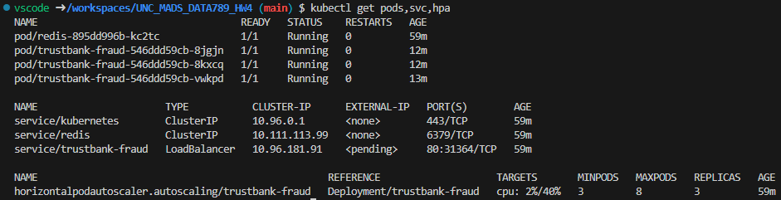

- ./scripts/smoke_test.sh http://localhost:8080
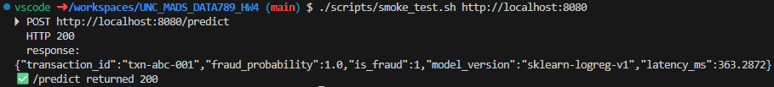

- Self-healing Demonstration
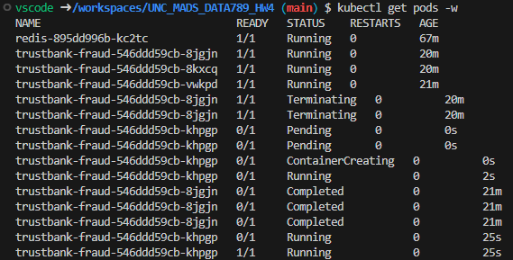
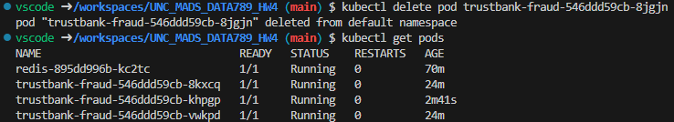

Part #2:
- Zero-downtime update
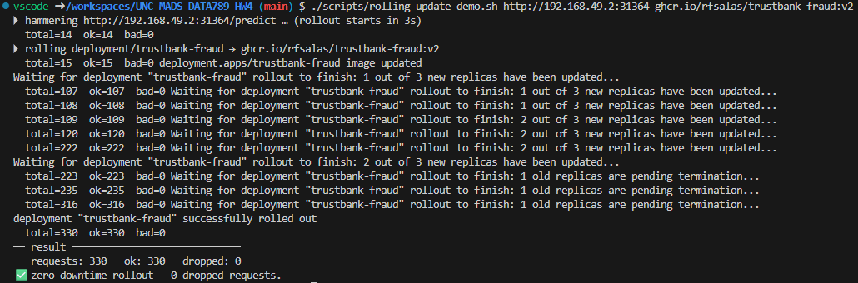

- Blue-Green Switch
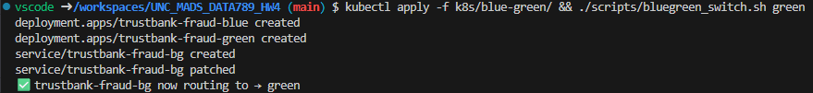
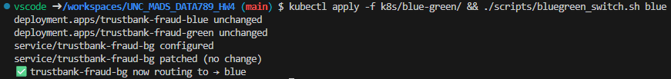

Part #3:
- Evidence
