Chris George
ECE 457 – Robotics
June 10, 2013

Balancing Robot

ECE 457 Robotics Final Report

Goal -- To build a small NXT-G balancing robot using existing NXT-G code translated into LabView. My lab partner, Anthony Goyette, and I accomplished this goal and this paper is about how we did it, what problems we encountered and how we overcame them.

Project Background
The NXT-G code we used came from a project we found online (http://www.hitechnic.com/blog/gyro-sensor/htway-bluetooth-version/). The NXT-G code included object avoidance and an infrared sensor for remote control, which was discarded for this project.

The code used a gyroscopic sensor to determine where the floor was, and then, once the robot stood up, the gyroscopic sensor output a radial rate of speed, in degrees/second, which essentially measured how quickly the robot was falling over. We then used an exponential moving average, the amount of time it took the computer to loop through the balancing calculation and a PID controller to calculate the amount of power for the motors and the direction it needed to be applied to compensate for the fall.

The first part of the code was calibrating the gyroscope, essentially telling the robot where the floor was. Here is the NXT version of the code, which included text at the beginning of the code that we originally deleted.
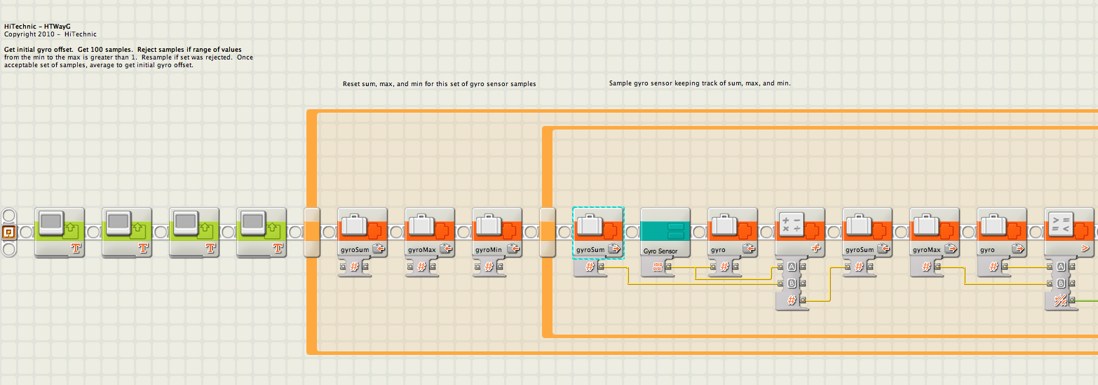

Figure 1 -- NXT-G balancing robot calibration code
This takes 100 readings from the gyroscope and averages them, and that becomes the first value from which the robot begins to balance itself. The original NXT-G code rejected any gyroscopic samples that were over 1, but we eliminated that code without issue.

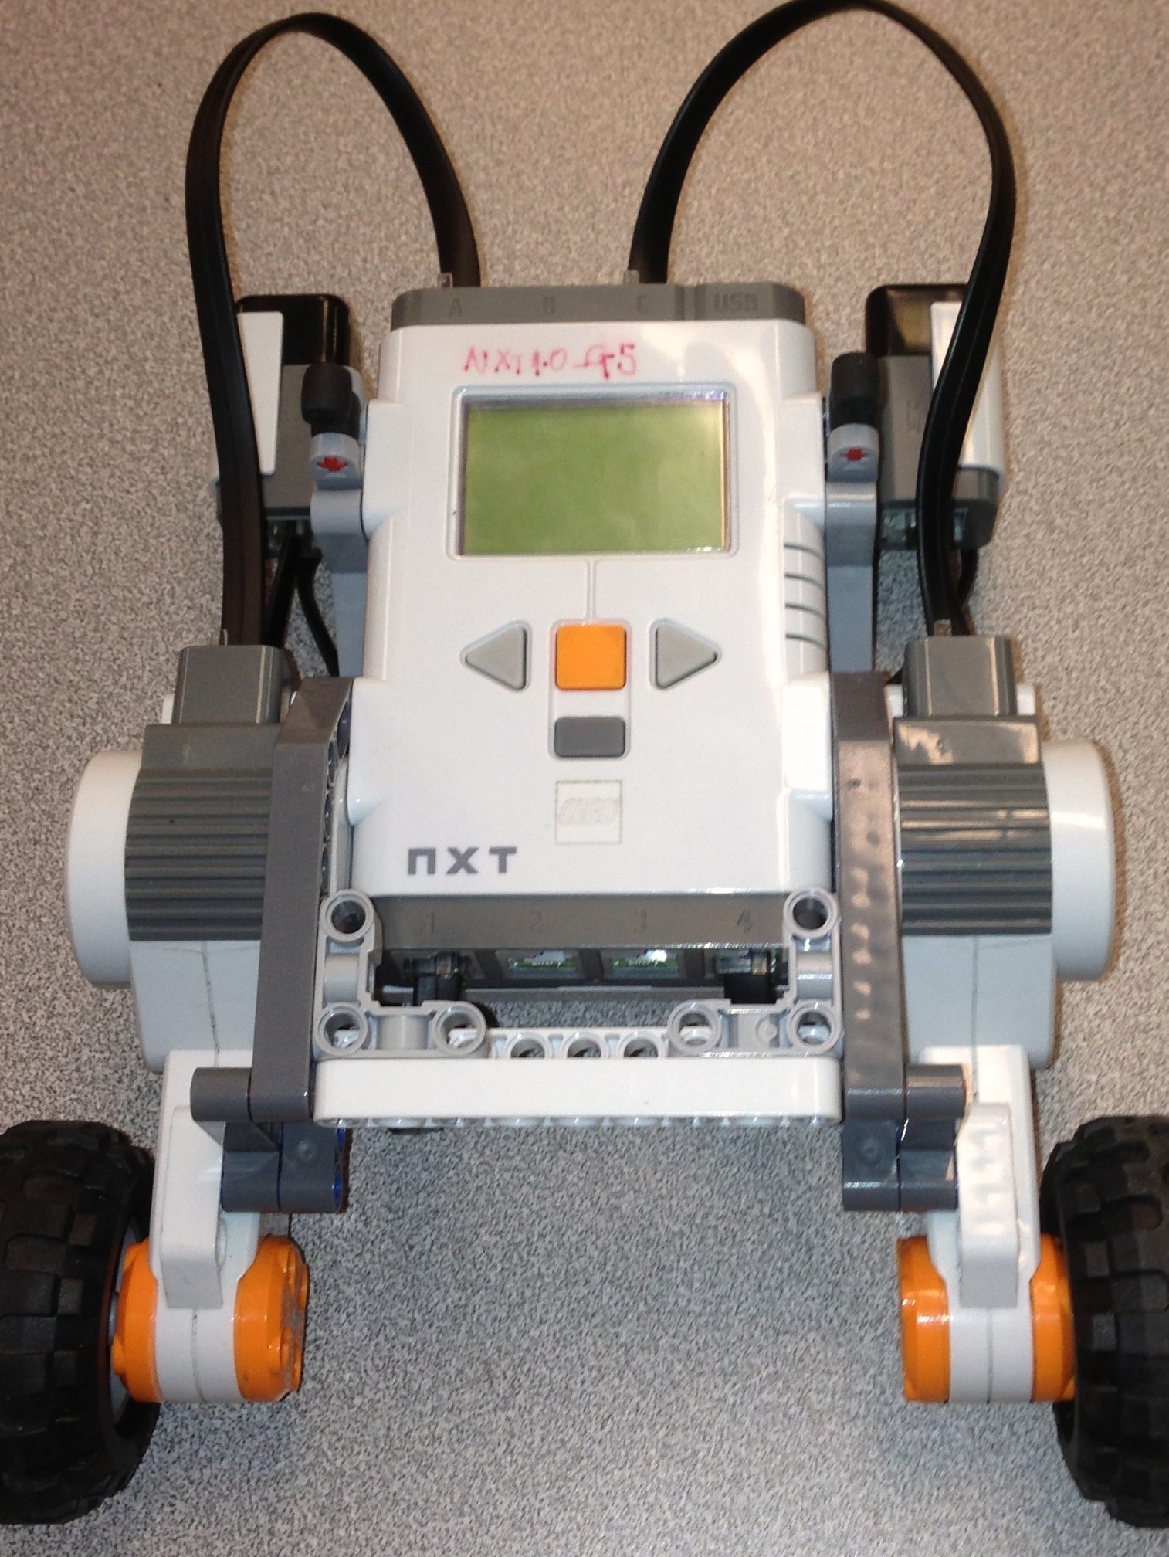
Figure 2 -- Robot in repose: the balancing robot in calibrating stage, lying flat on the ground

The robot pauses for five seconds, and then enters the balancing phase. The first value it calculates is the amount of time the last loop took. For the first loop, it uses a value of 0.008 seconds.
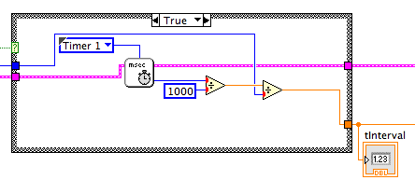

Figure 3 -- the calculation of tInterval in the Labview version of code

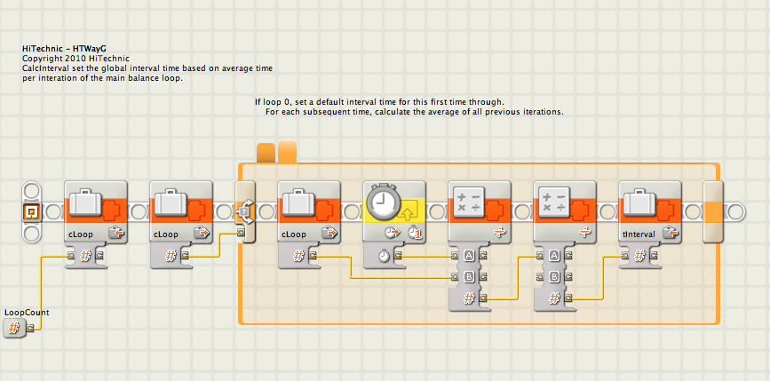

Figure 4 -- The NXT version of the time interval calculation in Figure 2.

The time interval is very important. It adjusts the power of the motor based on the time it took for the last loop to complete. In the balancing the robot, the longer it goes without an adjustment, the more it starts to accelerate toward the floor, the more power it will require to halt, and then reverse, that acceleration. This adjustment compensates for the time it goes without an adjustment. While this only produces very small power adjustments, they are crucial to the robot standing up.
Next, the program calculates an exponential moving average of the gyroscope readings.
This is how Wikipedia defines EMAs.
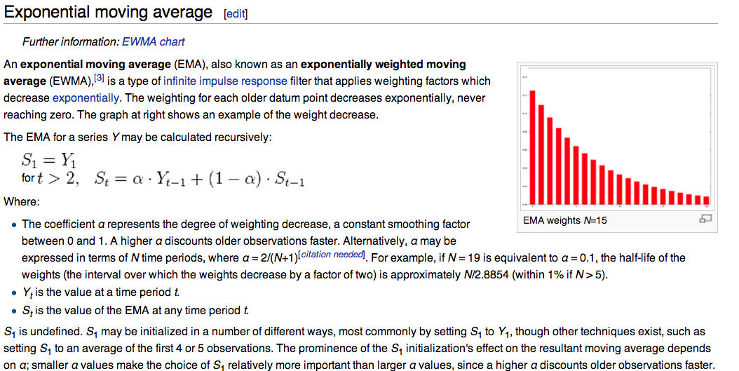
Figure 5 -- Screenshot of the Wikipedia definition of EMAs including a graph that shows the decreasing weight of past measurements.
For our program, α = 0.9995, which decreased the influence of previous loop iterations on the average quite rapidly, because it that made our (1-α) = 0.0005. Our Y_{(t-1)} is the value of the last gyroOffset calculated. All of these values become the gyroSpeed, which is recursively calculated using the last value of gyroSpeed * (1-α).
gyroSpeed is then multiplied by the time interval of the loop, which eliminates the time element of the equation – gyroSpeed is in deg/second, the time interval is in seconds, those two elements cancel each other out – to produce gyroAngle, the angular position of the robot relative to the ground.

Bringing it all together: the PID
The EMA is used in the calculation of the proportional part of the proportional-integral-derivative (PID) controller used to balance the robot. The EMA smooths out the present error portion of the equation, by ensuring that the current loop’s present error doesn’t differ too much from the previous loop’s error.
The present error is calculated thusly:
P = [1.15 * gyroSpeed (this is the EMA result)] + [7.5 * gyroAngle (also influenced by gyroSpeed and thus the EMA result) * 1 (tire size adjustment)]
The integral, also known as the accumulation of past errors according to Wikipedia, is calculated like this:
I = motorPos * 0.07, where motorPos = (the position of motor A (in degrees) + the position of motor B, aka motorSum) – the motorSum from the previous loop + the previous motorPos.

Note: motorSum – previous motorSum = motorDelta
And the derivative, also known as the predictor of future errors, is calculated like this:
D = motorSpeed *0.07, where motorSpeed = motorDelta / tInterval (the time interval discussed earlier in the paper)
P + I + D are then fed into the motor control, which tells the motor how much power and what direction (forward or backward, denoted by a + or – value) to give the motor. Typically, this is a very small number. If, for some reason, it goes over 100, the robot is programmed to stop and fall over. The motors cannot deliver more than 100 power, so we figured that was a good point to shut everything down.

Difficulties overcome
Lay the robot flat: after the bot was built and the code was written and uploaded, we had difficulties getting the robot to balance at all. It immediately fell over. We didn’t realize that the robot needed to be put flat on the ground in order for the gyroscope to properly calibrate. After we did that, the robot balanced for longer.
While loop calibration wasn’t working: We discovered that the while loop written in the NXT code would stop the robot cold after it was done. It appeared to be written in such a way as to reject invalid gyroscope samples, but when it rejected those samples, it stopped the sampling loop entirely, stopping the robot entirely. We eliminated the while loop, and replaced it with a for-loop that ran 100 times and averaged the value once the loop stopped.
motorDelta calculation: The NXT-G code used four variables to store the past four values of motorDelta, and then average them out to get a better value of motorDelta. We couldn’t figure out how to implement this in LabView and eliminated it, using only the most immediate past value of motorDelta to calculate the motorSpeed.
When variable values won’t die: After we solved these problems, the robot balanced. But it only balanced in debug mode, where the computer handled the calculations and gave the robot only motor control commands. We wanted the robot, and not the computer, to do both the calculations and the motor control, but when we uploaded the code to the robot, the bot just fell over. After we deleted the software and uploaded the code without first running it in debug mode from the computer, the robot balanced. We figured that if we first ran the robot in debug mode and then uploaded the code, the variable values from debug mode were preserved. With those values preserved (and none reset to zero), the code on the robot would immediately miscalculate balancing values and fail.
No new .vi’s: I want to credit my partner with a crucial decision we made early in the project. Anthony had previously chosen an NXT-G version of this code to mimic, but he translated it into LabView and found all kinds of problems with it. He pointed out that part of the problem was that there were lots of .vi files associated with the old code, when really we could do the entire program with one main .vi file and some stock Labview-for-NXT-G .vi’s and probably take some processing work off the robot’s chip. He was exactly right and we re-coded the entire program (using new source NXT-G code he found on the web) using no new .vi’s, and it worked very well.
PID worked perfectly, first time: Lastly, we didn’t have to overcome a problem I thought we surely would have to overcome. In our previous project, we build a line-following robot controlled with a PID, which we had to tune quite a bit to get it going properly. In this case, the constant values for the PID worked perfectly the first time, with no tuning. This was very lucky, I think. It saved us a lot of time.
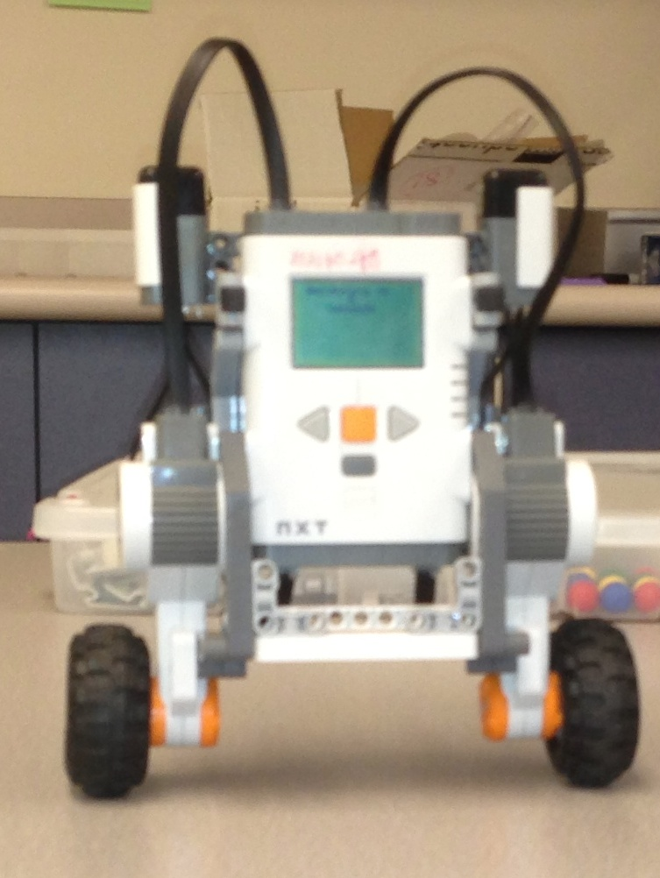
Figure 6 -- Robot raring to go.

A note on the color of the variable names. It is intended to mimic the color, and thus the type, of the variables in LabView. Blue is for integers, orange is for doubles

