***rsync (File Synchronisation Tool)***

***Installation Guide/Walkthrough***

This is a guide of the process I have taken to achieve task 4, the connecting of 2 virtual machines to talk on a network using software called SSH. This is not just a straight forward task and there are a couple of steps required to be done before using RSYNC to copy files across which isn’t instantly apparent.

First of all in the terminals we type; sudo apt-get install rsync (ON BOTH VMs)

Now I have my 2 virtual machines set up (Chris and Chris2), the command I use to check the file location of the rsync files which are installed within the version of Ubuntu on the VM’s is **whereis rsync** shown in the screenshots gives the file location for each VM rsync files.



Figure and 2 Showing were the rsync files are contained on the terminals.



Figure 3 shows where we connect the terminals together

|  |  |
| --- | --- |
|  |  |

This is done so that we can link the client and server, via an internal network connection, this simulates both machines connected to a network.

The next step in the guide is to change the adapter settings on the VM’s. To do this I go to settings, Click on network. I then change the option in the box show in the screenshot to internal network and click OK.

Figure settings to be changed on both terminals shown here.

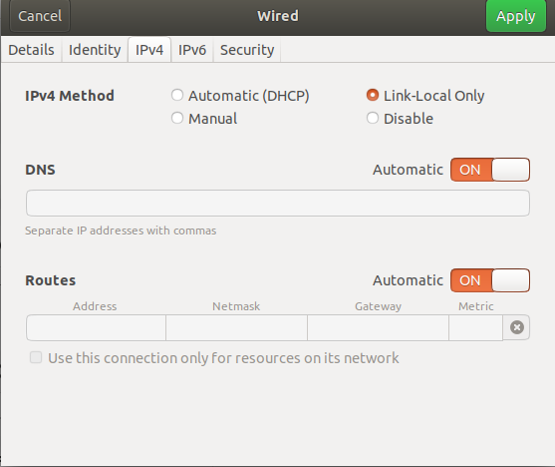

This step repeated on both VM’s. If you don’t do this you will not be able to proceed to the next step. I will also have to change the Ipv4 settings on the terminal, I change this to link-local shown in the screenshots. This is also done on both terminals.

Figure setting up the network by choosing the wired connec

After these first steps, I can then go back to the command line and type the following command **ifconfig** that display the terminals new IP address shown in the screenshot. As they are using the same adapter I noticed that the IP addresses are quite simi

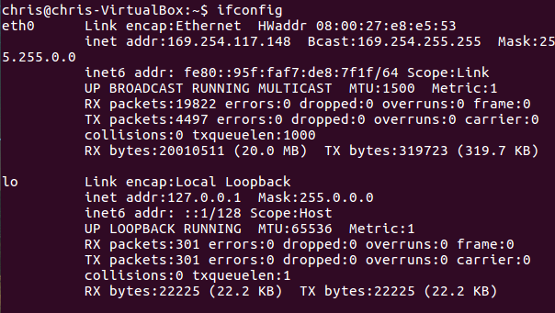

FROM REMOTE TO LOCAL

"Copy from remote to local home directory"

We use rsync -avz [USERNAME]@[IP_ADDRESS]:/home /home

FROM LOCAL TO REMOTE

"Copy from local to remote home directory"

We use rsync -avz /home [USERNAME]@[IP_ADDRESS]:/home/

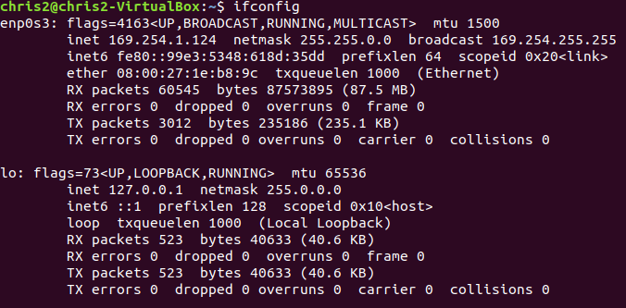

The ifconfig command is used on both terminals, shown above is Chris 2.

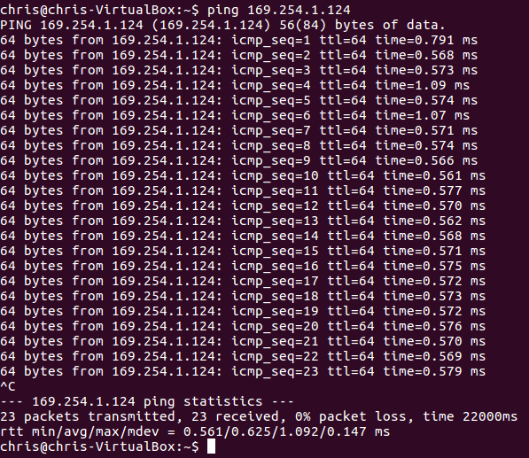

Just too double check this connection; I type the ping command to the other terminal so that to check they are able to talk, Shown above.



After I have used **sudo apt-get update** **and sudo apt-get install upgrade**, this is the command shown below, I now use on both machines to continue.

I also use these commands **sudo cp /etc /ssh /sshd_config /e**

**sudo chmod a-w / etc / ssh /sshd_config**

**nano / etc /ssh /sshd_config**

**sudo service ssh restart**

**sudo mkdir ~/.ssh**

**sudo service ssh restart**

Once I have done this I can set up the ssh keys on both computers for the logging in users

I use the following commands; ssh**-keygen –t rsa** and **ssh chris2@169.254.1.14**

This copies Chris 2 to Chris shown below.

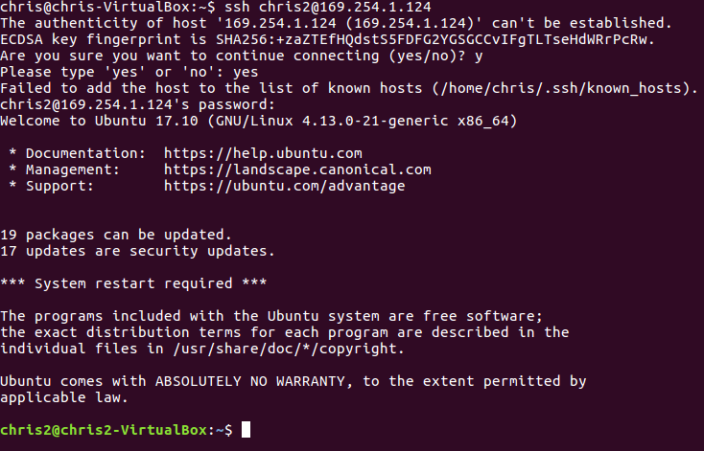



Biliography;

<https://ubuntuforums.org/showthread.php?t=2375048>

[www.makeacheasier.com](http://www.makeacheasier.com)