CLI Chess
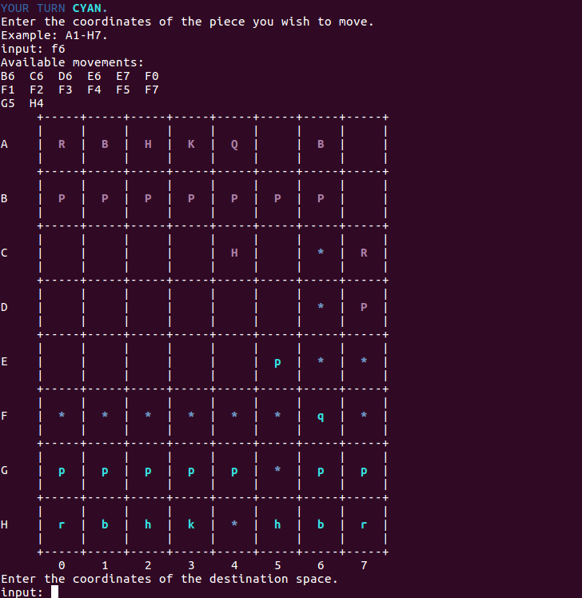
Created by Chris Herre
Introduction
CLI Chess is an ASCII-based Chess game that uses letter symbols to represent the Pieces on a normal Chess board.

R or r = Rook
B or b = Bishop
H or h = Knight (or Horse)
K or k = King
Q or q = Queen

Lowercase and uppercase characters were used originally to differentiate between black and white Pieces in the code before colors were added. The game is played by both players, Cyan and Magenta, taking turns specifying which Piece they want to maneuver, as well as a destination position for that Piece to go. Each Piece has predefined movements just like the regular movement rules of Chess. This is an incomplete version of the game, so most movements work correctly as they should, with some exceptions such as Pawn Promotion, Castling, and En Passant. These movements are still under development, otherwise every other movement should work the way it should.
There is a coordinate system A-H for rows and 0-7 for columns that the players use to specify their movements. For example B0 would be a movable Piece on the first turn, which is a Pawn and could move to C0 or D0. If a Piece currently has no available movements, a message will be displayed, and the player will be re-prompted to input an alternative Piece for their turn.
When a player specifies a valid Piece to move, little *s will be displayed onto the unoccupied positions that are available as destinations for that Piece.
The game runs continuously until one players king becomes captured. When that happens, a message will be displayed declaring that player as the loser and the program will cleanup and terminate.
If a player’s king is in check, meaning in danger of being captured on the enemy player’s next turn, a green warning message will be displayed. However, in other Chess games movement is restricted to some extent when a players king is in check, they usually are forced to move their king out of check. That logic is not present in this version of the game because I didn’t have time to finish all the minor details of the Chess rules.

Concepts Utilized

Abstract Class/Pure Virtual | Piece.h line 36
Child Classes | Pawn.h, Rook.h, Bishop.h, Knight.h, King.h, Queen.h
Polymorphism | main.cpp lines 108-115,  line 74, and 90 for the instance creations
Templates | main.cpp lines 67-77,  lines 384-389
Inheritance | Queen.h line 23 and 35
Advanced file I/O | main.cpp refreshBoard() lines 396-410
Chapter 10 input validation isalpha, isdigit | main.cpp validateInput(string& input) line 203
Hashmap | main.cpp line 104
STL Vector | Piece.h line 36
Static functions | main.cpp line 290
Try/catch | main.cpp line 419
Dynamic memory cleanup | main.cpp line 154
Passing file streams to functions | main.cpp line 271

Flowchart

Attached as “csc17a_assignment5.pdf”

Psuedocode

void main
{
// Map file positions for all Pieces to coordinates like A0-H7
// Read the blank Board file and overwrite the last game file
Piece **all = new Piece*[32];
Piece **pawns = new Piece*[16];
Piece **knights = new Piece*[4];
Piece **bishops = new Piece*[4];
Piece **rooks = new Piece*[4];
Piece **kings = new Piece*[2];
Piece **queens = new Piece*[2];
Piece **piece = new Piece*[1];
FOR ALL Pawns
// Initialize a Pawn instance at a starting coordinate
// Set its symbol capital or lowercase
// Set **all at CURRENT_INDEX + OFFSET = **pawns at CURRENT_INDEX
END FOR ALL
FOR ALL Knights
// Initialize a Knight instance at a starting coordinate
// Set its symbol capital or lowercase
// Set **all at CURRENT_INDEX + OFFSET = **knights at CURRENT_INDEX
END FOR ALL
// do the same for all arrays above, except **piece
.
.
.
FOR ALL Queens
// Initialize a Queen instance at a starting coordinate
// Set its symbol capital or lowercase
// Set **all at CURRENT_INDEX + OFFSET = **queens at CURRENT_INDEX
END FOR ALL
short turn = 0;
// open the game file for reading and writing
// Write the Pieces onto the Board at starting positions previously defined
// Draw the game Board
// Close the game file
WHILE a king on either side has NOT been captured
// Reopen the game file as fstream f
collectInput(input, input2, all, piece, f, m, col, turn, kings);
// Close f after each iteration
END WHILE
// See if magenta's king was captured
// If yes, say magenta lost
// See if cyan's king was captured
// If yes, say cyan lost
// cleanup dynamic memory
}

bool proceed
{
// if magenta's turn, prompt for input
// else if cyan's turn, prompt for input
// show input instructions
// check if input is valid
// if not return false
piece[0] = NULL;
// set piece[0] to the Piece at the position the player specified
// if not piece exists at the specified position, return false
// check if the wrong player is taking a turn
// if yes, then return false
return true;

}

void collectInput
{
bool add = true;
if (!proceed(piece, all, input, turn))
return;
vector<string> v = piece[0]->getAvailPositions(all);
sort(v.begin(), v.end());
// if no available moves
// print position not available
add = false;
return;
// open game file for reading and writing
// display hint *s on the available positions
// Rewrite all 32 Pieces on their current positions
// Redraw the Board
// Prompt for the destination location
// validate the destination input
// if availablePositions contains destination input
// move piece[0] to the destination
// redraw the Board
// else
// set the hints to blank spaces
// redraw the Board
add = false;
if (add)
turn++;
}

