**ICTOPIA DESKTOP PRODUCTIVITY – INTERACTIVES QA**

Lesson 1

* working well

Lesson 2

* the template is downloadable
* working well

Lesson 3

* each picture is directing to next page for download
* working well

Lesson 4

* working well

Lesson 5

* working well

Lesson 6

* working well

Lesson 7

* Activity A is working well
* Activity B is working well

Lesson 8



* remove the letter “t”
* Activity A is working well
* Activity B is working well

Lesson 9

* the numberings in the TG are not in order that can make confusion for the users of TG
* everything is working well

Lesson 10

* Working well

Lesson 11

* Working well

Lesson 12

* the pdf file is working
* working well

Lesson 13

* working well

Lesson 14

* all search engine links are working
* working well

Lesson 15

* working well

Lesson 16

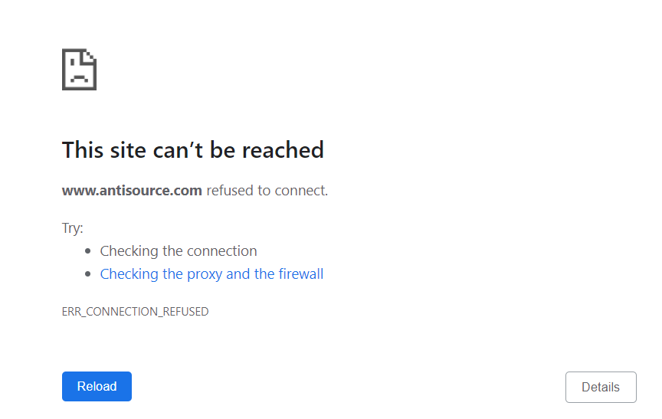

* this link is not working <https://www.antisource.com/>