AIRTEL AFRICA
Shadow IT Deployment Justification and Architecture Document
Virtual Machine / Infrastructure Approval Request
Application: Airtel Champions Field Force and HBB Operations Platform
(Sales Champions, Home Broadband install, Airtel Money agent and ODU retrieval modules)
Document classification | Internal
Document version | 1.0 (Draft for IT Architectural Review Board and IT Security)
Prepared for | Airtel Kenya (Airtel Networks Kenya Ltd) - Opco ITD [confirm Opco]
Prepared by | [Requestor name / business function]
Date | August 2026
Governing policy | Airtel Africa Shadow IT Policy v2.0 (Doc code IT-ShadowIT, released 19-Mar-2026)
Mandatory approvers | CIO, GCIO, GCISO (per policy Section 6)

Confidentiality: This document contains architecture and security information about an Airtel Africa business application. Handle as INTERNAL. Do not distribute outside the Airtel IT governance, security and approval chain.

1. Document Control

1.1 Document Information
Type of information | Document data
Document title | Airtel Champions App - Shadow IT Justification and Architecture (VM Approval)
Document code | [to be assigned by Opco ITD]
Application / product | Airtel Champions Field Force and HBB Operations Platform
Business function / owner | [Sales and Distribution / HBB Operations - confirm owner]
Requestor | [Name, title, AAUID]
Opco | Airtel Kenya (Airtel Networks Kenya Ltd) [confirm]
Applicability | Airtel Africa Plc and its entities
Classification | Internal
Version | 1.0
Status | Draft for review and approval

1.2 Reviewers (per policy Section 6)
Sl. | Review body / responsibility | Name | Outcome / date
1 | IT Architectural Review Board | [to be completed]
2 | IT Security | [to be completed]
3 | Opco ITD (sponsoring) | [to be completed]

1.3 Approvers (mandatory)
Policy v2.0 Section 6 states that deployment of a Shadow IT system for a business process that includes IT is mandatory to be approved by CIO, GCIO and GCISO. This submission is prepared to seek that approval.
Sl. | Role | Name | Signatory | Date
1 | Chief Information Officer (CIO) | [ ] | [ ] | [ ]
2 | Group Chief Information Officer (GCIO) | [ ] | [ ] | [ ]
3 | Group Chief Information Security Officer (GCISO) | [ ] | [ ] | [ ]

1.4 Revision History
Ver. | Date | Change description | Author
1.0 | Aug 2026 | Initial submission: as-is architecture, proposed migration to Airtel-managed VMs, VM sizing and controls. | [Requestor]

Table of Contents

(Right-click the table above in Microsoft Word and choose Update Field to populate page numbers.)

2. Executive Summary
The Airtel Champions App is a field force and operations platform used by Airtel sales champions, Home Broadband (HBB) installers, Airtel Money agents and headquarters teams. It was built by an external developer and is presently hosted entirely on third-party, Internet-based Software-as-a-Service (SaaS) platforms (Vercel and Supabase), outside Airtel Group IT visibility and control. Under Airtel Africa Shadow IT Policy v2.0 this constitutes Shadow IT.
This document is the justification and architecture submission required by Section 6 of that policy. It sets out what the application is, how it is built today, the risks of the current arrangement, and a proposed to-be architecture that migrates the entire solution onto Airtel-managed virtual machines inside an Airtel data centre or private cloud, under Group IT control. It includes the hardware (VM) specification, the sizing basis, the integration touch points, third-party licences and the security controls, so that the IT Architectural Review Board, IT Security and the approving CIO / GCIO / GCISO can take a decision.

What is being requested
- Approval to bring the Airtel Champions App under Group IT management (regularise the Shadow IT).
- Provisioning of the virtual machines specified in Section 7 across Production and Non-Production (UAT) environments.
- Retirement of the external SaaS subscriptions (Vercel, Supabase, Capgo) once migration is complete, with release of the associated firewall, DNS and licence entries per policy Section 6.

3. Product and Project Description
This section answers the VM-approval requirement to state the product or project for which the hardware is requested.

3.1 Overview
The Airtel Champions App is a Progressive Web Application (PWA) with an optional native mobile wrapper. It supports four operational domains through a single sign-on screen with a role and mode selector:
Domain / mode | Primary users | Function
Sales (Champions) | Sales executives, DSEs, zonal managers, HQ | Field sales activity capture, check-in/out, programmes, reporting and league tables.
HBB (Home Broadband) | Installers, supervisors, CX, warehouse, HQ | Installation job allocation, field capture, supervision and HQ dashboards.
Airtel Money | Airtel Money agents and admin | Agent-facing records and administration.
ODU Retrieval | HQ, CX, installers, warehouse | Recovery of Outdoor Units from ~19,000 inactive HBB customers: upload, call intake, field collection, warehouse validation, reconciliation and payment (KSh 600 per unit).

3.2 Data held
- Customer personally identifiable information (PII): names, phone numbers, locations of HBB and inactive customers.
- Field staff records and role based access data (phone number plus PIN credentials, session tokens).
- Operational records: installations, check-ins, GPS location traces, device photographs and barcodes / IMEIs.
- Payment-relevant records for ODU retrieval (payable units, reconciliation batches, KSh amounts, CSV payment exports).
Because the platform holds customer PII and payment-relevant records, policy Section 6 requires that it not be operated as Shadow IT without proper controls (encryption, access control, audit trails and backup per AAISP). Section 10 of this document sets out how the proposed architecture meets that requirement.

4. Shadow IT Justification (Policy Section 6)

4.1 Business need (what is needed)
Airtel Kenya's sales and HBB operations require a mobile-first tool to direct and measure a large distributed field force (roughly 5,000 to 6,000 named users across champions, DSEs, installers, supervisors and agents) and, most recently, to run the ODU retrieval programme that recovers leased equipment worth material value from about 19,000 inactive customers. No existing centrally provided Airtel application delivered this combination of field capture, geo-allocation, barcode capture and reconciliation within the required timeframe.

4.2 Why the alternative was used (and why it must now be regularised)
The application was delivered quickly on SaaS platforms to meet an immediate operational need. That speed came at the cost of central oversight: the solution now runs outside Airtel IT, on external infrastructure, holding customer PII and payment data. This is precisely the risk the Shadow IT Policy addresses. The business intent is not to retain an unsanctioned tool but to bring a proven, in-use application under Group IT control on Airtel-managed infrastructure.

4.3 How it will be used
The platform will continue to serve the Sales, HBB, Airtel Money and ODU workflows for Airtel Kenya field and office staff. Access is role based (see Appendix B). After migration it will be reached through the standard Airtel ingress (WAF and load balancer), with all data resident inside the Airtel estate.

4.4 Operational requirements (scoped in advance, per Section 6)
Item | Detail
Who maintains the process | Opco ITD application support, with the incumbent development team transitioned to a managed support contract under IT oversight. Database and OS administration by Opco infrastructure team.
Access levels | Role based access (RBAC) enforced in-application; infrastructure access restricted to named administrators via bastion with MFA; least privilege on DB and storage.
Support model | Business hours application support with on-call for Severity 1; standard Airtel change, incident and patch management.
Required duration | Long term (greater than one year). Per Section 6 this makes a centralised, IT-managed solution mandatory rather than a temporary exception.
Data handling | Encryption in transit and at rest, audit trails, backup and password / PIN policy per AAISP (Section 10).

5. Existing (As-Is) Architecture

5.1 Application architecture
The client is a React 18 and TypeScript single-page PWA built with Vite, wrapped for Android and iOS with Capacitor and updated over the air by Capgo. The browser client talks directly to a Supabase Cloud backend project. There is no Airtel-hosted middle tier: the browser holds the API key and calls the backend over HTTPS. Authentication is a custom phone-number plus PIN scheme with a session token issued by an edge function; Supabase's own GoTrue auth is present but unused.
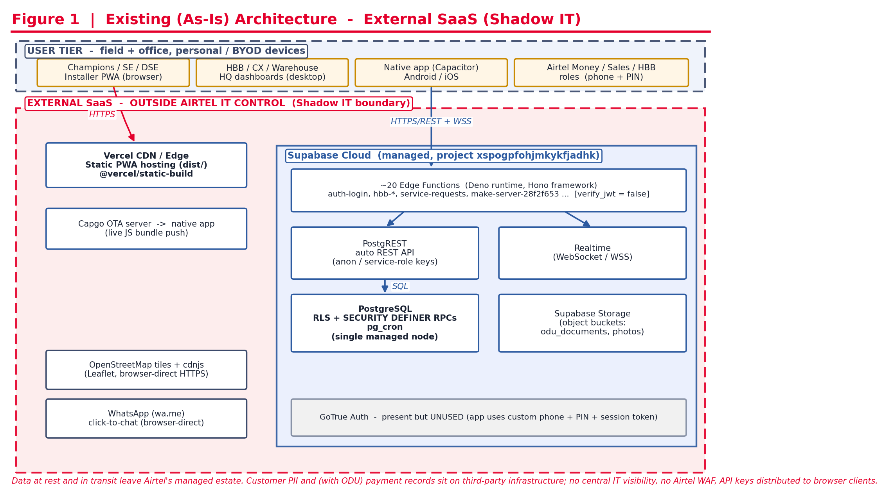
Figure 1. Existing (as-is) architecture. The entire solution runs on external SaaS outside Airtel IT control.

5.2 Network view and components
All components other than the end-user device are external, Internet-reachable SaaS. The logical components are:
- Vercel CDN / Edge: static hosting of the compiled PWA (dist/), global CDN delivery.
- Supabase Cloud (project xspogpfohjmkykfjadhk): the backend, comprising the components below.
- Edge Functions: about 20 Deno-runtime functions using the Hono framework (auth-login, se-login, hbb-*, service-requests, make-server-28f2f653 and others), all currently running with verify_jwt = false.
- PostgREST: an automatically generated REST API over PostgreSQL, called by the browser with anon and service-role keys.
- PostgreSQL: a single managed database node with Row Level Security (RLS), SECURITY DEFINER stored procedures and pg_cron scheduled jobs.
- Realtime: a WebSocket (WSS) channel for live updates.
- Supabase Storage: object buckets for ODU documents and photographs.
- Capgo: an external over-the-air update service that pushes JavaScript bundles to the installed native app.
- Browser-direct third-party endpoints: OpenStreetMap tiles and cdnjs (Leaflet maps), WhatsApp click-to-chat (wa.me).

5.3 Internal integration points
From | To | Protocol | Purpose
Edge Functions | PostgreSQL / PostgREST | SQL / REST | Business logic, RPC calls, reads and writes.
Browser client | PostgREST | HTTPS / REST | Direct data reads (RLS-scoped).
Browser client | Realtime | WSS | Live subscriptions.
Edge Functions | Supabase Storage | HTTPS (S3-style) | Signed URLs, document and photo objects.
pg_cron | PostgreSQL functions | In-database | Scheduled sweeps (for example ODU allocation timeout).

5.4 External integration points
System to system (northbound / southbound) and user to system, with protocols:
Integration | Direction | Protocol / port | Notes
User device to Vercel | User to system (inbound) | HTTPS / 443 | Loads the PWA.
User device to Supabase | User to system (inbound) | HTTPS / 443, WSS / 443 | Data and realtime; API key in client.
Capgo to native app | Southbound (push) | HTTPS / 443 | OTA JavaScript bundle updates.
Browser to OpenStreetMap / cdnjs | Northbound (egress) | HTTPS / 443 | Map tiles and Leaflet assets.
Browser to WhatsApp (wa.me) | Northbound (egress) | HTTPS / 443 | Click-to-chat deep link.
Build to Figma | Design-time only | HTTPS / 443 | Source of design assets; not a runtime dependency.

5.5 Infrastructure architecture and software stack (as-is)
Layer | As-is technology | Hosting / ownership
Presentation | React 18, TypeScript, Vite PWA; Capacitor native shell | Vercel CDN (external SaaS)
Application / API | Deno runtime, Hono framework (edge functions); PostgREST | Supabase Cloud (external SaaS)
Data | PostgreSQL (single managed node), pg_cron | Supabase Cloud (external SaaS)
Object storage | Supabase Storage buckets | Supabase Cloud (external SaaS)
Realtime / messaging | Supabase Realtime (WebSocket) | Supabase Cloud (external SaaS)
Mobile updates | Capgo OTA | Capgo (external SaaS)

5.6 Operating systems and clustering
Not visible to or controlled by Airtel. The OS, patching, clustering and high availability of Vercel and Supabase are managed by those providers under their own terms. PostgreSQL is presented as a single managed node; there is no Airtel-controlled replica or failover.

5.7 Database
PostgreSQL (managed by Supabase). Security is enforced through RLS and SECURITY DEFINER RPCs. Row-level identity is not based on a real IdP; the application uses anon and service-role API keys, with the service-role key capable of bypassing RLS.

5.8 Middleware
PostgREST (REST layer), the Hono web framework on Deno (edge functions), and Supabase Realtime. All are provider-operated; Airtel cannot tune, patch or monitor them directly.

5.9 Proprietary / COTS versus open source (as-is)
Component | Type | Licence / commercial basis
Vercel hosting | Proprietary SaaS | Paid subscription
Supabase Cloud | Open-source core, delivered as proprietary managed cloud | Paid subscription
Capgo OTA | Proprietary SaaS | Paid subscription
Figma (design) | Proprietary SaaS | Paid subscription (design-time only)
PostgreSQL, PostgREST, React, Vite, Radix UI, Leaflet | Open source | MIT / Apache / PostgreSQL / BSD (no licence fee)
OpenStreetMap tiles | Open data | Free (attribution / usage policy applies)

6. Proposed (To-Be) Architecture: Airtel-Managed VMs

6.1 Application architecture
The application is re-platformed onto Airtel-managed virtual machines inside an Airtel data centre or private cloud. The same application code is retained; only the hosting and the trust boundary change. End users reach the platform through the Airtel WAF and load balancer. A web tier serves the static PWA; an application tier runs the API / functions as containers; a data tier runs PostgreSQL in a highly available primary and replica configuration with an object store for documents and photographs. Secrets move into a vault and no API key is exposed to the browser for privileged access.
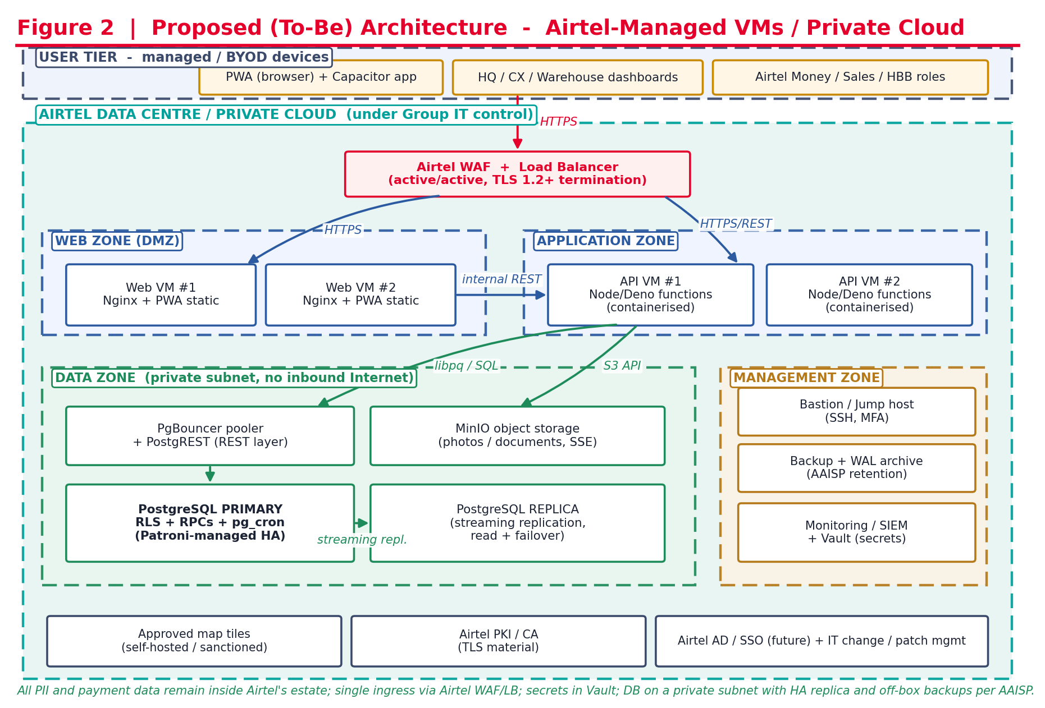
Figure 2. Proposed (to-be) architecture on Airtel-managed VMs. All PII and payment data remain inside the Airtel estate.

6.2 Network view and zoning
Zone | Components | Exposure
Ingress | Airtel WAF plus load balancer (active/active), TLS 1.2+ termination | Only public entry point
Web zone (DMZ) | Web VM #1 and #2 (Nginx serving PWA static) | Reachable from LB only
Application zone | API VM #1 and #2 (containerised Node/Deno functions) | Reachable from web zone and LB
Data zone (private subnet) | PostgreSQL primary and replica, PgBouncer, PostgREST, MinIO object storage | No inbound Internet; reachable from app zone only
Management zone | Bastion (SSH, MFA), backup and WAL archive, monitoring / SIEM, secrets vault | Admin access only

6.3 Internal integration points (to-be)
From | To | Protocol / port | Purpose
Load balancer | Web VMs | HTTPS / 443 | Serve PWA static assets.
Load balancer | API VMs | HTTPS / 443 | API and function calls.
Web VMs | API VMs | HTTPS / internal | Application requests.
API VMs | PgBouncer / PostgreSQL | libpq / 6432, 5432 | Pooled database access.
API VMs | MinIO | S3 API / 9000 | Object storage read and write (server-side encrypted).
PostgreSQL primary | PostgreSQL replica | Streaming replication / 5432 | High availability and read scaling.
All nodes | Vault, monitoring, backup | HTTPS / agent | Secrets, telemetry and backup.

6.4 External integration points (to-be)
Integration | Direction | Protocol / port | Change from as-is
User to Airtel WAF/LB | User to system (inbound) | HTTPS / 443 | Single controlled ingress replaces Vercel and direct Supabase calls.
Map tiles | Northbound (egress) | HTTPS / 443 | Move to a self-hosted or Airtel-sanctioned tile source.
Airtel PKI / CA | Internal | HTTPS | TLS certificate issuance.
Airtel AD / SSO (future) | Internal | LDAPS / SAML / OIDC | Optional future move from phone+PIN to enterprise identity.
Mobile app updates | Southbound (push) | HTTPS / 443 | Move OTA in-house or use signed store releases; retire external Capgo.

6.5 Infrastructure architecture and software stack (to-be)
Layer | To-be technology | Notes
Ingress | Airtel WAF and load balancer (reuse existing Airtel COTS, for example F5 / Imperva class) | Active/active, TLS termination
Web | Nginx serving compiled PWA | Stateless, horizontally scalable
Application | Node.js (or Deno) functions in containers (Docker / Podman) | Ported from Supabase edge functions
API layer | PostgREST plus PgBouncer | REST over PostgreSQL, pooled
Data | PostgreSQL 16 with Patroni and etcd | Primary plus replica, automatic failover
Object storage | MinIO (S3-compatible) | Server-side encryption; note AGPL licensing (Section 9)
Secrets | HashiCorp Vault | Removes keys from client and config
Observability | Monitoring / SIEM per Airtel standard | Central logging and alerting

6.6 Operating systems and clustering
- Operating system: Ubuntu Server 22.04 LTS or RHEL 9 per Airtel data-centre standard (confirm with infrastructure team).
- Web tier: two or more nodes, active/active behind the load balancer.
- Application tier: two or more container hosts, horizontally scalable.
- Database tier: PostgreSQL primary plus at least one streaming replica, orchestrated by Patroni with etcd for automatic failover.
- Object storage: MinIO single node initially, with the option of distributed (multi-node) mode for redundancy.

6.7 Database
PostgreSQL 16, self-managed on Airtel VMs, retaining the existing RLS policies and SECURITY DEFINER RPCs. High availability via streaming replication and Patroni. Point-in-time recovery via continuous WAL archiving to the management zone.

6.8 Middleware
Nginx (web and reverse proxy), PgBouncer (connection pooling), PostgREST (REST API), the container runtime (Docker or Podman), Patroni and etcd (database HA), and HashiCorp Vault (secrets). All are Airtel-operated, patchable and monitorable.

6.9 Proprietary / COTS versus open source (to-be)
Component | Type | Licence / commercial basis
PostgreSQL, Nginx, PostgREST, PgBouncer, Patroni, etcd | Open source | PostgreSQL / BSD / MIT / ISC / Apache (no fee)
MinIO | Open source | AGPLv3 (consider commercial licence to avoid AGPL obligations)
HashiCorp Vault | Open source (source-available) | BSL 1.1 (confirm licensing / consider OpenBao)
Operating system | Open source or licensed | Ubuntu LTS (free) or RHEL (paid subscription)
WAF and load balancer | COTS | Reuse existing Airtel licence
Container runtime | Open source | Docker CE / Podman (no fee)

7. Hardware / VM Specification and Sizing Justification
This section answers the VM-approval requirement to show how the hardware specification was reached and to provide the supporting data.

7.1 Sizing basis (supporting data)
Driver | Observed / estimated value | Sizing implication
Named users | ~5,000 to 6,000 (champions ~957, DSEs ~2,216, app_users ~2,604, installers ~476, agents and HQ) | Modest total population.
Peak concurrency | Estimated 10 to 15 percent of named users = ~600 to 900 concurrent at campaign peaks | Two web and two API nodes give headroom and HA.
Database size | Current data on the order of a few GB (largest sets: ODU inactive ~19,000 rows, DSE ~2,216, app_users ~2,604) | 32 GB RAM DB nodes cache the working set comfortably; 200 GB data volume allows years of growth.
Object storage | ODU device photos and documents: ~19,000 units x ~3 images x ~0.5 MB ~= 28 GB, plus other photos and growth | Provision 1 TB with room to grow.
Availability target | Business-critical field operations and payment records | Primary plus replica DB, active/active web and app tiers.

These figures are recommended baselines derived from current data volumes and a conservative growth allowance. They should be validated by IT through load testing before final procurement. Values marked [confirm] depend on the target Airtel environment and Opco standards.

7.2 Production VM specification
Role | Qty | vCPU | RAM | Disk | OS
Web (Nginx + PWA) | 2 | 2 | 4 GB | 40 GB | Ubuntu 22.04 LTS / RHEL 9
Application / API (containers) | 2 | 4 | 8 GB | 60 GB | Ubuntu 22.04 LTS / RHEL 9
PostgreSQL primary | 1 | 8 | 32 GB | 200 GB SSD | Ubuntu 22.04 LTS / RHEL 9
PostgreSQL replica | 1 | 8 | 32 GB | 200 GB SSD | Ubuntu 22.04 LTS / RHEL 9
MinIO object storage | 1 | 4 | 8 GB | 1 TB | Ubuntu 22.04 LTS / RHEL 9
Bastion / jump host | 1 | 2 | 4 GB | 40 GB | Ubuntu 22.04 LTS / RHEL 9
Monitoring + Vault | 1 | 4 | 8 GB | 100 GB | Ubuntu 22.04 LTS / RHEL 9

Production subtotal: 8 VMs, approximately 32 vCPU, 96 GB RAM, and about 1.64 TB of disk before backup allocation.

7.3 Non-Production (UAT) VM specification
Role | Qty | vCPU | RAM | Disk | OS
Web + Application (combined) | 1 | 4 | 8 GB | 60 GB | Ubuntu 22.04 LTS / RHEL 9
PostgreSQL (single node) | 1 | 4 | 16 GB | 100 GB SSD | Ubuntu 22.04 LTS / RHEL 9
MinIO object storage | 1 | 2 | 4 GB | 250 GB | Ubuntu 22.04 LTS / RHEL 9

UAT subtotal: 3 VMs, approximately 10 vCPU, 28 GB RAM, 410 GB disk. A scaled-down mirror for testing and release validation (policy expects code review and post-live support, addressing the operational instability risk in Section 5 of the policy).

7.4 Backup, WAL archive and disaster recovery
- Backup / WAL archive storage: allow 500 GB to 1 TB in the management zone for database backups and continuous WAL archiving (retention per AAISP).
- Disaster recovery: a warm replica at a secondary Airtel site is recommended as a Phase 2 item [confirm DR requirement and RPO/RTO with IT].

7.5 How the specification was derived
- Start from the named-user population and estimate peak concurrency (10 to 15 percent).
- Size the web and application tiers for that concurrency with N+1 redundancy (two nodes each), since the workload is light and mostly I/O bound.
- Size the database for the working set to fit in RAM (current data is only a few GB; 32 GB gives large cache headroom) and provision SSD for growth and WAL.
- Size object storage from the ODU photo volume estimate plus growth (1 TB).
- Add management, bastion, monitoring and secrets nodes for operability and security.
- Mirror a reduced footprint for UAT to enable testing and controlled releases.

8. Integration Touch Points (Consolidated)
Source | Target | Type | Protocol / port | Data | Auth
User device | Airtel WAF/LB | User to system | HTTPS / 443 | App traffic | Session token / (future SSO)
Web VMs | API VMs | System to system | HTTPS / internal | API requests | Internal service auth
API VMs | PostgreSQL | System to system | libpq / 5432, 6432 | Business data (PII, payments) | DB credential (Vault)
API VMs | MinIO | System to system | S3 API / 9000 | Documents, photos | Access key (Vault), SSE
Primary DB | Replica DB | System to system | Streaming repl / 5432 | WAL stream | Replication credential
Nodes | Vault / SIEM / Backup | System to system | HTTPS / agent | Secrets, logs, backups | mTLS / agent token
Browser | Map tiles (sanctioned) | Northbound egress | HTTPS / 443 | Map tiles | None

9. Third-Party and Paid Licences

9.1 Current (to be retired on migration)
Item | Type | Action
Vercel subscription | Hosting SaaS | Retire after web tier migration
Supabase subscription | Backend SaaS | Retire after data and API migration
Capgo subscription | OTA SaaS | Retire; move updates in-house or to signed store releases
Figma subscription | Design SaaS | Retain only if still used for design; not a runtime dependency
Apple Developer / Google Play | Mobile store | Retain if native app is published to stores [confirm]

9.2 Proposed (new or reused)
Item | Type | Basis
Operating system | OS | Ubuntu LTS (no fee) or RHEL subscription (paid) [choose per standard]
WAF and load balancer | COTS | Reuse existing Airtel licence
MinIO | Object storage | AGPLv3 free, or commercial licence to avoid AGPL obligations [decide]
HashiCorp Vault | Secrets | BSL free tier, Enterprise optional, or OpenBao (open source) [decide]
TLS certificates | PKI | Airtel internal CA (no external fee)
PostgreSQL, Nginx, PostgREST, PgBouncer, Patroni | Open source | No licence fee

10. Data Security and Compliance Controls (Policy Section 6 and AAISP)
Control area | As-is position | To-be control
Data residency | Customer PII and payment data on external SaaS | All data inside Airtel data centre / private cloud
Encryption in transit | HTTPS to SaaS | TLS 1.2+ terminated at Airtel WAF; internal TLS between tiers
Encryption at rest | Provider-managed | Full-disk / volume encryption; server-side encryption on MinIO; DB-level encryption per standard
Identity and access | Phone plus PIN; default PIN weakness; anon and service-role keys in client | RBAC retained and hardened; keys removed from client and held in Vault; enforce PIN policy; optional future SSO
Row level security | RLS defined but historically inconsistent | RLS enforced; privileged writes only through SECURITY DEFINER RPCs
Audit trails | Limited central visibility | Central logging and SIEM; DB audit; admin access via bastion with MFA
Backup and recovery | Provider-managed | Scheduled backups and WAL archive per AAISP; tested restore; optional DR site
Secrets management | Keys distributed to browser and config | HashiCorp Vault; no secrets in client or repo
Vulnerability and patching | Not under Airtel control | Standard Airtel patch and vulnerability management

Honest current-state note: the platform has known security gaps being remediated on a hardening branch, including a historic reliance on a universal default PIN (1234) with forced change disabled, and earlier inconsistent RLS enforcement. A zero-PII login redesign (blind-index login with the pepper held outside the database) has been shipped. These items must be closed as part of regularisation and are tracked in Section 12.

11. Risk Assessment (mapped to Policy Section 5)
Policy risk | Current exposure | Mitigation in proposed architecture
Security vulnerabilities | PII and payment data on external SaaS; keys in client; no Airtel WAF | In-house hosting, WAF, Vault, encryption, hardened auth
Compliance violations | Customer data outside Airtel control and data-residency governance | Data resident in Airtel estate; AAISP controls; DPA needs removed
Reduced visibility and control | No central monitoring of the stack | Central SIEM, logging, standard change and patch management
Financial implications | Recurring SaaS subscriptions (Vercel, Supabase, Capgo) | Retire subscriptions; run on Airtel infrastructure
Decreased productivity | Provider outages outside Airtel remedy | Airtel-operated HA (replica, active/active tiers)
Operational instability | Limited code review and post-live support | UAT environment, release process, managed support
Data silos and inconsistencies | Data isolated from Airtel systems | Path to integrate with Airtel identity and data platforms
Integration and scalability | Not vetted by central IT | Reviewed architecture; horizontal scaling; standard integration

12. Migration and Shadow IT Retirement Plan (Policy Section 6)
Phase | Activities | Outcome
0. Approval | IT Architectural Review Board and IT Security review; CIO / GCIO / GCISO approval; VM provisioning | Sanction and infrastructure ready
1. Build | Stand up VMs, network zones, WAF, DB HA, MinIO, Vault, monitoring; port edge functions to containers | Airtel-hosted environment ready
2. Data migration | Migrate PostgreSQL schema and data (the ODU infrastructure migration is a required source artefact) and storage objects; validate | Data resident in Airtel estate
3. Security hardening | Close PIN / default-credential gaps; enforce RLS; move keys to Vault; enable audit and backup | AAISP-aligned controls
4. Cutover | DNS to Airtel ingress; parallel run; go-live; user comms | Traffic on Airtel infrastructure
5. Retirement | Decommission Vercel, Supabase and Capgo; release firewall, DNS, domain and licence entries; confirm with IT | Shadow IT retired per Section 6

Per the v2.0 change in Section 6: while retiring the Shadow IT application, all entries in Firewall, Domain Server, User Licences and similar are to be released, and the respective function in IT is to ensure the same.

13. Assumptions and Items To Be Confirmed
- Opco is Airtel Kenya (inferred from Kenyan data: KSh currency, 07xx numbers, Nairobi and Thika locations). Confirm.
- Requestor identity, business owner and document code to be completed by the requesting function.
- Target VM environment (Airtel private cloud, on-premise virtualisation or sanctioned hyperscaler tenancy) and OS standard (Ubuntu LTS or RHEL).
- WAF / load balancer product and existing licence to reuse.
- Disaster recovery requirement, RPO and RTO.
- MinIO and Vault licensing decisions.
- Whether the native mobile app is published to app stores (affects store licences and OTA approach).
- Sizing to be validated by load testing before final procurement.

14. Approvals and Sign-off
This submission is presented for review and approval in line with Airtel Africa Shadow IT Policy v2.0, Section 6.
Role | Name | Decision | Signature | Date
Requestor / business owner
IT Architectural Review Board
IT Security
Opco ITD
CIO
GCIO
GCISO

Appendix A. Abbreviations
Abbreviation | Meaning
AAISP | Airtel Africa Information Security Policy
API | Application Programming Interface
CDN | Content Delivery Network
CIO / GCIO / GCISO | Chief Information Officer / Group CIO / Group Chief Information Security Officer
COTS | Commercial Off The Shelf
DMZ | Demilitarised Zone (perimeter network)
DSE | Direct Sales Executive
HA | High Availability
HBB | Home Broadband
IMEI | International Mobile Equipment Identity
ODU | Outdoor Unit (customer premises equipment)
Opco / ITD | Operating Company / IT Department
PII | Personally Identifiable Information
PWA | Progressive Web Application
RBAC / RLS | Role Based Access Control / Row Level Security
SaaS | Software as a Service
SSE | Server Side Encryption
WAF | Web Application Firewall
WAL | Write Ahead Log (PostgreSQL)

Appendix B. Role Based Access (RBAC) Summary
System | Roles
Sales | developer (master), director, admin, hq_staff, zonal_sales_manager, zonal_business_manager, sales_executive, networks_team
HBB | hbb_installer, hbb_installer_supervisor, hbb_dse, hbb_hq, hbb_cx, hbb_warehouse
Airtel Money | airtel_money_admin, airtel_money_agent

Credential model: phone number plus PIN, with a session token issued server-side. Individual login credentials are held separately and are not reproduced in this document.

