

UNIVERSITY OF OXFORD
SOFTWARE ENGINEERING PROGRAMME



Mobile and Sensor Networks

Practicals

Routing

April 2016
2. Routing

In this practical, we will implement and compare two important types of routing protocols, the distance-vector (DV) protocol and the link-state (LS) protocol.

2.1 The NetSim simulator
In this practical, we will primarily use the NetSim simulator, which is similar with the WSim simulator used in the previous practical. NetSim executes a set of steps every time slot, where time increases by 1 each slot. During each time slot a node can deliver one packet to its one-hop neighbour nodes via direct wireless links. You may download the appropriate codebase from http://sandbox.cs.ox.ac.uk/, and extract it to anywhere you like. You will have the full access to the source code p2_netsim.py, and you can try to read it and find out how the simulator works.
Open a terminal window in the virtual machine “Ubuntu_MOB”, navigate to the folder containing the python files, and run the following command to see the parameters you can set during simulation:
$ python p2_dv.py -h
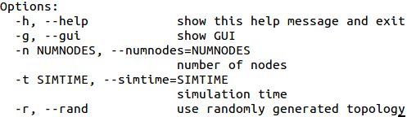
where -r will generate a network with random topology with the given number of nodes. -g will bring up a GUI, which may be useful for debugging. Just ignore the blue dot.
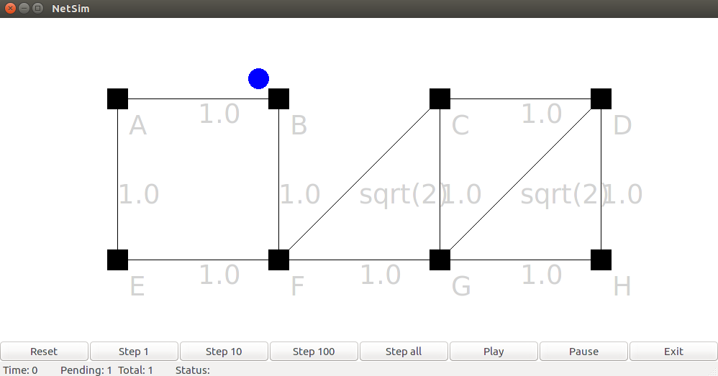
You can click on the nodes to see the current neighbour and routing information in the terminal window. Note that now it should be pretty empty, and after you implement the routing protocols you should be able to see the neighbour list and routing table/costs.
If you don’t specify the -g option, the simulator will run itself against several test cases.

2.2 Test cases
Your protocols will be tested against the following test cases (see p2_tests.py):
Euclidean network: the cost on the edges of the network is Euclidean, i.e. for three nodes A, B and C, we have (cost(AB) + cost(BC) > cost(AC), and the links between nodes are stable.
Non-Euclidean network: the links between nodes are stable, but the cost can be non-Euclidean.
Network with cost changes: the cost of the edges may change during simulation.
Network with cost change and broken links: the links between nodes are not stable and can break during simulation, while the cost may also change
Disconnected Network: the network can become disconnected during simulation.
Passing all the test doesn’t mean your code is correct, while the correct implementation could also fail in some test cases.

2.3 Distance-vector routing
In the distance-vector routing protocol, each node periodically broadcasts to its neighbours about its current routing table, i.e. a vector [(dst1, cost1), (dst2, cost2), …], which describes the current cost of reaching each destination from itself. When receiving such an advertisement from a neighbour, the node updates its current routing table accordingly. In this practical, we assume the links in the network are bi-directional with symmetric cost, i.e. the cost of a link from A to B is the same as that of B to A.
Your task is to implement both the advertisement and integration steps. We have provided the code skeleton in p2_dv.py. Here is some key information you might need when implementing your functions:
self.routes, which is the routing table of the node. It is a python dictionary [dst1, link1; dst2, link2, …], which maps a destination node to a Link. A Link object e.g. link1, represents the edge that connects the current node to its next hop neighbour towards the destination dst1. The cost associated with the link can be obtained by calling link1.cost (a variable defined in class Link). For instance, suppose node A connects to B, which then connects to C. Then in the routing table of A, you would see an entry [C, link_{AB} ]. link_{AB} can be obtained by calling self.getlink(B) (assuming your code is running on node A). Your code should update this routing table when you receive information from other nodes.
self.spcost, which is the cost table of the node. It is a python dictionary [dst1, cost1; dst2, cost2, …], which maps a destination node to the currently estimated cost of getting there. Your code should set this cost table as well.
Task 2.3.1: Implement make_dv_advertisement(self) function, which constructs the distance vector advertisement based on the current cost table self.spcost of the node. Your code should return a list, containing the constructed distance vector advertisement.

Task 2.3.2: Implement the integrate(self,link,adv) function, which updates the routing table and cost table based on the advertisement. The input parameter link is the link through which the actual advertisement adv has been delivered, i.e. the link that connects that node and the neighbour who advertised adv. You may want to use the distributed Bellman-Ford algorithm discussed in the lecture. Run:
$ python p2_dv.py
to check if your code passes the first two test cases.

Task 2.3.3: Improve your implementation of integrate(self,link,adv) function to handle cost changes. Consider the following scenario: node A connects to B, which connects to C. Assume that the costs are AB = 1, BC = 1. Suppose the current routing table at A contains this entry (C, link_{AB}), and the cost table has entry (C, 2). This means A knows that to go to C, it has to follow the link to B, and the cost is 2. Now let’s say the cost BC is changed to 10. How should you make your code robust to such a situation?

Task 2.3.4: We define the convergence time of a routing protocol as the total amount of timestamps it needs to make every node in the network has the correct routing table. In the final test case where the network becomes disconnected, the distance-vector routing protocol is expected to fail. Can you explain why?

2.4 Link-state routing
Recall from the lecture that in link-state routing, each node advertises its current link state (cost to its neighbours) to all the neighbours, and each recipient re-sends this information on all of its links. In this way, the link state is flooded through the network, and eventually all nodes know about all the links and nodes in the network topology. Then each node integrates the received information to compute the minimum cost path to every other node in the network.
Your task is to implement both the advertisement and integration steps. We have provided the code skeleton in p2_ls.py.

Task 2.4.1: Implement the make_ls_advertisement function, which constructs the link state advertisement based on the current knowledge of the node. The current link state is stored in a python dictionary (or equivalently a hashmap) self.neighbors, and can be retrieved by calling self.neighbors.values(), which returns a list of [(timestamp1, neighbour1, linkcost1), (timestamp2, neighbour2, linkcost2), … ] (Hint: you don’t need the timestamps). Your code should return a list, containing all the link state information possessed by this node.

Task 2.4.2 (optional): Implement the run_dijkstra(self,nodes) function, which computes the shortest path from this node to all other nodes in the network. The input parameter nodes is all the nodes we know about within the network. Here is some extra data structure you might need to reference.
self.LSA, which is the database of the received link state advertisement. It is again a python dictionary [advertiser, linkstate], which maps a node that sent this advertisement to the advertised link state. The linkstate is in a list [seqnum, (node1, cost1), (node2, cost2), …]. The first element seqnum denotes the “freshness” of this advertisement, and is increased by 1. The rest (node, cost) pairs represent the neighbours of the advertiser node, and the link cost.
Your code should be able to process the information encoded in self.LSA, and update the self.routes and self.spcost accordingly. Recap the Dijkstra algorithm from exercise 2, or Wiki: https://en.wikipedia.org/wiki/Dijkstra%27s_algorithm. Run
$ python p2_ls.py
to check if your code passes the test cases.

Task 2.4.3 (optional): Run both the distance-vector and link-state routing protocols. Check the convergence time of each test case: what can you observe? Can you explain why? Note that in our simulation, each node checks whether its neighbours are “alive” every 5 timestamps, and advertises to them at an interval of 20.

