

UNIVERSITY OF OXFORD
SOFTWARE ENGINEERING PROGRAMME



Mobile and Sensor Networks

Practicals

RF-based Localisation

April 2016

Introduction
In this practical we are going to implement and demonstrate the Horus [1] localization system. Horus is a popular probabilistic fingerprinting localization algorithm that works in two phases:
  - Offline phase: we survey the environment in order to build a radio map (i.e. fingerprint database). At each location we collect Wi-Fi RSS measurements with respect to several access points. These RSS measurements are called fingerprints. The assumption is that these fingerprints can be used as features to describe a known location.
  - Online phase: the goal is to estimate the user’s (unknown) location. To achieve this, we try to match the RSS measurements received at the user’s location to a location in the radio map.

Mathematical Model
Let X be a 2-dimensional physical space. At each location x ∈ X, we can get the signal strength from k access points. We denote the k-dimensional signal strength space as S. Each element in this space is a k-dimensional vector whose entries represent the signal strength readings from different access points. We denote samples from the signal strength space S as s. We also assume that the samples from different access points are independent.
The problem becomes, given a signal strength vector 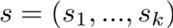, we want to find the location x ∈ X that maximizes the probability 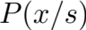.
- Offline phase: During the offline phase, the Horus system estimates the signal strength histogram for each access point at each location. These histograms represent the Horus system’s radio map.
- Online phase: Given a signal strength vector , we want to find the location x ∈ X that maximizes the probability , i.e. we want:
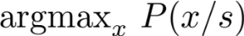
Using Bayes’ theorem, this can be shown to be equivalent to:
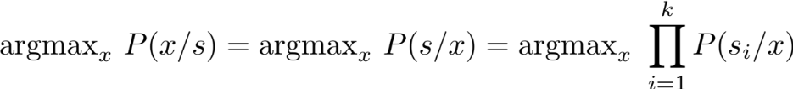
- Implementation
In this section we are going to cover the basic steps required to implement Horus.

  - Data collection: During the offline phase we survey the environment collecting RSS measurements. For this demonstration we have collected 60 samples per location. Navigate to “localization/set1/wifiData/” and open “Wifi_01.txt” with your editor.
0 3 3
1 AP_1 -38.05
2 AP_2 -54.45
3 AP_3 -42.42
4 AP_1 -39.02
5 AP_2 -62.02
6 AP_3 -44.18
7 AP_1 -38.60
8 AP_2 -60.45
9 AP_3 -37.94
10 AP_1 -37.72
11 AP_2 -64.34
12 AP_3 -45.23
13 AP_1 -39.11
14 AP_2 -59.09
The first line (i.e. line number 0) shows the (x, y) coordinate of the location where we have collected the Wi-Fi measurements. The next lines show the RSS measurements (in dBm) from each access point at this particular location. For each location (x, y) we have collected 60 RSS samples per access point.
In total we have collected Wi-Fi samples from 121 locations. The folder “localization/set1/wifiData/” contains 121 files, one for each location.
During the online phase we want to estimate the user’s unknown location using RSS readings collected at that location. Navigate to “localization/set1/testWifiData/” and answer the following questions:
- What is the number of unknown locations that we are going to estimate?
- How many RSS measurements have we collected per location per access point?
- What do you see in the first line of each file? Comment on that.
Finally, we have collected two datasets (i.e. set1 and set2); set1 contains RSS measurements with respect to 3 APs and set2 with respect to 5 APs.

  - Implementation – Reading RSS measurements: Navigate to “localization/” and open “fingerprinting_skeleton.py” with your editor. This python script provides the code skeleton for the Horus fingerprinting system.
The function load_wifi_data(data_folder,n_samples,n_ap) takes as input the data-folder (i.e. set1 or set2), the number of samples per location (i.e. 60), and the number of access points (i.e. 3 for set1 or 5 for set2) and creates a Wifi database as follows:
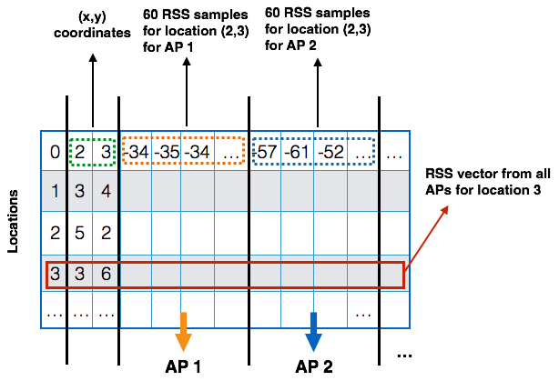
The function returns two databases namely trainDB and testDB. The first contains the fingerprints collected during the offline phase (121 locations, 60 sample per location for each AP). The second contains the test data (63 locations, 50 samples per location for each AP).

  - Visualizing fingerprints: We can use the function show_fingerprints(trainDB,n_ap) to visualize the locations where we have collected RSS measurements during the offline phase.

  - Modeling using Gaussian distributions: Instead of just using a single RSS value to represent a location, we can take advantage the variability (i.e. variance) of the measurements by modelling the readings in each location using a Gaussian distribution. The function fit_data(), approximates the RSS measurements in each location using a Gaussian distribution and transforms the trainDB as shown below:
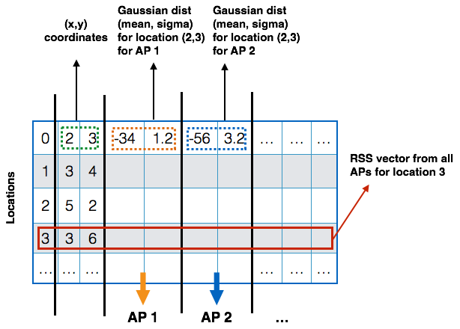

Run the function plot_histogram() to visualize the RSS measurements collected at a particular location during the offline phase and observe the Gaussian approximation. Then answer the following questions:
- Is the Gaussian distribution a good choice? If not, can you think a better way?
- What are the pros and cons of using Gaussian distribution over the histogram in this scenario? Explain your answers.

  - Implementing Horus: Find the function predict() in “fingerprinting_skeleton.py” and write your code in order to implement the location estimation process of Horus as explained in Section 2. The function should take as input the radio map and the test-set and estimate the user’s location. The function should return 2 separate arrays (of the same size, m x 2, where m is the number of locations in the test), one that contains the ground truth locations and a second array that contains the estimated locations.

  - Visualize the results: Once you finish with your implementation you can visualize the estimated locations by uncommenting the function plot_path() and you can plot the localization error using the function plot_error().

  - Increase the number of APs: Set the data_set variable to “set2” and re-run your code. Plot the error and compare it with the previous results. What do you observe? How does the number of APs affect the localization accuracy?

References:
[1] The Horus WLAN Location Determination System

