

UNIVERSITY OF OXFORD
SOFTWARE ENGINEERING PROGRAMME



Mobile and Sensor Networks

Practicals

Medium Access Control (MAC) Protocols

April 2016
1. Medium Access Control (MAC) Protocols

In this practical, we will implement some contention-free (TDMA) and contention-based (Aloha and CSMA) MAC protocols, and study their performance in different context.

1.1 Performance Metrics
To evaluate the performance of a MAC protocol, we consider the following two metrics.
Utilisation U, which is the ratio of the total throughput of all nodes to the maximum data rate of the channel. Intuitively, higher utilisation means the protocol uses the wireless channel better, without unnecessary idle.
Fairness F, which is defined as:
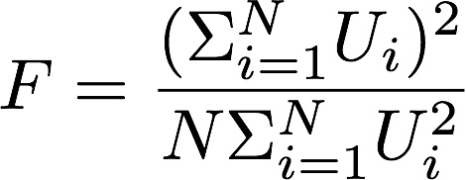
Here N is the total amount of nodes, U_{i} is the utilisation of each node. Clearly, if just one node occupies the channel, F would be 1/N, which is the worst case. If all nodes use the channel equally, F would be 1, which is the best case we want to achieve.

1.2 The WSim simulator
In this practical, we will primarily use the WSim simulator. It is a simple packet level network simulator for a shared media network. In WSim, all the nodes run the same MAC protocol, and it executes a set of steps every time slot (time increments by 1 each slot). You will have the full access to the source code, and you can implement your own protocols as you wish. For this practical, we have provided the code template that runs, and your main task is to understand and compare different MAC protocols.

1.3 TDMA
In this set of tasks, you will learn how to use the WSim simulator by running simulations of TDMA. As discussed in the lecture, TDMA divides time into slots (assume the length of each slot is 1), and the nodes send data one by one. Say we have N nodes. Then at time t, the i-th node will transmit if and only if
- It has some data to send; and
- t mod N == i
Start the virtual machine “Ubuntu_MOB” under the course folder. The login password is “user”. You may download the appropriate codebase from http://sandbox.cs.ox.ac.uk/, and extract it to anywhere you like.
Open a terminal window, navigate to the folder containing the python files, and run the following command:
$ python p1_tdma.py -g
This should bring up the GUI of the simulator as follows:

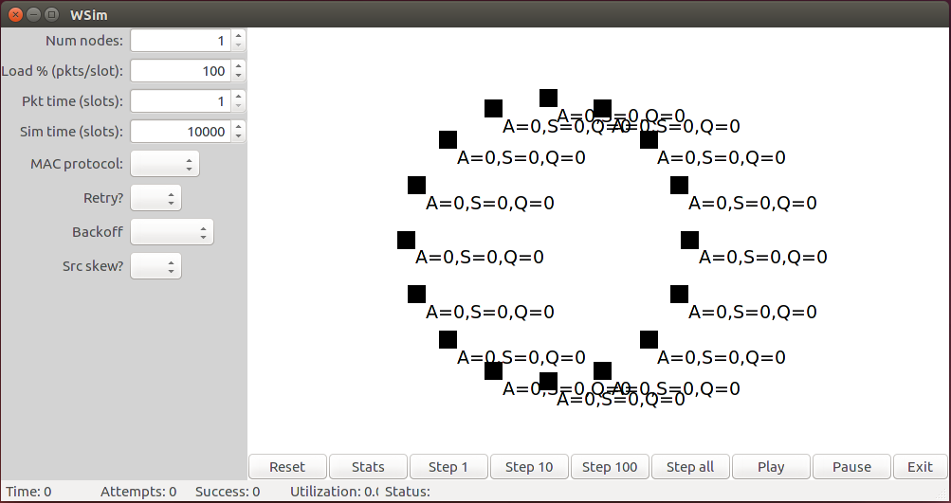

Each black block is a node, where A is the number of packets it has tried to send, S is the number of success, and Q is packages left in its queue. The bottom is the commands you can use, and the left panel shows the parameters.
Set the the parameters as follows, and click “Reset” to update the GUI:
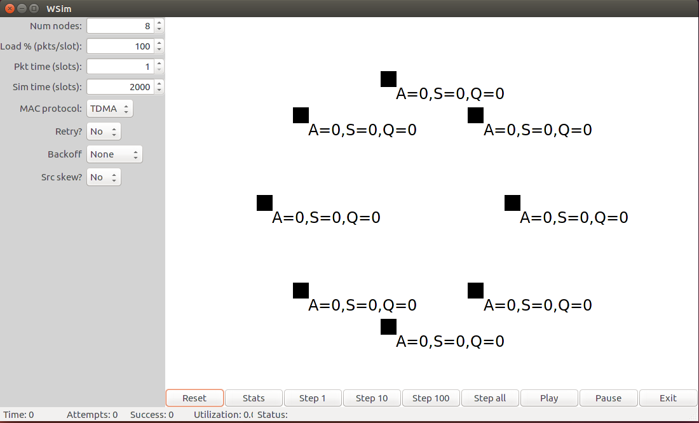

Now you can run the simulation, either manually (click “Step 1”, “Step 10”, …), or automatically (click “Play”). To speed up, you can click “Step all”. For now you shouldn’t see any meaningful output, but when you finish Task 1.3.1, you should be able to see the statistics in the terminal window:

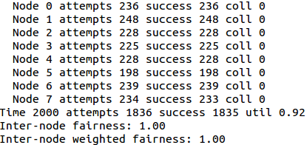

Or more conveniently, you may use the command line to directly see the final results and a bar chart showing the throughput of each node.
$ python p1_tdma.py -t 10000 -n 8
You could set the following parameters:
Option Name | -g | -s | -n | -r | -k
Description | GUI trigger | Packet size | Number of  nodes | Retry packet  after failure | Skew of the load
Default Value | False | 1 (time slot) | 16 | False | False

In particular, -k specifies whether the load between nodes are “skewed”. When this is set to be true, the maximum possible throughout of between nodes nodes will obey a geometrically-spaced amounts, i.e., Node 0 has the throughput of U/2, node 1 of U/4, node 2 a load of U/8 and so on. The last two nodes each present the same load, U/2^{N-1}. You can think that in this case, some nodes have much more battery power, so it could send packets more frequently than the others.

Task 1.3.1: We have provided the code skeleton in p1_tdma.py. Implement the channel_access(self,time,ptime,numnodes) function, which schedules the nodes to access the wireless channel. The input parameter time is the current time on the node, ptime is the size of the packet, and numnodes is the total amount of node in the network. You can get the id of current node by calling self.get_id() function. Your function should True if the channel is clear to send, and False otherwise.

Task 1.3.2: Vary the the packet size ranging from 1 to 10. What happens in terms of utilisation and fairness and why?

Task 1.3.3: In practice, if we typically have very large packets, will TDMA perform well?

Task 1.3.4: Try to play with the “Retry?” option (-r). If it is set to be True, will TDMA perform better? Why?

Task 1.3.5: Try to play with the “Src skew?” option (-k). Check both the utilisation and fairness: can you see the problem? Can you explain why? Note that in this case we should care about the “Inter-node weighted fairness”, which describes the fairness given the actual load of the nodes, i.e. it is fair to allow nodes with higher load to use the channel more.

1.4 Stabling Slotted Aloha with Backoff
Now you are familiar with the WSim simulator. In this practical, we will explore how to stable Aloha with a backoff strategy. As explained in the lecture, if a node fails to transmit a packet, it retransmits at a future slot with a certain probability p. This approach is not stable, since in practice for different amount of nodes with different loads, the optimal p value is unknown. To address this problem, we should consider a smarter strategy.
In fact, the search for the right p can be guided by feedback: if a packet transmission is unsuccessful, we should decrease p, and vice versa. For example, you can use the binary exponential rule described in the lectures.

Task 1.4.1: We have provided the code skeleton in p1_stabaloha.py. Implement the channel_access(self,time,ptime,numnodes) function, to simulate the behaviour of slotted Aloha. The input parameter time is the current time on the node, ptime is the size of the packet, and numnodes is the total amount of node in the network. You can retrieve the current probability of whether transmit or not by calling self.p. Your function should True if the channel is clear to send, and False otherwise.

Task 1.4.2: Implement the above two rules in functions on_collision(self,packet) and on_xmit_success(self,packet). The input parameter packet is actual packet the node tries to send, and you don’t need it in this task. To help you understand the code, here are some key information:
self.p the current p of the node
self.network.pmin the minimum probability pmin, which is the minium p you would like to set.
self.network.pmax the maximum probability pmax, which is the maximum p you would like to set.
Note that here we want the slotted Aloha, i.e. the length of the time slot is the same as the packet size, and the nodes only try to transmit at the beginning of each time slot.

Task 1.4.3: Test your code with different pmin and pmax values, e.g.
$ python p1_stabaloha.py -s 10 -t 10000 -r -n 8 --pmin=0.05 --pmax=0.95
When you vary the value of pmin and pmax, what do you observe? The top of the result fig shows the successful/collided packets across time, and the bottom is the throughput of each node.

Task 1.4.4: Test your code with the extreme case where pmin == pmax, e.g.
$ python p1_stabaloha.py -s 10 -t 10000 -r -n 8 --pmin=0.3 --pmax=0.3
Comparing to using different pmin and pmax, what do you observe? Why?

Task 1.4.5: Run the following two simulations to compare the performance of the stabilised Aloha with TDMA:
$ python p1_stabaloha.py -s 10 -t 10000 -r True -n 8 --pmin=0.05 --pmax=0.95
$ python p1_tdma.py -s 10 -t 10000 -n 8
What can you observe?

Task 1.4.6: Recall that TDMA has problems with skewed load. Run the following two simulations to compare the performance of the stabilised Aloha with TDMA:
$ python p1_stabaloha.py -s 10 -t 10000 -r True -n 8 --pmin=0.05 --pmax=0.95 -k True
$ python p1_tdma.py -s 10 -t 10000 -n 8 -k True
What can you observe? Why? Now change the node number to 32, what happens? What about 64, or 128 nodes?

Task 1.4.7: Can you think of different increasing/decreasing rules? Try to implement them and check their performance.

1.5 CSMA
Now let’s see how CSMA works in practice, and compare it with TDMA and the stabilised Aloha. Unlike TDMA or Aloha, CSMA sense the wireless channel before trying to send any data. We consider the same stabilisation approach as in the stabilised Aloha, i.e. each node has a probability p to transmit, which will increase if successful, and decrease otherwise.

Task 1.5.1: We have provided the code skeleton in p1_csma.py. Implement the function channel_access(self,time,ptime,numnodes), to sense the wireless channel before sending. The input parameter time is the current timestamp maintained by the node, ptime is the length of the packet to be sent, and numnodes is the total number of nodes. In this task, you don’t need to worry about the input parameters, and your code should return True if it is clear to send, and False otherwise. You can tell if the channel is busy or not by calling the function self.network.channel_busy(). Note that unlike the previous slotted Aloha, here we should allow packet size to be different from the slot size, e.g. the nodes can transmit packets of length 10 at the beginning of each timestamp. Also, don’t forget the node has to transmit according the probability p.

Task 1.5.2: Implement the increasing and decreasing rules in functions on_collision (self,packet) and on_xmit_success (self,packet). As in the previous practical, you know the following:
self.p the current p of the node
self.network.pmin the minimum probability pmin, which is set beforehand.
self.network.pmax the maximum probability pmax, which is set beforehand.

Task 1.5.3: Run the following simulation (note that here we set the packet size to 1):
$ python p1_csma.py -r True -n 8 -s 1 -t 10000 --pmin=0.05 --pmax=0.95
Check the utilisation and fairness. Now try with the stabilised Aloha:
$ python p1_stabaloha.py -r True -n 8 -s 1 -t 10000 --pmin=0.05 --pmax=0.95
What do you observe? Why?

Task 1.5.4: Now we change the packet size to 10, and re-run the two simulations in Task 1.5.3:
$ python p1_csma.py -r True -n 8 -s 10 -t 10000 --pmin=0.05 --pmax=0.95
$ python p1_stabaloha.py -r True -n 8 -s 10 -t 10000 --pmin=0.05 --pmax=0.95
What do you observe? Why? What if you vary the pmain and pmax?

Task 1.5.5: Now set the source skew (-k) to True. Try the following simulations:
$ python p1_tdma.py -n 8 -s 10 -t 10000 -k True
$ python p1_stabaloha.py -r True -n 8 -s 10 -t 10000 --pmin=0.05 --pmax=0.95 -k True
$ python p1_csma.py -r True -n 8 -s 10 -t 10000 --pmin=0.05 --pmax=0.95 -k True
Does CSMA suffer from load skewness? Now vary the node number to 32, 64, and 128. Does CSMA also scales better?

