A machine learning pest image recognition model to assist federal agencies in protecting American forests
Christopher Marais

University of Florida
College of Agriculture and Life Sciences
School of Forestry, Fisheries, and Geomatic Sciences
FNR 5608 – Project Proposal
7 December 2022

Introduction
Bark beetle is the common name for beetle species that fall into the Scolytinae clade. Some of these species can cause extensive tree mortality through infestations. Infestations often happen due to invasive bark beetle species or due to the environment changing as a result of climate change.
To the surprise of most Floridians, the most important agricultural commodity in Florida are pine trees. Pine forests are also the backbone of the state’s ecosystem services, including water and soil retention, carbon storage, biodiversity conservation, and recreation. Unfortunately, pines are grown here in vast monocultures, which is a biosecurity liability: monocultures are prone to invasions of pests and pathogens. The collapse of the citrus industry in Florida provides a poignant example.
The post-COVID era makes the importance of disease prevention obvious. This is also true for bark beetle infestations and the threat they pose to the pine forests of. However, to prevent something it first needs to be detected and identified.
Identifying the species to which an individual bark beetle belongs by visual classification is a difficult task. Bark beetles are very small at only a few millimeters (1-5mm) in length and have very similar visual characteristics between species. A significant amount of training and experience is required for a person to identify bark beetles effectively and reliably. Identifying bark beetle species molecularly through methods such as DNA sequencing is comparatively slow and expensive, and not practical at the scale of production forests or nature reserves. The current process of identifying bark beetles is time consuming with a long delay between trap deployment and identification. Samples are currently classified by hand by the United States Department of Agriculture (USDA) leading to identification fatigue and human error. The current approach is also to discard all samples after identification. This creates a data gap where no backlog of data is kept for backreferencing. Unfortunately, the current process also takes months, and prevents realistic early detection and rapid response. Our goal is to cut down the bottleneck – finding suspects among thousands of non-targets – from months to a few minutes.
In this study we aim to produce a machine learning model capable of classifying native bark beetle genera and species using microscopic images together with beetle size in length and width. This model will be used to test the following hypotheses:
- Size is the most informative factor in classifying bark beetle species visually
- A hierarchical convolutional neural network is more accurate than a standard convolutional neural network at classifying images as genera and species
- The Machine learning model is significantly more consistent, and faster at classifying beetles accurately than the current process
- Adding a broad range of beetle image data to the training data improves classification accuracy for identifying native bark beetle species and genera

Literature Review

Bark and Ambrosia Beetles
Bark and ambrosia beetles refer to beetles in the Curculionidae family, more specifically to beetles in the Scolytinae and Platypodinae subfamilies (T.H. Atkinson Bark and Ambrosia Beetle Pages: Home, n.d.). This includes over 7000 different species of beetles with approximately 250 genera that make up 26 different tribes (Pistone et al., 2018). All bark and ambrosia beetles are wood boring beetles that bore into many different species of woody plants globally. Even though as a group these beetles have a global range, some species are limited to particular regions and also attack only particular tree or plant species (Kirkendall et al., 2015; KnÍŽek & Beaver, 2007).
Most bark beetle species are not considered pests; however, some can cause large scale damage to forests (Bark Beetles in a Changing Environment on JSTOR, n.d.) . Increased winter temperatures and invasive bark beetle species are the most common drivers of bark beetle attacks that result in large scale tree mortality (Krokene, 2015). It is hypothesized that climate change reduces bark beetle development and temperature-induced mortality which in turn allows them to develop bigger and more damaging swarms in areas where these beetles were previously scarcer (Bark Beetles in a Changing Environment on JSTOR, n.d.). Increased trade and travel in the modern world also allow for more cross contamination and introduction of invasive species between regions.
Bark beetles can have a substantial impact ecologically by altering habitats and affecting multiple organisms (Morris et al., 2017). Damage caused to forests also have a notable economic impact on the pulp, paper, and timber industries (Grégoire et al., 2015). It has been estimated that southern pine beetle-induced timber mortality in the U.S. South has resulted in approximately $43 million in losses annually (Holmes & Koch, n.d.). It is clear that bark and ambrosia beetles pose a significant risk and that this risk is amplified with the rise of climate change and trade between countries. Even though there are techniques that forest managers can employ to counter unwanted bark and ambrosia beetle infestations such as thinning. They often do not have enough time to counter an attack (Bark Beetles in a Changing Environment on JSTOR, n.d.). There have been several attempts to predict bark beetle outbreaks, however, these empirical models tend to be contextual to a specific area or bark beetle species (Ortiz et al., 2013; Rammer & Seidl, 2019). To build supervised predictive machine learning models on the spread of invasive species it is crucial to have accurate data, algorithms, and outputs.
An essential part of recording species or tribe specific data is to identify samples correctly. This is not trivial when working with bark and ambrosia beetles as they tend to be smaller than 8 mm in length. This small size makes it hard to classify species by eye and often microscopes are required to investigate the smaller intricate features that differ between tribes and species (Hulcr et al., 2015). This same limitation requires that some training or experience is needed to classify beetles reliably. An alternative method and more accurate way of classifying bark beetle species is to use DNA barcoding(Jordal & Kambestad, 2014). However, this is not a scalable way to identify large amounts of beetles collected from multiple traps from multiple forests.
In a previous program the United States Department of Agriculture had more than 300 traps in 22 different states. This program was aimed at early detection and rapid response of bark and ambrosia beetles (Rabaglia et al., 2008). This program relied on three taxonomists to correctly identify bark and ambrosia beetles which posed a bottleneck in the processing of samples. A more standardized alternative to visually classify samples would be to make use of an automated image recognition system. This can potentially lower the costs and decrease the bottleneck in processing samples. The power of image recognition for species classification has already been shown in mobile applications such as iNaturalist(Horn et al., 2017) and Google’s Wildlife Insights (Ahumada et al., 2020). Some other examples include classification models aimed at classifying carabid beetles and ants(Boer & Vos, 2018; Hansen et al., 2020; Marques et al., 2018). A lot of work has also been done on many other insects or small objects proving that this field has a lot of potential(Martineau et al., 2017; Parmezan et al., 2022; Tresson et al., 2021). However, no such studies have yet been done for bark and ambrosia beetles.

Image classification with machine learning
Machine learning (ML) is a commonly used method in automating image classification. The convolutional neural network (CNN) architecture has specifically shown to be extremely effective at accurate image classification. One drawback of a conventional CNN is that it does not leverage the existing hierarchies that classes commonly form a part of. In this study we will use and compare a Branch Convolutional Neural Network (B-CNN) to a conventional CNN. The B-CNN can leverage the existing hierarchies in our classes to ostensibly improve classification accuracy.
In the past 10 years deep learning and more specifically convolutional neural networks (CNN) have dominated image machine learning applications(Chen et al., 2021). Many different variants of this deep learning architecture have been explored, but the core concepts persist as a reliable way of training machine learning models on image data. CNNs offer some simple advantages over standard artificial neural networks (ANNs). The convolutional layers allow them to reduce the number of parameters when compared to ANNs. CNNs are also image translation invariant whereas ANNs are sensitive to different translations of images(O’Shea & Nash, 2015). One augmented version of the CNN worth mentioning is the hierarchical Branch Convolutional Neural Network (B-CNN) (Figure 1) architecture(Zhu & Bain, n.d.). This version of the CNN is adapted to have multiple output layers making it capable to classify on orders of class resolution. Meaning that it is capable of classifying classes nested within one another. An expansion of this hierarchical approach known as the Hierarchical Bilinear Convolutional Neural Network (HB-CNN) takes a multi-task learning approach to produce even better results(Zhang et al., 2021). This shows that these hierarchical algorithms are capable to ingest predefined hierarchical information to improve performance.
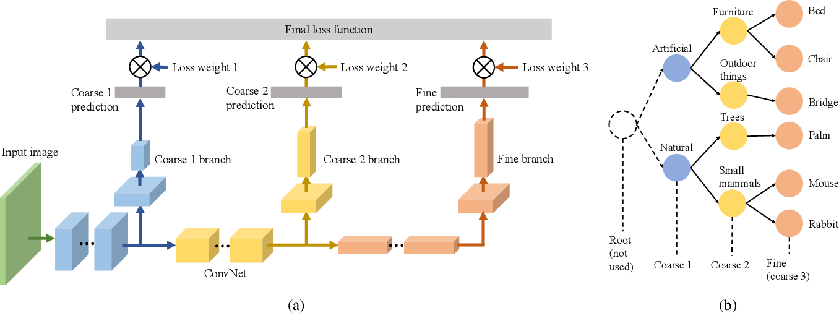
Figure 1: “(a) Architecture of Branch Convolutional Neural Network (B-CNN). The network at the bottom can be an arbitrary ConvNet. There can be multiple branch networks and each of them outputs a coarse prediction. The final loss function is a weighted summation of all coarse losses. (b) A sample hierarchical label tree where classes are taken from CIFAR-100 dataset.” - (Zhu & Bain, n.d.)
One common hurdle when classifying small entities is that there are often multiple objects in a single image that need to be classified individually. The standard way of overcoming this is by either taking individual images of samples or to perform object detection in an image and then break up a single image into multiple small images that each can be classified (Zou et al., 2019). Object detection itself is also a form of image classification or more specifically pixel classification. The purpose of object detection is to identify the pixels in an image that belong to a specific entity. Examples may include non-neural network-based methods, such as Histogram of Oriented Gradients (HOG) feature description, or a neural network-based, such as in the case of the You Only Look Once (YOLO) algorithm (Dalal et al., 2005; Redmon et al., 2015). One thing that is vital when using these automated object detection methods is that the noise in the background of the image, the complexity, and size of the objects all contribute to the efficacy of the algorithm being used (Hu & Ramanan, 2017). For our purposes the HOG approach might be more practical as we expect our input data to have a neutral and consistent background.
A commonly mentioned criticism of deep learning is that the operations of the system are not undefined to the user. This has led to a rising interest in the field of explainable artificial intelligence (XAI) (Linardatos et al., 2020; Samek et al., n.d.). This field is concerned with the ways in which machine learning models are interpreted. For computer vision tasks using deep learning models, XAI is often implemented by identifying the most important pixels in an image to the model in use (Vermeire et al., 2022). There are many different tools in which to do this, but most tools make use of the trained parameters of a network and some defined input image to identify the pixels that are most critical to the model’s outcome (Linardatos et al., 2020). These pixels can then be visualized, analyzed, and reviewed to understand the model. By highlighting the features or pixels on a model image it is possible to gain insight into the biases about the training data and the model. This way the “black box” element of deep neural networks can be reduced and some insights about visual beetle classification can be gained.

Research Design
The research project can be divided up into different steps into building and understanding a model capable of classifying bark beetle species from images. These steps are general guidelines to during which smaller hurdles and objectives will be overcome and achieved respectively (Figure 2).

Data collection, management, and exploratory analysis
The main aim and output of the project is to, through established machine learning methods, train a model that can classify various bark beetle species from images. An additional output of the project is to generate a database of images to enrich the current collection of bark beetle samples. Therefore data collection is arguably one of the most important steps of this project.
The images used to train the models and do experiments with will be generated in the Forest Entomology lab at the University of Florida using high resolution cameras. The initial images will be stored and backed up in their RAW format. During experimentation and model testing the images will be processed into JPEG and PNG formats. These processed images will be stored alongside the RAW images. The generated models will be stored as serialized objects alongside the Python code to interpret and use them.
We have reviewed existing datasets and are generating our own data specifically to enrich the current collection of samples and to produce images of a sufficient resolution. However, the model will be tested using images from an existing (https://barkbeetles.info/) database in collaboration with the owners of the database. These images will only be stored temporarily for the duration of the testing period. Identification of the images used during testing will be recorded and stored with instructions of where they be obtained.
All data will be stored with descriptive guides containing the metadata of where, when and how the data was obtained. Additionally, these guides will indicate how the data was processed and used. The metadata automatically generated during the capturing of images will be stored in a table in CSV format alongside the names of the images.
The data generated and processed in this study do not carry significant ethical weight. The images will remain the intellectual property of the lab until publication. The data will be made available to other researchers on BioImage Archive when the study is published.
The metadata, code and guides on the data will be stored as a private repository on Github alongside the models and the code which will be written in Python. This repository will be updated whenever new data is generated, or code is changed. The repository will be made public after publication of the study. The Github repository will be the main backup and storage of the metadata and code. Additional copies will exist on two machines. One in the Forest Entomology lab on the University of Florida campus. Another will be on my (Christopher Marais) personal laptop.
The images in their RAW format will mainly be stored and backed up on OneDrive and on the Forest Entomology lab server with another backup on an external hard drive. Additional copies will exist on my laptop and on the high-performance server at the University of Florida (HiperGator). The backups on the lab server and OneDrive will be updated whenever new images are added. The external hard drive will be updated weekly and the copies on the HiperGator will be updated as required for processing.
All images in their RAW format, code, and models will be stored long-term. Any processed images will be stored short to medium term and relaced with guides on how to process the images for long term storage. All data on any personal computers or the HiperGator will be removed after the study is complete.
All data collected in this project will be held private to the Forest Entomology lab until publication of the study whereafter it will be made publicly available through GitHub and BioImage Archive. All documentation for how to access the data and the publication will be made available on GitHub. The GitHub repository will also be referenced if the study is published.
All responsibilities regarding the maintenance, creation and management of the data created in this study will be mine (Christopher Marais) for the duration of the study. After the completion of the study all data management responsibilities will be passed on to the project supervisor (Dr Jiri Hulcr).
After the data has been collected it will be explored statistically and visually. This will allow for a better understanding of the data available and inform decision making about feature selection. This step of data exploration will also be useful in identifying any anomalies with the data that have to be removed or normalized during data cleaning. By exploring and understanding the data it will also be possible to adjust our model design process to suit the data as good as possible by opting for different algorithms or data transfer processes.

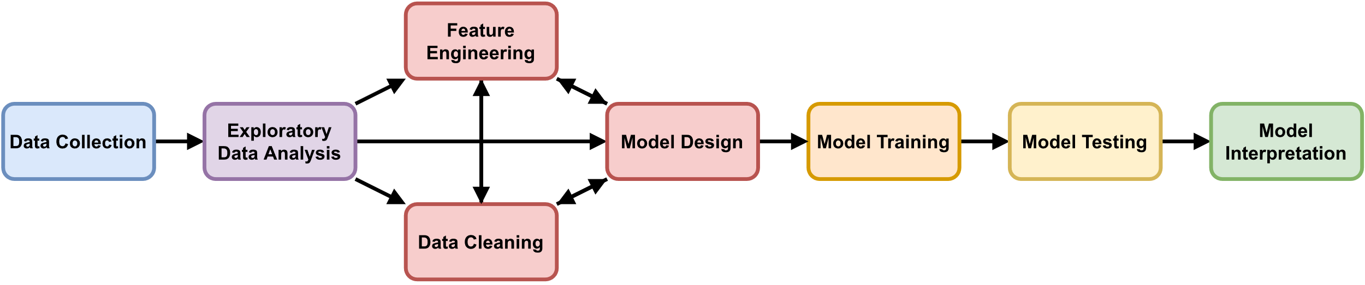
Figure 2: Research project flow pipeline for engineering and understanding an image classification model.

Feature engineering, data cleaning, and model design
After the data collection and exploratory analysis is complete the engineering portion of the project takes priority. During this part the data has to be appropriately cleaned, a model has to be designed and the features to be used from the data in the model has to be selected. These three components all affect one another. The type of model chosen during the design portion is affected by which features are chosen. Likewise, the features have to be chosen to suit the model algorithm. The interplay between these parts means that this will be the portion of the project where iteration and prototyping will be integral. These components will therefore happen concurrently alongside model training (Figure 3). After model training we will loop back to this phase iteratively. When a satisfactory prototype has been developed it will be used as a basis for the final model to move forward in the project flow.
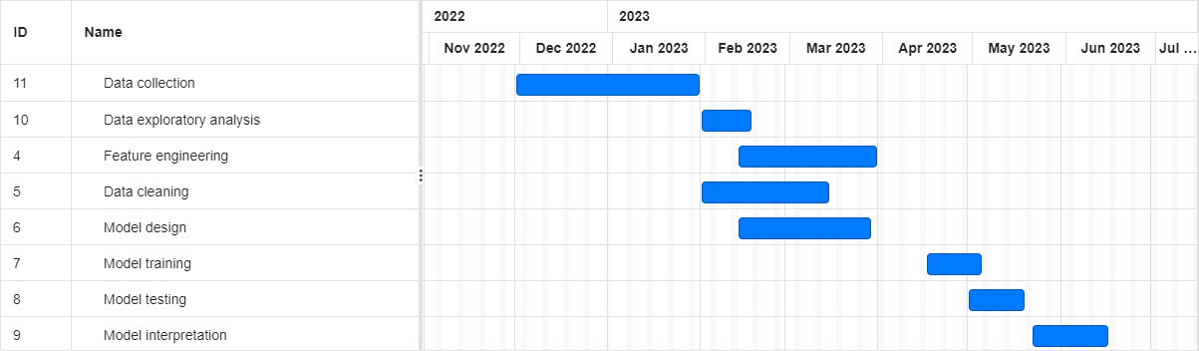
Figure 3: Project flow timeline

Model training, testing and interpretation

Conclusion
This research may provide clues into which features are the most informative for identifying beetle species. It will provide insights into which beetles are the most difficult to distinguish from one another, be it for a lack of data, or for a lack of visual variation between species. This information may contribute to the field of bark beetle classification in general in addition to the benefits that can be gained by improving detection and rapid response to bark beetle infestations.
- Contribute to bark beetle classification by identifying features
- Contribute to USDA for improving bottleneck
- Contribute to machine learning as a case study of which contexts certain techniques are useful

References
Ahumada, J. A., Fegraus, E., Birch, T., Flores, N., Kays, R., O’Brien, T. G., Palmer, J., Schuttler, S., Zhao, J. Y., Jetz, W., Kinnaird, M., Kulkarni, S., Lyet, A., Thau, D., Duong, M., Oliver, R., & Dancer, A. (2020). Wildlife Insights: A Platform to Maximize the Potential of Camera Trap and Other Passive Sensor Wildlife Data for the Planet. Environmental Conservation, 47(1), 1–6. https://doi.org/10.1017/S0376892919000298
Bark Beetles in a Changing Environment on JSTOR. (n.d.). Retrieved October 25, 2022, from https://www.jstor.org/stable/20113226#metadata_info_tab_contents
Boer, M. J. A., & Vos, R. A. (2018). Taxonomic Classification of Ants (Formicidae) from Images using Deep Learning. BioRxiv, 407452. https://doi.org/10.1101/407452
Chen, L., Li, S., Bai, Q., Yang, J., Jiang, S., & Miao, Y. (2021). Review of Image Classification Algorithms Based on Convolutional Neural Networks. Remote Sensing 2021, Vol. 13, Page 4712, 13(22), 4712. https://doi.org/10.3390/RS13224712
Dalal, N., Histograms, B. T., & Triggs, B. (2005). Histograms of Oriented Gradients for Human Detection. 886–893. https://doi.org/10.1109/CVPR.2005.177ï
Grégoire, J. C., Raffa, K. F., & Lindgren, B. S. (2015). Economics and Politics of Bark Beetles. Bark Beetles: Biology and Ecology of Native and Invasive Species, 585–613. https://doi.org/10.1016/B978-0-12-417156-5.00015-0
Hansen, O. L. P., Svenning, J. C., Olsen, K., Dupont, S., Garner, B. H., Iosifidis, A., Price, B. W., & Høye, T. T. (2020). Species-level image classification with convolutional neural network enables insect identification from habitus images. Ecology and Evolution, 10(2), 737–747. https://doi.org/10.1002/ECE3.5921
Holmes, T., & Koch, F. (n.d.). Bark Beetle Epidemics, Life Satisfaction, and Economic Well-Being. https://doi.org/10.3390/f10080696
Horn, G. van, Aodha, O. mac, Song, Y., Cui, Y., Sun, C., Shepard, A., Adam, H., Perona, P., & Belongie, S. (2017). The iNaturalist Species Classification and Detection Dataset. Proceedings of the IEEE Computer Society Conference on Computer Vision and Pattern Recognition, 8769–8778. https://doi.org/10.48550/arxiv.1707.06642
Hu, P., & Ramanan, D. (2017). Finding tiny faces. Proceedings - 30th IEEE Conference on Computer Vision and Pattern Recognition, CVPR 2017, 2017-January, 1522–1530. https://doi.org/10.1109/CVPR.2017.166
Hulcr, J., Atkinson, T. H., Cognato, A. I., Jordal, B. H., & McKenna, D. D. (2015). Morphology, Taxonomy, and Phylogenetics of Bark Beetles. Bark Beetles: Biology and Ecology of Native and Invasive Species, 41–84. https://doi.org/10.1016/B978-0-12-417156-5.00002-2
Jordal, B. H., & Kambestad, M. (2014). DNA barcoding of bark and ambrosia beetles reveals excessive NUMTs and consistent east-west divergence across Palearctic forests. Molecular Ecology Resources, 14(1), 7–17. https://doi.org/10.1111/1755-0998.12150
Kirkendall, L. R., Biedermann, P. H. W., & Jordal, B. H. (2015). Evolution and Diversity of Bark and Ambrosia Beetles. Bark Beetles: Biology and Ecology of Native and Invasive Species, 85–156. https://doi.org/10.1016/B978-0-12-417156-5.00003-4
KnÍŽek, M., & Beaver, R. (2007). Taxonomy and Systematics of Bark and Ambrosia Beetles. Bark and Wood Boring Insects in Living Trees in Europe, a Synthesis, 41–54. https://doi.org/10.1007/978-1-4020-2241-8_5
Krokene, P. (2015). Conifer Defense and Resistance to Bark Beetles. Bark Beetles: Biology and Ecology of Native and Invasive Species, 177–207. https://doi.org/10.1016/B978-0-12-417156-5.00005-8
Linardatos, P., Papastefanopoulos, V., & Kotsiantis, S. (2020). Explainable AI: A Review of Machine Learning Interpretability Methods. Entropy 2021, Vol. 23, Page 18, 23(1), 18. https://doi.org/10.3390/E23010018
Marques, A. C. R., Raimundo, M. M., Cavalheiro, E. M. B., Salles, L. F. P., Lyra, C., & von Zuben, F. J. (2018). Ant genera identification using an ensemble of convolutional neural networks. PLOS ONE, 13(1), e0192011. https://doi.org/10.1371/JOURNAL.PONE.0192011
Martineau, M., Conte, D., Raveaux, R., Arnault, I., Munier, D., & Venturini, G. (2017). A survey on image-based insect classification. Pattern Recognition, 65, 273–284. https://doi.org/10.1016/J.PATCOG.2016.12.020
Morris, J. L., Cottrell, S., Fettig, C. J., Hansen, W. D., Sherriff, R. L., Carter, V. A., Clear, J. L., Clement, J., DeRose, R. J., Hicke, J. A., Higuera, P. E., Mattor, K. M., Seddon, A. W. R., Seppä, H. T., Stednick, J. D., & Seybold, S. J. (2017). Managing bark beetle impacts on ecosystems and society: priority questions to motivate future research. Journal of Applied Ecology, 54(3), 750–760. https://doi.org/10.1111/1365-2664.12782
Ortiz, S. M., Breidenbach, J., & Kändler, G. (2013). Early Detection of Bark Beetle Green Attack Using TerraSAR-X and RapidEye Data. Remote Sensing 2013, Vol. 5, Pages 1912-1931, 5(4), 1912–1931. https://doi.org/10.3390/RS5041912
O’Shea, K., & Nash, R. (2015). An Introduction to Convolutional Neural Networks. https://doi.org/10.48550/arxiv.1511.08458
Parmezan, A. R. S., Souza, V. M. A., Seth, A., Žliobaitė, I., & Batista, G. E. A. P. A. (2022). Hierarchical classification of pollinating flying insects under changing environments. Ecological Informatics, 70, 101751. https://doi.org/10.1016/J.ECOINF.2022.101751
Pistone, D., Gohli, J., & Jordal, B. H. (2018). Molecular phylogeny of bark and ambrosia beetles (Curculionidae: Scolytinae) based on 18 molecular markers. Systematic Entomology, 43(2), 387–406. https://doi.org/10.1111/SYEN.12281
Rabaglia, R., Duerr, D., Acciavatti, R., & Ragenovich, I. (2008). Early Detection and Rapid Response for Non-Native Bark and Ambrosia Beetles. www.forestryimages.org
Rammer, W., & Seidl, R. (2019). Harnessing Deep Learning in Ecology: An Example Predicting Bark Beetle Outbreaks. Frontiers in Plant Science, 10, 1327. https://doi.org/10.3389/FPLS.2019.01327/BIBTEX
Redmon, J., Divvala, S., Girshick, R., & Farhadi, A. (2015). You Only Look Once: Unified, Real-Time Object Detection. ArXiv, 2016-December, arXiv:1506.02640. https://doi.org/10.1109/CVPR.2016.91
Samek, W., Wiegand, T., & Müller, K.-R. (n.d.). EXPLAINABLE ARTIFICIAL INTELLIGENCE: UNDERSTANDING, VISUALIZING AND INTERPRETING DEEP LEARNING MODELS.
T.H. Atkinson Bark and Ambrosia beetle pages: Home. (n.d.). Retrieved October 26, 2022, from https://www.barkbeetles.info/
Tresson, P., Carval, D., Tixier, P., & Puech, W. (2021). Hierarchical Classification of Very Small Objects: Application to the Detection of Arthropod Species. IEEE Access, 9, 63925–63932. https://doi.org/10.1109/ACCESS.2021.3075293
Vermeire, T., Brughmans, D., Goethals, S., de Oliveira, R. M. B., & Martens, D. (2022). Explainable image classification with evidence counterfactual. Pattern Analysis and Applications, 25(2), 315–335. https://doi.org/10.1007/S10044-021-01055-Y/TABLES/5
Zhang, X., Tang, L., Luo, H., Zhong, S., Guan, Z., Chen, L., Zhao, C., Peng, J., & Fan, J. (2021). Hierarchical bilinear convolutional neural network for image classification. IET Computer Vision, 15(3), 197–207. https://doi.org/10.1049/CVI2.12023
Zhu, X., & Bain, M. (n.d.). B-CNN: Branch Convolutional Neural Network for Hierarchical Classification. Retrieved October 26, 2022, from https://github.com/
Zou, Z., Shi, Z., Guo, Y., Ye, J., & Member, S. (2019). Object Detection in 20 Years: A Survey. https://doi.org/10.48550/arxiv.1905.05055

