

1. Global polynomial regression

* merits
* Drawbacks
  + Requires high degree to have a highly flexible model
  + Undesirable results at boundaries of the data
  + Flexibility is kept constant

Unpenalized splines

* merits
  + High flexibiklity without high degree necessary
  + Variable flexibility possible for regions that require it and lower flexibility where it isn’t necessary
  + can accommodate thresholds
  + more flexible fits
  + more stable estimates especially at boundaries of the data
* Drawbacks
  + Multiple lines that could be broken and need to be smoothed
  + Roughness that is fixed and requires penalization to smooth out
  + Roughness penalized more severely for smaller samples
  + High variance at the outer range of the predictors

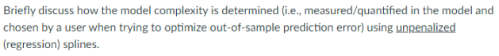

1. Through the number of knots used in the model. This can be optimised through cross-validation MSE on degrees of freedom which equals knots
2. 

We can penalize nonlinearity by penalizing the variability in the function. This can be done by using the second derivative as an indication of variability in the function or it’s roughness.



1. We can use the nonnegative tuning parameter of the penalty term as an indication of the effective degrees of freedom of the function.



1. The penalty is necessary so that the function is not forced into a shape that maximises flexibility and reduces the MSE to 0. The Penalty reduces flexibility. Penalized splines are more generalisable to out of sample data. The drawback of the penalized spline approach is that is may in some cases with small amounts of data be too rigid.

1. d

Wiggle = degrees of freedom with splines kind of like degree of curve