|  |
| --- |
|  |
| The Specification |
| [Type the document subtitle] |
|  |
| **[Your Name]** |
| **[Pick the date]** |

[Type the abstract of the document here. The abstract is typically a short summary of the contents of the document. Type the abstract of the document here. The abstract is typically a short summary of the contents of the document.]

Table of Contents

[To update the table of contents, right click the message below and select Update Field (F9 on PC, ⌥⌘U on Mac).]

**No table of contents entries found.**

1. Pages
   1. Page Tree

Home  
 Page 1  
 Page 2  
 Page 3  
 Page 4  
Customer Account  
Intervals  
Backup  
Users  
Report  
Place Order  
Create Account  
Job Process  
Payment  
Tasks

* 1. Home
     1. User Interface

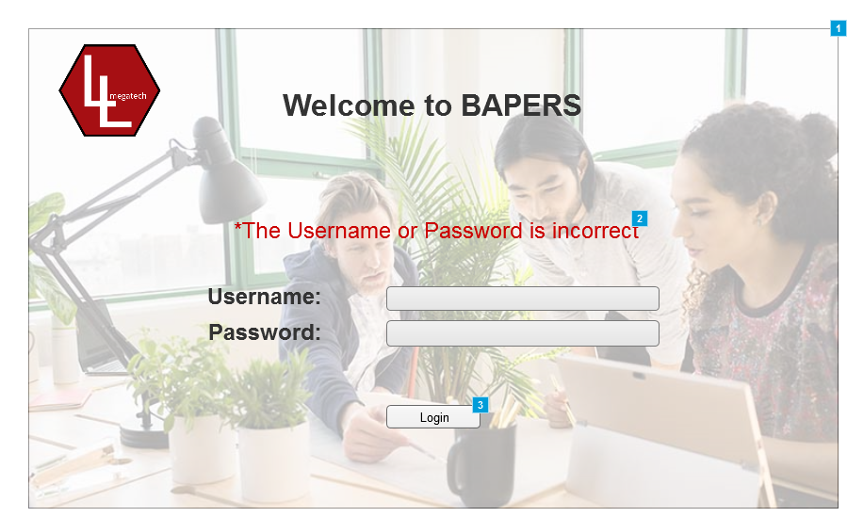

* + 1. Widget Table

| Footnote | Description | Risk |
| --- | --- | --- |
| 1 | Main login screen | Low |
| 2 | Text that appears if the login details introduced are wrong |  |
| 3 | When pressed, depending on the user and the details introduced, it either gives acces to the system or not. |  |

* 1. Page 1
     1. User Interface

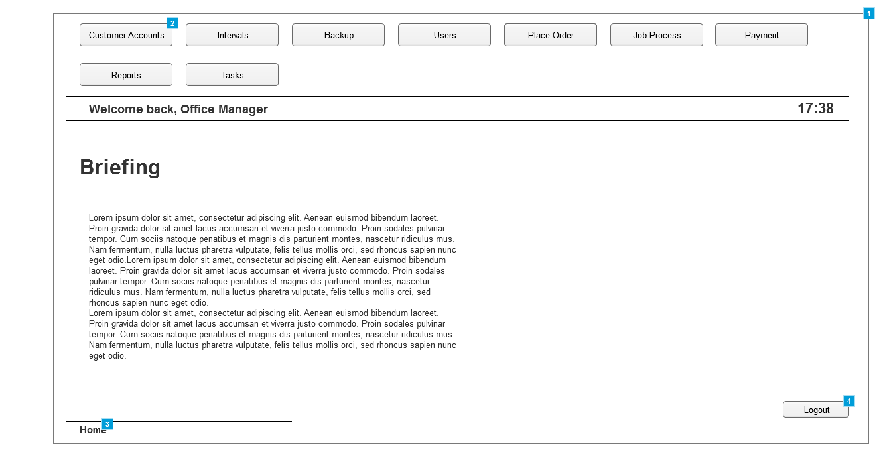

* + 1. Widget Table

| Footnote | Description |
| --- | --- |
| 1 | Home screen pannel for the Office Manager |
| 2 | Buttons that when clicked, thake the user to the screen descibed in the tab. Buttons change depending on the users and their permissions |
| 3 | Displays the system path, for easier understanding where in the system the user is located. Can be cliked to go to a previos screen in that path, |
| 4 | Button that, when clicked, logs the user out of the system. |

* 1. Page 2
     1. User Interface

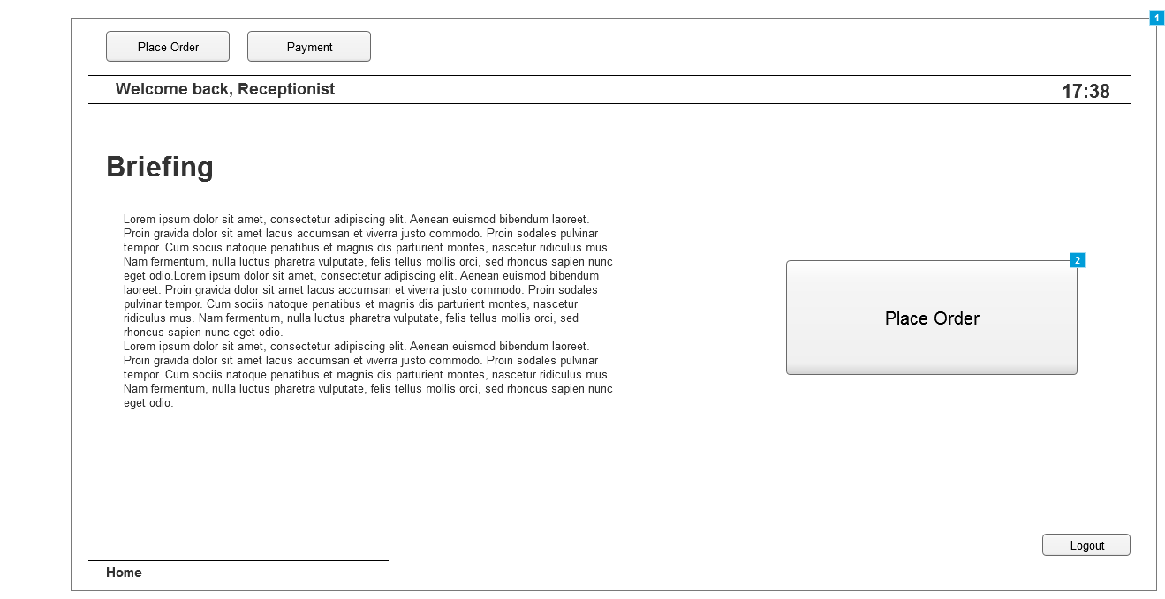

* + 1. Widget Table

| Footnote | Description |
| --- | --- |
| 1 | Home screen pannel for the Receptionist |
| 2 | Quick acces to "Place Order Tab" since is one of the main tasks. |

* 1. Page 3
     1. User Interface

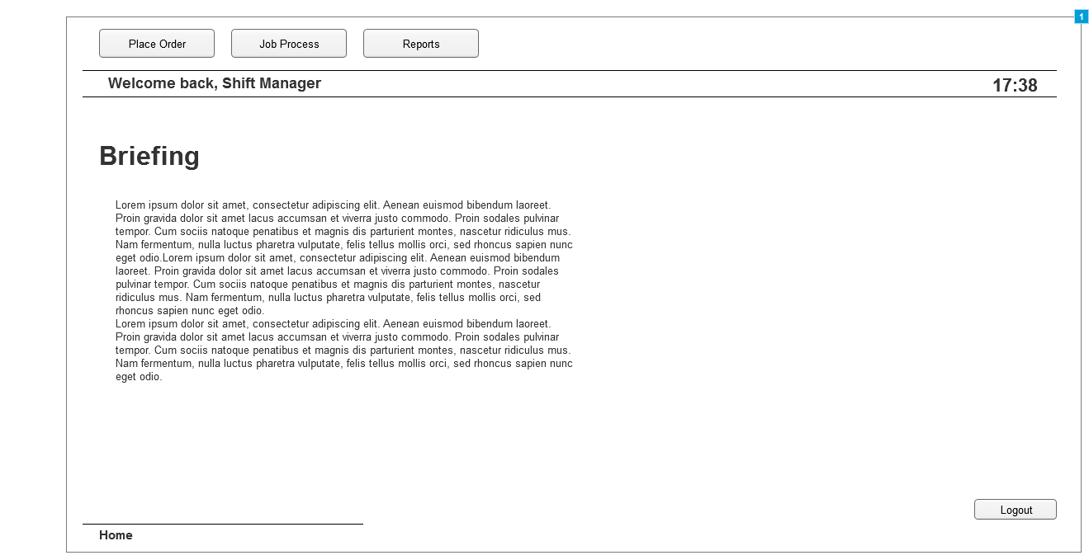

* + 1. Widget Table

| Footnote | Description |
| --- | --- |
| 1 | Home screen pannel for the Shift Manager |

* 1. Page 4
     1. User Interface

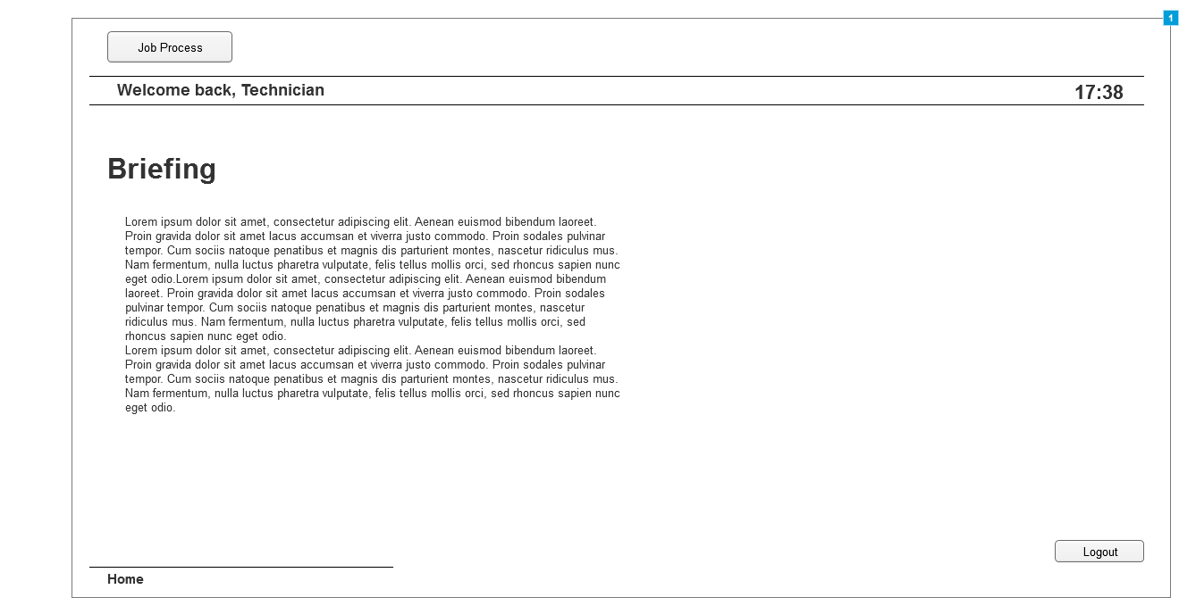

* + 1. Widget Table

| Footnote | Description |
| --- | --- |
| 1 | Home screen pannel for the Technician |

* 1. Customer Account
     1. User Interface

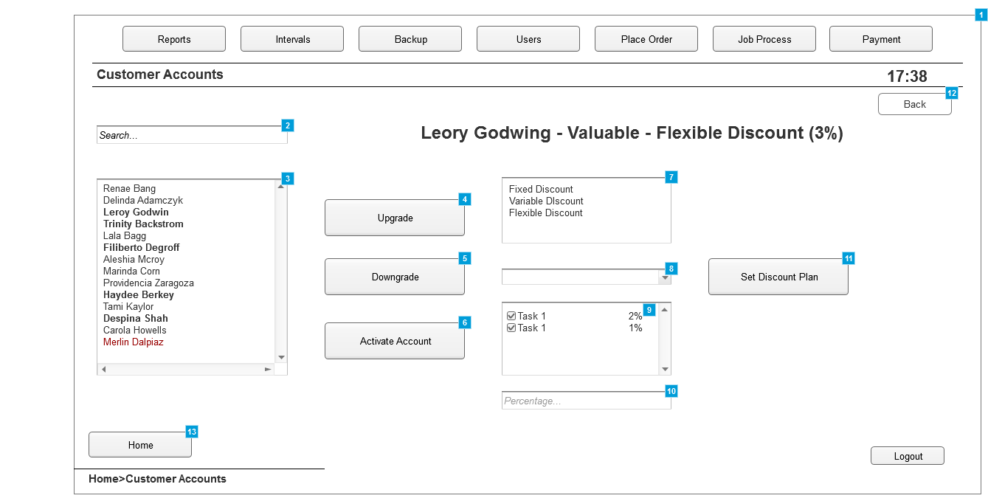

* + 1. Widget Table

| Footnote | Description |
| --- | --- |
| 1 | Pannel where the existing customer accounts are managed |
| 2 | Search box, to look-up existing customer accounts, once chosen, upgrading/downgrading options are available as well as updating the discount plans associated with the account |
| 3 | List box where all the existing customer accounts are displayed.   -The ones in Bold display Valued Customers -The normal ones dispaly normal customers -The ones in red display Suspended Customer Accounts |
| 4 | Upgrades the customer to the "Valued" status, only available if the customer is not already in this status |
| 5 | Downgrades the customer from the "Valued" status to the "Normal" one. |
| 6 | Reactivates a "Suspended" account |
| 7 | Pannel displaying the available discount plans |
| 8 | Tab that allows to choose tasks and apply discounts to each one. Appears only if "Flexible Discount" is selected |
| 9 | If a discount for a task need to be deleted, unticking the box will do this. Selecting an existing task from the list and adding a different percentage will overwrite the previous one |
| 10 | The percentage of the discount will be introduced here |
| 11 | Button that, when clicked, confirms the discount options selected |
| 12 | Button that allows the user to go back to the previous screen |
| 13 | Button that takes the user to the home tab |

* 1. Intervals
     1. User Interface

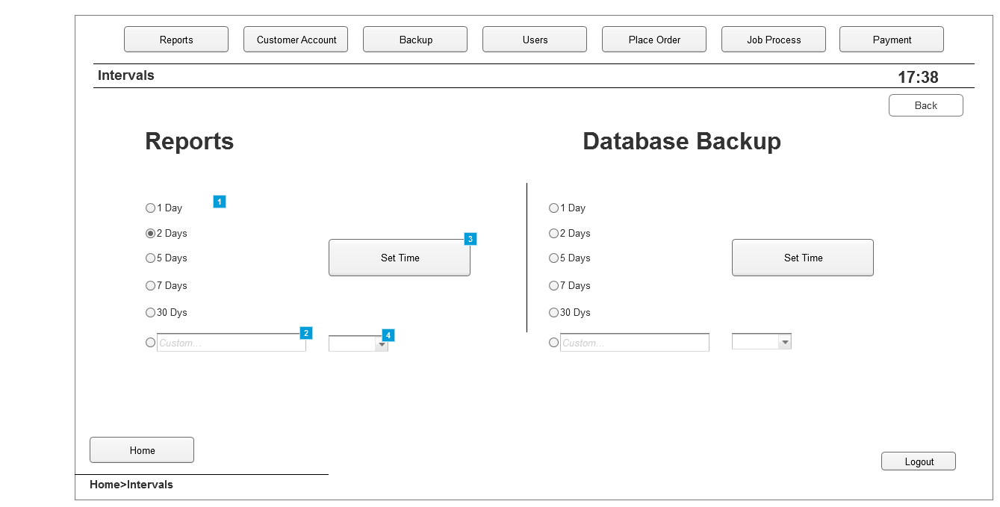

* + 1. Widget Table

| Footnote | Description |
| --- | --- |
| 1 | Premade options to choose the time intervals at which reports are created. Similar for Database Backup |
| 2 | Pannel to introduce a custom time period for generating the repots. Same can be done to the Database Backup |
| 3 | Button that, when clicked, sets the time intervals at which reports are created. |
| 4 | Droplist allowing to set minutes, hours or days for the custom time intervals |

* 1. Backup
     1. User Interface

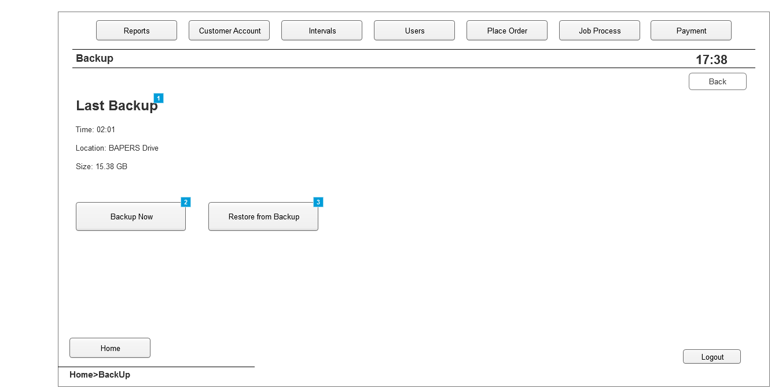

* + 1. Widget Table

| Footnote | Description |
| --- | --- |
| 1 | Information about the last backup created |
| 2 | Button that, when clicked, creates a system backup |
| 3 | Button that, when clicked, resores data from the last backup created |

* 1. Users
     1. User Interface

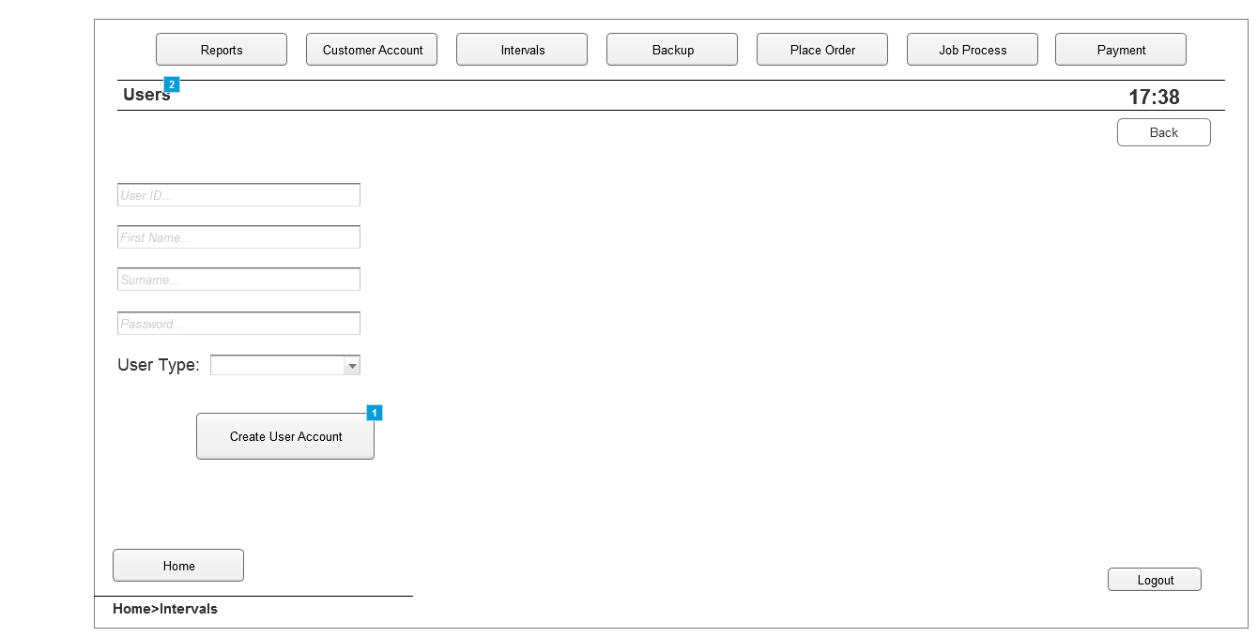

* + 1. Widget Table

| Footnote | Description |
| --- | --- |
| 1 | Button that, when clicked, creates the user account with the details introduced |
| 2 | Tab where new users are added to the system |

* 1. Report
     1. User Interface

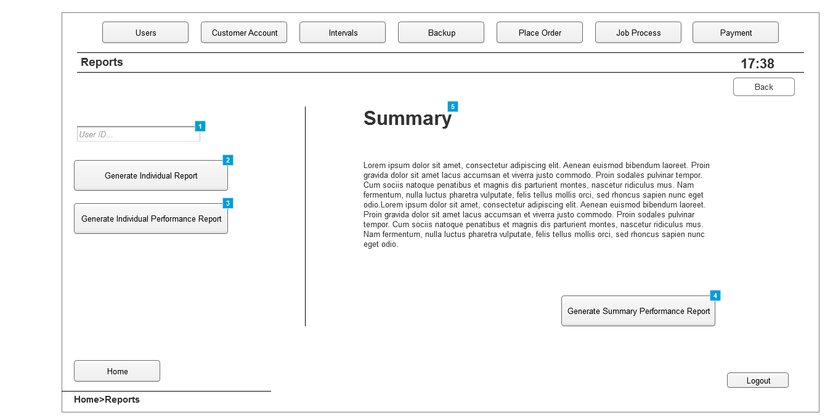

* + 1. Widget Table

| Footnote | Description |
| --- | --- |
| 1 | Box where user ID is introduced . This referes to the system users. Once a user is selected, more options are available |
| 2 | Button that, when clicked, generates an individual report for the user selected |
| 3 | Button that, when clicked, generates an individual performance report for the user selected |
| 4 | Button that, when clicked, generates a summary performance report |
| 5 | Summary and details about it |

* 1. Place Order
     1. User Interface

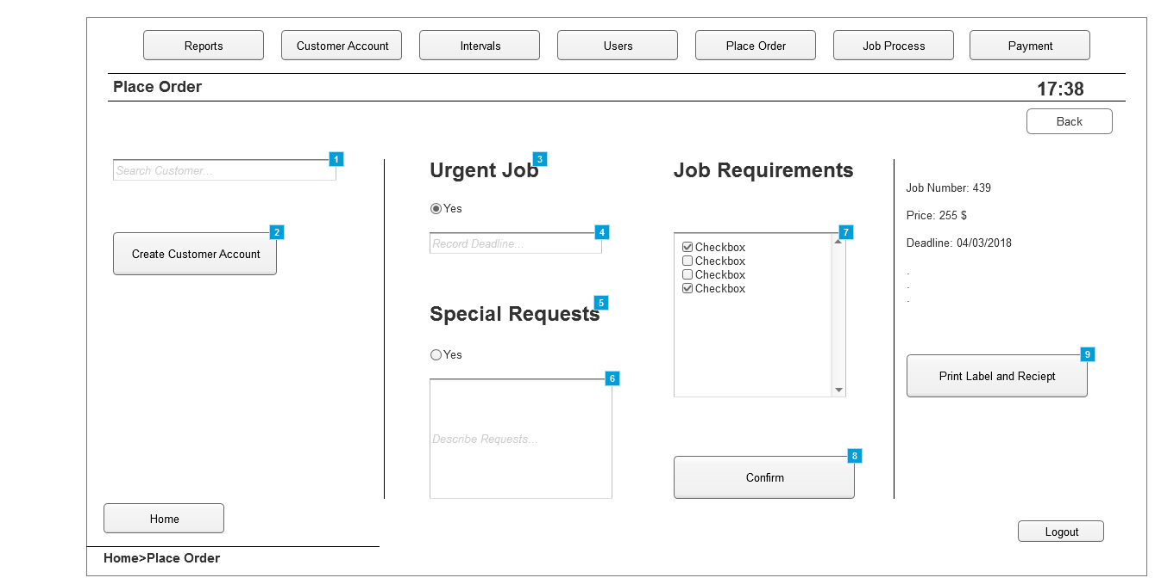

* + 1. Widget Table

| Footnote | Description |
| --- | --- |
| 1 | Pannel where customer accounts can be searched, if created, to allow for placing an order |
| 2 | Button that, when clicked, takes the user to the "Create Account" window. Used in case the customer does not have an account yet |
| 3 | Option to select if job placed is urgent. |
| 4 | Pannel to introduce deadline if job is urgent |
| 5 | Option to select if special requests exist about the job |
| 6 | Pannle to introduce details about the request |
| 7 | List of all tasks available. Checked only the ones which are needed for the job |
| 8 | Button that, when clicked, generates the job number and final price |
| 9 | Button that, when clicked, Assigns the job and prints the label and the reciept. |

* 1. Create Account
     1. User Interface

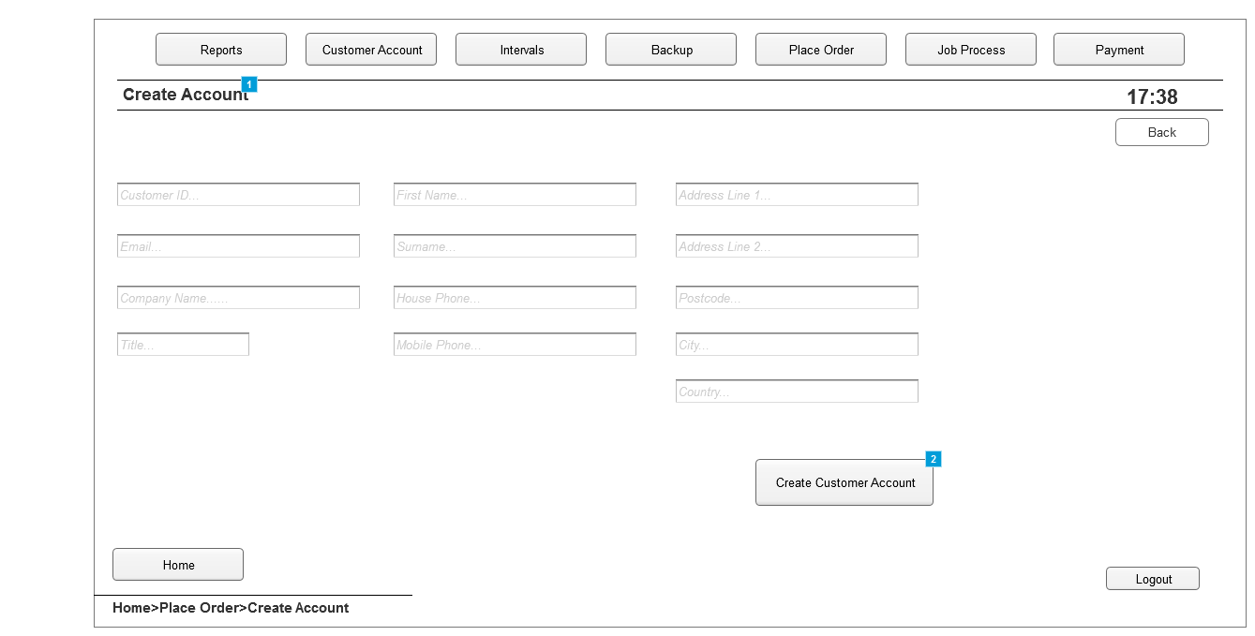

* + 1. Widget Table

| Footnote | Description |
| --- | --- |
| 1 | Tab where new customer accounts are created |
| 2 | Button that, when clicked, creates the customer account with the details introduced in each field. |

* 1. Job Process
     1. User Interface

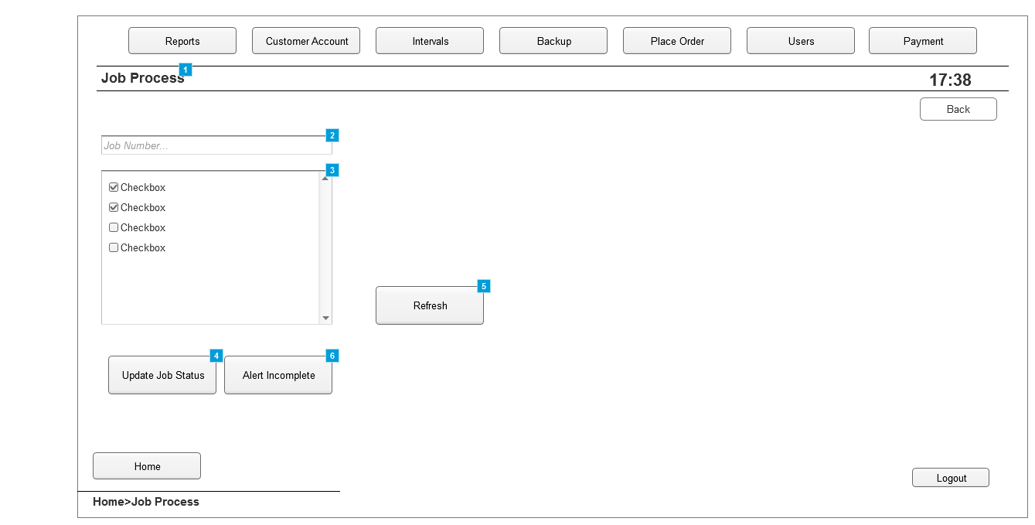

* + 1. Widget Table

| Footnote | Description |
| --- | --- |
| 1 | Tab where the ongoing jobs can be managed |
| 2 | Pannel where the job number is introduced to get details about a job |
| 3 | List with the tasks available. Those ticked indicate that the particular task is completed |
| 4 | Button that, when clicked, updatates the status of the jobs, A task must be tiked or unticked to be able to update |
| 5 | Button that, when clicked, refreshes the list to see if changes have been made |
| 6 | Button that is click to alret that the job is not going to be completed on time |

* 1. Payment
     1. User Interface

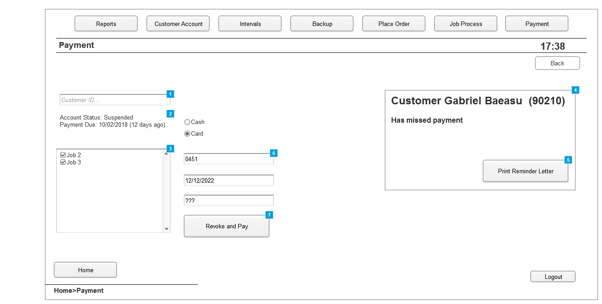

* + 1. Widget Table

| Footnote | Description |
| --- | --- |
| 1 | Pannel where a customer is searched to get details about the job placed |
| 2 | Details about the customer account, |
| 3 | List of all the jobs placed, only one will be displayed if the customer is not "Valued"  If the job is ticked, it means it will be paid for in the next payment. |
| 4 | Pop-up window alerting the Office Manager that a customer has missed payment |
| 5 | Button that, when clicked will print the reminder letter for the user |
| 6 | Pannels where information about card or cash payment is introduced |
| 7 | Button that, when clicked, completes payment and revokes suspension of an account if account is suspended. |

* 1. Tasks
     1. User Interface

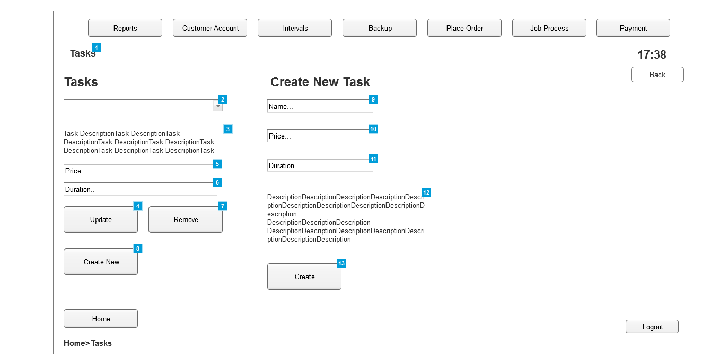

* + 1. Widget Table

| Footnote | Description |
| --- | --- |
| 1 | Tab where tasks can be managed |
| 2 | List of all the tasks available in the system |
| 3 | Description of the task selected |
| 4 | Button that. when clicked, updates any details changed about the selected task |
| 5 | Price of the selected task |
| 6 | Time it takes for the task to be completed |
| 7 | Button that. when clicked, removes the selected task |
| 8 | Button that. when clicked, displays the "Create Task" options |
| 9 | Pannel to introduce the name of the new task |
| 10 | Pannel to introduce the price of the new task |
| 11 | Pannel to introduce the time taken for the new task to be completed |
| 12 | Description of the new task |
| 13 | Button that, when clicked, creates and adds the task to the list of existing tasks. |