|  |
| --- |
|  |
| The Specification |
| [Type the document subtitle] |
|  |
| **Gabriel Baeasu** |
| **[Pick the date]** |

[Type the abstract of the document here. The abstract is typically a short summary of the contents of the document. Type the abstract of the document here. The abstract is typically a short summary of the contents of the document.]

Table of Contents

[To update the table of contents, right click the message below and select Update Field (F9 on PC, ⌥⌘U on Mac).]

1. Pages 4

1.1. Page Tree 4

1.2. Home 5

1.2.1. User Interface 5

1.2.2. Widget Table 5

1.3. Page 1 6

1.3.1. User Interface 6

1.3.2. Widget Table 6

1.4. Page 2 7

1.4.1. User Interface 7

1.4.2. Widget Table 7

1.5. Page 3 8

1.5.1. User Interface 8

1.5.2. Widget Table 8

1.6. Page 4 9

1.6.1. User Interface 9

1.6.2. Widget Table 9

1.7. Customer Account 10

1.7.1. User Interface 10

1.7.2. Widget Table 10

1.8. Intervals 11

1.8.1. User Interface 11

1.8.2. Widget Table 11

1.9. Backup 12

1.9.1. User Interface 12

1.9.2. Widget Table 12

1.10. Users 13

1.10.1. User Interface 13

1.11. Report 14

1.11.1. User Interface 14

1.11.2. Widget Table 14

1.12. Place Order 15

1.12.1. User Interface 15

1.12.2. Widget Table 15

1.13. Create Account 16

1.13.1. User Interface 16

1.14. Job Process 17

1.14.1. User Interface 17

1.14.2. Widget Table 17

1.15. Payment 18

1.15.1. User Interface 18

1.15.2. Widget Table 18

1.16. Tasks 19

1.16.1. User Interface 19

1.16.2. Widget Table 19

1. Pages
   1. Page Tree

Home  
 Page 1  
 Page 2  
 Page 3  
 Page 4  
Customer Account  
Intervals  
Backup  
Users  
Report  
Place Order  
 Create Account  
Job Process  
Payment  
Tasks

* 1. Home
     1. User Interface

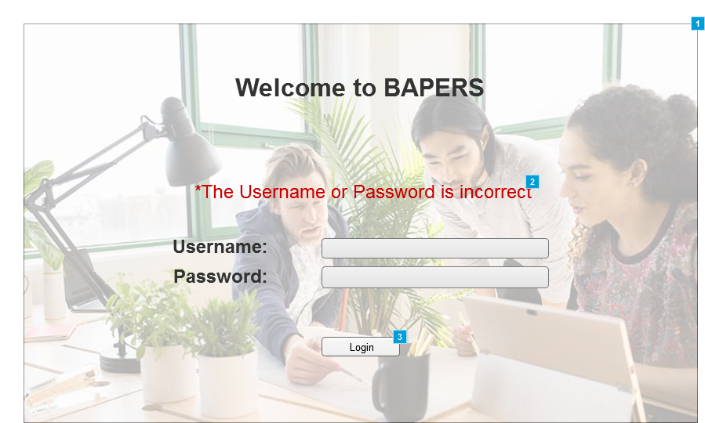

* + 1. Widget Table

|  |  |  |
| --- | --- | --- |
| Footnote | Description | Risk |
| 1 | Main login screen | Low |
| 2 | Text that appears if the login details introduced are wrong |  |
| 3 | When pressed, depending on the user and the details introduced, it either gives acces to the system or not. |  |

* 1. Page 1
     1. User Interface

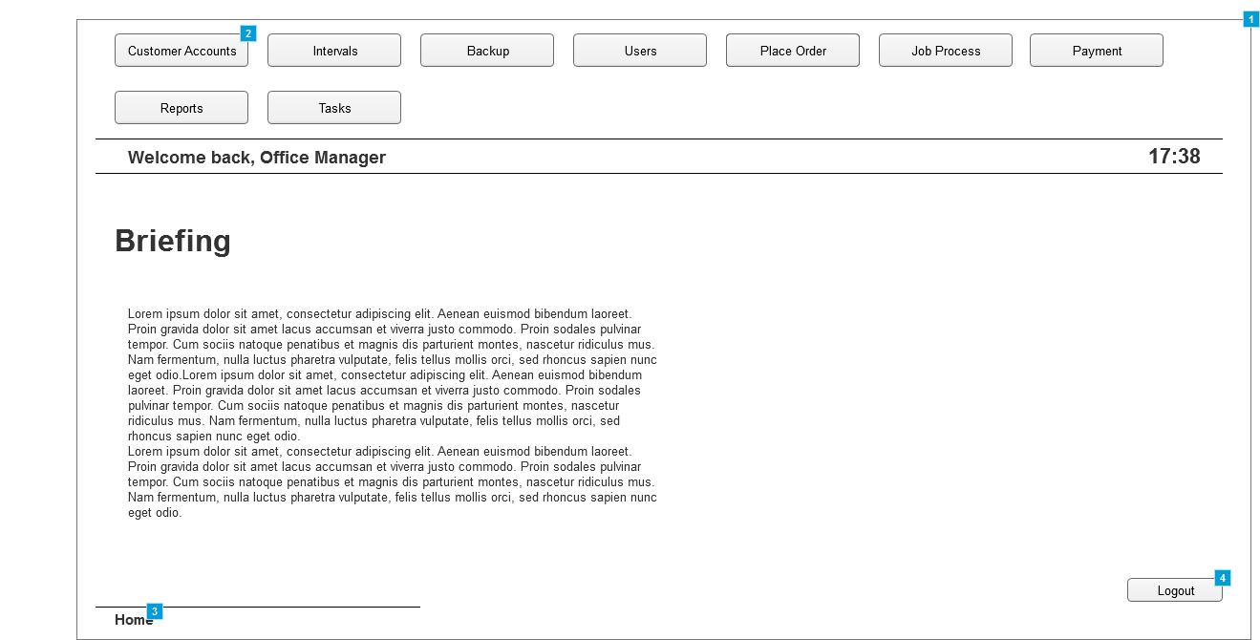

* + 1. Widget Table

|  |  |
| --- | --- |
| Footnote | Description |
| 1 | Home screen pannel for the Office Manager |
| 2 | Buttons that when clicked, thake the user to the screen descibed in the tab. Buttons change depending on the users and their permissions |
| 3 | Displays the system path, for easier understanding where in the system the user is located. Can be cliked to go to a previos screen in that path, |
| 4 | Button that, when clicked, logs the user out of the system. |

* 1. Page 2
     1. User Interface

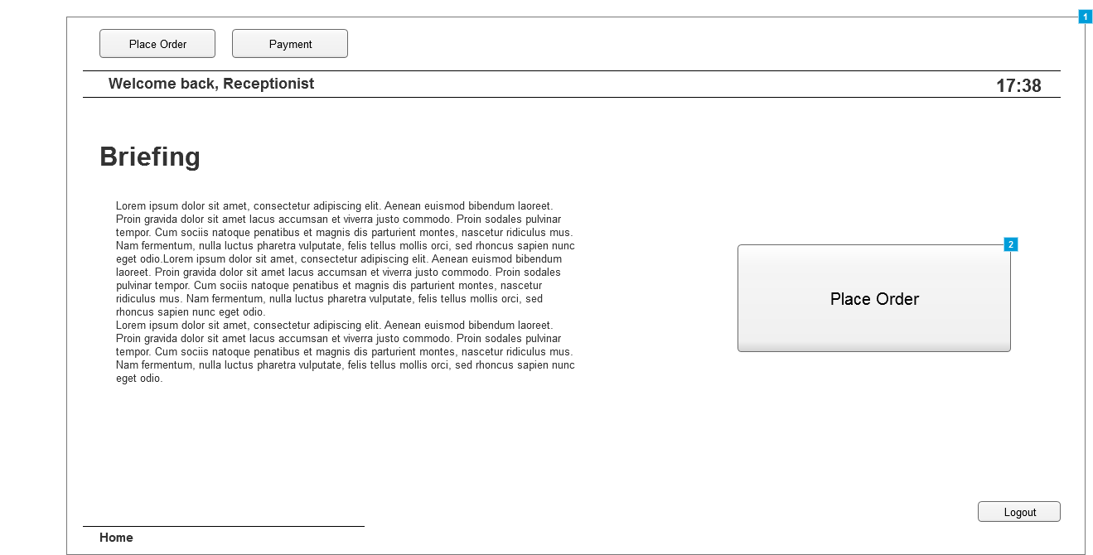

* + 1. Widget Table

|  |  |
| --- | --- |
| Footnote | Description |
| 1 | Home screen panel for the Receptionist |
| 2 | Quick access to "Place Order Tab" since is one of the main tasks. |

* 1. Page 3
     1. User Interface

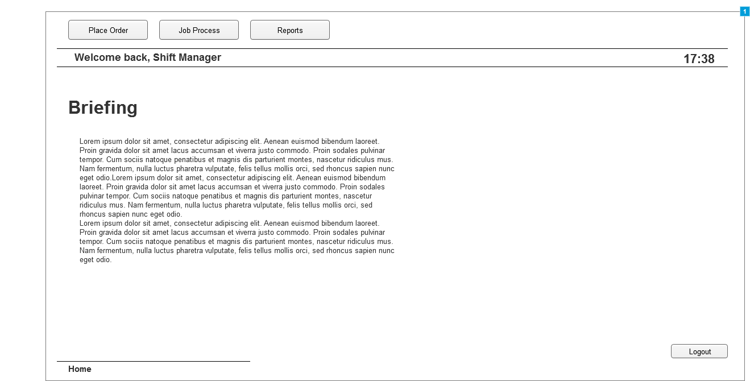

* + 1. Widget Table

|  |  |
| --- | --- |
| Footnote | Description |
| 1 | Home screen panel for the Shift Manager |

* 1. Page 4
     1. User Interface

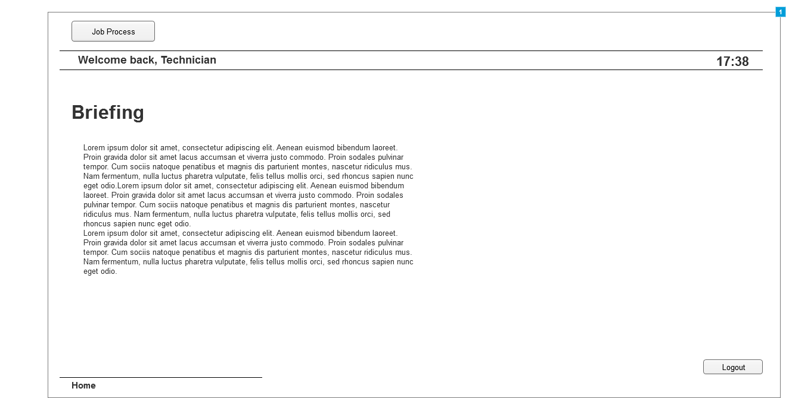

* + 1. Widget Table

|  |  |
| --- | --- |
| Footnote | Description |
| 1 | Home screen panel for the Technician |

* 1. Customer Account
     1. User Interface

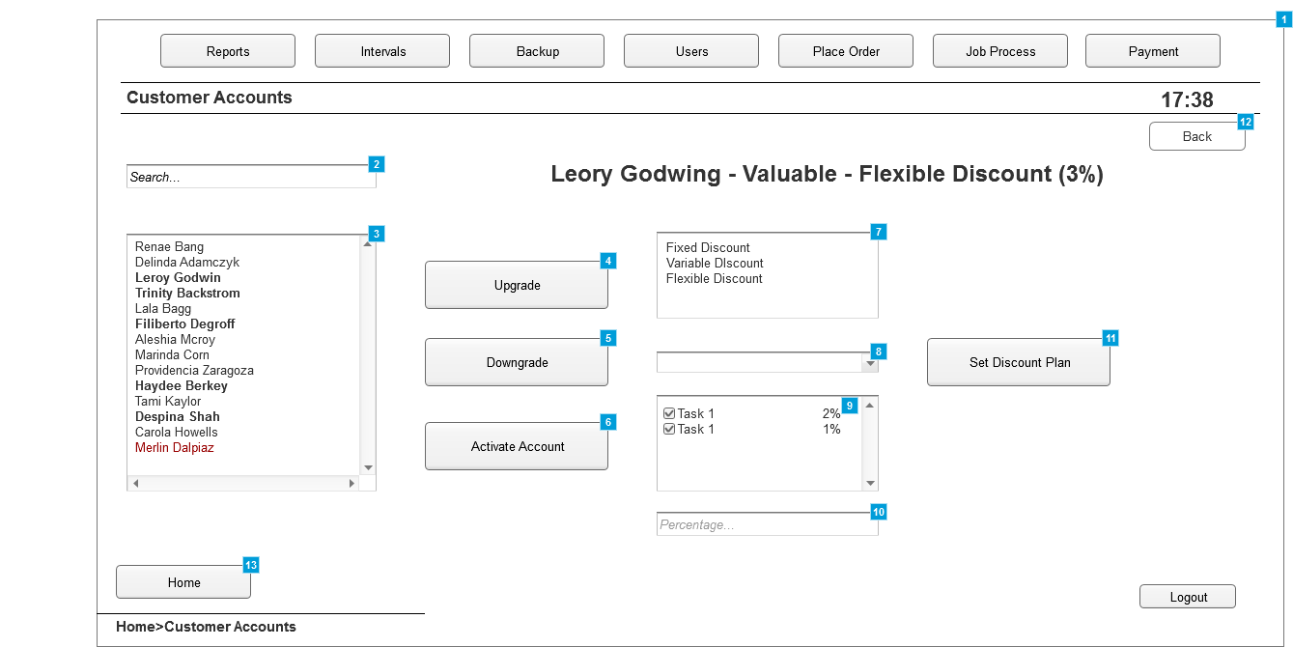

* + 1. Widget Table

|  |  |
| --- | --- |
| Footnote | Description |
| 1 | Panel where the existing customer accounts are managed |
| 2 | Search box, to look-up existing customer accounts, once chosen, upgrading/downgrading options are available as well as updating the discount plans associated with the account |
| 3 | List box where all the existing customer accounts are displayed.   -The ones in Bold display Valued Customers -The normal ones display normal customers -The ones in red display Suspended Customer Accounts |
| 4 | Upgrades the customer to the "Valued" status, only available if the customer is not already in this status |
| 5 | Downgrades the customer from the "Valued" status to the "Normal" one. |
| 6 | Reactivates a "Suspended" account |
| 7 | Panel displaying the available discount plans |
| 8 | Tab that allows to choose tasks and apply discounts to each one. Appears only if "Flexible Discount" is selected |
| 9 | If a discount for a tatxtsk need to be deleted, unticking the box will do this. Selecting an existing task from the list and adding a different percentage will overwrite the previous one |
| 10 | The percentage of the discount will be introduced here |
| 11 | Button that, when clicked, confirms the discount options selected |
| 12 | Button that allows the user to go back to the previous screen |
| 13 | Button that takes the user to the home tab |

* 1. Intervals
     1. User Interface

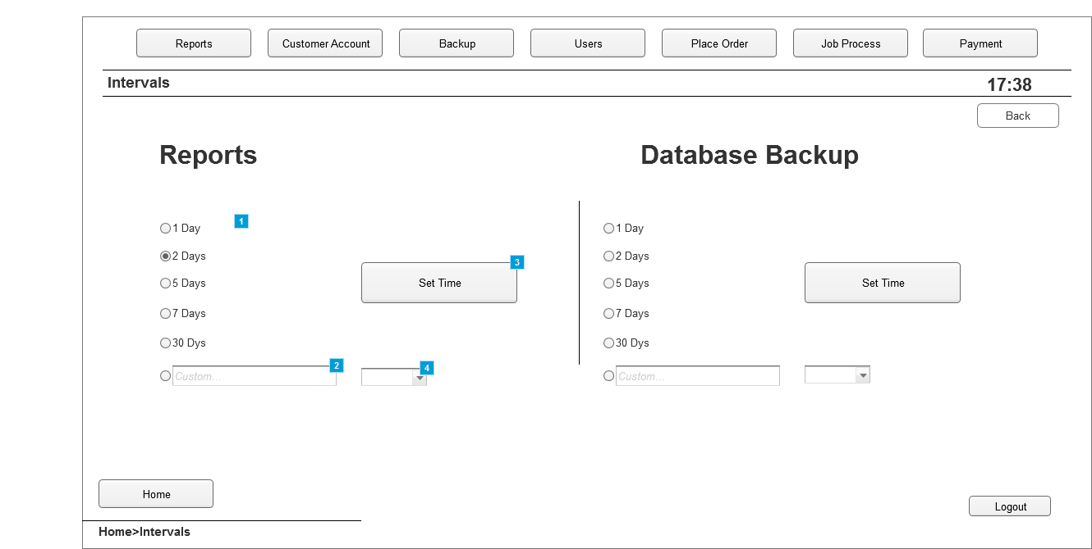

* + 1. Widget Table

|  |  |
| --- | --- |
| Footnote | Description |
| 1 | Premade options to choose the time intervals at which reports are created. Similar for Database Backup |
| 2 | Pannel to introduce a custom time period for generating the repots. Same can be done to the Database Backup |
| 3 | Button that, when clicked, sets the time intervals at which reports are created. |
| 4 | Droplist allowing to set minutes, hours or days for the custom time intervals |

* 1. Backup
     1. User Interface

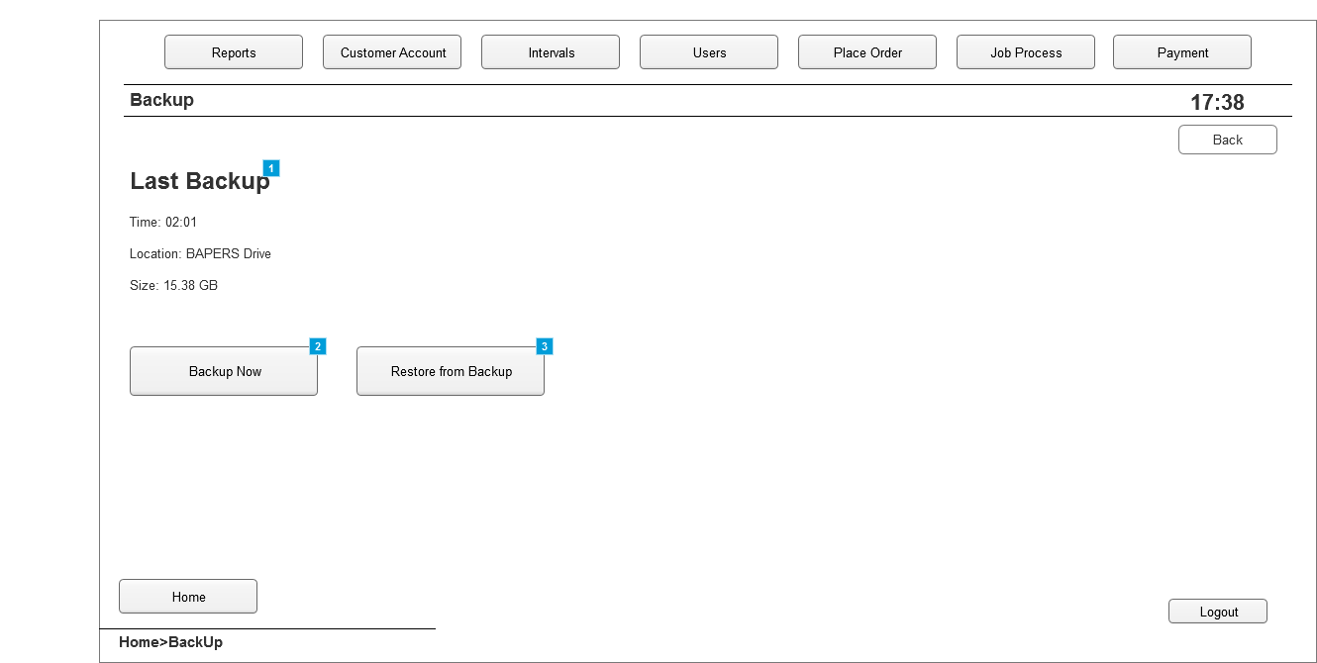

* + 1. Widget Table

|  |  |
| --- | --- |
| Footnote | Description |
| 1 | Information about the last backup created |
| 2 | Button that, when clicked, creates a system backup |
| 3 | Button that, when clicked, restores data from the last backup created |

* 1. Users
     1. User Interface

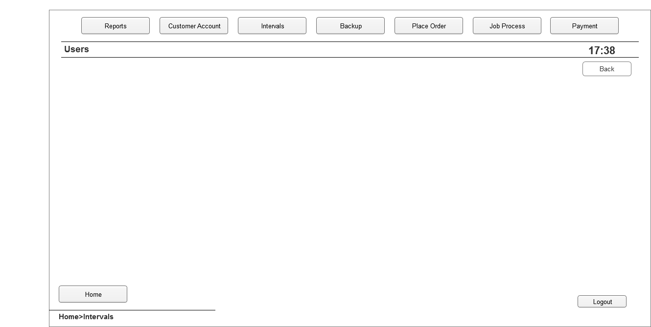

* 1. Report
     1. User Interface

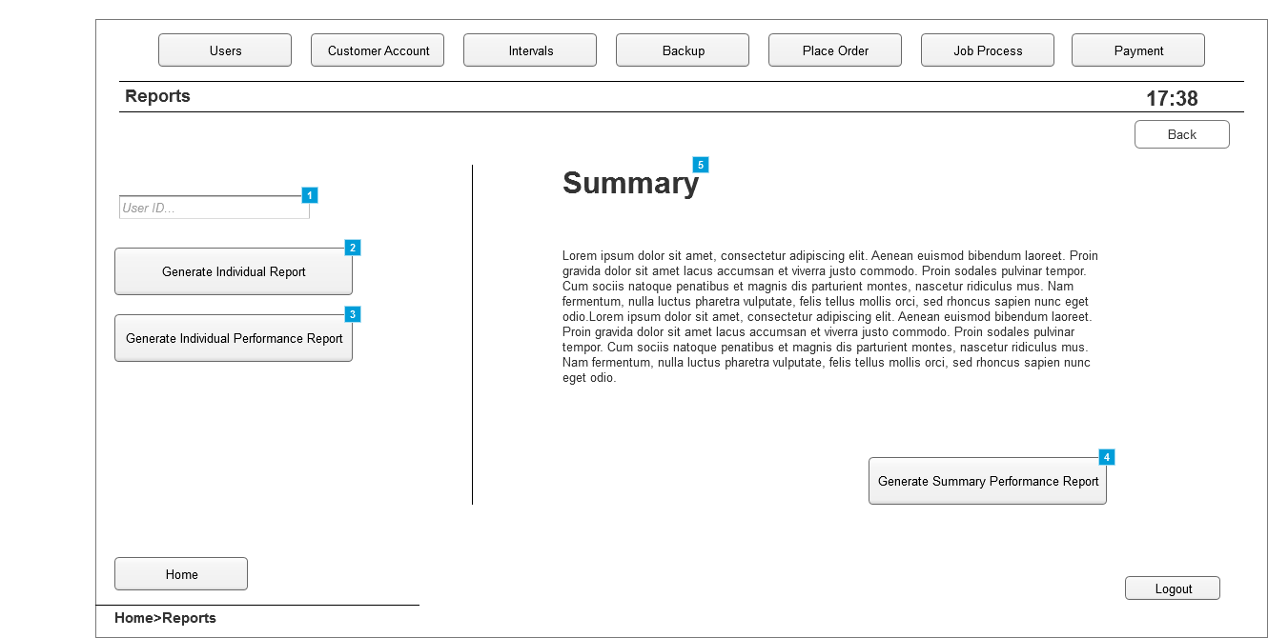

* + 1. Widget Table

|  |  |
| --- | --- |
| Footnote | Description |
| 1 | Box where user ID is introduced. This refers to the system users. Once a user is selected, more options are available |
| 2 | Button that, when clicked, generates an individual report for the user selected |
| 3 | Button that, when clicked, generates an individual performance report for the user selected |
| 4 | Button that, when clicked, generates a summary performance report |
| 5 | Summary and details about it |

* 1. Place Order
     1. User Interface

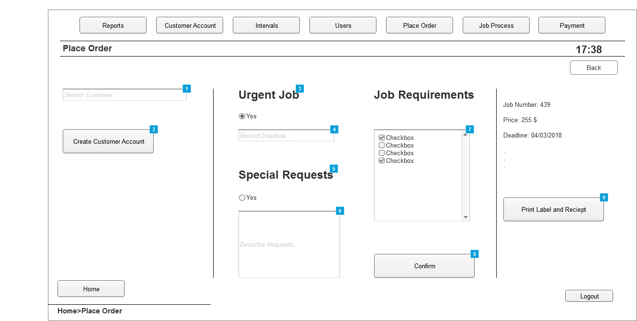

* + 1. Widget Table

|  |  |
| --- | --- |
| Footnote | Description |
| 1 | Panel where customer accounts can be searched, if created, to allow for placing an order |
| 2 | Button that, when clicked, takes the user to the "Create Account" window. Used in case the customer does not have an account yet |
| 3 | Option to select if job placed is urgent. |
| 4 | Panel to introduce deadline if job is urgent |
| 5 | Option to select if special requests exist about the job |
| 6 | Pane to introduce details about the request |
| 7 | List of all tasks available. Checked only the ones which are needed for the job |
| 8 | Button that, when clicked, generates the job number and final price |
| 9 | Button that, when clicked, Assigns the job and prints the label and the receipt. |

* 1. Create Account
     1. User Interface

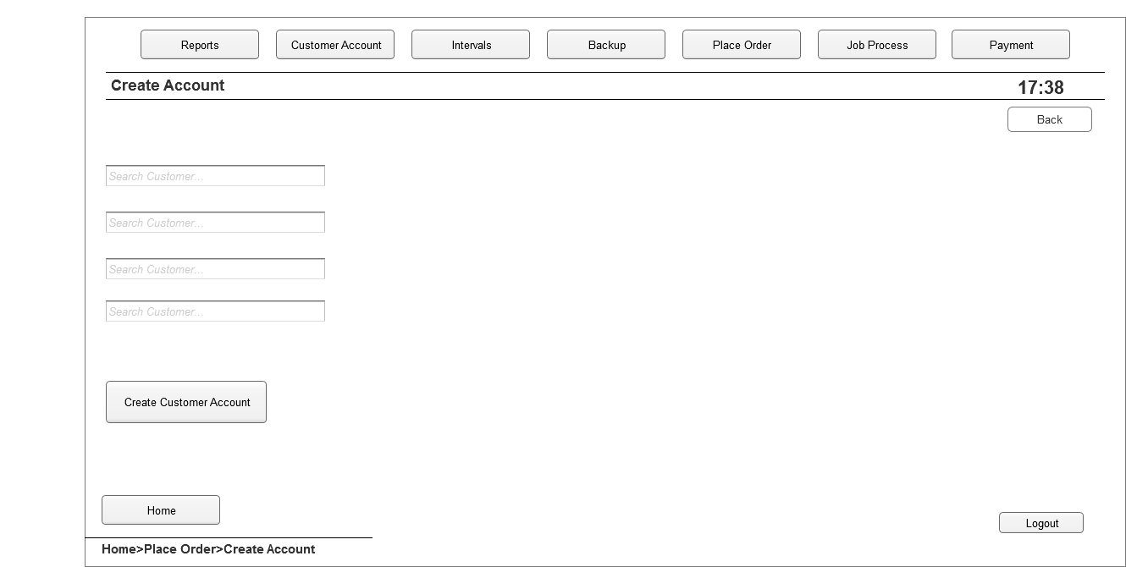

* 1. Job Process
     1. User Interface

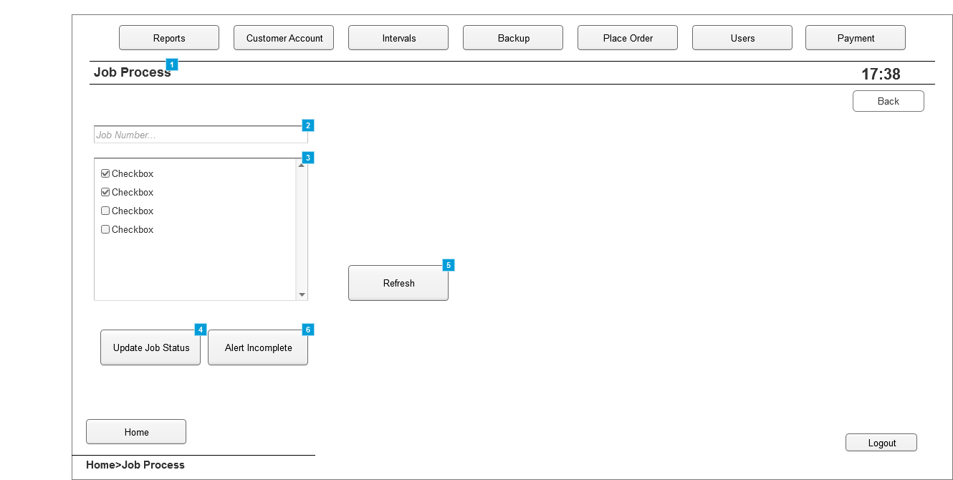

* + 1. Widget Table

|  |  |
| --- | --- |
| Footnote | Description |
| 1 | Tab where the ongoing jobs can be managed |
| 2 | Panel where the job number is introduced to get details about a job |
| 3 | List with the tasks available. Those ticked indicate that the task is completed |
| 4 | Button that, when clicked, updates the status of the jobs, A task must be tied or unticked to be able to update |
| 5 | Button that, when clicked, refreshes the list to see if changes have been made |
| 6 | Button that is click to alert that the job is not going to be completed on time |

* 1. Payment
     1. User Interface

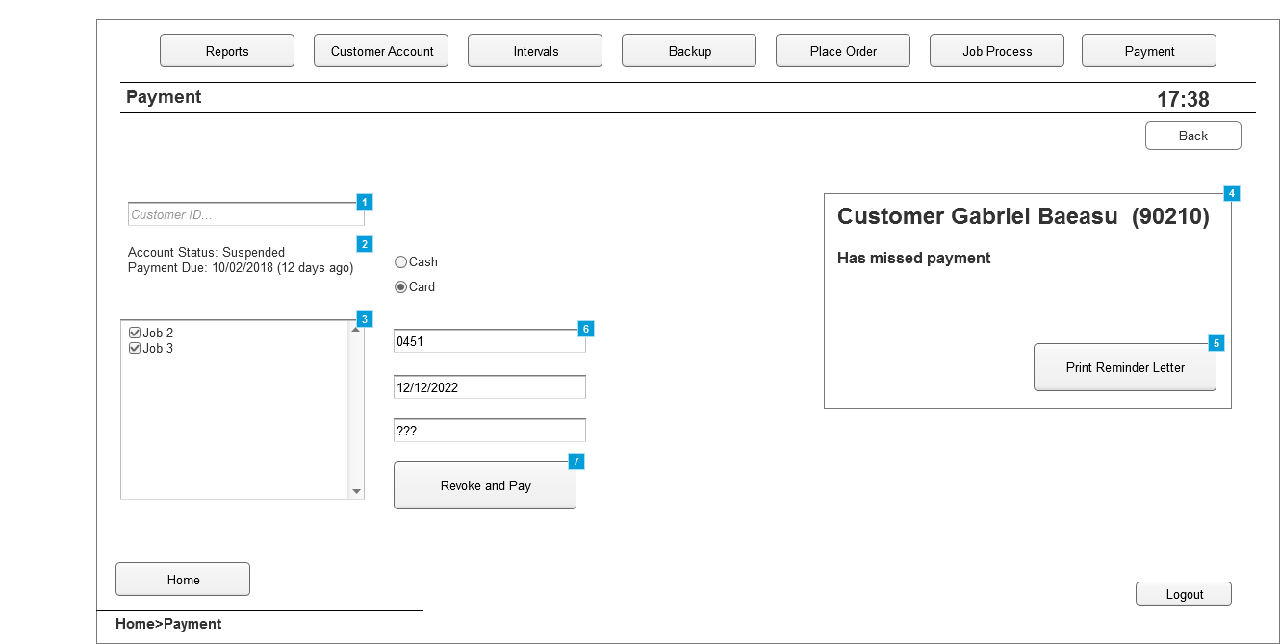

* + 1. Widget Table

|  |  |
| --- | --- |
| Footnote | Description |
| 1 | Panel where a customer is searched to get details about the job placed |
| 2 | Details about the customer account, |
| 3 | List of all the jobs placed, only one will be displayed if the customer is not "Valued"  If the job is ticked, it means it will be paid for in the next payment. |
| 4 | Pop-up window alerting the Office Manager that a customer has missed payment |
| 5 | Button that, when clicked will print the reminder letter for the user |
| 6 | Panels where information about card or cash payment is introduced |
| 7 | Button that, when clicked, completes payment and revokes suspension of an account if account is suspended. |

* 1. Tasks
     1. User Interface

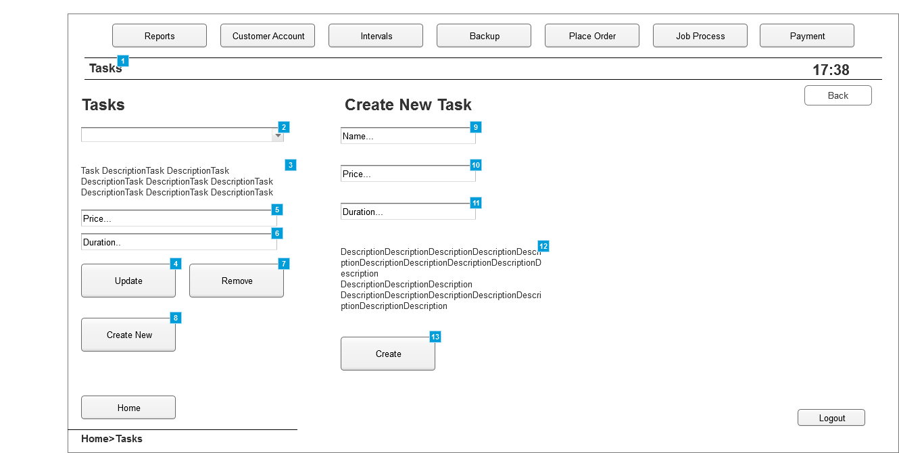

* + 1. Widget Table

|  |  |
| --- | --- |
| Footnote | Description |
| 1 | Tab where tasks can be managed |
| 2 | List of all the tasks available in the system |
| 3 | Description of the task selected |
| 4 | Button that. when clicked, updates any details changed about the selected task |
| 5 | Price of the selected task |
| 6 | Time it takes for the task to be completed |
| 7 | Button that. when clicked, removes the selected task |
| 8 | Button that. when clicked, displays the "Create Task" options |
| 9 | Panel to introduce the name of the new task |
| 10 | Panel to introduce the price of the new task |
| 11 | Panel to introduce the time taken for the new task to be completed |
| 12 | Description of the new task |
| 13 | Button that, when clicked, creates and adds the task to the list of existing tasks. |