|  |
| --- |
|  |
| The Specification |
| [Type the document subtitle] |
|  |
| **[Your Name]** |
| **[Pick the date]** |

[Type the abstract of the document here. The abstract is typically a short summary of the contents of the document. Type the abstract of the document here. The abstract is typically a short summary of the contents of the document.]

Table of Contents

[To update the table of contents, right click the message below and select Update Field (F9 on PC, ⌥⌘U on Mac).]

1. Pages 4

1.1. Page Tree 4

1.2. Home 5

1.2.1. User Interface 5

1.3. Page 1 6

1.3.1. User Interface 6

1.4. Page 2 7

1.4.1. User Interface 7

1.5. Page 3 8

1.5.1. User Interface 8

1.6. Page 4 9

1.6.1. User Interface 9

1.7. Customer Account 10

1.7.1. User Interface 10

1.8. Intervals 11

1.8.1. User Interface 11

1.9. Backup 12

1.9.1. User Interface 12

1.10. Users 13

1.10.1. User Interface 13

1.11. Report 14

1.11.1. User Interface 14

1.12. Place Order 15

1.12.1. User Interface 15

1.13. Create Account 16

1.13.1. User Interface 16

1.14. Job Process 17

1.14.1. User Interface 17

1.15. Payment 18

1.15.1. User Interface 18

1.16. Tasks 19

1.16.1. User Interface 19

1. Pages
   1. Page Tree

Home  
 Page 1  
 Page 2  
 Page 3  
 Page 4  
Customer Account  
Intervals  
Backup  
Users  
Report  
Place Order  
 Create Account  
Job Process  
Payment  
Tasks

* 1. Home
     1. User Interface

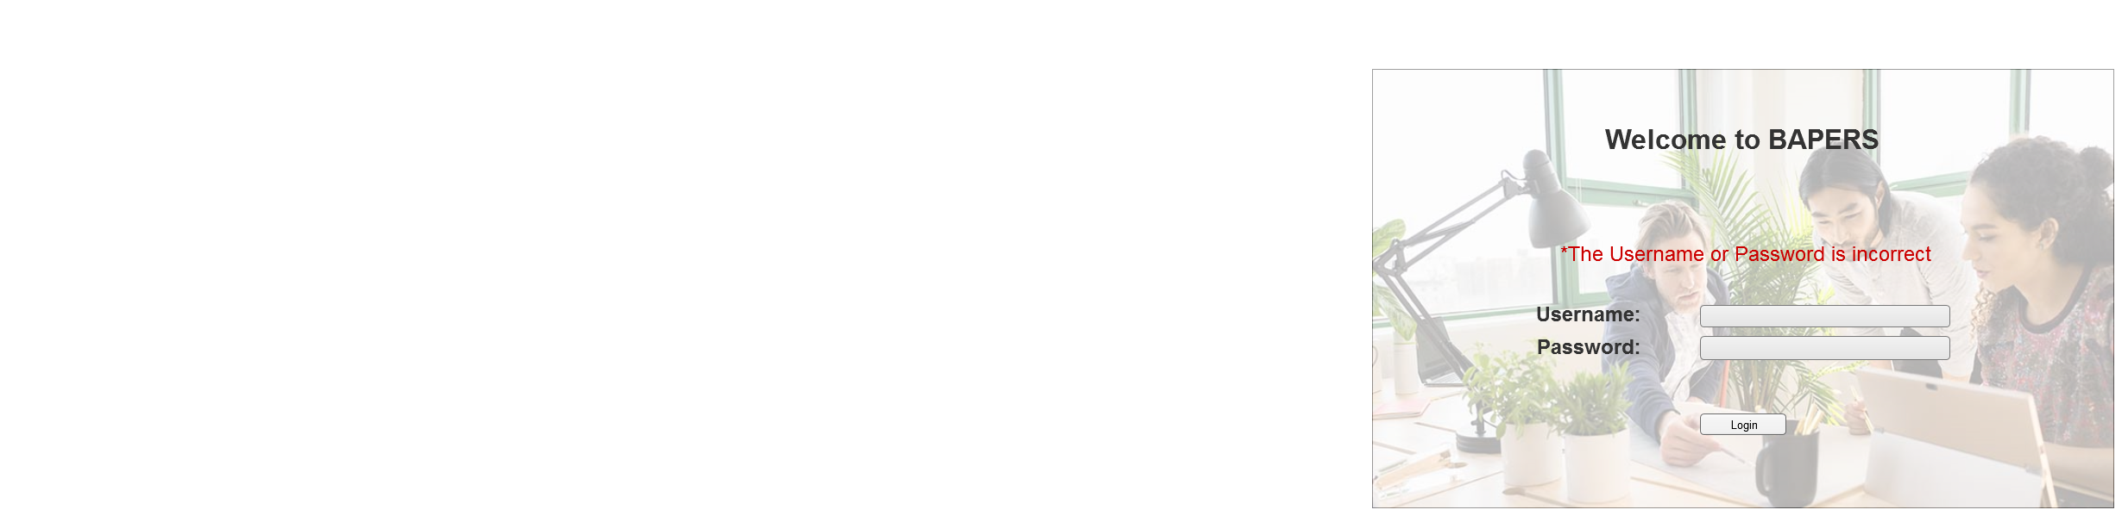

* 1. Page 1
     1. User Interface

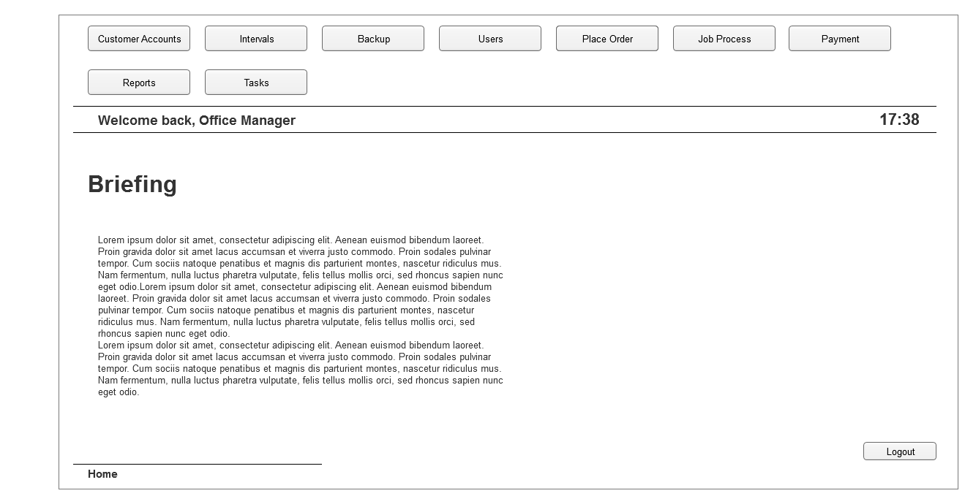

* 1. Page 2
     1. User Interface

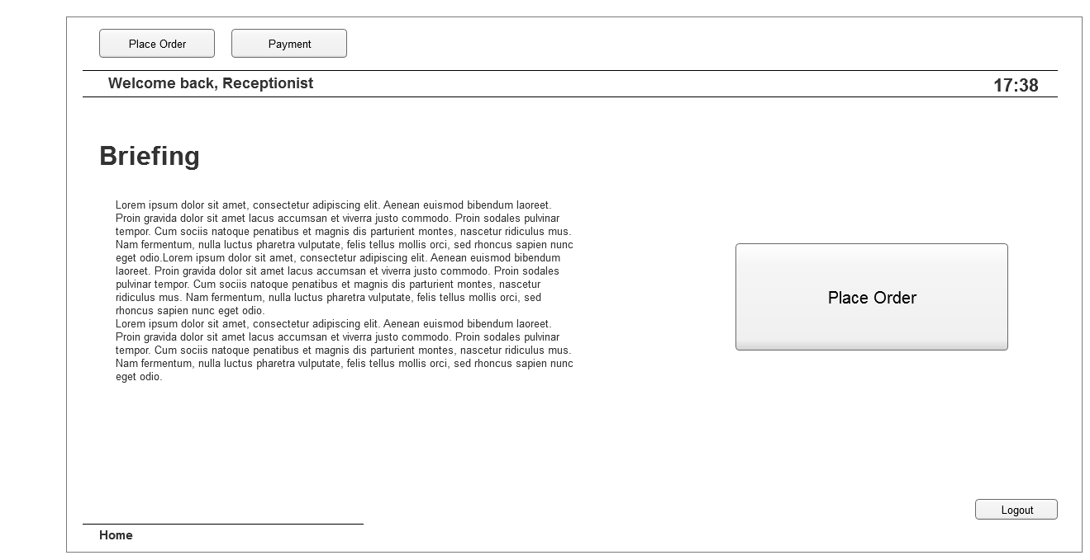

* 1. Page 3
     1. User Interface

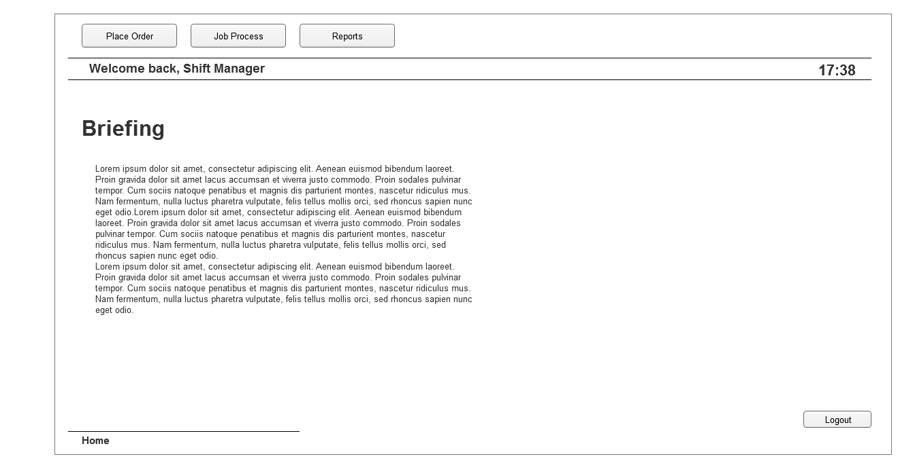

* 1. Page 4
     1. User Interface

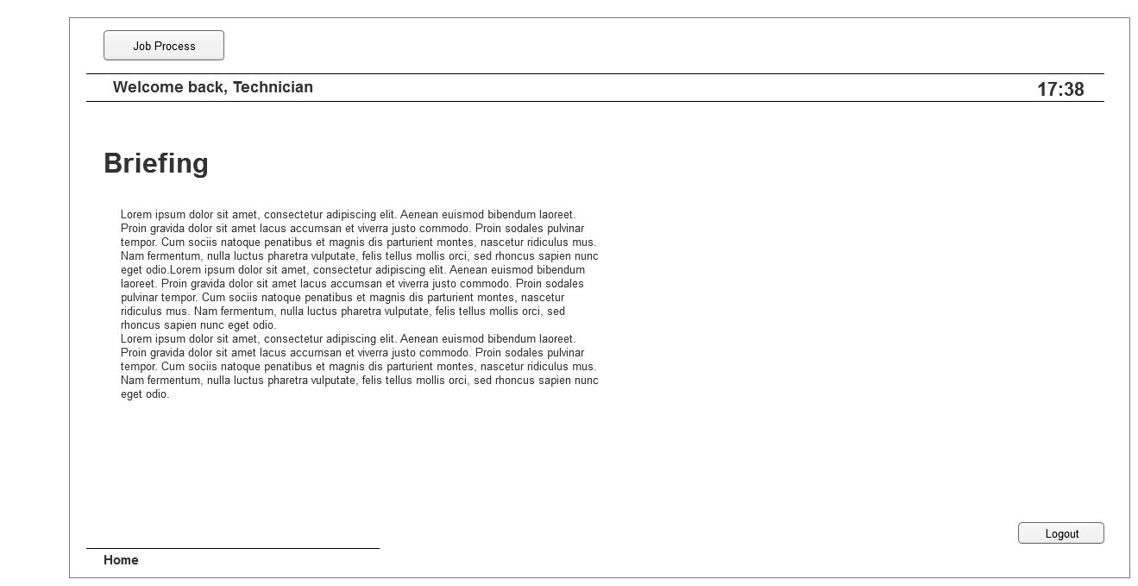

* 1. Customer Account
     1. User Interface

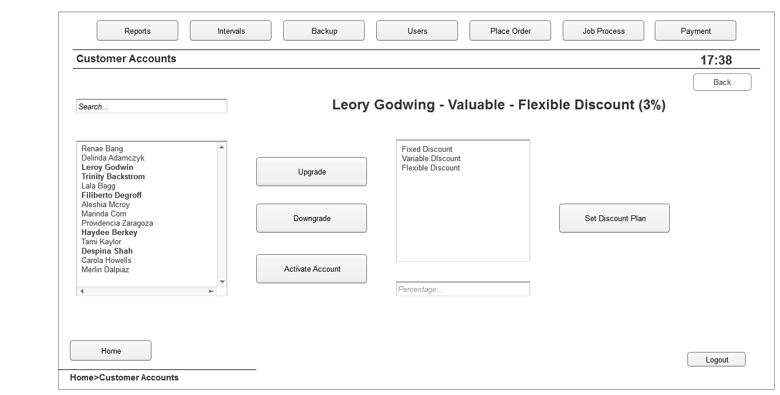

* 1. Intervals
     1. User Interface

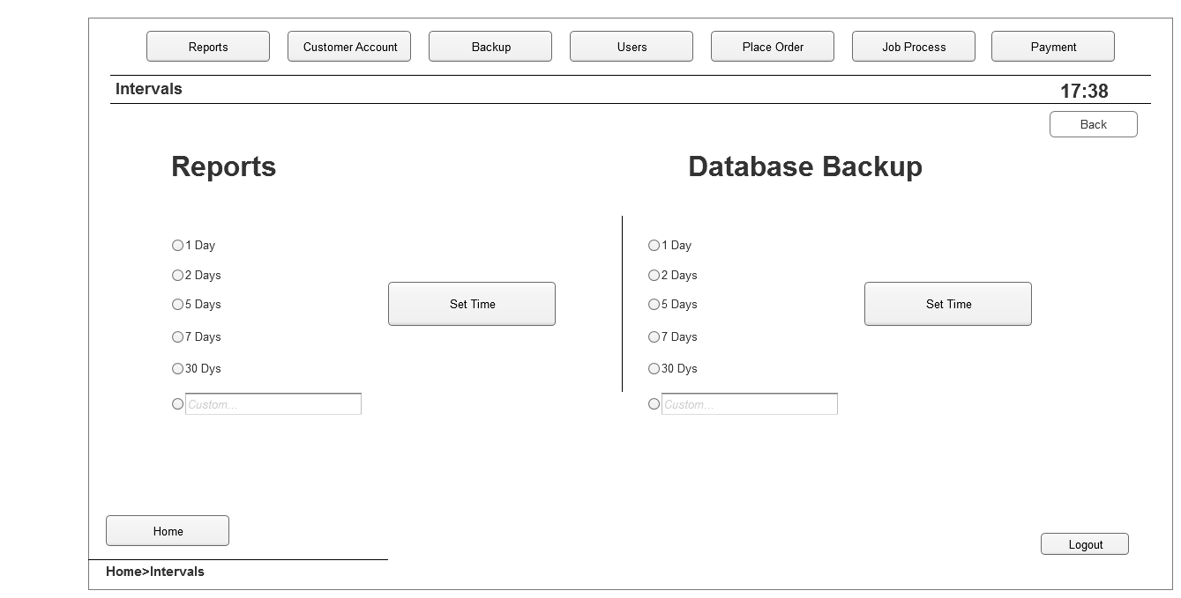

* 1. Backup
     1. User Interface

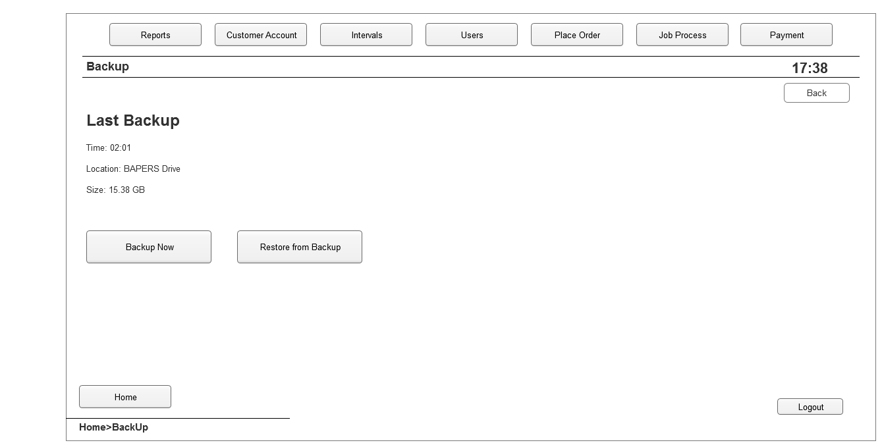

* 1. Users
     1. User Interface

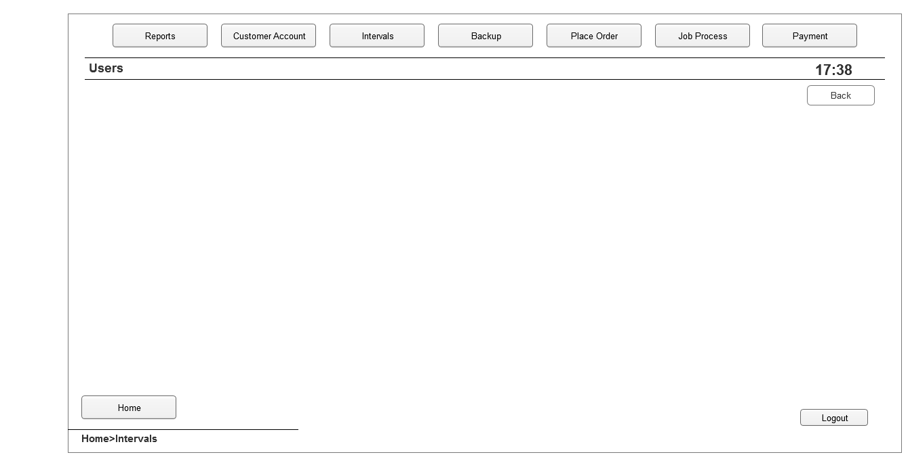

* 1. Report
     1. User Interface

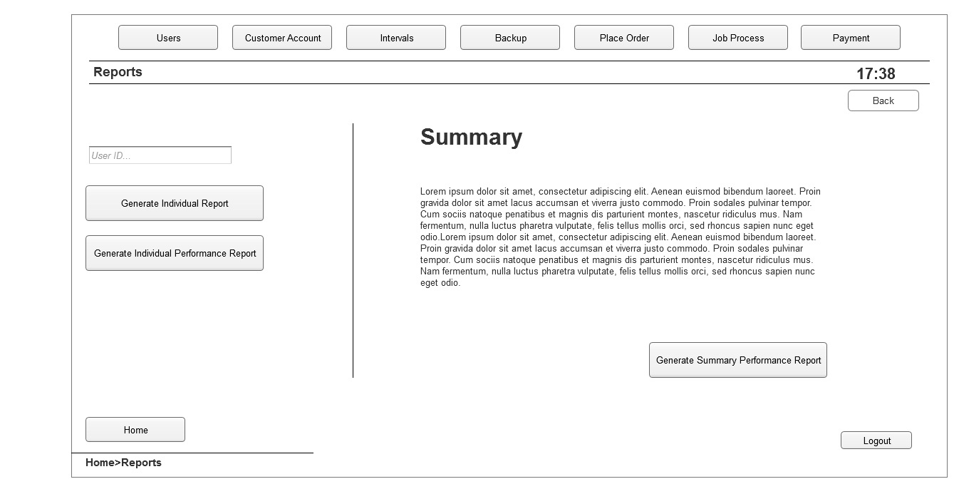

* 1. Place Order
     1. User Interface

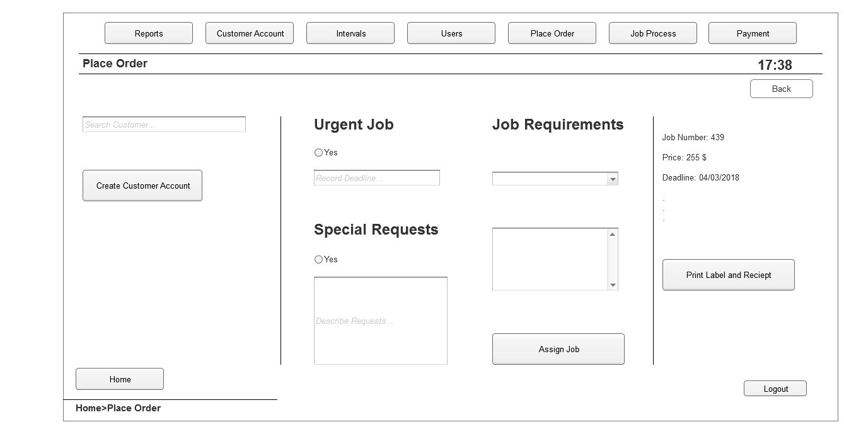

* 1. Create Account
     1. User Interface

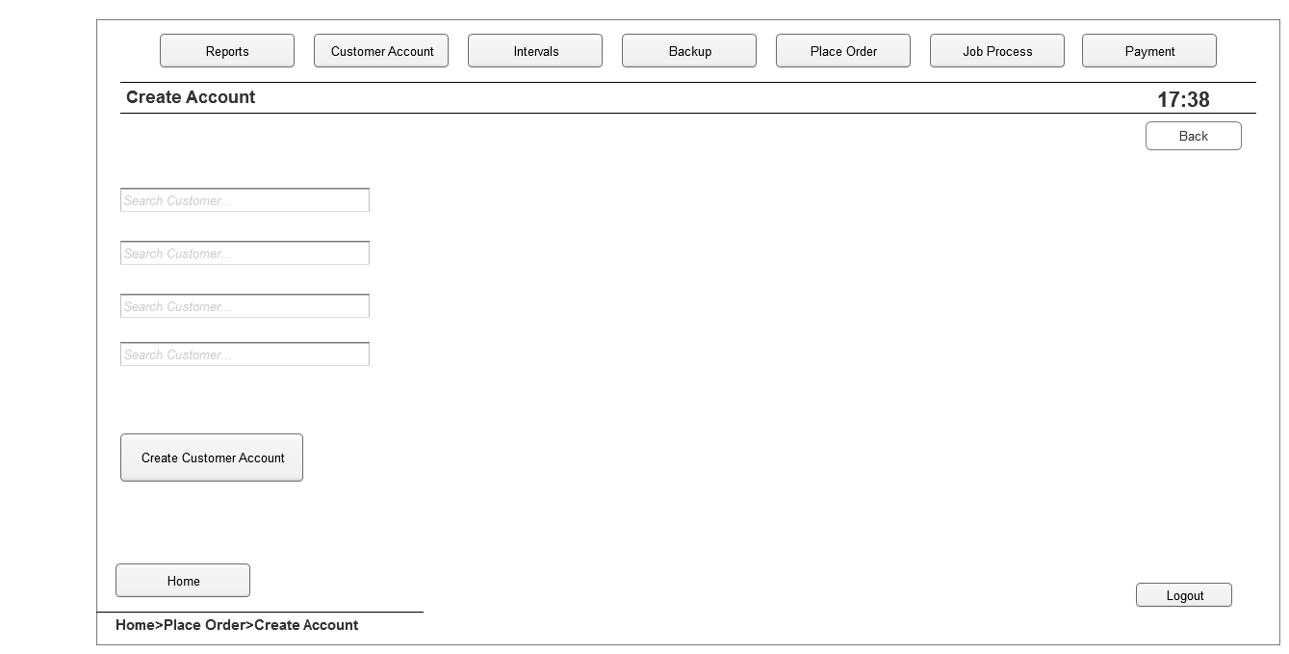

* 1. Job Process
     1. User Interface

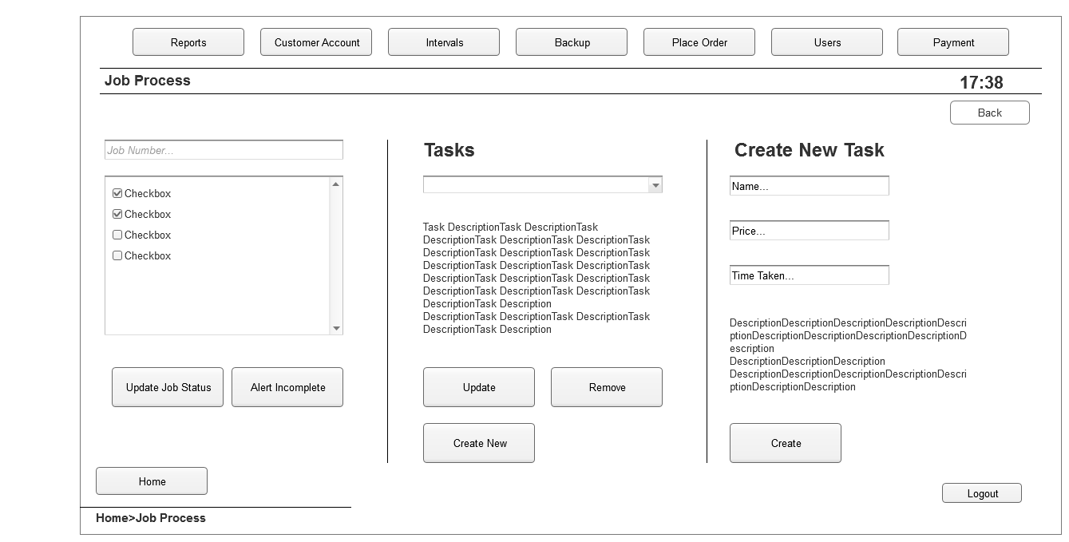

* 1. Payment
     1. User Interface

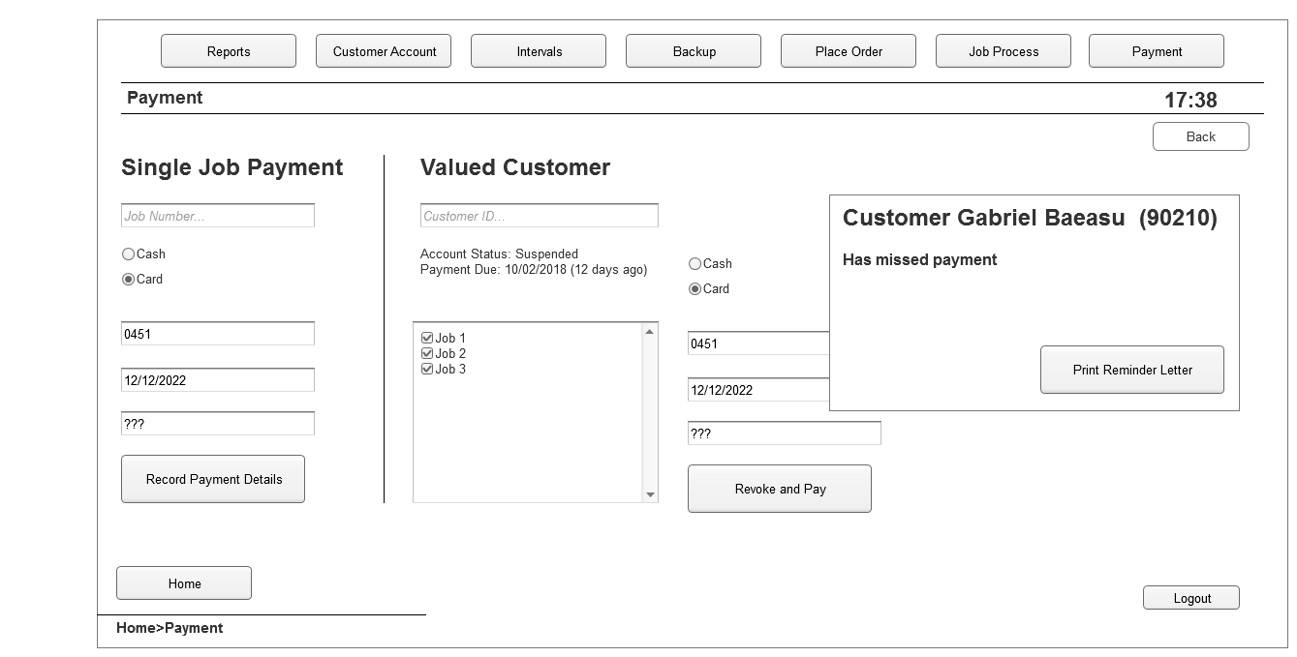

* 1. Tasks
     1. User Interface

