Program launch command:

C:\Users\Christopher.Pratt\Documents\000 Wireless Charger PCprogrammer\WcaInterfaceProtocolSuite\WcaProgrammerConsole\bin\Debug\WcaProgrammerConsole.exe COM46 MO_WC_EOL_51_0_1_1.S19

WcaProgrammerConsole.exe COM46 MO_WC_51_0_2_1.S19

WcaProgrammerConsole.exe COM46 MO_WC_EOL_51_0_1_1.S19

Example 07 write command for writing the ESN and HW at the same time:

55, 12, 00 64 07 02 01 04 00 55 73 02 74 09 00 00 00 01 00 fa 28

The ESN is supposed to be: 9740273550004

The HW is: 1.0

So, we know the ESN is written literally in the HEX in little endian like this: 04 00 55 73 02 74 09

The next 3 sets of 0’s (00 00 00) are just a buffer to separate the HW and ESN numbers to save space in the OTP.

So the HW is written as: 01 00

When queried for General Parameters, the ESN and HW can be parsed by the 3 sets of 00.

# Programming Instructions

1. Enter this command to program to EOL code
   1. C:\Users\Christopher.Pratt\Documents\000 Wireless Charger PCprogrammer\WcaInterfaceProtocolSuite\WcaProgrammerConsole\bin\Debug\WcaProgrammerConsole.exe COM44 MO_WC_EOL_51_0_1_1.S19
2. Remove power
3. Apply power and press “b” within 100 milliseconds of re-applying power
4. Once “POS-ACK” is received, press “program” and the device will be programmed.
5. Once finished type “startapp” to start application

# Change esn

1. Type “readesnb” to read existing ESN and take note of it for re-programming. 9740273550004
2. Hit “setesn” to type in existing ESN and then the new hardware will be updated in device

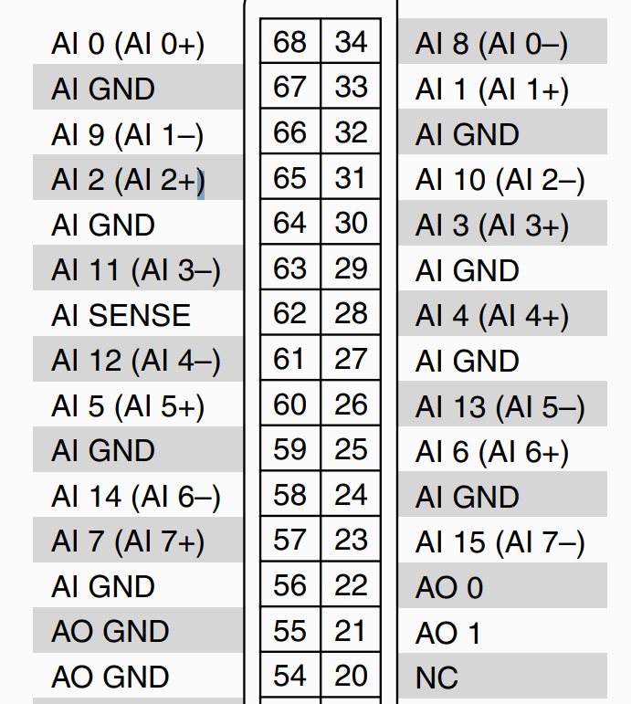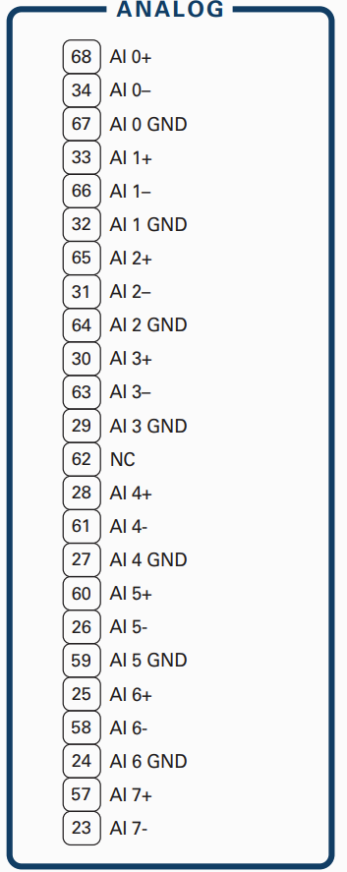

Red is coil 0

Green is coil 1,2

Yellow coil 2