UF1: Sistemes ERP-CRM. Implantació.
NF2: Instal·lació ERP
EA4: Admin and configure Nav
Pràctica 5

Tasks:

From pdf “MODULE 2: USER INTERFACE” answer these questions:
- What can you use the Search box for?
  - To find any page, report, or view present on the Departments page.
  - To find any page, report, or form present on the Departments page.
  - To find any page or report present on the Departments page.
  - To find any page, report, or view present on the Home page.
Answer:C
- Which of the following statements about the navigation pane is true?
  - You can remove the Home menu.
  - You cannot remove the Departments menu.
  - At a minimum, the navigation pane contains the Home and the Departments a menu.
  - None answer is correct

Answe:C_
- Name some of the advantages of the ribbon?
Las ventajas que presenta es que este es intuitivo, siendo este bastante visual, permitiendo encontrar los elementos de forma fácil y rápido, también es bastante personalizable, permitiendo adaptarlo al gusto del usuario añadiendo o quitando funciones, este permitiendo que el usuario mayor rapidez en sus tareas, y una de las mayores ventajas es que este se asimila a muchos programas de su año, siendo estos el WORD por ejemplo, facilitando asi la facil comprensión de que realiza cada elemento.
- Assign a Role Center:
Scenario
You are the accounting manager at CRONUS International Ltd., and uses the default Role Center (Sales Order Processor). However, this Role Center is not aligned with your daily activities. Therefore you are advised to use the accounting manager profile.
Assign the accounting manager profile to your user account.
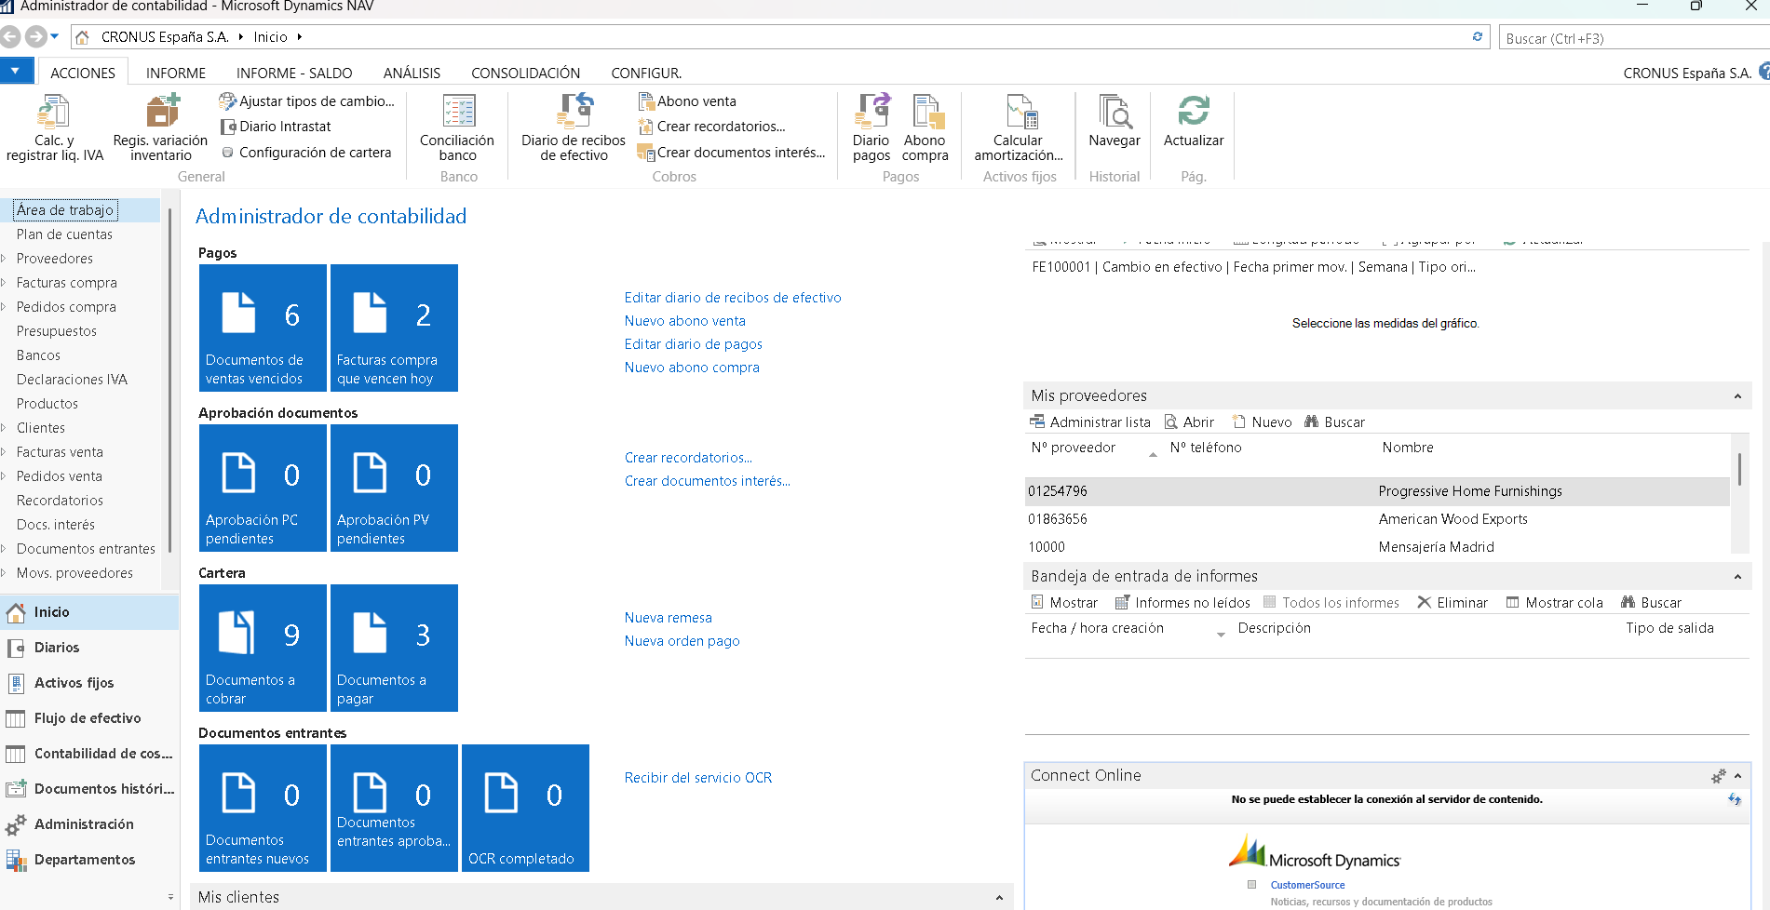

From pdf “MODULE 3: USER PERSONALIZATION” answer these scenarios:
- Add a List Place to the Navigation Pane
Scenario
As the order processor at CRONUS International Ltd., you generally perform tasks in the sales order processes. Your profile has provided you with the corresponding available activity buttons in the navigation pane.
However, sometimes you have to perform some tasks outside your usual job description. You want to perform the following tasks from the navigation pane:
• Send out mailing lists, by using the Segments and Contacts of the Marketing application area.
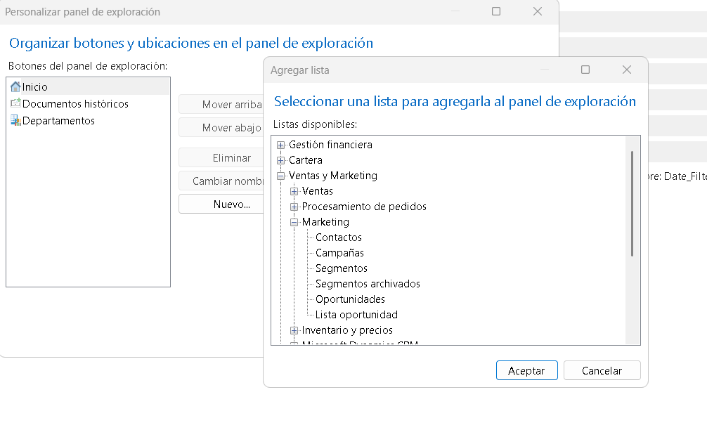
• Process a Purchase Order, for the supply of office material or a specific order related to a sales order.
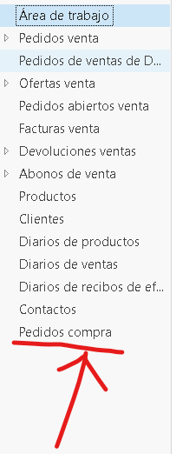
• Process and follow up on Approval Request Entries and Approval Entries.
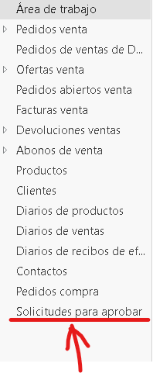

- Add a Chart to the Role Center
Scenario
As the sales order (SO) processor you want to adjust your Role Center by adding the following charts:
• Customer Sales and Profit (generic)
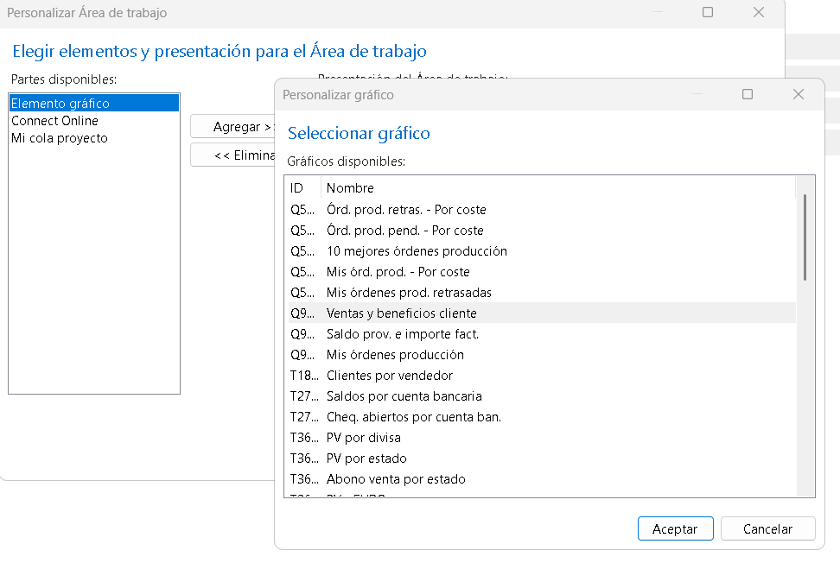

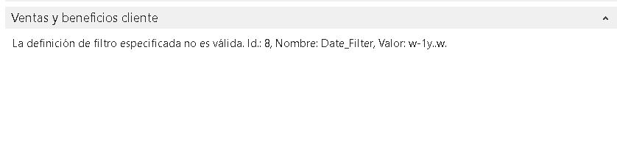

• SO per location (generic)

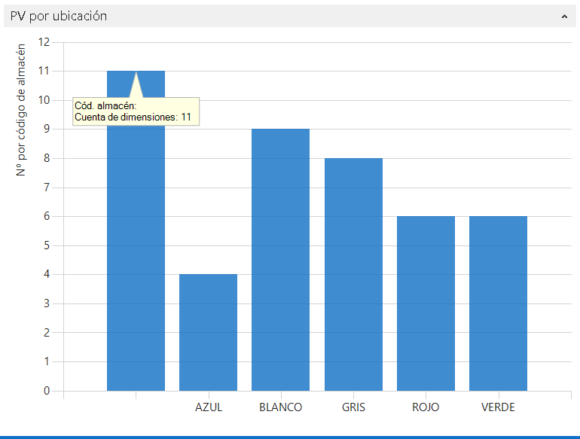

Answer:____

From pdf “MODULE 4: BASIC FUNCTIONALITIES” answer these questions:
- How many employees are there in CRONUS International, Ltd.?
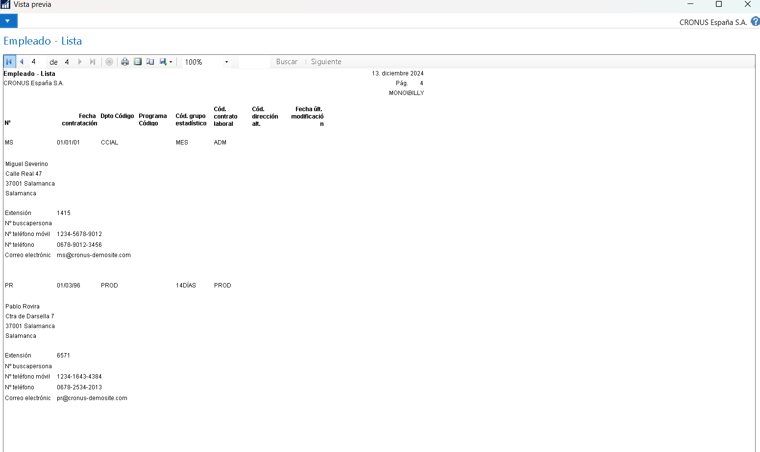
Hay 8 empleados.
- Who is the contact at customer ”Beef House” ?
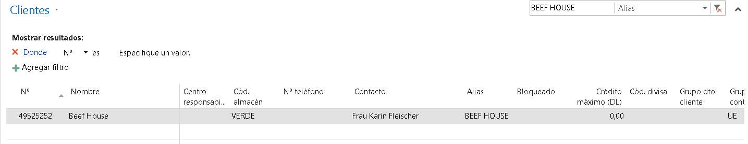
El contacto es Frau Karin Fleischer
- Who is the contact at customer with number 47563218?
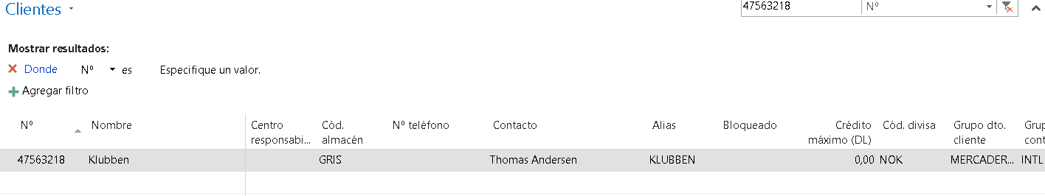
El contacto es Thomas Andersen
Answer:____
- How many bank account are set up in Cronus International, Ltd. ?
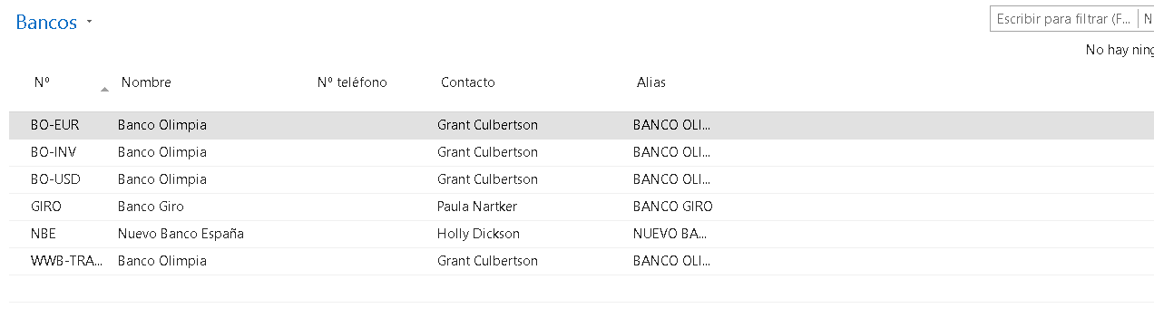
Hay en total 6 cuentas bancarias.
Answer:____
- What is current inventory of item no. 70000?
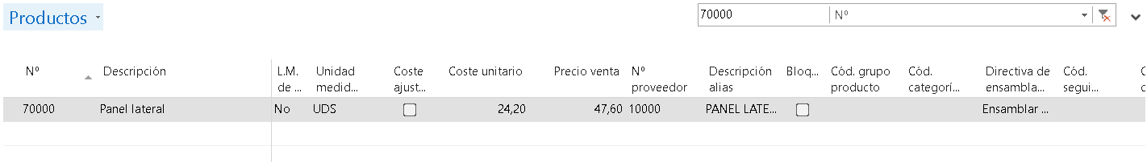
El producto es Panel Lateral.
Answer:____
- Who is the contact at customer 49525252, Beef House?
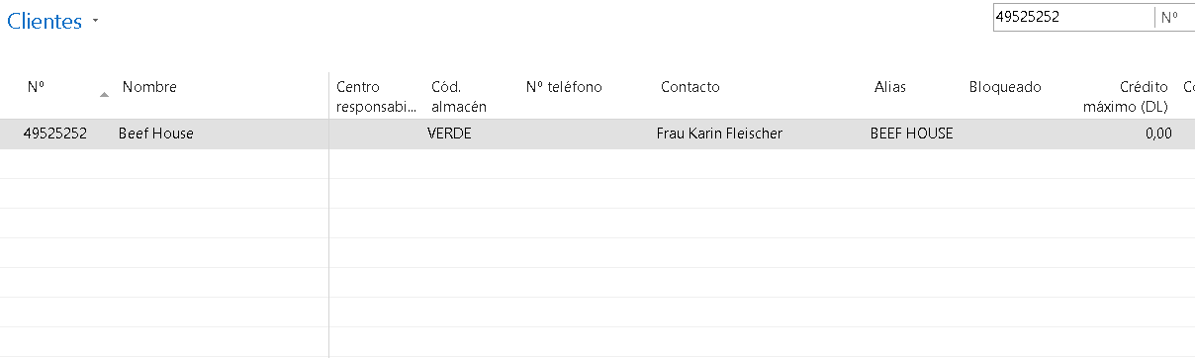
El contacto es Frau Karin Fleischer
Answer:____
- What is the current balance (LCY) on customer 49525252, Beef House?
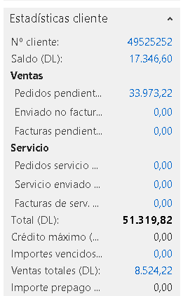
El current balance es de 17346,60 euros.
Answer:____
- How many open invoices does customer 49525252, Beef House, have?
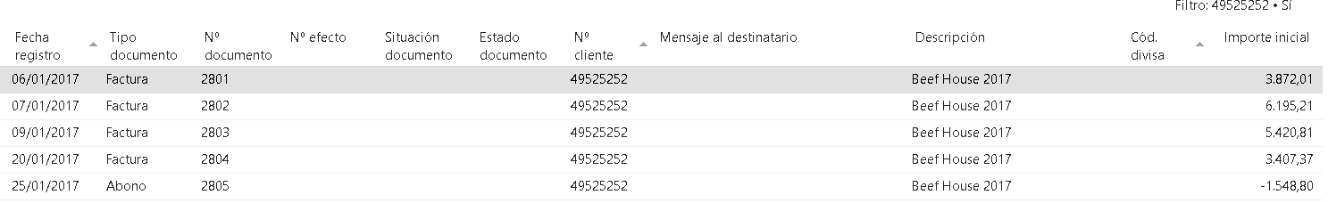
Tiene en total 4 facturas y 1 abono.
Answer:____
- What is the unit price of item number 70040?
El precio unidad del producto es de 85,40 Euros.
Answer:____
- What keys do you press to delete a customer?
Se pulsa Control+Suprimir o se puede pulsar el botón de borrar.
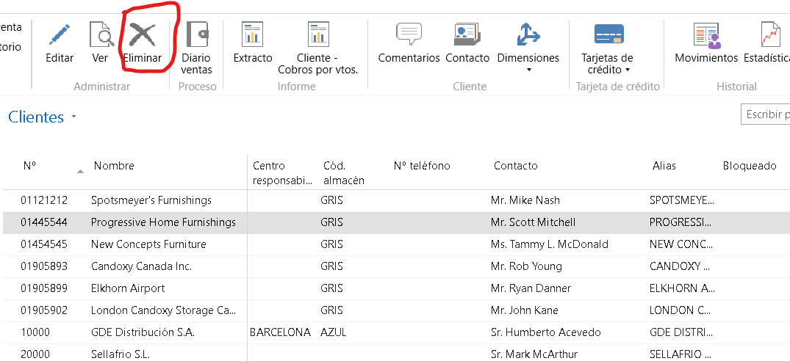
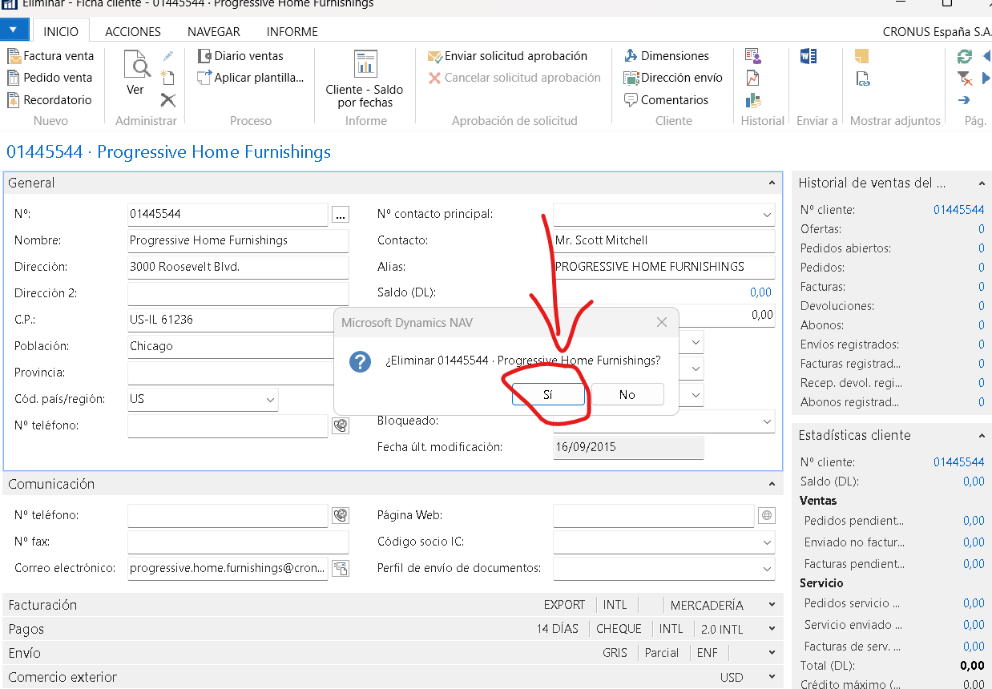
Answer:____
- What would the following filter expression display: 1100..2100?
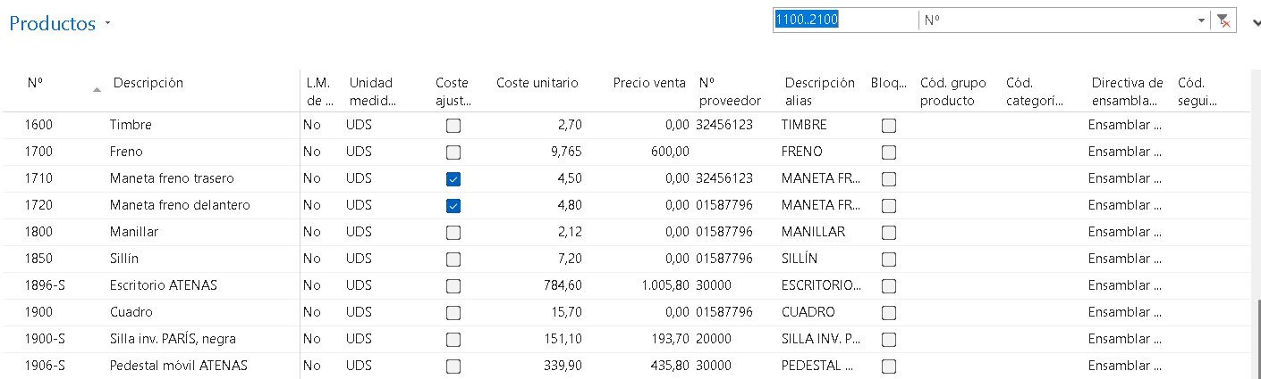
Lo que realiza es que nos muestra todos los productos desde 1100 de id hasta el 2100.
Answer:____
- From what type of field can you drill down to related entries?
El nombre del tipo es FlowFields.

- What is the e-mail address of vendor Mountain Fisheries ?
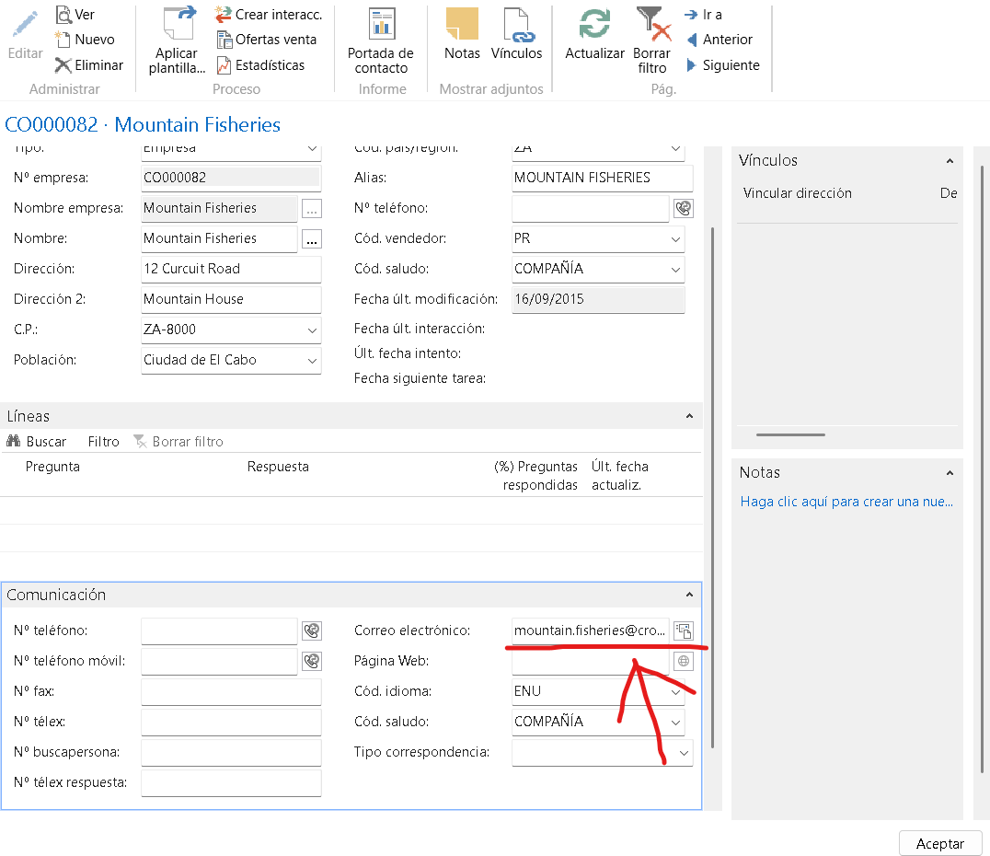
El correo electrónico es mountain.fisheries@cronuscorp.net.
Answer:____
- What is status of sales order 6003?
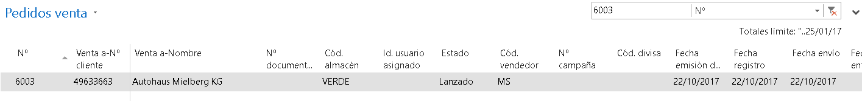
Su estado es el de Lanzado.
Answer:____
- Who is purchaser responsible of purchase order no. 104002?
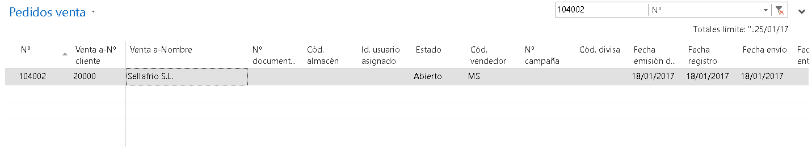
El responsable es Sellafrio S.L..
Answer:____

