pathXTM
Software Design Description

Author: Christopher Ford
Debugging EnterprisesTM
March, 2013
Version 1.0

Abstract: This document describes the software design for pathX, a casual mini-game that is an abstraction of a life of crime.

Based on IEEE Std 1016TM-2009 document format

No part of this publication may be reproduced in any form, in an electronic retrieval system or otherwise, without the prior written permission of the publisher.
1 Introduction

This is the Software Design Description (SDD) for the pathXTM mini-game application. Note that this document format is based on the IEEE Standard 1016-2009 recommendation for software design.

  - Purpose

This document is to serve as the blueprint for the construction of the pathX application. This design will use UML class diagrams to provide complete detail regarding all packages, classes, instance variables, class variables, and method signatures needed to build the application. In addition, UML Sequence diagrams will be used to specify object interactions post-initialization of the application, meaning in response to user interactions or timed events.

1.2 Scope

pathX will be the first in a series of casual games. Tools for it's construction should be developed with this in mind such that additional casual games may avoid duplication of work. As such, a framework called the MiniGame Framework, will be designed and constructed along with the pathX game such that is may be used to build additional min-games. So, this design contains design descriptions for the development of both the framework and game. Note that Java is the target language for this software design.

  - Definitions, acronyms, and abbreviations

Class Diagram – A UML document format that describes classes graphically. Specifically, it describes their instance variables, method headers, and relationships to other classes.

IEEE – Institute of Electrical and Electronics Engineers, the “world’s largest professional association for the advancement of technology”.

Framework – In an object-oriented language, a collection of classes and interfaces that collectively provide a service for building applications or additional frameworks all with a common need.

Java – A high-level programming language that uses a virtual machine layer between the Java application and the hardware to provide program portability.
Mini-Game – A standalone game that is a subset of a larger game application, typically sharing the primary game theme with that parent game application.

Mini Game Framework – The software framework to be developed in tandem with the pathX game such that additional mini-games can easily be constructed.

Sequence Diagram – A UML document format that specifies how object methods interact with one another.

Sprite – a renderable, and sometimes movable or clickable image in the game.

SpriteType – a type of Sprite, meaning all the artwork and states corresponding to a category of sprite. We do this because all the suns share artwork, so we will load all their artwork into a common Sprite Type, but each Sprite has its own position and velocity, so each will be its own Sprite that knows what Sprite Type it belongs to.

UML – Unified Modeling Language, a standard set of document formats for designing software graphically.

PathX – The title of the casual game described in the document.

  - References

IEEE Std 830TM-1998 (R2009) – IEEE Standard for Information Technology – Systems Design – Software Design Descriptions

pathXTM SRS – Debugging Enterprises’ Software Requirements Specification for the pathX mini-game application.

  - Overview

This Software Design Description document provides a working design for the pathX software application as described in the pathX Software Requirements Specification. Note that all parties in the implementation stage must agree upon all connections between components before proceeding with the implementation stage. Section 2 of this document will provide the Package-Level Viewpoint, specifying the packages and frameworks to be designed. Section 3 will provide the Class-Level Viewpoint, using UML Class Diagrams to specify how the classes should be constructed. Section 4 will provide the Method-Level System Viewpoint, describing how methods will interact with one another. Section 5 provides deployment information like file structures and formats to use. Section 6 provides a Table of Contents, an Index, and References. Note that all UML Diagrams in this document were created using the Visual Paradigm editor.

- Package-Level Design Viewpoint

As mentioned, this design will encompass both the pathX game application and the Mini-Game Framework to be used in its construction. In building both we will heavily rely on the Java API to provide services. Following are descriptions of the components to be built, as well as how the Java API will be used to build them.
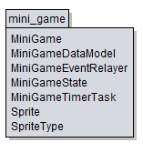
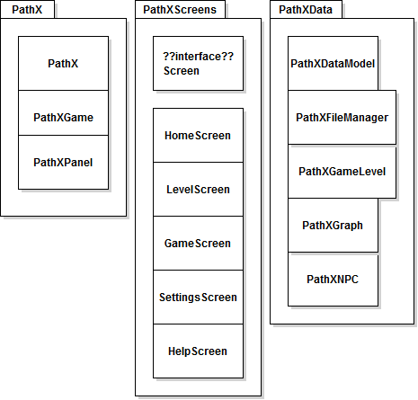

Figure 2.1: Design Packages Overview

2.3 Java API Usage Descriptions
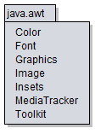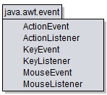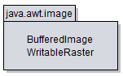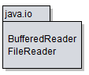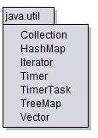
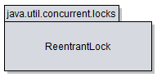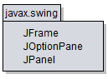

Figure 2.2: Java API Classes and Packages To Be Used

Both the framework and the mini-game application will be developed using the Java programming languages. As such, this design will make use of the classes specified in Figure 2.2

2.3 Java API Usage Descriptions

Tables 2.1-2.7 below summarize how each of these classes will be used.

Class/Interface | Use
Color | For setting the rendering colors for text and the progress bar
Font | For setting the fonts for rendered text
Graphics | For rendering text, images, and shapes to the canvas
Image | For storing image data
Insets | For changing component margins
MediaTracker | For ensuring synchronous image loading
Toolkit | For loading images

Table 2.1: Uses for classes in the Java API’s java.awt package

Class/Interface | Use
ActionEvent | For getting information about an action event like which button was pressed.
ActionListener | For responding to an action event, like a button press. We will provide our own custom implementation of this interface.
KeyEvent | For getting information about a key event, like which key was pressed.
KeyListener | For responding to a key event, like a key press. We will provide our own custom implementation of this interface.
MouseEvent | For getting information about a mouse event, like where was the mouse pressed?
MouseListener | For responding to a mouse event, like a mouse button press. We will provide our own custom implementation of this interface.

Table 2.2: Uses for classes in the Java API’s java.awt.event package

Class/Interface | Use
BufferedImage | For storing image data where pixel information can be accessed and changed.
WritableRaster | For changing pixel data in a BufferedImage. We’ll use this to add transparency to pixels loaded with the color key.

Table 2.3: Uses for classes in the Java API’s java.awt.image package

Class/Interface | Use
BufferedReader | For reading text files, we’ll use this for loading some game data at startup.
FileReader | For reading files.

Table 2.4: Uses for classes in the Java API’s java.io package

Class/Interface | Use
Collection | For storing groups of data, Values in a Map, i.e. TreeMap or HashMap are stored in Collections. We’ll need to iterate through Collections for rendering.
HashMap | For storing (name,value) key pairs, we’ll use it for storing our Images, accessible using their ID names.
Iterator | For iterating through a data structure during operations like rendering.
Timer | Will execute our custom task at fixed intervals.
TimerTask | Our custom task to be executed at a fixed framerate. We will extend this class and provide the task implementation in the run method.
TreeMap | For storing (name,value) key pairs, we’ll use it for storing SpriteTypes and GUI components, accessible using their ID names.
Vector | For storing data like the Strings for rendering debugging text.

Table 2.5: Uses for classes in the Java API’s java.io package

Class/Interface | Use
ReentrantLock | For ensuring only one thread has access to program data.

Table 2.6: Uses for classes in the Java API’s java.util.concurrent package

Class/Interface | Use
JFrame | Provides the window for our GUI.
JOptionPane | Provides a popup dialog for error feedback.
JPanel | Provides a canvas for the game to be rendered onto.

Table 2.7: Uses for classes in the Java API’s javax.swing package

- Class-Level Design Viewpoint

As mentioned, this design will encompass both the pathX game application and the Mini-Game Framework. The following UML Class Diagrams reflect this. Note that due to the complexity of the project, we present the class designs using a series of diagrams going from overview diagrams down to detailed ones.

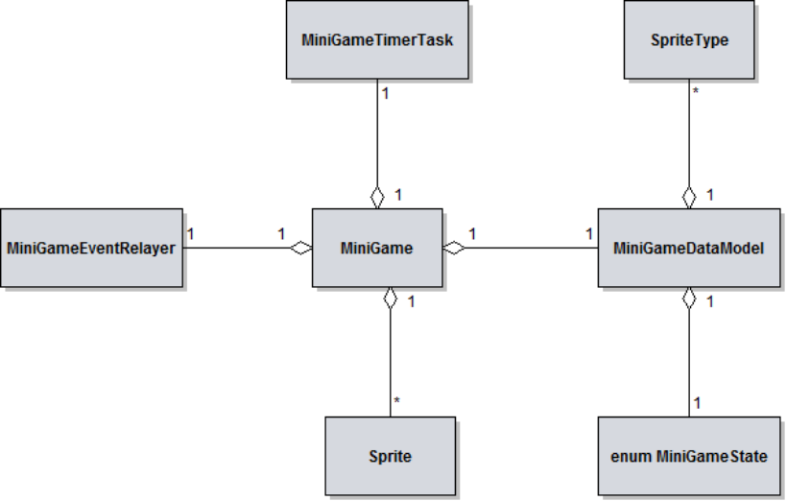

Figure 3.1: Mini-Game Framework Overview UML Class Diagram

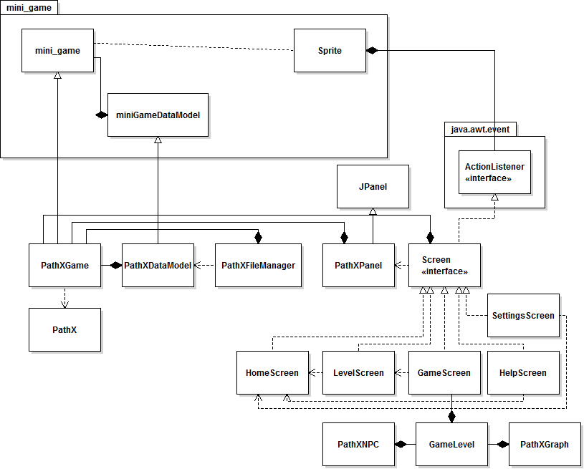

Figure 3.2: pathX Overview UML Class Diagram

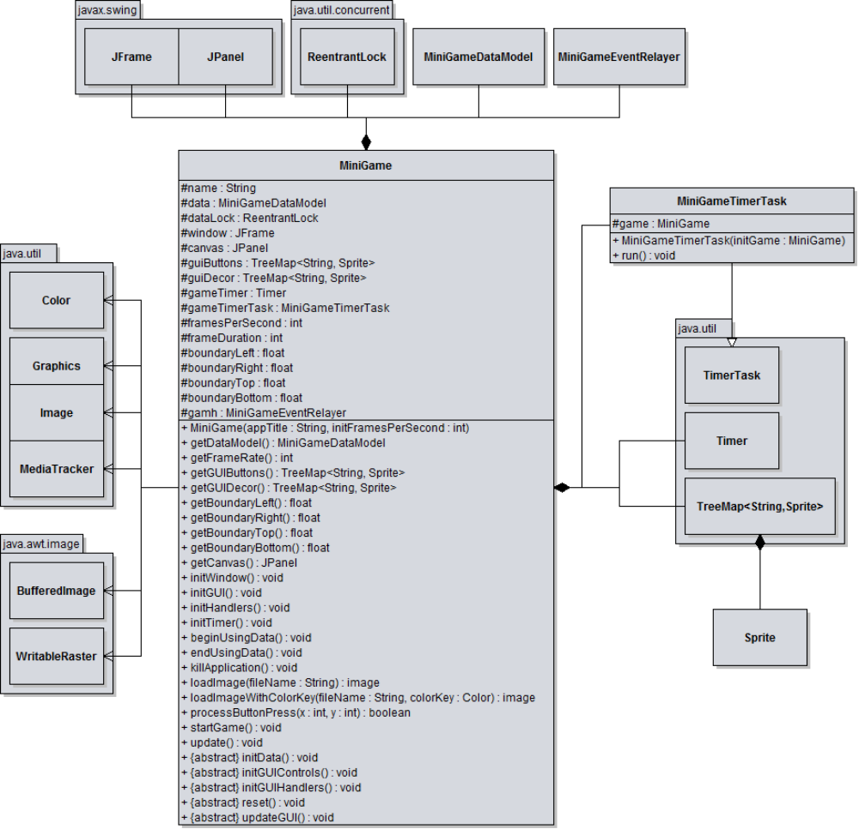
Figure 3.3: Detailed MiniGame and MiniGameTimerTask UML Class Diagram

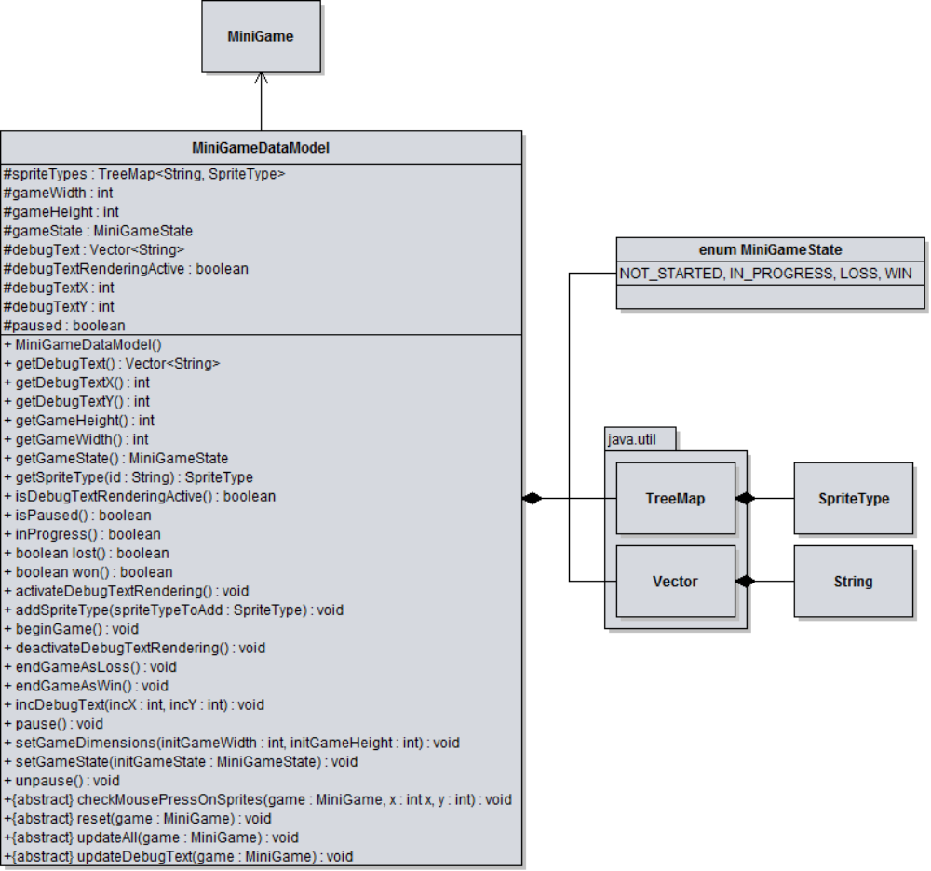

Figure 3.4: Detailed MiniDataModel UML Class Diagram

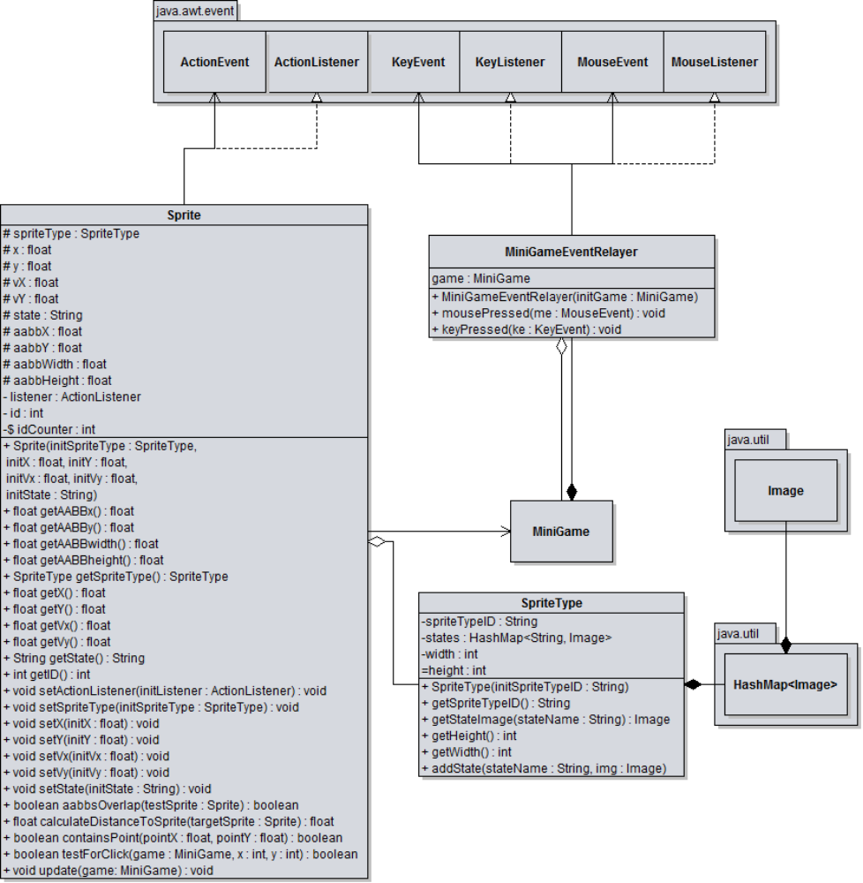
Figure 3.5: Detailed Sprite, Sprite, and MiniGameEventRelayer UML Class Diagram

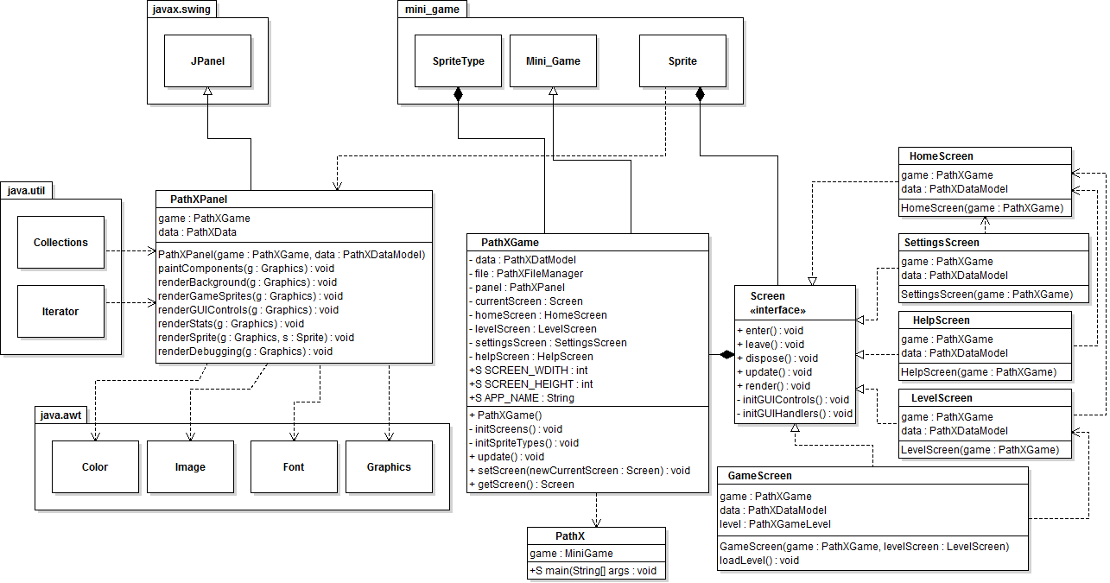
Figure 3.6: Detailed PathXPanel, PathXGame and Screen UML Class Diagram

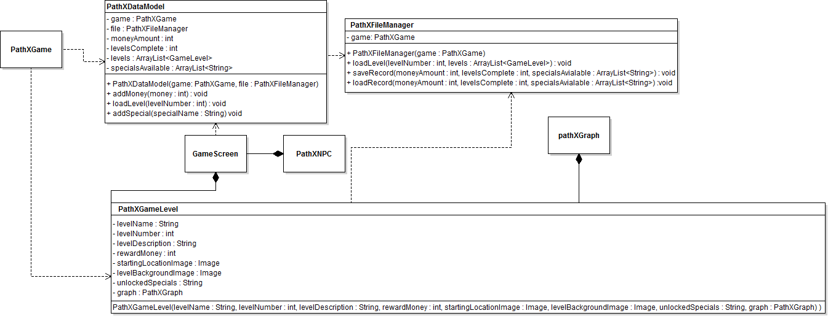
Figure 3.7: Detailed PathXData, PathXFileManager and PathXGameLevel UML Class Diagram
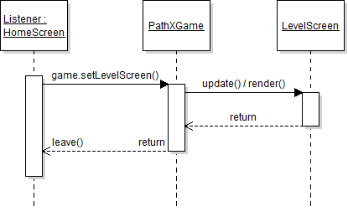
4.1 : HomeScreen to LevelScreen Sequence Diagram

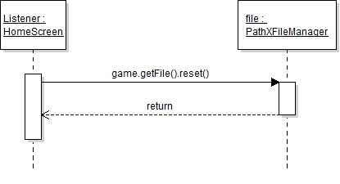
4.2 : HomeScreen reset Sequence Diagram

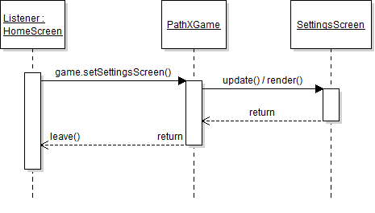
4.3 : HomeScreen to SettingsScreen Sequence Diagram

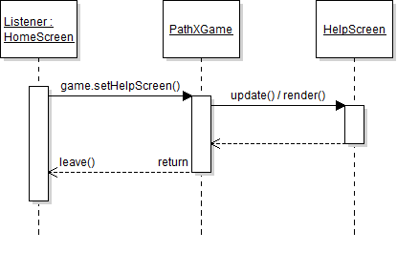
4.4 : HomeScreen to HelpScreen Sequence Diagram

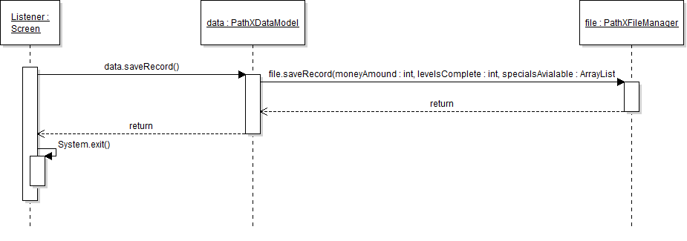
4.5 : Exit out of any screen Sequence Diagram
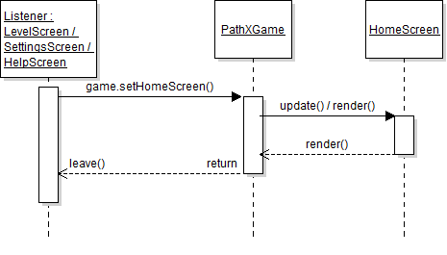
4.6 : Return to Home Screen from Level, Settings or Help Screen Sequence Diagram

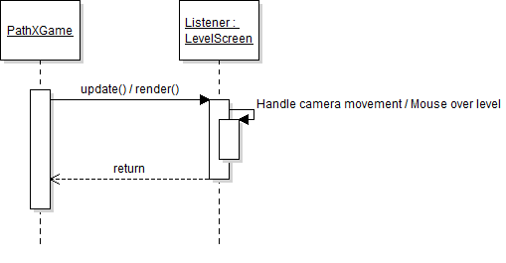
4.7 / 4.8 : Scroll View / Mouse Over Level Sequence Diagrams

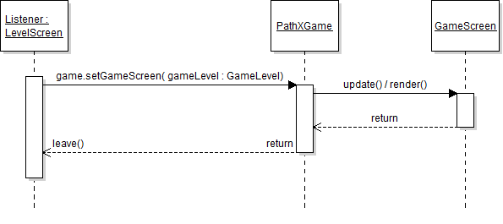
4.9 : Enter GameScreen Sequence Diagram
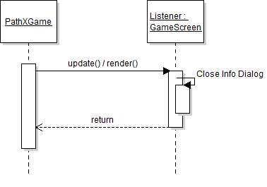
4.10 : Closing Info Dialog Sequence Diagram

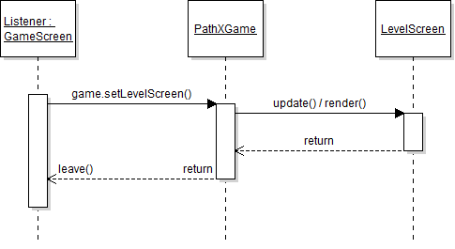
4.11 : Exiting GameScreen into LevelScreen Sequence Diagram

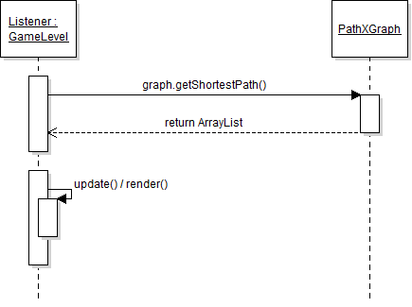
4.12 / 4.13 : Select Path Destination Sequence Diagram

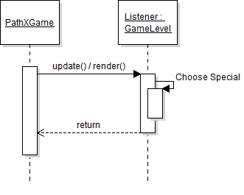
4.14 : Select Special Sequence Diagram

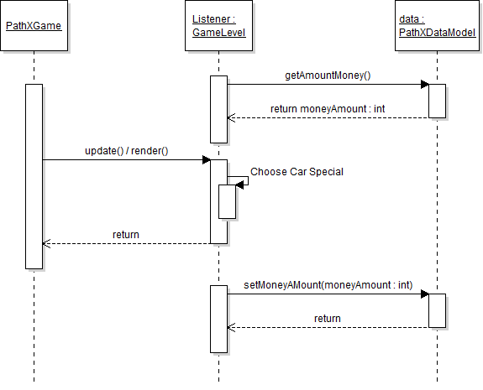
4.15 : Pay/Asssign Car Sequence Diagram
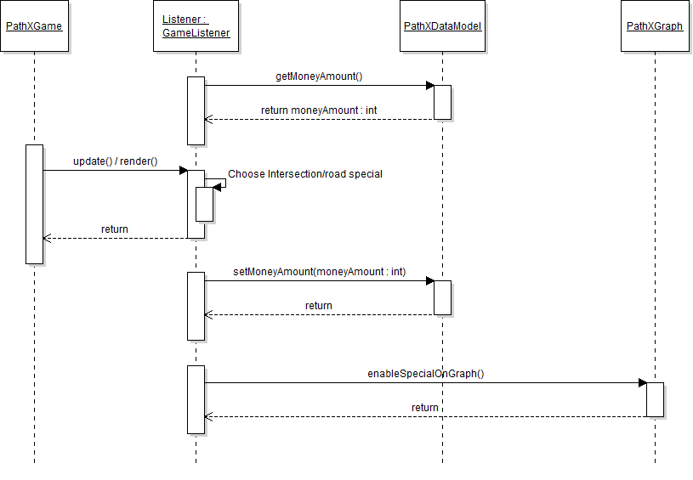
4.16 / 4.17 : Pay/Assign Intersection/Road Special Sequence Diagram

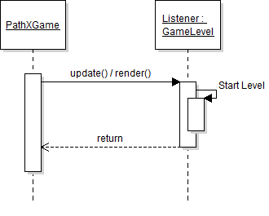
4.18 : Start Level Sequence Diagram
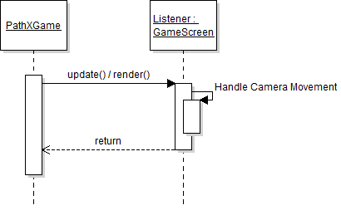
4.19 : Scroll Through GameScreen Sequence Diagram

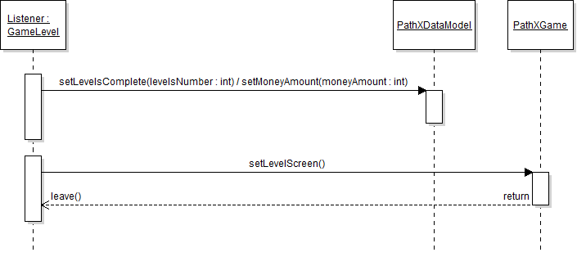
4.20 : Close Win/Loss Dialog & Quit Level Sequence Diagram

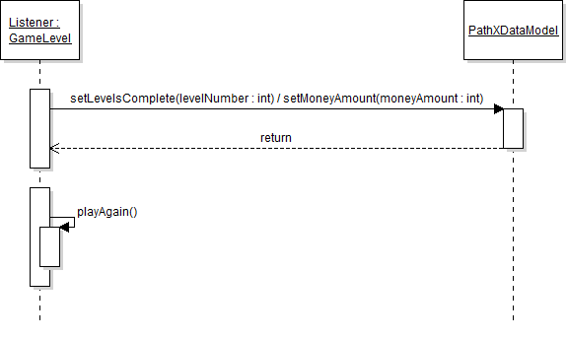
4.21 : Close Win/Loss Dialog & Play Again Sequence Diagram

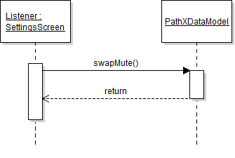
4.22 : Mute/Unmute Sequence Diagram

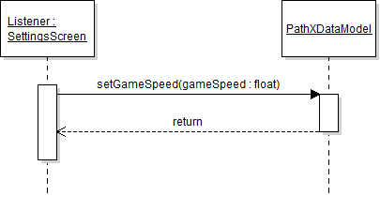
4.23 : Change Game Speed Sequence Diagram

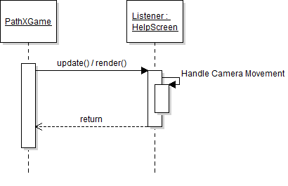
4.24 : Scroll Through Help Sequence Diagram

5. File Structure and Formats

Note that the Mini Game Framework will be provided inside MiniGameFramework.jar, a Java Archive file that will encapsulate the entire framework. This should be imported into the necessary project for the PathX application and will be included in the deployment of a single, executable JAR file titled PathX.jar. Note that all necessary data and art files must accompany this program. Figure 5.1 specifies the necessary file structure the launched application should use. Note that all necessary images should of course go in the image directory.

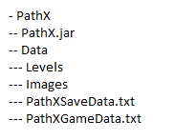

Figure 5.1: PathXGameData File Structure

The PathXGameData.txt provides the file and state names for all sprite states in the game. The file is a raw text file that can be used to describe M Sprite Types, each with their own N states as follows:

NumSpriteTypes
SpriteType_1|NumStatesFor_1
SpriteType_1STATE_1|SpriteType_1STATE_1_FileNameAndPath
…
SpriteType_1STATE_N1|SpriteType_1STATE_N1_FileNameAndPath
…
SpriteType_M|NumStatesFor_M
SpriteType_MSTATE_1|SpriteType_MSTATE_1_FileNameAndPath
…
SpriteType_MSTATE_N2|SpriteType_MSTATE_N2_FileNameAndPath

We can describe these values as follows:

NumSpriteTypes – an integer that lists the total number of Sprite Types to be loaded. Note that this value must correspond to the number of Sprite Types that will be described by the file using the proper format.

SpriteType_X – the textual name of a type of sprite, which should correspond to a PathX named constant.

NumStatesFor_X – an integer that lists the total number of states for Sprite Type #X. Note that this value must correspond to the number of states for that Sprite Type that will be described by the file using the proper format.

SpriteTye_X_Y – the textual name of a state for sprite X. Note that this value must correspond to a PathX named constant.

SpriteType_XSTATE_Y_FileNameAndPath – the textual relative path (from the game’s home directory) and file name for the image to be used to represent sprite type X when it is in state Y.

Figure 5.2: PathXSaveData File Structure

The PathXSaveData.txt provides the information for all of the save data for the project. The file is structure is shown here:

MoneyAmount ######
LevelsComplete ###
UpgradesAvailable
Upgrade#1
Upgrade#2
Upgrade#3
6. Supporting Information

Note that this document should serve as a reference for those implementing the code, so we’ll provide a table of contents to help quickly find important sections.

  - Table of contents

- Introduction 2
  - Purpose 2
  - Scope 2
  - Definitions, acronyms, and abbreviations 2
  - References 3
  - Overview 3
- Package-Level Design Viewpoint 4
1. PathX and Mini Game overview 4
2. Java API Usage 5
3. Java API Usage Descriptions 5
- Class-Level Design Viewpoint 8
- Method-Level Design Viewpoint 14
- File Structure and Formats 17
- Supporting Information 18
  - Table of contents 18
  - Appendixes 18

  - Appendixes

N/A

