OD Prototyping in the General Mission Analysis Tool

D. Conway
S. Hughes
M. Wilkins

November 24, 2008

Table of Contents
1 Introduction 1
2 Design Requirements 2
3 OD System Components and Interactions Overview 3
3.1 User Perspective 3
3.2 Architectural Perspective 4
4 High Level View of a GMAT Run 6
5 OD Component Design 7
5.1 Estimator 7
5.1.1 Estimator State Manager 8
5.1.2 Measurement Manager 8
5.2 Propagator 9
5.2.1 Propagator State Manager 9
5.2.2 Event Manager 9
5.3 Measurement 9
5.4 Run Estimator Command 10
6 OD Object Initialization 10
7 Appendix 1: The Sample Script 13
1 Acronym List 15
1.1 Command Pre-Run Initialization 15
1.1.1 RunEstimator 15
1.1.1 Command Run-Time Initialization 16
1.1.2 Command Execution 16
1.1.3 Command Finalization 16

Introduction

Implementing orbit determination features in GMAT requires that new objects and commands be implemented and that modifications are made to some existing objects and commands. Additionally, several new system components must be developed to act as mediators between OD components and other components such as propagators. This document describes all components necessary to solve a basic OD problem in GMAT and contains a preliminary design that describes how GMAT solves a simple OD problem.
We begin with an overview of the components required to perform OD from a user and system perspective and describe the activities and interactions at a high level. Next, we step through the execution of the OD test script and explain what GMAT does at each step in during the execution of the script. We keep in mind throughout the design process that the design must be extensible to more complex problems as described in the high level design requirements below.

Design Requirements

- The system shall solve the OD test problem defined in Appendix I
- The system shall be extendable to handle new measurement models or measurement corrections.
- The system shall be extendable to handle new dynamics models
- The system shall be extendable to handle new solve for and consider parameters
- The system shall be extendable to handle new estimators
- The system shall be extendable to handle new quantities that require numerical or analytic integration.

First Year Functionality

- Estimators
  - Batch Least Squares
  - Filter (What kind??)
- Measurements
  - Ground Station
    - Ra/Dec
    - Az/El
    - Range
    - Range Rate
    - Doppler
- Corrections
  - Light time
  - Troposphere
  - Ionosphere
- OD parameters (Solve-for and Consider)
  - Cartesian State
  - Ground station location
  - Cr ( or ballistic coef.)
  - Cd ( or ballistic coef.)
  - Measurement bias
  - Solve for stochastic properties

OD System Components and Interactions Overview

User Perspective

To uniquely define an orbit determination problem, a user must often provide hundreds of pieces of information ranging from clock drift parameters, process noise characteristics, spacecraft physical properties, ground station properties, and atmospheric modelling parameters to name just a few. The objects and supporting data for OD in GMAT are summarized in Fig. 1. The logical organization establishes key physical and computational elements into one of five categories: (1) Measurement Participants, (2) Sensors, (3) Estimators, (4) Measurements and (5) Dynamics. In GMAT, the user has access to the objects shown in Fig. 1, and can configure the data identified on each object in a gray bubble. A yellow bubble indicates that the user can attach a previously created and configured object of the identified type. Below we briefly discuss each logical category of object from a user perspective starting with measurement participants.

Measurement participants are models of physical objects that “participate” in the process of creating a measured quantity that is related to the spacecraft state. Examples of measurement participants include spacecraft, ground stations, and celestial objects. In GMAT, measurement participants are created and configured separately from measurement objects (which are discussed below). For example, if a user requires a Doppler measurement between, say, Hubble and Canberra, they first configure a spacecraft to model Hubble, and then they configure a ground station to model Canberra.

The sensor models contained in GMAT include but are not limited to clocks, receivers, transmitters, transponders and lasers. The user can create and configure sensors for their application and attach the sensor to the appropriate parent object such as a spacecraft or ground station.

Measurement objects are complex and a large amount of user-provided data is required to perform the functions described above. In GMAT, a measurement provides the following data: (1) observed measurement values which are read from a file, (2) computed (or expected) values of measurements, (3) simulated measurement values if requested, and (4) internal to GMAT, the measurement partial derivatives.

GMAT contains several estimators including batch, sequential, and initial orbit determination solvers. These algorithms solve for a state estimate by processing measurements generated by measurement objects configured by the user. Hence, the user provides a list of all measurements to include in a particular estimation run. In addition, the solver object is where the user specifies which parameters are to be treated as solve-for and consider quantities.

Propagators are used in two areas for estimation problems. Propagators are attached to an estimator to propagate all objects associated with the solve-for and consider parameters and expected values of the measurements. For these cases, a user creates and configures a propagator just like in a mission analysis problem: A separate propagator can be provided so that simulated observations use different dynamics than those used for the computation of expected values.

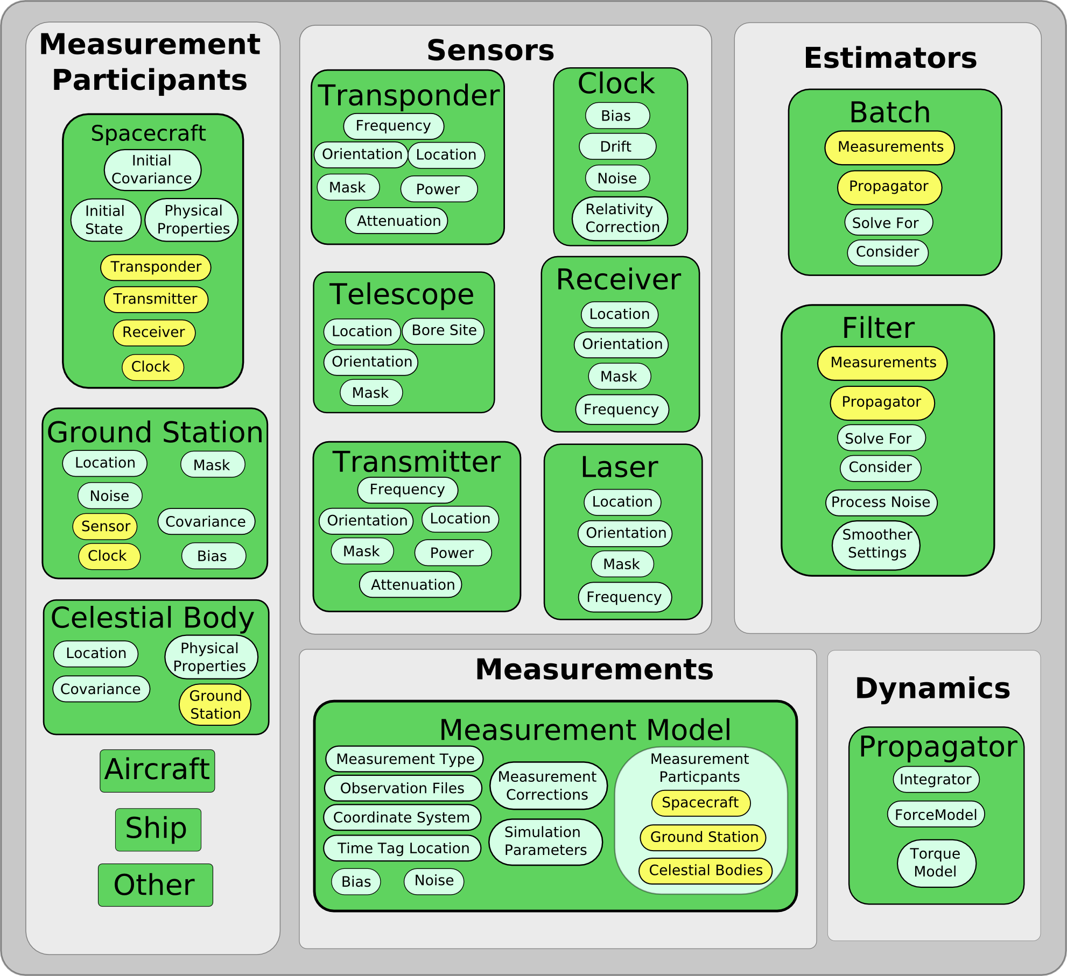
Figure 1: Logical Grouping of OD Objects

Architectural Perspective

From an architectural perspective, there are two logical organization of classes used in the orbit determination process: user configured objects, and helper classes that facilitate communication and interaction between components. The user configured classes are participants (with attached sensors), measurements, propagators, and estimators. The helper classes, which are shown in green boxes in Fig. 2, are the EstimatorStateManager (ESM), Propagator State Manager (PSM), the MeasurementManager (MM), and the Event Manager (EM). The ESM and PSM are derived from a new class called State Manager that is a helper class that manages the complex process of bookkeeping and interaction among system components required for propagation and estimation. The propagator and estimator only know vectors of numbers. The State Managers map those numbers to the objects that they relate to and vice versa.

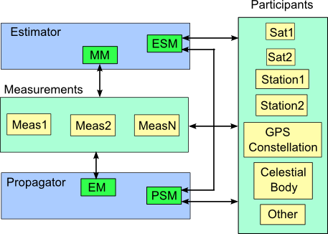
Figure 2: OD Components and Interaction

Estimator: The estimator class is the base class for all estimators. An estimator has two owned-objects, an Estimator State Manager and a Measurement Manager.

Estimator State Manager: The estimator state manager is a helper class for an estimator. The ESM gets and sets data on participants, and tells the propagator (via the Propagator State Manager), what objects require propagation.

Measurement Manager: The measurement manager coordinates measurement information among all the measurements objects being used during an OD process. The MM sorts observations into time-wise order from multiple data types, keeps track of measurement-state dependencies, and assembles the measurement partials matrix based on the state dependency data.

Propagator State Manager: The propagator state manager is a helper class for a propagator. The PSM gets and sets data on participants.

Event Manager: (Not Implemented) The event manager is a helper class for a propagator and manages the location of discrete events during the propagation process. The event manager lets the propagator know when an discrete has been bracketed, and controls the iteration process in locating the event. This is required for OD to determine light time correction.

Figure 2 illustrates which components can interact via arrows between the components. The Estimator State Manager communicates with participants, and with the Propagator State Manager. The measurement manager communicates with the measurements. Measurement manager communicates with, in addition to those listed above, measurement participants. The Propagator state manager can communicate with the Estimator State Manager and with Participants. The Event Manager communicates with measurements. These interactions are discussed in detail in the sections below that discuss each component at a lower level.

High Level View of a GMAT Run

The main steps in performed by GMAT, for a simple orbit determination run are:

  - Resource initialization.
    - Initialize coordinate systems
    - Initialize spacecraft
    - Initialize all other resources except subscribers
    - Initialize parameters
    - Initialize subscribers
  - Command PreExecution Intialization. Perform up front initialization that can be done prior to running the mission control sequence.
    - Pointer-initialization
    - Object Validation
    - Configure propagation state manager and dimension the PSV
    - Configure estimation state manager and dimension the ESV
  - Command Execution-Time Initialization: Perform the remaining initialization of the commands that cannot be performed until we have reached the command while running through the mission sequence.
    - ODE map, and analytic map
    - ODE map, and analytic map
    - Populate the ESV with numeric values
    - Populate the PSV with numeric values
    - Initialize the measurements
  - Command Execution
  - Command Finalization
    - Publish final data
    - Reset flags so that reentrant call will reinitialize data.

A brief description of the five primary steps in running a GMAT mission:

Resource Initialization: Object inititialization occurs when Moderator calls the InitializeSandbox. Initialize of resources occurs in a specific order: coordinate systems and spacecraft are initialized first. All of the resource level objects are initialized next, with the exception of subscribers. Next parameters get initialized and then subscribers and then the mission control sequence. When object gets initialized in the sandbox by the Object Initializer, first the object is found in the local or global object store. Then a call is made to the object to a method called GetRefObjectNameArray. This array is a list of names of other objects that have been created by the user and associated with the current object being initialized. The object initializer steps through the list of Ref Objects by name, finds each reference objects, and passes the pointer for that object into the object being initialized through a call to SetRefObject. When initialization for an object is done, the object has an array of names for attached objects, and pointers to the actual objects.

Command PreExecutionInitialization: Because commands are run in the order entered by the user, and the order of commands determines the states of resources during execution, only a limited amount of initialization can be performed prior to executing the mission control sequence. During command pre-execution initialization, as much initialization is performed as possible This includes setting pointers to owned objects, and dimension arrays such as the propagation state vector.

Command ExecutionTime Initialization: Execution time for a command is the point at which that command is being executed. The states of all the resources are now known. At this point, state vectors are populated with their numeric values.

OD Component Design

Estimator

The Estimator class is the base class for all estimators. This class needs a lot of work. To do: Design Estimator class hierarchy and show how different estimators (SRIF, SigmaPOint) derive from the Estimator base class. Show how Estimator derives from Solver?? Add consider parameters.

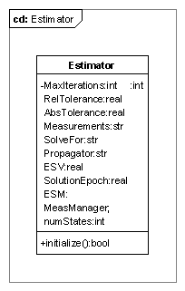

Estimator State Manager

The Estimator State Manager is derived from the StateManager base class. Design of the State Manager class is based on the Mediator design pattern of Gamma (?? Is this still true) et.al. and promotes loose coupling among system components by using a many to one relationship instead of a many to many relationship. Using the mediator pattern for the State Managers, an Estimator does not have to communicate directly with all of the objects involved in an estimation problem, the estimator simply communicates with the ESM. The ESM and PSM coordinate state data management between the estimators and propagators. The advantage is that estimators and propagators can remain streamlined and efficient and that new state types can be easily incorporated at a later time without changes to the estimators and propagators. The trade off is that the state manager centralizes complexity and must be carefully designed for ease of maintenance. However, if designed well, the State Manager will make incorporating new objects easier.

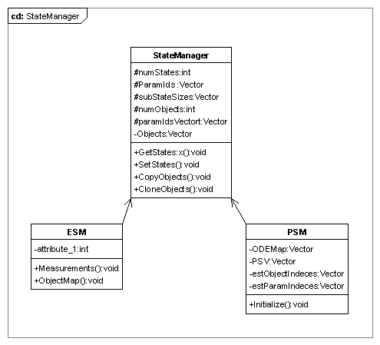

Measurement Manager

The measurement manager passes is the interface between the Estimator and the measurement objects defined by the user. The primary job of the measurement manager is to manage data from multiple measurement objects, and multiple data types on each object. The measurement manager keeps a time-ordered list of all observations, and when requested, provides data such as observed and computed values and the measurement partials at the measurement epoch.

To do: Design the PartialsMap that shows how to determine nonzero partials for each measurement, and how to concatenate the H vector from nonzero derivative chunks passed back from measurements.

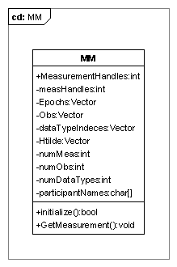

Propagator

PropSetup is initialized as it would be for any other mission.

Propagator State Manager

Event Manager

Measurement

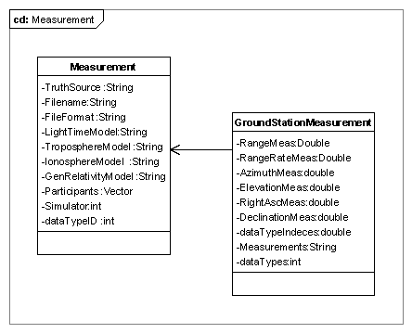
Call ObsGenerator::Initialize to initialize the ObsGenerator. If a database connect to database, if a file should we read into memory.

Call MeasurementModel::GetRefObjectNameArray and pass the pointers for all attached objects. This includes participants, in this case Spacecraft and Ground station, and if there is a simulator, the name of the propagator for the simulator.

For all objects that appear in the Solverfor and Consider lists check that there is at least one measurement that uses this object, which means it appears in the participants list for the measurement. There’s a separate issue of checking that observation files actually contain data for the participants.

Set up the Estimation state vector based on the solve for and consider variables. Here we allocate memory for the state vector, and we define that mapping between components of the state vector and their ode models. When this is done we have the state vector allocated, and ODEmodel that matches the state vector component by component.

Run Estimator Command

OD Object Initialization

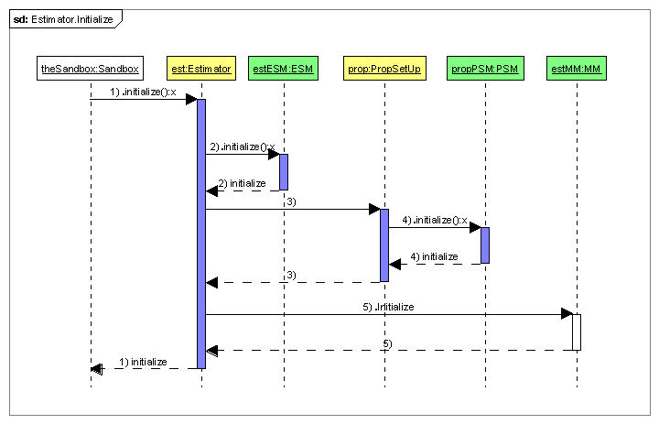
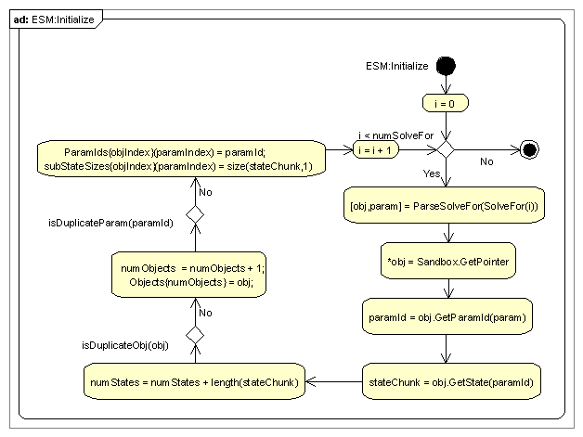

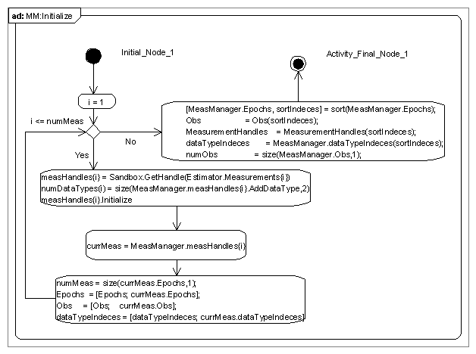

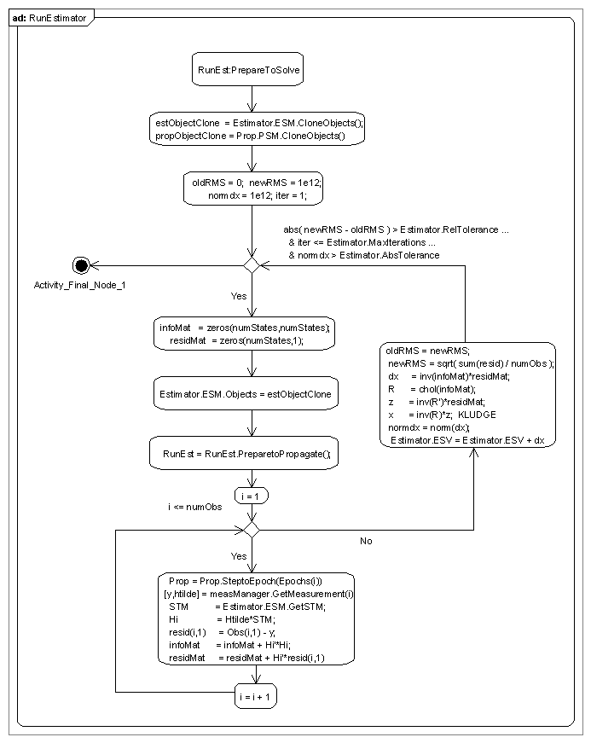

Appendix 1: The Sample Script

%==========================================================================
%==========================================================================
%------ Define the spacecraft properties
%==========================================================================
%==========================================================================
ODSat = Spacecraft();
ODSat.Id = 21639;
ODSat.Epoch = 24228.72771990741;
ODSat.X = 9882.164071524565;
ODSat.Y = -23;
ODSat.Z = 1837.579337039707;
ODSat.VX = 0;
ODSat.VY = 6.233189510799131;
ODSat.VZ = 0.8480529946665489;
ODSat.DryMass = 1703.6700;
ODSat.OrbitCovariance = diag([100000^2*ones(3,1);1000^2*ones(3,1)]);
ODSat.Cr = 2.2;
ODSat.Cd = 1.8;

%==========================================================================
%==========================================================================
%------ Define the batch least squares solver
%==========================================================================
%==========================================================================
MauiData = GroundStationMeasurement();
MauiData.Filename = 'LEOMaui.mat';
MauiData.AddDataType{1} = {'Range','ODSat','Maui'};

%==========================================================================
%==========================================================================
%------ Define the batch least squares solver
%==========================================================================
%==========================================================================
BLS = BatchEstimator();
BLS.MaxIterations = 10;
BLS.RelTolerance = 1e-5;
BLS.AbsTolerance = 1e-5;
BLS.Measurements = {'MauiData'};
BLS.SolveFor = {'ODSat.CartesianState'};
BLS.Propagator = 'ODProp';

%==========================================================================
%==========================================================================
%----- Define the ground station properties
%==========================================================================
%==========================================================================
Maui = GroundStation();
Maui.Id = 222;
Maui.X = -4450.8;
Maui.Y = 2676.1;
Maui.Z = -3691.38 ;

%==========================================================================
%==========================================================================
%----- Define the Propagator
%==========================================================================
%==========================================================================
ODProp = Propagator();
ODProp.FM.CentralBody = 'Earth';
ODProp.FM.PointMasses = {'Earth'};
ODProp.FM.SRP = 'Off';
ODProp.Type = 'RungeKutta89';
ODProp.InitialStepSize = 60;
ODProp.Accuracy = 1.0e-8;

RunEstimator BLS;

Before initialization there are objects in the sandbox and there is a propagator but no mechanism for mapping data between them and the objects that perform the propagation don’t exist yet. After initialization, the prop setups used for propagation have been created and the propagate command has pointers to all of the prop set ups. Each prop setup’s prop state manager has an array of pointers to the STUFF it must propagate. The propagator has pointers to both propsetups and the ode models

When we enter there is a string array of propagators and a string array of stuff and settings for each stuff element. This figure shows how the prop setup, prop state manager, ODE model, and integrator are created. Don’t know how

Acronym List

ESM Estimator State Manager
PSM Propagate State Manager
MM Measurement Manager
EM Event Manager
GMAT General Mission Analysis Tool

Old but still useful Stuff

Command Pre-Run Initialization

RunEstimator

RunEstimator::Intialize. Give the RunEstimator command the pointer to the requested solver. Call the Estimator to get the name of the propagator, find that object, and make a local clone. At this point, the Estimation state manager passes the state info to the propagation state manager so the propagator can. First, RunEstimator command calls the propagator and receivers a pointer to the PropagationStateManager, passes that pointer to the estimation state manager and then tells the estimation state manager to initialize the PropagationStateManager. We do this up front

The propagation state manager takes the ode mapping from the estimation state manager and sets up the ODE model so that derivative information is set to go into the correct state components. State managers hold the mapping between objects and the values that integrated. The Propagator and estimator only know vectors of numbers. The State managers map those numbers to the objects that relate to.

Old Stuff

Command Run-Time Initialization
Assume we are at the point where Moderator::ExecuteSandbox has been called and we are stepping through the list of command and we are at the point where SandBox is calling RunEstimator::Execute.

RunEstimator

If the RunEstimator command is not already executing, then call PrepareToPropagate(). The PrepareToPropagate command calls the estimation state manager and tell it to PrepareToPropagate. Then EstimationStateManager calls the propagationStateManager, gives it the actual data (initial conditions) and tells it to prepare to propagate.

Command Execution
Execution: Run the state machine, propagate as needed.

Command Finalization
Finalization: Publish final data, and reset flags so that reentrant call will reinitialize everything.

