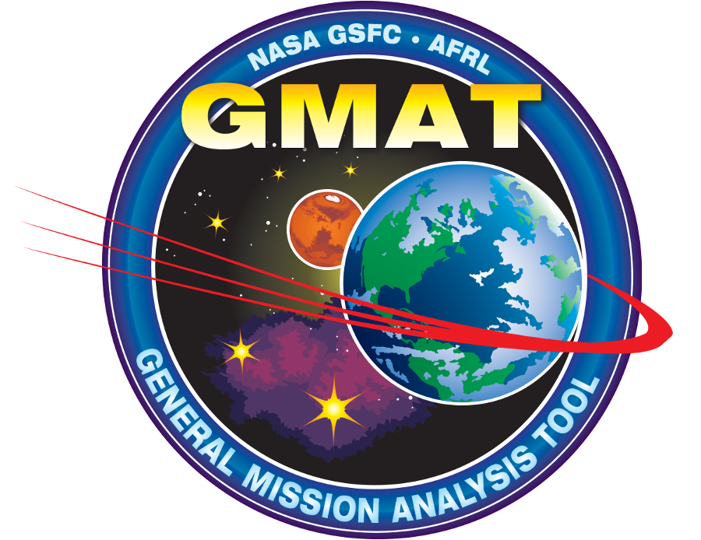
Navigation and Mission Design Branch
(NASA GSFC, Codes 595,583,582)

Product Plan (PP)
for
General Mission Analysis Tool (GMAT)

OCP Version: Draft.

OCP Date: Oct. 2011

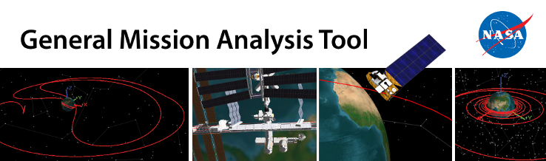

Written by:

_____________________________ ______________
Steven P. Hughes / GMAT Product Lead Date
Navigation and Mission Design Branch

Approved by:

_____________________________ ______________
Mark Beckman / 595 Branch Head Date
Navigation and Mission Design Branch

_____________________________ ______________
Sue Hoge / Director Date
Flight Dynamics Facility

_____________________________ ______________
Cheryl Gramling / Chief Navigation Engineer Date
Navigation and Mission Design Branch

Reviewed by:

_____________________________ ______________
Isaac McGinnis / Software Assurance Engineer Date
Mission Support Division

PLAN UPDATE HISTORY

Version | Date | Description | Affected Pages
1.0 | TBD | Initial Baseline Version | All

Table of Contents
Introduction 5
Objectives of This Effort 5
Deliverables 5
What We Will Not Deliver 6
What 595 Will Provide 6
Acceptance Criteria 6
Product Delivery 7
Management Approach 7
Roles and Responsibilities 7
Work Assignments 10
High Level Schedule 11
Metrics and Progress Tracking 11
Configuration Control Board 11
Status Reporting 12
Risk Management 12
Safety and Security 13
Verification and Validation 13
Overview 13
Requirements Verification 14
Interface Specification 15
Testing 15
Defect Resolution 16
User Documentation 16
Wrap-Up 16
Configuration Control 16
Data Management 17
Configuration Management Overview 17
Configuration Identification 18
Levels of Control 18
Change Authority 18
Planned Baselines 19
Creation and Storage of Baselines 20
Configuration Control 20
Configuration Status Accounting 22
Configuration Audits 23
Control of Non-conforming Products 24
Control of Customer-Supplied Products 24
Quality Assurance 24
Software Assurance Process 25
Peer Reviews / Inspections 25
Code 320 QA Support 25
Appendix 1: Product Breakdown Structure 26
Appendix 2: Acronyms and Abbreviations 29

Introduction

This document is the GMAT Product Plan tailored to processes for the Production Release of the General Mission Analysis Tool (GMAT). I have mercilessly removed information from the official product plan to avoid obfuscating what is essential to the production release of GMAT 2013a. –SPH

The objectives of this plan are
- To describe goals and overarching philosophy to help team members make daily work decisions
- To describe management infrastructure and processes
- To describe technical processes for the work
- To describe product control intrafrastructure includ

Objectives of This Effort

The objective this effort is to document and perform final V&V for GMAT R2013a. GMAT is already tested extensively. This effort is to make a final pass through the system documenting features and addressing test gaps. The specific goals for GMAT R2013a:
- Deliver release candidate of GMAT R2013a bv Dec. 2012 or earlier
- Deliver production release of GMAT R2013a by April 2013 or earlier
- Position GMAT for large-scale community adoption of GMAT 2013a v1.0
- Position project for operational certification in Spring of 2013
- Win NASA Software of the Year in FY14

The following statements are guiding philosophy for work on GMAT R3013a which should be used to aid daily decision making.

- We are testing and documenting what we have, which is a lot!
- We should prioritize issues by user-pain:
  - what affects users the most
  - what affects the most users.
- This isn’t the last version, it is the first version. It does not have to do everything we would like it to do.
- Prioritize features by importance and work in that order
- Put functionality we can’t polish by release in plug-ins and turn off
- Process: As simple as possible, but not simpler (Einstein)

Deliverables

The primary deliverables for Production Release are:

- Product Plan (this document)
- Production release Windows application ready for operational certification.
- User’s guide (with Version Description Document)
- Requirements specification
- Test plan
- Test procedures
- Test results
- Bidirectional requirements to test matrix
- NTR forms
- Delivery Letter

What We Will Not Deliver

We will NOT deliver the following items:

- Mathematical specification (draft available)
- Design specifications (draft available)
- Mac application
- Linux application

We will NOT deliver the following features:

- FRR-37 GMAT Functions
- FRR-41 Event Locator
- FRR-27 Ephemeris Propagator
- FRR-15 Ground Station Model
- FRC-12 Save Command
- FRC-18 GMAT Function Call Command
- Global Command
- PrepareMissionSequence command
- C-API
- Matlab Server
- Socket Server

What 595 Will Provide

Code 595 will provide the following items to the GMAT project:
- List of possible missions potentially to be the first to use GMAT from analysis through operations.
- Beta testers

Acceptance Criteria

Customer acceptance of the system will be based on the system meeting the following acceptance criteria:

- All acceptance tests have been formally executed and witnessed by customer
- All critical or urgent problem reports are either closed, documented, or have customer-accepted work-arounds in place
- All acceptance test results have been peer reviewed and passed

Product Delivery

GMAT will be delivered as a standard desktop application including the following:

- Automated installer
- User’s Manual
- Version Description Document

Management Approach

This chapter describes the management process to be used for GMAT Production Release.

Product Breakdown Structure

Resources
FRR-1 Representations for Setting Orbit State
FRR-2 Representations for Setting Orbit Epoch
FRR-3 Representations for Setting Spacecraft Attitude
FRR-4 Spacecraft Ballistic , Mass, and Inertia Properties
FRR-5 Spacecraft Visualization Properties
FRR-7 Spacecraft Kinematic Attitude propagation
FRR-8 Spacecraft Tank Model
FRR-9 Spacecraft Thruster Model
FRR-10 Spacecraft Formations
FRR-11 Impulsive Burn Model
FRR-12 Finite Burn Model
FRR-13 Dynamics Modeling
FRR-14 Numerical Integrators
FRR-16 Solar System Model
FRR-17 Libration Points
FRR-18 Barycenter Model
FRR-19 Differential Corrector
FRR-20 fmincon Optimizer
FRR-21 vf13ad Optimizer
FRR-28 Orbit View
FRR-29 XY-Plots
FRR-30 Report Files
FRR-31 Ephemeris File
FRR-32 User Defined Variables
FRR-33 User Defined Arrays
FRR-34 User Defined Strings
FRR-35 Coordinate Systems
FRR-38 Parameters and Calculations
FRR-42 Groundtrack Plot*

FRC-1 Optimize Commands
FRC-2 Vary Command
FRC-3 Target Commands
FRC-4 Control Flow Commands
FRC-5 Achieve Command
FRC-6 Minimize Command
FRC-7 Nonlinear Constraint Command
FRC-8 Finite Burn Commands
FRC-9 Maneuver Command
FRC-10 Propagate Command
FRC-11 Report Command
FRC-13 Script Event Commands
FRC-14 Pen Up and Pen Down Commands
FRC-15 Stop Command
FRC-16 Toggle Command
FRC-17 Matlab Function Call Command
FRC-19 Assignment Command
FRC-22 Begin Mission Sequence
FRC-23 Clear Plot Command
FRC-24 Mark Point

FRAC-2 General Application Control
FRAC-3 Script and Function Editor
FRAC-4 GUI Tool Bar
FRAC-5 GUI Menu Bar
FRAC-6 Resource Tree
FRAC-7 Mission Tree
FRAC-8 Command Summary
FRAC-9 XY Plot Control

Roles, Responsibilities, Deliverables

Responsibilities and deliverables for GMAT project members during Production Release preparation are defined below and broken down by role.

Role | Responsibilities/Deliverables
PDL | - Provide high level feature prioritization to ensure critical features are tested early so non-critical features can be removed from the system if needed to remain on schedule.  - Verify requirements
GUI Test Lead | - Manage the GUI test effort  - Write test plans  - Write test procedures  - Prioritize and Triage GUI bugs.  - Manage GUI regression test process
Script Test Lead | - Manage the script test effort  - Present test strategy for script at ORR  - Work with PDT to prioritize script bugs.
Feature Area Lead | - Responsibilities  - On time delivery of feature area  - Quality of features and docs  - Coordinate and support the developer, tester, and tech writer to see feature to completion.  - Review of other area member work products  - Improve error messages  - Provide engineering analysis when need to diagnose bugs  - Verify bug fixes  - Deliverables  - Weekly metrics and progress tracking  - Specs  - Finalized Requirements  - Field spec  - Functional spec  - Script test procedures  - Detailed bug reports
Software Development Engineer (SDE) | - Responsibilities  - On time fixes of defects  - Quality of code and application  - Read code and  - Document fields and data types in field spec items  - Verify all inputs are validated  - Verify reasonable handling of data types  - Improve error messages  - Deliverables  - Weekly metrics and progress tracking  - P1 Bug fixes  - High Value P2 Bug fixes  - Spec review comments/suggestions
Software Test Engineer  (STE) | - Responsibilities  - Quality of GUI interface  - Run regression tests  - Verify bug fixes  - Deliverables  - Weekly metrics and progress tracking  - Tests  - Generic GUI Tests Using Templates  - Feature Unique GUI Test Procedures  - Feature Unique GUI Tests  - Detailed bug reports
Technical Writer  (TW) | - Write reference material  - Review tutorials
Configuration Control Board  (CCB) | - Bug Triage Prioritization  - Project status monitoring

Work Assignments

Documentation and final V&V will be performed in feature groups as shown below. Each group is assigned a lead, an SDE, and an STE. The responsibilities and deliverables of these roles are described in the Roles and Responsibilities section. Exceptions to the assignments by category are denoted in parenthesis below next to the feature area.

Basic Dynamics/Models | Powered Flight | Solver Infrastructure | Programming Infrastructure | Output\Utils
Lead: SPH  SDE: WCS  STE: SJH | Lead: DSC  SDE: DJC  STE: SJH | Lead: SPH  SDE: DJC  STE: TGG | Lead: JJKP  SDE: WCS  STE: TGG | Lead: RHQ  SDE: LOJ  STE: JMB
FRR-1 Spacecraft orbit state | FRR-8 Tank model | FRR-19 Differential Corr. (DSQ) | FRR-32 Variable | FRAC-8 Command Summary (WCS)  FRR-30 ReportFile
FRR-2 Spacecraft orbit epoch | FRR-9 Thruster model | FRR-3 Target command (DSQ) | FRR-33 Array | FRR-28 OrbitView
FRR-13 Dynamics models (DJC) | FRR-11 Impulsive burn | FRR-5 Achieve Command (DSQ) | FRR-34 String | FRR-42 GroundTrackPlot
FRR-14 Numerical integrator(DJC) | FRR-12 Finite burn | FRR-2 Vary Command | Script Language (LOJ) | FRR-31 EphemerisFile
FRC-10 Propagate command (DJC) | FRC-9 Maneuver command | FRR-21 VF13ad Optimizer | FRAC-3 Script Editor (LOJ) | FRR-29 XYPlot
FRC-7 Spacecraft attitude | FRC-8 Finite burn commands | FRR-20 fmincon Optimizer | FRC-13 Script Event | FRC-11 Report Command
FRC-4 Spacecraft Properties | FRR-?? Spacecraft Hardware | FRC-1 Optimize Command | FRC-19 Assignment command (LOJ) | FRC-16 Toggle
FRR-35 Coordinate system |  | FRC-6 Minimize Command | FRC-?? BeginMissionSequence | FRR-5 Spacecraft vis. Properties
FRR-16 Solar system |  | FRC-7 Nonlinear Constraint | FRR-38 Calculation Parameters (EGD)
FRR-17 Libration point |  |  | FRC-4 If-Else command (EGD) | FRAC-?? Orbit Designer
FRR-18 Barycenter |  |  | FRC-15 Stop | FRC-23 Clear Plot
 |  |  | FRC-4 If command (EGD) | FRC-24 MarkPoint
 |  |  | FRC-4 Else command (EGD) | FRC-14 PenUp/PenDown
 |  |  | FRC-4 While command (EGD)
 |  |  | FRC-4 For Command (EGD)
 |  |  | FRR-?? MATLAB function (LOJ)
 |  |  | EIR-1 Matlab interface (LOJ)
 |  |  | FRC-17 MATLAB function call (LOJ)

Exceptions. DJC is SDE for FRR-10, FRR-13, FRR-14. LOJ is SDE for all MATLAB functionality. EGD is Lead for FRR-38, FRC-4

High Level Schedule

The following are key dates for GMAT Production Release:
Visual Freeze – Oct. 31
Code Freeze – Nov. 23
Beta 1 – Dec. 3
Beta 2 – Jan. 7
RC1 – Feb. 1
RC2 – Feb. 15
R2013a – Mar. 1

Scheduling Philosophy:
- Schedule critical and/or less tested items early.
- Schedule “removable” and/or better tested items later.

We will perform QA for GMAT 2013a (Production release) using 5 intermediate milestones by grouping features by similarity and degree of interaction. The areas are:

Metrics and Progress Tracking

The following metrics will be used to track progress for Production Release:

- P1 Bugs Created vs. Resolved
- P2 Bugs Created vs. Resolved
- Percent tests passing
- Specs complete
- User docs complete
- Test complete

Maintenance and reporting for Bug metrics is the responsibility of the Software Development Engineers. Maintenance of Percent test passing is the responsibility of the test team. Maintenance and reporting of the Spec metrics is the responsibility of the Feature Group leads. Metrics will be updated weekly.

Configuration Control Board

Bugs are addressed in order of criticality where:

- Blocks mission customers or team processes such as testing.
- Critical
  - Crashes
  - Numeric errors
- Affects all or many users.
- Affects significant number of users and there is no workaround

There is always work that needs to be done that doesn’t map directly to goals of a current milestone. Here is how we handle triaging those issues.
- Team members triage issues they have submitted at the beginning of each milestone.
- From [Berkun, 2005]: “Anything that does not affect the rate of completion of P1 work items should never take priority over the things that do.” We’ll make an exception: if you can convince a majority of the team that something is important that is not on the schedule, we’ll put it on the schedule.
- Present items you would like to see added to the schedule at the first team meeting in a new milestone.

Status Reporting

Meeting minutes for weekly meetings are maintained in Google docs and contain required and present attendees, agenda, discussion items and actions. All meeting minutes are written by starting from the Meeting Minutes Template. CCB meeting decisions are documented in the project’s issue tracking system.

The following will be reported at monthly Branch Status Review meetings and also provided via email. A template will be developed, modeled after the Branch Status Review template in the GSFC PAL, but with changes to reflect the unique character of the GMAT project.
- Management Review
  - Schedule/status
  - Risks
  - Issues
- Technical Review
  - Development
  - Testing
  - Documentation
- Metrics

Risk Management

The PDL is responsible for risk identification and monitoring and will be supported in this activity by other members of the PDT. Risk status shall be reported at monthly Branch Status Reviews and major milestone reviews. The following is an initial set of Risks that were identified for the project. The latest detailed information on these Risks and new Risks can be found in the Risk Management Tool located here.

Risk ID | Initial Risk Description
2 | New development with significant re-factorization of the system will occur during certification process. (IRAD and key new functionality)
? | Difficult to estimate time to fix bugs because testing is not complete so we don’t know all issues.
5 | Requirements have not been rigorously reviewed by FDF and Branch and so customers don’t know precisely what will be delivered.
 | No test plan will find all issues and users will find things our approach doesn’t find. We need formal GMAT beta test plan.

Safety and Security

GMAT and similar products such as FreeFlyer and STK are “Class C” software. All components have been examined for Safety Criticality and found not to be safety critical.

Verification and Validation

Overview
This section describes how the GMAT test team will perform verification and validation. The purpose of the verification and validation effort is to prepare GMAT for testing in analysis and operational environments so that few, if any, unknown issues are found during FDF shadow operations. For V&V purposes, GMAT is broken down by requirements groups into approximately 115 feature areas: at the time of this writing, 64 Resources features, 29 command features, and 23 application control features.

Verification and validation will occur on a feature-by-feature approach where the steps in the V&V process are Requirements Verification, User Interface Specification, Testing, Defect Resolution, and User Documentation. The PDL, or his designee, shall evaluate and record the results of all verification and validation activities and ensure that corrective actions are tracked to closure. Each of these steps is described in detail in the sections below.

Most GMAT features have two primary interfaces; a script interface and a GUI interface. The organizational structure of the test team is broken down by feature area and interface type as shown below. Owners of individual feature areas are not shown in the diagram and can be found in the Product Breakdown Structure. The roles for each test team member are described below the organizational chart.

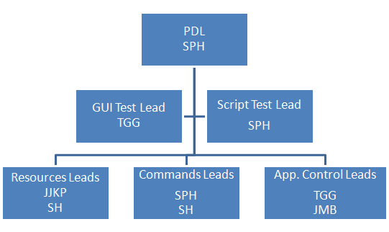

Requirements Verification

The goals of requirements verification phase are to ensure that requirements are clear, testable, and complete, and to define which requirements will be deferred until after operational certification. Validated requirements will be will be frozen by feature group until after certification is complete and the first operational version of GMAT is delivered. The final deliverable of the requirements verification process is a verified Software Requirements Specification that describes all functionality to be delivered in GMAT v1.0. (The Requirements to Test Matrix and other QA tools are discussed in the Testing section.)

Requirements verification is performed on a feature-by-feature level and is managed by the feature lead. The verification process starts by comparing existing requirements for the feature found in the GMAT SRS with existing functionality in GMAT. The verification process is then performed using the following steps:

- Identify required functionality that has not been implemented in the system.
- Identify functionality that has been implemented but is not in the requirements.
- Develop recommendation for final requirements that include how to handle:
  - New functionality that should be implemented ( only critical new functionality will be considered)
  - Un-required functionality that has been implemented in the system.
- Peer review the recommended final requirements obtaining inputs from the PDL, Test Area Lead, Feature Lead, Tester, Engineer, and Developer. (This does not have to occur in an in-person meeting, and can be performed in google docs or using track-changes in a word doc.)
- Update and finalize the requirements based on peer-review.
- Provide final requirements to PDL for update in the SRS.

Note to requirements reviewers: the GMAT script-based regression test systems makes extensive use of requirements IDs that are defined in the SRS. Changes to requirements IDs can be made, but they must be made in both the SRS and test case (TC) files. When another solution is possible, do not change requirements IDs. In the case that changing an ID is the best solution, do NOT change requirements IDs without letting the feature lead and feature tester know of the changes before they are actually made in the SRS.

Interface Specification

The goals of the interface specification phase are to ensure that user and external interfaces meet requirements for v1.0 and to provide engineering specifications of those interfaces so that testers and end-user documenters have the necessary information to test and document the system. The final deliverable of the interface specification process is a set of documents that completely describes the behavior of the GMAT script, GUI, and external user interfaces. User interface specifications are written on a feature-by-feature level and are managed by the feature lead using the following steps:

- Identify all script and GUI fields and interface elements that are implemented for the feature.
- Determine if any required interface elements are missing and check in bugs so that they will be added during defect resolution.
- Determine if any non-required interface elements exist and check in bugs so that they will be removed during defect resolution.
- Document each required interface component (text box, combo box, field name etc.) in the User Interface Specification.
- Peer review the interface specification with input from PDL, Test Area Lead, Feature Lead, Tester, Engineer, and Developer.
- Finalize the interface specification based on peer-review input.

Testing

GMAT testing is a complex activity that is described in detail in the GMAT Test Plan and GMAT Test Procedures documents. Due to the complexity of the testing activity only a high level overview of the testing process is presented here. Inputs to the testing process are the Requirements Specification, Interface Specification. The deliverables of testing activities are:

  - Test Summaries
  - Test cases
  - Defect reports
  - Requirements to Test Matrix

The Requirements to Test Matrix (RTM) and the Interface to Test Matrix (ITM) accomplish different quality assurance purposes and are automated outputs of the GMAT test process. The RTM ensures that GMAT meets requirements (Acceptance Tests). The ITM maps functional and validation tests to specific user interface elements to ensure all elements perform as designed. For example, GMAT often requires several fields or “Features” to meet a requirement. One GMAT requirement states that “The system shall allow the user to define the spacecraft state using Classical Keplerian Elements”. The design allows the user to specify the Cartesian state as individual values rather than setting the entire state as a six vector at one time. The result is that there are six fields (interfaces) that map to a single requirement. Each of these fields requires for example Input Validation tests and Functional tests. The ITM ensures that each required test type is performed for each interface element.

Defect Resolution

The goal of the defect resolution effort is to resolve software defects, and to document known critical issues that are present in the release version. Defects are addressed in priority (P) order where P1 means must fix, P2 means hope to fix, and P3 and below means the issue will not be fixed. When a feature is fully tested and all issues planned for correction have been addressed, code related specifically to that feature is locked in the version control system. Defect resolution is performed using the following steps.

- Fix interface bugs first. Interfaces must be complete so that testers and documenters can perform their tasks.
- Fix defects marked as priority P1 in the bug tracking database.
- When all P1 bugs are fixed. Address P2 Bugs.

User Documentation

GMAT user documentation includes required User’s Guide content and selected portions of what is commonly located in the Version Description Document. All content required in the Version Description Document that targets GMAT end-users is located in the GMAT User’s Guide. The GMAT User’s Guide is broken down into the follow main sections:

- Introduction
- Creating Your First Mission
- How To
- Tutorials
- Reference Material

Wrap-Up

- Spec walkthrough
- All remaining issues are tracked in JIRA
- All P1 tests are written and committed

Configuration Control

This section describes the approaches the Product Development Team (PDT) will use to manage and control the project’s data and products.

The PDT has tailored the standard configuration management processes in the Organizational Support / Configuration Management area of the GSFC PAL to fit the unique nature of this web-based collaborative project. The guidance on data management, configuration management, and the checklists for configuration audits was consulted to insure completeness of the processes used but was modified to fit the web-based collaborative needs of the project.

Data Management

The location of all GMAT project data including process documentation, technical documentation, software source code, and data files is described in the project’s Data Management List (DML), The DML has been combined with a product-based Work Breakdown Structure (WBS) and the Stakeholder Involvement matrix. The WBS/DML is organized by process area for management activities and by engineering areas for technical activities. The WBS/DML will be monitored for completeness on at least a quarterly basis, with each item verified to ensure it is being stored as planned at least once a year. The DML contains the complete list of all GMAT Configuration Items (CI). For each CI, there is a brief description, along with the level of control for each item, and those with change authority. The current version of the WBS/DML is provided here.

Configuration Management Overview

This section describes how the GMAT Product Development Team performs Configuration Management (CM). The CM process is performed under the direction of the Product Development Lead (PDL) and the Configuration Management Officer (CMO). The primary CM activities for the GMAT project are described in the table below and later sections describe how each activity is performed. Day-to-day CM activities are guided by the Data Management List and the CM process described in this Chapter.
Area | Activities
Configuration Identification | - Define levels of control  - Roles with change authority  - Establish baselines  - Baseline creation and storage
Configuration Control | - Establish data storage locations and tools  - Establish CCB  - Define CCB responsibilities, authority, and processes  - Evaluate change requests and approve or disapprove
Configuration Status Accounting | - Establishment process to manage change of controlled items  - Record and monitor changes to evolving CIs
Configuration Audits | - Establishment of validation activities that ensure that the software conforms to released documentation and approved changes

Configuration Identification

This section describes the levels of control and change authority for GMAT configuration items, and describes how baselines for configuration items are created and stored.

Levels of Control

The GMAT Data Management List contains a complete list of all project configuration items along with the level of control and the role with change authority for each item. GMAT configuration items are all assigned one of the following levels of control:

Level of Control Acronym | Policy and Requirements
CM | - A configuration item which requires version control  - Changes must be approved by the CCB
VERA | - A configuration item which requires version control.  - Changes can only be made by individuals acting in a role with change authority.
VER | - A configuration item which requires version control.  - Changes can be made by any team member.  - For CI items defined as VER, the DML contains a (N/A) in the change authority column.
STORED | - An item that is not version controlled, such as email, notes, meeting minutes that are simply stored in a documented location.

Change Authority

GMAT configuration items marked as CM or VERA are all assigned an owner by role and only individuals acting in the assigned roles are permitted to make changes to a configuration item. This process ensures that changes to configuration items are made only by those with the required expertise and if necessary, CCB approval is obtained. For example, only software developers can modify source code and make files, only flight dynamics engineers can modify mathematical and algorithmic specifications. Roles for the GMAT project are defined in the Roles and Responsibilities sections. The DML contains a complete list of configuration items and the role with change authority for each item. The next section describes which roles have change authority for major project configuration items.

Planned Baselines

The table below contains a summary of baselined configuration items along with their level of control, change authority role, and project phase when baselined. As new configuration items are identified, they are added to the DML along with the required level of control and change authority. Only configuration items shown in the table below are baselined. Baselines are created and maintained through the process described in the next section.

Configuration Item | Level of Control | Change Authority | Phase when Baselined
Feature Prioritization | CM | CCB | Cycle Start
Product Plan | CM | CCB | Cycle Start
Requirements Specification | CM | CCB | Release
User Interface Specification | CM | CCB | Release
Feature Specification | VERA | SE/DE | Release
Mathematical Specification | VERA | FDE | Release
Design Specification | VERA | SE | Release
Source Code | VERA | SE | Release
Build/Make Files | VERA | SE | Release
Doxygen Output | VER | N/A | Release
User’s Guide | VERA | TW | Release
Version Description Doc. | VER | N/A | Release
Test Plan | VERA | TE | Release
Requirements to Test Matrix | VER | N/A | Release

Creation and Storage of Baselines

The GMAT team creates and stores baselines for all configuration items stored on SourceForge and Jazz by creating Tags in the revision control software and by creating repository branches for each major release. After code freeze for a release, a tag is created in the revision control system using the release ID (2012a for example). Next, a branch is created in the repository structure with a duplicate of all versioned items at the time of the release. The Tag ensures that all configuration items in the revision control system can be retrieved by release ID. The branch ensures that the GMAT team can address critical issues in a specific release and provide an incremental build for users years after the initial release date. This is important when switching to a new version that is unacceptably risky to a customer and the best solution is to fix a bug in the version approved for use by the customers organization.

Configuration Control
The section below describes policies and procedures for making changes to GMAT configuration items, the primary storage location for those items, and the organization and function of the CCB.

Data Storage Locations

The GMAT team uses the primary data storage locations shown in the table below. Similar types of data are stored in different locations so that code and documents approved for public release are publicly available while code/docs not yet approved for release -- or that are proprietary or potentially ITAR -- are firewalled. Configuration items approved for public release under the NASA Open Source Agreement (NOSA) are located on the project’s SourceForge page. All other configuration items that require version control are stored on the JAZZ server maintained by Code 580. Backups of the SourceForge repository are performed monthly by the GMAT team. Backups of the JAZZ repository are performed (Daily ??) by code 580.

The GMAT team uses Google docs for selected project documentation to facilitate collaboration and co-authoring and reviewing of documents. The publicly available google docs service is used for docs related to publicly approved material. The NASA google docs service is used for material not approved for public release and these documents are not available to the public until approved for release.

Name | What is Stored | Type of Control | Location
Source Forge | Files approved for public release:  - Code  - Data  - Build files  - Prototypes  - Documents | Manual Version Control | https://gmat.svn.sourceforge.net/svnroot/gmat
Jazz | Files not approved for release yet, items that are proprietary, or ITAR:  - Code  - Libraries  - Documents  - Test system | Manual Version Control | https://gs580s-jazz.ndc.nasa.gov/svn/GMAT
Google Docs | Initial file generated for use on the GMAT project. | Automatic Version Control | https://docs.google.com
Personal Hard Disk | - Individual data  - SBU data | Stored Manually | Team member’s personal hard disk

Configuration Control Board

The GMAT Configuration Control Board (CCB) is composed of selected members (by role) of the product development team and provides documented authorization for all changes to configuration items defined as CM-level control in the Data Management List. CCB members are selected to ensure broad interdisciplinary representation, and additional subject matter experts are selected as needed for the material under review. The Acting CCB (ACCB) is formed when the PDL or designee selects team members and subject matter experts for the purpose of analyzing or approving a requested change or issue for a CM-level configuration item. The Acting CCB for one type of request may be different than the Acting CCB for another request. For example, approval of changes to software requirements requires may require a different set of individuals than changes to the product plan or test plan.

Most CCB decisions are made during weekly GMAT meetings and do not require a meeting for the sole purpose of performing CCB activities. These decisions are marked as CCB approved in the weekly meeting minutes and the initials of the Acting CCB members are added to the meeting minutes. In the rare event that a meeting is held just for the sole purpose of CCB activites, the minutes are documented in the same manner as the weekly meetings. Additionally, to ensure efficiency of GMAT development process, ACCB concurrence can be documented electronically without an in-person meeting by obtaining electronic signatures in the issues tool discussed Issues Tracking section of the Management Approach chapter.

Defect Reporting

Software defect reports are managed in the project’s Bugzilla database (see DML for URL). Processes for reporting and resolving defects are discussed in detail in the GMAT Test Plan and only a high level overview is included here. Defects related to the GMAT application are classified by feature area. There are special categories for documentation, test system, and other types of defects. All defects follow these basic steps:

- New -- The initial state of a defect report.
- Assigned -- Assigned to an individual for analysis and tracking. If the bug is marked as P1 (Priority 1), then the assignee is the individual responsible for addressing the defect.
- Needs Test -- The assignee has resolved the defect, unit tested, and passed the issue to tester so if appropriate, a test case is added to the regression system.
- Needs Documentation - The defect has been resolved; if necessary, explain the issue in documentation.
- Resolved -- There is no remaining work; the defect is closed.

The prioritization of a bug is used to indicate that it has been approved for resolution. Defects marked as P1 must be addressed by the next major release. Defects marked as P2 are bugs that should be fixed if the schedule allows. Defects prioritized as P3 or below will not be addressed in the next release.

Configuration Status Accounting

The purpose of Configuration Status Accounting is to record and monitor changes to evolving CIs throughout the project life cycle. The change history for configuration items maintained in the project’s SourceForge or Jazz repositories is automatically documented for all of these items by Subversion (SVN). SVN client software such as TortoiseSVN or SmartSVN provide tools to view the change logs of all version controlled files. Below is the change log for a randomly selected source code file. All GMAT configuration items that require configuration status accounting are maintained in a SVN repository.

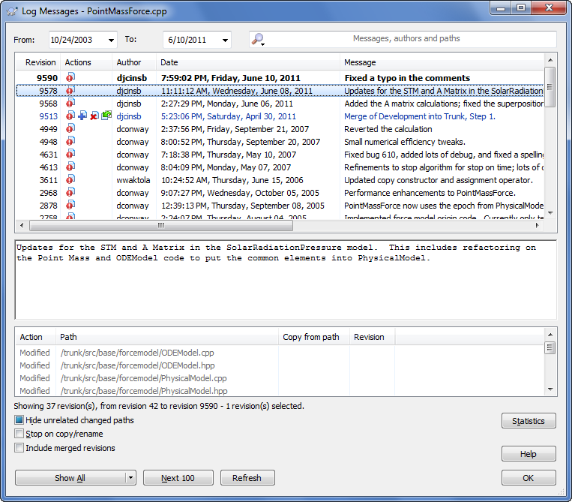

Additional configuration status accounting items are CCB minutes, discussed in the Meeting Minutes section, Configuration Audit reports, discussed in the configuration audits section.

Configuration Audits

Configuration audits are performed to maintain the integrity of the configuration baselines. Specifically, audits ensure that developed and installed products meet their technical requirements, that the products are accurately described in documentation, and that the products do not include any unauthorized changes. The CMO will conduct configuration audits, document and retain the audit results as indicated in the DML, and forward the audit results to the PDL and/or relevant stakeholders. The PDL and members of the PDT will work closely with the CMO to resolve any problems identified in the audit results.
The CMO will conduct the following configuration audits:
- Baseline audit will be conducted for major releases. A Baseline audit verifies that the content and versions of the CIs are consistent with the baseline documentation that defines them (i.e., the Baselines Table). See Planned Baselines for content description.

- Physical Configuration audit (PCA) will be conducted for major releases. The PCA verifies that a CI, as built, conforms to the technical documentation that defines it (i.e., it verifies that all baseline elements of the delivery match the documentation). During this audit, the CMO will analyze the following to assure that the documentation is accurate:
  - Baselines Table
  - DML
  - Version Description Document (VDD)
  - Physical contents of the project’s CM Libraries (where the CIs reside)

- Functional Configuration audit (FCA) will be conducted for major releases. The FCA verifies that the CI has been completed satisfactorily, that the item has achieved the performance and functional characteristics, and that its operational and support documents are complete and satisfactory. During this audit, the CMO will analyze the:
  - Requirements Traceability Matrix
  - Requirements documentation
  - Test reports
  - Change authorizations

Control of Non-conforming Products

Issues related to non-conforming products are managed using the Issues Tool described in the Issues Tracking section. Any member of the PDT may fill out a problem report (i.e., non-conformance) against any system product or tool at any time. Issues are reviewed monthly or at the request of any team member or stakeholder. All non-conformance issues that adversely impacts the cost, schedule, or scope of the effort are reported to stakeholders and customers for approval of the proposed solution.

Control of Customer-Supplied Products
There are currently no customer supplied products.

Quality Assurance

The GMAT Software Assurance Plan (SAP) provides the framework necessary to ensure a consistent approach to software quality assurance throughout the project life cycle. It defines the approach that will be used by the Chief Safety and Mission Assurance Officer (CSO) and Software Assurance Engineers (SAEs) to monitor and assess software development processes and products to provide objective insight into the maturity and quality of the software. The Software Assurance (SA) support will be provided by Code 320 and paid for by the GMAT Project. The PDT will work closely with the Code 320 SAE during SA activities.

Software Assurance Process
The SAE will comply with the Software Assessment Process and use the software quality checklists and forms available on the GSFC Software Assurance web site to conduct product and process assessments.

The SAE will identify and document non-compliances, observations, and risks from all assessments and report these results to the PDL. The PDL will review assessment results, retain assessment results as indicated in the WBS/DML, and work with the SAE and members of the PDT to develop a corrective action plan to resolve identified problems. The PDL will document the audit, its findings, and, as appropriate, the corrective action plan in the Audit Findings and Corrective Action Tool. The PDL will use this tool to track all corrective actions to closure. The SAE will monitor the status of non-compliances to ensure they are resolved and will escalate any non-compliances that cannot be resolved within the PDT to ?????.

Peer Reviews / Inspections
The peer review / inspections process enables rigorous and formal review of work products to certify quality and conformance to standards. The PDT will use the checklists provided in the Product Development area of the GSFC PAL for the various types of peer reviews / inspections.

The PDT will use the peer review / inspections process to prepare for and conduct peer reviews / inspections, to document results, and to certify completion for the following work products:
- Requirements
- Implementation (i.e., design and code work products that ?????)
- Test Plan
- Product Plan

The PDT will use the Inspection Moderator Tool to support this process. The PDT will retain the review and certification records and measures produced by this tool as described in the DML.

Code 320 QA Support

This section summarizes the tasks to be performed during the new software development, operations support activities, and sustaining engineering of the software commensurate with the software classification. These tasks are selected based on the project schedule, Software Management Plan (SMP), planned deliverables, contractual deliverables, and identified reviews.

NOTE: Given the maturity of the GMAT product, the level of software assurance has been reduced. Process assessments are conducted annually, while sample products are randomly evaluated.

Product Assessments
Products planned for assessment by the SAE are:
- Product Plan (Includes the Configuration, Requirements, and Risk Management Plans)
- GMAT User’s guide (w/ Version Description Documents)
- Risk Management Tool
- Software Metrics
- Branch Status Review Package
- Project Schedule
- Requirements Traceability Matrix (bi-directional between requirements and tests)

Process Assessments
Processes planned for assessment by the SAE are:
- Project Planning
- Project Monitoring and Control
- Measurement and Analysis
- Risk Management
- Configuration Management
- Requirements Management

Additional Activities
- Attends Branch Status Reviews (BSRs).
- Attends Major Mission Milestone Reviews
- Attends Developer Status Meetings, as time permits.
- Attends Configuration Control Board (CCB) meetings and reviews Problem Reports
- Attends PDL Tag-ups for Project Status.
- Maintains GMAT SA Action Item Log.

