STK Truth Data for GroundTrack_Earth_LEO_Prograde.script

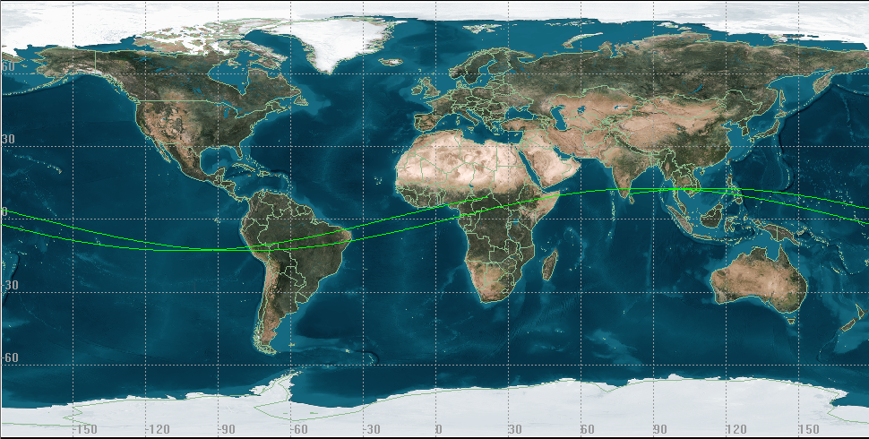

STK Truth Data for GroundTrack_Earth_LEO_Retrograde.script

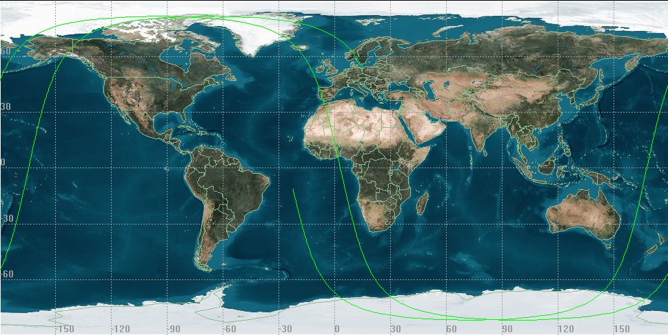
STK Truth Data for GroundTrack_Earth_GEO.script

