STK Truth Data for GroundTrack_Earth_LEO_Prograde.script

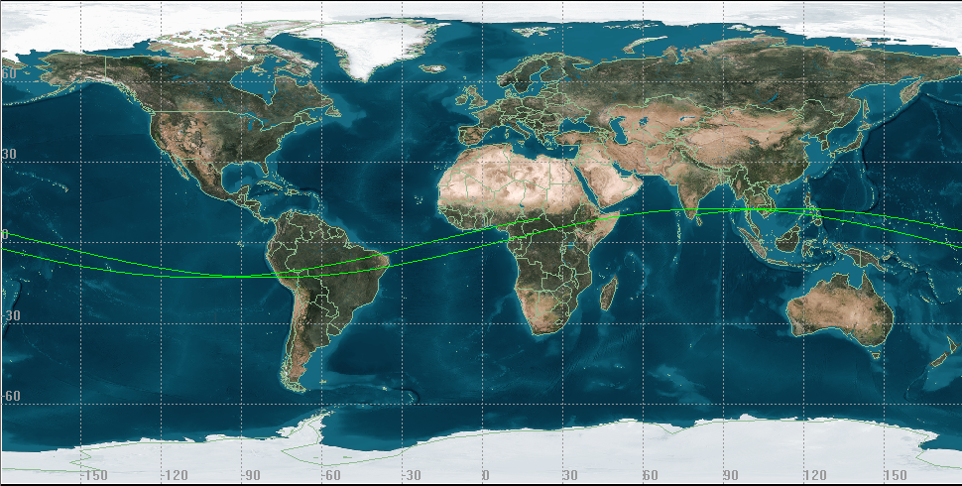

STK Truth Data for GroundTrack_Earth_LEO_Retrograde.script

