OD Prototyping in the General Mission Analysis Tool

D. Conway
S. Hughes
M. Wilkins

November 24, 2008

Table of Contents
1 Introduction 1
2 Design Requirements 2
3 System Components and Interactions 2
3.1 User Perspective 2
3.2 Architecture Perspective 4
4 Object Initialization 6
4.1 Overview of the GMAT Initialization Process 6
4.2 Spacecraft 6
4.3 Ground Stations 7
4.4 Measurement 7
4.5 Estimator 7
4.6 Propagator 7
5 Command Pre-Run Initialization 7
5.1 RunEstimator 7
5.2 EstimationStateManager 8
6 Command Run-Time Initialization 8
7 Command Execution 9
8 Command Finalization 9
9 Appendix 1: The Sample Script 9

Introduction

Implementing orbit determination features in GMAT requires that new objects and commands be implemented and that modifications are made to some existing objects and commands. Additionally, several new system components must be developed to act as mediators between OD components and other components such as propagators. This document describes all components necessary to solve a basic OD problem in GMAT and contains a preliminary design that describes how GMAT solves a simple OD problem.
The design presented in this document shows how GMAT solves a simple OD problem using batch least squares to process range and angles data for one ground station and spacecraft. We begin with an overview of the components required to perform OD from a user and system perspective and describe the activities and interactions at a high level. Next, we step through the execution of the OD test script and explain what GMAT does at each step in during the execution of the script. We keep in mind throughout the design process that the design must be extensible to more complex problems as described in the high level design requirements below.

Design Requirements

- The system shall solve the OD test problem defined in Appendix I
- The system shall be extendable to handle new measurement models or measurement corrections.
- The system shall be extendable to handle new dynamics models
- The system shall be extendable to handle new solve for and consider parameters
- The system shall be extendable to handle new estimators
- The system shall be extendable to handle new quantities that require numerical or analytic integration.

System Components and Interactions

User Perspective

To uniquely define an orbit determination problem, a user must often provide hundreds of pieces of information ranging from clock drift parameters, process noise characteristics, spacecraft physical properties, ground station properties, and atmospheric modelling parameters to name just a few. The objects and supporting data for OD in GMAT are summarized in Fig. 1. The logical organization establishes key physical and computational elements into one of five categories: (1) Measurement Participants, (2) Sensors, (3) Estimators, (4) Measurements and (5) Dynamics. In GMAT, the user has access to the objects shown in Fig. 1, and can configure the data identified on each object in the gray bubble. A yellow bubble indicates that the user can attach a previously created and configured object of the identified type. Below we briefly discuss each logical category of object from a user perspective starting with measurement participants.

Measurement participants are models of physical objects that “participate” in the process of creating a measured quantity that is related to the spacecraft state. Examples of measurement participants include spacecraft, ground stations, and celestial objects. In GMAT, measurement participants are created and configured separately from measurement objects (which are discussed below). For example, if a user requires a Doppler measurement between, say, Hubble and Canberra, they first configure a spacecraft to model Hubble, and then they configure a ground station to model Canberra.

The sensor models contained in GMAT include but are not limited to clocks, receivers, transmitters, transponders and lasers. The user can create and configure sensors for their application and attach the sensor to the appropriate parent object such as a spacecraft or ground station.

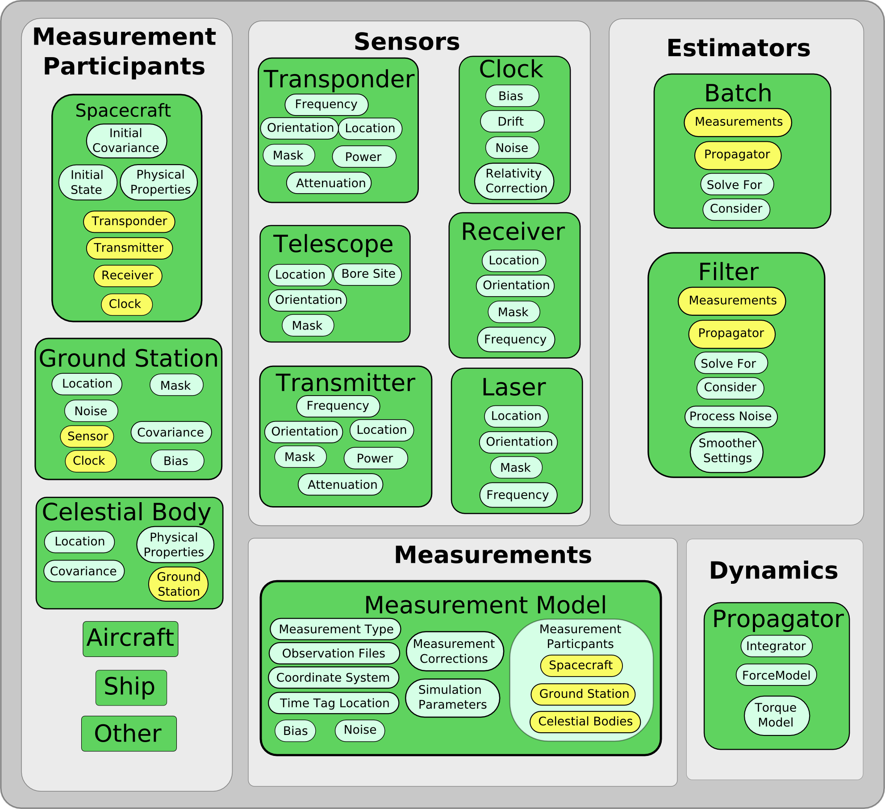

Measurement objects are complex and a large amount of user-provided data is required to perform the functions described above. In GMAT, a measurement provides the following data: (1) observed measurement values which are read from a file, (2) computed (or expected) values of measurements, (3) simulated measurement values if requested, and (4) internal to GMAT, the measurement partial derivatives.

GMAT contains several estimators including batch, sequential, and initial orbit determination solvers. These algorithms solve for a state estimate by processing measurements generated by measurement objects configured by the user. Hence, the user provide a list of all measurements to include in a particular estimation run. In addition, the solver object is where the user specifies which parameters are to be treated as solve-for and consider quantities.

Propagators are used in two areas for estimation problems. Propagators are attached to an estimator to propagate all objects associated with the solve-for and consider parameters and expected values of the measurements. For these cases, a user creates and configures a propagator just like in a mission analysis problem: A separate propagator can be provided so that simulated observations use different dynamics than those used for the computation of expected values.

Architecture Perspective

A figure showing the principal architectural components used by GMAT for orbit determination are shown in Fig 2. There is a one to one mapping between several architectural components and the components available to the user: measurement participants, measurements, an estimator, and the RunEstimator command.

There are additional components from an architectural perspective called the Estimation State Manager (ESM) and the Propagation Manager (PSM). The ESM and PSM are derived from a new class called State Manager that is a helper class that manages state information for estimation and propagation. These classes manage the complex process of bookkeeping and interactions among system components required for propagation and estimation. The propagator and estimator only know vectors of numbers. The State Managers map those numbers to the objects that they relate to and vice versa.

The design of the State Manager class is based on the Mediator design pattern of Gamma et.al. and promotes loose coupling among system components by using a many to one relationship instead of a many to many relationship. Using the mediator pattern for the State Managers, an Estimator does not have to communicate directly with all of the objects involved in an estimation problem, the estimator simply communicates with the ESM. The same can be said of the propagators and the propagation state manager. The ESM and PSM coordinate state data management between the estimators and propagators. The advantage is that estimators and propagators can remain streamlined and efficient and that new state types can be easily incorporated at a later time without changes to the estimators and propagators. The trade off is that the state manager centralizes complexity and must be carefully designed for ease of maintenance. However, if designed well, the State Manager will make incorporating new objects easier.

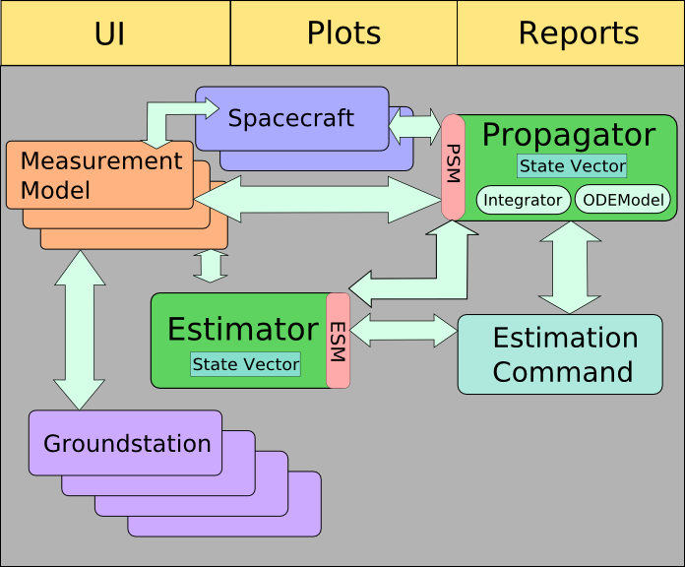

The main steps in performing orbit determination in GMAT are:

  - Object initialization
    - Initialize coordinate systems
    - Initialize spacecraft
    - Initialize all other resources except subscribers
    - Initialize parameters
    - Initialize subscribers
  - RunEstimate PreRun-Initialization: Performs up front initialization that can be done prior to running the mission control sequence.
    - Pointer-initialization
    - Object Validation
    - Configure propagation state manager
    - Configure estimation state manager
  - RunEstimate Run-Time Initialization: Performs the remaining initialization of the command that cannot be performed until we have reached the command while running through the mission sequence.
    - Initialize the ESV, ODE map, and analytic map
    - Initialize the PSV, ODE map, and analytic map
    - Set the ESV
    - Set the PSV,
    - Initialize the measurements
  - Execute the RunEstimate Command
  - Finalize the run estimate command

Object Initialization
This section describes how objects are initialized for the toy problem. This includes changes to initialization of objects such as spacecraft, and initialization of new objects for OD.

Overview of the GMAT Initialization Process

- Clone objects into Sandbox.
- Moderator::InitializeSandbox. Initializes all objects and sets up the connections between them.
- Moderator::ExecuteSandbox. This runs the mission control sequence.

What happens during Sandbox Initialization. Initialize objects starts with resources and initializes them in a specific order. It initializes coordinate systems and spacecraft before anything else. All of the resource level objects get initialized next, with the exception of subscribers. Next parameters get initialized and then subscribers and then the mission control sequence.

There two pieces that need to be broken out to handle OD. We need to break out the resource level objects and break out mission control sequence piece to handle estimation commands. Let’s start with the resource.

When object gets initialized in the sandbox by the Object Initializer, first the object is found in the local or global object store. Then a call is made to the object to a method called GetRefObjectNameArray. This array is a list of names of other objects that have been created by the user and associated with the current object being initialized. The object initializer steps through the list of Ref Objects by name, finds each reference objects, and passes the pointer for that object into the object being initialized through a call to SetRefObject. When initialization for an object is done, the object has an array of names for attached objects, and pointers to the actual objects.

Spacecraft

Spacecraft we need to initialize to attitude and orbit STM (set to identiy) in Spacecraft::Initialize.

Ground Stations

Calculate body fixed location of the ground station. When we have sensor, we will need to initialize the attached sensors via call GroundStation::GetRefObjectNameArray.

Measurement

Call ObsGenerator::Initialize to initialize the ObsGenerator. If a database connect to database, if a file should we read into memory.

Call MeasurementModel::GetRefObjectNameArray and pass the pointers for all attached objects. This includes participants, in this case Spacecraft and Ground station, and if there is a simulator, the name of the propagator for the simulator.

Estimator

Assemble a list of ReferencedObjects that include all measurements. These are returned when Estimator::GetRefObjectNameArray is called so that pointers to the objects can be passed to the estimator. The propagator is only treated as a name on Estimator and how the propagator is managed is discussed later in the treatment on initializing the RunEstimator command.

For all objects that appear in the Solverfor and Consider lists check that there is at least one measurement that uses this object, which means it appears in the participants list for the measurement. There’s a separate issue of checking that observation files actually contain data for the participants.

Set up the Estimation state vector based on the solve for and consider variables. Here we allocate memory for the state vector, and we define that mapping between components of the state vector and their ode models. When this is done we have the state vector allocated, and ODEmodel that matches the state vector component by component.

Propagator

PropSetup is initialized as it would be for any other mission.

Command Pre-Run Initialization

RunEstimator

RunEstimator::Intialize. Give the RunEstimator command the pointer to the requested solver. Call the Estimator to get the name of the propagator, find that object, and make a local clone. At this point, the Estimation state manager passes the state info to the propagation state manager so the propagator can. First, RunEstimator command calls the propagator and receivers a pointer to the PropagationStateManager, passes that pointer to the estimation state manager and then tells the estimation state manager to initialize the PropagationStateManager. We do this up front

The propagation state manager takes the ode mapping from the estimation state manager and sets up the ODE model so that derivative information is set to go into the correct state components. State managers hold the mapping between objects and the values that integrated. The Propagator and estimator only know vectors of numbers. The State managers map those numbers to the objects that relate to.

EstimationStateManager

State Manager: State managers hold the mapping between objects and the values that integrated. The Propagator and estimator only know vectors of numbers. The State managers map those numbers to the objects that relate to.

Figure () shows how the ESV is constructed by the ESM. The state is built by the ESM when the RunEstimator command calls take action(‘BuildState’) on the Estimator and then Estimator calls ESM::BuildState. During step 4, ESM calls all measurement models and constructs a list of unique participants. 4, 5, and 6 GMAT is collecting data on what needs to be estimated and storing the types so that it can later assemble the state vector during step 7. During step 8, GMAT assembles the propagation state vector for all items that require propagation.

Command Run-Time Initialization
Assume we are at the point where Moderator::ExecuteSandbox has been called and we are stepping through the list of command and we are at the point where SandBox is calling RunEstimator::Execute.

RunEstimator

If the RunEstimator command is not already executing, then call PrepareToPropagate(). The PrepareToPropagate command calls the estimation state manager and tell it to PrepareToPropagate. Then EstimationStateManager calls the propagationStateManager, gives it the actual data (initial conditions) and tells it to prepare to propagate.

Execution: Run the state machine, propagate as needed.

Finalization: Publish final data, and reset flags so that reentrant call will reinitialize everything.

Command Execution

Command Finalization

Unanswered Questions

1) Do we have to initialize spacecraft covariance.

Appendix 1: The Sample Script

Old Notes
List of Diagrams for Propagation:
- Big View : Initialization, Prepare to prop, execute, finalize.
- Initialization for Propagate : This diagram shows a loop over all prop setups in a propagate command.
- Initialize Numeric Propagator : Loop over the objects in numeric prop set up to generate the string arrays of objects that require propagation and keywords for what quantities require propagation.
- Initialize Analytic Propagator: Loop over the objects in analytic prop set up to generate the string arrays of objects that require propagation and keywords for what quantities require propagation. Do we initialize ephem files here or somewhere else??
- Prepare to propagate: Get pointers to data we need that we know will not be changing. Is this where we determine if there are estimation states from estimation state manager and from finite burns, or does that occur at Execuction because we may not know all the data at this point?
- Execute propagation. Performing the propagation. Is this where we show where stopping conditions and event location fits in?
- Finalize propagation. This may be part of execute propagation, not sure.

List of Diagrams for Propagation:
- Estimation state manager. Determine what objects need to be propagated for estimation. This creates a set of string arrays for what objects require propagation and what quantities need to be propagated??
- Run estimator
- Estimator STM manager. This diagram shows how numeric and and analytic portions of the estimation STM are managed and passed to appropriate components to map measurement partials to the estimation anchor time.

Changes to be made in current diagram
Change StateMangager to PropagationStateManager
Change SpaceObject --> propagated object

Details for Initialize Numeric Propagator
propagate object list is populated from two places. The first portion is when the command is parsed from prop setups. For each element in the last of prop setups there are two string arrays. One for the objects for example (Sat1, Sat2,Sat3), and one for the keyword. An example:

Propagate MyProp(Sat1, Sat2, 'STM', Sat3)

Two string arrays

['Sat1';'Sat2';'Sat3'] and ['' , 'STM', ''];

Questions
- What if STM is not requested in propagate command but it is needed by estimator
- How do we handle redundant information like when the estimation state manager says to prop Sat1 STM and the user requested to prop Sat1 STM in the propagate command

Before initialization there are objects in the sandbox and there is a propagator but no mechanism for mapping data between them and the objects that perform the propagation don’t exist yet. After initialization, the prop setups used for propagation have been created and the propagate command has pointers to all of the prop set ups. Each prop setup’s prop state manager has an array of pointers to the STUFF it must propagate. The propagator has pointers to both propsetups and the ode models

When we enter there is a string array of propagators and a string array of stuff and settings for each stuff element. This figure shows how the prop setup, prop state manager, ODE model, and integrator are created. Don’t know how

