Ground Track Plot Design

1. Purpose

The purpose of this document is to describe the design of the ground track plot described in the

GMAT Requirements. The ground track plot displays spherical latitude and longitude over a Poincare projection of a body’s surface geography of the propagated spacecraft. [ref. Requirements]

1. Requirement Traceability

|  |  |  |
| --- | --- | --- |
| Requirement | Description | Design Reference |
| 3.1.1 | Input - Central body | Figure 2 |
| 3.2.1 | Output - Display plot | Figure 6, 7, 8, 9, 10, 11 |
| 3.4 | Output - Display epoch | Figure 6, 7, 8, 9, 10, 11 |
| 3.6.1 | Input - Data collection rate | Figure 2 |
| 3.6.2 | Input - Plot update rate | Figure 2 |
| 3.6.3 | Input - Number of points to redraw | Figure 2 |
| 3.13 | Input - Option to show or now show plot | Figure 2 |

1. Design Approach

The GroundTrackPlot is designed so that it follows the publisher and subscriber scheme of the GMAT system architecture. In other words GroundTrackPlot can be plotted only when there are data published through the Publisher. Usually a Propagate command publishes data for the propagating spacecraft during execution. To perform the task it is divided into three components: base, GUI and interface. The base component is derived from the base Subscriber class. The GUI component is derived from the wxWidgets classes. The PlotInterface component interfaces between the base and GUI components.

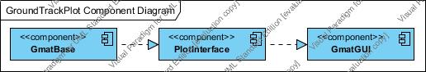

Figure

The detailed class diagram is shown in Figure 2.

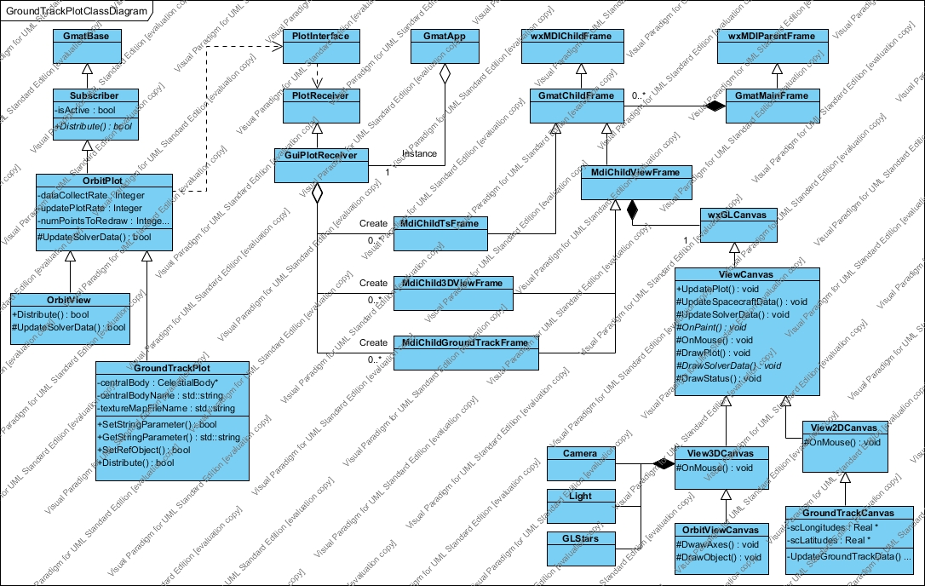

Figure

1. Creation and Setting Properties

The GroundTrackPlot object is created when GMAT parses the script with a “Create GroundTrackPlot” line or when the user adds a new subscriber “GroundTrackPlot” onto the GUI Resource Tree. The create action from the Interpreter is sent to the Moderator and the SubscriberFactory creates a new Subscriber of type GroundTrackPlot and returns its pointer to the Moderator. Then the ConfigManager adds its object pointer to the object store.

When GMAT parses the script with the property setting syntax or when the user is entering values via the GUI, the property values are set through generic Set*Parameter() methods which are inherited from the GmatBase class.

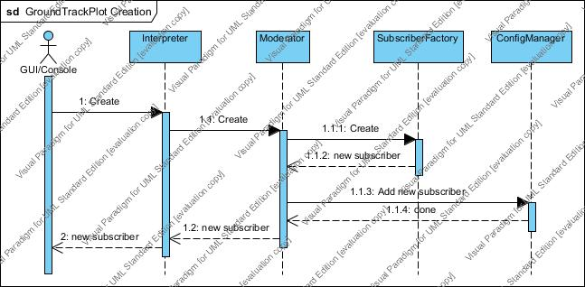

Figure

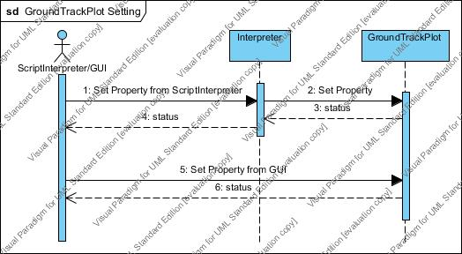

Figure

1. Initialization and Execution

When objects are added to the Sandbox for initialization and execution, pointers to the subscribers - GroundTrackPlots - are added to the Publisher. When a GroundTrackPlot object is initialized it sends an action to PlotInterface to create an instance of MDIChildViewFrame which can be managed by its parent MDI frame - GmatMainFrame. Then the MDIChildViewFrame creates an instance of GroundTrackCanvas where the plot is drawn. Then it sends plotting information such as central body, drawing color, texture map file, etc. to GroundTrackCanvas via PlotInterface.

When the Sandbox executes a Propagate command, it publishes current states of the propagating spacecraft through the Publisher. The Publisher then distributes the data to its known list of subscribers. The GroundTrackPlot receives the data and sends it to the GroundTrackCanvas for drawing.

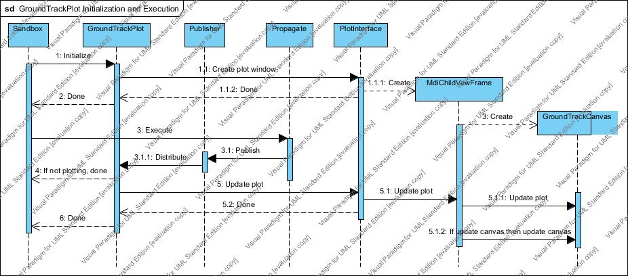

Figure

The figure 6 shows how incoming data to GroundTrackPlot::Distribute() is processed and passed to the drawing canvas through PlotInterface.

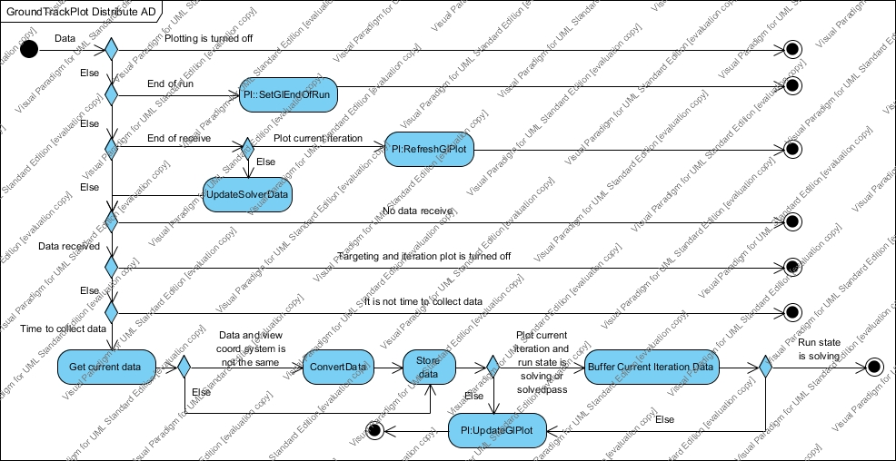

Figure

The figure 7 shows how solver iteration data is processed and passed to drawing canvas through PlotInterface.

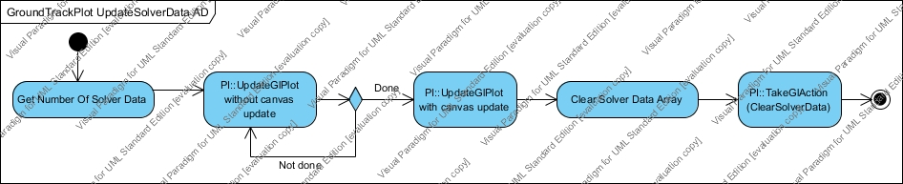

Figure

1. Plotting

When the GroundTrackCanvas EVT_PAINT event is triggered the canvas checks if GL is initialized or not. If not initialized, it calls InitOpenGL() to initialize GL and load textures from texture map file. During the execution of the command sequence, the base subscriber GroundTrackPlot collects data distributed via the Publisher and sends them to the GroundTrackCanvas based on the user specified sampling rate. When it is time to update the plot, based on the user specified update plot rate, it sends a signal to PlotInterface and then to MDIChildGroundTrackFrame to update the canvas. Then the canvas redraws the plot.

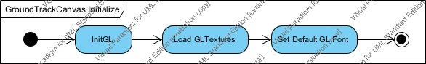

Figure

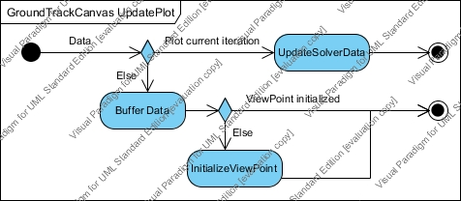

Figure

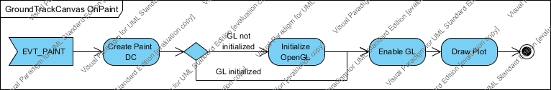

Figure

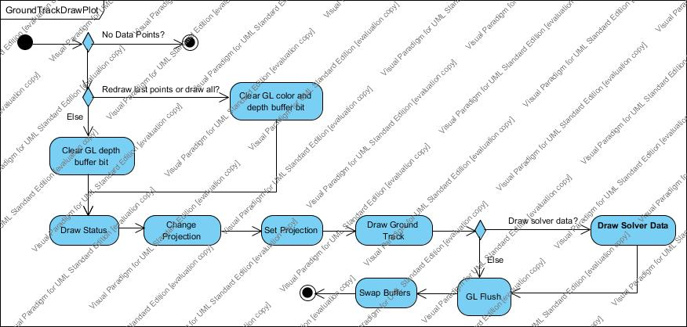

Figure

1. User interaction with the plot

To be designed at the next iteration.