*Java Script - Breakout*

# Introduction

My game “Cosmic Breakout” is based off the Atari consoles breakout. It features a similar layout, with a bat or paddle at the bottom of the screen and rows of coloured bricks at the top. The score, number of lives and current level are along the top of the screen. The paddle can be moved left or right to deflect a ball back towards the bricks and bricks can be destroyed by hitting them with the ball. And the final similarity is that if the ball gets past the players bat and touches the bottom edge of the screen the player will lose lives.

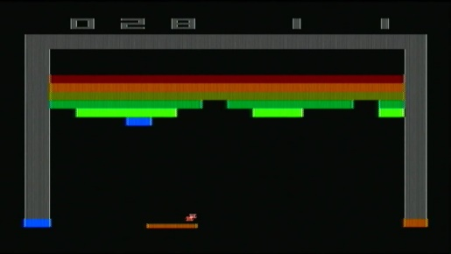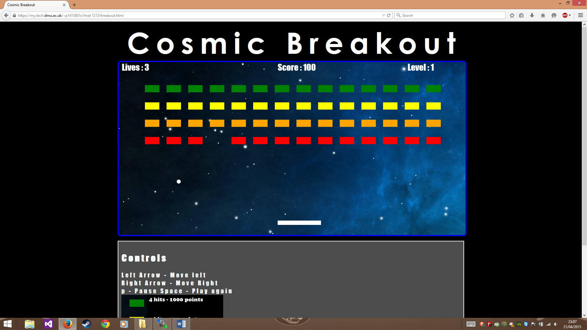

# My game.

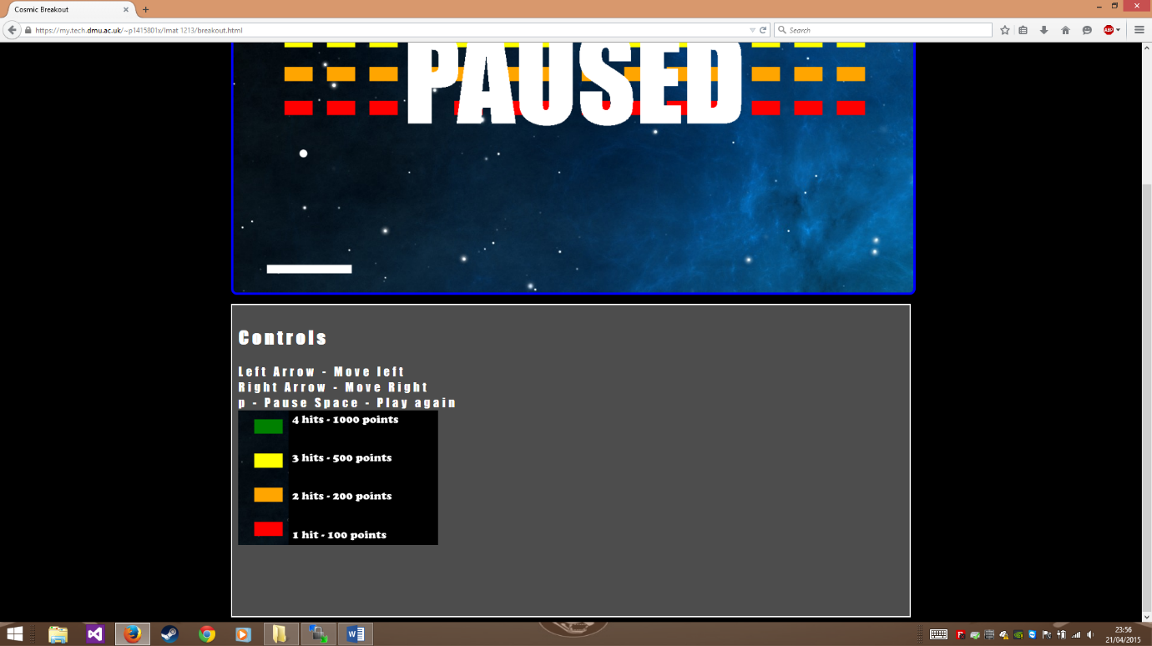When the player opens my game on the web he or she will be placed in level one of cosmic break out. 4 rows of coloured bricks are arranged above the player. The player will start with 3 lives and a score of 0, this is indicated by the HUD. Below the window is a summary of controls and a diagram explaining the properties of the different coloured bricks. Some bricks require more hits to be removed but hold a higher score gain.

The ball will begin motion instantly, in level 1 the ball moves very slowly. This is to ease the transition into the game. Upon completing a level the speed of the ball is increased. This will mean that with each new level the difficulty will be increased making it harder to move the paddle under the ball in time. The balls motion is controlled using a 2d vector, an x and y speed component. The relevant component is reserve when the ball collides with a brick, the bat or the edge of the screen, triggering a sound effect when it does.

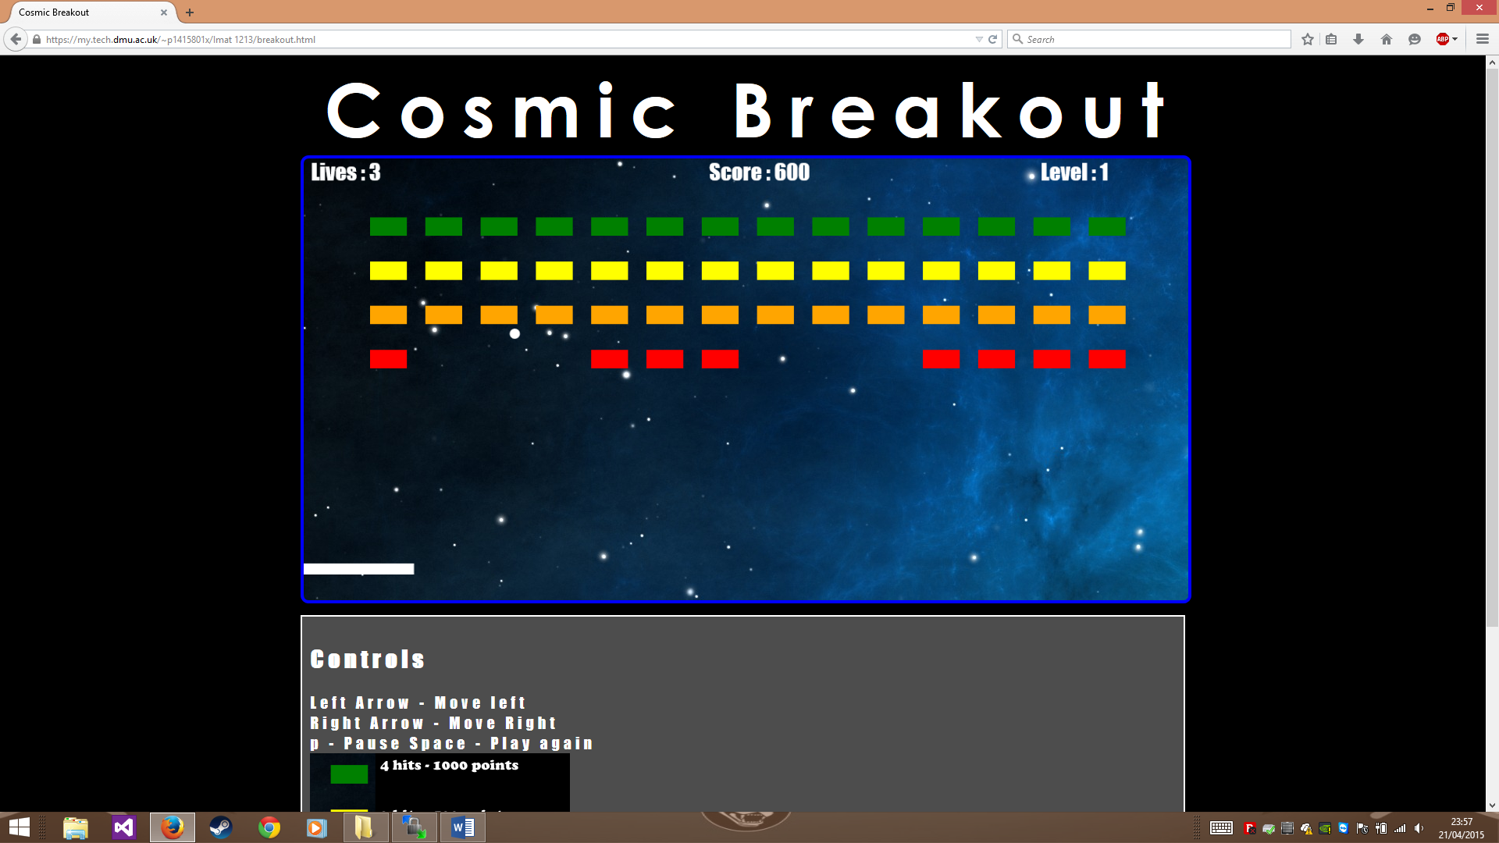

If the player is able to get a score that is divisible by a 1000 a “power up “ is spawned. This falls from the top of the screen and can be caught by the bat. If the player catches the power up a randomly generated effect will benefit the player. Some include bigger bats, more balls and more lives and points. The game can be played infinitely and has no end. So I added a pause feature.

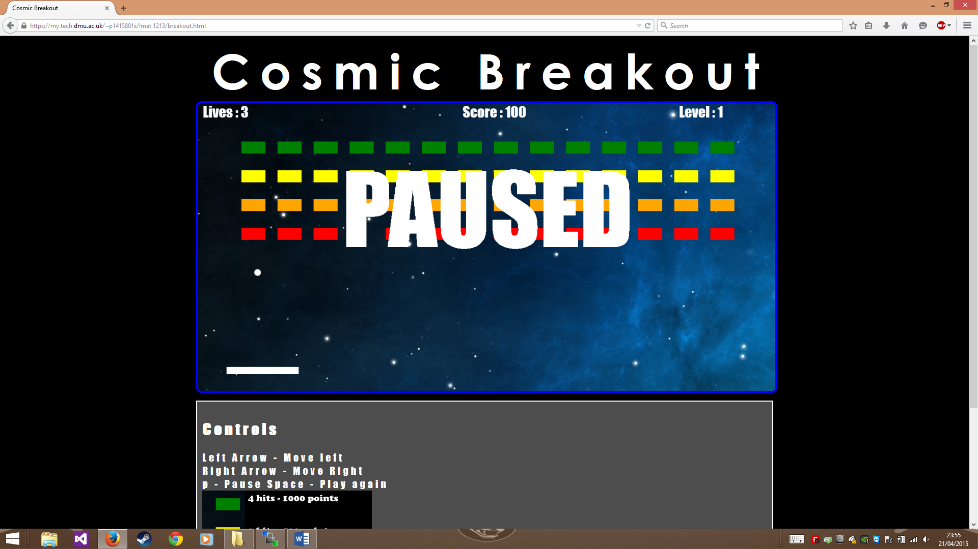

# Conclusion

My game is exceptionally fun to play, due to the power ups. It starts of very slow paced but soon picks up. I have spent a very long time testing it and the game play runs smooth and bug free long into the hard levels. The different toughness of the blocks and the randomness of the power ups offers varied game play with comical sound effects. However my game does not manipulate the direction of the ball very well and can sometimes feel stale in the lower levels. If I had more time to work on this, I would alter the direction of the balls angle depending on the angle it hits a surface.

# References

<http://i.ytimg.com/vi/Up-a5x3coC0/maxresdefault.jpg>

<http://wallzine.com/download/bull-nebula-taurus.jpg>

<https://www.youtube.com/watch?v=cDcG9V-C5i4>

<https://www.youtube.com/watch?v=9ZBV5g1OJdI>

<https://www.youtube.com/watch?v=38iO-uW-nK8>

https://www.youtube.com/watch?v=gLuZpMqOsc0