Seeing with the Brain:
Mapping Current Methods and Interventions in CVI
B258030
Word Count: 6511
Human Cognitive Neuropsychology (MSc)

Abstract
Cerebral visual impairment (CVI) is the leading cause of childhood visual disability in high-income settings, yet research remains heterogeneous in definitions, assessments and outcomes. This dissertation first outlines the historical context for CVI, then presents a quantitative systematic review and complementary evidence map evaluating how CVI is diagnosed and characterised. Database searches identified 528 records; 198 studies met eligibility criteria. Diagnostic studies variably reported accuracy, reliability and validity for clinical tests and functional-vision measures, but non-aligned inclusion criteria, constructs and thresholds limited comparability. Intervention studies spanned habilitation, environmental adaptations, technology-assisted training and clinical treatments, with outcomes reported in diverse, often study-specific metrics. As a result, meta-analysis was feasible only in narrow pockets, and most results required structured descriptive synthesis. The central conclusion is that decision-useful evidence is being produced, but inconsistent constructs and reporting hinder the accumulation of evidence. A practical route forward is to align inclusion criteria to a shared CVI construct, map outcomes to named domains that matter for participation and report a small core of comparable numbers at agreed review points. This would allow estimates to travel across centres and directly inform practice.
Keywords: cerebral visual impairment; paediatric; diagnosis; functional vision; interventions.

Introduction

1. Orientation and purpose
Cerebral visual impairment (CVI), also termed cortical visual impairment, is a diagnostic label used for patterns of visual dysfunction arising from damage to, or atypical development of, the posterior visual pathways and higher visual processing centres. In practice, CVI is characterised by difficulties with visual attention and crowding in complex scenes, reduced motion processing, visual field loss or neglect-like behaviours, problems with face or object recognition, and visuomotor planning challenges that affect everyday activities. Over the past three decades, CVI has been recognised as the leading cause of childhood blindness and low vision in high-income countries (Chang & Merabet, 2024). Extensive registry and population-based studies in Europe and North America corroborate this pattern, identifying CVI as the most prevalent diagnosis among infants and toddlers enrolled in early-intervention or low-vision services (Blind Babies Foundation, 1995; Flanagan et al., 2003; Newcomb, 2010).
Several factors likely contribute to this shift. Improved neonatal and paediatric intensive-care practices have increased survival following hypoxic–ischaemic or other perinatal brain injuries, and advances in treating formerly blinding eye diseases have reduced the relative proportion of ocular causes (Good et al., 1994). Increased clinical recognition and broader use of the CVI label may also contribute to higher reported rates.
This dissertation first traces the evolution of ideas from nineteenth-century descriptions of cortical blindness to contemporary spectrum-based conceptions of CVI, then presents the systematic review. Using pre-specified eligibility criteria, the review addresses two aims: to examine how CVI is diagnosed and characterised, and to evaluate the effectiveness of interventions and supports. The contribution of this work is to link measurement properties of diagnostic tools with functional outcomes and intervention effects across developmental stages, clarifying where current measures map onto everyday visual needs and where evidence gaps remain.

2. Historical evolution of knowledge about brain-based vision loss

2.1 ‘Cortical blindness’ in adults (early 20th century to mid-20th century)
Early 20th-century wartime neurology provided the first systematic evidence that vision could be selectively lost through cerebral, rather than ocular, injury. Tatsuji Inouye related occipital missile wounds to contralateral field defects, establishing a cortical map of vision; George Riddoch described motion-selective residual vision after occipital injury; and Gordon Holmes correlated wound trajectories with scotoma patterns in more than 300 soldiers, refining the calcarine field map (Inouye, 1909; Riddoch, 1917; Holmes, 1918). These adult studies consolidated the entity commonly termed ‘cortical blindness’ and showed that specific cortical loci support discrete visual functions, laying the groundwork for later accounts of childhood CVI.

2.2 From ‘cortical blindness’ to visual impairment in children (1970s–1980s)
For much of the 20th century, paediatric vision loss without a clear ocular cause was grouped under ‘cortical blindness’, implying total and irreversible loss (Hoyt, 2003). This view began to shift in the 1970s as advances in neonatal intensive care increased survival after perinatal brain injury. Clinicians observed infants and young children (typically 0–5 years) with intact eyes and anterior visual pathways (cornea, lens, retina, optic nerve) who nevertheless showed atypical visual behaviour. Reports described inconsistent looking and orienting, a tendency to fixate on lights or high-luminance targets, a preference for saturated colours over low-contrast or cluttered stimuli, and greater responsiveness to moving than static stimuli.
A pivotal case series by Whiting and colleagues introduced the term Permanent Cortical Visual Impairment for this population. Their 1985 report of fifty children detailed recurrent features such as light fixation (sustained looking toward light sources), colour preference (reliable orienting to saturated hues), and fluctuating visual attention (marked variability with fatigue and visual clutter). Many children improved over months to years, challenging the assumption that cerebral vision loss in childhood is fixed (Whiting et al., 1985).
Good, Jan and colleagues (1994) reinforced these observations, linking hypoxic–ischaemic encephalopathy, periventricular leukomalacia, and other early brain injuries to characteristic profiles on imaging and electrophysiology. Unlike typical adult occipital lesions that produce stable field defects, paediatric cases often show mixed, evolving patterns of function reflecting diverse lesion sites and developmental trajectories (Good et al., 1994). Here, ‘developmental’ refers to the course of visual function across maturation after an early brain insult, shaped by experience and learning, rather than implying that the cause itself arises from normal development.

2.3 Broadening to cerebral visual impairment (1990s–2000s)
Magnetic resonance imaging shifted attention from grey-matter necrosis alone to white-matter pathways and extrastriate networks. Injury involving the optic radiations (within the retino-geniculo-striate pathway) and higher associative pathways disrupted visual development even when ocular structures were typical. In very pre-term infants (typically <32 weeks’ gestation), Lanzi et al. (1998) linked periventricular leukomalacia to later visuoperceptual deficits, widening the pathophysiological lens. In parallel, the dorsal “where/how” and ventral “what” stream framework, originating in non-human primate and human work (Ungerleider & Mishkin, 1982; Goodale & Milner, 1991), was applied to paediatric cerebral vision disorders to organise higher-order symptoms such as visuospatial disorientation, optic-ataxia-like reach errors, and prosopagnosia-like face processing difficulties (Dutton, 2003). On this basis, many centres moved from the narrow label ‘cortical’ to the broader ‘cerebral visual impairment’ to acknowledge that multiple cerebral structures, not the cortex alone, underpin childhood visual dysfunction.

2.4 The modern spectrum and service frameworks (2010s–2020s)
Recent accounts describe CVI as a heterogeneous spectrum that encompasses unexplained acuity reduction, dorsal-stream-related visuospatial and motion-processing difficulties, and ventral-stream-related object and face recognition problems. Philip and Dutton (2014) synthesised behavioural, psychophysical, and neuroimaging evidence and advocated structured, multidisciplinary pathways with early environmental adaptations. In the UK, a consensus guide set out step-wise clinical investigations and promoted consistent terminology across eye care, education, and rehabilitation (Pilling et al., 2022). The Royal College of Ophthalmologists issued practice points in 2023 detailing core diagnostic elements, risk factors, observed behaviours, and examination findings, and recommending integrated communication with families and schools (RCOphth, 2023).
Internationally, the NIH CVI Working Group proposed a five-pillar working definition to standardise case ascertainment for research and clinical pathways. The pillars emphasise brain involvement, visual dysfunction disproportionate to ocular findings, measurable deficits, frequent co-occurring neurodevelopmental conditions, and the practical challenge that CVI remains under-recognised in many services; the pillars are intended to harmonise inclusion criteria rather than define pathobiology per se (Chang & Merabet, 2024). Collectively, these developments chart a move from case series and expert reviews to harmonised, mechanism-informed frameworks. They provide the context and rationale for the systematic review presented in this dissertation.

3. Contemporary definitions and nomenclature
The terminology for brain-based visual impairment has evolved with advances in neuroscience and paediatric care. The adult label ‘cortical blindness’, first applied to bilateral occipital injuries (Holmes, 1918), implied absolute and irreversible loss of sight. As clinicians observed preterm and hypoxic infants who showed inconsistent but improvable visual behaviour, Whiting and colleagues introduced ‘cortical visual impairment (CVI)’ to reflect a functional continuum rather than total blindness (Whiting et al., 1985).
Definitions of CVI currently vary. A systematic review of 66 studies identified more than two dozen distinct definitions and concluded that no single, internationally accepted standard exists (Sakki et al., 2018). In parallel, professional bodies in the United Kingdom and the United States have issued practical diagnostic frameworks for consistent case ascertainment in clinics rather than formal, universal definitions:
- United Kingdom: A multidisciplinary consensus guideline for paediatric eye clinics recommends diagnosis based on three converging data sources: (1) known neurological risk factors, (2) caregiver-reported atypical visual behaviours, and (3) clinical evidence of brain-based visual dysfunction (Pilling et al., 2022). Examples include prematurity or hypoxic–ischaemic injury; behaviours such as crowding sensitivity, visual inattention in clutter, peripheral viewing, or a preference for motion or saturated colour; and clinical findings from acuity, contrast, crowding, visual fields, ocular motility, and developmental assessment, with neuroimaging where indicated. The Royal College of Ophthalmologists has since condensed these elements into concise guidance for routine eye-clinic use (Royal College of Ophthalmologists, 2023).
- United States: The National Institutes of Health CVI Working Group proposes five diagnostic pillars to harmonise inclusion criteria across services and studies: demonstrable brain involvement; ocular findings insufficient to explain the impairment; measurable visual deficits; frequent co-occurring neurodevelopmental conditions; and the practical reality that CVI remains under-recognised in many clinical contexts (Chang & Merabet, 2024).
Despite differences in format, both frameworks converge on two points. First, ocular pathology alone does not account for the visual dysfunction, so thorough anterior segment and retinal examinations remain essential. Second, and by contrast with adult ‘cortical blindness’, children with CVI typically retain some visual function and may improve over time with appropriate support (Whiting et al., 1985; Good et al., 1994).
Persistent heterogeneity in research definitions nonetheless complicates comparison across studies. This dissertation addresses that gap by mapping how diagnostic criteria and outcome measures are defined and applied, evaluating the accuracy, reliability, and validity of commonly used tools, and linking those measures to functional outcomes and intervention effects. In doing so, it updates and extends findings beyond Sakki et al. (2018) by focusing on measurement properties and practice-relevant endpoints.

4. Aetiology, comorbidities, and prognosis
CVI arises from neurological events that disrupt the development or function of the post-chiasmal visual pathways (posterior to the optic chiasm, including optic tracts, lateral geniculate nuclei, optic radiations, and occipital and associative cortices). It is not a single disease entity but a spectrum of injuries and developmental abnormalities that often intersect with other neurodevelopmental conditions. The main aetiological groups include:
- Prematurity and periventricular leukomalacia (PVL): periventricular white-matter injury, particularly in infants born before 32 weeks’ gestation.
- Hypoxic–ischaemic encephalopathy (HIE): for example, perinatal asphyxia in term births.
- Genetic and metabolic conditions: for example, chromosomal or monogenic disorders, including Down syndrome.
- Infectious, traumatic, and teratogenic causes: for example, neonatal meningitis, traumatic brain injury, and fetal alcohol spectrum disorder. These causes are relatively less common in high-income countries (Good et al., 1994).
4.1 Comorbidities and diagnostic complexity
Comorbidity is common and can obscure the visual contribution to functional difficulties. Approximately half of affected children have epilepsy, which is associated with poorer visual outcomes (Huo et al., 1999). Cerebral palsy, particularly spastic diplegia, frequently co-occurs due to shared vulnerability of periventricular regions (Dutton, 2013). Behaviours such as reduced eye contact, visual avoidance in cluttered scenes, and persistent peripheral viewing can resemble features seen in autism. They may lead to misattribution if visual factors are not considered (Molinaro et al., 2020). A multidisciplinary approach is therefore required: paediatric ophthalmology and orthoptics for ocular and oculomotor assessment; neurology for seizure and lesion characterisation; neuropsychology for functional vision and higher-order perceptual testing; allied health and education professionals for real-world assessment and support planning; and neuroimaging when clinically indicated.
4.2 Prognosis and capacity for change over time
Outcomes are heterogeneous. Across three longitudinal studies, roughly 40–50% of children showed improvement over time, while 9–14% experienced regression, often in association with epilepsy. Complete recovery is rarely reported and appears uncommon; most children who improve continue to show residual difficulties. Early visual acuity tends to predict later outcomes, and case series report changes consistent with improving function, including white-matter integrity in the optic radiations and increased occipito-parietal activity following targeted intervention (Dutton, 2013). Favourable indicators include more focal injury, absence of seizures, and access to enriched environments and habilitation; widespread injury and uncontrolled epilepsy are associated with limited recovery.

5. Neuroscientific foundations

5.1 Dual-stream model
Ungerleider and Mishkin’s dorsal and ventral framework, refined by Goodale and Milner, differentiates a parieto-occipital “where/how” stream that supports spatial localisation, motion processing, visuospatial attention and visually guided action, from an occipito-temporal “what” stream that supports object and face recognition (Ungerleider & Mishkin, 1982; Goodale & Milner, 1992). In clinical terms, predominant dorsal-stream dysfunction is associated with navigation difficulties, optic-ataxia-like reach errors, impaired motion and depth judgement, spatial disorientation and marked crowding in visually complex scenes. Predominant ventral-stream dysfunction more often presents as impaired object and face identification, form-constancy problems and difficulty generalising across viewpoints despite relatively preserved acuity (Dutton, 2003).
Preserved reflexive responses to light or looming do not contradict these patterns. Subcortical and brainstem pathways mediate such responses and can remain intact even when cortical processing required for scene interpretation is compromised. The dual-stream framework, therefore, explains higher-order patterns of difficulty, whereas brainstem-mediated reflexes reflect a cortical versus subcortical distinction.

5.2 Contributions of neuroimaging and electrophysiology
Routine paediatric magnetic resonance imaging reveals characteristic lesion patterns that map to later visual profiles. In very preterm infants, periventricular leukomalacia (PVL), ischaemic injury to periventricular white matter, predicts subsequent visuoperceptual and visuomotor difficulties. In term infants, watershed and deep grey-matter injury patterns are typical after hypoxic–ischaemic events. Diffusion tensor imaging, which quantifies white-matter microstructure, typically shows reduced fractional anisotropy in the optic radiations and parietal association tracts, and lower anisotropy correlates with poorer performance on visual perception tasks (Ortibus et al., 2011). Functional MRI demonstrates selective hypoactivation of dorsal or ventral regions that mirrors behavioural profiles (Guzzetta et al., 2010). Visual-evoked potentials (VEPs) remain useful to exclude severe anterior pathway disease; however, normal VEPs can co-exist with higher-order deficits, underscoring the need for assessment beyond acuity and early cortical responses. Together, these modalities situate CVI within developmental systems neuroscience and provide candidate biomarkers for prognosis and research stratification.

6. Evolution of assessment and outcome measurement
Advances in neuroscience have been matched by movement away from generic vision tests toward instruments that capture the functional hallmarks of brain-based visual dysfunction. To keep the structure clear, this section is organised by assessment type.

6.1 Physiological and basic acuity measures
- Visual-evoked potentials (VEPs): VEPs offer an objective index of post-retinal pathway integrity but correlate weakly with everyday visual functioning in CVI.
- Forced-choice preferential looking (FPL): Methods such as Teller Acuity Cards yield behaviourally derived acuity in infants and young children. Birch and Bane (1991) showed that FPL acuity can be recorded in most children with CVI and that early thresholds predict later developmental trajectories. These approaches, however, do not describe how vision is used in real-world contexts.

6.2 Functional-vision instrument: the CVI Range
Roman-Lantzy’s CVI Range scores ten behavioural characteristics across three developmental phases to index functional vision and guide intervention (Roman-Lantzy, 2007). The ten characteristics commonly assessed are: colour preference; need for movement; visual latency; visual-field preferences; difficulty with visual novelty; visual complexity or crowding; light-gazing or non-purposeful gaze; difficulty with distance viewing; atypical visual reflexes; and reduced visually guided reach. Psychometric work by Newcomb (2010) reported excellent internal consistency (α = .96), inter-rater reliability (ICC = .98) and test–retest reliability (ICC = .99) over a short retest interval of weeks. The CVI Range is widely used to track change and to tailor environmental adaptations and teaching targets.

6.3 Multidomain, stream-aligned protocol: the Perkins CVI Protocol
Responding to calls for multidisciplinary, stream-oriented assessment, the Perkins CVI Protocol (2024) integrates a structured caregiver interview, naturalistic observation and direct tasks. Findings are mapped onto dorsal-aligned domains (for example, crowding, motion, visuospatial attention, visually guided action) and ventral-aligned domains (for example, object and face recognition, form constancy, category learning). Report outputs include a profile across domains with linked recommendations. Initial validation reports strong content validity and high inter-rater reliability (ICC = .92) across clinical and educational settings, with an accompanying workbook that provides a ten-step workflow and editable report templates.

6.4 Persistent heterogeneity and consensus priorities
Despite these advances, practice remains uneven internationally. A UK consensus guide highlights variability in diagnostic pathways and training among paediatric ophthalmology services and recommends converging evidence from neurological risk, caregiver-reported behaviours and clinical findings (Pilling et al., 2023). In the United States, the National Institutes of Health CVI Working Group has proposed a five-pillar framework to harmonise terminology and support registry development (Chang & Merabet, 2024). These efforts emphasise the need for core outcome sets and stream-sensitive metrics that link laboratory measures to participation-relevant outcomes, priorities that shape the systematic review that follows.

7. Conclusion and rationale for the systematic review
This introduction has traced the evolution of cerebral visual impairment (CVI) from its early description as ‘cortical blindness’ to its current understanding as a heterogeneous spectrum of brain-based visual disorders. Advances in neuroscience, neuroimaging and paediatrics have supported a shift from case reports to empirically grounded frameworks for diagnosis, assessment and intervention. CVI is now recognised as the leading cause of childhood visual impairment in high-income countries (Chang & Merabet, 2024), yet clinical practice remains fragmented. Diagnostic criteria are applied inconsistently, assessment tools vary in psychometric quality and implementation, and interventions range from informal adaptations to structured programmes, with limited agreement on what works best for whom.
A systematic review is timely for three reasons. First, recent consensus documents in the United Kingdom and the United States (Pilling et al., 2022; Royal College of Ophthalmologists, 2023; Chang & Merabet, 2024) provide explicit criteria against which current research tools can be appraised. Second, CVI-specific assessments such as the CVI Range and the Perkins CVI Protocol, and technology-mediated interventions such as CViConnect, signal an expanding empirical base that requires careful evaluation of validity, reliability and clinical utility. Third, a clear synthesis is needed for early intervention, service planning and training across paediatric clinical, educational and rehabilitation settings.
7.1 Scope and objectives
This review applies the PICO framework to define scope. The population comprises infants, children, and young people with suspected or diagnosed cerebral or cortical visual impairment. The intervention element includes diagnostic criteria, clinical tests, functional-vision measures used to characterise CVI, and interventions intended to improve outcomes. Comparators include alternative diagnostic criteria, standard care, or no intervention, as appropriate to study design. Outcomes of interest are diagnostic accuracy, reliability, validity, visual function, and participation.
The review addresses two primary questions. First, in children and young people with suspected or diagnosed CVI, how do diagnostic criteria, clinical tests, and functional-vision outcome measures compare in terms of accuracy, reliability, and validity for identifying and characterising CVI? Second, in children and young people with CVI, what effects do interventions such as training programmes, environmental adaptations, assistive technologies, pharmacological treatments, or surgical treatments have on visual function and participation across developmental stages, compared with standard care or no intervention? A secondary objective profiles the evidence base by study design, publication trends, and thematic clusters, and identifies research gaps.

7.2 Contribution beyond prior reviews
This review updates the literature beyond Sakki et al. (2018) through August 2025, restricts inclusion to peer-reviewed paediatric studies, excludes review articles, and integrates both measurement and intervention evidence. Tools and outcomes are mapped to contemporary UK and US frameworks, with an emphasis on endpoints that are informative for practice. A detailed account of appraisal, synthesis, and reporting follows in the Methods.

Method

8.1 Review questions
The review addressed two primary questions: (1) In children and young people with suspected or diagnosed CVI, how do various diagnostic criteria, clinical tests, and functional-vision outcome measures compare in terms of accuracy, reliability, and validity for identifying and characterizing CVI? (2) In children and young people with CVI, what effects do different interventions (for example training programmes, environmental adaptations, assistive technologies, pharmacological or surgical treatments) have on visual function and participation across developmental stages, compared to standard care or no intervention? For Question 1, “functional-vision outcome measures” denotes measures used to characterise CVI in the diagnostic context, not only post-intervention endpoints. In both questions the evidence was first catalogued to describe what is currently used, then appraised to evaluate measurement properties for Question 1 and intervention effects for Question 2. A secondary objective profiled study designs, publication trends, and thematic clusters across the CVI literature and identified research gaps.
8.2 Design and reporting
This study was a quantitative systematic review with a complementary evidence map. Reporting followed PRISMA 2020. Database searches were completed before finalising some methodological elements because of dissertation timelines and initial scoping; the protocol specifying eligibility rules, data items, and analysis plans was completed immediately afterward and applied prospectively during screening and extraction.

8.3 Information sources and search strategy
We searched Ovid MEDLINE, Embase, PsycINFO, Emcare, and Global Health from inception to August 2025. A common strategy was used in each database, combining the title and abstract terms “cortical visual impairment” and “cerebral visual impairment,” restricting to journal articles, and excluding non-research publication types. The core Ovid query was:
("cortical visual impairment" OR "cerebral visual impairment").ti,ab.
NOT (review.pt. OR editorial.pt. OR comment.pt. OR letter.pt.)
AND journal article.pt.

8.4 Eligibility criteria
Eligible populations were infants, children, and young people with suspected or diagnosed cerebral or cortical visual impairment. Studies from any country and from clinical, educational, rehabilitation, or research settings were eligible when CVI was explicitly named as cerebral or cortical visual impairment. Studies focused solely on ocular causes were excluded when ocular pathology fully accounted for the deficits and there was no evidence of post-chiasmal involvement, even if CVI terminology was used. For Question 1, eligible designs reported at least one quantitative index of diagnostic performance, reliability, or validity for a CVI-relevant test, criterion, or functional-vision measure. For Question 2, eligible designs evaluated an intervention for CVI with quantitative outcomes for visual function or participation; any comparator was permissible, including within-person pre-to-post designs. Only peer-reviewed journal articles were included. Records tagged as reviews, editorials, comments, or letters were excluded at search. To ensure inclusion of completed publications, records labelled Epub Ahead of Print, In-Process, In-Data-Review, or other non-indexed citations were excluded at full-text if no final issue assignment was available. Conference abstracts, protocols, theses, and book chapters were excluded.

8.5 Study selection
Search results were exported to Covidence, deduplicated automatically, and verified manually. Screening was completed by a single reviewer because of dissertation constraints. To mitigate single-reviewer bias, eligibility criteria were piloted, decision rules were documented in advance, and the academic supervisor was consulted only to resolve specific uncertainties. Titles and abstracts were screened against the criteria, followed by full-text assessment with a recorded exclusion reason for each ineligible article.

8.6 Data extraction
A single reviewer extracted study-level and outcome-level information using piloted forms aligned with the extraction tables. Study-level items covered bibliographic details, funding and conflicts, country and setting, design characteristics, participant description and eligibility, and, where relevant, arm descriptions for interventions. Outcome-level items were organised into four domains: diagnostic performance (index test, reference standard, thresholds, and 2×2 data where available), reliability (estimate type and magnitude with confidence intervals and model specification), validity (effect type and magnitude, comparator, and timing), and intervention outcomes (continuous and dichotomous), with adverse events recorded separately. Multiple reports of the same study were collated. When essential numerical data were missing or unclear, authors were contacted where feasible. The supervisor could adjudicate data issues but did not otherwise participate in extraction.

8.7 Effect measures and data handling
Pre-specified metrics were applied where data permitted, with no imputation beyond what could be derived from reported statistics. For diagnostic accuracy we recorded sensitivity, specificity, likelihood ratios, diagnostic odds ratio, and area under the ROC curve, and calculated confidence intervals from 2×2 counts where available. Reliability estimates were extracted as intraclass correlation coefficients or Cohen’s kappa with standard errors and confidence intervals, annotated by model or variant. Validity evidence included correlations transformed with Fisher z and known-groups differences converted to Hedges g. For intervention studies, continuous outcomes were expressed as Hedges g using change scores or post-test values, preferring adjusted estimates when reported; dichotomous outcomes were expressed as risk ratios with confidence intervals. Where only test statistics were available, standard conversions were applied. When standardisation risked loss of interpretability, results were reported in both standardised units and original scales.

8.8 Synthesis and analysis
Given the diversity of designs and measures, synthesis combined meta-analysis where appropriate with structured quantitative approaches when pooling was not defensible. Meta-analysis was undertaken when at least three sufficiently comparable studies evaluated the same tool or intervention for the same outcome, using random-effects models. Diagnostic accuracy was synthesised with bivariate random-effects or hierarchical summary ROC models when feasible; continuous outcomes were pooled using restricted maximum likelihood. Heterogeneity was quantified with τ² and I². When pooling was unsuitable, directions and magnitudes of effects were summarised within outcome and tool groupings using medians and interquartile ranges and effect-direction or harvest plots, following Synthesis Without Meta-analysis guidance. Where data allowed, heterogeneity was explored through subgroup analyses or meta-regression by age band, aetiology mix, setting, outcome domain, and risk of bias. Potential small-study effects were examined with contour-enhanced funnel plots when at least ten studies contributed to a meta-analysis.

8.9 Evidence-base profiling
To address the secondary objective, we extracted design, year, country, journal, funding, sample size, and method type for all included articles, summarised temporal and geographical patterns, mapped methods to outcomes, and conducted a keyword co-occurrence analysis of titles, abstracts, and author keywords using VOSviewer to identify thematic clusters.

8.10 Data management and software
Screening and extraction were managed in Covidence. Quantitative analyses were conducted in R using metafor and mada, with figures produced in base R and ggplot2. Bibliometric visualisations were generated with VOSviewer.

8.11 Certainty of evidence and sensitivity analyses
For outcomes that were pooled, certainty was assessed using GRADE, considering risk of bias, inconsistency, indirectness, imprecision, and publication bias. Sensitivity analyses excluded studies at high risk of bias and records without final publication status to evaluate robustness.

8.12 Role of the supervisor
The supervisor’s role was limited to resolving specific uncertainties raised by the reviewer and did not extend to screening, extraction, risk of bias assessment, or analysis.

8.13 Reproducibility
Reproducibility is supported by inclusion of the full search string, the database list, explicit eligibility criteria, single-reviewer procedures with predefined escalation to the supervisor, and predefined effect metrics and conversion rules, allowing independent verification while accommodating the heterogeneity of the CVI literature.

Results
9.1 Study selection
Searches identified 528 records; 32 duplicates were removed. After screening 496 titles and abstracts, 205 full texts were assessed. Seven full texts were not retrievable through institutional subscriptions. In total, 198 studies met the eligibility criteria and were included
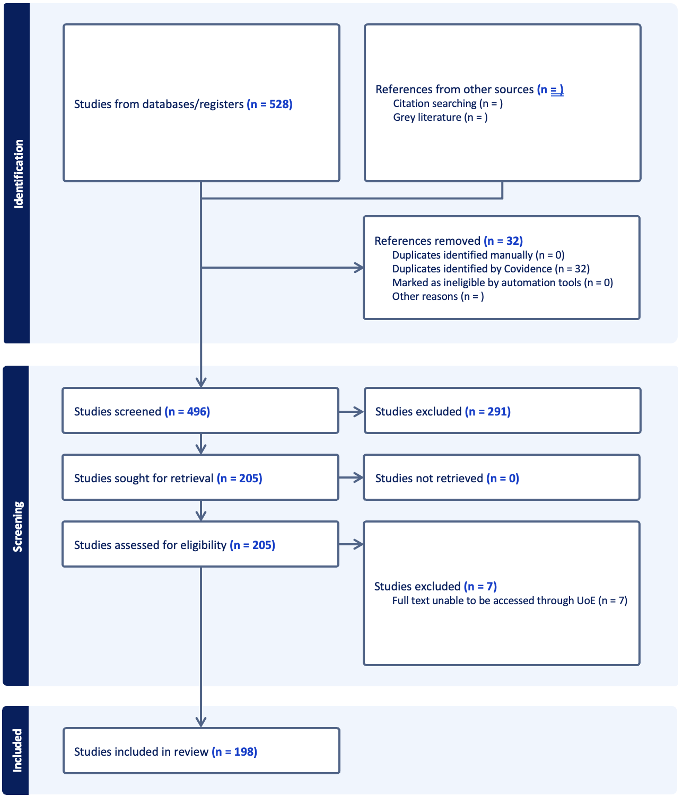
Figure 1 - PRISMA flow diagram. Identification, screening, eligibility assessment, and inclusion for the review

9.2 Evidence-base profile
The included literature spans 1985 to 2025, with increased output after 2018; the median publication year is 2021. Publications are distributed across many journals, with repeated appearances in Developmental Medicine & Child Neurology and Frontiers in Human Neuroscience among others. Studies were conducted internationally, with the largest counts from the United States and the United Kingdom, alongside contributions from the Netherlands, Italy, Belgium, India, Canada, Turkey, Switzerland, and New Zealand. A co-authorship network derived from the included records displays several collaboration clusters rather than a single unified group
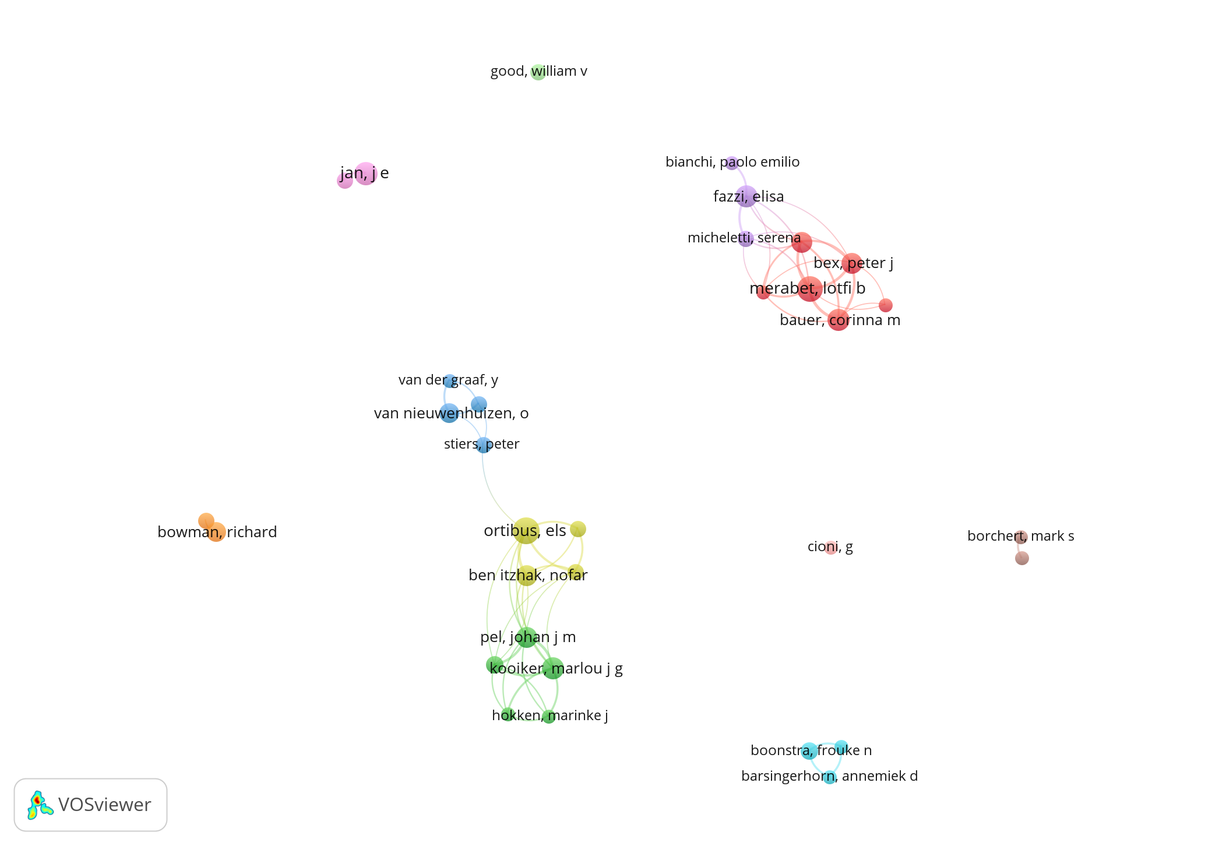
Figure 2 - Co-authorship network (VOSviewer). Collaboration clusters based on co-author links within the included records. Node size reflects document count; edges indicate co-authorship; colours denote clusters.
Designs were mixed. Observational designs were most frequent, followed by cohort or longitudinal work, diagnostic-accuracy and validation studies, and a smaller number of intervention studies, including very few randomised trials. Reported per-arm sample sizes were typically modest where provided. Outcome domains were heterogeneous, and instruments were numerous and often study specific, which limits direct comparability across records.

9.3 Quantitative syntheses

9.3.1 Validity
Six studies reported correlations with sufficient detail for synthesis. Using the random-effects approach specified in the Methods, the pooled correlation was r = 0.86 with a 95% confidence interval of 0.74 to 0.92. Given the small number of coefficients and diversity of instruments, no subgroup analyses were attempted.
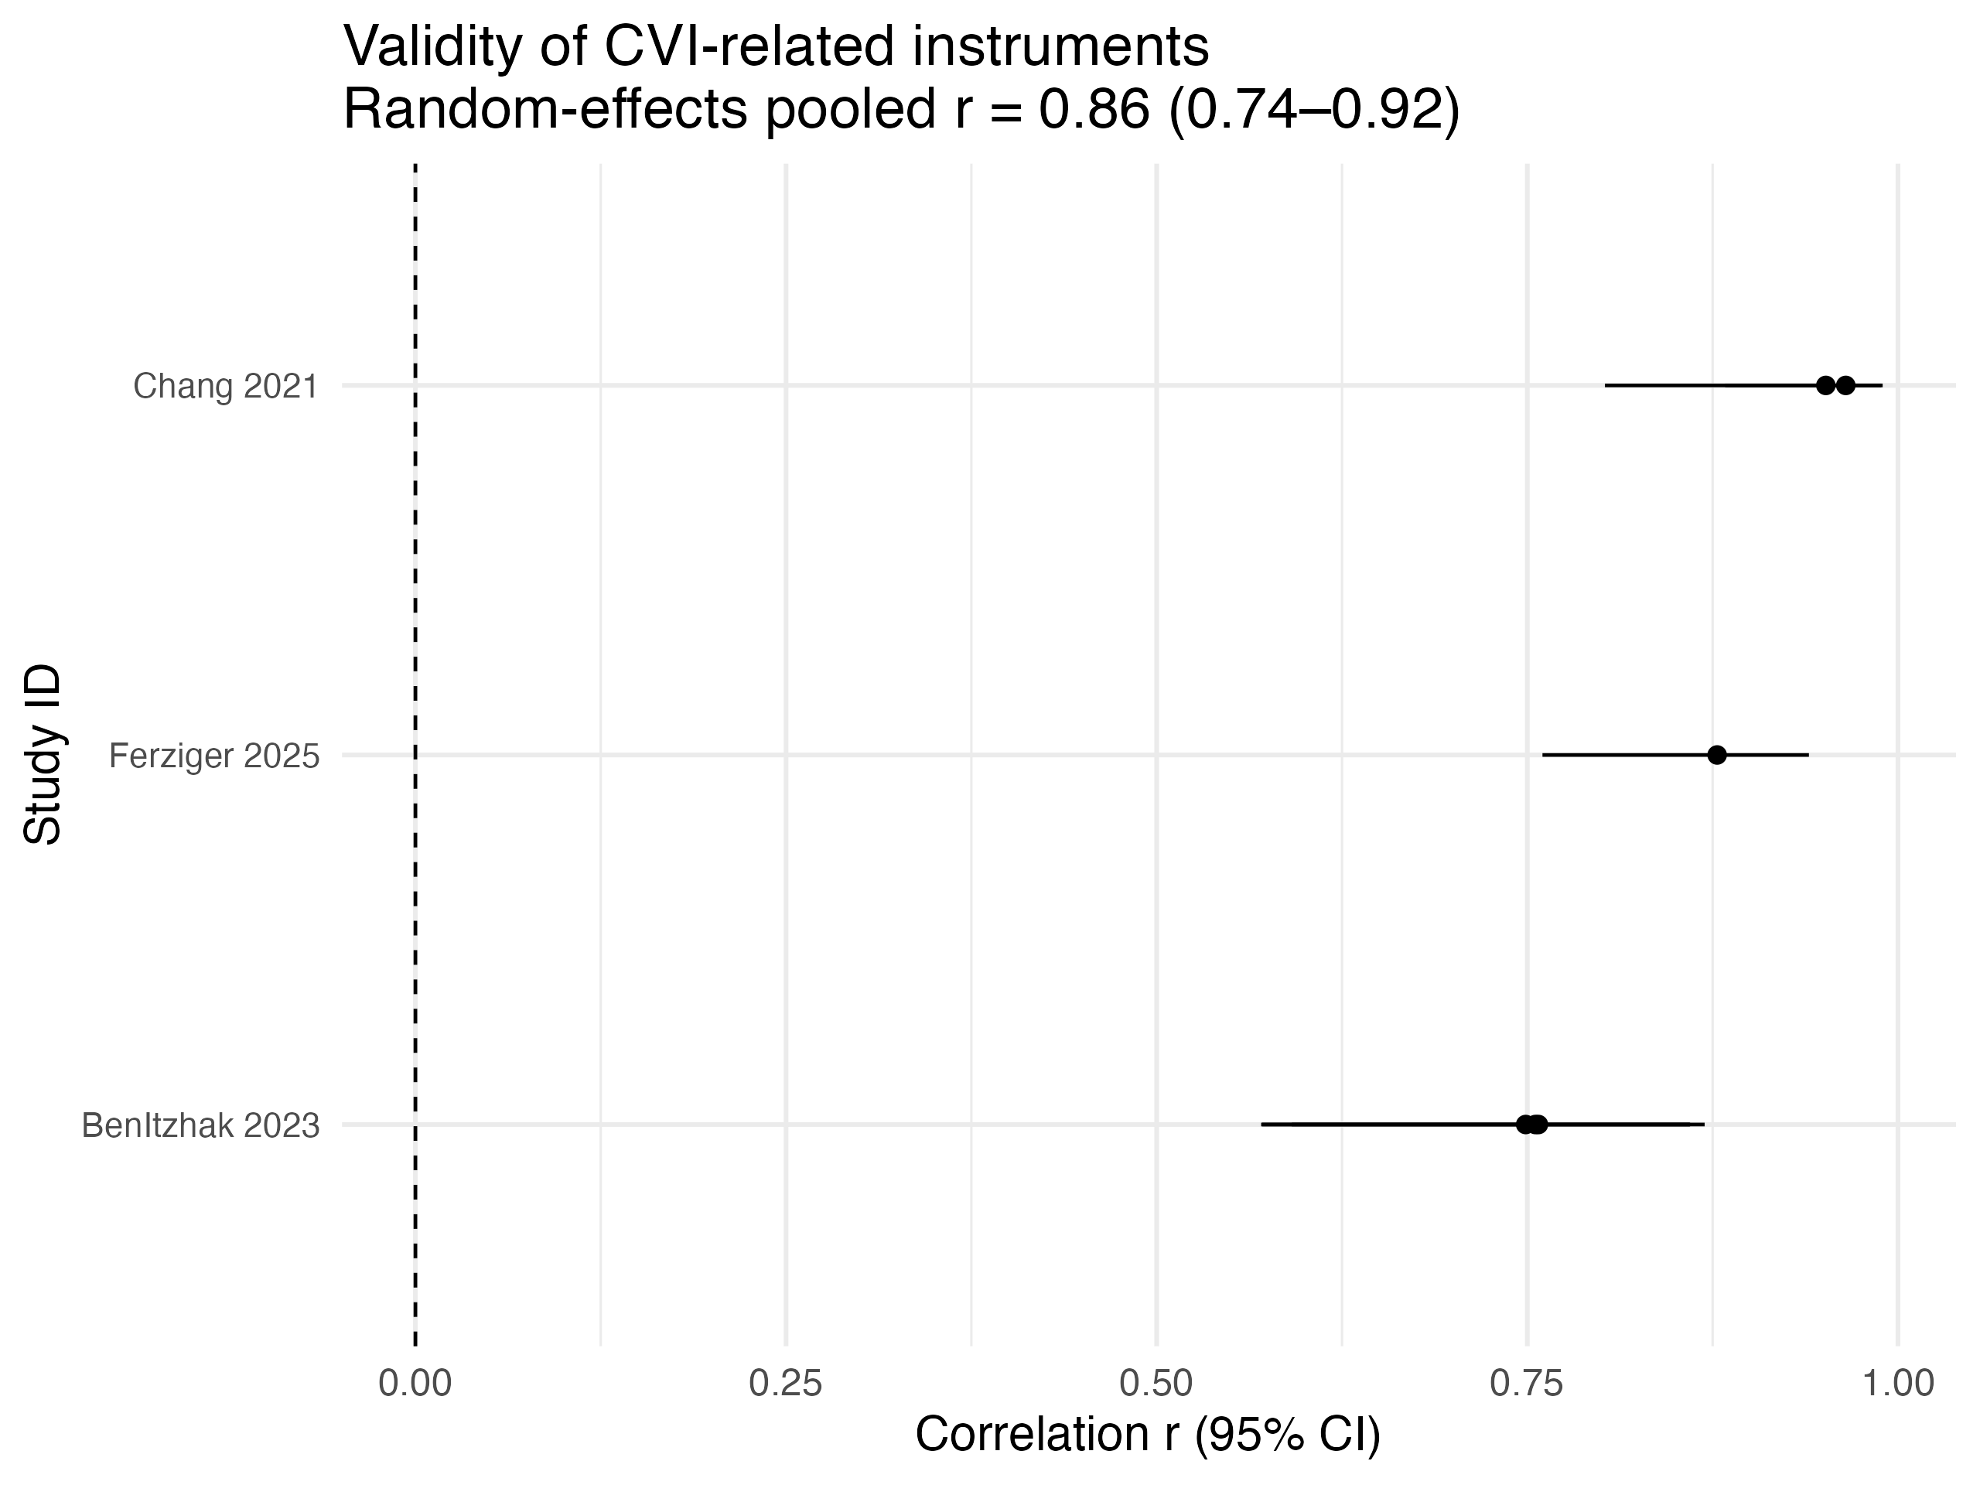
Figure 3 - Validity synthesis. Random-effects pooled correlation for convergent or criterion validity from k = 6 coefficients, back-transformed to r with 95% confidence interval.

9.3.2 Diagnostic accuracy
Four studies provided extractable sensitivity and specificity at defined thresholds. The median sensitivity was 0.85 (IQR (interquartile range) 0.67 to 0.89) and the median specificity was 0.90 (IQR 0.65 to 0.96). Thresholds, reference standards, and index tests were not aligned across studies, so estimates are presented at study level without pooling

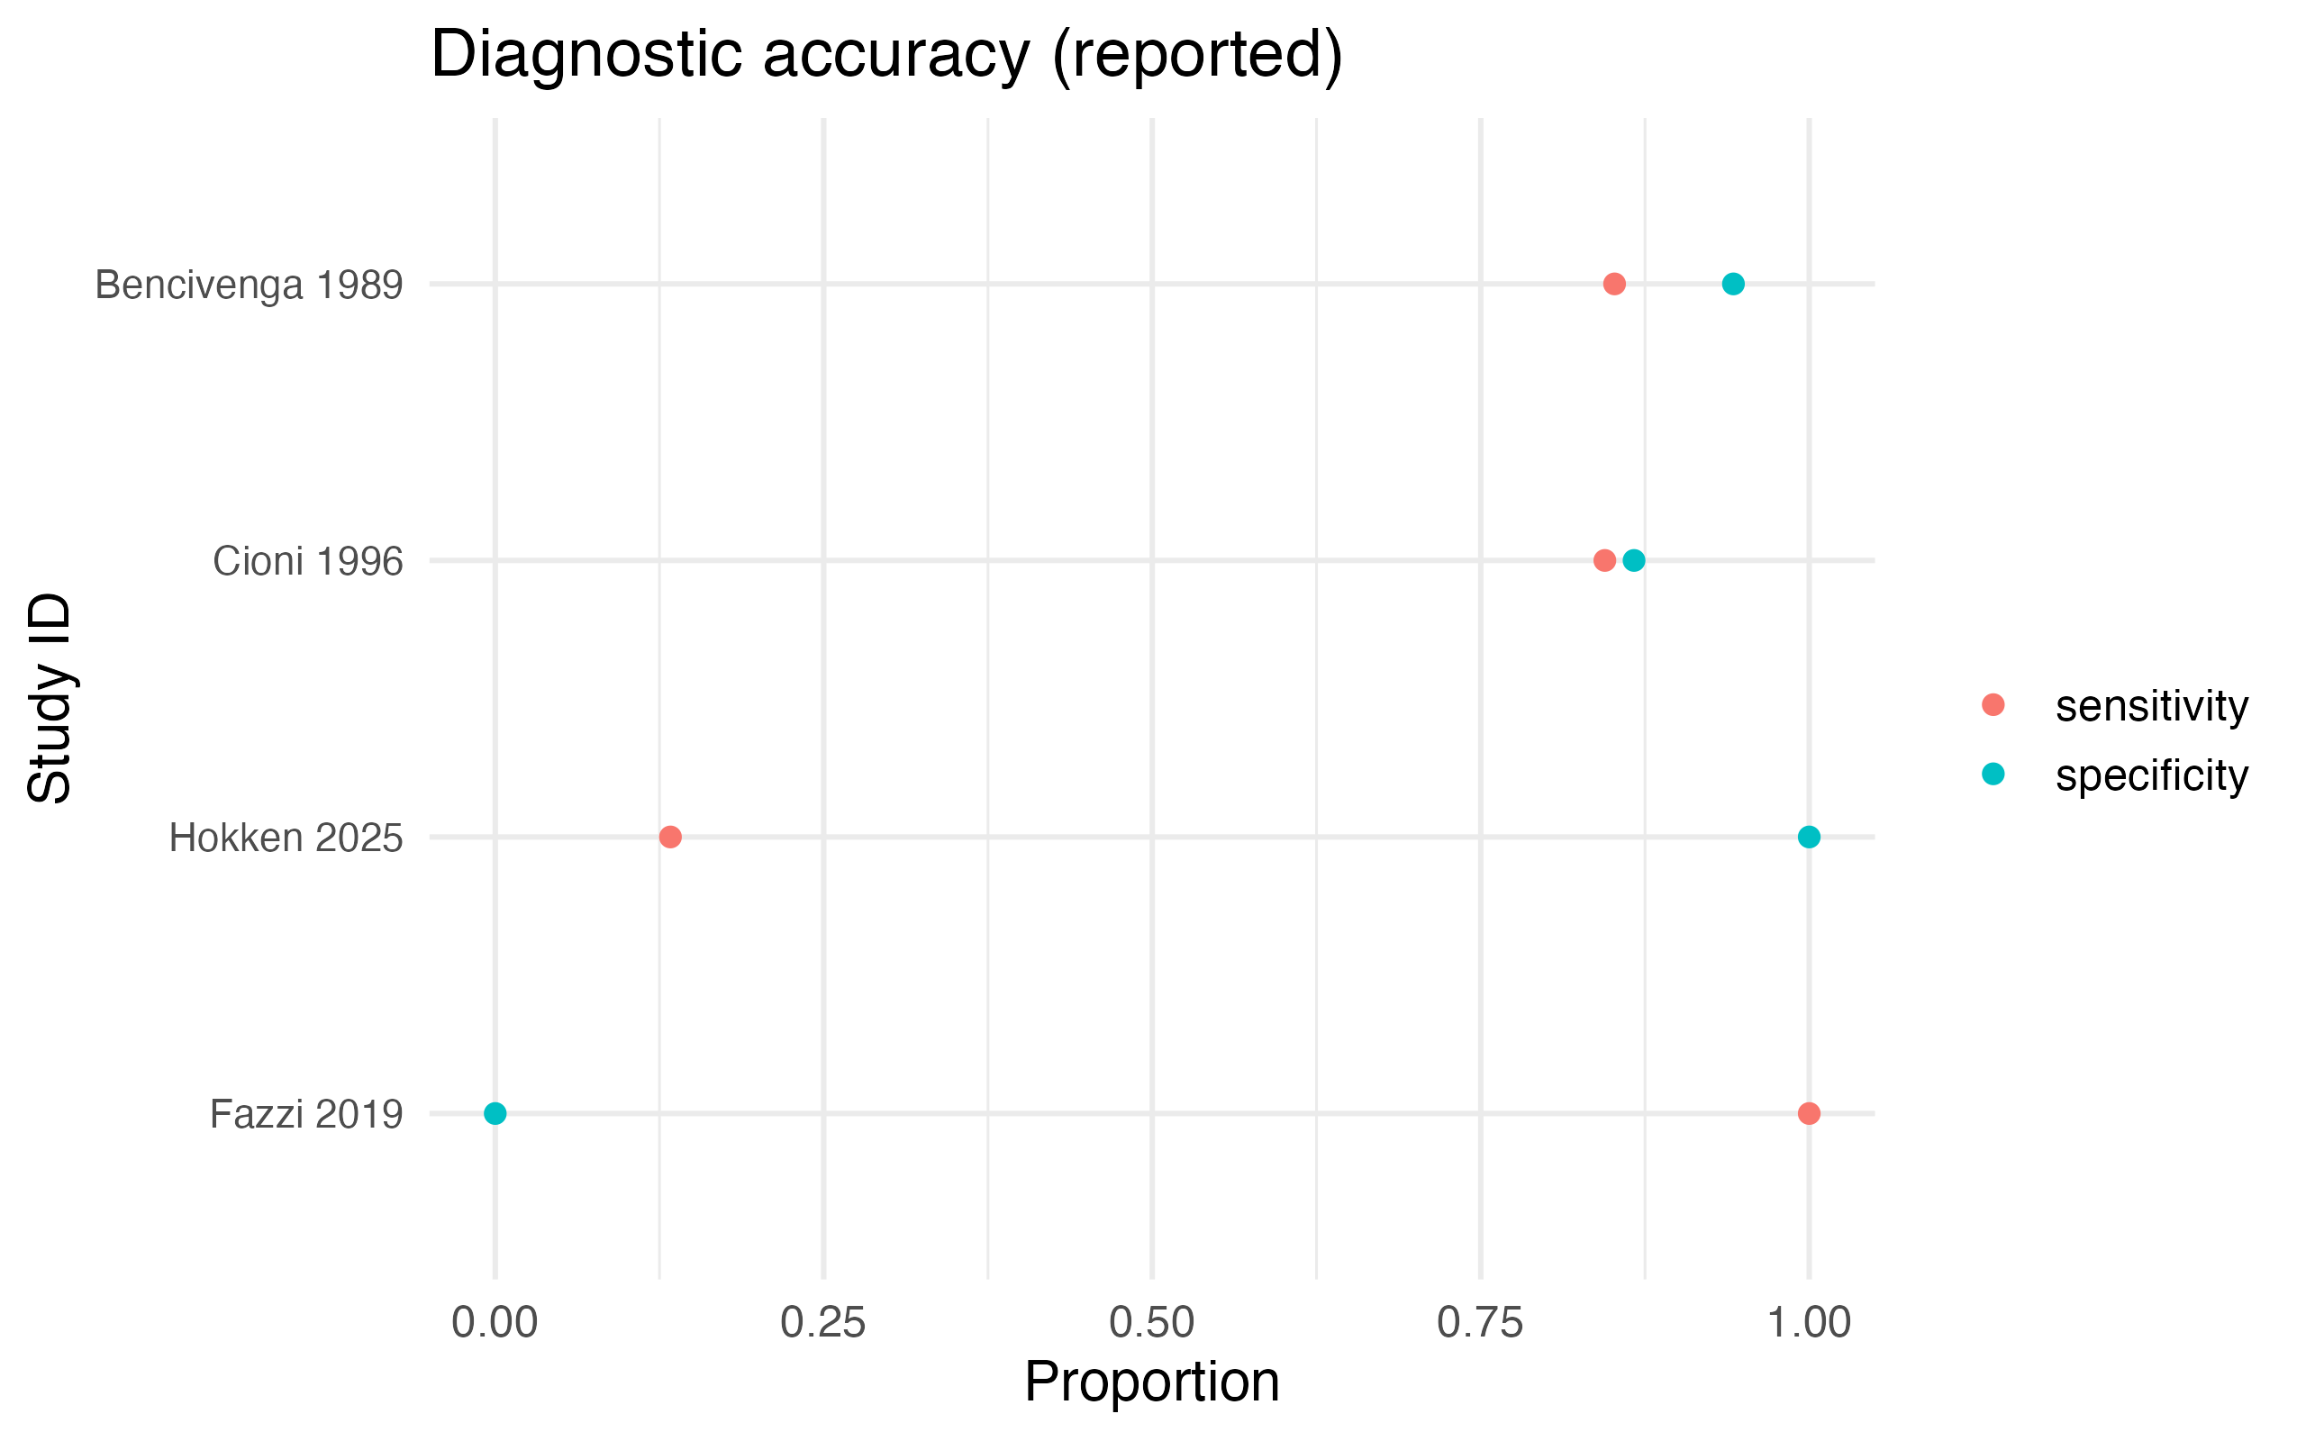
Figure 4 - Diagnostic accuracy indices. Study-level sensitivity and specificity at reported thresholds; presented unpooled due to non-aligned thresholds and reference standards.

9.3.3 Intervention effects
One controlled comparison reported a standardised mean difference of approximately Hedges g ≈ 1.0, but arm-level numerics were insufficient to verify the estimate or derive a confidence interval. Other intervention studies did not report aligned means, standard deviations, and Ns at a common timepoint, which precluded calculation of comparable effects. Results are shown descriptively

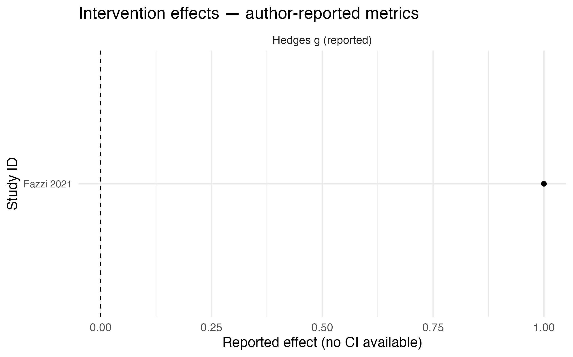
Figure 5 - Intervention effects reported by authors. Standardised mean differences reported in the source papers where arm-level numerics were incomplete for verification or confidence-interval calculation.

9.3.4 Adverse events
One comparison allowed computation of an adverse-event risk ratio. After continuity correction the point estimate was Risk Ratio (RR) ≈ 3.17; the confidence interval was wide and crossed 1, reflecting imprecision from low event counts

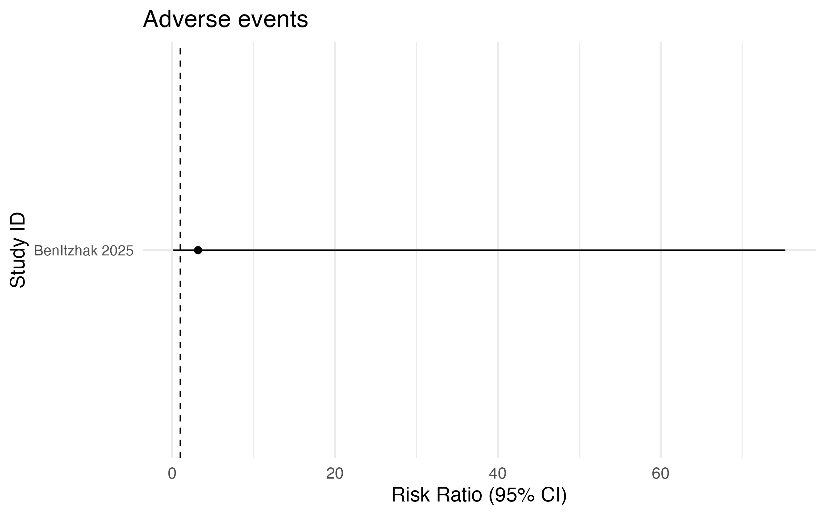
Figure 6 - Adverse events. Risk ratio for the single comparison with extractable x/n data; confidence interval shown to illustrate imprecision.

9.4 Reporting completeness and constraints on synthesis
The principal constraint on aggregation was incomplete numeric reporting at aligned timepoints. For continuous outcomes, no eligible study provided, in extractable fields, mean, standard deviation, and N for both arms at the same analysis timepoint. For dichotomous outcomes, only one comparison reported x/n per arm at a shared timepoint for an adverse event, and none for primary efficacy. For validity and diagnostic performance, many papers described results narratively, but only six and four studies respectively included sufficient numeric detail for synthesis. In line with the Methods, meta-analysis was therefore limited to the validity subset; other results are presented descriptively or at study level. The scarcity of analysable data is itself a key result of this review.

Discussion

10.1 Interpretation of the main results
This review set out to examine how CVI is defined and characterised in research with children and young people, and to evaluate what can be concluded about intervention effects on visual function and participation. The core quantitative picture that emerges is stark. From the 198 included studies, we were able to synthesise a small validity subset, present diagnostic accuracy only at the study level because thresholds and reference standards did not align and describe intervention findings where the arm-level numerics required for effect estimation were missing. In other words, the limiting factor is not a lack of studies but a lack of comparable, analysable data. That absence is itself an important result. It shows that despite output growth, the literature has not converged on the shared definitions, reference points, and minimal reporting needed for cumulative science. The consequence is that robust inferences about the accuracy of particular tools, or the average effect of specific intervention types, remain out of reach. This does not imply that tools lack validity or that interventions are ineffective. It shows that the evidence is not yet structured in a way that allows those questions to be answered with precision.

10.2 Why heterogeneity persists
The reasons for this situation are consistent across study designs and settings, and they begin at the point of case definition. Many papers enrol participants labelled as having CVI without spelling out the inclusion criteria used to make that judgement. Phrases such as “ophthalmologically diagnosed with CVI” appear without a description of decision rules, cut-points, or corroborating evidence. Where definitions are provided, they are assembled from different combinations of neurological risk factors, caregiver-reported behaviours, clinical findings and, occasionally, imaging. Those components are not wrong in themselves, but when they are used inconsistently or without an explicit weighting, the same label refers to meaningfully different populations across studies. Any downstream estimate of test performance or intervention response is then tied to a local construct rather than to CVI as a construct that travels.
Measurement choices amplify this problem. Instruments tapping acuity, crowding, motion processing, visuospatial attention, visually guided action, object and face recognition, and participation are used in idiosyncratic ways. The same tool may serve as an index test in one study and as an outcome measure in another, sometimes with altered scoring or undeclared thresholds. Reference standards are seldom named, and assessment timepoints vary across and within studies. Without precise mapping from instrument to construct, it is challenging to build validity arguments that extend beyond a single sample, and impossible to judge whether two studies are measuring the same thing when they use the same label.
Finally, reporting often stops short of the numerics that make synthesis possible. For continuous outcomes, studies rarely provide, in extractable form, mean, standard deviation, and sample size for each arm at a shared analysis timepoint. For dichotomous outcomes, x over n per arm at the same time point is uncommon. Diagnostic studies frequently omit the 2×2 counts that underpin sensitivity, specificity and likelihood ratios. Narrative results may be detailed and clinically insightful, but without machine-readable numerics, they cannot be combined, compared, or subjected to bias diagnostics. The constraints we encountered in this review follow directly from these gaps. We could pool a small set of correlations because those papers reported the minimal information needed; we could not pool diagnostic accuracy or intervention outcomes because most did not.

10.3 Implications for inference and services
The immediate implication is that caution is required when making comparative claims. If cohorts are defined differently, an instrument can look accurate in one sample and less so in another for reasons that have little to do with the instrument itself. If tools are not anchored to shared domains and timepoints, change scores cannot be compared across centres, and promising approaches cannot be separated from noise. If studies do not report the figures needed for synthesis, the field cannot quantify precision or explore heterogeneity by age, aetiology, setting, or baseline function. As a result, practice continues to rely on local expertise and narrative integration. This may be clinically workable, and many children do benefit from thoughtful adaptations and targeted support. It is not, however, a substitute for a research base that yields dependable estimates, allows replication, and links assessments to interventions in ways that can be generalised.
The longer-term implication is strategic. After several decades of work, CVI research has achieved recognition, developed service frameworks, and created several plausible instruments and programmes. What it has not done is build a measurement spine that allows knowledge to accumulate. That is why the field still struggles to answer basic questions: which tests best support diagnosis when ocular findings are insufficient to explain impairment; which domains are most responsive to intervention; which profiles predict benefit from specific supports; and what magnitude of change is typical over realistic time horizons. Without converging on a shared definition and a minimal numeric dataset, these questions will remain open no matter how many additional case series or single-centre reports are published.

10.4 A practical agenda for the next phase
The path forward does not require perfect consensus or a wholesale redesign of services. It requires a small set of practical commitments that fit within existing workflows. Studies need to define CVI explicitly, explaining how ocular disease was judged insufficient to account for impairment and which neurological risks, behaviours, and clinical findings were required for inclusion. Index tests should be judged against a named reference standard, with a clear decision rule and a stated interval between assessments. Instruments should be tied to domains in ways that make their intended construct explicit; a result described as functional vision in one paper should not, in another, be indexing motion sensitivity or crowding under the same label. Above all, reports need to provide the minimal numerics that travel: for continuous outcomes, mean, standard deviation, and sample size per arm at a single analysis timepoint; for dichotomous outcomes, x over n per arm at that timepoint; for correlations, the sample size; for diagnostic studies, the 2×2 counts alongside any ROC summaries. Established reporting frameworks already exist for each of these scenarios and can be applied without changing the clinical encounter. If these basics are adopted, the present rate of publication would be enough to generate a synthesisable body of evidence within five years.
This agenda also applies to services. Clinical pathways that combine neurological risk, characteristic behaviours, and targeted clinical findings can be paired with routine collection of a small set of domain-aligned, numeric outcomes at consistent intervals. Even in busy clinics and schools, recording one or two shared measures that map to dorsal and ventral stream functions would create the anchors needed for cross-site comparability, while leaving room for additional measures tailored to individual goals. In research settings, pre-registration of analysis plans and alignment to tools such as Standards for Reporting of Diagnostic Accuracy (STARD), COnsensus-based Standards for the selection of health Measurement INstruments (COSMIN), CONsolidated Standards Of Reporting Trials (CONSORT) with Template for Intervention Description and Replication (TIDieR), and Risk Of Bias In Non-randomized Studies of Interventions (ROBINS-I) would improve clarity and reduce avoidable bias without narrowing the scope of questions that can be asked.

10.5 Strengths and limitations of this review
The review’s strengths follow from its design: a comprehensive search, explicit eligibility criteria, prespecified effect metrics, and transparent handling of what could and could not be estimated. The main limitation mirrors the literature we assessed. Sparse and non-aligned numerics constrained pooling, particularly for diagnostic accuracy and intervention outcomes, so many results are presented descriptively or at the study level. Screening, extraction, and appraisal were performed by a single reviewer with documented decision rules and escalation for uncertainties; this approach suits dissertation resources but remains a constraint. These factors do not undermine the central conclusion. They reinforce it by showing how even a methodologically careful review is limited by the structure of the underlying evidence.
10.6 Conclusion
This review set out to connect how childhood CVI is defined and measured with what can be concluded about intervention benefit. The central outcome is clear. The evidence base is active and clinically engaged, yet it lacks a shared footing that would allow findings to accumulate. Across studies, variation in who is included, what is measured, and how results are recorded keeps most estimates local to their setting. That constraint explains the narrow scope for pooling and is the decisive result of the project.
A practical route forward follows directly from current practice. Services already combine neurological risk, characteristic behaviours, and targeted clinical findings, then translate that profile into support plans. If research mirrors this routine by making inclusion criteria explicit, by aligning assessments to clearly named domains that matter for participation, and by recording a small set of comparable numbers at agreed review points, results will travel across centres. This requires coordination, training, and consistent data capture rather than new technology.
The benefits of such alignment would be immediate. The field could quantify the accuracy of commonly used tools against a shared construct of CVI, describe typical magnitudes of change in relevant domains, and identify which profiles are most likely to benefit from specific supports. Without this foundation, publication volume will continue to grow while the questions that matter to families, educators, and clinicians remain unresolved.
The contribution of this dissertation is to make that endpoint visible. It traces how the field arrived at its current position, applies explicit methods to what has been published, and shows precisely where structure is missing. The remedy is within reach and consistent with how clinics and schools already work. If adopted now, it can convert persuasive single-centre accounts into evidence that guides everyday decisions within the next decade. Children with CVI, and the teams who support them, need the field to take that step.

References
Adhikari, S. (2022). Knowledge Assessment on Cortical Visual Impairment Among Ophthalmologists in Nepal. Nepalese journal of ophthalmology: a biannual peer-reviewed academic journal of the Nepal Ophthalmic Society: NEPJOPH, 14 (27), 93-102.
Aki, E. (2025). Cognitive Rehabilitation Improves Functional Vision Skills in Children with Cerebral Visual Impairment. Brain sciences, 15 (6), 590. https://doi.org/10.3390/brainsci15060590
Aki, E. (2025). Motor-Based Application Process for Cerebral Visual Impairment-Related Questionnaires for School-Age Children with Cerebral Palsy. Occupational therapy in health care, 39 (3), 644-666.
Ali, A. (2019). Neuro-ophthalmological manifestations of tuberous sclerosis: current perspectives. Eye and Brain, 11, 13-23.
Anderson, D. P. (1993). Photophobia and cortical visual impairment. Developmental Medicine & Child Neurology, 35 (6), 473-7.
Baker, K. (2024). Cerebral visual impairment: genetic diagnoses and phenotypic associations. Journal of medical genetics, 61 (6), 605-612.
Bane, M. C. (1991). Forced-choice preferential looking acuity of children with cortical visual impairment. Developmental Medicine & Child Neurology, 33 (8), 722-9.
Battaglia, D. I. (2021). Cortical Visual Impairment in CDKL5 Deficiency Disorder. Frontiers in Neurology, 12, 805745.
Benassi, M. (2020). Cerebral visual impairment captured with a structured history inventory in extremely preterm born children aged 6.5 years. Journal of AAPOS, 24 (1), 28. e1-28. e8.
Bex, P. J. (2023). Deficits in Face Recognition and Consequent Quality-of-Life Factors in Individuals with Cerebral Visual Impairment. Vision, 7 (1).
Bex, P. J. (2023). Motion and form coherence processing in individuals with cerebral visual impairment. Developmental Medicine & Child Neurology, 65 (10), 1379-1386.
Bianchi, P. E. (1998). Cerebral visual impairment in periventricular leukomalacia. Neuropediatrics, 29 (3), 145-50.
Bianchi, P. E. (2006). Changes in the optic disc excavation of children affected by cerebral visual impairment: a tomographic analysis. Investigative Ophthalmology & Visual Science, 47 (2), 484-8.
Bianchi, P. E. (2007). Spectrum of visual disorders in children with cerebral visual impairment. Journal of Child Neurology, 22 (3), 294-301.
Bini, S. (2020). Final versus referral diagnosis of childhood visual impairment in an Italian tertiary low vision rehabilitation centre. European Journal of Ophthalmology, 30 (5), 1156-1161.
Birch, E. E., & Bane, M. C. (1991). Forced-choice preferential looking acuity of children with cortical visual impairment. Developmental Medicine & Child Neurology, 33 (8), 722-729.
Blind Babies Foundation. (1995). Registry report: Northern California Blind Babies Foundation [Unpublished report].
Boldrini, A. (1998). Visual outcome at 5 years of newborn infants at risk of cerebral visual impairment. Developmental Medicine & Child Neurology, 40 (5), 302-9.
Boltshauser, E. (1992). Cortical visual impairment following bacterial meningitis: magnetic resonance imaging and visual evoked potentials findings in two cases. European journal of pediatrics, 151 (10), 779-82.
Boonstra, F. N. (2021). The Developmental Eye Movement Test as a Diagnostic Aid in Cerebral Visual Impairment. Frontiers in Human Neuroscience, 15, 732927.
Boonstra, F. N. (2022). The Developmental Eye Movement Test Does Not Detect Oculomotor Problems: Evidence from Children with Nystagmus. Optometry and Vision Science, 99 (9), 711-717.
Boonstra, F. N. (2022). The speed acuity test as a diagnostic aid in cerebral visual impairment. Scientific Reports, 12 (1), 10596. https://doi.org/10.1038/s41598-022-14673-1
Boonstra, F. N. (2023). Childhood cerebral visual impairment subtype classification based on an extensive versus a limited test battery. Frontiers in Neuroscience, 17, 1266201.
Borchert, M. (2018). Factors Associated With Lack of Vision Improvement in Children With Cortical Visual Impairment. Journal of Neuro-Ophthalmology, 38 (4), 429-433.
Borchert, M. S. (2021). Validity and reliability of eye tracking for visual acuity assessment in children with cortical visual impairment. Journal of AAPOS, 25 (6), 334. e1-334.e5.
Borchert, M. S. (2024). Comparison of Eye Tracking and Teller Acuity Cards for Visual Acuity Assessment in Pediatric Cortical/Cerebral Visual Impairment. American journal of ophthalmology, 260, 115-121.
Borchert, M. S. (2025). Cerebral/Cortical Visual Impairment Classification and Categorization Using Eye Tracking Measures of Oculomotor Function. Ophthalmology science, 5 (3), 100728. https://doi.org/10.1016/j.xops.2025.100728
Bose, A. (2023). Ocular morbidity and co-morbidities in children attending a nodal district early intervention center in Uttar Pradesh. Indian Journal of Ophthalmology, 71 (1), 203-208.
Bosnjak, V. M. (2014). Functional vision in children with perinatal brain damage. The journal of maternal-fetal & neonatal medicine: the official journal of the European Association of Perinatal Medicine, the Federation of Asia and Oceania Perinatal Societies, the International Society of Perinatal Obstetricians, 27(14), 1491-4.
Bowman, R. (2016). A Validation of an Examination Protocol for Cerebral Visual Impairment Among Children in a Clinical Population in India. Journal of Clinical and Diagnostic Research, 10 (12), NC01-NC04.
Bowman, R. (2020). Clinical use of the Insight Inventory in cerebral visual impairment and the effectiveness of tailored habilitational strategies. Developmental Medicine & Child Neurology, 62 (11), 1324-1330.
Bowman, R. (2021). Exploratory Investigation of Brain MRI Lesions According to Whole Sample and Visual Function Subtyping in Children With Cerebral Visual Impairment. Frontiers in Human Neuroscience, 15, 765371.
Bowman, R. (2022). Prognostic value of transient pattern visual evoked potentials in children with cerebral visual impairment. Developmental Medicine & Child Neurology, 64 (5), 618-624.
Bowman, R. (2022). Visual impairment and perceptual visual disorders in children with cerebral palsy in Nigeria. British Journal of Ophthalmology, 106 (3), 427-434.
Brodsky, M. C. (2020). Prenatal or Perinatal Injury? Diagnosing the Cortically Blind Infant. American journal of ophthalmology, 211, 56-62.
Brodsky, M. C. (2021). Abnormal Vestibular-Ocular Reflexes in Children With Cortical Visual Impairment. Journal of Neuro-Ophthalmology, 41 (4), 531-536.
Buncic, J. R. (2000). Which ocular and neurologic conditions cause disparate results in visual acuity scores recorded with visually evoked potential and teller acuity cards? Journal of AAPOS, 4 (5), 295-301.
Butler, P. (2023). Validation of the Austin Assessment: A screening tool for cerebral visual impairment related visual issues. PloS one, 18 (11), e0293904.
C-hsin, L. (2020). Improvements on Face Recognition and Visual Perceptual Skills in a Child with Cerebral Visual Impairment: A Follow-up Study. Archives of Physical Medicine and Rehabilitation, 101 (11).
Canapicchi, R. (1992). Neuroimaging and functional outcome of neonatal leukomalacia. Behavioural Brain Research, 49 (1), 7-19.
Chang, M. Y. (2021). Ophthalmologic characteristics and outcomes of children with cortical visual impairment and cerebral palsy. Journal of AAPOS, 25 (4), 223. e1-223.e6.
Chang, M. Y., & Merabet, L. B. (2024). Special commentary: Cerebral/cortical visual impairment working definition. Ophthalmology, 131 (12), 1359–1365. https://doi.org/10.1016/j.ophtha.2024.07.012
Chung, H. J. (2021). Development of the Parental Questionnaire for Cerebral Visual Impairment in Children Younger than 72 Months. Journal of clinical neurology, 17 (3), 354-362.
Cochrane, D. D. (1991). Rapid recovery from cortical visual impairment following correction of prolonged shunt malfunction in congenital hydrocephalus. Archives of neurology, 48 (9), 956-7.
Connolly, M. (2000). Cortical visual impairment in children with infantile spasms. Journal of AAPOS, 4 (3), 175-8.
Dai, S. (2014). Cross-sectional study on childhood cerebral visual impairment in New Zealand. Journal of AAPOS, 18 (1), 71-4.
Dale, N. (2021). Visual function subtyping in children with early-onset cerebral visual impairment. Developmental Medicine & Child Neurology, 63 (3), 303-312.
De Tanti, A. (2018). Diagnostic work-up and rehabilitation of cerebral visual impairment in infancy: A case of epileptic perinatal encephalopathy due to KCNQ2-related channelopathy. Journal of Pediatric Rehabilitation Medicine, 11 (2), 133-137.
de Vries, L. S. (1994). Relation between neonatal cranial ultrasound abnormalities and cerebral visual impairment in infancy. Developmental Medicine & Child Neurology, 36 (1), 3-15.
Demarest, S. (2021). Cerebral Visual Impairment in CDKL5 Deficiency Disorder Correlates With Developmental Achievement. Journal of Child Neurology, 36 (11), 974-980.
Demarest, S. (2025). Cortical Visual Impairment Across a Range of Neurodevelopmental Disorders: Clinical Characterization, Diagnostic Tool Evaluation, and Association with Developmental Outcomes. Journal of Child Neurology. Advance online publication. https://doi.org/10.1177/08830738251361698
Donahue, S. P. (2007). Cortical visual impairment: etiology, associated findings, and prognosis in a tertiary care setting. Journal of AAPOS, 11 (3), 235-9.
Dutton, G. N. (2003). Cognitive vision, its disorders and differential diagnosis in adults and children: Knowing where and what things are. Eye, 17 (3), 289–304. https://doi.org/10.1038/sj.eye.6700344
Dutton, G. N. (2013). The spectrum of cerebral visual impairment as a sequel to premature birth: An overview. Documenta Ophthalmologica , 127 (1), 69–78. https://doi.org/10.1007/s10633-013-9382-1
Dutton, G. N. (2018). Cerebral visual impairment in children: Causes and associated ophthalmological problems. Indian Journal of Ophthalmology, 66 (6), 812-815.
Dutton, G. N. (2019). Cerebral visual impairment is a major cause of profound visual impairment in children aged less than 3 years: A study from tertiary eye care center in South India. Indian Journal of Ophthalmology, 67 (10), 1544-1547.
Fazzi, E. (2022). Age-Related Effects on the Spectrum of Cerebral Visual Impairment in Children With Cerebral Palsy. Frontiers in Human Neuroscience, 16, 750464.
Ferris, J. (2021). Cerebral visual impairment-related vision problems in primary school children: a cross-sectional survey. Developmental Medicine & Child Neurology, 63 (6), 683-689.
Flanagan, N. M., Jackson, A. J., & Hill, A. E. (2003). Visual impairment in childhood: Insights into underdiagnosis and service needs. Child: Care, Health and Development, 29(4), 249–256. https://doi.org/10.1046/j.1365-2214.2003.00341.x
Fulton, A. B. (2005). Development of visual acuity in children with cerebral visual impairment. Archives of ophthalmology (Chicago, Ill.: 1960), 123(9), 1215-20.
Galli, J. (2021). Early visual training and environmental adaptation for infants with visual impairment. Developmental Medicine & Child Neurology, 63 (10), 1180-1193.
Ganesh, S. (2022). Cerebral visual impairment in children: Multicentric study determining the causes, associated neurological and ocular findings, and risk factors for severe vision impairment. Indian Journal of Ophthalmology, 70 (12), 4410-4415.
Goergen, E. (1999). Early intervention for children with cerebral visual impairment: preliminary results. Journal of Intellectual Disability Research, 43 (1), 1-12.
Good, W. V., Jan, J. E., DeSa, L., Barkovich, A. J., Groenveld, M., & Hoyt, C. S. (1994). Cortical visual impairment in children. Survey of Ophthalmology, 38 (4), 351-364. https://doi.org/10.1016/0039-6257(94)90073-6
Good, W. V. (1999). Chronic cortical visual impairment in children: aetiology, prognosis, and associated neurological deficits. British Journal of Ophthalmology, 83 (6), 670-5.
Good, W. V. (2001). Development of a quantitative method to measure vision in children with chronic cortical visual impairment. Transactions of the American Ophthalmological Society, 99, 253-69.
Good, W. V. (2004). Vernier acuity is selectively affected in infants and children with cortical visual impairment. Developmental Medicine & Child Neurology, 46 (8), 526-32.
Goodale, M. A., & Milner, A. D. (1992). Separate visual pathways for perception and action. Trends in Neurosciences, 15 (1), 20–25. https://doi.org/10.1016/0166-2236(92)90344-8
Goossens, J. (2018). Symbol Discrimination Speed in Children With Visual Impairments. Investigative Ophthalmology & Visual Science, 59 (10), 3963-3972.
Guerrini, R. (2023). Stretch-activated ion channel TMEM63B associates with developmental and epileptic encephalopathies and progressive neurodegeneration. American Journal of Human Genetics, 110 (8), 1356-1376.
Haegerstrom-Portnoy, G. (2007). Longitudinal quantitative assessment of vision function in children with cortical visual impairment. Optometry and Vision Science, 84 (6), 471-80.
Haegerstrom-Portnoy, G. (2009). VEP vernier, VEP grating, and behavioral grating acuity in patients with cortical visual impairment. Optometry and Vision Science, 86 (6), 774-80.
Haegerstrom-Portnoy, G. (2010). Early visual-evoked potential acuity and future behavioral acuity in cortical visual impairment. Optometry and Vision Science, 87 (2), 80-6.
Haragoppa, S. (2023). Ocular abnormalities in children with developmental delay. Indian Journal of Ophthalmology, 71 (10), 3328-3334.
Harpster, K. (2023). "Even though a lot of kids have it, not a lot of people have knowledge of it": A qualitative study exploring the perspectives of parents of children with cerebral/cortical visual impairment. Research in Developmental Disabilities, 135, 104443.
Heidary, G. (2021). Cerebral visual impairment in CDKL5 deficiency disorder: vision as an outcome measure. Developmental Medicine & Child Neurology, 63 (11), 1308-1315.
Heidary, G. (2021). Evaluation of the Relationship Between Preferential Looking Testing and Visual Evoked Potentials as a Biomarker of Cerebral Visual Impairment. Frontiers in Human Neuroscience, 15, 769259.
Heidary, G. (2025). Cerebral/Cortical visual impairment (CVI) in Down syndrome: a case series. Frontiers in Human Neuroscience, 19, 1563420.
Holmes, G. (1918). Disturbances of vision by cerebral lesions. British Journal of Ophthalmology, 2 (7), 353-384. https://doi.org/10.1136/bjo.2.7.353
Holmes, J. M. (2021). Quality of life and functional vision across pediatric eye conditions assessed using the PedEyeQ. Journal of AAPOS, 25 (1), 23. e1-23. e5.
Hou, C. (2006). Sweep visual evoked potential grating acuity thresholds paradoxically improve in low-luminance conditions in children with cortical visual impairment. Investigative Ophthalmology & Visual Science, 47 (7), 3220-4.
Hoyt, C. S. (1987). Behavioural characteristics of children with permanent cortical visual impairment. Developmental Medicine & Child Neurology, 29 (5), 571-6.
Hoyt, C. S. (2003). Visual function in the brain-damaged child. Eye, 17 (3), 369-384. https://doi.org/10.1038/sj.eye.6700341
Huo, R., Burden, S. K., Hoyt, C. S., & Good, W. V. (1999). Chronic cortical visual impairment in children: Aetiology, prognosis, and associated neurological deficits. British Journal of Ophthalmology, 83 (6), 670-675. https://doi.org/10.1136/bjo.83.6.670
Hwang, J. M. (2015). Transient cortical visual impairment after video-assisted thoracic surgery: a case report. BMC Ophthalmology, 15, 168. https://doi.org/10.1186/s12886-015-0157-1
Idil, A. (2021). Causes of severe visual impairment in infants and methods of management. Eye, 35 (4), 1191-1197.
Idil, A. (2022). Ocular and cerebral causes of visual impairment in young children and a new scoring system to evaluate visual function. International ophthalmology, 42 (6), 1897-1904.
Imms, C. (2022). Measure of Early Vision Use: initial validation with parents of children with cerebral palsy. Disability and rehabilitation, 44 (15), 4066-4074.
Inouye, T. (1909). Die Sehstörungen bei Schussverletzungen der kortikalen Sehsphäre. Engelmann.
Itzhak, N. B. (2024). An evaluation of health-related quality of life and its relation with functional vision in children with cerebral visual impairment. Research in Developmental Disabilities, 154, 104861.
Itzhak, N. B. (2024). Visual, perceptual functions, and functional vision in children with unilateral cerebral palsy compared to children with neurotypical development. Developmental Medicine & Child Neurology, 66 (8), 1084-1095.
Jacobson, L. (2002). Oculomotor dysfunction in cerebral visual impairment following perinatal hypoxia. Developmental Medicine & Child Neurology, 44 (8), 542-50.
Jan, J. E. (1989). Quantitative VEP analysis in children with cortical visual impairment. Brain topography, 1 (3), 193-8.
Jan, J. E. (2006). Long-term outcome of children with cortical visual impairment. Developmental Medicine & Child Neurology, 48 (6), 508-12.
Khakoo, Y. (1996). Cortical visual impairment caused by twin pregnancy. American journal of ophthalmology, 122 (5), 709-16.
Kooiker, M. J. G. (2024). Eyes on CVI: Eye movements unveil distinct visual search patterns in Cerebral Visual Impairment compared to ADHD, dyslexia, and neurotypical children. Research in Developmental Disabilities, 151, 104767.
Kooiker, M. J. G. (2024). Gestalt, Navon and Kanizsa illusion processing in CVI, ADHD, and dyslexia Children with Normal verbal IQ. Frontiers in Human Neuroscience, 18, 1496796.
Kooiker, M. J. G. (2025). CVI questionnaires for preschool children: Towards early screening of visual difficulties in daily life. Applied Neuropsychology: Child, 1-11.
Kooiker, M. J. G. (2025). Parent-reported problems in children with Cerebral Visual Impairment: Improving the discriminative ability from ADHD and dyslexia using screening inventories. Neuropsychological rehabilitation, 35 (1), 54-74.
Kran, B. S. (2020). A New Contrast Sensitivity Test for Pediatric Patients: Feasibility and Inter-Examiner Reliability in Ocular Disorders and Cerebral Visual Impairment. Translational Vision Science & Technology, 9 (9), 30.
Kran, B. S. (2021). Implications of a Remote Study of Children With Cerebral Visual Impairment for Conducting Virtual Pediatric Eye Care Research: Virtual Assessment Is Possible for Children With CVI. Frontiers in Human Neuroscience, 15, 733179.
Kubova, Z. (2008). Ophthalmological examination and VEPs in preterm children with perinatal CNS involvement. Documenta Ophthalmologica , 117 (2), 137-45.
Kulkarni, A. (2024). Higher visual function deficits are independent of visual acuity measures in children with cerebral visual impairment. Frontiers in Human Neuroscience, 18, 1451257.
Kumar, R. (2021). Higher Visual Function Deficits in Children With Cerebral Visual Impairment and Good Visual Acuity. Frontiers in Human Neuroscience, 15, 711873.
Lagae, L. (2011). Screening for cerebral visual impairment: value of a CVI questionnaire. Neuropediatrics , 42 (4), 138-47.
Lambert, S. R. (2006). Cryptic cerebral visual impairment in children. British Journal of Ophthalmology, 90 (8), 960-3.
Lanzi, G. (1996). Cerebral visual impairment in periventricular leukomalacia: MR correlation. AJNR. American journal of neuroradiology, 17 (5), 979-85.
Lanzi, G., Fazzi, E., Uggetti, C., Cavallini, A., Poloni, M., & Fazzi-Bertelli, L. (1998). Cerebral visual impairment in periventricular leukomalacia. Neuropediatrics , 29 (3), 145–150. https://doi.org/10.1055/s-2007-973557
Leisman, G. (2006). Rehabilitation of cortical visual impairment in children. The International Journal of Neuroscience, 116 (9), 1015-33.
Liasis, A. (2018). ERGs on the brain: the benefits of simultaneous flash retinal and cortical responses in paediatric cerebral visual impairment. Documenta Ophthalmologica , 136 (3), 223-227.
Light, J. C. (2023). "It's like a guessing game all the time": parent insights on barriers, supports, and priorities for children with cortical visual impairment and complex communication needs. Augmentative and Alternative Communication, 39 (4), 256-269.
Light, J. C. (2025). Teletraining to Teach Communication Partners to Support Students With Multiple Disabilities Including Cortical Visual Impairment and Emerging Symbolic Communication in Communicating Choices. American journal of speech-language pathology, 34 (2), 487-504.
Little, S. (2023). Visual Behaviours (ViBes) in Cerebral Visual Impairment: Validating a Descriptive Tool to Support Diagnosis and Monitoring. British and Irish Orthoptic Journal, 19 (1), 44-51.
Liu, N. (2011). Assessment of cortical visual impairment in infants with periventricular leukomalacia: a pilot event-related FMRI study. Korean journal of radiology, 12 (4), 463-72.
Lundgren, P. (2022). Retrospective evaluation of ophthalmological and neurological outcomes for infants born before 24 weeks gestational age in a Swedish cohort. BMJ Open, 12 (8), e055567.
Lyon, G. J. (2024). Ophthalmic manifestations of NAA10-related and NAA15-related neurodevelopmental syndromes: Analysis of cortical visual impairment and refractive errors. American Journal of Medical Genetics: Part A, 194 (12), e63821.
Mankad, K. (2024). The clinical and genetic spectrum of inherited glycosylphosphatidylinositol deficiency disorders. Brain, 147 (8), 2775-2790.
May, W. N. (2021). Characterization of Visual Pathway Abnormalities in Infants With Congenital Zika Syndrome Using Computed Tomography and Magnetic Resonance Imaging. Journal of Neuro-Ophthalmology, 41 (4), e598-e605.
McCormick, A. Q. (1985). Permanent cortical visual impairment in children. Developmental Medicine & Child Neurology, 27 (6), 730-9.
Merabet, L. B. (2014). Abnormal white matter tractography of visual pathways detected by high-angular-resolution diffusion imaging (HARDI) corresponds to visual dysfunction in cortical/cerebral visual impairment. Journal of AAPOS, 18 (4), 398-401.
Merabet, L. B. (2021). Neural correlates associated with impaired global motion perception in cerebral visual impairment (CVI). NeuroImage: Clinical, 32, 102821.
Merabet, L. B. (2021). Visual search performance in cerebral visual impairment is associated with altered alpha band oscillations. Neuropsychologia, 161, 108011.
Merabet, L. B. (2022). Assessing Higher-Order Visual Processing in Cerebral Visual Impairment Using Naturalistic Virtual-Reality-Based Visual Search Tasks. Children, 9 (8).
Merabet, L. B. (2022). Assessing visuospatial processing in cerebral visual impairment using a novel and naturalistic static visual search task. Research in Developmental Disabilities, 131, 104364.
Merabet, L. B. (2023). Altered neural oscillations underlying visuospatial processing in cerebral visual impairment. Brain communications, 5 (5), fcad232.
Merabet, L. B. (2023). Object identification in cerebral visual impairment characterized by gaze behavior and image saliency analysis. Brain & development, 45 (8), 432-444.
Merabet, L. B. (2024). Aberrant White Matter Development in Cerebral Visual Impairment: A Proposed Mechanism for Visual Dysfunction Following Early Brain Injury. Journal of integrative neuroscience, 23 (1), 1.
Merabet, L. B. (2024). Impaired Visuospatial Processing in Cerebral Visual Impairment Revealed by Performance on a Conjunction Visual Search Task. British Journal of Visual Impairment, 42 (3), 587-598.
Merabet, L. B. (2024). Reorganization of integration and segregation networks in brain-based visual impairment. NeuroImage: Clinical, 44, 103688.
Merabet, L. B. (2024). Visual search patterns during exploration of naturalistic scenes are driven by saliency cues in individuals with cerebral visual impairment. Scientific Reports, 14 (1), 3074.
Mercuri, E. (2006). Thalamic atrophy in infants with PVL and cerebral visual impairment. Early human development, 82 (9), 591-5.
Molinaro, A. (2019). Autism in Children With Cerebral and Peripheral Visual Impairment: Fact or Artifact? Seminars in pediatric neurology, 31, 57-67.
Nami, M. (2021). Improved Visual Function in a Case of Ultra-low Vision following Ischemic Encephalopathy Using Transcranial Electrical Stimulation: A Brief Report. Developmental neurorehabilitation, 24 (1), 68-72.
Newcomb, S. (2010). Reliability of the CVI Range: A functional vision assessment for children with cortical visual impairment. Journal of Visual Impairment & Blindness, 104 (10), 637-647. https://doi.org/10.1177/0145482X1010401009
Neyrial, M. (2006). [Cerebral visual impairment in brain-damaged children - four case studies]. Journal Français d'Ophtalmologie , 29 (1), 24-31.
Norcia, A. M. (2021). Motion Processing Deficits in Children With Cerebral Visual Impairment and Good Visual Acuity. Investigative Ophthalmology & Visual Science, 62 (14), 12.
O'Connor, J. T. (2024). Cortical Vision Impairment (CVI)-informed assessment and treatment of challenging behavior in a child with SCN2A-related disorder. Journal of Neurodevelopmental Disorders, 16 (1), 66.
Oosterlaan, J. (2015). A functional approach to cerebral visual impairments in very preterm/very-low-birth-weight children. Pediatric research, 78 (2), 190-7.
Ortibus, E. (2020). Assessment tool for visual perception deficits in cerebral visual impairment: reliability and validity. Developmental Medicine & Child Neurology, 62 (1), 118-124.
Ortibus, E. (2020). Assessment tool for visual perception deficits in cerebral visual impairment: development and normative data of typically developing children. Developmental Medicine & Child Neurology, 62 (1), 111-117.
Ortibus, E. (2020). Visuoperceptual profiles of children using the Flemish cerebral visual impairment questionnaire. Developmental Medicine & Child Neurology, 62 (8), 969-976.
Ortibus, E. (2021). Quantifying visuoperceptual profiles of children with cerebral visual impairment. Child Neuropsychology, 27 (8), 995-1023.
Ortibus, E. (2021). The relation between visual orienting functions, daily visual behaviour and visuoperceptual performance in children with cerebral visual impairment. Research in Developmental Disabilities, 119, 104092.
Ortibus, E. (2023). Including visual orienting functions into cerebral visual impairment screening: Reliability, variability, and ecological validity. Research in Developmental Disabilities, 132, 104391.
Ortibus, E. (2023). The relation between visual orienting functions, visual perception, and functional vision in children with cerebral visual impairment. Research in Developmental Disabilities, 142, 104619.
Ortibus, E. (2024). A deep learning model for brain segmentation across pediatric and adult populations. Scientific Reports, 14 (1), 11735.
Ortibus, E. (2025). The effectiveness of an individualised and adaptive game-based rehabilitation, iVision, on visual perception in cerebral visual impairment: A triple-blind randomised controlled trial. Research in Developmental Disabilities, 156, 104899.
Ovali, F. (2024). Neurological and Visual Outcomes in Infants and Toddlers Following Therapeutic Hypothermia for Neonatal Hypoxic-Ischemic Encephalopathy. Pediatric neurology, 151, 131-137.
Pandey, S. (2018). A pilot study regarding basic knowledge of "cortical visual impairment in children" among ophthalmologists. Indian Journal of Ophthalmology, 66 (2), 279-284.
Pekcetin, S. (2023). Relationship between Sensory Processing Skills and Feeding Behaviors in Children Aged 3-6 Years with Cerebral Palsy with Cerebral Visual Impairment. Children, 10 (7).
Philip, S. S., & Dutton, G. N. (2014). Identifying and characterising cerebral visual impairment in children: A review. Clinical & Experimental Optometry, 97 (3), 196-208. https://doi.org/10.1111/cxo.12155
Phillips, J. O. (2001). The infant who is visually unresponsive on a cortical basis. Ophthalmology, 108 (11), 2076-87.
Pilling, R. F., Allen, L., Bowman, R., Ravenscroft, J., Saunders, K. J., & Williams, C. (2022). Clinical assessment, investigation, diagnosis and initial management of cerebral visual impairment: A consensus practice guide. Eye, 37 (10), 1958–1965. https://doi.org/10.1038/s41433-022-02261-6
Pilling, R. (2024). Spectrum of Visual Dysfunction Detected by a Novel Testing Protocol Within a Special School Eye Care Service. British and Irish Orthoptic Journal, 20 (1), 219-225.
Pilling, R. F. (2025). Early years examination to identify suspect cerebral visual impairment (EYE-CVI): a feasibility study. BMJ Open Ophthalmology, 10 (1). https://doi.org/10.1136/bmjophth-2025-002212
Prusky, G. T. (2021). Tracking-Based Interactive Assessment of Saccades, Pursuits, Visual Field, and Contrast Sensitivity in Children With Brain Injury. Frontiers in Human Neuroscience, 15, 737409.
Qiao, T. (2022). Surgical outcomes and observation in exotropia cerebral palsy children with cortical visual impairment. BMC Ophthalmology, 22 (1), 364. https://doi.org/10.1186/s12886-022-02581-x
Raj, S. (2021). A Pilot Nurse-Led Tele-Counseling Intervention to Parents of Children With Cerebral Visual Impairment on Adherence to Eye Activities During COVID-19 Pandemic: A Pre-experimental Study. Frontiers in Medicine, 8, 740265.
Ravenscroft, J. (2019). Towards population screening for Cerebral Visual Impairment: validity of the Five Questions and the CVI Questionnaire. PLoS ONE, 14 (3), e0214290. https://doi.org/10.1371/journal.pone.0214290
Riddoch, G. (1917). Dissociation of visual perceptions due to occipital injuries, with especial reference to appreciation of movement. Brain, 40 (1), 15-57. https://doi.org/10.1093/brain/40.1.15
Roman-Lantzy, C. (2021). Children With Cortical Visual Impairment and Complex Communication Needs: Identifying Gaps Between Needs and Current Practice. Language, speech, and hearing services in schools, 52(2), 612-629.
Roman-Lantzy, C. (2022). Profiles of Children With Cortical Visual Impairment Who Use Augmentative and Alternative Communication: A Retrospective Examination. American journal of speech-language pathology, 31 (6), 2707-2721.
Roman-Lantzy, C. (2022). Working with children with cortical visual impairment who use augmentative and alternative communication: implications for improving current practice. Augmentative and Alternative Communication, 38 (2), 91-105.
Ross, N. C. (2024). Rasch analysis and targeting assessment of the teach-CVI survey tool in a cohort of CVI patients. Frontiers in Ophthalmology, 4, 1495000.
Royal College of Ophthalmologists. (2023). Practice points for cerebral visual impairment. Author.
Sakki, H. E. A., Dale, N. J., Sargent, J., Perez-Roche, T., & Bowman, R. (2018). Is there consensus in defining childhood cerebral visual impairment? A systematic review of terminology and definitions. British Journal of Ophthalmology, 102 (3), 424-432. https://doi.org/10.1136/bjophthalmol-2017-310694
Satgunam, P. (2023). Parent-Reported Visual Concerns in Children with Cerebral Visual Impairment Presenting to a Pediatric Neurology Clinic. Clinical Optometry, 15, 147-158.
Saunders, K. (1996). Cortical visual dysfunction in children: a clinical study. Eye, 10 (Pt 3), 302-9.
Schaaf, C. P. (2014). NR2F1 mutations cause optic atrophy with intellectual disability. American Journal of Human Genetics, 94 (2), 303-9.
Schwartz, T. L. (2021). Physician Prescribing and Referral Patterns in Children with Cerebral Visual Impairment. Optometry and Vision Science, 98 (9), 1078-1084.
Self, J. (2025). A school-based intervention to improve mental health outcomes for children with cerebral visual impairment (CVI): feasibility cluster randomised trial. Pilot and Feasibility Studies, 11 (1), 24.
Shah, V. S. (2022). Longitudinal neurological analysis of moderate and severe pediatric cerebral visual impairment. Frontiers in Human Neuroscience, 16, 772353.
Shrestha, U. (2020). Profiles of Cortical Visual Impairment (CVI) Patients Visiting Pediatric Outpatient Department. Nepalese journal of ophthalmology: a biannual peer-reviewed academic journal of the Nepal Ophthalmic Society: NEPJOPH, 12 (23), 25-31.
Signorini, S. (2022). Visual Function and Neuropsychological Profile in Children with Cerebral Visual Impairment. Children, 9 (6).
Spekreijse, H. (1996). Early predictors of cerebral visual impairment in infants with cystic leukomalacia. Neuropediatrics, 27 (1), 16-25.
Stadskleiv, K. (2023). Norwegian paediatric habilitation centres judge their own competence on cerebral visual impairment as limited. Acta Paediatrica , 112 (7), 1530-1536.
Steen, H. V. D. (2011). Effects of visual processing and congenital nystagmus on visually guided ocular motor behaviour. Developmental Medicine & Child Neurology, 53 (4), 344-9.
Steggerda, S. J. (2025). Individualized Neuroprognostication in Neonates With Hypoxic-Ischemic Encephalopathy Treated With Hypothermia. Neurology: Clinical Practice, 15 (1), e200370.
Stiers, P. (2009). Assessment of cerebral visual impairment with the L94 visual perceptual battery: clinical value and correlation with MRI findings. Developmental Medicine & Child Neurology, 51 (3), 209-17.
Swaminathan, M. (2023). Development of an integrated telerehabilitation model in children with cerebral visual impairment in South India during the COVID-19 pandemic - A pilot study. Indian Journal of Ophthalmology, 71 (5), 2181-2187.
Sykanda, A. M. (1990). Light-gazing by visually impaired children. Developmental Medicine & Child Neurology, 32 (9), 755-9.
Taskin, I. (2023). Evaluation of Behavioral Characteristics in Response to Visual Stimuli in Infants with Cerebral Visual Impairment. Turkish journal of ophthalmology, 53 (1), 1-7.
Treffers, W. F. (1998). Visual behaviours of neurologically impaired children with cerebral visual impairment: an ethological study. British Journal of Ophthalmology, 82 (11), 1231-5.
Tsuburaya, K. (2002). Contrast sensitivity of patients with severe motor and intellectual disabilities and cerebral visual impairment. Journal of Child Neurology, 17 (10), 731-7.
Ugen, S. (2025). The development of a screener for Cerebral Visual Impairment. Applied Neuropsychology: Child, 1-14.
Ungerleider, L. G., & Mishkin, U. (1982). Two cortical visual systems. In D. J. Ingle, M. A. Goodale, & R. J. W. Mansfield (Eds.), Analysis of visual behavior (pp. 549–586). MIT Press.
van der Graaf, Y. (1994). Cerebral visual impairment in cerebral palsy: relation to structural abnormalities of the cerebrum. Neuropediatrics , 25 (2), 68-72.
van der Knaap, M. S. (2005). Predictive value of neonatal MRI with respect to late MRI findings and clinical outcome. A study in infants with periventricular densities on neonatal ultrasound. Neuropediatrics , 36 (2), 78-89.
van der Schans, C. P. (2015). Reliability of the modified Paediatric Evaluation of Disability Inventory, Dutch version (PEDI-NL) for children with cerebral palsy and cerebral visual impairment. Research in Developmental Disabilities, 37, 189-201.
van der Schans, C. P. (2017). Gross motor function in children with spastic Cerebral Palsy and Cerebral Visual Impairment: A comparison between outcomes of the original and the Cerebral Visual Impairment adapted Gross Motor Function Measure-88 (GMFM-88-CVI). Research in Developmental Disabilities, 60, 269-276.
van der Steen, J. (2014). Orienting responses to various visual stimuli in children with visual processing impairments or infantile nystagmus syndrome. Journal of Child Neurology, 29 (12), 1632-7.
van der Steen, J. (2014). Viewing behavior and related clinical characteristics in a population of children with visual impairments in the Netherlands. Research in Developmental Disabilities, 35 (6), 1393-401.
van der Steen, J. (2021). Early Screening of Visual Processing Dysfunctions in Children Born Very or Extremely Preterm. Frontiers in Human Neuroscience, 15, 729080.
van Hof-van Duin, J. (1996). Correlation between cerebral visual impairment and magnetic resonance imaging in children with neonatal encephalopathy. Developmental Medicine & Child Neurology, 38 (2), 120-32.
van Hof-van Duin, J. (1997). Cerebral visual impairment in preterm infants with periventricular leukomalacia. Pediatric neurology, 17 (4), 331-8.
van Nieuwenhuizen, O. (1995). Haemorrhagic-ischaemic lesions of the neonatal brain: correlation between cerebral visual impairment, neurodevelopmental outcome and MRI in infancy. Developmental Medicine & Child Neurology, 37 (1), 41-55.
van Rens, G. (2014). Evaluating rehabilitation goals of visually impaired children in multidisciplinary care according to ICF-CY guidelines. Acta ophthalmologica , 92 (7), 689-96.
Vandenbussche, E. (1998). Impaired visual perceptual performance on an object recognition task in children with cerebral visual impairment. Neuropediatrics , 29 (2), 80-8.
Vandenbussche, E. (2001). The variety of visual perceptual impairments in pre-school children with perinatal brain damage. Brain & development, 23 (5), 333-48.
Vandenbussche, E. (2004). Optotype and grating visual acuity in patients with ocular and cerebral visual impairment. Investigative Ophthalmology & Visual Science, 45 (12), 4333-9.
Vandenbussche, E. (2004). The dissociation of perception and cognition in children with early brain damage. Brain & development, 26 (2), 81-92.
Vatavuk, Z. (2025). Reversible Cortical Visual Impairment in an Adolescent Due to a Posterior Fossa Arachnoid Cyst: A Case Report. Life, 15 (7).
Veenish, S. (2023). Cerebral visual impairment and effect of phase-wise stimulation strategies-An interim analysis. Indian Journal of Ophthalmology, 71 (10), 3318-3321.
Virupaxi, H. (2024). Correlation of optic nerve on magnetic resonance imaging with visual acuity in children with cerebral visual impairment. Oman Journal of Ophthalmology, 17 (3), 371-375.
Wagle, W. A. (1992). Development of object vision in infants with permanent cortical visual impairment. American journal of ophthalmology, 114 (5), 575-8.
Warburg, M. (1988). Acuity card testing of patients with cerebral visual impairment. Developmental Medicine & Child Neurology, 30 (5), 632-7.
Weiss, A. H. (2021). Cerebral Visual Impairment Characterized by Abnormal Visual Orienting Behavior With Preserved Visual Cortical Activation. Investigative Ophthalmology & Visual Science, 62 (6), 15.
Westall, C. A. (2009). Paradoxical robust visual evoked potentials in young patients with cortical blindness. Documenta Ophthalmologica , 119 (2), 101-7.
Whiting, S., Jan, J. E., Wong, P. K. H., Flodmark, O., Farrell, K., & McCormick, A. Q. (1985). Permanent cortical visual impairment in children. Developmental Medicine & Child Neurology, 27 (6), 730-739. https://doi.org/10.1111/j.1469-8749.1985.tb04695.x
Willemse, J. (1993). Impact of cerebral visual impairment on the everyday life of cerebral palsied children. Child: Care, Health and Development, 19(6), 411-23.
Williams, C. (2021). Bridging the Gap: Parent and Child Perspectives of Living With Cerebral Visual Impairments. Frontiers in Human Neuroscience, 15, 689683.
Wong, P. K. (1986). Cortical visual impairment following birth asphyxia. Pediatric neurology, 2 (3), 133-7.
Wong, P. K. (1986). Electroencephalograms of children with permanent cortical visual impairment. The Canadian Journal of Neurological Sciences, 13 (3), 256-61.
Wong, P. K. (1990). Computed tomography of the brains of children with cortical visual impairment. Developmental Medicine & Child Neurology, 32(7), 611-620. https://doi.org/10.1111/j.1469-8749.1990.tb08545.x
Woodhouse, J. M. (2021). Behavioural Features of Cerebral Visual Impairment Are Common in Children With Down Syndrome. Frontiers in Human Neuroscience, 15, 673342.
Wright, R. (2023). Australian children with cerebral visual impairment: using what we know now to improve future approaches. Strabismus, 31 (4), 253-261.
Yeung, D. W. C. (2006). Pilot study of efficacy of tongue and body acupuncture in children with visual impairment. Journal of Child Neurology, 21 (6), 463-73.
Zivotofsky, A. (2025). Gaze responses in children with cerebral palsy, cerebral visual impairment, and severe intellectual and developmental disabilities. Developmental Medicine & Child Neurology. Advance online publication. https://doi.org/10.1111/dmcn.16426

