Dear Sir/Madam,

I have a question on using a Bloomberg Terminal at the university.

I am an independent researcher, focusing on financial markets. I hope to use a Bloomberg Terminal for a few days as part of my research, but don’t have one myself. Could I use one of those at the university? This will only be for a few days, and I am happy pay for registration or some form of study if necessary.

Kind Regards,

Chris

**Said Business School**

Emailed.

Open public course: <http://www.sbs.ox.ac.uk/faculty-research/entrepreneurship/initiatives/building-business/about-building-business>

**British Library (lots of resources)**

<http://www.bl.uk/eresources/business/cd-busin.html>

[Customer-Services@bl.uk](mailto:Customer-Services@bl.uk)

[bipc@bl.uk](mailto:bipc@bl.uk)

The Business & IP Centre is on the first-floor of the British Library, on the right-hand side of the building, opposite the Social Sciences Reading Room.

**Royal Holloway**

<https://www.royalholloway.ac.uk/management/informationforcurrentstudents/resources/bloomberg.aspx>

**School of Management:**

* Two terminals are located in the Moore Building foyer.
* One terminal is housed in the Moore Annex, Room 35.

These terminals can be used without the need for booking during normal School opening times.

**Bedford Library -**You will find more terminals in the library.  These can also be used without the need for booking, with use subject to the Library's opening times.

Bedford Library: +44 (0)1784 443323

Contacts: <https://www.royalholloway.ac.uk/aboutus/contactus/specificcontactdetails.aspx>

[ITServiceDesk@rhul.ac.uk](mailto:itservicedesk@rhul.ac.uk)

[library@rhul.ac.uk](mailto:library@rhul.ac.uk)

**University of East London (has business school)**

Contacts: <http://www.uel.ac.uk/contactus/>

[servicedesk@uel.ac.uk](mailto:servicedesk@uel.ac.uk)

[study@uel.ac.uk](mailto:study@uel.ac.uk)

**London Met business school**

<http://www.londonmet.ac.uk/faculties/guildhall-faculty-of-business-and-law/>

[fbl@londonmet.ac.uk](mailto:fbl@londonmet.ac.uk)

[admissions@londonmet.ac.uk](mailto:admissions@londonmet.ac.uk)

**\*\*\*London BS**

<https://www.london.edu/experience/campus-services/library/visiting#.Vg-1b1NfaME>

[library@london.edu](mailto:library@london.edu)

(Library) Databases include:

* Bloomberg
* Factset
* Datastream
* Capital IQ
* Thomson One.

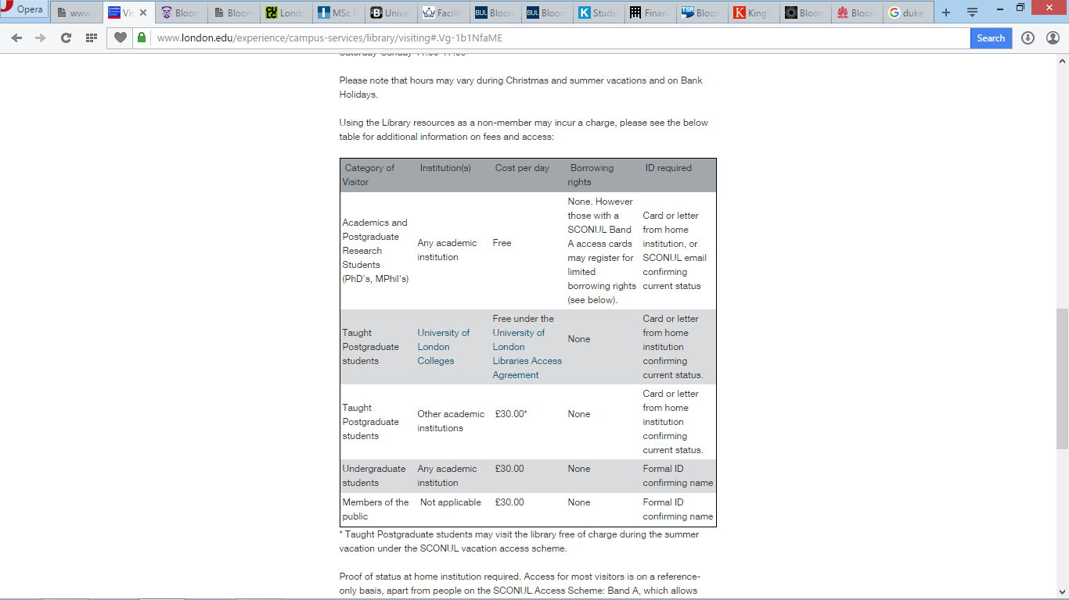

**Imperial College business school**

<http://wwwf.imperial.ac.uk/business-school/programmes/msc-finance/>

**Software facilities**

You will have access to Bloomberg terminals, Reuters Eikon, Datastream, Matlab and two bespoke computer labs.

Media: [l.singleton@imperial.ac.uk](mailto:l.singleton@imperial.ac.uk)

[library@imperial.ac.uk](mailto:library@imperial.ac.uk)

Dear Chris,

 Thank you for your email. Imperial college resources are for educational purposes only and for current Imperial students and staff. Unfortunately Bloomberg licenses do not allow us to provide any access to external users.

 You may wish to visit the Business and IP centre in the British Library as an option:

<http://www.bl.uk/bipc/>

 Best wishes,

Alexandra

Emailed again on short courses

**Queen Mary University of London**

<http://econ.qmul.ac.uk/undergraduate/facilities/index.html>

Has short mandarin course: <http://eshop.qmul.ac.uk/browse/extra_info.asp?compid=1&modid=1&deptid=44&catid=75&prodid=999>

22 Bloomberg terminals -  Bloomberg Trading Room??

* Time Series Data Software: A full range of economic and financial data is available through DataStream, Macrobond and the WRDS platform (including Bankscope and CRSP).
* Statistical Analysis Software: A wide range of Econometric software including Eviews, Stata, Matlab, Gauss etc.

(general) [j.kilvington@qmul.ac.uk](mailto:j.kilvington@qmul.ac.uk) (emailed asking about short courses)

(general) [econ-postgrad@qmul.ac.uk](mailto:s.adams@qmul.ac.uk?subject=Email%20from%20Economics%20website)

**Brunel University London (*** access is to any student??, bookable online.)**

<http://libguides.brunel.ac.uk/c.php?g=202078&p=1329628>

<http://www.brunel.ac.uk/services/library/databases/archive/bloomberg>

Ten Bloomberg pcs are located in the Financial Resources Suite on Floor 1 of the Library. If you wish to use Bloomberg you need to [book a terminal](http://libcalendar.brunel.ac.uk/booking/bloomberg). For more information on getting started and using Bloomberg look under the [Raw Data LibGuide for Bloomberg](http://libguides.brunel.ac.uk/content.php?pid=528567&sid=4348964).

Each slot is one hour long, and you can book up to a week in advance. The PCs are available to book during the following hours in term-time:

* **Monday - Friday: 9am – 2am**
* **Saturday: 9am – 2am**
* **Sunday: 9am – 2am**

(Access to the Financial Resources Suite has been extended from 10pm to 2am on a trial basis.)

[library@brunel.ac.uk](mailto:library@brunel.ac.uk)

**Kingston**

http://www.kingston.ac.uk/contact-us/#studying

We are very pleased that here at the Kingston Business School we have a full subscription to Bloomberg services and offer our students access and training through 12 twin-screen full trading stations

[**enterprise@kingston.ac.uk**](mailto:enterprise@kingston.ac.uk) **(emailed on non-financne degree)**

**University of Westminster**

<http://www.westminster.ac.uk/about-us/faculties/business/about-the-faculty/facilities/financial-markets-suite>

[Professor Orla Gough](http://www.westminster.ac.uk/about-us/faculties/business/about-the-faculty/facilities/?a=4509), Head, Department of Finance and Business Law

Email: [gougho@wmin.ac.uk](mailto:gougho@wmin.ac.uk)  Tel: +44 (0)20 7911 5000 ext 3012

(contact first) [Dr Harry Thapar](http://www.westminster.ac.uk/about-us/our-people/directory/thapar-harry), Financial Markets Suite Project Manager

Email: [thaparh@wmin.ac.uk](mailto:thaparh@wmin.ac.uk)

**Kings College**

[**http://www.kcl.ac.uk/nms/depts/mathematics/research/finmath/bloomberg/bloombergterminals.aspx**](http://www.kcl.ac.uk/nms/depts/mathematics/research/finmath/bloomberg/bloombergterminals.aspx)

Bloomberg Terminal room - For further information please contact Dr Tiziana Di Matteo([tiziana.di_matteo@kcl.ac.uk](mailto:tiziana.di_matteo@kcl.ac.uk))

Dear Chris  
Thank you for your message and interest. I am sorry but these are at the present only open to our FM MSc student and PhD students. I hope in your understanding   
  
Best regards  
Tiziana

**City University London (*** access is to any student??, bookable online.)**

[**http://libcal.city.ac.uk**](http://libcal.city.ac.uk)

Bloomberg Dealing room

* [enquiries@city.ac.uk](mailto:enquiries@city.ac.uk) (have emailed about short courses)

**City Business Library (referred to by British Library librarian)**

http://www.cityoflondon.gov.uk/business/economic-research-and-information/city-business-library/Pages/default.aspx

[cbl@cityoflondon.gov.uk](mailto:cbl@cityoflondon.gov.uk) (emailed)

**Bristol: UWE**

[**http://www1.uwe.ac.uk/whyuwe/fantasticfacilities/financialtradingroom.aspx**](http://www1.uwe.ac.uk/whyuwe/fantasticfacilities/financialtradingroom.aspx)

1 day course: <http://courses.uwe.ac.uk/Z20000034#entry>

**University of Bristol**

No Bloomberg listed. Have emailed.

**City of Bristol College**

No Bloomberg listed. Have emailed.

**Bath College**

No Bloomberg listed. Have emailed.

**University of Bath, School of Management**

No Bloomberg listed. Have emailed.