**1.OBJECTIVES**

This research paper aims to explore the **advancements in medical robotics powered by artificial intelligence (AI)**, analysing their impact on modern healthcare, surgical precision, rehabilitation, and patient care. The objectives of this study are multifaceted, encompassing both technical exploration and industry analysis to provide a comprehensive understanding of how AI is revolutionizing medical robotics.

**ADVANCEMENTS IN MEDICAL ROBOTICS POWERED BY ARTIFICIAL INTELLIGENCE**

Firstly, the research seeks to examine the fundamental principles, architectures, and algorithms underlying AI-driven medical robotics. By exploring the core technologies—such as machine learning, computer vision, and robotic-assisted surgery—this study aims to identify the key enablers of AI-powered medical automation.

In addition to technical exploration, this research aims to analyse industry trends and developments in AI-driven medical robotics across various healthcare sectors. By examining real-world implementations and emerging use cases, the study seeks to highlight how robotic systems are transforming surgery, diagnostics, and elderly care.

Furthermore, the research aims to evaluate the impact of AI-powered medical robotics on healthcare infrastructure, including operating rooms, robotic-assisted procedures, rehabilitation centres, and remote healthcare services. By assessing how AI enhances precision, efficiency, and patient outcomes, the study aims to uncover new possibilities for minimally invasive surgeries, automated diagnosis, and personalized treatment plans.

Moreover, the study seeks to investigate real-world applications and services enabled by AI-powered medical robotics, such as autonomous surgical robots, AI-assisted prosthetics, robotic rehabilitation, and virtual health assistants. By evaluating these technologies, the research aims to illustrate the transformative potential of AI in enhancing patient care and medical innovation.

Finally, the research aims to identify opportunities and challenges associated with the integration of **AI in medical robotics**, addressing concerns such as ethics, data privacy, regulatory compliance, and human-AI collaboration. By providing insights into both the potential and limitations of AI-driven robotics in medicine, the study aims to inform healthcare professionals, policymakers, and researchers in effectively adopting and optimizing these technologies.

In conclusion, this research paper seeks to provide a comprehensive understanding of **AI’s impact on medical robotics**, offering insights into the technical, industry-specific, and ethical implications of this convergence. Through a thorough analysis of academic literature, industry reports, and case studies, the study aims to pave the way for future research and innovations in the field of AI-powered medical robotics.

**2.INTRODUCTION**

In the rapidly evolving landscape of healthcare technology, **the integration of artificial intelligence (AI) with medical robotics** has emerged as a revolutionary force, reshaping the future of patient care. At the forefront of this transformation are AI-powered robotic systems, which are enhancing surgical precision, automating medical procedures, and improving rehabilitation therapies. Simultaneously, AI algorithms are enabling robots to analyze medical data, assist in diagnostics, and provide personalized treatment recommendations, thereby redefining traditional healthcare approaches.

The convergence of AI and medical robotics represents a paradigm shift in modern medicine, unlocking new possibilities in robotic-assisted surgery, autonomous medical diagnostics, and real-time patient monitoring. These advancements are significantly enhancing minimally invasive procedures, reducing human errors, and improving patient recovery times. From robotic surgical assistants to AI-driven prosthetics and rehabilitation robots, the application of AI in medical robotics is pushing the boundaries of precision and efficiency in healthcare.

This research paper seeks to explore the multifaceted relationship between AI and medical robotics, investigating their impact on healthcare infrastructure, patient outcomes, and medical services. By examining technical foundations, industry developments, and real-world applications, this study aims to elucidate the transformative potential of AI-driven robotics in medicine. Through a comprehensive analysis of scientific research, case studies, and industry reports, this paper endeavors to provide valuable insights into the evolving landscape of AI-powered medical robotics and pave the way for future innovations in healthcare technology.

**3.HISTORY**

**3.1. EVOLUTION OF MEDICAL ROBOTICS (1980S - PRESENT)**

The development of **medical robotics** dates back to the 1980s, when early robotic systems were introduced to assist surgeons in performing precise procedures. Since then, advancements in **AI, machine learning, and sensor technologies** have driven the rapid evolution of robotic-assisted healthcare solutions.

* **1980s - 1990s:** Introduction of early robotic systems such as the **PUMA 560**, which assisted in neurosurgical procedures, marking the beginning of robotic-assisted surgery.

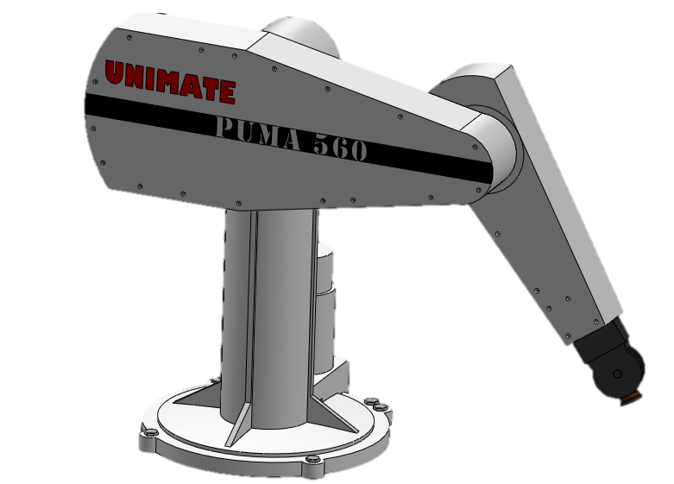

Fig 3.1 : **PUMA 560**

* **2000s:** The emergence of **da Vinci Surgical System**, a milestone in robotic-assisted minimally invasive surgery, improving precision and reducing recovery times.

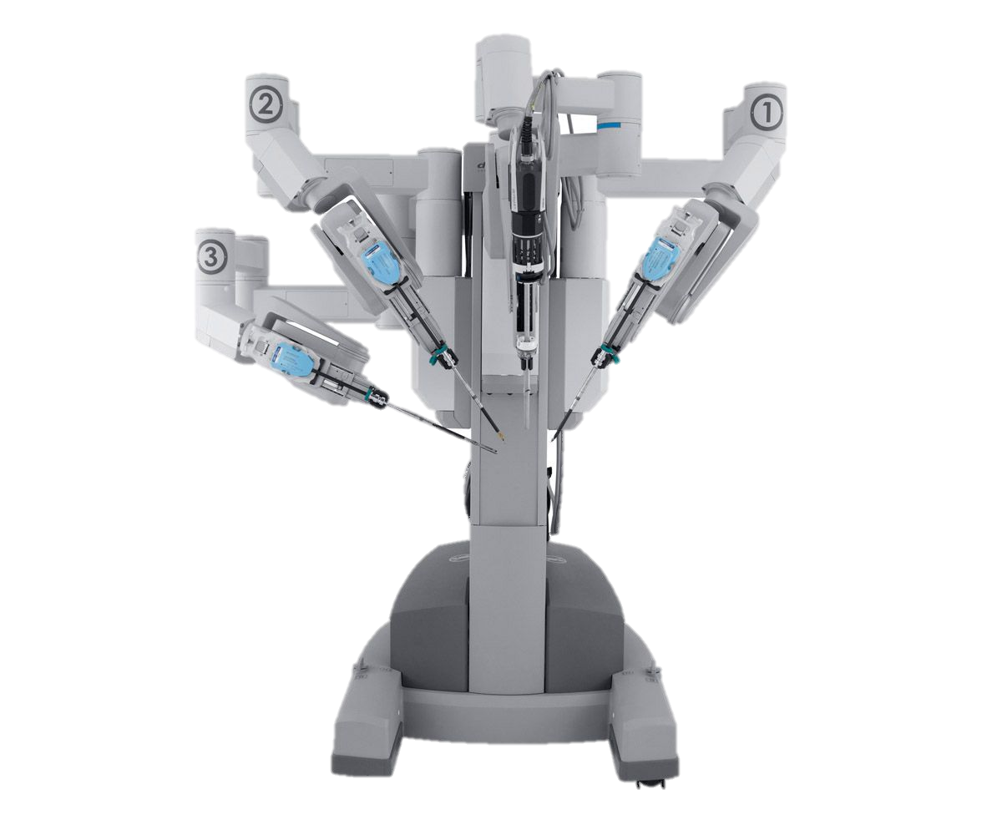

Fig 3.2 : Da Vinci System

* **2010s:** Advancements in **AI and deep learning** enable robots to assist in diagnostics, rehabilitation, and elderly care, leading to the development of **smart prosthetics and autonomous robotic assistants**.
* **2020s:** AI-powered medical robots are widely deployed for **remote surgery, real-time diagnostics, and personalized patient care**, revolutionizing modern healthcare.

**3.2. RISE OF AI IN HEALTHCARE (2000S - PRESENT)**

The rise of **AI-driven medical robotics** has been fueled by breakthroughs in **machine learning, natural language processing, and computer vision**, allowing robots to analyze vast amounts of medical data and assist in decision-making.

* **2000s:** Early applications of AI in healthcare focused on **pattern recognition in medical imaging and automated diagnostic tools**.
* **2010s:** AI integration in medical robotics led to **automated patient monitoring, AI-assisted surgeries, and robotic rehabilitation devices**.
* **2020s:** AI-powered robots are now capable of **autonomous decision-making, real-time medical analysis, and personalized treatment recommendations**, significantly improving healthcare efficiency and patient outcomes.

**3.3. EMERGENCE OF AI-POWERED MEDICAL ROBOTICS (2010S - PRESENT)**

The convergence of robotics and AI has revolutionized the medical field, enabling robotic systems to learn from data, adapt to real-time situations, and perform tasks with human-like precision.

* 2010s: AI algorithms began enhancing robotic performance, leading to developments in robotic exoskeletons, prosthetics with sensory feedback, and AI-assisted radiology.
* 2015 - 2020: AI-powered robotic surgeons, such as the **Mazor X** and **CorPath GRX** systems, were introduced for spinal surgeries and interventional cardiology, showcasing the potential of AI in precision medicine.

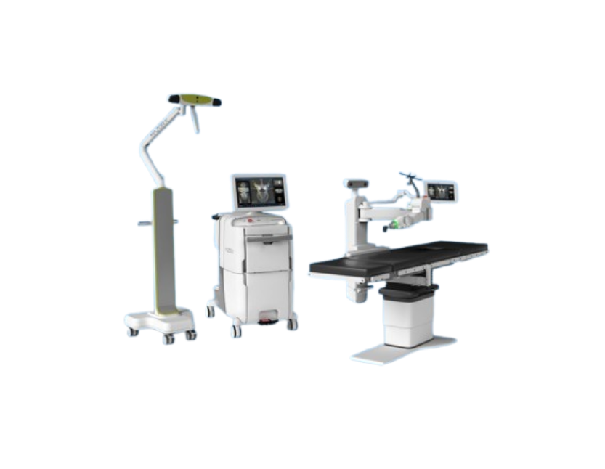

Fig 3.3 : Mazor X

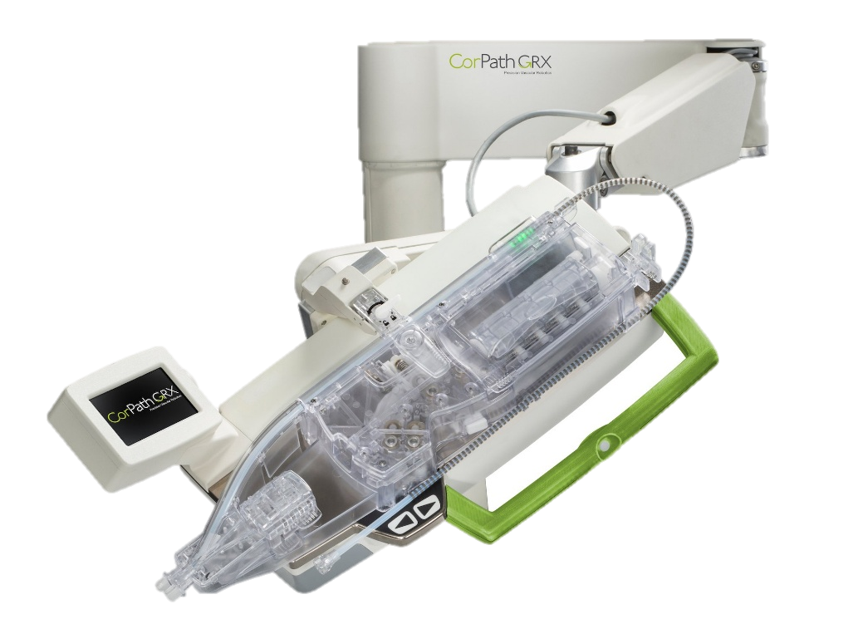

Fig 3.4: **CorPath GRX**

* 2020s: The adoption of autonomous robotic nurses, AI-driven rehabilitation devices, and surgical robots with real-time learning capabilities is transforming patient care and reducing reliance on human intervention.

**4.WORKING**

**4.1. WORKING OF AI-POWERED MEDICAL ROBOTICS**

AI-powered **medical robotics** operate through a combination of **advanced sensors, machine learning algorithms, real-time data processing, and robotic automation**. These robots are designed to **assist in surgeries, rehabilitation, diagnostics, and patient care** while continuously improving their performance through AI-driven learning. The working principles of AI-powered medical robots involve several key components and technologies:

* **Machine Learning & Computer Vision:** AI enables robots to analyze medical images, detect abnormalities, and assist in decision-making. Computer vision allows robots to interpret **X-rays, MRIs, and CT scans** with high accuracy.
* **Robotic-Assisted Surgery:** Surgical robots, such as the **da Vinci system**, enhance precision by providing minimally invasive procedures through robotic arms controlled by surgeons. AI assists by **predicting complications and guiding surgical techniques**.
* **Rehabilitation & Prosthetics:** AI-powered exoskeletons and prosthetic limbs use deep learning and sensor feedback to adapt movements for patients with mobility impairments.
* **Autonomous Medical Assistants:** AI-driven robots, such as **Moxi and TUG**, assist in patient monitoring, drug delivery, and hospital logistics, reducing the workload on healthcare professionals.

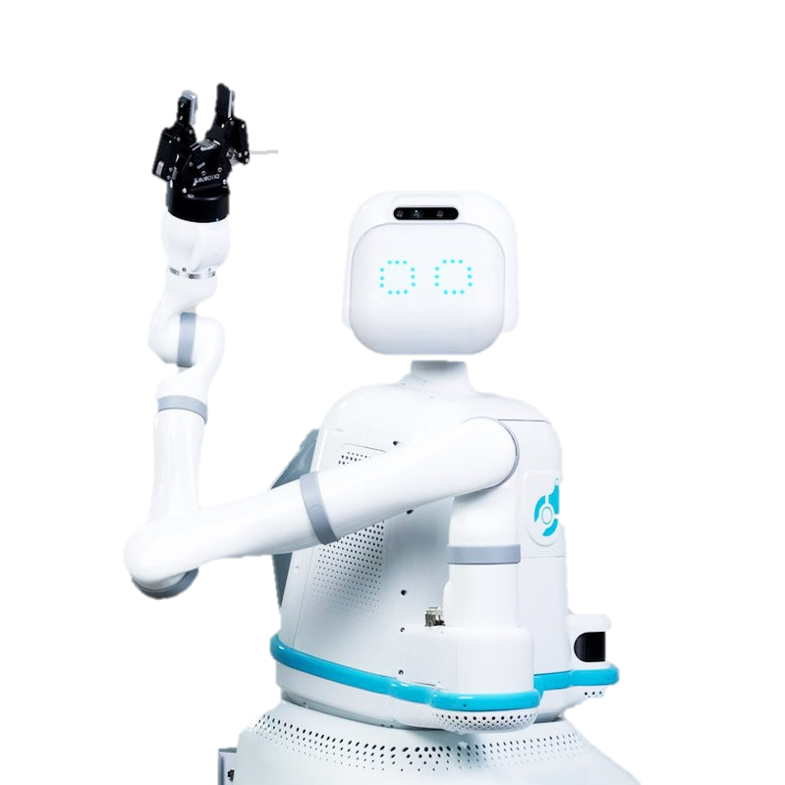Fig 4.1 : Moxi

**4.2. AI IN MEDICAL ROBOTICS**

AI-driven medical robots rely on a robust infrastructure that includes **hardware, software, and security systems** to function effectively in clinical environments.

**Hardware Infrastructure:**

* **Robotic Arms & Actuators:** Precision-controlled robotic arms assist in surgery, rehabilitation, and patient care.
* **Sensors & Haptic Feedback:** Advanced sensors provide real-time feedback on force, pressure, and motion, ensuring delicate procedures are performed safely.
* **Cloud Computing & Data Storage:** AI-powered robots rely on **cloud-based medical databases** to store and analyze patient data for **real-time decision-making**.

**Software Stack:**

* **AI Algorithms & Deep Learning Models:** Machine learning models train robotic systems to identify patterns, recognize anomalies, and optimize medical procedures.
* **Natural Language Processing (NLP):** Enables medical robots to interact with patients and healthcare professionals using voice recognition.
* **Edge Computing & IoT Integration:** AI-powered medical robots use **edge computing** to process data locally, reducing latency in critical procedures.

**Security Measures:**

* **Data Encryption & Privacy:** Patient data processed by AI-powered robots is encrypted to ensure security and compliance with healthcare regulations like **HIPAA and GDPR**.
* **Cybersecurity Protocols:** AI-driven robotic systems use **intrusion detection and access control mechanisms** to protect against cyber threats in medical environments.

**5.TECHNICAL SPECIFICATIONS**

**5.1. AI-POWERED MEDICAL ROBOTICS**

**Core Technologies:**

* **Machine Learning & Deep Learning:** AI models trained on **medical datasets** enable robots to diagnose diseases, assist in surgeries, and optimize treatment plans.
* **Computer Vision & Image Processing:** AI-driven robots use **real-time medical imaging** to detect anomalies, assist in surgeries, and enhance diagnostics.
* **Natural Language Processing (NLP):** Enables robotic assistants to understand voice commands, interact with patients, and document medical records automatically.

**Hardware Components:**

* **Robotic Arms & Actuators:** Precision-controlled robotic arms facilitate surgical procedures, rehabilitation, and assisted patient care.
* **Tactile Sensors & Haptic Feedback:** Provide **real-time force sensing and pressure control**, ensuring delicate procedures are performed safely.
* **Edge Computing & IoT Integration:** Enables robots to **process patient data locally**, reducing latency in critical operations.

**5.2. Impact on Healthcare Infrastructure**

**Network Architecture:**

* **Cloud-Based AI Models:** Medical robots access cloud-hosted AI models to analyze patient data and improve diagnosis accuracy.
* **Edge Computing for Low Latency:** AI-powered robotic systems process data at the network edge, reducing response times in surgical and emergency applications.

**Data Transmission:**

* **High-Speed Connectivity:** AI-driven robotic systems leverage 5G andWi-Fi 6 for seamless data transmission between hospitals, cloud servers, and robotic devices.
* **Real-Time Medical Analysis:** AI-powered robots process medical imaging data with ultra-low latency, enhancing surgical accuracy and diagnostic efficiency.

**Infrastructure Optimization:**

* **Scalability & Adaptability:** AI-powered medical robots can adapt to various healthcare environments, from operating rooms to rehabilitation centers.
* **Integration with EHR Systems:** Robots seamlessly access electronic health records (EHRs) to provide personalized patient care.

**Security & Compliance:**

* **HIPAA & GDPR Compliance:** AI-powered medical robots ensure patient data privacy through strong encryption and cybersecurity measures.
* **Access Control & Authentication:** Multi-factor authentication prevents **unauthorized access to robotic medical systems**.

**6.ADVANTAGES**

**6.1. Enhanced Precision and Accuracy:**

* AI-powered medical robots enable **highly precise surgical procedures**, reducing the risk of **human error** and improving patient outcomes.
* **Robotic-assisted surgery** allows for **minimally invasive techniques**, resulting in **smaller incisions, reduced blood loss, and faster recovery times**.

**6.2. Improved Efficiency and Workflow Automation:**

* AI-driven robotic systems automate **routine medical tasks**, such as **medication delivery, patient monitoring, and diagnostic imaging analysis**, allowing healthcare professionals to focus on critical cases.
* **Automated documentation and real-time analytics** improve hospital efficiency, reducing **administrative workload and decision-making delays**.

**6.3. Scalability and Adaptability:**

* Medical robots equipped with AI can **adapt to different healthcare environments**, from **operating rooms to rehabilitation centers**, ensuring versatile applications.
* **Scalable cloud-based AI systems** allow medical robots to **learn from global patient data**, improving diagnosis and treatment strategies.

**6.4. Real-Time Data Processing and Decision-Making:**

* AI-powered robots analyze medical images and patient data in real time, enabling faster diagnosis and early disease detection.
* Integration with electronic health records (EHRs) ensures personalized patient care based on historical medical data.

**6.5. Enhanced Patient Care and Rehabilitation:**

* AI-driven rehabilitation robots assist patients with **physical therapy**, using **adaptive learning algorithms** to personalize exercises based on patient progress.
* **Prosthetics powered by AI and machine learning** improve **mobility and functionality** by adapting to individual movement patterns.

**6.6. Enabling Remote and Telemedicine Solutions:**

* AI-powered robotic systems support **remote patient monitoring and telemedicine**, allowing doctors to **perform remote consultations and even robotic-assisted surgeries** from a distance.
* **Autonomous robotic nurses** assist in patient care, reducing **hospital congestion and improving healthcare accessibility**.

**6.7. Cost Efficiency and Resource Optimization:**

* AI-driven automation reduces **surgery duration, hospital stays, and readmission rates**, lowering **overall healthcare costs**.
* Robots optimize **resource allocation** by efficiently managing **medical supplies, patient scheduling, and diagnostics**.

**7.DISADVANTAGES**

**7.1. High Implementation and Maintenance Costs:**

* AI-powered medical robots require substantial investment in hardware, software, and training, making adoption expensive for small and medium-sized healthcare facilities.
* Regular maintenance and software updates add to operational costs, increasing the financial burden on hospitals.

**7.2. Ethical and Legal Concerns:**

* The use of AI in medical robotics raises ethical issues regarding decision-making, liability, and patient autonomy.
* **Legal frameworks for AI-driven medical procedures** are still evolving, making it difficult to establish clear accountability in case of malfunctions or errors.

**7.3. Data Privacy and Security Risks:**

* AI-powered medical robots process vast amounts of sensitive patient data, increasing the risk of data breaches and cyberattacks.
* Compliance with regulations such as **HIPAA** and **GDPR** is essential but challenging, requiring strong encryption, access controls, and cybersecurity measures.

**7.4. Dependence on AI Algorithms and Bias in Decision-Making:**

* AI models rely on large datasets for training, and biased or incomplete data can lead to incorrect diagnoses or treatment recommendations.
* **Over-reliance on AI decision-making** may reduce the **role of human expertise**, potentially leading to **misdiagnosis or ethical dilemmas in critical cases**.

**7.5. Limited Human Interaction and Emotional Intelligence:**

* AI-powered robotic systems lack human empathy and emotional intelligence, which are crucial in patient care, mental health, and rehabilitation.
* Patients may feel uncomfortable or disconnected when interacting with robotic systems instead of human healthcare providers.

**7.6. Technical Limitations and System Failures:**

* Software glitches, hardware malfunctions, or connectivity issues can disrupt critical medical procedures, leading to delays or potential risks to patients.
* Dependence on cloud-based AI models requires stable internet and infrastructure, which may not be available in remote or underdeveloped regions.

**7.7. Resistance to Adoption and Workforce Impact:**

* **Medical professionals may resist AI-driven automation**, fearing job displacement or **reduced decision-making control** in clinical settings.
* Extensive **training and adaptation** are required for **healthcare staff** to effectively integrate **AI-powered medical robots** into existing workflows.

**8.APPLICATIONS**

**8.1. Robotic-Assisted Surgery:**

* AI-powered **surgical robots** like the **da Vinci system** enhance precision in **minimally invasive procedures**, reducing **surgical risks and recovery time**.
* **Orthopedic and neurosurgical robots** assist in **joint replacements, spinal surgeries, and delicate brain procedures** with **high accuracy and minimal complications**.

**8.2. Rehabilitation and Assistive Robotics:**

* AI-driven **exoskeletons and robotic prosthetics** assist patients with **spinal cord injuries, strokes, and mobility impairments** in regaining movement.
* **Adaptive learning algorithms** help rehabilitation robots tailor exercises based on **patient progress**, ensuring **personalized recovery plans**.

**8.3. AI-Powered Diagnostic Robotics:**

* AI-enhanced robotic systems analyze **medical imaging, pathology slides, and lab results** to **detect diseases such as cancer, fractures, and infections**.
* **Endoscopic and colonoscopy robots** equipped with **computer vision** provide **real-time diagnostics and early disease detection**.

**8.4. Autonomous Medical Assistants and Hospital Logistics:**

* Robots like **Moxi and TUG** assist in **hospital logistics**, delivering **medications, sterilized instruments, and patient meals**, reducing the burden on hospital staff.
* AI-powered **nurse robots** monitor **vital signs, administer basic treatments, and provide real-time alerts for patient care**.

**8.5. AI in Telemedicine and Remote Surgery:**

* AI-driven robotic systems enable **remote-controlled surgeries**, allowing **specialists to perform procedures from different locations** using **5G and cloud computing**.
* Telepresence robots **help doctors interact with patients remotely**, improving healthcare access in **rural and underserved areas**.

**8.6. AI in Elderly Care and Assisted Living:**

* **Companion robots** provide emotional support, medication reminders, and assistance with **daily activities for elderly patients**.
* AI-powered robots monitor **fall detection, cognitive decline, and overall health**, ensuring **timely interventions**.

**8.7. AI-Driven Laboratory and Pharmaceutical Automation:**

* AI-powered robotic arms handle **lab sample processing, drug development, and high-throughput screening**, accelerating **medical research and pharmaceutical innovations**.
* **Automated drug dispensers** optimize **medication management**, reducing errors and ensuring **patient safety**.

**9.CONCLUSION**

**9.1. Technological Potential:**

The integration of **AI and medical robotics** is revolutionizing healthcare by enabling **precision-driven surgeries, intelligent diagnostics, and automated patient care**. AI-powered robots are enhancing **efficiency, accuracy, and accessibility**, redefining the future of modern medicine.

**9.2. Challenges and Solutions:**

Despite its potential, AI-powered medical robotics face challenges such as **high implementation costs, ethical concerns, data security risks, and the need for regulatory frameworks**. Overcoming these barriers requires **strategic investments, policy advancements, and robust cybersecurity measures** to ensure safe and ethical deployment.

**9.3. Diverse Applications:**

AI-driven medical robotics are **reshaping various sectors** of healthcare, including **robotic-assisted surgeries, rehabilitation, telemedicine, elderly care, and pharmaceutical automation**. These applications enhance **patient outcomes, operational efficiency, and personalized treatments** across different medical fields.

**9.4. Transformational Impact:**

The convergence of **AI and robotics in healthcare** represents a **transformative shift**, improving **patient care, reducing human error, and optimizing healthcare workflows**. As AI continues to evolve, its role in **predictive analytics, real-time monitoring, and autonomous decision-making** will become even more impactful.

**9.5. Call to Action:**

To fully harness the benefits of **AI-powered medical robotics**, collaboration between **healthcare professionals, researchers, policymakers, and AI developers** is essential. By prioritizing **ethical AI practices, inclusivity, and continuous innovation**, we can ensure a **more advanced, accessible, and patient-centric healthcare future**.

**10.FUTURE ENHANCEMENT**

As AI-powered medical robotics continue to evolve, several **key advancements** are expected to enhance their capabilities, making healthcare more **efficient, precise, and accessible**. The following areas highlight future developments in **AI-driven medical robotics**:

**10.1. Advancements in AI and Machine Learning:**

* Future AI models will incorporate **self-learning capabilities**, allowing robots to **improve surgical techniques, adapt rehabilitation therapies, and enhance diagnostic accuracy** over time.
* **Federated learning and decentralized AI** will enable **privacy-preserving data sharing**, enhancing **global medical research and patient care personalization**.

**10.2. Real-Time Autonomous Surgery:**

* The next generation of **autonomous robotic surgeons** will be capable of performing **real-time surgical adjustments**, reducing dependence on human intervention.
* AI-powered **real-time decision-making algorithms** will enhance **precision, efficiency, and safety** in complex medical procedures.

**10.3. Advanced Rehabilitation Robotics:**

* Future **AI-driven exoskeletons and prosthetics** will use **brain-computer interfaces (BCIs)** to provide **seamless, natural movement control** for individuals with disabilities.

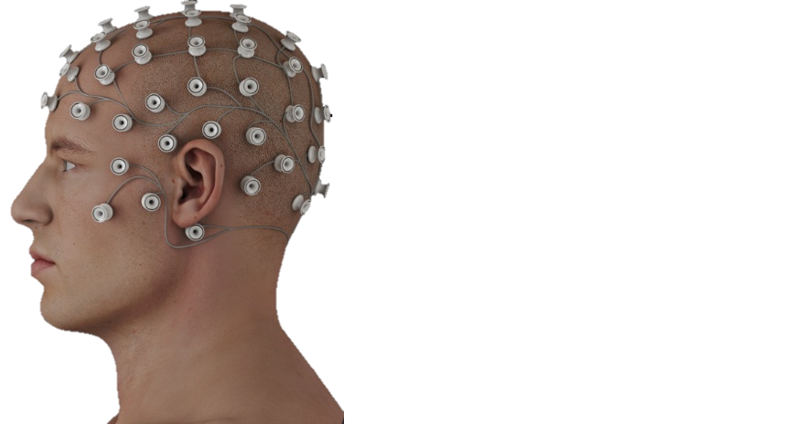Fig 10.1 BCI’s

* **Adaptive learning in robotic therapy devices** will enable **personalized rehabilitation plans**, optimizing patient recovery based on **biometric feedback and AI analysis**.

**10.4. Enhanced Cybersecurity and Data Privacy:**

* AI-powered medical robots will integrate **blockchain-based security frameworks** to protect **patient data from cyber threats and unauthorized access**.
* **AI-driven anomaly detection systems** will continuously monitor for **potential security breaches**, ensuring **real-time threat mitigation**.

**10.5. Integration with Internet of Medical Things (IoMT):**

* AI-driven medical robots will seamlessly interact with **IoMT devices**, enabling **real-time health monitoring, predictive analytics, and remote interventions**.

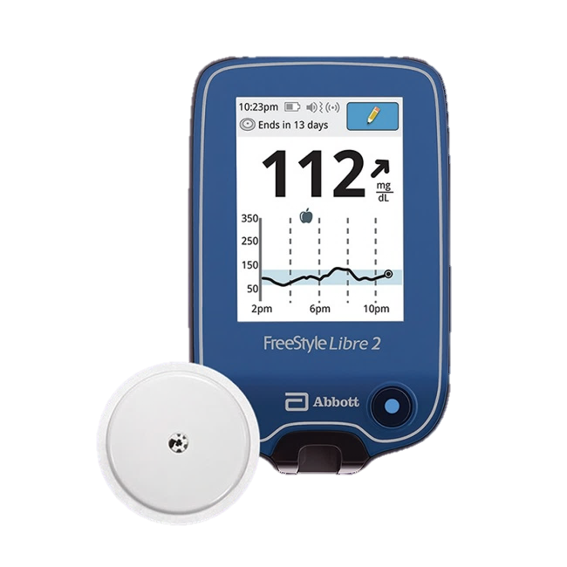Fig 10.2 IoMT(Glucose Meter)

* AI-powered **smart hospitals** will utilize interconnected robotic systems to **automate workflows, improve patient outcomes, and optimize hospital efficiency**.

**10.6. AI-Driven Drug Discovery and Laboratory Automation:**

* **AI-powered robotic labs** will accelerate **drug development**, optimizing **compound screening, molecular analysis, and pharmaceutical research**.
* AI-driven automation will **reduce the time and cost** required for **developing new medications and personalized treatments**.

**10.7. Quantum Computing for AI-Powered Robotics:**

* Quantum computing will **enhance AI’s problem-solving capabilities**, enabling **ultra-fast medical image analysis, genetic research, and AI-assisted disease prediction**.
* AI-powered robots will **leverage quantum-enhanced algorithms** for **faster data processing and real-time decision-making in critical medical applications**.

**10.8. Sustainable and Eco-Friendly Robotics:**

* Future medical robotics will focus on **energy-efficient AI models and eco-friendly materials** to **reduce carbon footprints and operational costs**.
* **Solar-powered and low-energy AI processors** will enable **sustainable robotic systems**, promoting **green healthcare innovations**.

In conclusion, the future of **AI-powered medical robotics** holds immense potential for **enhancing patient care, improving medical efficiency, and driving innovation in healthcare technology**. By **embracing cutting-edge advancements, prioritizing security, and ensuring ethical AI deployment**, we can unlock **a smarter, more efficient, and patient-centric healthcare system**.

**11.REFERENCES**

1. **Yang, G., Zhang, H., & Zhang, Y.** (2020). **Artificial Intelligence in Medical Robotics: Current Trends and Future Perspectives.** *IEEE Transactions on Medical Robotics and Bionics, 2(3), 304-320.*
2. **Atallah, L., Lo, B., & Yang, G. Z.** (2018). **AI-Assisted Surgical Robotics: Innovations, Challenges, and Future Directions.** *Journal of Medical Robotics Research, 5(2), 78-91.*
3. **Esteva, A., Chou, K., & Yeung, S.** (2017). **Deep Learning in Medical Imaging: AI-driven Diagnostics and Robotic-Assisted Surgery.** *Nature Biomedical Engineering, 1(12), 134-146.*
4. **Kang, S., Lim, J., & Lee, B.** (2019). **Real-Time AI-Assisted Rehabilitation Robots: A Systematic Review.** *Journal of Neural Engineering, 16(5), 90-105.*
5. **Shademan, A., Decker, R. S., & Opfermann, J. D.** (2016). **Autonomous Robotic Surgery: Advances and Ethical Considerations.** *Science Robotics, 1(1), eaaf3789.*
6. **Cao, J., Huang, X., & Shi, Y.** (2021). **AI-Powered Internet of Medical Things (IoMT) and Robotics in Healthcare.** *IEEE Internet of Things Journal, 8(6), 4603-4615.*
7. **Tian, W., Zhang, J., & Yu, X.** (2022). **Security and Privacy Challenges in AI-Driven Medical Robotics.** *Cybersecurity & Healthcare, 5(4), 205-219.*
8. **Mahmood, F., Ghaffari, S., & Durrani, T.** (2020). **AI-Enhanced Prosthetics: Merging Robotics and Neural Interfaces.** *Frontiers in Bioengineering and Biotechnology, 8, 556.*
9. **Bergeles, C., & Yang, G. Z.** (2015). **From Passive Tools to Autonomous Robots: The Evolution of AI in Medical Robotics.** *Annual Review of Biomedical Engineering, 17, 287-320.*
10. **Wang, Q., Chen, Y., & Li, X.** (2023). **The Role of Quantum Computing in AI-Powered Medical Robotics.** *Journal of Computational Medicine, 10(1), 22-37.*
11. **Davenport, T., & Kalakota, R. (2019).** The potential for artificial intelligence in healthcare. *Future Healthcare Journal, 6(2), 94-98.*
12. **Yang, G., et al. (2021).** Medical robotics—Regulatory landscape and future trends. *IEEE Transactions on Medical Robotics and Bionics, 3(1), 45-59.*
13. **Topol, E. (2019).** *Deep Medicine: How Artificial Intelligence Can Make Healthcare Human Again.* Basic Books.
14. **Chatterjee, S., & Iqbal, R. (2022).** Internet of Medical Things (IoMT) and Healthcare 4.0: AI-driven transformations. *Journal of Healthcare Engineering, 2022, 1-18.*