User Manual

Ιs this the first time you use this application?

If so please read carefully the following instructions.

The main menu includes the following options:

1. All the menus that are available
2. Useful Websites about Covid-19
3. Help
4. Contact Us
5. Rate Us
6. Exit

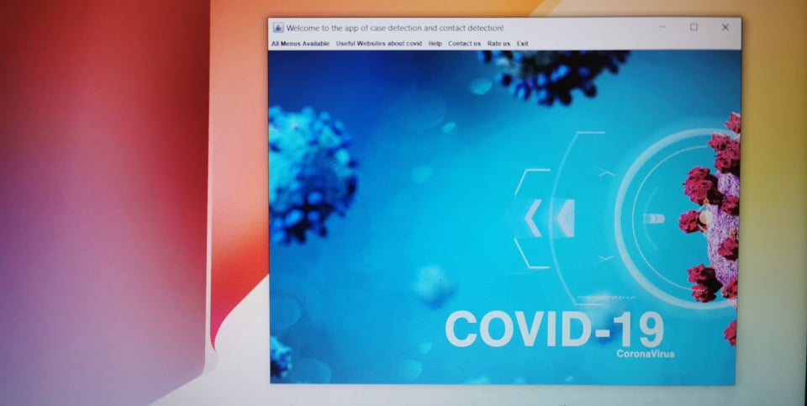

In you click the first option you have this following options(foto)

* Government Menu
* 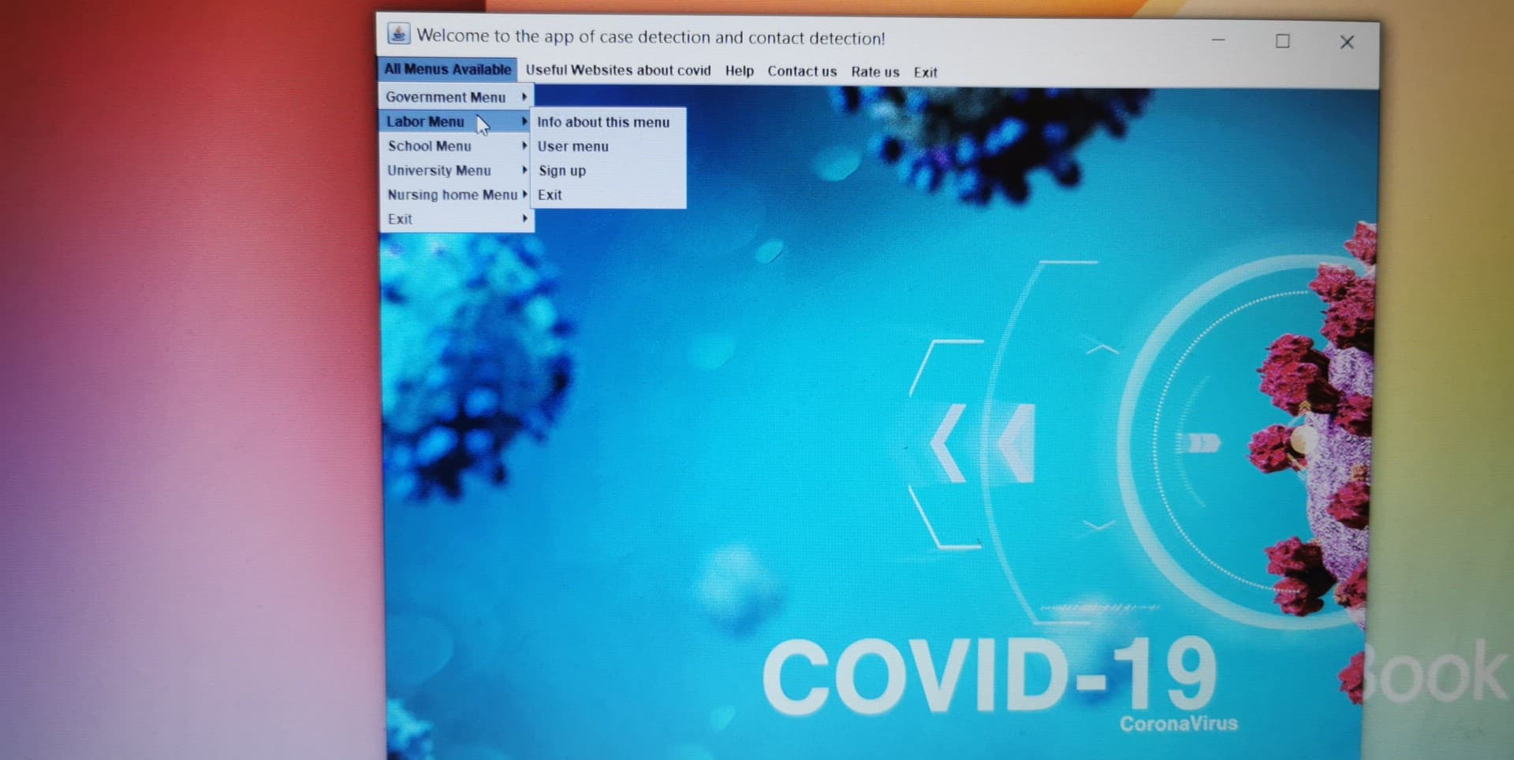Labor Menu
* School Menu
* University Menu
* Nursing Home Menu
* Exit

By selecting one of these options, you will automatically be transferred to the menu and its option you like.

When you choose the second option you access to the following **helpful websites**.

This websites may help you to : know how to deal with Covid-19 case, give the right instruction to prevent spread, check for the number of cases worldwide and be up to date to the latest news.

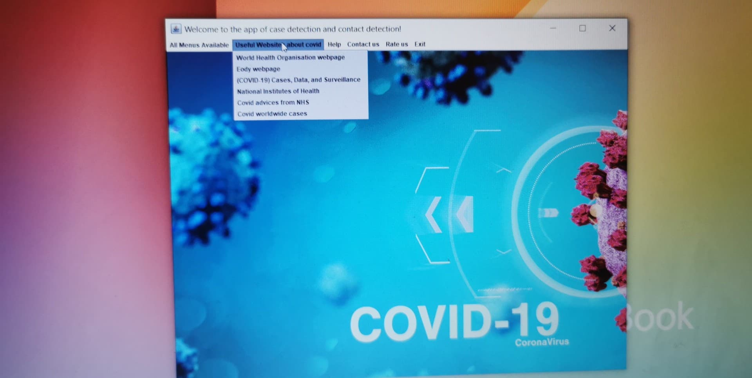

**Help** when clicked provides you answers to many potential questions that you may have, the terms and Conditions and lastly gives you the opportunity to contact us in you detect a problem to our app.

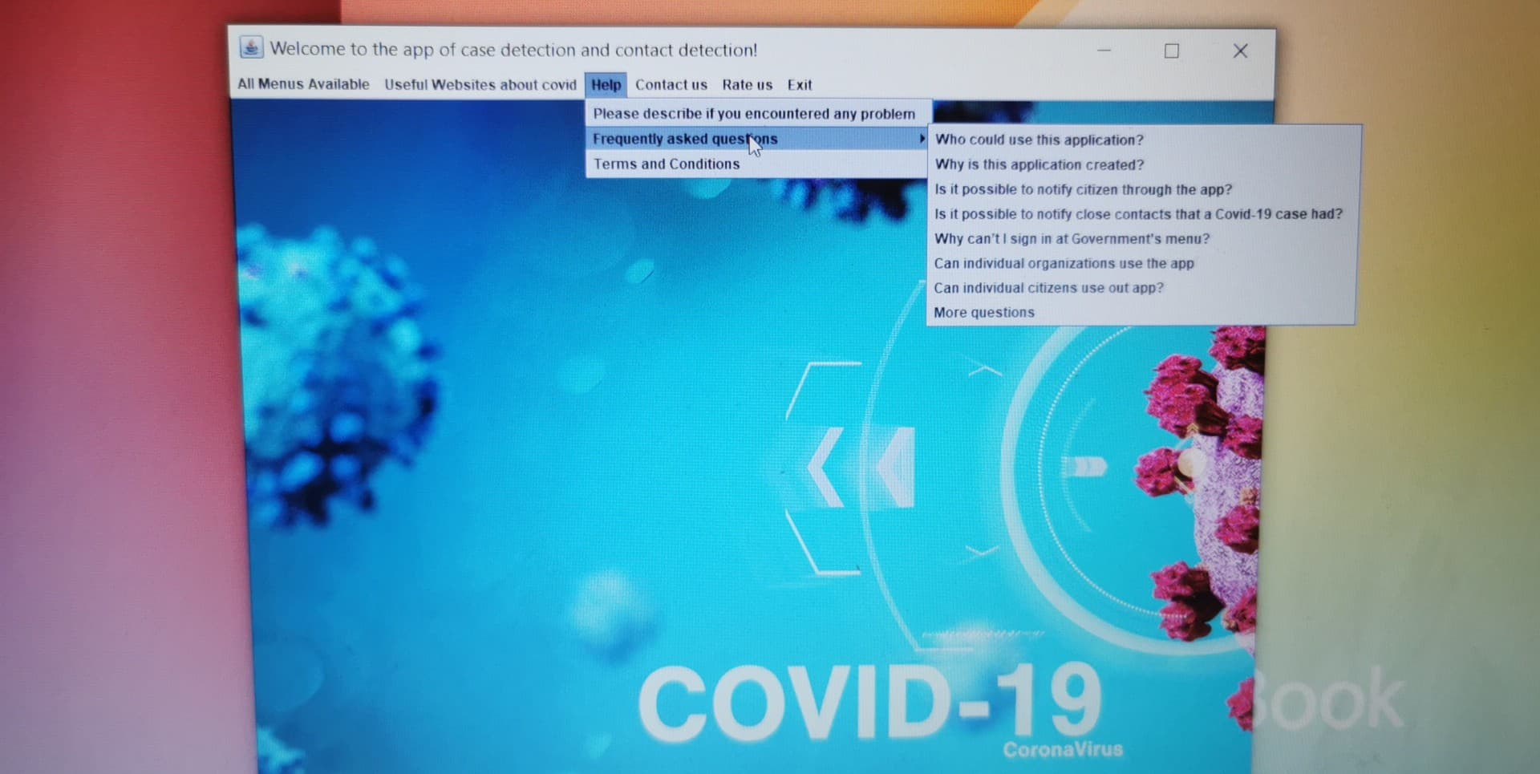

If you want to contact us you choose the **Contact Us** option and you will be asked to insert you email address. Once you do so we will be notified and respond as soon as possible with further instructions and solutions to your problem.



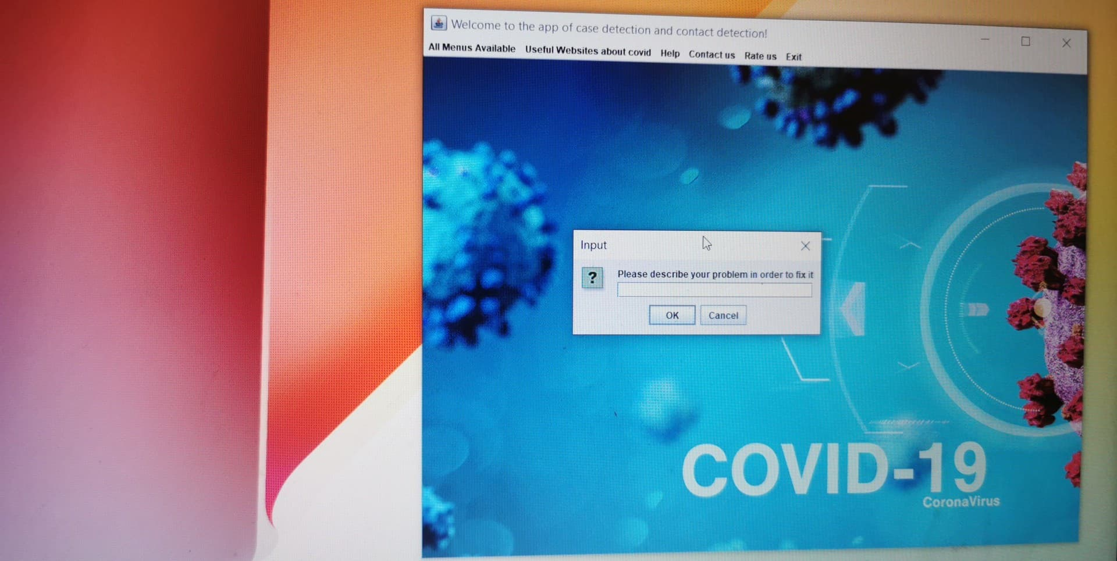

If you click **Rate Us** you can rate us through a monkey survey one like the following.

We would like to be aware of your opinion, you have the ability to rate us and make our application even better. That’s why we do think your opinion is more than important !!!

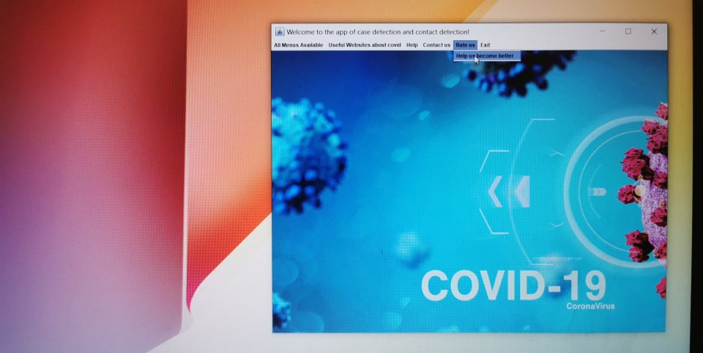

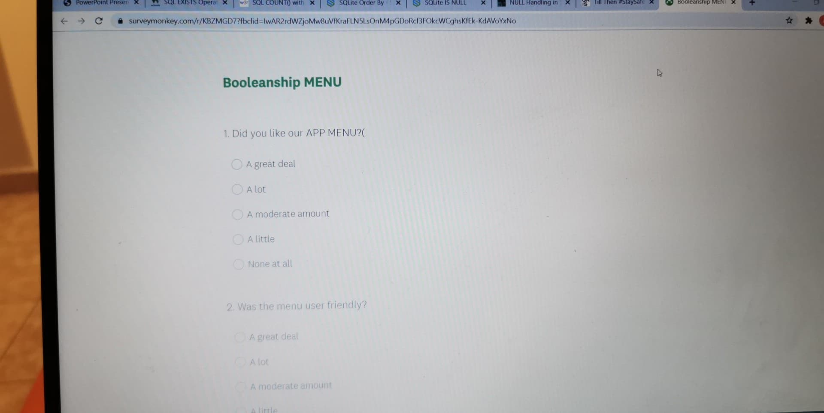

And finally when you click **Exit** you will be redirecting to a website with information about.

Registration Form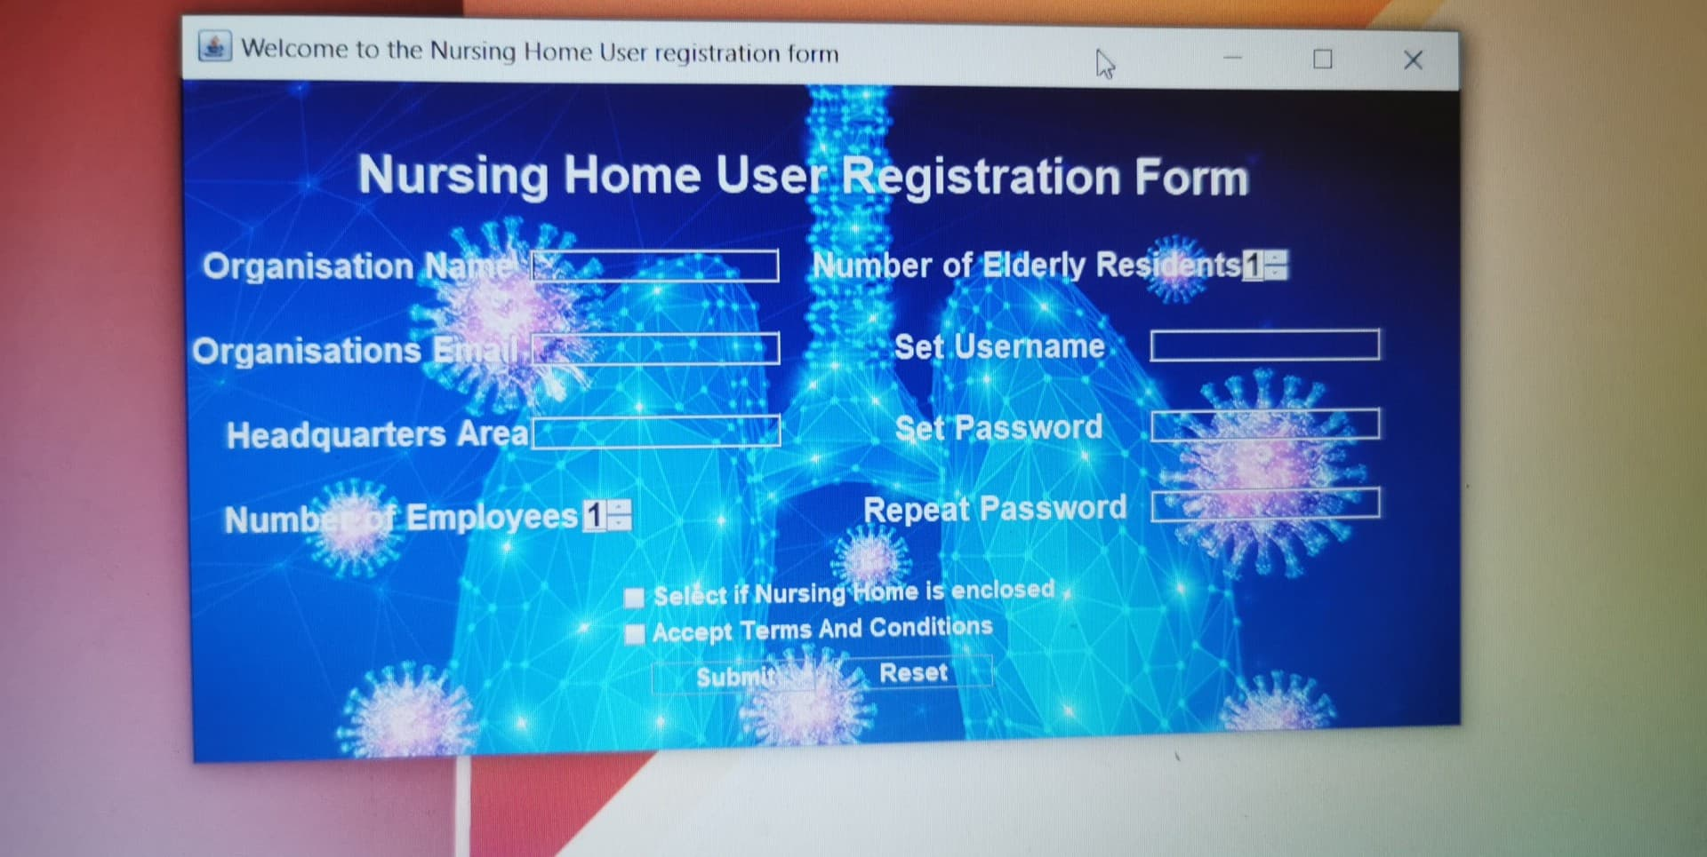

After filling out the registration form, you will have to enter the code that we have send you in your email. The username that you will select has to be unique, for that reason there is a chance we will ask you to choose another username because of the fact that someone else has already taken it.

When you successfully end this progress, your organization has been successfully saved in our database.

That means you will be able to sign in whenever you want and use your account in order to inspect your organization. Whatever you insert into our application it will be automatically be saved in our database, and you will be able to use it whenever it ought to.

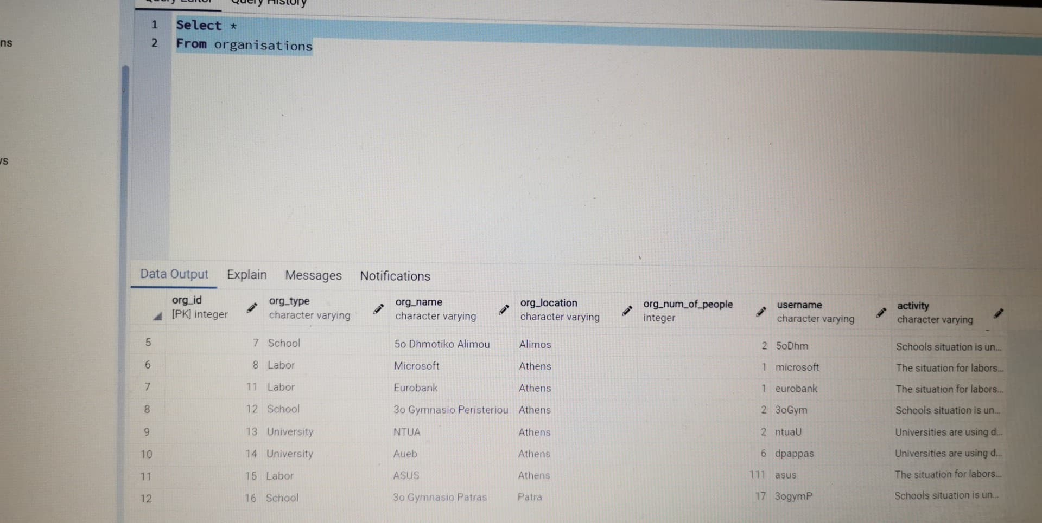

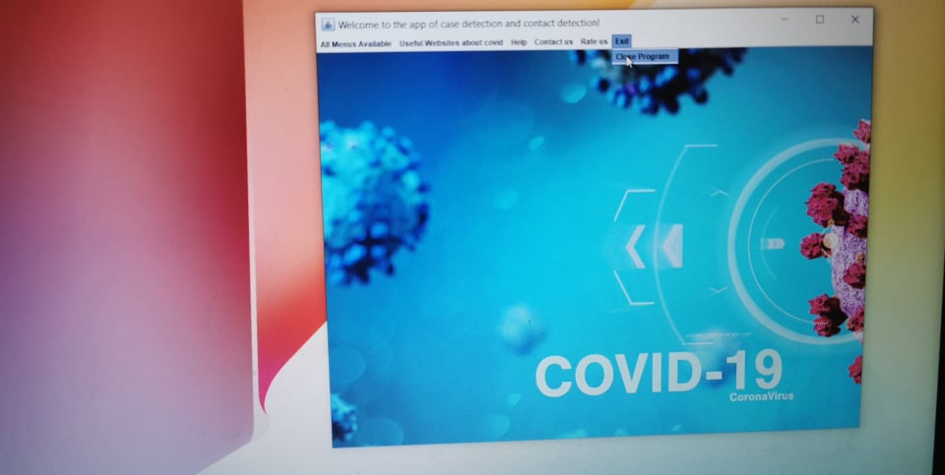

When you will choose the option **Sign In** in one of the 4 menu(except government it’s only for authorized users) you will be redirection to the Sing in form where you will be asked to insert your username and password to verify you. Once you do so you will have all the menu option available.

Register option: Display the fields that you have to fill out. You have to give a username and an password. These fields do not share or give to anybody, they are for personal use and only. In case that the username you gave is already used, you will have to find out another one in order to continue. As long as you achieve to successfully register, the application will automatically transfer you to the sign in menu.

Sign in option: If you would like to have access to Your Organization profile, you will have to give the right credentials, in case you do not because of not remembering them, you must communicate with your local government to find out a solution

When you sign in first time, you will have to form the structure of your Organization. That means you will have to add members in your organizations, initialize fields accordingly the organization you have.

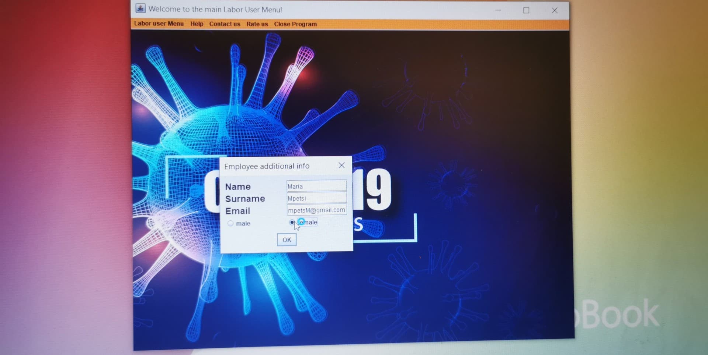

After that moment you will be able to monitor your Organization, that means you will able to declare a new Covid -19 case, shut down your organization for a few days, add or to remove a member.

Surveillance login form:

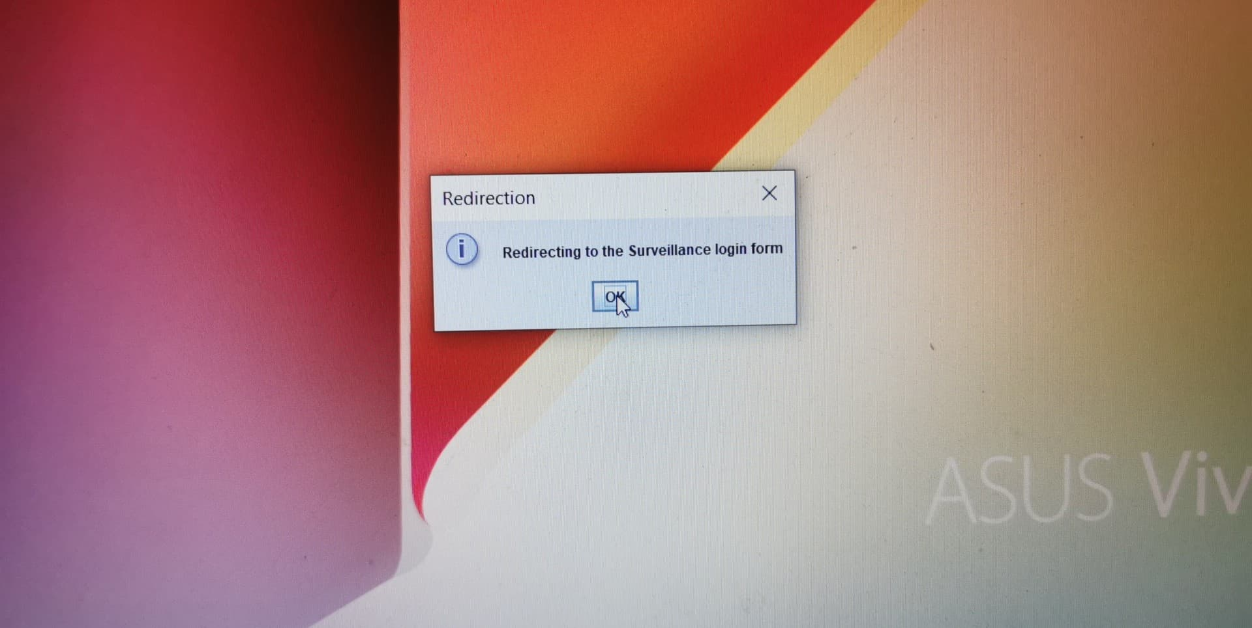

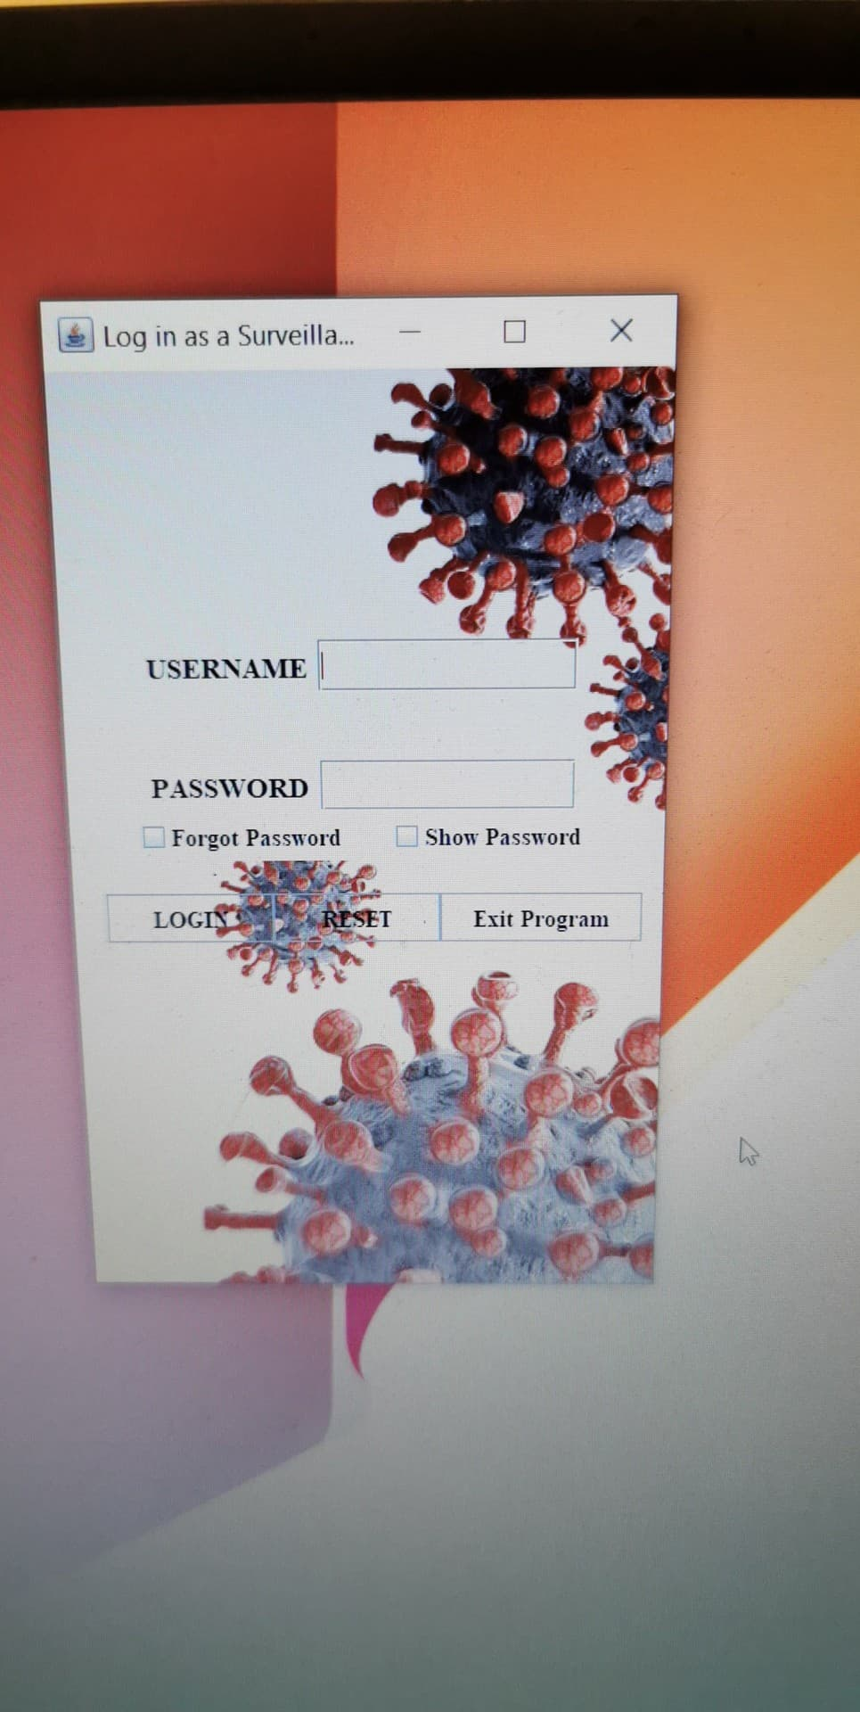

This menu is quite a safe, because of the fact that if someone would like to change the password, he will have to have access in the given email and enter the configuration code.

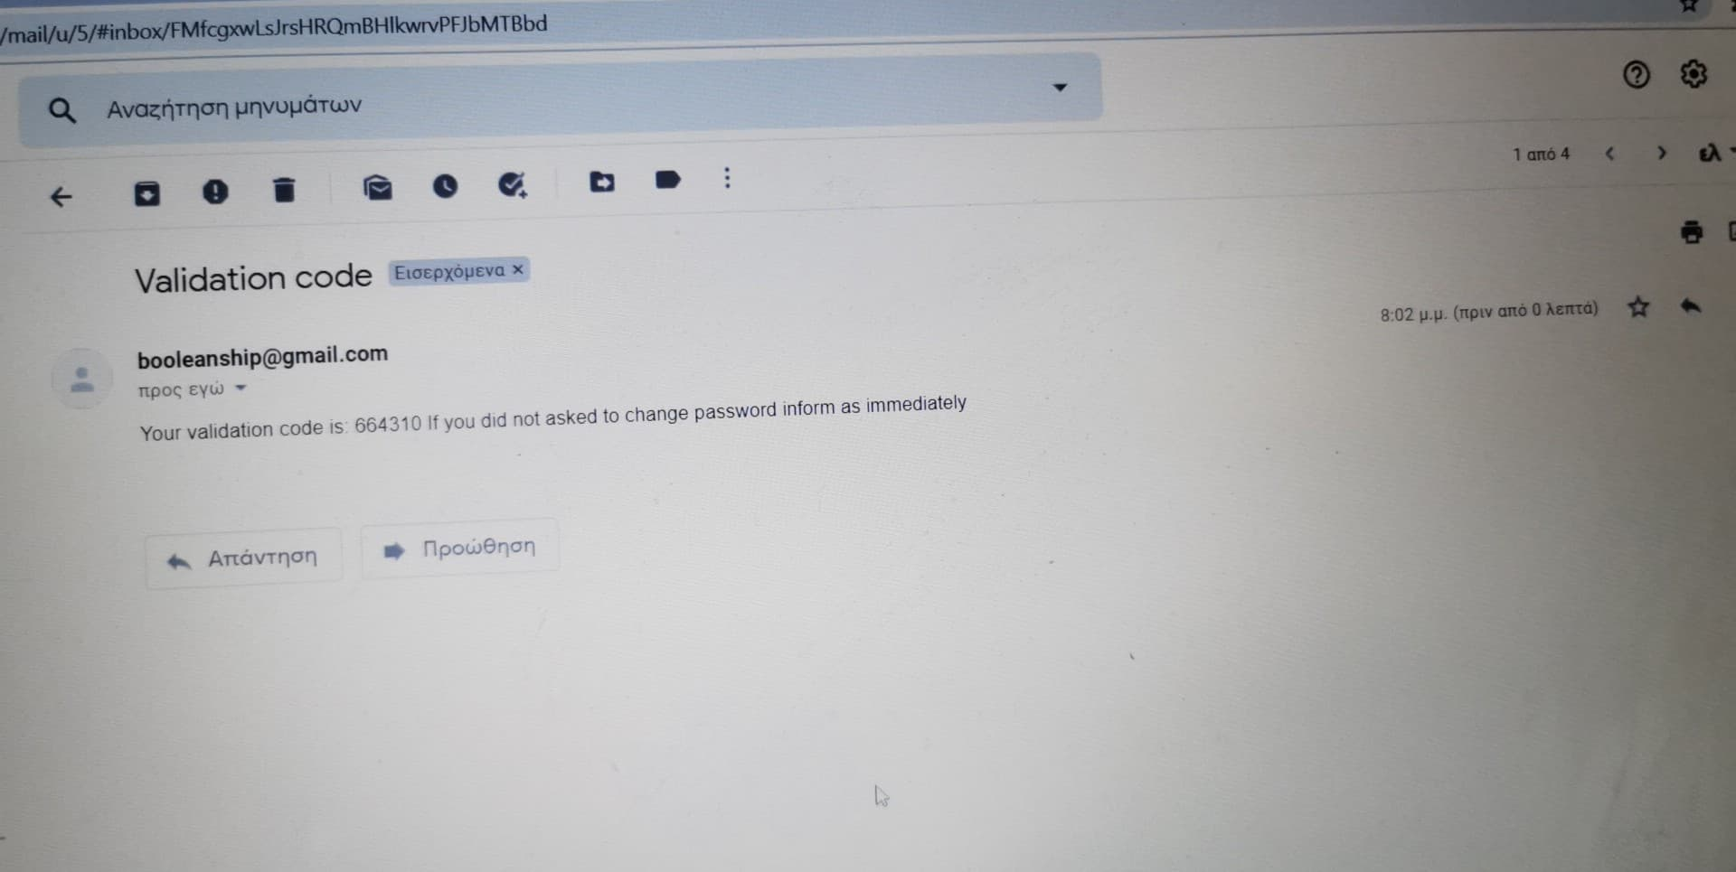

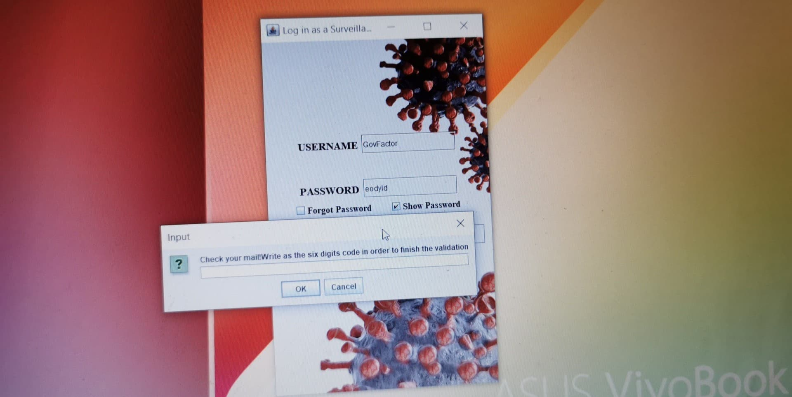

The Government User Menu has these option:

1)See all Register Organizations

2)See all recorded Covid -19 cases

3)See all contacts of Covid -19 cases

4)Collective email to all Organisations

5)Declare a positive test

6)Change Password

7)Exit

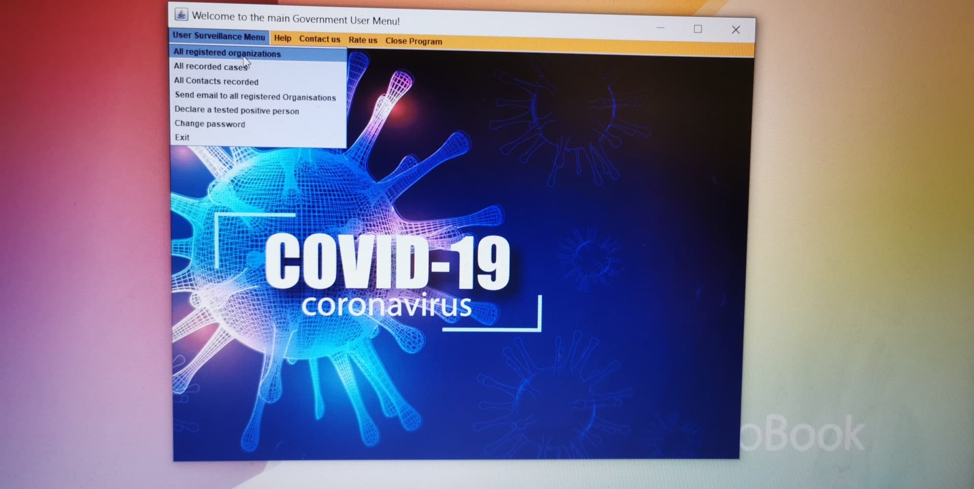

Meaning of these option:

1)The government can understand the imprint of all organizations, where are the located, how many do they have, and the most important how many Covid -19 cases has each one. That means the government has an easy way to direct this pandemic and discover important data like how transmissibility factor inside organizations ect.

2)Is a file which contains all the people get sicked by Covid -19

3)Is a file of all the contacts of the Covid -19 positive. In this way government can see how much contagious is Covid -19 and the people that potential transmitter.

4)This option is very important because government can inform all organizations immediately with significant news.

5)When a Covid -19 positive test exists, the government, which does most of the testes, government office has to enter it into the system in order to be informed the organization the person that is positive belongs and to be fast tracking done.

6)Change password option is for safety reasons, but it can only be done after an email confirmation.