Software Methodologies COMP2231
2018/2019
Image Processing Assignment

Abstract

The bilateral filter is a non-linear filter that blurs the image while also preserving strong edges. The joint bilateral filter follows the same structure however, takes two images, one with flash on and one without. The joint bilateral in combination with detail layers can produce more detailed results while also assisting in getting these layers. The filter is wide known and has been implemented in a Adobe Photoshop and GIMP while having many applications such as denoising and detail transfer. This report will inspect both the bilateral filter and the joint bilateral filter by themselves in detail.

Introduction
talk about noise and why on some occasions it would be good to remove it.
1. Bilateral Filter

Gaussian smoothing is efficient at noise removal however, it also removes image detail (e.g. blur) which is a common counter-effect of some noise-removal filters such as mean. Noise is random variations in pixel values not directly attributed to scene’s contents.

Yet, for certain applications, edges need to be preserved alongside the removal of noise. In Gaussian filter, influence of one pixel on another is determined only by spatial proximity (e.g. the nearer they are to one another then the stronger the influence)

Bilateral Filter is an example of an edge preserving filter. It retains detail by not only taking the Euclidean distance into account but by accounting for intensity difference as well. This means that if the difference is too great, something common in edges then the new pixel will be mostly affected by the ones on its side of the edge.

Bilateral filter is non-linear, as the new pixel is not a linear function of the input pixels. That is because the constants change for each new neighbourhood. So, while Gaussian is a linear filter as the distance between the pixels and their neighbours remains the same. bilateral filter is edge-preserving.
Edge-preserving smoothing is an image processing technique that smooths away noise or textures while retaining sharp edges. Similar to the bilateral are the median and the anisotropic diffusion, both of which are non-linear and are better are preserving edges than linear smoothing filters.(reference 1)

talk about some applications

The formula used for the bilateral filter is:

Formula:

The bilateral filter was applied to 2 test images, one coloured and one grey scale. Here are the results:
The original picture had amounts of noise in them but the filtered images have managed to smooth out the surfaces (as visible by the area around the eyes) but also retain sharp edges (as visible by the contrast between the chin and the neck) in Test 1.
Illustration 1: Test 1 Original
Illustration 2: Test 1 Filtered (11,75,11)
Illustration 3: Test 1 Filtered (75,75,11)
In Illustration 3 , it is visible that while sigma colour increases, the photo appears to have a cartoonish feel to it while at the same time it loses some details which is visible around the mouth. However, in some cases this might be what is needed, especially in some computer vision algorithms where only the outline edges are needed and not the details inside the objects.
Illustration 4: Test 2 Original
Illustration 5: Test 2 Filtered (75,75,11)
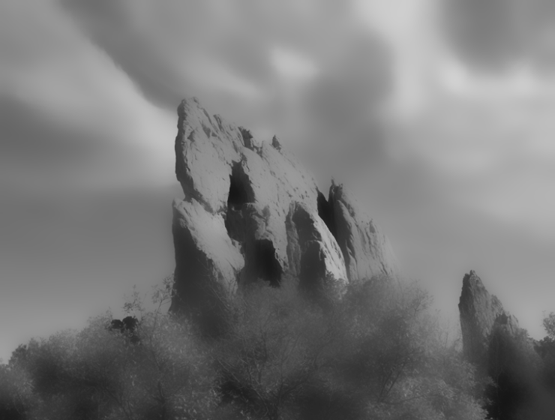Illustration 6: Test 2 Filtered (75,150,11)
Test 2 shows that by increasing the standard deviation for distance, it causes results similar to a Gaussian blur. What’s more, in the original image, there existed a lot of detailed edges (e.g. trees and clouds) which could confuse an algorithm but in Illustration 5, the filtered result would make it easier for a program to track and separate the mountains from its surroundings.

2. Joint Bilateral Filter

The joint bilateral filter, takes 2 images taken in rapid succession. One of the images is taken without flash and the other one with flash. With the flash image its easier to track edges however, there is a drop-off in colour accuracy. In order to combat this and get a result that has the best of both worlds

Instead of multiplying by the intensity of the flash picture intensities, the noflash picture intensities are multiplied and in doing so, the colours are more accurate while the edges are sharper. (input new formula here)

input images: originalno flash, original flash, bilateral filtered and joint bilateralfiltered

While the joint bilateral filter is very effective, considering the added sharpness that can be implemented with detail transfer, it is hard coming up with images that are an appropriate match. The pair of images will most likely need to be taken using a tripod that is not always readily accessible.
Maybe in later years as the normal cameras are getting quicker, a function can be implemented to take pictures in quick succession, one with flash and one without so that the effects of filter can be accessible.

