**Decoding working memory information from persistent and activity-silent neurons in the primate prefrontal cortex**

Lilianna Thrower*1, Wenhao Dang*1, Rye G. Jaffe1, Christos Constantinidis1,2,3

1. Department of Biomedical Engineering, Vanderbilt University, Nashville TN 37235, USA.

2. Neuroscience Program, Vanderbilt University, Nashville TN 37235, USA.

3. Department of Ophthalmology and Visual Sciences, Vanderbilt University Medical Center, Nashville TN 37232, USA.

* These authors contributed equally to this work

Abbreviated Title: Working Memory PFC Decoding

Address correspondence to:

Christos Constantinidis, PhD.

Christos.Constantinidis.1@vanderbilt.edu

The authors report no conflicts of interest during the research conducted.

**ABSTRACT**

The persistent activity of neurons in the prefrontal cortex has been thought to represent the information maintained in working memory though alternative models have recently challenged this idea. Activity-silent theories posit that stimulus information may be maintained by the activity pattern of neurons that do not generate persistent activity, significantly elevated about their baseline. We thus tested the ability of neurons that do and do not generate persistent activity in the prefrontal cortex of monkeys to represent spatial and object information in working memory. Neurons that generated persistent activity represented more information about the stimuli, in both spatial and object working memory tasks. The amount of information that could be decoded from neural activity depended on the choice of decoder and parameters used, but neurons with persistent activity outperformed non-persistent neurons, consistently. Although averaged across all neurons and stimuli, firing rate did not appear clearly elevated above baseline during the maintenance of neural activity particularly for object working memory, this grant average masked neurons that generated persistent activity selective for their preferred stimuli, which carried the majority of information about the stimulus identity. These results reveal that prefrontal neurons with generate persistent activity constitute the primary mechanism of working memory maintenance in the cortex.

**INTRODUCTION**

The ability to maintain and manipulate information in memory over a period of seconds is commonly referred to as working memory (Baddeley, 2012). Early neurophysiological experiments in non-human primates identified neurons that not only respond to sensory stimuli but remain active during a period after the stimuli were no longer present, thus providing a neural correlate of working memory (Fuster and Alexander, 1971). This persistent activity has since been widely replicated, including in human recordings (Kaminski et al., 2017). Computational models typically simulate persistent activity through neural networks with recurrent connections between units with similar tuning for spatial location (Hart and Huk, 2020). Activation in the network behaves as a continuous attractor (Seung et al., 2000), with a stimulus generating a bump (peak) of activity in the network. This activity bump is maintained through the delay period, but may drift randomly, with the peak at the end of the delay period determining the location that is ultimately recalled by the subject, hence the term, bump attractor (Wimmer et al., 2014). Drifts in neuronal activity thus account for deviations of behavior.

Persistent activity is not universally accepted as the neural correlate of working memory (Zaksas and Pasternak, 2006; Lara and Wallis, 2014; Lundqvist et al., 2018). Alternative mechanisms have been proposed that do not depend on persistent activity to represent information during the delay period of working memory tasks, including “activity-silent” models, which suggest that information can be decoded from the PFC without generation of elevated persistent activity across the population (Stokes, 2015). For example, experimental studies have shown that the identity of a stimulus maintained in memory can be decoded from a population of neurons whose activity is not elevated above baseline levels of firing rate, but whose pattern of activity may vary dynamically over time, with different neurons becoming active at different time points (Stokes et al., 2013). Computational models have also been proposed that could account for such changes via synaptic strength modification instead of spike generation (Mongillo et al., 2008; Sugase-Miyamoto et al., 2008). Moreover, Recurrent Neural Networks have been used successfully to model complex cognitive tasks, including those related to working memory (Mante et al., 2013; Masse et al., 2019; Yang et al., 2019; Kim and Sejnowski, 2021), demonstrating that it is possible to perform working memory tasks by virtue of rapid changes in synaptic weights after a stimulus presentation.

We were therefore motivated to compare the predictions of the bump-attractor and activity-silent models, using a database of recordings obtained from the prefrontal cortex of monkeys as they performed spatial and object working memory tasks. We examined how effectively stimulus information was represented from neurons that do and do not generate persistent activity. We also compared working memory for spatial location and object information.

**METHODS**

Animals: Data obtained from male rhesus monkeys (*Macaca mulatta*), ages 5–9 years old, weighing 5–12 kg, as previously documented (Riley et al., 2018), were analyzed in this study. None of these animals had any prior experimentation experience at the onset of our study. Monkeys were either single-housed or pair-housed in communal rooms with sensory interactions with other monkeys. All experimental procedures followed guidelines set by the U.S. Public Health Service Policy on Humane Care and Use of Laboratory Animals and the National Research Council’s Guide for the Care and Use of Laboratory Animals and were reviewed and approved by the Wake Forest University Institutional Animal Care and Use Committee.

Experimental setup: Monkeys sat with their heads fixed in a primate chair while viewing a monitor positioned 68 cm away from their eyes with dim ambient illumination and were required to fixate on a 0.2° white square appearing in the center of the screen. During each trial, the animals maintained fixation on the square while visual stimuli were presented either at a peripheral location or over the fovea, in order to receive a liquid reward (typically fruit juice). Any break of fixation immediately terminated the trial, and no reward was given. Eye position was monitored throughout the trial using a non-invasive, infrared eye position scanning system (model RK-716; ISCAN, Burlington, MA). The system achieved a < 0.3° resolution around the center of vision. Eye position was sampled at 240 Hz, digitized and recorded. The visual stimulus display, monitoring of eye position, and synchronization of stimuli with neurophysiological data were performed with in-house software implemented on the MATLAB environment (Mathworks, Natick, MA), utilizing the Psychophysics Toolbox (Meyer and Constantinidis, 2005).

Behavioral task: Monkeys were trained to complete spatial and shape working memory tasks. The stimuli shown in the spatial task were white 2° squares, presented in one of nine possible locations arranged in a 3 × 3 grid with 10° distance between adjacent stimuli. Here, we analyzed responses to only 8 stimuli, shown in the periphery of the grid (thus omitting analysis of the central, foveal stimulus). The stimuli shown in the shape task were white 2° geometric shapes, drawn from a set comprising a circle, diamond, the letter H, the hashtag symbol, the plus sign, a square, a triangle, and an inverted Y-letter. These stimuli could also be presented in one of nine possible locations arranged in a 3 × 3 grid with 10° distance between adjacent stimuli.

Presentation began with a fixation interval of 1 s where only the fixation point was displayed, followed by 500 ms of stimulus presentation (referred to hereafter as cue), followed by a 1.5 s delay interval where, again, only the fixation point was displayed. A second stimulus (referred to hereafter as sample) was subsequently shown for 500 ms. In the spatial task, this second stimulus would be either identical in location to the initial stimulus, or diametrically opposite the first stimulus. In the feature task, this second stimulus would appear in the same location to the initial stimulus and would either be an identical shape or not. Only one nonmatch stimulus was paired with each cue, so that the number of match and nonmatch trials were balanced in each set. In both the spatial and feature task, this second stimulus display was followed by a second delay period of 1.5 s where only the fixation point was displayed. The monkeys were thus required to remember the spatial location and/or shape of the first presented stimulus, and then, after the second delay period, would report whether the second stimulus was identical to the first or not, by making an eye movement to one of two target stimuli (green for matching stimuli, blue for non-matching) that appeared after the second delay period. Each target stimulus could appear at one of two locations orthogonal to the cue/sample stimuli, pseudo-randomized in each trial, so that the location of the correct target could not be predicted before the end of the trial.

A conjunction task was also used, which combined the active spatial and feature tasks, using the same shape stimuli and presented at the same possible locations, with the same timing. In a single recording session, only four shape-location combinations involving two shapes and two locations were used. The conjunction task was the most complex task in the current study, as the monkeys were required to match two different types of information: location and shape.

Surgery and neurophysiology: A 20 mm diameter craniotomy was performed over the PFC and a recording cylinder was implanted over the site. The location of the cylinder was visualized through anatomical magnetic resonance imaging (MRI) and stereotaxic coordinates post-surgery. For two of the four monkeys that were trained to complete active spatial, feature and conjunction WM tasks, the recording cylinder was moved after an initial round of recordings in the post-training phase to sample an additional surface of the PFC.

Anatomical localization. Each monkey underwent an MRI scan prior to neurophysiological recordings. Electrode penetrations were mapped onto the cortical surface. We identified 6 lateral PFC regions: a posterior-dorsal region that included area 8A, a mid-dorsal region that included area 8B and area 9/ 46, an anterior-dorsal region that included area 9 and area 46, a posterior-ventral region that included area 45, an anterior-ventral region that included area 47/12, and a frontopolar region that included area 10. However, the frontopolar region was not sampled sufficiently to be included in the present analyses.

Neuronal recordings: Neural recordings were carried out in the aforementioned areas of the PFC both before and after training in each WM task. Subsets of the data presented here were previously used to determine the collective properties of neurons in the dorsal and ventral PFC, as well as the properties of neurons before and after training in the posterior-dorsal, mid-dorsal, anterior-dorsal, posterior-ventral, and anterior-ventral PFC subdivisions. Extracellular recordings were performed with multiple microelectrodes that were either glass- or epoxylite-coated tungsten, with a 250 μm diameter and 1–4 MΩ impedance at 1 kHz (Alpha-Omega Engineering, Nazareth, Israel). A Microdrive system (EPS drive, Alpha- Omega Engineering) advanced arrays of up to 8-microelectrodes, spaced 0.2–1.5 mm apart, through the dura and into the PFC. The signal from each electrode was amplified and band-pass filtered between 500 Hz and 8 kHz while being recorded with a modular data acquisition system (APM system, FHC, Bowdoin, ME). Waveforms that exceeded a user-defined threshold were sampled at 25 μs resolution, digitized, and stored for off-line analysis. Neurons were sampled in an unbiased fashion, collecting data from all units isolated by our electrodes, with no regard to the response properties of the isolated neurons. A semi-automated cluster analysis relied on the KlustaKwik algorithm, which applied principal component analysis of the waveforms to sort recorded spike waveforms into separate units. To ensure a stable firing rate in the analyzed recordings, we identified recordings in which a significant effect of trial sequence was evident at the baseline firing rate (ANOVA, p < 0.05), e.g., due to a neuron disappearing or appearing during a run, as we were collecting data from multiple electrodes. Data from these sessions were truncated so that analysis was only performed on a range of trials with stable firing rate. Less than 10% of neurons were corrected in this way. Identical data collection procedures, recording equipment, and spike sorting algorithms were used before and after training in order to prevent any analytical confounds.

Data analysis: Data analysis was implemented with the MATLAB computational environment (Mathworks, Natick, MA). Neuron analysis involved, initially, determining the mean firing rate of each neuron in each trial epoch. Next, we compared responses of each neuron in the 1 s fixation period with each of the task epochs that followed (cue presentation, first delay period, sample presentation, second delay period). Any neuron that displayed a significantly greater response in a particular epoch over the fixation was identified as a task-responsive neuron (one-tailed paired t-test; p < 0.05). We particularly focused on the neurons with significantly elevated delay period activity in the first delay period. These are the neurons classically defined as having persistent activity (Funahashi et al., 1989; Constantinidis et al., 2018).

Decoding analysis was performed as follows: Spiking responses from 1 s before cue onset to 5 s after cue onset were binned using a 400-ms-wide window and 100 ms steps to create a spike count vector with 57 elements. We additionally examined decoder performance for a 1 s interval in the center of the delay period (250 ms after the cue offset). Spike count vectors from multiple neurons were used to create pseudo-populations of 50, 100, and 200 randomly selected neurons with persistent activity or not. Five decoding algorithms were implemented using the MATLAB fitc functions to decode stimuli location: support vector machine (SVM) with a gaussian kernel, SVM with a linear kernel, discriminant analysis, classification trees, and naive bayes. Decoder performance was estimated via 10-fold and 5-fold cross-validation methods. The decoding baseline was 12.5% for both tasks as we used 8 possible locations for the spatial task and 8 possible shapes for the feature task.

**RESULTS**

Extracellular neurophysiological recordings were collected from the lateral PFC of three monkeys trained to perform the match/nonmatch WM tasks (Meyer et al., 2011; Riley et al., 2018). The task required them to view two stimuli appearing in sequence with an intervening delay period between them and, after a second delay period, to report whether or not the second stimulus was identical to the first. The two stimuli could differ in terms of their location (spatial task, Fig. 1A), shape (feature task, Fig. 1B), or both (conjunction task, Fig. 1C). If the second stimulus matched with the first, monkeys would saccade towards a green target during a subsequent interval. Otherwise, they would saccade to a blue target at the diametrically opposite location.

A total of 1104 cells from three monkeys and 1091 cells from two monkeys were collected while the animals were performing the spatial and feature tasks, respectively. Neurons with at least 12 trials for each stimulus were examined in our analyses, resulting in 414 neurons with persistent activity in the delay period (“persistent neurons” for simplicity, thereafter) and 578 non-persistent neurons, for the spatial task. From the latter group, we additionally identified 207 task-responsive, but non-persistent neurons (i.e. neurons that had significantly activity in a task period other than the delay period). Similarly, we identified 315 persistent neurons and 495 non-persistent neurons, which included 83 task-responsive but non-persistent neurons, for the shape task.

**Comparison of persistent and non-persistent neurons**

We compared the classification accuracy of Support Vector Machine (SVM) decoding for neurons with and without persistent delay period activity across the time course of the spatial match-non match task (Fig. 2A). Mean classifier performance for decoding the location of the first (cue) stimulus with 10-fold cross-validation is shown in Fig. 2. Persistent neurons exhibited higher classification performance at all task intervals, including the delay period. By contrast, classification accuracy essentially returned to chance levels at about 0.5 s after the beginning of the delay period for non-persistent neurons.

We also compared the classification accuracy of persistent neurons against the accuracy of task-responsive but non-persistent neurons, using equal sample sizes (Fig. 2B). Both populations reached a similar peak shortly after the presentation of the first (cue) stimulus, indicated by the horizontal line in Fig. 2. However, decoding accuracy diverged during the delay period, with the largest difference between populations being seen during the first delay period (0.5-2.0s). A similar difference in decoding performance was also present during the second delay period, although it should be noted that at this point in the task, maintenance of the first stimulus appearance is no longer required; the monkeys could make a judgement about whether or not the two stimuli were matching after the appearance of the second stimulus, without needing to continue maintaining the location of either the first or second stimulus in memory. Comparisons that follow involve persistent neurons with task-responsive, non-persistent neurons, to better understand the difference in properties in the delay period for neurons that carry comparable information during the stimulus presentation period.

To determine whether persistent and task-responsive, non-persistent neurons could maintain spatial location information with equal accuracy during the delay period, and to avoid neurons with potentially long response latencies that might carry over at the first part of the delay interval, we calculated SVM decoding accuracy for the middle of the first delay period (0.75-1.75s). Mean decoding accuracy was higher for persistent populations (0.47) than non-persistent populations (0.17) for 100 trials (Fig. 3), with essentially no overlap between the two distributions. A statistical comparison based on 100 simulations for each condition revealed a significant difference (t-test, *t198*=72.6, p<0.001). This suggests that persistent neurons encode information substantially more accurately during the delay period.

**\*\*\* PSTH averaging ALL spatial locations? \*\*\***

**Effect of sample size and classifier parameters**

The absolute performance achieved by classifiers depends on the amount of neural data used, as well as the choice of parameters. It was therefore important to examine whether the difference between persistent and non-persistent neurons was sensitive to these factors. We first varied the population size. Populations of 50, 100, and 200 neurons showed time courses consistent with the spatial task with the SVM decoding algorithm. Higher decoding accuracy for persistent populations during the first delay period was consistent across population sizes (Fig. 4A). We saw increased accuracy at the first timepoint in the delay period as a function of the number of neurons, for both persistent and non-persistent populations (Fig. 4B). However, persistent neurons achieved consistently higher performance.

Decoding performance over time for the spatial task with the SVM decoder was also consistent between 10-fold and 5-fold cross-validation (Fig. 5). For both non-persistent and persistent populations, we once again saw the maxima when the stimuli were present, and saw the minima during the delay periods when the stimuli were not present. Higher accuracy during delay periods for persistent neurons was seen for 10-fold and 5-fold cross-validation.

Finally, we compared the performance of different classifiers, including SVM, Discriminant Analysis, Naïve Bayes, and Classification trees (Fig. 6). SVM generally performed the best in our dataset. However, for every classifier, persistent neurons consistently outperformed non-persistent neurons in the delay period of the task.

**Decoding object working memory**

The results of the prior sections suggest that neurons that generate persistent activity can maintain spatial working memory better than those without persistent activity. However, alternative theories of working memory have argued that the role of the prefrontal cortex is to “highlight” the spatial location of remembered stimuli, playing a supervisory role, while sensory areas maintain the actual features of stimuli in memory (Curtis and D'Esposito, 2003; Tong and Pratte, 2012; D'Esposito and Postle, 2015; Lara and Wallis, 2015). Indeed, the findings that put forth activity-silent theories relied on the general lack of increased persistent activity during the delay periods of object working memory tasks (Stokes et al., 2013; Stokes, 2015). It was therefore critical to compare results from the shape working memory task, which required monkeys to remember the shapes of stimuli, that were always presented at the same location (Fig. 1B). A total of XXX neurons, which generated persistent activity, and a total of XXX neurons, which did not, were sufficient data for this analysis. Results are shown in Fig. 7. The absolute value of classification was lower in the object task, compared to the spatial task, as a result of fewer neurons being engaged by any given stimulus. Persistent and non-persistent neurons reached similar classification accuracy during the stimulus presentation period. Importantly, persistent neurons consistently outperformed non-persistent neurons during the delay periods of the task. In this respect, the results of the spatial and object working memory tasks were qualitatively similar.

Hypothesis testing – comparison of D1=1 / D1=0

Difference of D1=0 from chance

**\*\*\* PSTH averaging ALL shapes? \*\*\***

**\*\*\* Conjunction results? \*\*\***

**DISCUSSION**

The role of persistent activity has been reevaluated recently (Stokes, 2015; Riley and Constantinidis, 2016; Buschman and Miller, 2022). Although strong evidence links persistent activity of prefrontal neurons with behavior in some working memory tasks (Constantinidis et al., 2018), objections have been raised about a general role of persistent activity across all working memory functions. It has thus been suggested that persistent activity in spatial tasks may represent motor preparation rather than the remembered spatial location of the stimuli per se (Lundqvist et al., 2018). Alternatively, the prefrontal cortex may play a supervisory role, “highlighting” the locations of stimuli, but not maintaining information about object identity (Ester et al., 2013; Sreenivasan et al., 2014; D'Esposito and Postle, 2015).

Our study identified neurons that generate readily persistent activity in a spatial working memory task that separated the stimulus location from the eventual motor response. Indeed, most information about the remembered stimulus location—which was necessary to perform the match-nonmatch task—was maintained by neurons that generated persistent activity. This persistent activity was also shown to be informative about the identity of stimuli held in memory, not just their spatial location. Our results therefore demonstrate that persistent activity is the primary mechanism of information maintenance across working memory stimulus domains.

**Information decoding from persistent and non-persistent neurons**

Our analysis identified neurons with persistent activity, classically defined as activity that is elevated by a statistical criterion in the delay period compared to the fixation period of the task (Funahashi et al., 1989). The visual displays that our subjects observed during these two task epochs were identical, with only the fixation point appearing on-screen (see Fig. 1). The difference between these epochs thus lay in the stimulus presentation between them, which the subjects were taught to maintain in memory. Neurons that generated persistent activity accounted for most of the spatial and object information that could be decoded by the prefrontal population during the delay period. The effect was consistent across differently sized sets of neurons used to implement classification, across different classification parameters and across different kinds of classifiers. An important caveat is that neurons without persistent activity still exhibited some information, as predicted by activity silent theories (Stokes, 2015). On the other hand, it is also possible that some of the neurons which failed to meet our statistical criterion, generated persistent activity, nonetheless.

Neurons with persistent activity comprised the minority of neurons in the shape working memory task. In fact, overall neuronal activity, averaged across all neurons and stimuli, barely suggested increased firing rate in the delay period of the task. However, classification based on non-persistent neurons barely exceeded chance performance. This result thus provides direct evidence in favor of the idea that prefrontal neurons maintain stimulus related information in working memory by virtue of persistent discharges (Jaffe and Constantinidis, 2021).

**Activity Silent Mechanisms**

Strong theoretical and experimental evidence exists for some types of activity-silent mechanisms operating during working memory tasks. For example, activity elicited after repeated presentation of the same stimulus is typically reduced for many neurons, a phenomenon termed repetition suppression, even though persistent activity may not be present in most of these neurons (Grill-Spector et al., 2006). The response difference to matching and nonmatching stimuli has predictive power over behavioral performance, differing systematically in correct and error trials, and thus providing evidence of memory being influenced by this activity (Zaksas and Pasternak, 2006; Qi et al., 2012). Computational models have been proposed that could account for such changes via mechanisms that depend on synaptic strength modifications instead of spike generation (Mongillo et al., 2008; Sugase-Miyamoto et al., 2008). Recurrent Neural Networks have been used successfully to model complex cognitive tasks, including those related to working memory (Mante et al., 2013; Masse et al., 2019; Yang et al., 2019; Kim and Sejnowski, 2021), demonstrating that it is possible to perform working memory tasks by virtue of rapid changes in synaptic weights after a stimulus presentation. However, these studies have also suggested that synaptic mechanisms alone are inadequate to maintain information for more demanding tasks, such as tasks involving multiple sequential stimuli (Masse et al., 2019).

Serial bias is another phenomenon attributed to silent mechanisms. Specifically, the location of a previous trial’s stimulus biases the response in the current trial. Recent spatial working memory studies have suggested this mechanism to be both present and compatible with persistent activity mechanisms. When the appearance of a fixation point increases neural excitability prior to the stimulus presentation, the previous trial’s activity bump could undergo a transient reactivation, which may then merge with the new bump (Barbosa et al., 2020).

**Working memory for complex tasks**

PFC neurons also generate persistent discharges in memory tasks that require the maintenance of stimulus features such as shape, color, direction of motion (Hoshi et al., 1998; Sakagami et al., 2001; Averbeck et al., 2003; Inoue and Mikami, 2006; Genovesio et al., 2009; Mendoza-Halliday et al., 2014), the identity of objects, faces, and abstract pictures (Wilson et al., 1993; Miller et al., 1996; O Scalaidhe et al., 1997; Rao et al., 1997; Rainer et al., 1998; Rainer and Miller, 2000; Freedman et al., 2001; Roy et al., 2014). These findings are also complicated by the fact that prefrontal persistent activity represents information beyond the characteristics of stimuli, including the abstract rules of the cognitive task (White and Wise, 1999; Wallis et al., 2001), categories (Freedman et al., 2001; Shima et al., 2007), numerical quantities (Nieder et al., 2002) and other abstract factors. It has thus been suggested that persistent activity may be mostly driven by task processes, rather than stimulus maintenance (Owen et al., 1998). Indeed, training to perform working memory tasks generally increases firing rate, particularly in delay periods, and induces a variety of other changes in factors such as variability and correlation (Qi and Constantinidis, 2013; Constantinidis and Klingberg, 2016).

Our current results argue against the interpretation that the activity of prefrontal neurons is entirely representing task and rule information. On the contrary, we identified stimulus selective, persistent activity that maintained information about the remembered stimuli themselves during the delay period of the task within the prefrontal cortex. Generation of persistent activity in the prefrontal cortex thus appears the main mechanism of working memory maintenance.

**ACKNOWLEDGMENTS**

Research reported in this paper was supported by the NIH National Eye Institute under award numbers R01 EY017077 and P30 EY008126 and by the National Institute of Mental Health under award number R01 MH116675. We wish to acknowledge Chrissy Suell for technical help; Kai Malcolm for initial simulations that led to this project; and Junda Zhu, and Zhengyang Wang for helpful comments on the manuscript.

**REFERENCES**

Ahlheim, C., Love, B.C. (2018). Estimating the functional dimensionality of neural representations. Neuroimage.*179*, 51-62.

Averbeck BB, Chafee MV, Crowe DA, Georgopoulos AP (2003) Neural activity in prefrontal cortex during copying geometrical shapesI. Single cells encode shape, sequence, and metric parameters. Exp Brain Res 150:127-141.

Baddeley A (2012) Working memory: theories, models, and controversies. Annu Rev Psychol 63:1-29.

Barbosa J, Stein H, Martinez RL, Galan-Gadea A, Li S, Dalmau J, Adam KCS, Valls-Sole J, Constantinidis C, Compte A (2020) Interplay between persistent activity and activity-silent dynamics in the prefrontal cortex underlies serial biases in working memory. Nat Neurosci 23:1016-1024.

Buschman TJ, Miller EK (2022) Working Memory Is Complex and Dynamic, Like Your Thoughts. J Cogn Neurosci 35:17-23.

Constantinidis C, Klingberg T (2016) The neuroscience of working memory capacity and training. Nat Rev Neurosci 17:438-449.

Constantinidis C, Funahashi S, Lee D, Murray JD, Qi XL, Wang M, Arnsten AFT (2018) Persistent Spiking Activity Underlies Working Memory. J Neurosci 38:7020-7028.

Curtis CE, D'Esposito M (2003) Persistent activity in the prefrontal cortex during working memory. Trends in Cognitive Sciences 7:415-423.

D'Esposito M, Postle BR (2015) The cognitive neuroscience of working memory. Annu Rev Psychol 66:115-142.

Ester EF, Anderson DE, Serences JT, Awh E (2013) A Neural Measure of Precision in Visual Working Memory. Journal of Cognitive Neuroscience 25:754-761.

Freedman DJ, Riesenhuber M, Poggio T, Miller EK (2001) Categorical representation of visual stimuli in the primate prefrontal cortex. Science 291:312-316.

Funahashi S, Bruce CJ, Goldman-Rakic PS (1989) Mnemonic coding of visual space in the monkey's dorsolateral prefrontal cortex. J Neurophysiol 61:331-349.

Fuster JM, Alexander GE (1971) Neuron activity related to short-term memory. Science 173:652-654.

Genovesio A, Tsujimoto S, Wise SP (2009) Feature- and order-based timing representations in the frontal cortex. Neuron 63:254-266.

Grill-Spector K, Henson R, Martin A (2006) Repetition and the brain: neural models of stimulus-specific effects. Trends Cogn Sci 10:14-23.

Hart E, Huk AC (2020) Recurrent circuit dynamics underlie persistent activity in the macaque frontoparietal network. Elife 9.

Hoshi E, Shima K, Tanji J (1998) Task-dependent selectivity of movement-related neuronal activity in the primate prefrontal cortex. J Neurophysiol 80:3392-3397.

Inoue M, Mikami A (2006) Prefrontal activity during serial probe reproduction task: encoding, mnemonic, and retrieval processes. J Neurophysiol 95:1008-1041.

Jaffe RJ, Constantinidis C (2021) Working Memory: From Neural Activity to the Sentient Mind. Compr Physiol 11:1-41.

Kaminski J, Sullivan S, Chung JM, Ross IB, Mamelak AN, Rutishauser U (2017) Persistently active neurons in human medial frontal and medial temporal lobe support working memory. Nat Neurosci 20:590-601.

Kim R, Sejnowski TJ (2021) Strong inhibitory signaling underlies stable temporal dynamics and working memory in spiking neural networks. Nat Neurosci 24:129-139.

Lara AH, Wallis JD (2014) Executive control processes underlying multi-item working memory. Nat Neurosci 17:876-883.

Lara AH, Wallis JD (2015) The Role of Prefrontal Cortex in Working Memory: A Mini Review. Front Syst Neurosci 9:173.

Lundqvist M, Herman P, Miller EK (2018) Working Memory: Delay Activity, Yes! Persistent Activity? Maybe Not. J Neurosci 38:7013-7019.

Mante V, Sussillo D, Shenoy KV, Newsome WT (2013) Context-dependent computation by recurrent dynamics in prefrontal cortex. Nature 503:78-84.

Masse NY, Yang GR, Song HF, Wang XJ, Freedman DJ (2019) Circuit mechanisms for the maintenance and manipulation of information in working memory. Nat Neurosci 22:1159-1167.

Mendoza-Halliday D, Torres S, Martinez-Trujillo JC (2014) Sharp emergence of feature-selective sustained activity along the dorsal visual pathway. Nat Neurosci 17:1255-1262.

Meyer T, Constantinidis C (2005) A software solution for the control of visual behavioral experimentation. J Neurosci Methods 142:27-34.

Meyer T, Qi XL, Stanford TR, Constantinidis C (2011) Stimulus selectivity in dorsal and ventral prefrontal cortex after training in working memory tasks. J Neurosci 31:6266-6276.

Miller EK, Erickson CA, Desimone R (1996) Neural mechanisms of visual working memory in prefrontal cortex of the macaque. J Neurosci 16:5154-5167.

Mongillo G, Barak O, Tsodyks M (2008) Synaptic theory of working memory. Science 319:1543-1546.

Nieder A, Freedman DJ, Miller EK (2002) Representation of the quantity of visual items in the primate prefrontal cortex. Science 297:1708-1711.

O Scalaidhe S, Wilson FA, Goldman-Rakic PS (1997) Areal segregation of face-processing neurons in prefrontal cortex. Science 278:1135-1138.

Owen AM, Stern CE, Look RB, Tracey I, Rosen BR, Petrides M (1998) Functional organization of spatial and nonspatial working memory processing within the human lateral frontal cortex. Proc Natl Acad Sci U S A 95:7721-7726.

Qi XL, Constantinidis C (2013) Neural changes after training to perform cognitive tasks. Behav Brain Res 241:235-243.

Qi XL, Meyer T, Stanford TR, Constantinidis C (2012) Neural correlates of a decision variable before learning to perform a Match/Nonmatch task. J Neurosci 32:6161-6169.

Rainer G, Miller EK (2000) Effects of visual experience on the representation of objects in the prefrontal cortex. Neuron 27:179-189.

Rainer G, Asaad WF, Miller EK (1998) Selective representation of relevant information by neurons in the primate prefrontal cortex. Nature 393:577-579.

Rao SC, Rainer G, Miller EK (1997) Integration of what and where in the primate prefrontal cortex. Science 276:821-824.

Riley MR, Constantinidis C (2016) Role of prefrontal persistent activity in working memory. Front Syst Neurosci 9:181.

Riley MR, Qi XL, Zhou X, Constantinidis C (2018) Anterior-posterior gradient of plasticity in primate prefrontal cortex. Nat Commun 9:3790.

Roy JE, Buschman TJ, Miller EK (2014) PFC neurons reflect categorical decisions about ambiguous stimuli. J Cogn Neurosci 26:1283-1291.

Sakagami M, Tsutsui K, Lauwereyns J, Koizumi M, Kobayashi S, Hikosaka O (2001) A code for behavioral inhibition on the basis of color, but not motion, in ventrolateral prefrontal cortex of macaque monkey. J Neurosci 21:4801-4808.

Seung HS, Lee DD, Reis BY, Tank DW (2000) Stability of the memory of eye position in a recurrent network of conductance-based model neurons. Neuron 26:259-271.

Shima K, Isoda M, Mushiake H, Tanji J (2007) Categorization of behavioural sequences in the prefrontal cortex. Nature 445:315-318.

Sreenivasan KK, Vytlacil J, D'Esposito M (2014) Distributed and Dynamic Storage of Working Memory Stimulus Information in Extrastriate Cortex. Journal of Cognitive Neuroscience 26:1141-1153.

Stokes MG (2015) 'Activity-silent' working memory in prefrontal cortex: a dynamic coding framework. Trends Cogn Sci 19:394-405.

Stokes MG, Kusunoki M, Sigala N, Nili H, Gaffan D, Duncan J (2013) Dynamic coding for cognitive control in prefrontal cortex. Neuron 78:364-375.

Sugase-Miyamoto Y, Liu Z, Wiener MC, Optican LM, Richmond BJ (2008) Short-term memory trace in rapidly adapting synapses of inferior temporal cortex. PLoS Comput Biol 4:e1000073.

Tong F, Pratte MS (2012) Decoding patterns of human brain activity. Annual review of psychology 63:483-509.

Wallis JD, Anderson KC, Miller EK (2001) Single neurons in prefrontal cortex encode abstract rules. Nature 411:953-956.

White IM, Wise SP (1999) Rule-dependent neuronal activity in the prefrontal cortex. Exp Brain Res 126:315-335.

Wilson FA, O Scalaidhe SP, Goldman-Rakic PS (1993) Dissociation of object and spatial processing domains in primate prefrontal cortex. Science 260:1955-1958.

Wimmer K, Nykamp DQ, Constantinidis C, Compte A (2014) Bump attractor dynamics in prefrontal cortex explains behavioral precision in spatial working memory. Nat Neurosci 17:431-439.

Yang GR, Joglekar MR, Song HF, Newsome WT, Wang XJ (2019) Task representations in neural networks trained to perform many cognitive tasks. Nat Neurosci 22:297-306.

Zaksas D, Pasternak T (2006) Directional signals in the prefrontal cortex and in area MT during a working memory for visual motion task. J Neurosci 26:11726-11742.

**FIGURES**

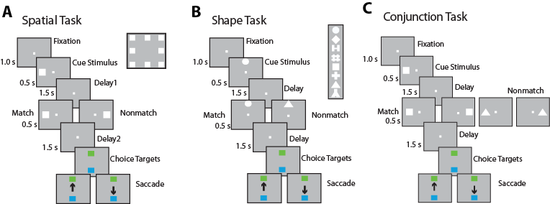

**Figure 1**. Task structure and stimuli used. The animals were required to maintain center fixation throughout the trial. When the fixation point was turned off, monkeys were required to make a saccade to a green target if two the stimuli presented were identical (matched) or to a blue target if the stimuli were different (did not match). (A) Spatial location match-nonmatch task. Eight cue locations used for analysis are shown in the inset. (B) Shape feature match-to-sample task. Eight shapes used for analysis are shown in the inset. (C) Spatial-shape conjunction task. Two locations and two stimulus shapes were used for any single particular session. Stimuli in all tasks extended 2 degree of visual angle.

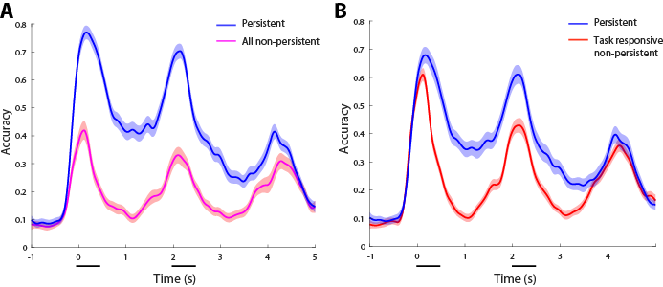

**Figure 2**. SVM decoding performance for the spatial task as a function of time relative to the onset of the cue. (B) Accuracy for populations of persistent and all non-persistent neurons with n=XXX neurons and 10-fold cross-validation. Shaded area represent standard deviation calculated over 100 repetitions. Only match trials, defined by the first and second stimuli being identical, are shown here. (B) Accuracy for populations of persistent and task-responsive but non-persistent neurons with n=200 neurons and 10-fold cross-validation.

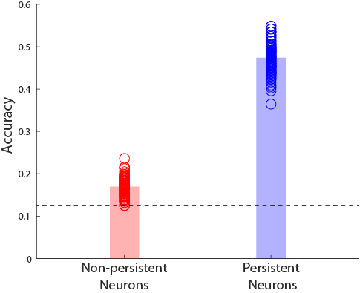

**Figure 3**. SVM decoding performance for the spatial task. Accuracy for the middle 1 s of the first delay period. Simulations are shown separately for persistent and (task-responsive) non-persistent neurons with n=200 neurons and 10-fold cross-validation. Horizontal line represents chance performance.

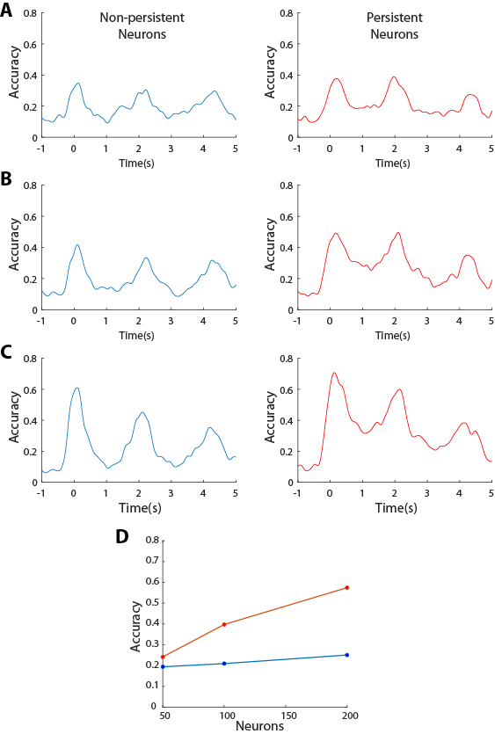

**Figure 4**. SVM decoding performance in the spatial task, for different sample sizes of persistent and (task-responsive) non-persistent neurons. A-C. Sample size of n=50, 100, and 200 neurons respectively. D. Accuracy of data shown for the first time point of the delay period.

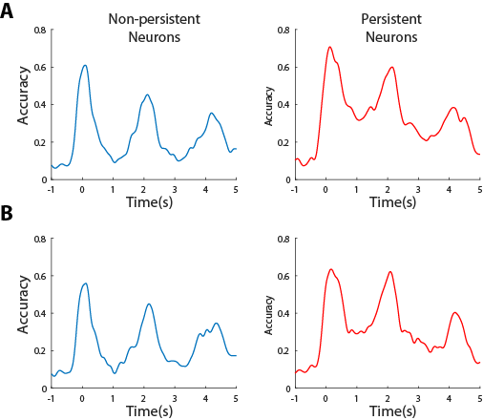

**Figure 5**. SVM decoding performance in the spatial task, for different parameters of cross-validation. A. Five-fold cross validation. B. Ten-fold cross validation. Sample size n=200 neurons, for all cases.

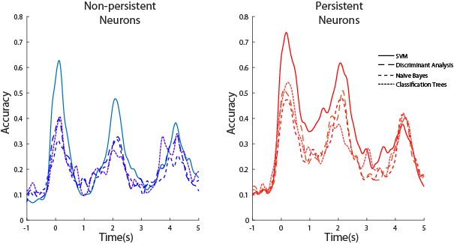

**Figure 6**. Decoding performance in the spatial task, for persistent and (task responsive) non-persistent neurons, using different classifiers. Sample size n=200 neurons, for all cases.

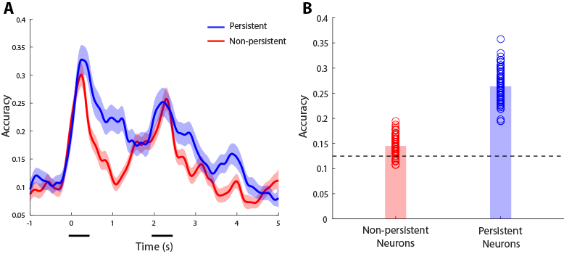

**Figure 7**. Decoding performance in the shape working memory task, for persistent and (task responsive) non-persistent neurons, using the SVM classifier, with a 10-fold cross-validation. Sample size n=180 neurons, for both cases. A. Time course of decoding accuracy during the duration of the trial. Conventions are the same as in Fig. 2. B. Decoding accuracy during the middle 1 s of the delay period (0.75 – 1.75 s). Conventions are the same as in Fig. 3.